Transmission model of syphilis:

Assumptions around transient protection from re-infection following treatment

In the transmission model, we assume that in the absence of treatment, individuals remain in the late latent stage of infection and are protected from repeated infections [1-3]. With treatment, individuals enter a treated state before returning to the susceptible state. In this treated state, individuals are protected from re-infection. The time spent in the treated state is allowed to vary with the stage at which an individual receives treatment, consistent with human challenge experiments suggesting that receipt of treatment later during infection may provide more durable immunity [2, 4].

In the model, we assign prior probability distributions that describe our best estimates of the likely values of these durations of immunity, and use model calibration to confront the model (and the associated prior parameter values) with data to refine these estimates (producing posterior distributions). The prior values related to protective immunity are summarized in the table below. The immune period is assumed to be short (7-21 days) following treatment for primary and secondary syphilis (effectively representing the persistence of antibiotic in the body following treatment). We assume that the period of protective immunity following treatment for early latent infection is equal to or longer than the duration for treated primary or secondary syphilis. This is implemented in the model by multiplying the duration of protective immunity following treatment of primary or secondary syphilis by a multiplier that is allowed to range from 1-10, giving a possible prior for duration of immunity of 7-210 days. Estimates of duration of immunity following treatment of late latent syphilis have a wide prior distribution, reflecting the uncertainty associated with this parameter, with the 95% credible interval spanning 30 days to 5 years.

**Model parameters describing protective immunity following treatment**

|  |  |  |  |  |
| --- | --- | --- | --- | --- |
| Parameter | Details | Prior distributionb | Value (mean and 95% interval) | Source |
| Average duration of protection from re-infection following treatment (days)* |  |  |  | [2, 4] |
|  | Primary and secondary syphilis | Normal(14.0, 3.6) | 14.0 (7.0-21.0) |  |
|  | Late latent syphilis | Normal(927.5, 457.9) | 927.5 (30.0-1825.0) |  |
| Multiplier for duration of protection from re-infection if treated during early latent stage | Relative to primary and secondary infection | Uniform(1,10) | 5.5 (1.2, 9.8) | [4]; assumption |

*Duration of immunity for treated early latent infection calculated as: duration of protection following treatment for P&S syphilis x multiplier for duration of protection if treated during early latent stage.

Presented below is an example of the prior and posterior distributions generated after model calibration (this is not a final output, just an illustration of the types of results we are seeing with the model). The grey area represents the prior distribution for each parameter, and the blue histograms represent a sample from the posterior distributions. After calibration, the duration of immunity following treatment of primary or secondary syphilis is estimated to be 10-20 days, and that for early latent is approximately 2.5 times the estimates from primary and secondary syphilis (25-50 days). The value for protective immunity following treatment for late latent syphilis is approximately 1 year.

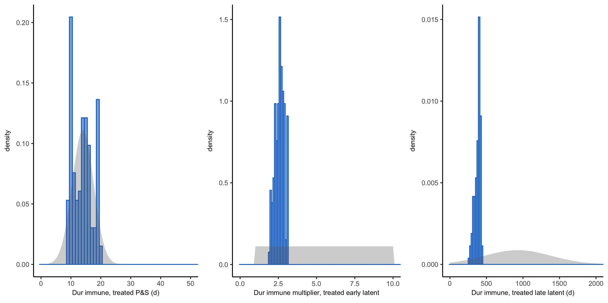

Before we finalize the calibration, we need to decide how to address the uncertainty associated with protective immunity. Because we are building separate models for Louisiana and Massachusetts, it is possible that the estimated values for the above parameters may vary by jurisdiction.

Options for modeling protective immunity:

1. Proceed as above
   1. Are the current ranges and assumptions acceptable?
      1. If not, what should be changed?
2. Set to a fixed value and do not vary during the calibration period
   1. What values should be used?
3. Proceed as above, but also repeat the calibration assuming no or limited values of protective immunity in supplementary analyses to see how this assumption changes the results.

**References**

1. Peeling RW, Hook EW, 3rd. The pathogenesis of syphilis: the Great Mimicker, revisited. J Pathol **2006**; 208:224-32.

2. Magnuson H, Evan T, Sidney O, Kaplan B, De Mello L, Cutler J. Inoculation syphilis in human volunteers. Medicine **1956**; 32:33-82.

3. Miller JN. Immunity in experimental syphilis. VI. Successful vaccination of rabbits with Treponema pallidum, Nichols strain, attenuated by irradiation. J Immunol **1973**; 110:1206-15.

4. Garnett GP, Aral SO, Hoyle DV, Cates W, Anderson RM. The natural history of syphilis. Implications for the transmission dynamics and control of infection. Sex Transm Dis **1997**; 24:185-200.