Estimating the Impact of Contact Tracing

Christian Testa

June 12, 2019

In this document, we’re going to estimate the impact on prevalence of contact tracing in the 2012 to 2016 time period.

In order to do this, we will:

1. Smooth the yearly data on fractions of cases detected due to contact tracing. We use smoothed data from all male cases detected due to contact tracing as our estimate for a fraction of cases in MSM detected due to contact tracing because the contact tracing data provided does not disaggregate MSM.
2. Use this data to take out the fraction of screening attributable to contact tracing.
3. Run a basecase and counterfactual (not including the screening attributable to contact tracing) simulations.
4. Plot the comparison, in raw prevalence numbers as well as by percentage difference between the basecase and counterfactual.

Conclusions:

* In Louisiana, prevalence in the basecase in 2016 is 764.6 per 100,000. In the counterfactual scenario (without contact tracing), prevalence is 918.5 per 100,000. In a percentage, the basecase prevalence in 2016 is 16.8% lower than in the counterfactual.
* In Massachusetts, prevalence in the basecase in 2016 is 127.4 per 100,000. In the counterfactual scenario (without contact tracing), prevalence is 137.6 per 100,000. In a percentage, the basecase prevalence in 2016 is 7.44% lower than in the counterfactual.

## Smoothing our Data with Linear Models

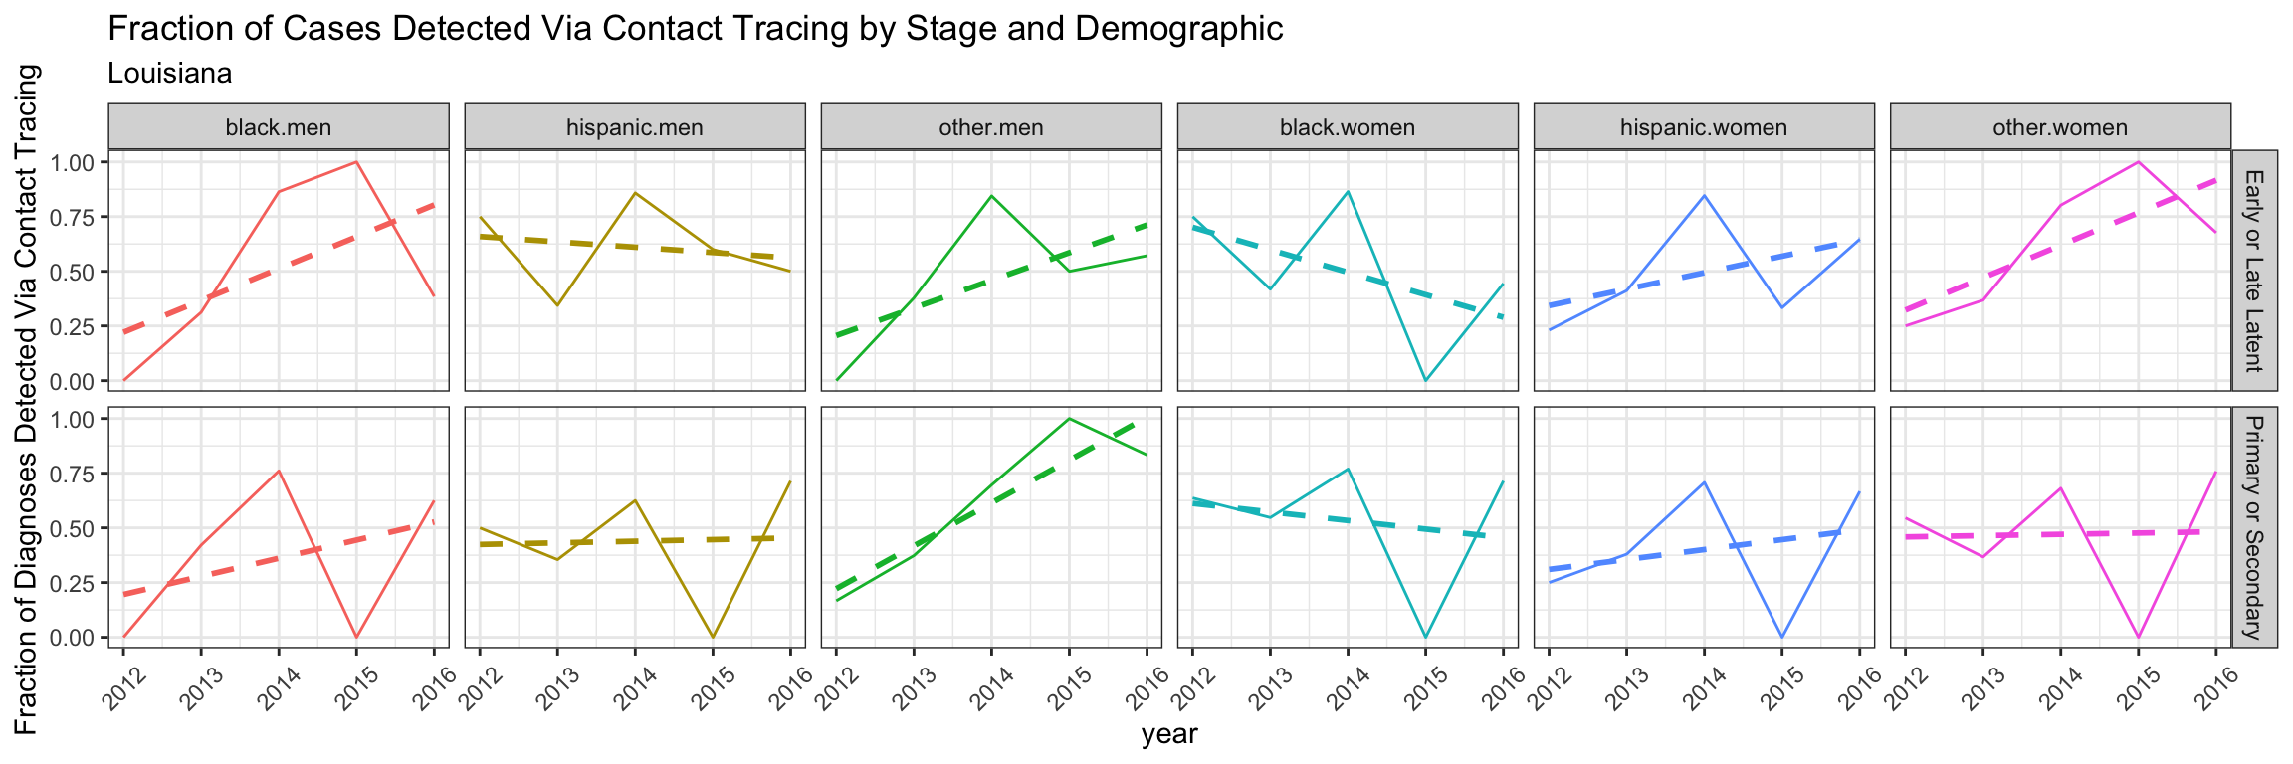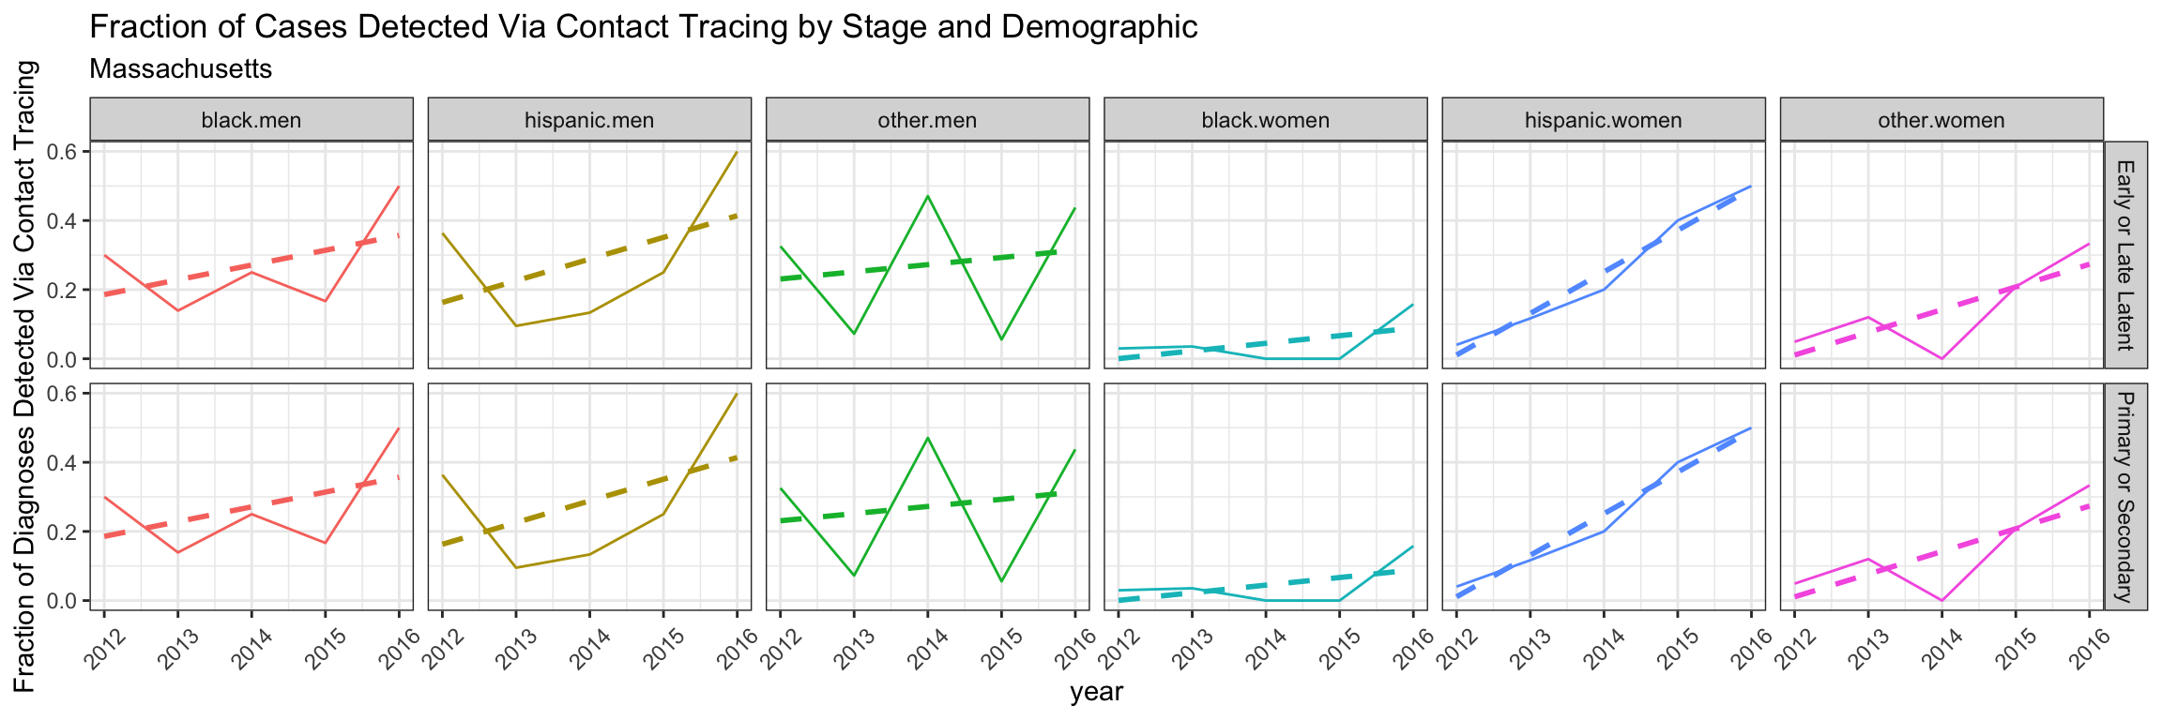

## Simulating the Basecase and Counterfactual

