Analyzing Screening Guidelines Scenarios

Christian Testa

The following outputs are in measures of infections per 100,000.

For reference, the assumed population sizes of Louisiana and Massachusetts are 2,787,423 and 4,230,601 respectively (assumed from 2015 census estimates).

### Prevalence and Incidence

### Base Case, Annual, and MSM Annual Screening Scenarios

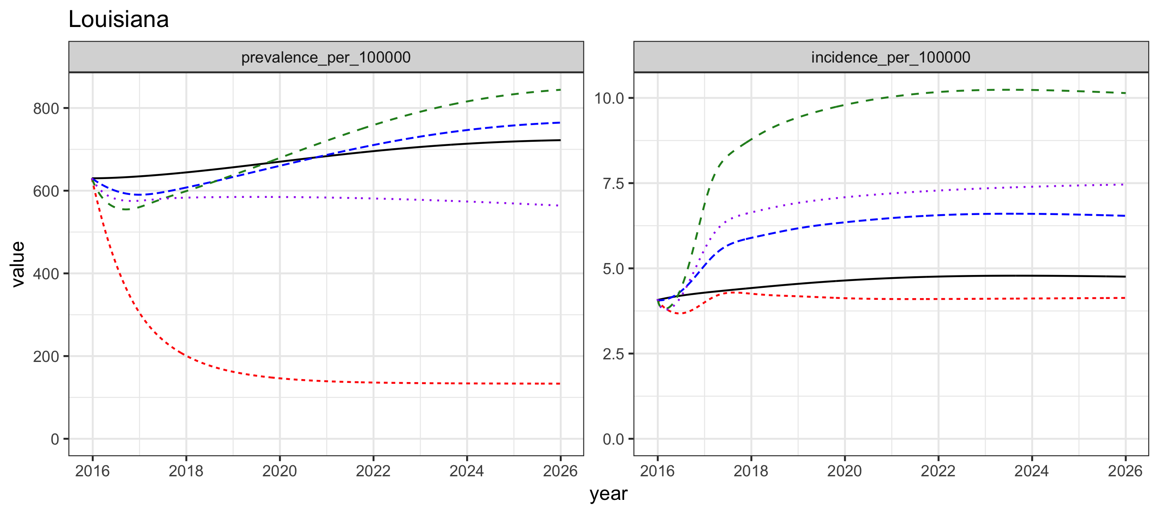

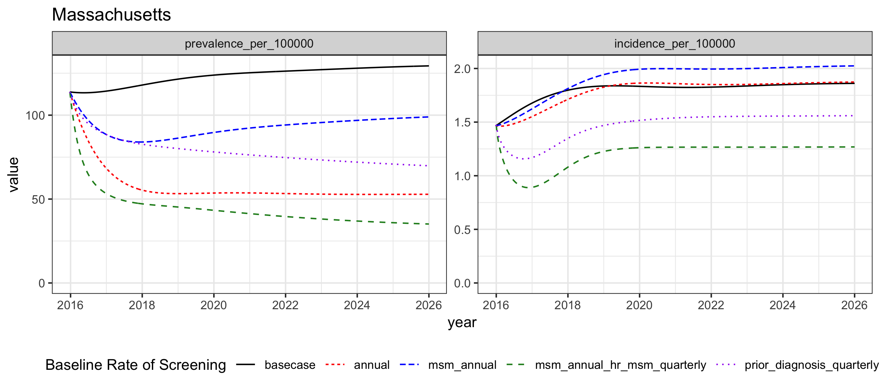

### Infectious and Noninfectious Prevalence

### Base Case, Annual, and MSM Annual Screening Scenarios

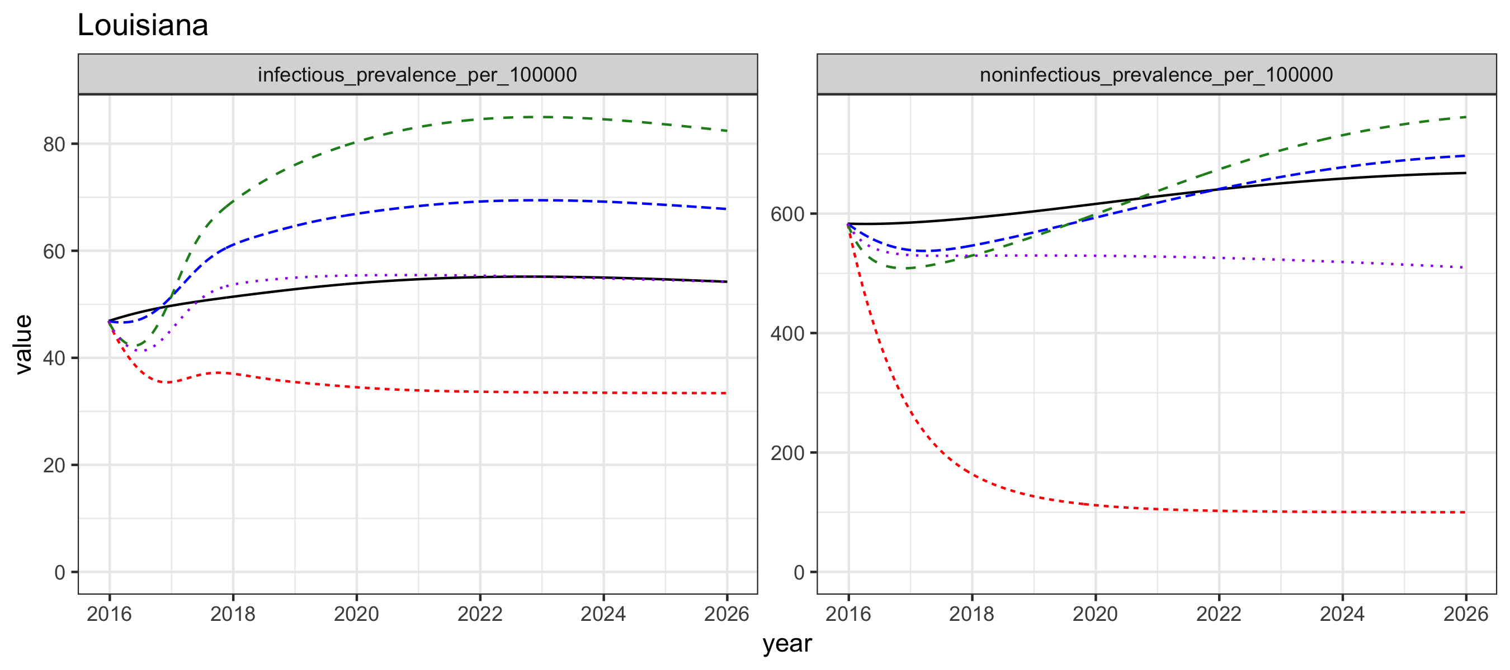

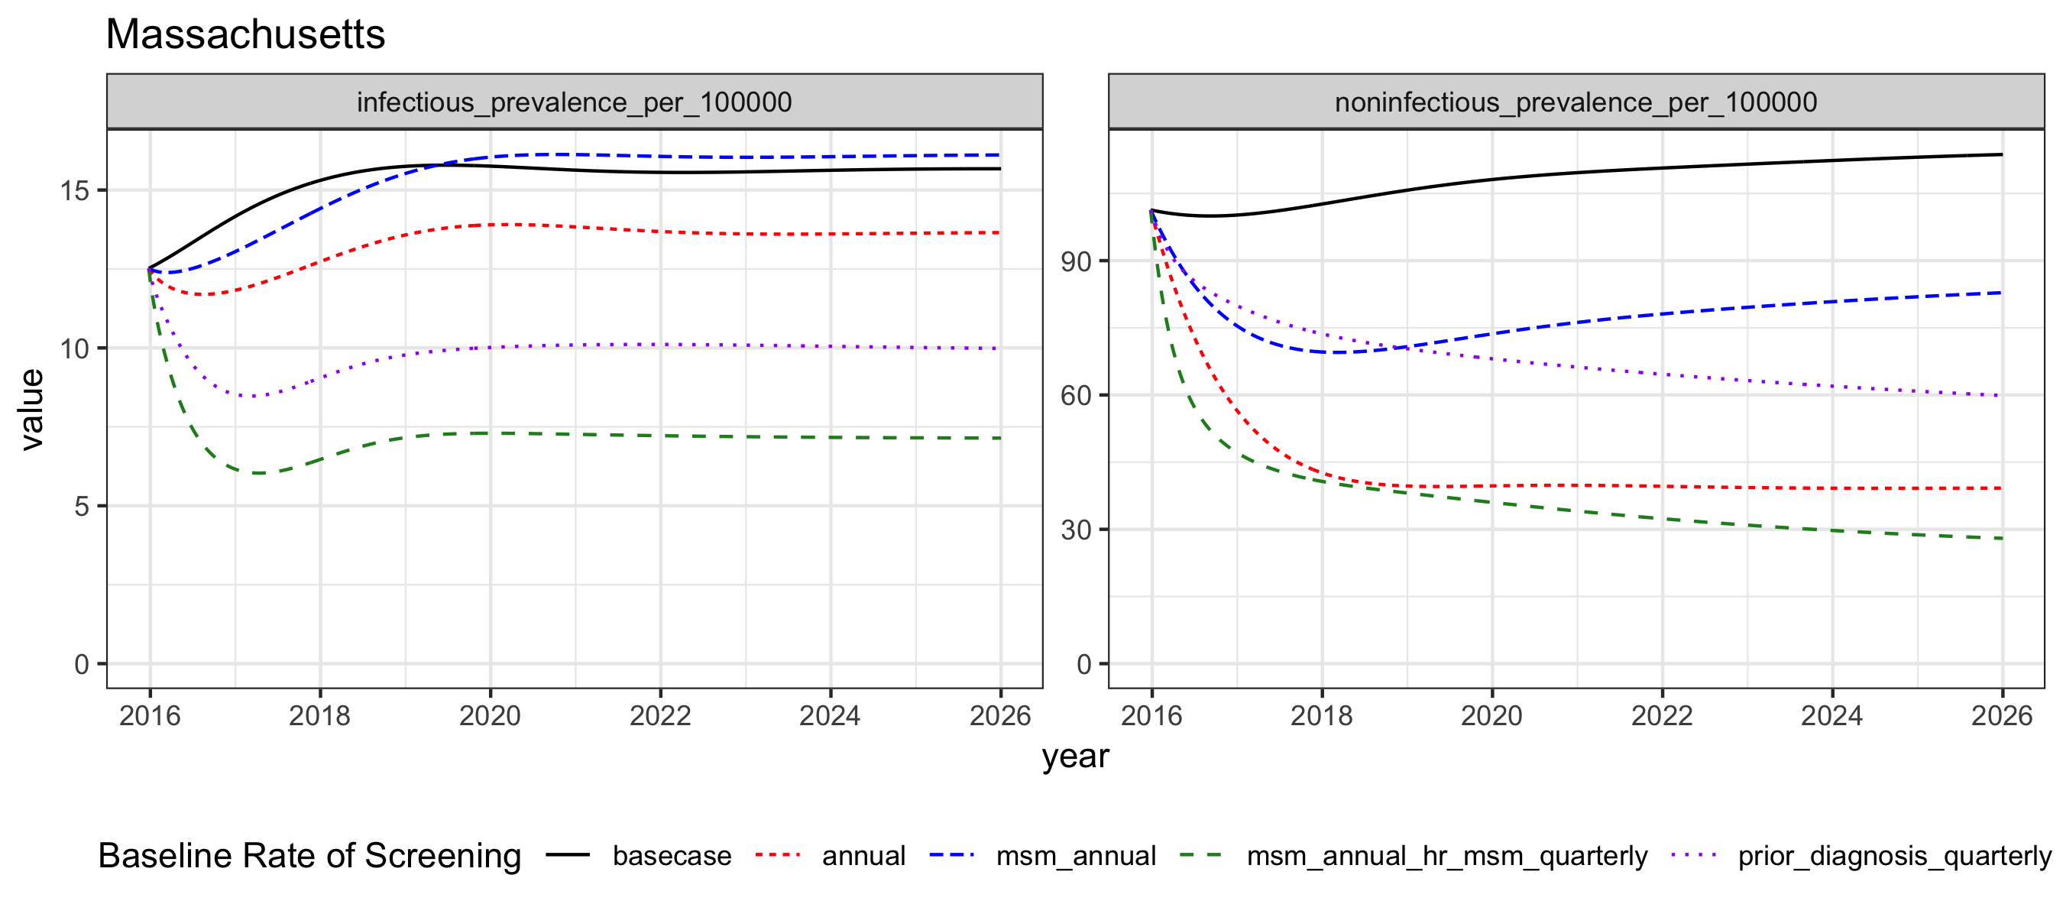

# Incidence and Diagnoses, Separated by All Infections and Those with Prior Diagnosis

### Louisiana

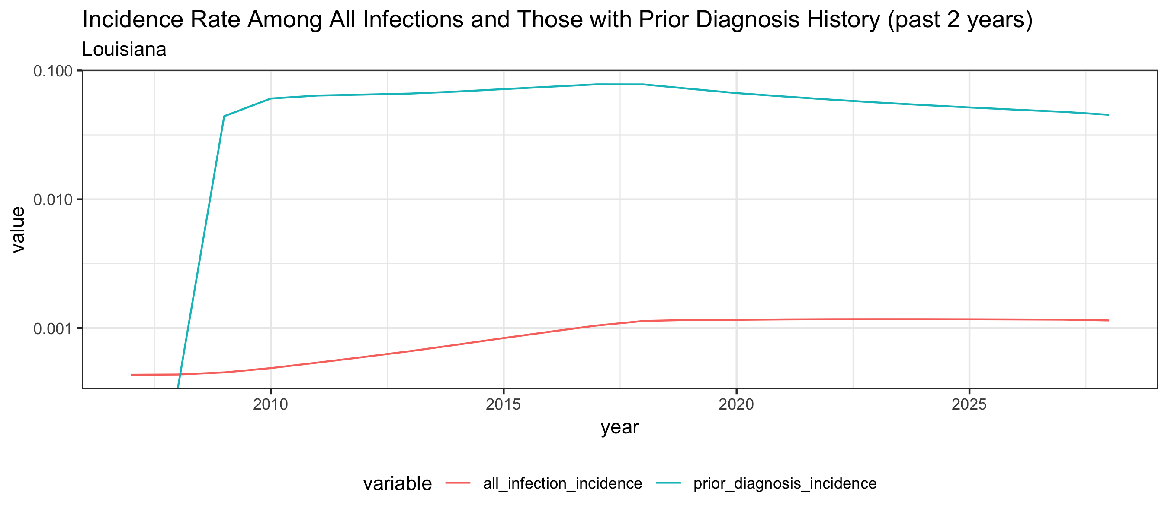

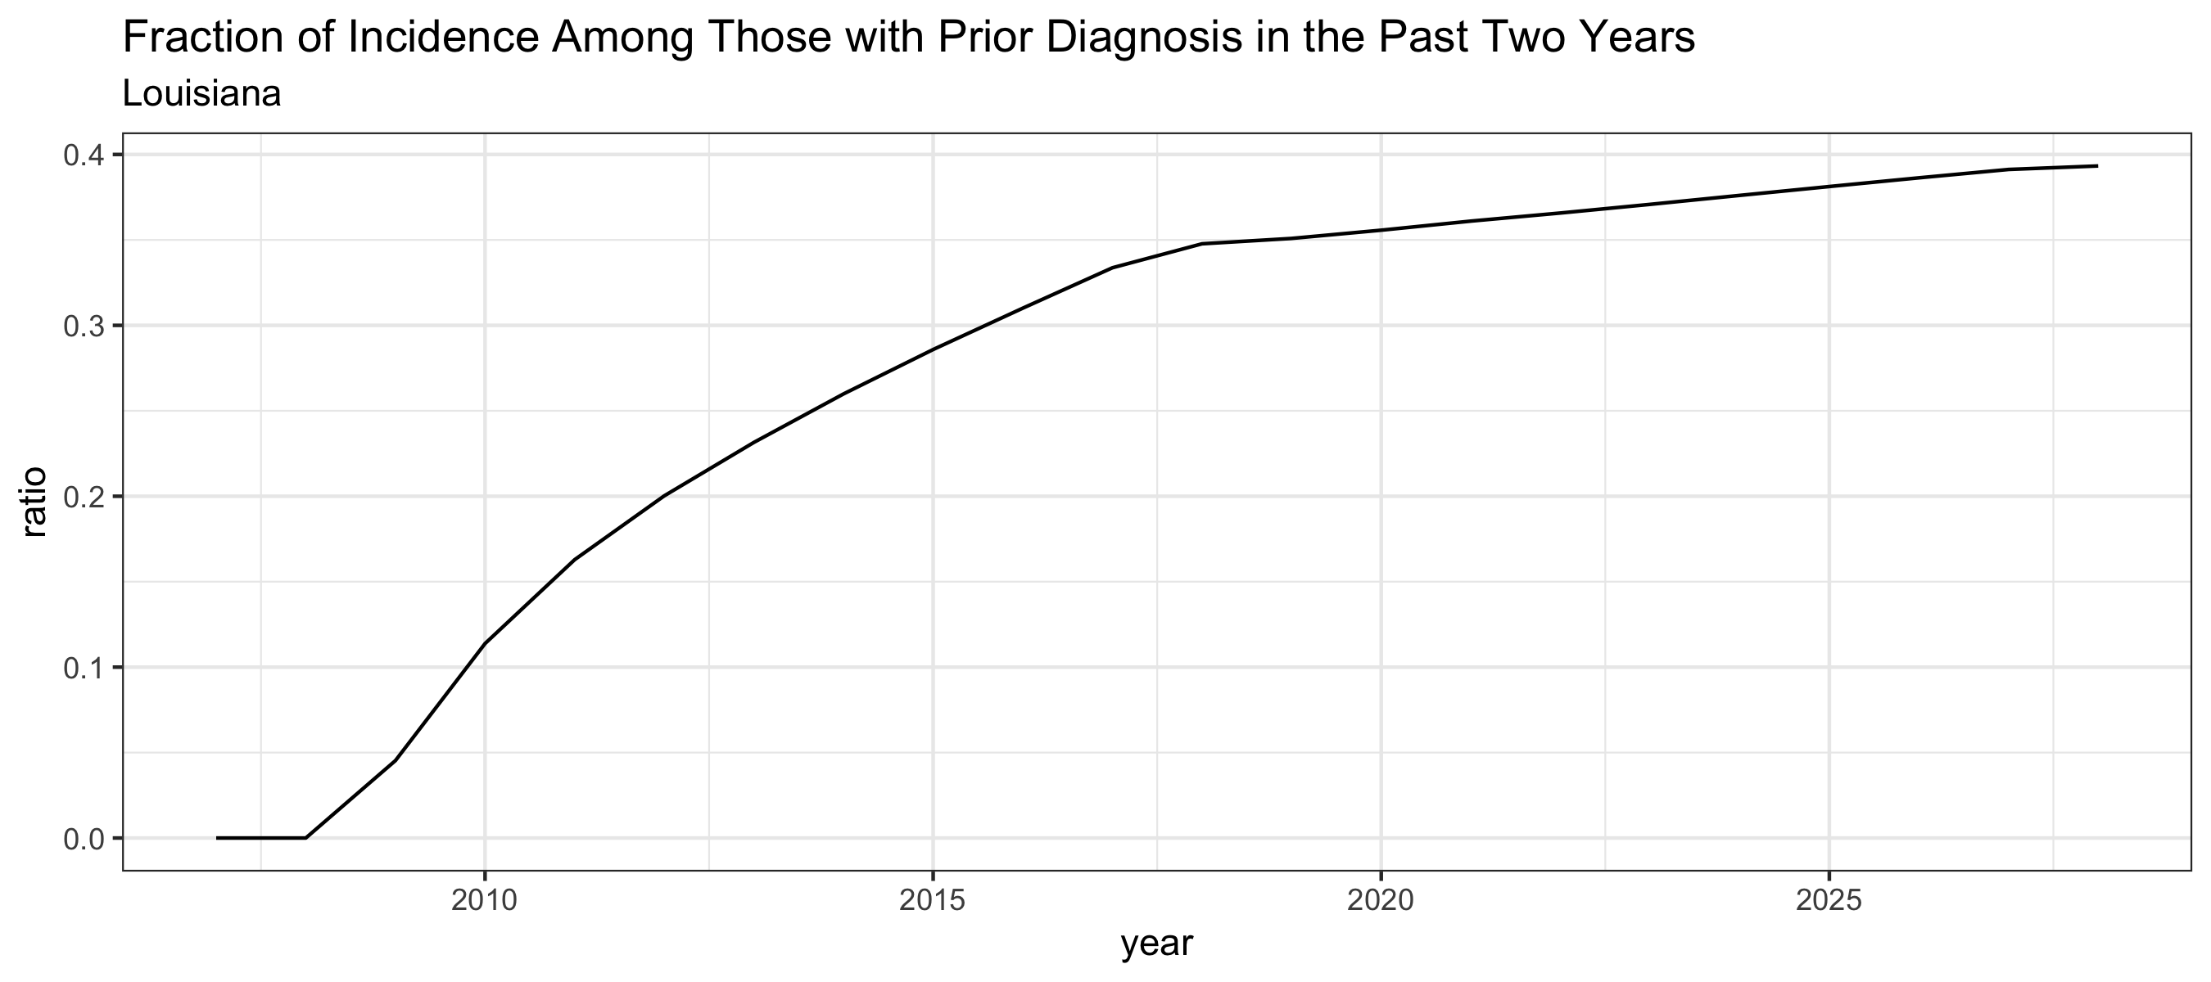

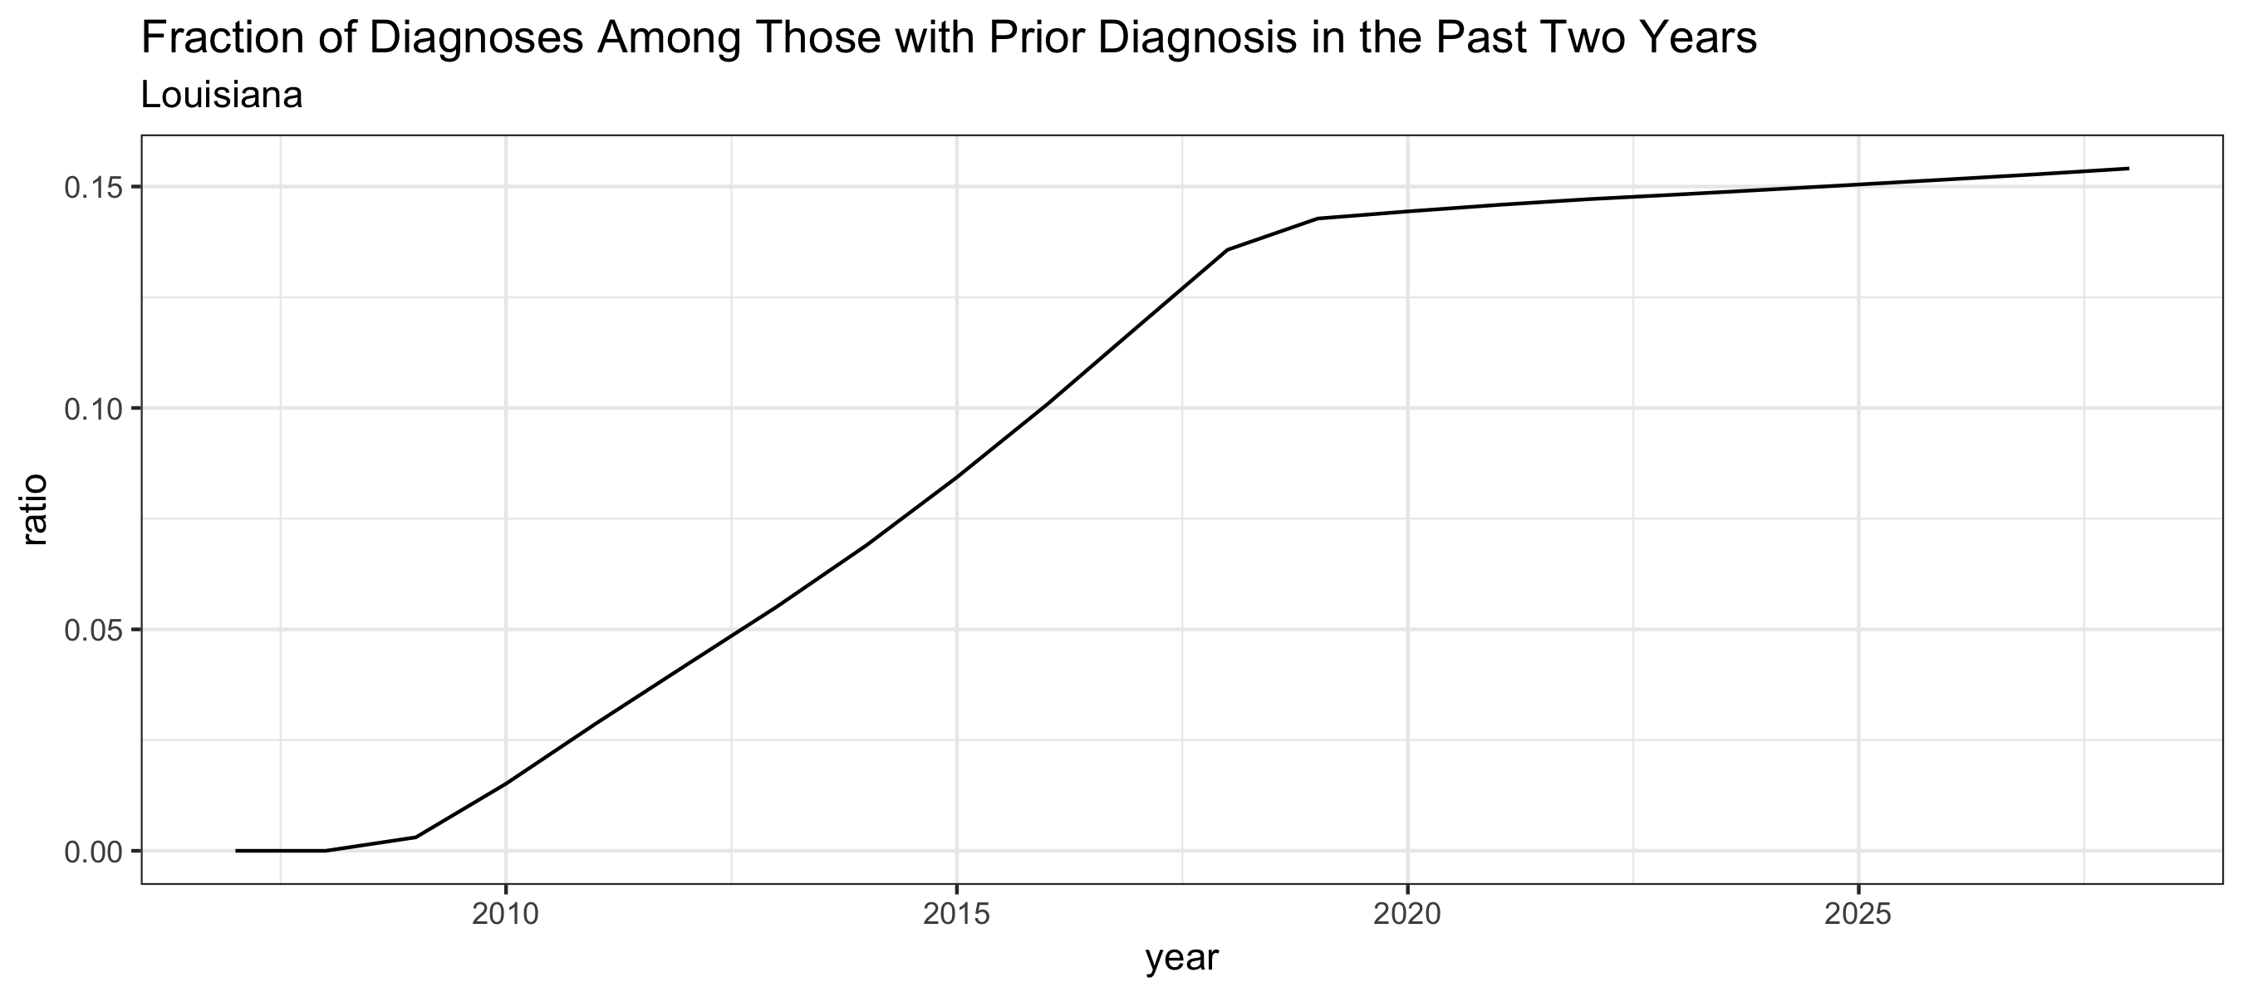

### Massachusetts

