Analyzing Screening Guidelines Scenarios

Christian Testa

The following outputs are in measures of infections per 100,000.

For reference, the assumed population sizes of Louisiana and Massachusetts are 2,787,423 and 4,230,601 respectively (assumed from 2015 census estimates).

### Prevalence and Incidence

### Basecase, Annual, and MSM Annual Screening Scenarios

## Saving 10 x 6 in image

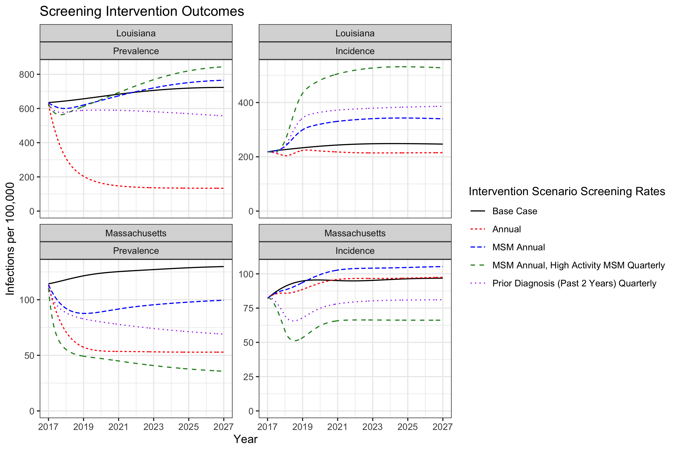

### Infectious and Noninfectious Prevalence

### Basecase, Annual, and MSM Annual Screening Scenarios

## Warning: Removed 1042 rows containing missing values (geom_path).

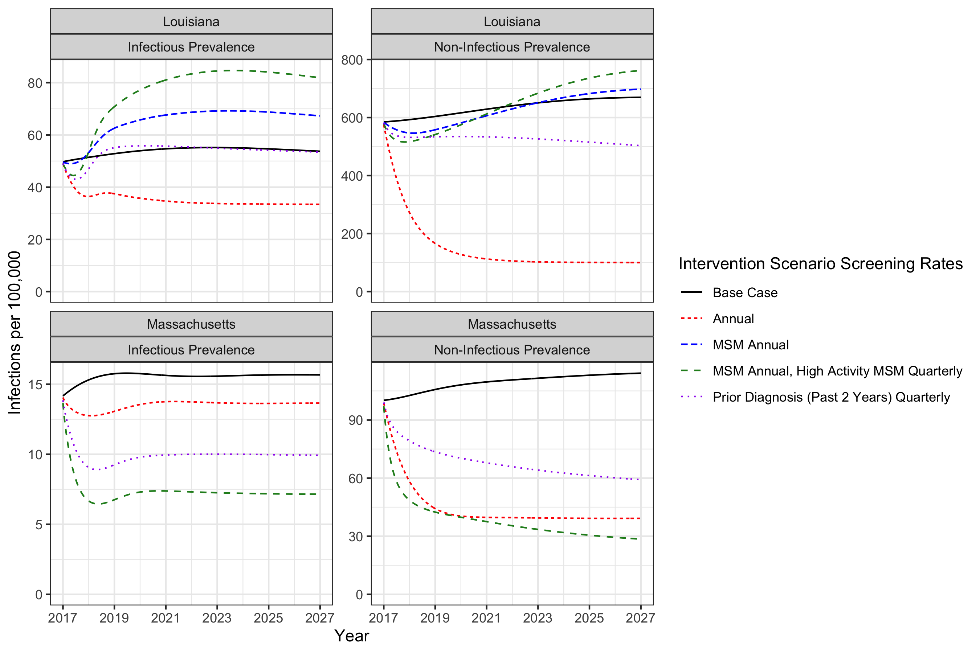

## Saving 10 x 6 in image

## Warning: Removed 1042 rows containing missing values (geom_path).

Let’s look at the incidence rate among those with prior infections vs. all incidence.

Let’s also look at what fraction of incidence is occuring among those with a prior infection in the past two years.

## Warning: Transformation introduced infinite values in continuous y-axis

## Warning: Removed 1 rows containing missing values (geom_path).

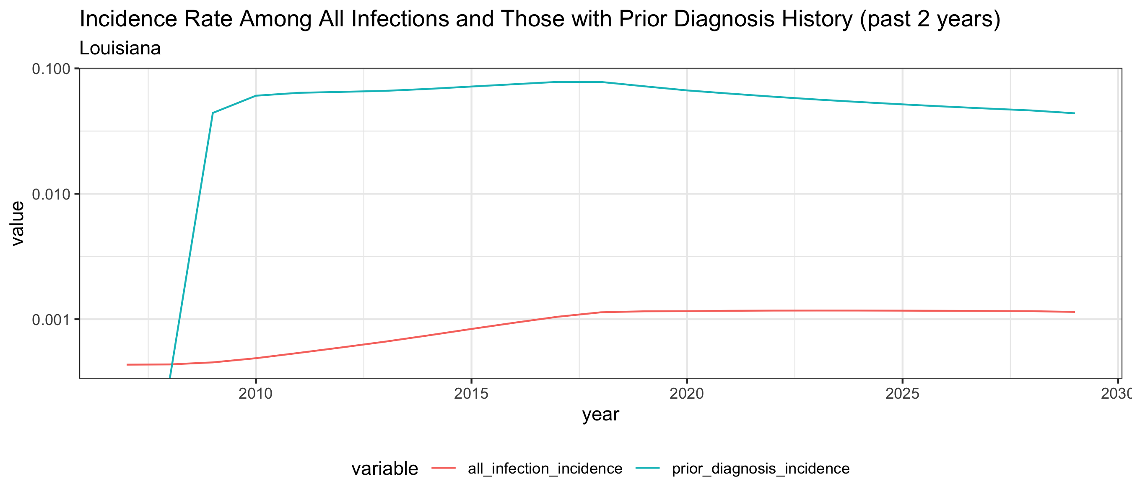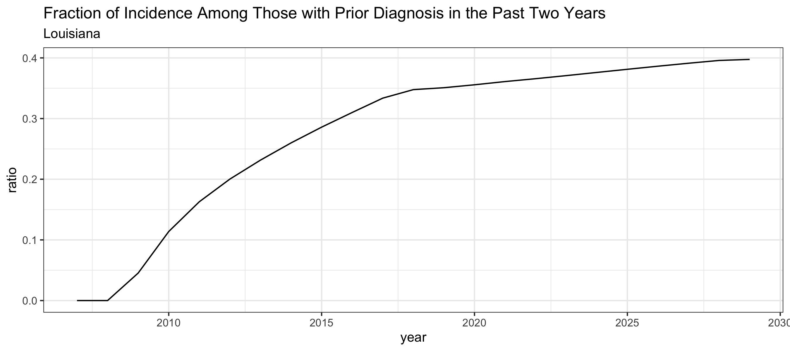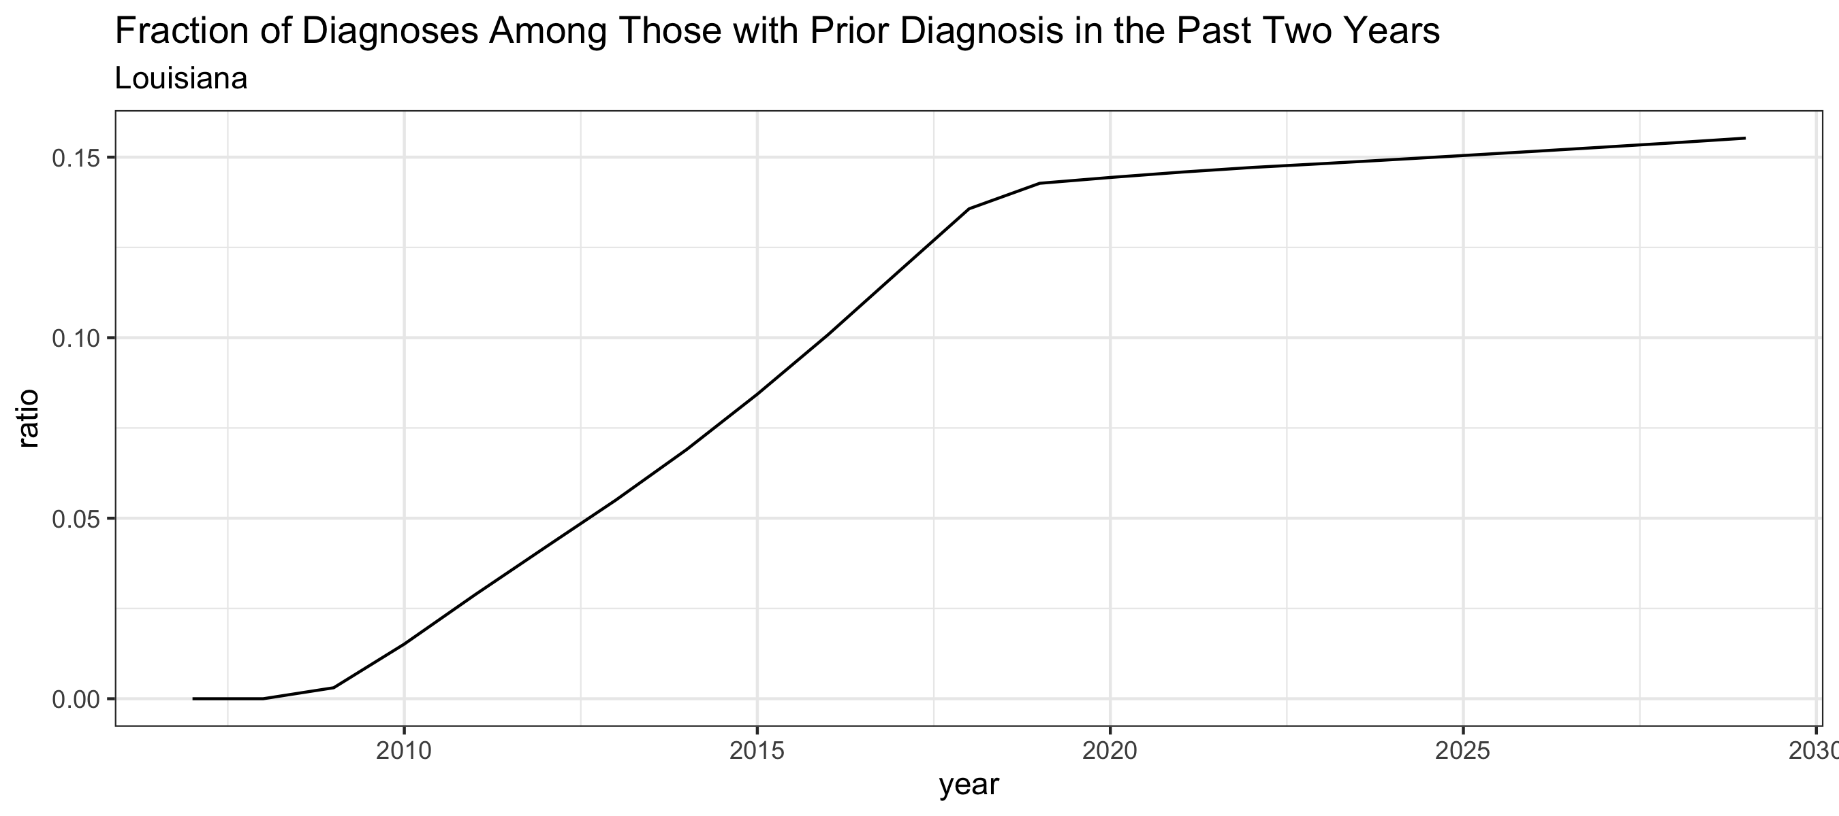

## Warning: Transformation introduced infinite values in continuous y-axis  
  
## Warning: Removed 1 rows containing missing values (geom_path).

