Mini Manuscript

Christian Testa

July 25, 2019

The purpose of this document is to provide figures and tables which could be included in our research manuscript in an organized fashion.

This mini-manuscript is divided into the following sections:

* Introduction
* Background
* Methodology
  + Model Calibration
  + Intervention Scenario Simulation
* Results
  + Calibration Findings
  + Intervention Simulation Findings
* Analysis
  + How could interventions which increase screening cause an increase in prevalence?
  + Why do LA and MA behave so differently under different intervention scenarios?

# Introduction

# Background

Let me know if we’d like to include any plots of the longer time trends (from before and including our data calibration time period) and I can make any formatting adjustments we’d want to these kinds of plots:



Data on Case Rates and Breakdown by Sex and Race/Ethnicity

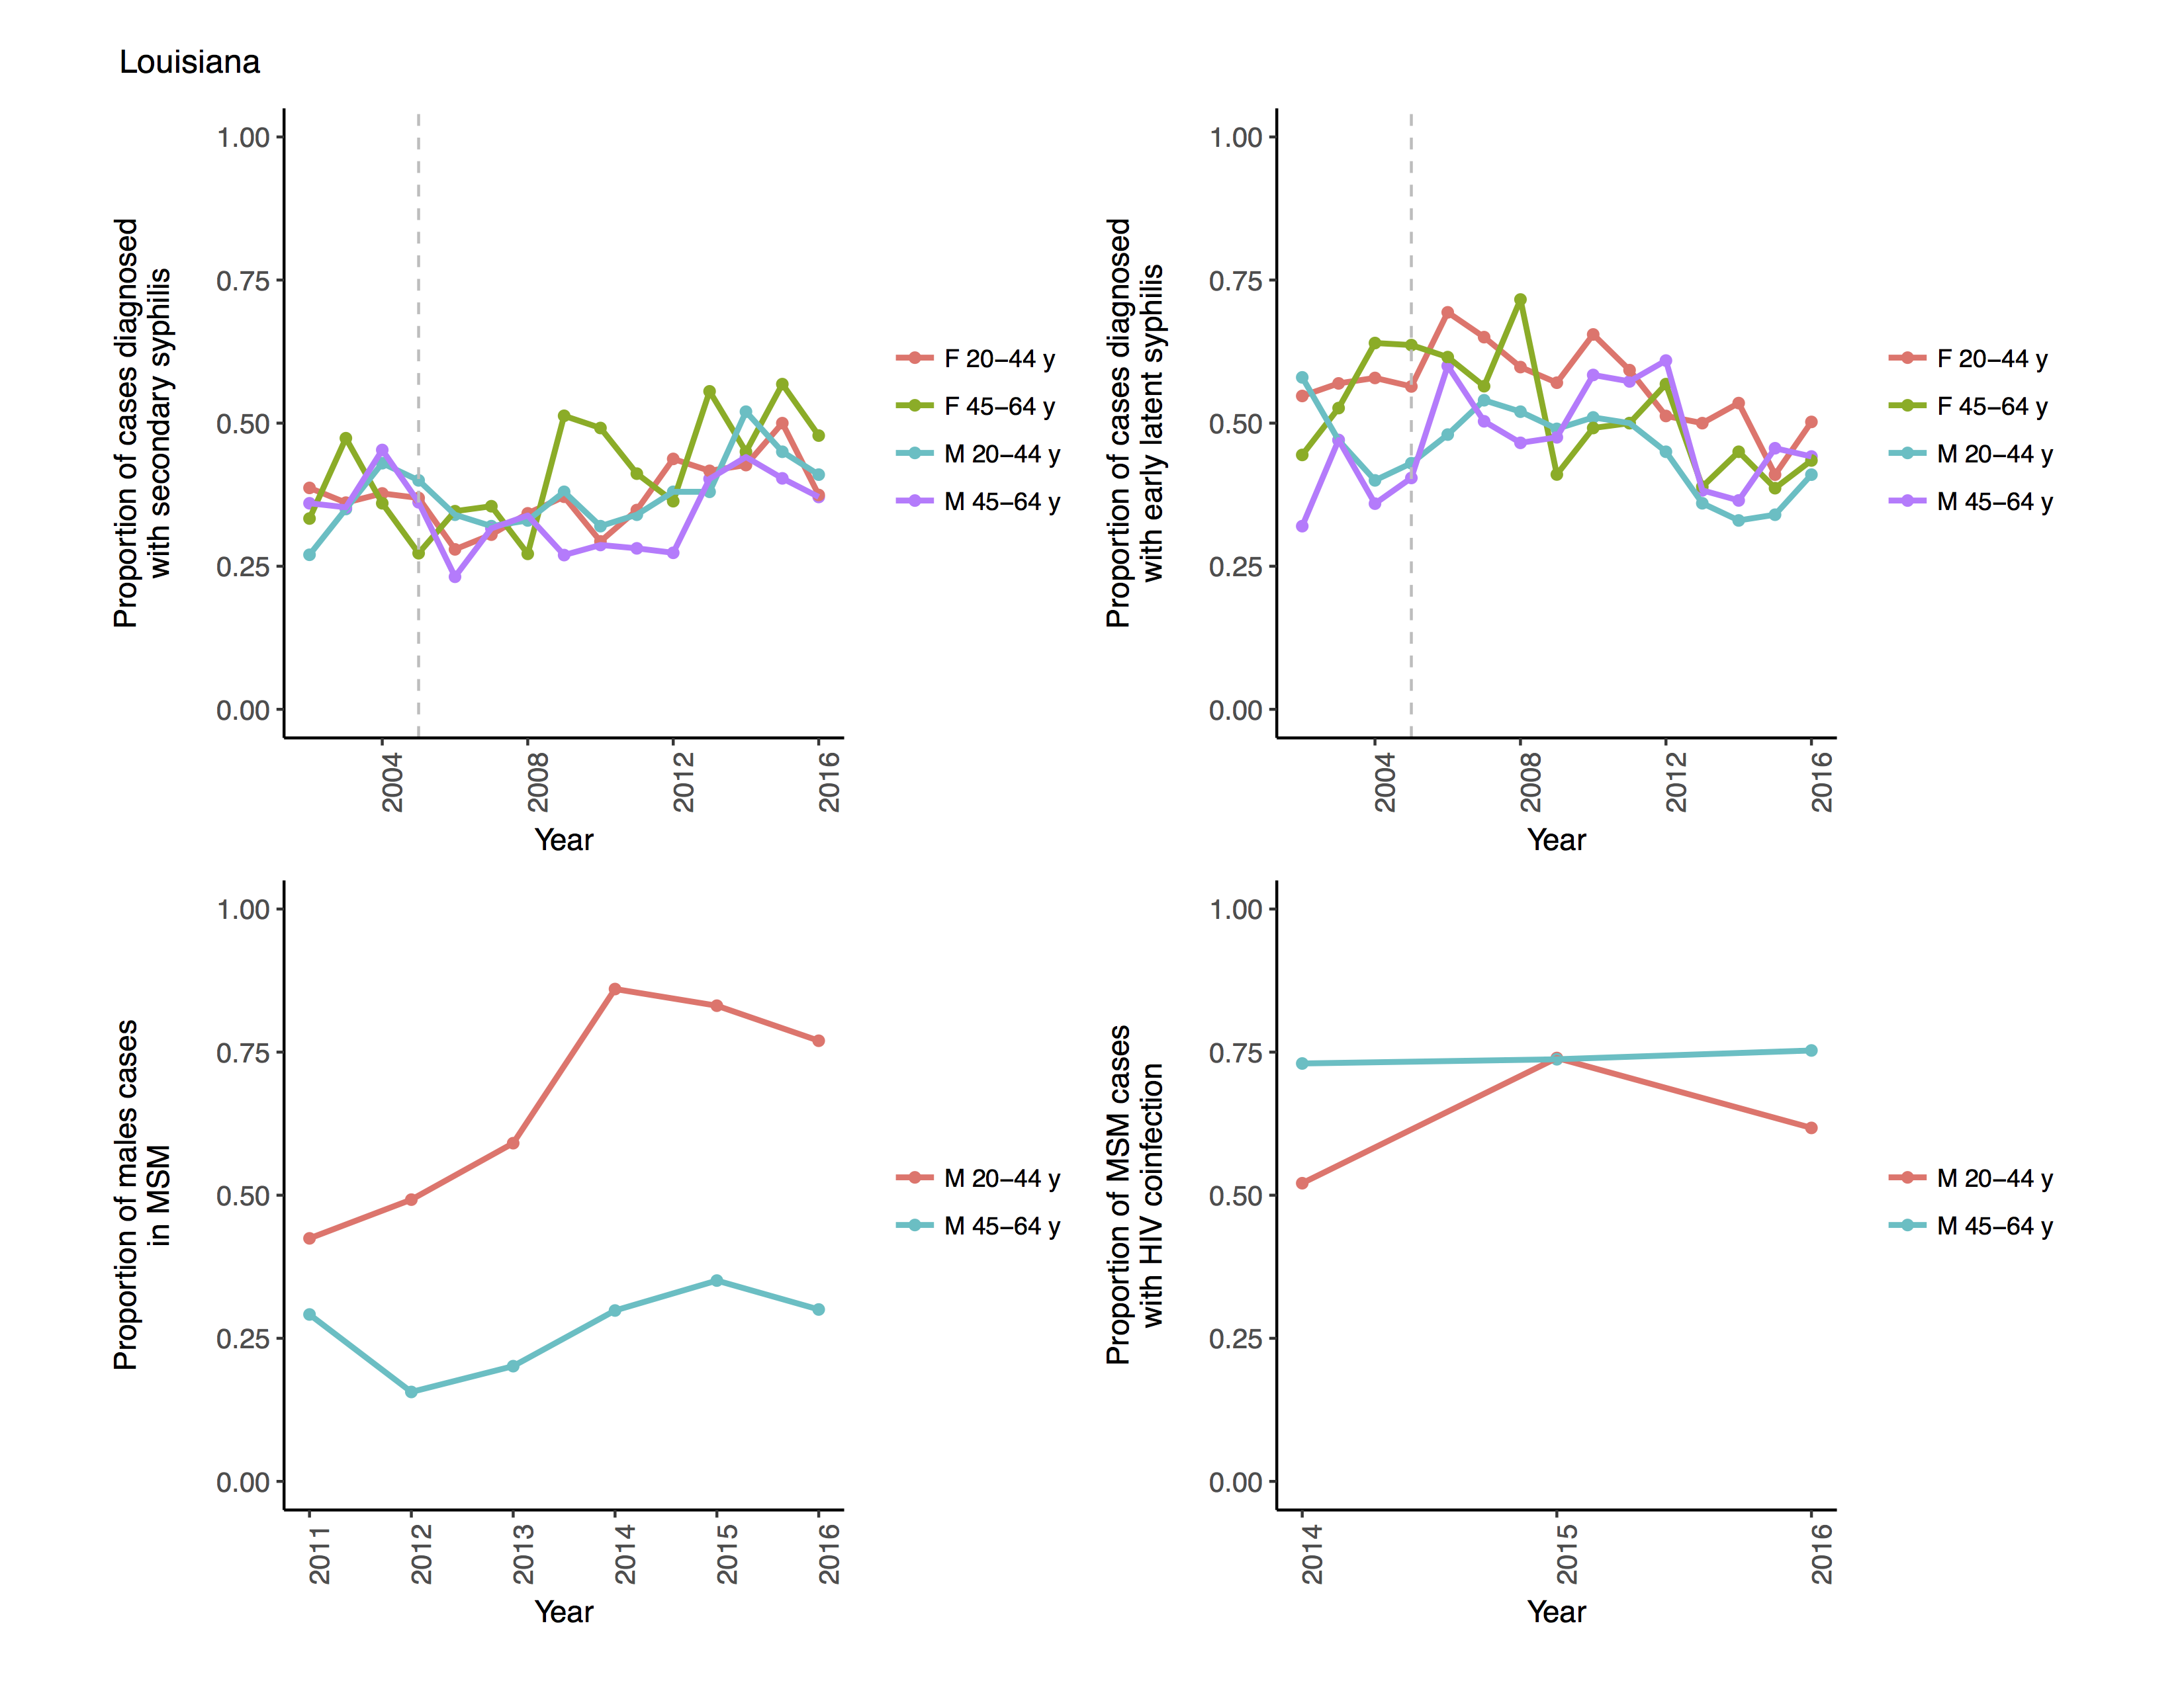

Data on Case Proportions by Secondary/Latent Stage, HIV Coinfection, and Infection in MSM



Data on Case Rates and Breakdown by Sex and Race/Ethnicity

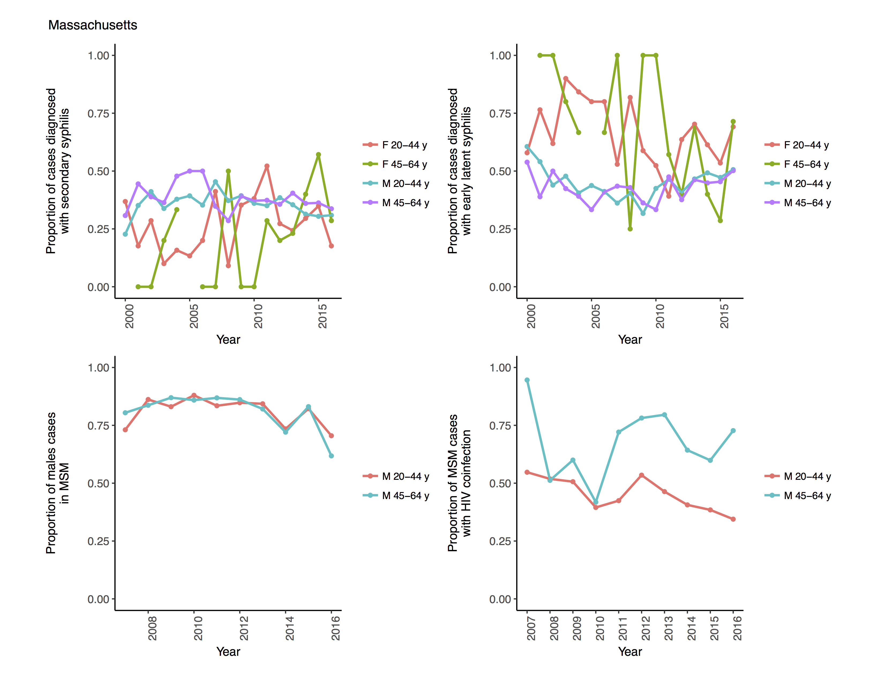

Data on Case Proportions by Secondary/Latent Stage, HIV Coinfection, and Infection in MSM

# Methodology

## Methodology – Model Calibration

See priors/posteriors plots in the figures/calibration_plots/ folder.

## Methodology – Intervention Scenario Simulation

# Results

## Results – Calibration Findings

I think it would be nice to present model estimated: Incidence, Prevalence, Diagnosis, Screening, Partnership Rates at least by sex and/or race/ethnicity, or for every compartment

## Results – Intervention Simulation Findings

I think intervention outcomes should include: Incidence, Prevalence, Additional Tests Performed Compared to the Basecase, Number Needed to Treat to Avert One Incident/Prevalent Infection

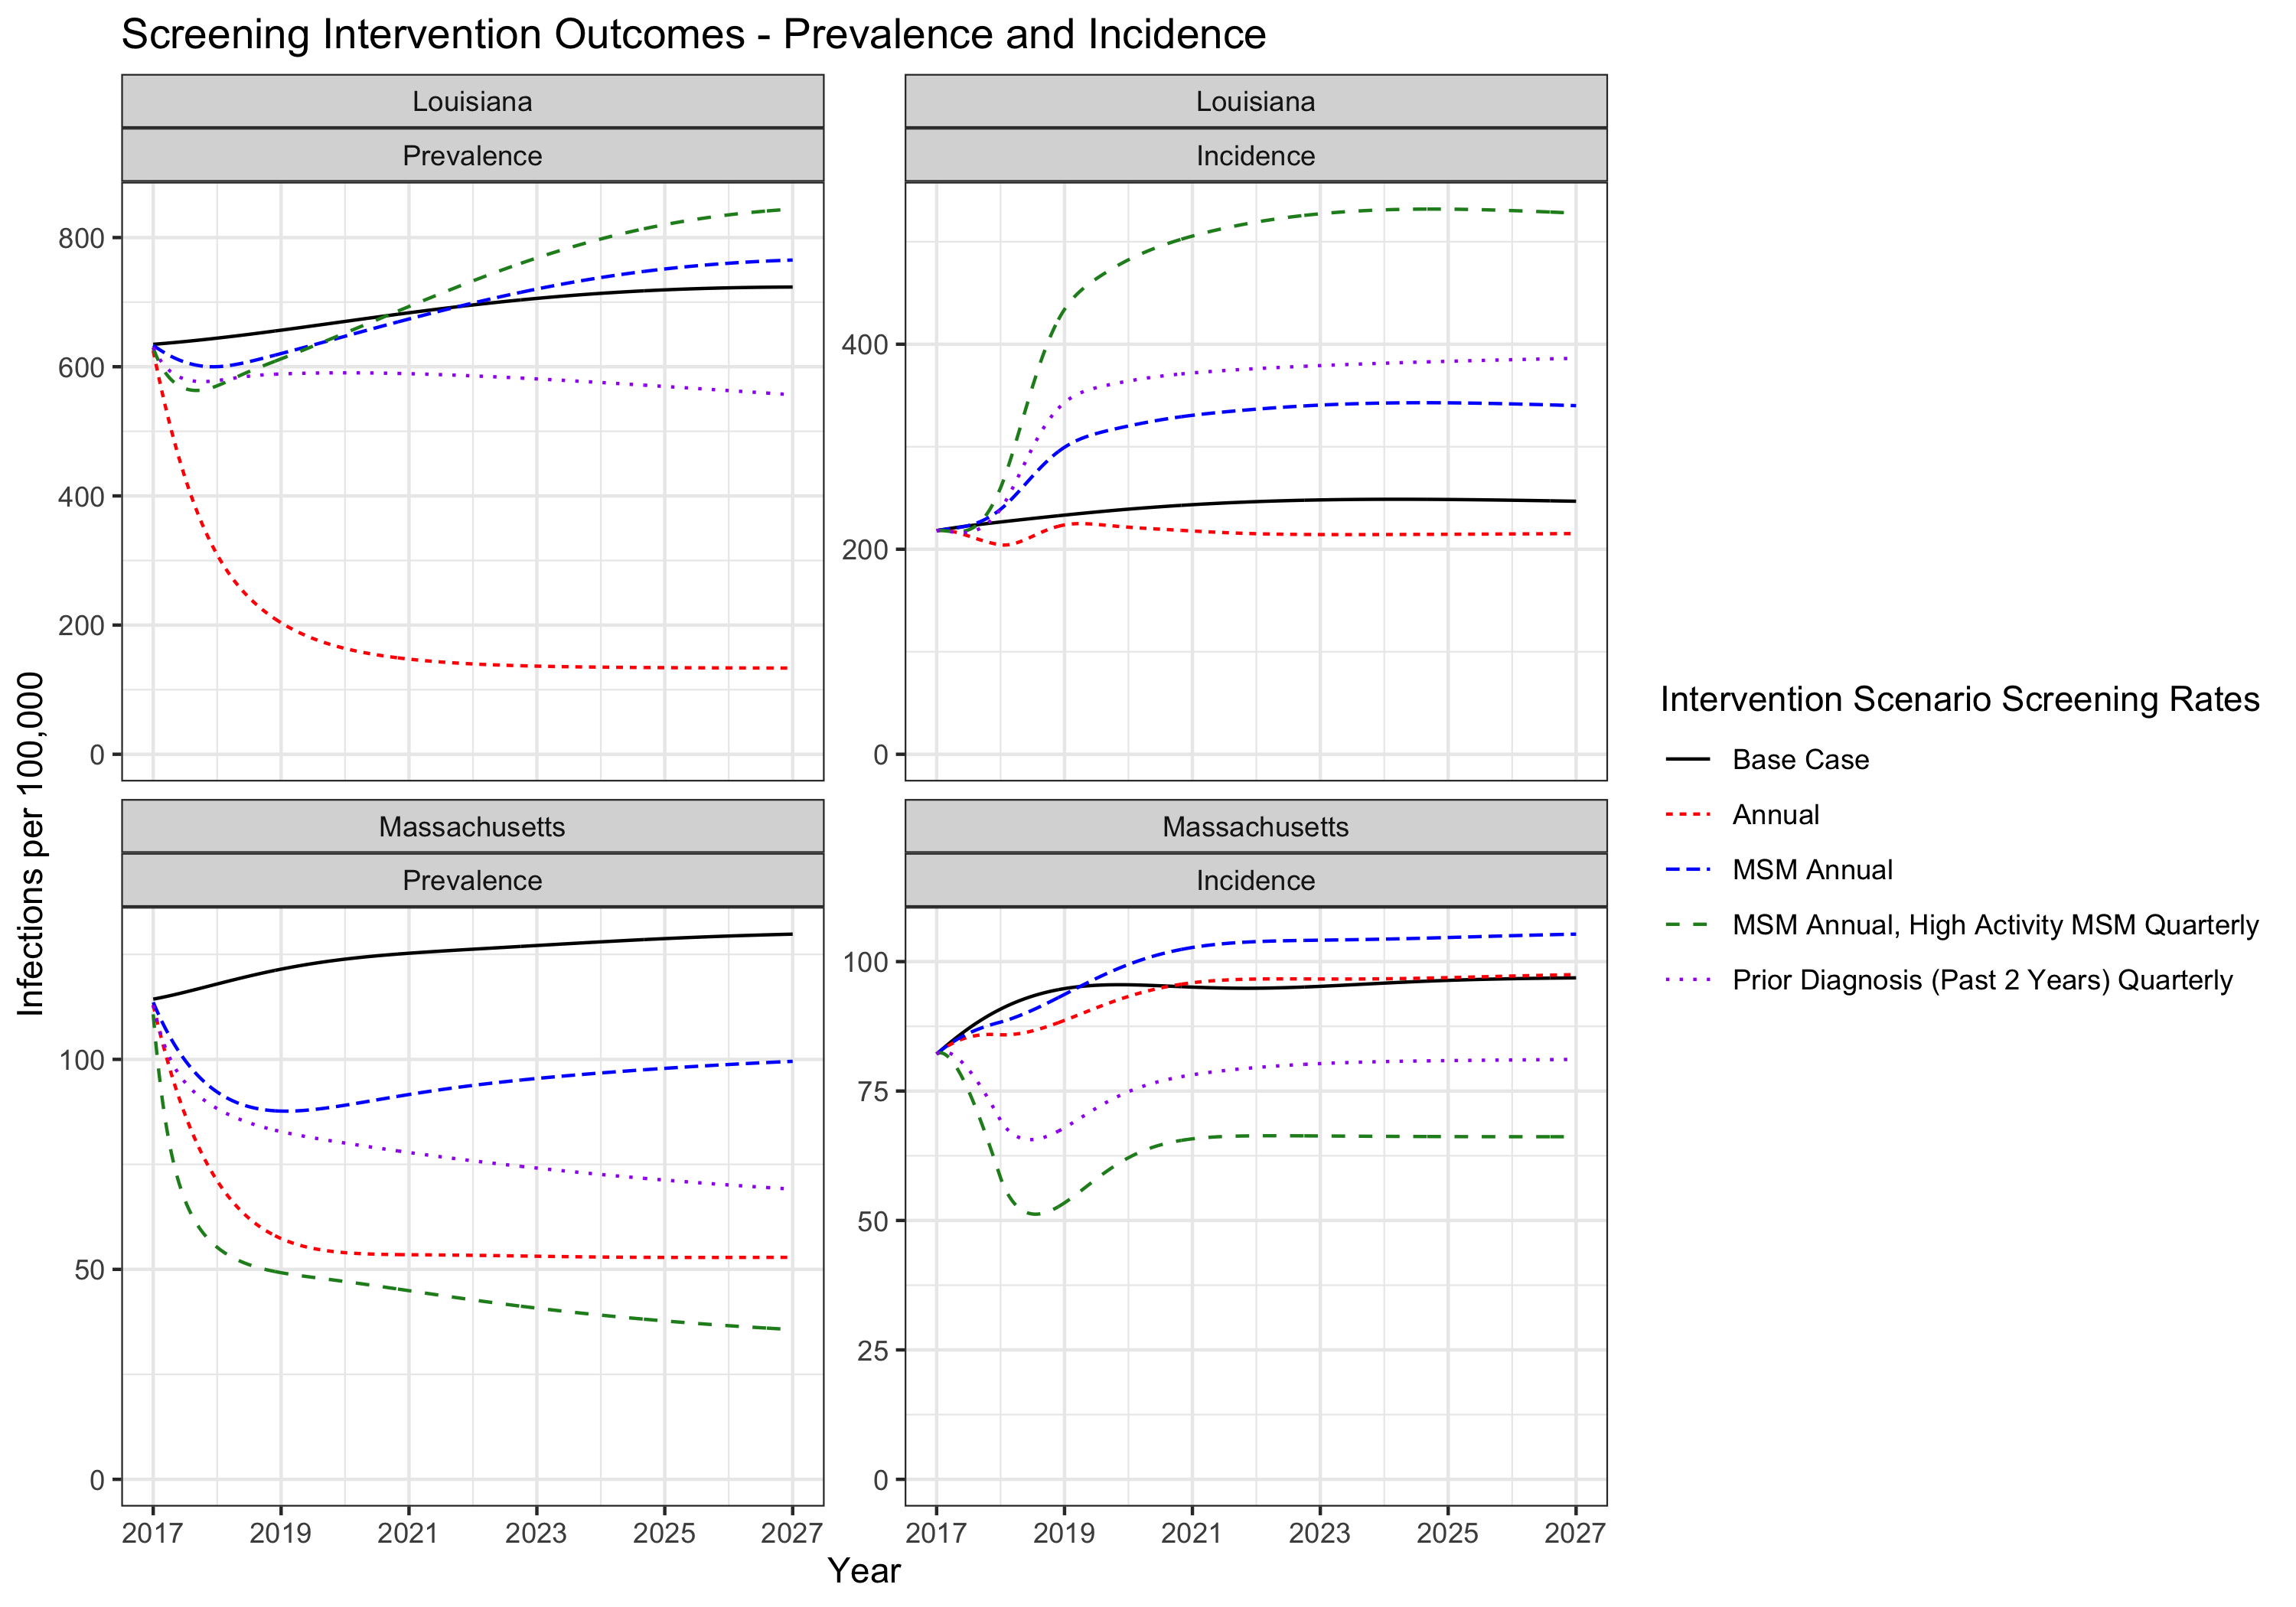

Prevalence and Incidence Under a Handful of Intervention Scenarios

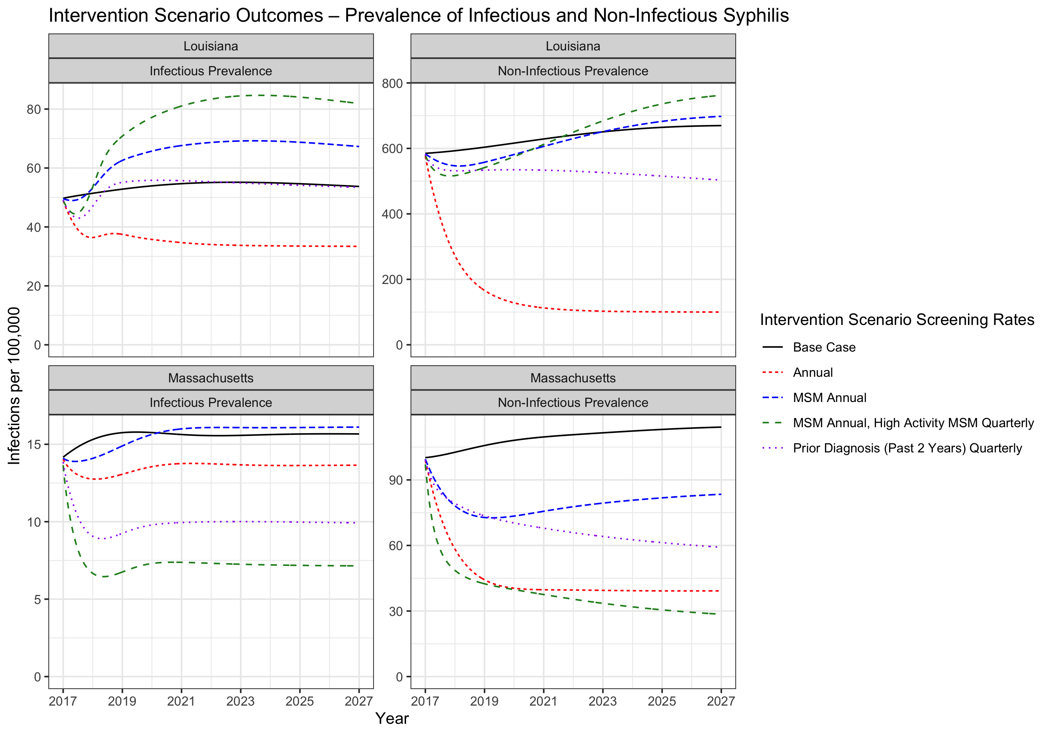

Prevalence of Infectious and Non-Infectious Syphilis Under the Same Intervention Scenarios

# Analysis

## Analysis 1 – How do interventions increase prevalence?

We hypothesize that the interventions increase prevalence by increasing symptomatic prevalence due to treatment of asymptomatic infections followed by reinfection.

This is a testable hypothesis in that if we simulate an intervention which increases prevalence with the modification that after treatment individuals cannot be reinfected, and we observe that prevalence does not increase, this should validate our hypothesis.

## Analysis 2 – Why do Louisiana and Massachusetts behave differently in intervention scenarios?

We have demonstrated that the parameters of the model which most significantly cause the Louisiana and Massachusetts results to differ in terms of their prevalence outcomes due to screening interventions are the partnership rate parameters.

### Experimental Analysis – Can we replace parameters to make Louisiana look like Massachusetts in the MSM Annual screening scenario?

What we’ve done in the following figure is simulate and record the prevalence in Louisiana under the the MSM annual scenario (denoted ‘base’). Then, we’ve taken 3 sets of parameters which have been found to impact the level of prevalence and how it responds to the screening level adjustment in the MSM annual intervention scenario and overwritten the values in the Louisiana optimized model parametrization with the same parameters from the Massachusetts optimized model parametrization.

Those sets of parameters are the parameters which control assortativity (risk assortativity, race/ethnicity assortativity, and age assortativity), partnership rates, and rates of self-treatment.

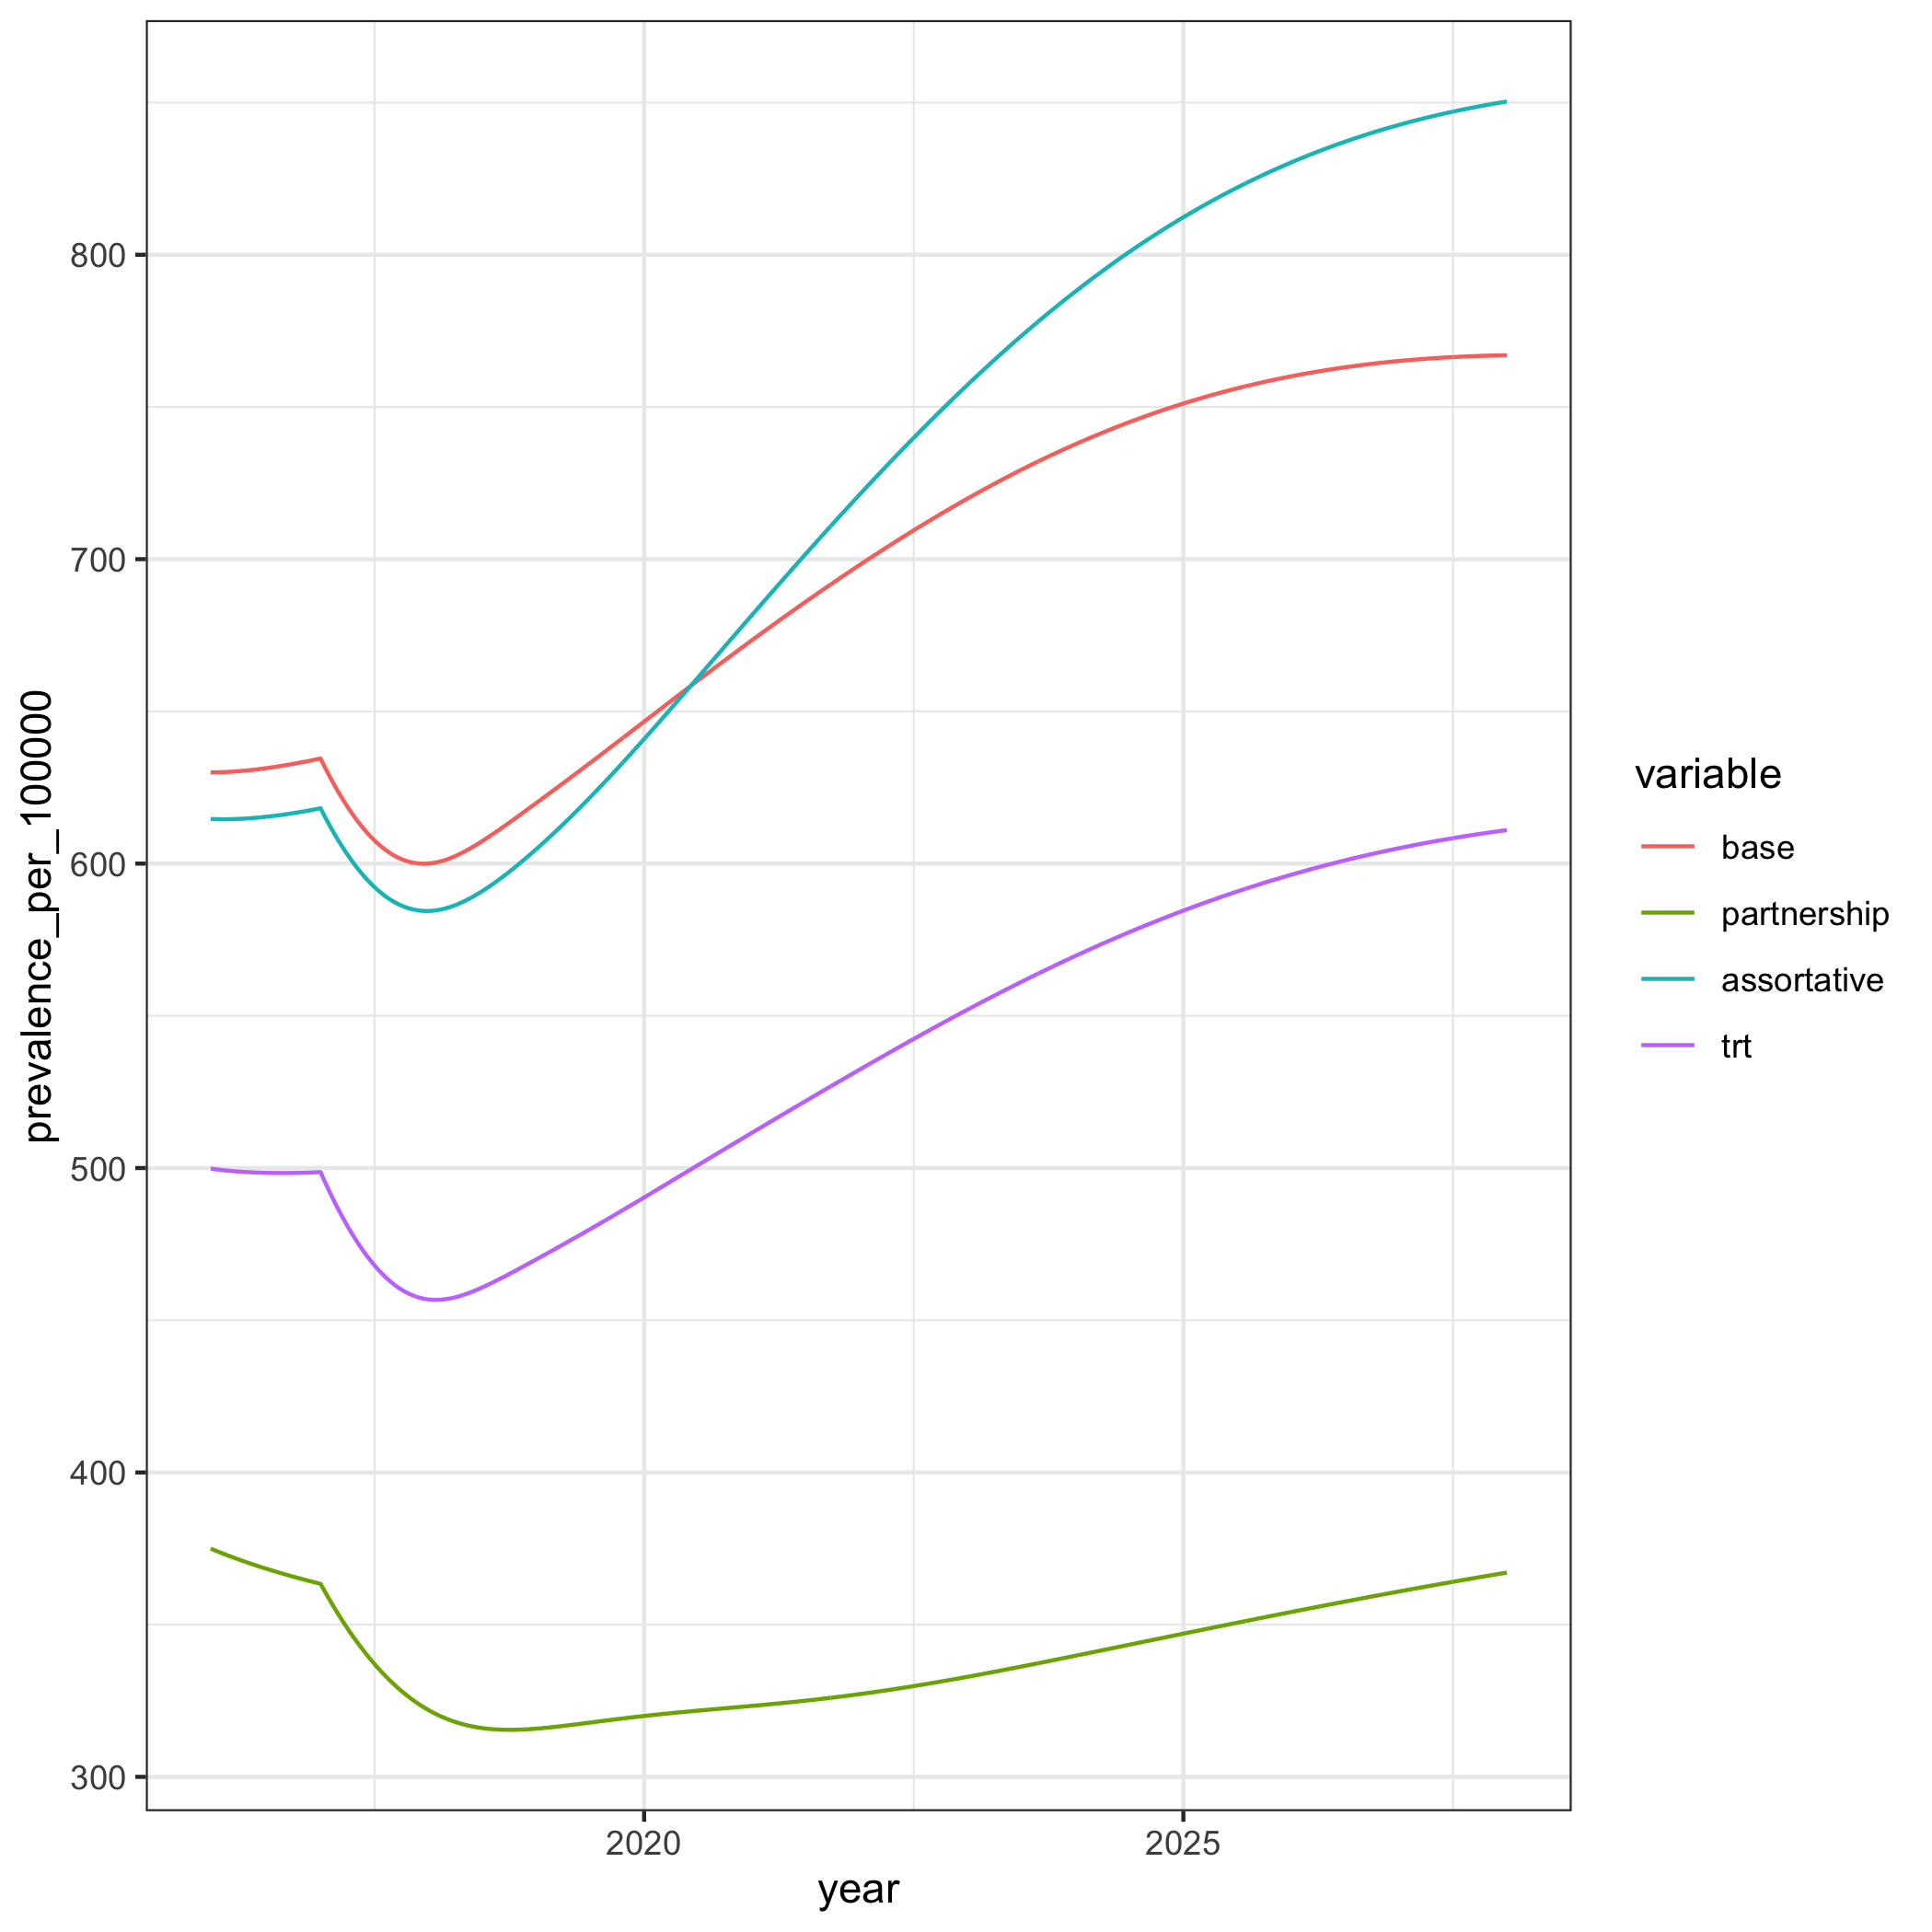

Replacing Parameters for Louisiana from Massachusetts to Understand Why Screening MSM Yields Negative Outcomes in Louisiana

As we can see, the set of parameters which causes the prevalence in Louisiana to respond most similarly to Massachusetts in the MSM Annual intervention scenario are the partnership rate parameters.

More on this topic may be needed.

# Conclusions