Syphilis Project Update

Christian Testa

July 8th, 2019

In this project we are modeling syphilis in Louisiana and Massachusetts.

In each of these two states, we have calibrated the model and can use it to simulate hypothetical scenarios which may yield useful insight into the effects of public health interventions.

This document will walk readers through the background of the model, an analysis of four initial hypothetical interventions, and our intentions for future developments.

## Model Background

#### Data Used

Calibration targets include:

* Reported Cases by Stage, Sex, Race/Ethnicity
* Proportion of Male Cases Among MSM
* Proportion of Cases Among MSM with HIV Coinfection
* Subpopulation Assortative Mixing (Age, Race)

#### Model Structure

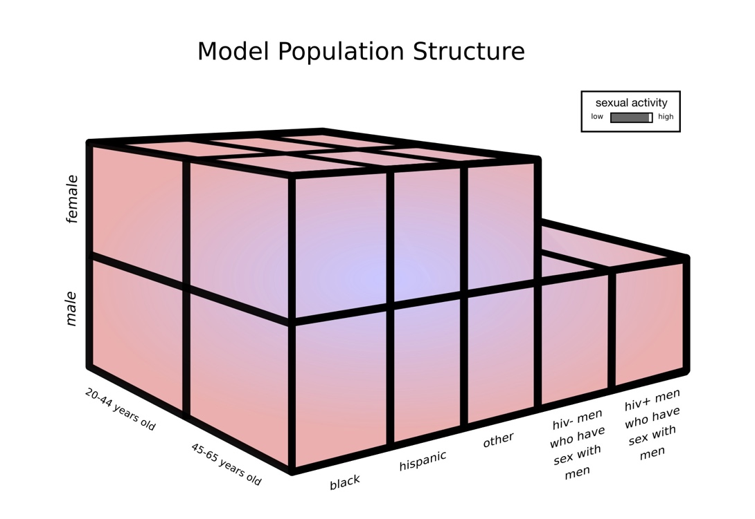

|  |  |
| --- | --- |
|  | Compartments  A: Not Sexually Active  S: Susceptible  E: Exposed  I1: Infectious – Primary  I2: Infectious – Secondary  L1: Early Latent L2: Late Latent  T1: Treatment (Primary/Secondary)  T2: Treatment (Early Latent)  T3: Treatment (Late Latent)  SR: Susceptible to Reinfection  ER: Exposed to Reinfection  IR1: Infectious Reinfection – Primary  IR2: Infectious Reinfection - Secondary  LR1: Early Latent Reinfection  LR2: Late Latent Reinfection |

#### Calibration

In order to calibrate our model, we run an optimization algorithm to determine several parameter vectors which optimize the model fit to the prior and likelihood distributions. These parameter vectors are then used as the starting places for multiple Monte Carlo Markov Chains which are used to estimate model uncertainty.

|  |  |
| --- | --- |
| Louisiana | Massachusetts |
|  |  |
| Figure: Fit to Case Report Rates by Sex and Age | |

## Intervention Analysis

Given the different epidemic characteristics in the two states during the calibration period, we began by evaluating the following research question:

How do interventions which are targeted to the general population, MSM, high sexual activity MSM, and those with a recent diagnosis (in the past 2 years) compare?

The purpose of this initial analysis was to begin to understand the model behavior after calibration to the different outbreaks.

Key points about the simulated inventions:

* For the **Base Case**, screening is maintained at 2016 levels.
* For the **Annual** scenario, everyone in the population receives at least annual screening.
* For the **MSM Annual** screening scenario, MSM receive at least annual screening but all other populations’ screening levels are maintained at their 2016 levels.
* For the **High Activity MSM Quarterly** screening scenario, the 10% of the MSM population which are high sexual activity receive screening tests at least every 3 months.
* For the **Prior Diagnosis (Past 2 Years) Quarterly** screening scenario, the modeled population of those who have had a prior diagnosis in the past two years receive screening tests at least every 3 months.
* For the increased screening scenarios, screening was only increased in a particular population subgroup if it was below the desired level in the base case; if screening in a targeted subgroup was occurring at least annually in the base case, it was maintained at this level.
* The presented outputs are infections (prevalent or incident) per 100,000.
* The number of tests being performed at baseline differs between the two states.

For reference, the assumed population sizes of Louisiana and Massachusetts are 2,787,423 and 4,230,601 respectively (assumed from 2015 census estimates).

#### Prevalence and Incidence in Screening Intervention Scenarios

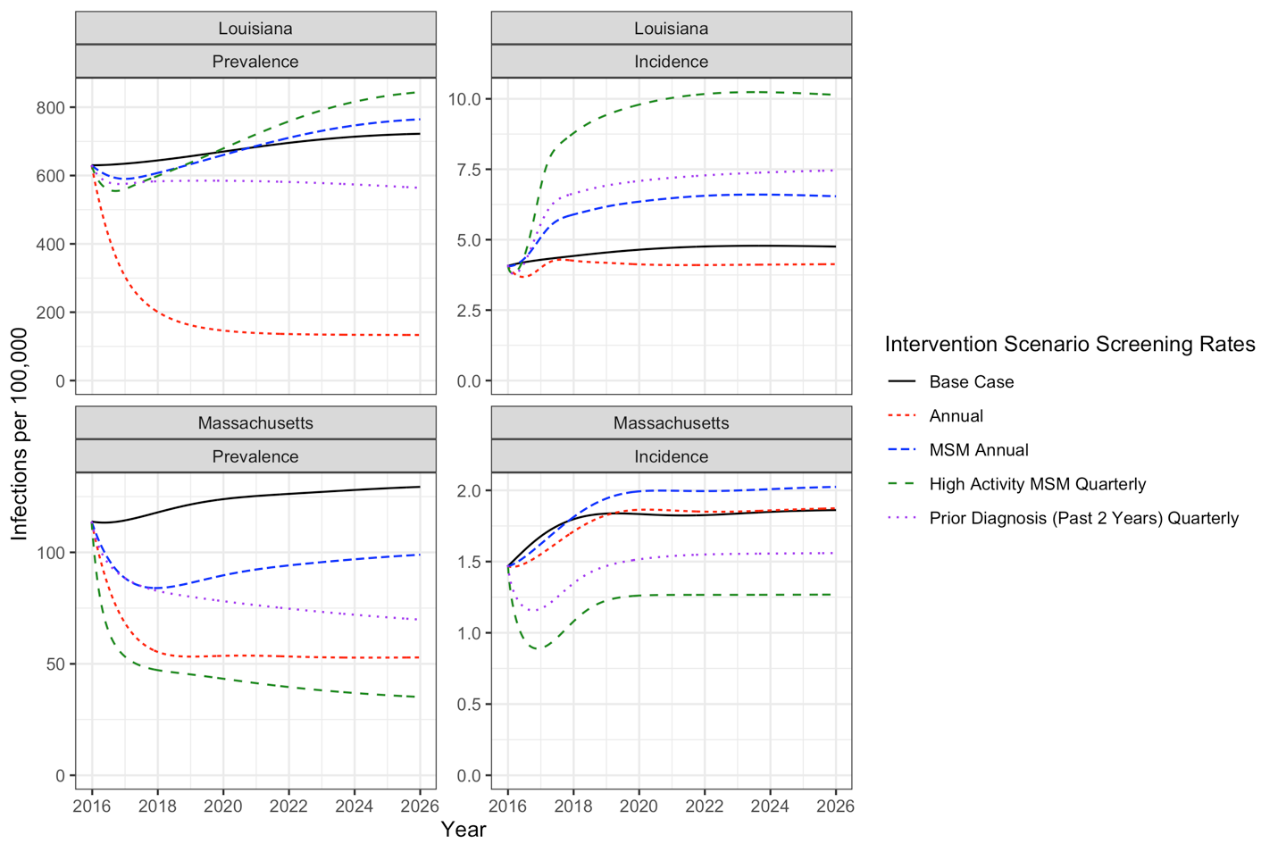

Key Points:

* At a very high level (and disregarding number of tests performed), we see that it is possible for screening to have different effects in the two modeled populations.
  + In particular, increased screening of MSM in the context of the Louisiana outbreak has the potential to increase syphilis prevalence and incidence in the population.
* The metric used to measure population burden also matters.
  + Screening can reduce population prevalence despite having a limited or negative effect on population incidence.
  + We explore this effect further below by comparing infectious (primary and secondary) and non-infectious (latent) prevalence in the 5 scenarios.

#### Infectious and Noninfectious Prevalence in Screening Intervention Scenarios

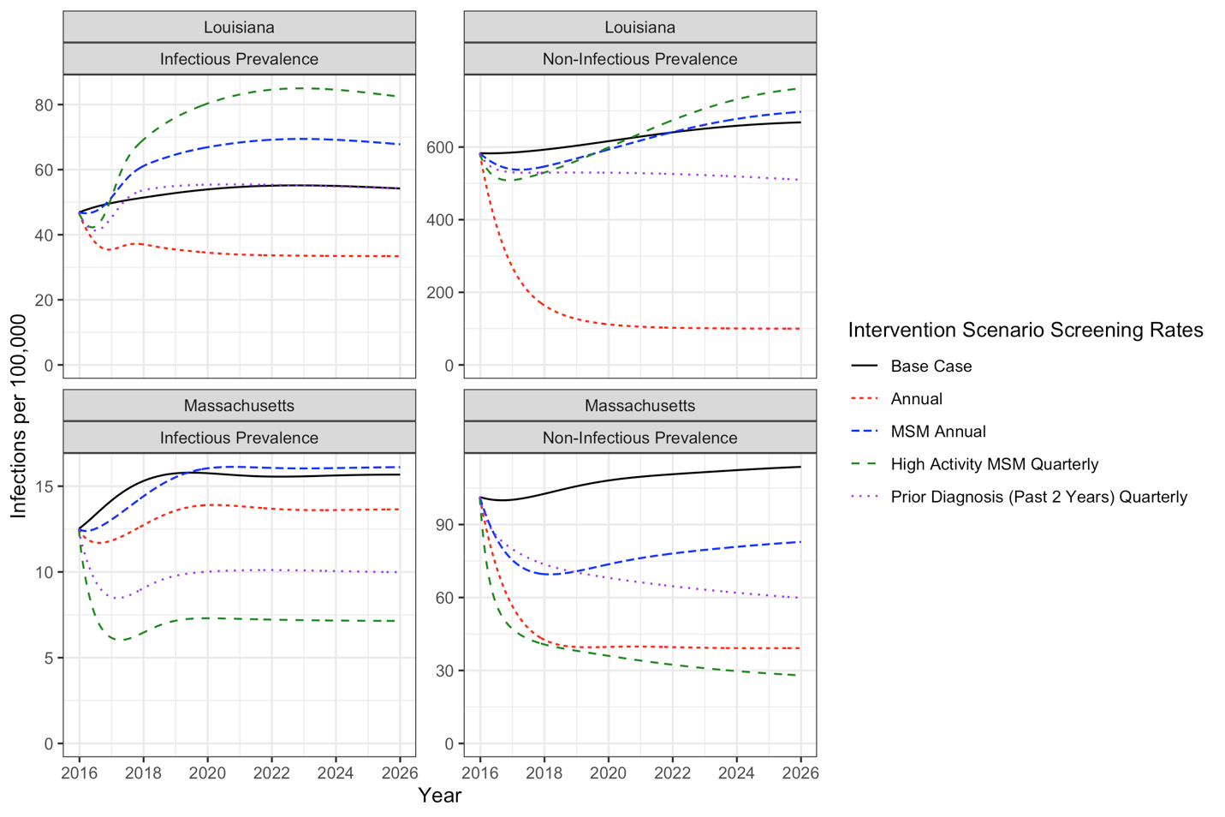

Key Points:

* There are a lot of latent infections at baseline.
* When screening intensity is increased in the population, we see a decline in the prevalence of latent infections but an increase in early stage infections (after an initial decline)

#### Discussion

**Annual**: In both Louisiana and Massachusetts, screening the entire population at least annually is effective at reducing the number of prevalent infections.

In Louisiana, the Annual screening scenario reduces the incidence rate relative to the base case. However, in Massachusetts while the incidence rate is reduced for a few years, ultimately the incidence rate stabilizes at a higher rate than the Base Case incidence rate.

**MSM Annual**: In Massachusetts, the MSM Annual screening scenario averts prevalent infections, but does increase the incidence rate. However, in Louisana screening MSM annually without changing any other populations’ screening levels ultimately increases the prevalence rate beyond the basecase rate after an initial period of reduction in prevalence.

We believe that this effect is due to the re-infection of individuals who had latent infections and are treated who may then become infectious after re-infection. The second set of figures shows that the msm_annual intervention scenario yields a short-term reduction in both infectious and non-infectious syphilis followed by a sharp increase in the prevalence of infectious syphilis above the basecase infectious prevalence level. This explains why in both settings we see that the MSM Annual intervention increases incidence.

**High Activity MSM Quarterly**: The High Activity MSM Quarterly scenario is the most effective simulated intervention in Massachusetts (with respect to both prevalence and incidence). However, this scenario is also the scenario with the most negative outcomes in Louisiana (largest increase in prevalence and incidence).

**Prior Diagnosis (Past 2 Years) Quarterly**: Screening individuals with a prior diagnosis in the past 2 years is the 2nd most effective modeled intervention strategy in Louisiana at reducing prevalence (after the Annual intervention scenario), and the 3rd most effective in Massachusetts (after High Activity MSM Quarterly and Annual).

## Future Plans

In order to improve our understanding of the effectiveness of these intervention strategies, we plan to simulate additional levels of screening (annual, semi-annually, and quarterly for each targeted population) and to add measures of Number Needed to Test to Avert One Additional Case.

We are currently assuming that there is a period of protection from re-infection following treatment of infection. The durations vary by stage of infection, with duration assumed to be longest for late latent infection. The durations are estimated during model calibration. We plan to repeat the above analyses using a model that has been calibrated without the assumption of a period of immunity following treatment to determine if/how this effects the results.