Syphilis Project Update

Christian Testa

May 28th, 2019

In this project we are modeling syphilis in Louisiana and Massachusetts.

In each of these two states, we have calibrated the model and can use it to simulate hypothetical scenarios which may yield useful insight into effective health policy.

This document will walk readers through the background of the model, an analysis of two hypothetical interventions, and our intentions for future developments.

## Model Background

#### Data Being Used

Calibration targets include:

* Reported Cases by Stage, Sex, Race
* Proportion of Male Cases Among MSM
* Proportion of Cases Among MSM with HIV Coinfection
* Subpopulation Assortative Mixing (Age, Race)

|  |  |
| --- | --- |
| Louisiana | Massachusetts |
|  |  |
| Figure: Fit to Case Report Rates by Sex and Age | |

#### Model Structure

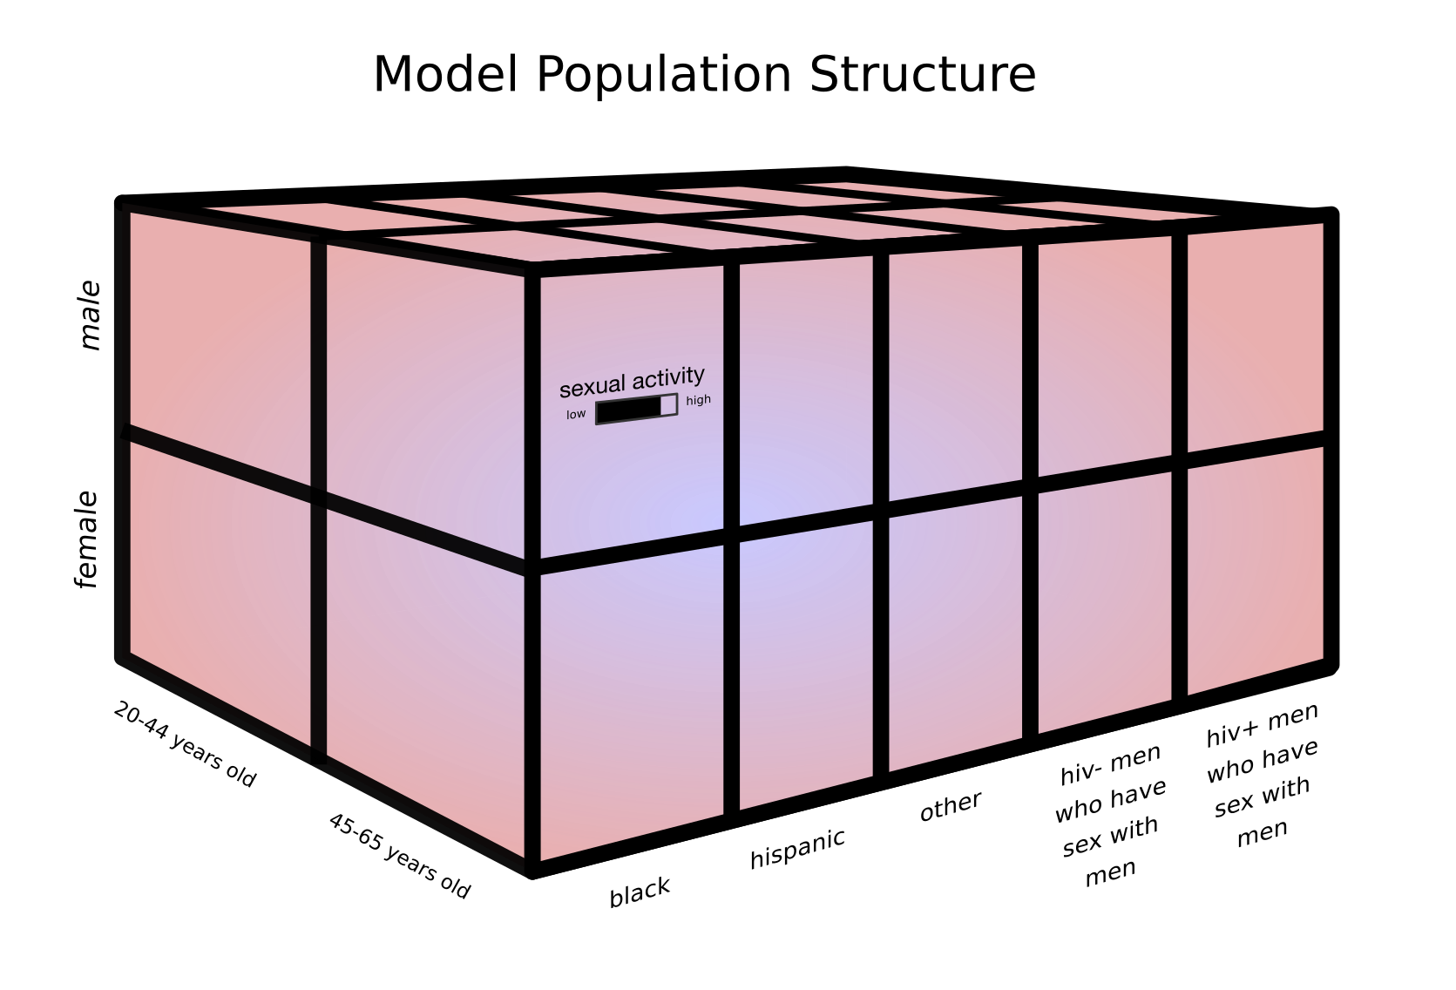

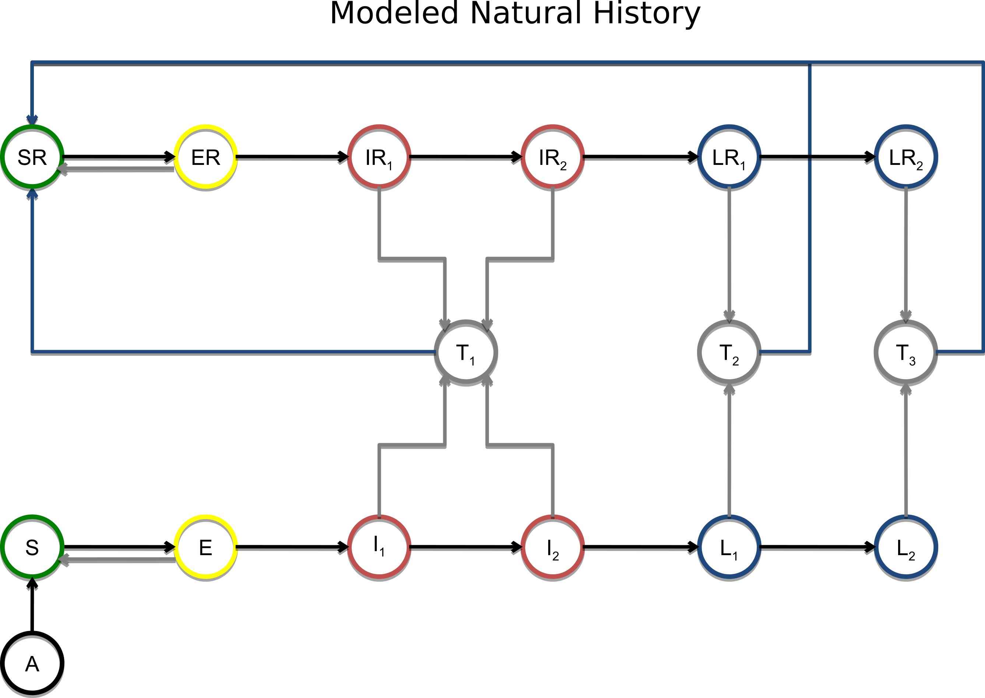

#### Calibration

In order to calibrate our model, we run an optimization algorithm to determine several parameter vectors which optimize the model fit to the prior and likelihood distributions. These parameter vectors are then used as the starting places for multiple Monte Carlo Markov Chains which are used to estimate model uncertainty.

#### Visualizations of the Modeled Epidemiology

[More content intended to go here, e.g. proportion of prevalence among race/gender/age/MSM/hiv-status/etc.]

## Intervention Analysis

The primary research question we have investigated here is:

How does an intervention which is focused on raising the baseline level of screening in the entire population compare to one targeted on the men who have sex with men (MSM) populations?

The following outputs are in measures of infections per 100,000.

For reference, the assumed population sizes of Louisiana and Massachusetts are 2,787,423 and 4,230,601 respectively (assumed from 2015 census estimates).

#### Prevalence and Incidence

#### Basecase, Annual, and MSM Annual Screening Scenarios

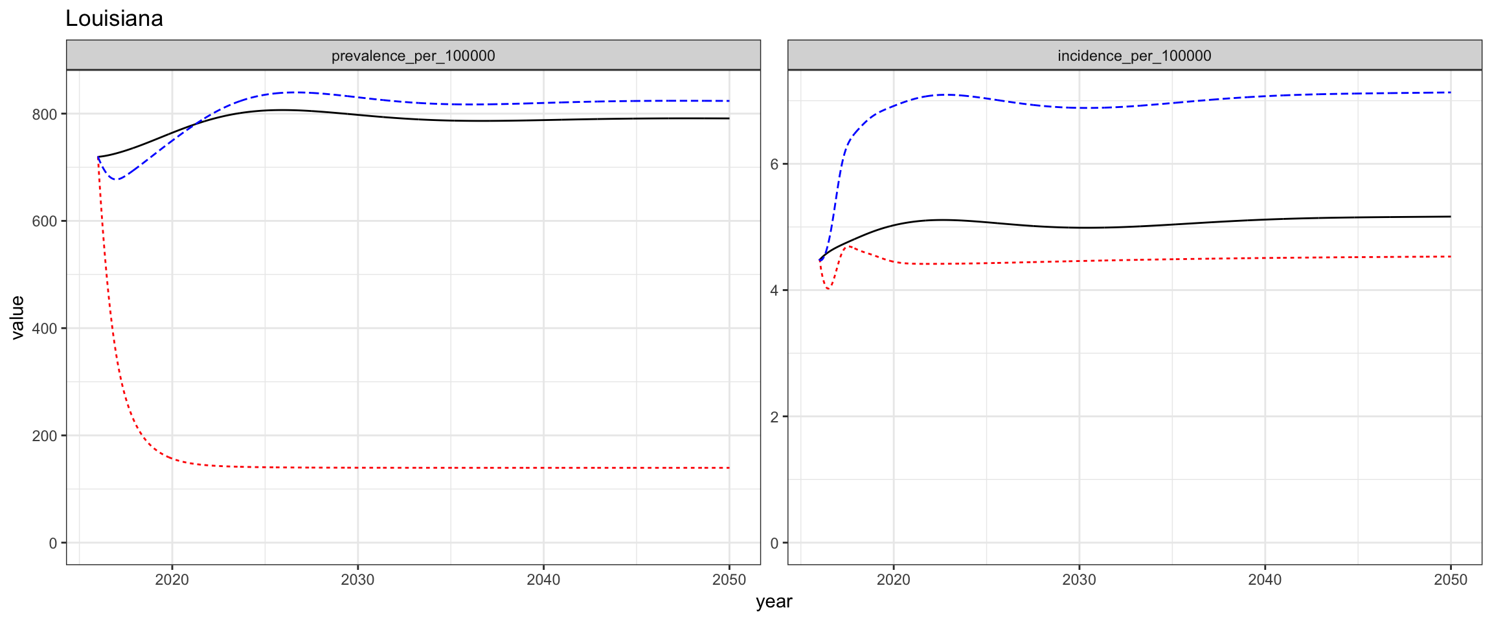 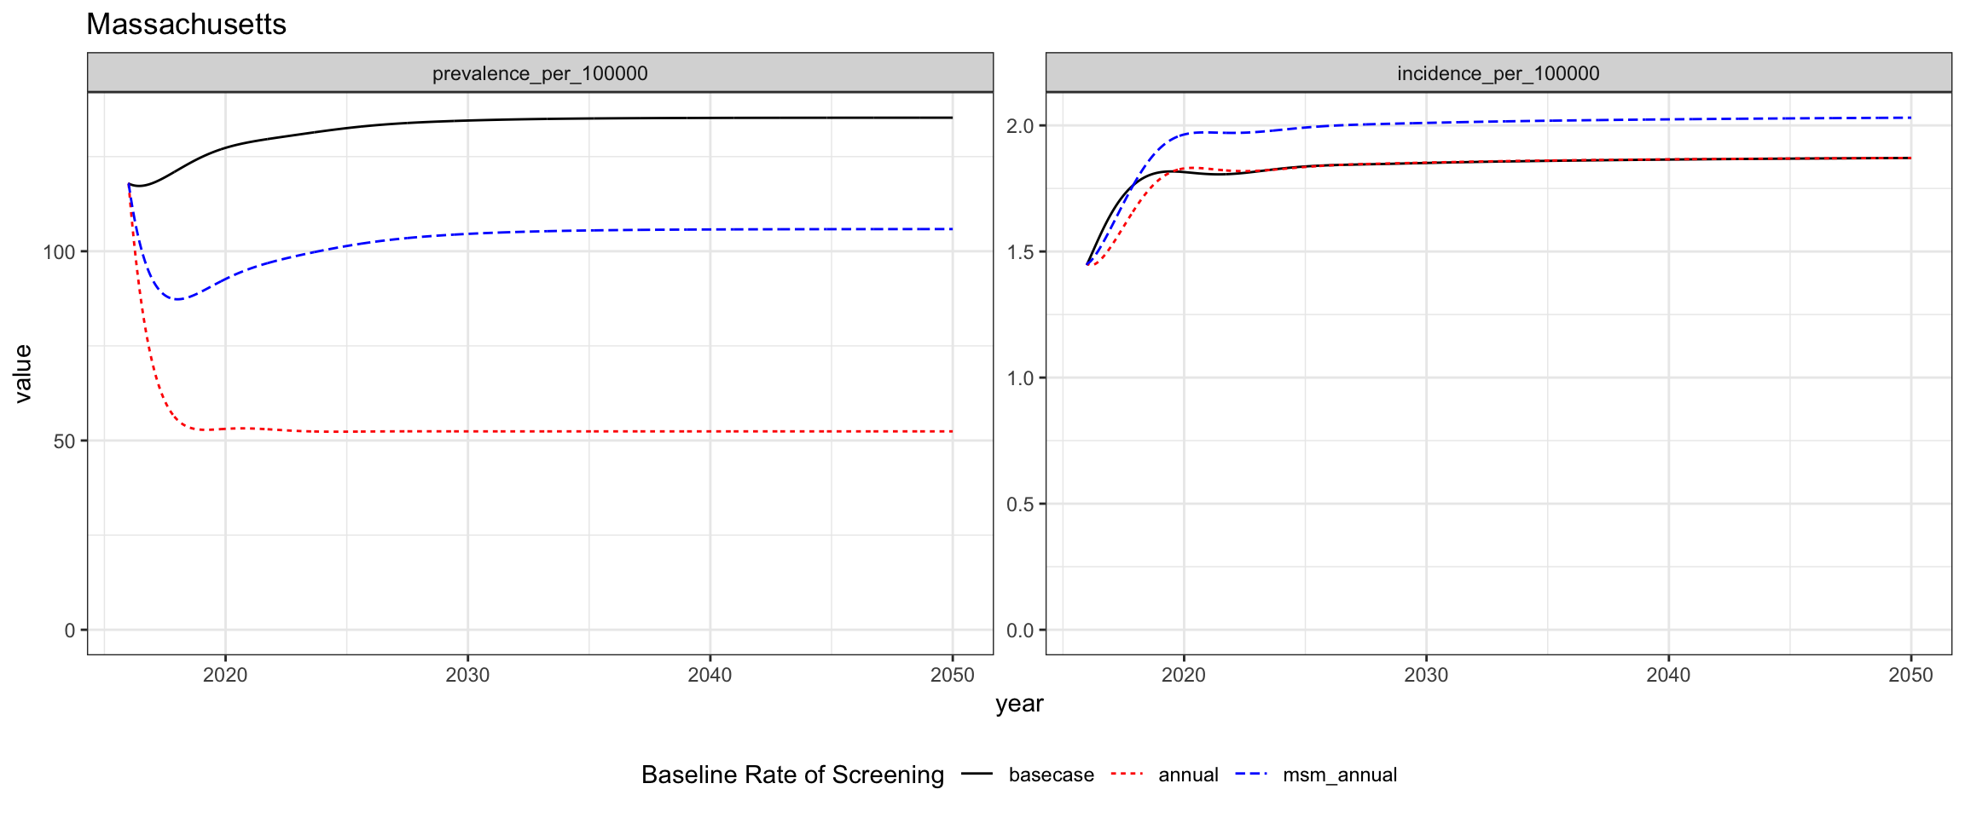

#### Infectious and Noninfectious Prevalence

#### Basecase, Annual, and MSM Annual Screening Scenarios

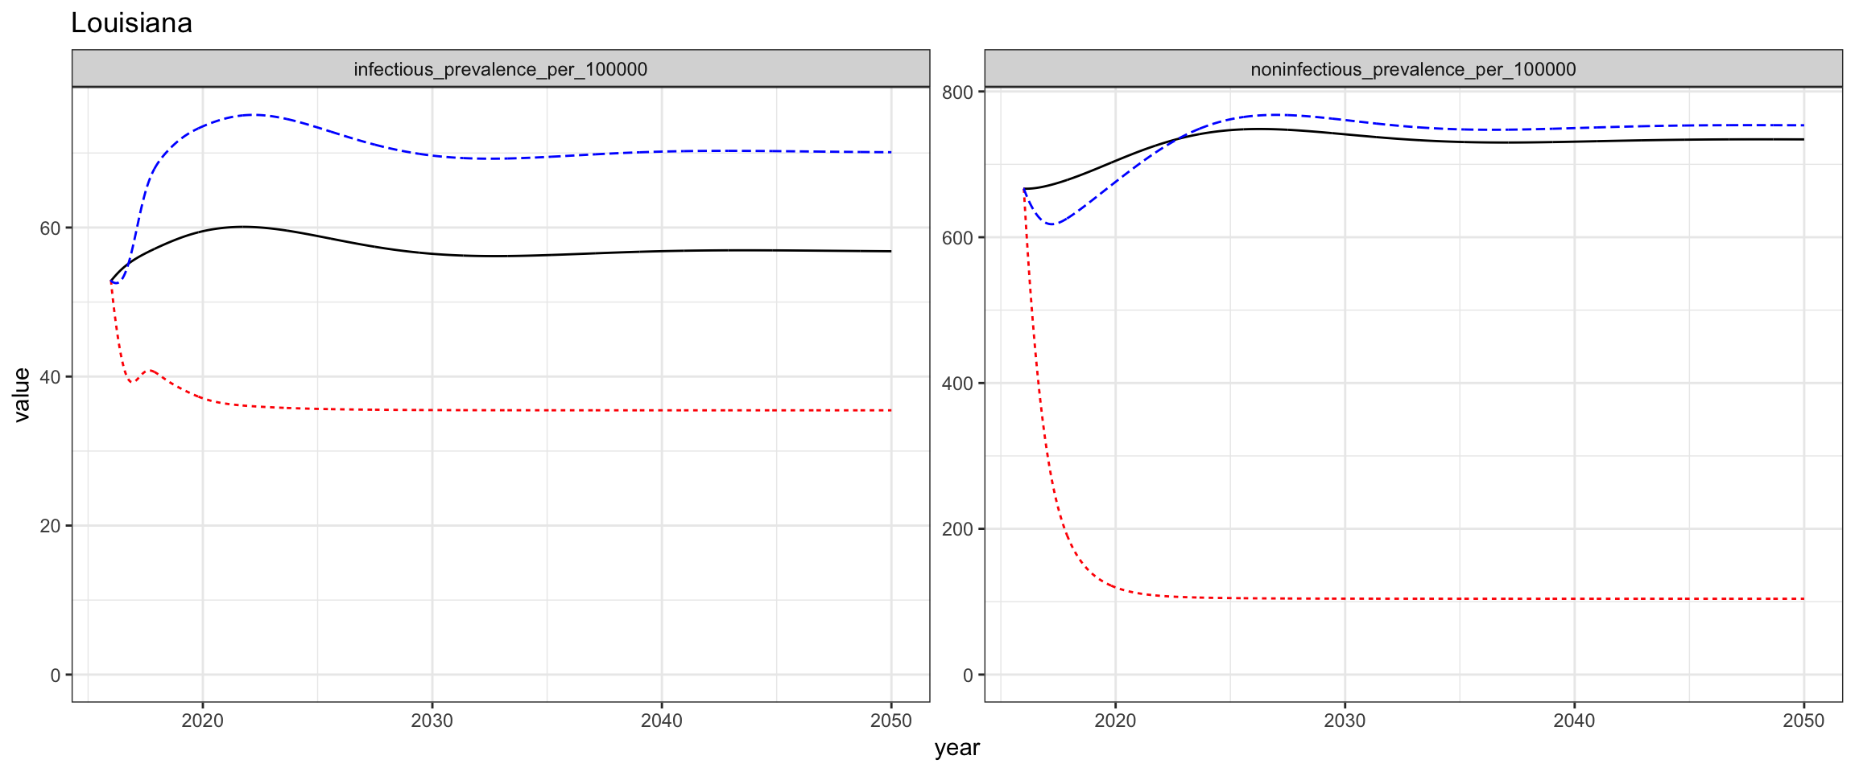 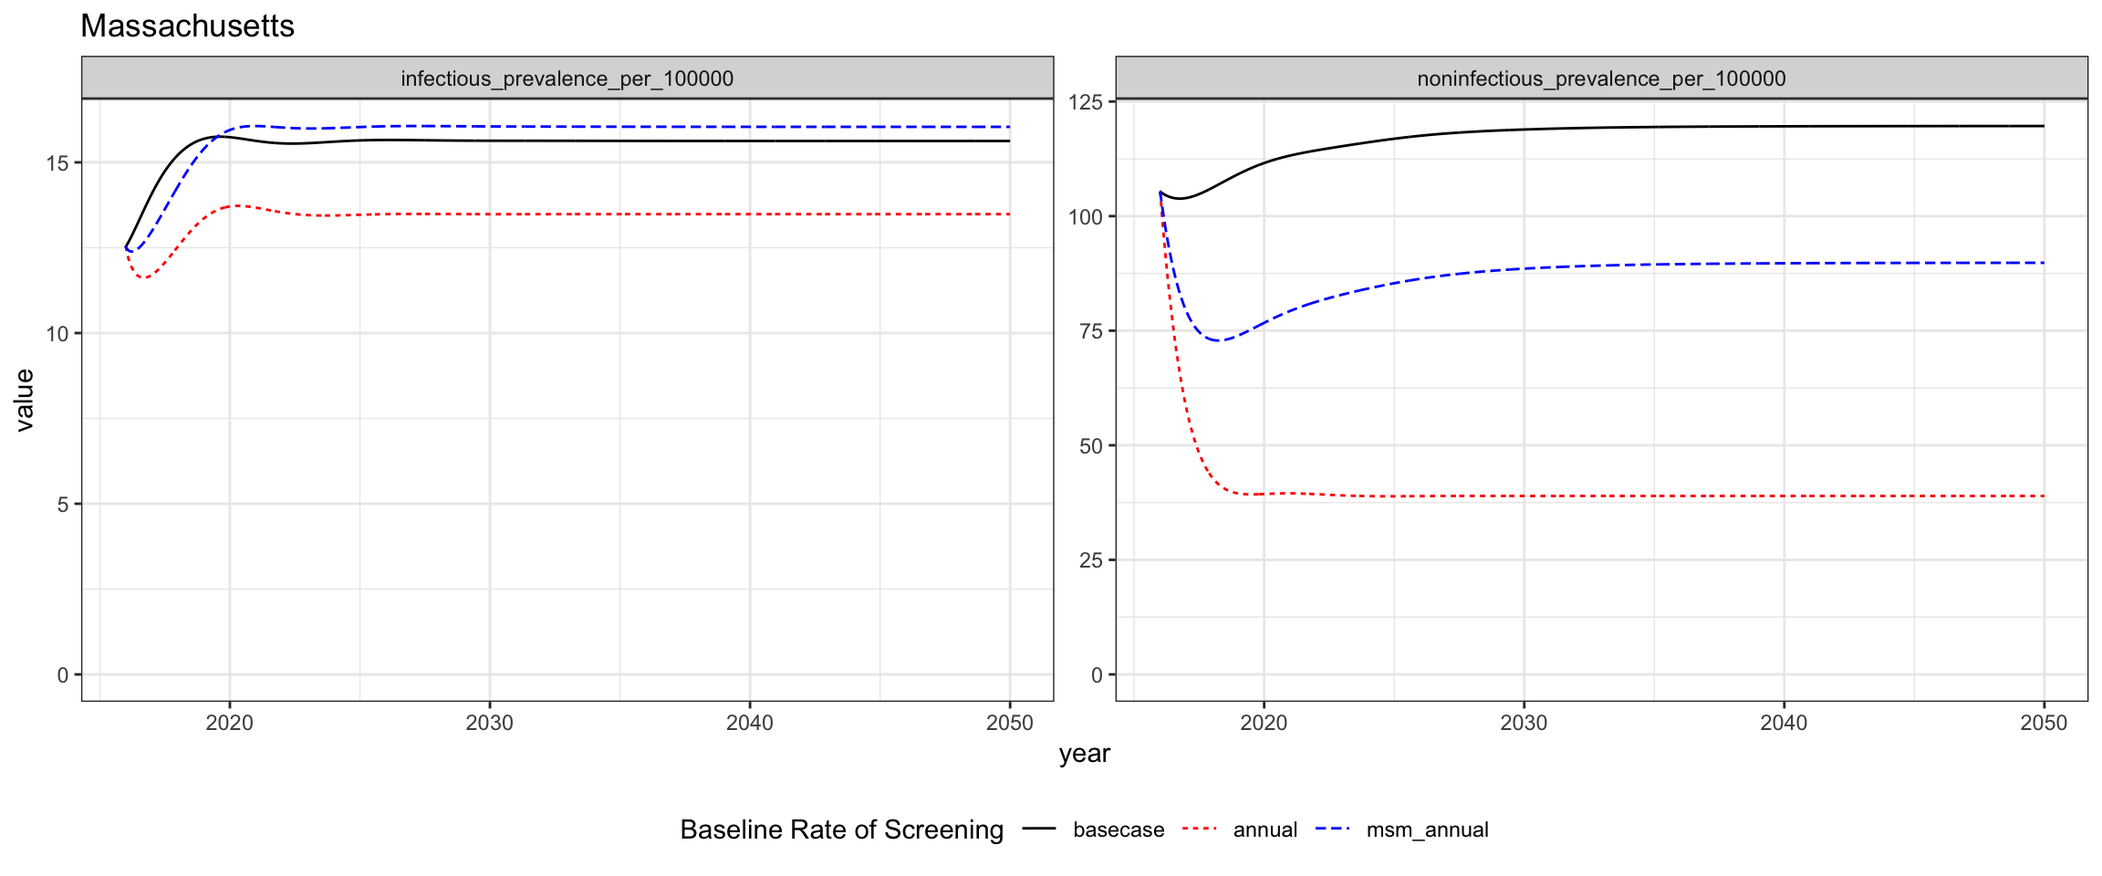

#### Discussion

In the above depicted scenarios, we have simulated the outcomes of three scenarios: the basecase, where screening is maintained at 2015 levels indefinitely into the future, the annual scenario, where everyone receives at least annual screening, and the msm_annual screening where msm receive at least annual screening but all other populations’ screening levels are maintained at their 2015 levels.

In both Louisiana and Massachusetts, screening the entire population at least annually is effective at reducing the number of prevalent infections.

In Louisiana, annual screening reduces the incidence rate relative to the basecase. However, in Massachusetts the incidence rate is reduced for a few years, but ultimately stabilizes at a higher rate than the basecase incidence rate.

In Massachusetts, screening MSM at least annually averts prevalent infections, but does increase the incidence rate. However, in Louisana screening MSM annually without changing any other populations’ screening levels ultimately increases the prevalence rate beyond the basecase rate after an initial period of reduction in prevalence.

We believe that this effect is due to the re-infection of individuals who had latent infectious and are treated who may then become infectious after re-infection. The second set of figures shows that the msm_annual intervention scenario yields a short-term reduction in both infectious and non-infectious syphilis followed by a sharp increase in the prevalence of infectious syphilis above the basecase infectious prevalence level. This explains why in both settings we see that the msm_annual intervention increases incidence.

## Future Plans

We will be analyzing interventions like these in further depth to determine scenarios that could make for effective prevention policy.

To investigate the counterintuitive effect that screening MSM annually has, we will be investigating the impact of increasing screening levels in those susceptible to re-infection.