SPRINT 2 Sistema Go-Fit

Ana Carolina Zamudia

Evangelina Gialdi

Lia Domizzi

Liza Barreyro

Laura Avendaño

Lucía Carrizo

Instituto Superior Politécnico Córdoba

Practica profesionalizante

2 de Noviembre de 2021

PLAN DE NEGOCIO GO-FIT

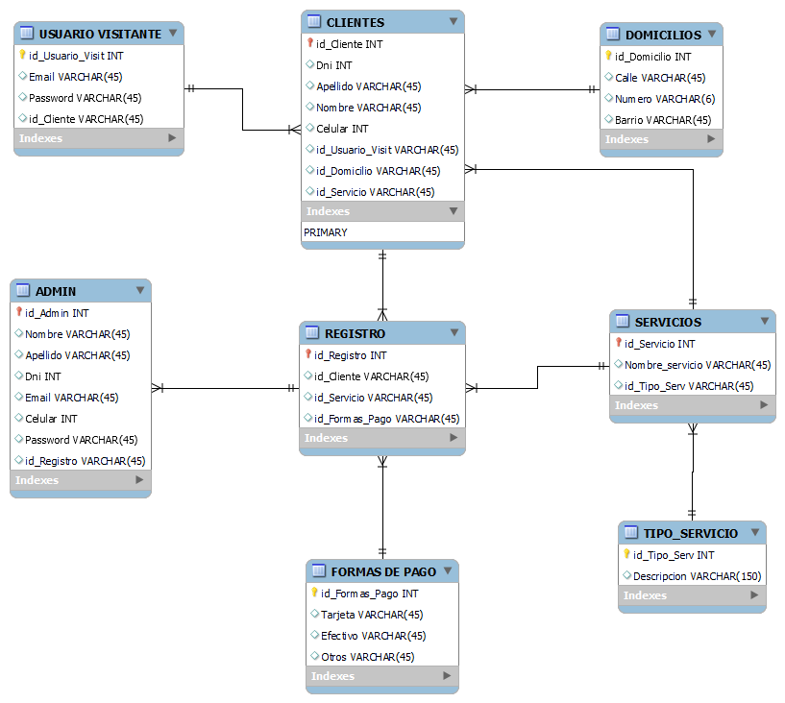

SCRIPT DDL GO-FIT BD

-- MySQL Workbench Forward Engineering

SET @OLD_UNIQUE_CHECKS=@@UNIQUE_CHECKS, UNIQUE_CHECKS=0;

SET @OLD_FOREIGN_KEY_CHECKS=@@FOREIGN_KEY_CHECKS, FOREIGN_KEY_CHECKS=0;

SET @OLD_SQL_MODE=@@SQL_MODE, SQL_MODE='ONLY_FULL_GROUP_BY,STRICT_TRANS_TABLES,NO_ZERO_IN_DATE,NO_ZERO_DATE,ERROR_FOR_DIVISION_BY_ZERO,NO_ENGINE_SUBSTITUTION';

-- -----------------------------------------------------

-- Schema sistema Go-Fit

-- -----------------------------------------------------

-- -----------------------------------------------------

-- Schema sistema Go-Fit

-- -----------------------------------------------------

CREATE SCHEMA IF NOT EXISTS `sistema Go-Fit` ;

USE `sistema Go-Fit` ;

-- -----------------------------------------------------

-- Table `sistema Go-Fit`.`USUARIO VISITANTE`

-- -----------------------------------------------------

CREATE TABLE IF NOT EXISTS `sistema Go-Fit`.`USUARIO VISITANTE` (

`id_Usuario_Visit` INT NOT NULL AUTO_INCREMENT,

`Email` VARCHAR(45) NULL,

`Password` VARCHAR(45) NULL,

`id_Cliente` VARCHAR(45) NULL,

PRIMARY KEY (`id_Usuario_Visit`))

ENGINE = InnoDB;

CREATE UNIQUE INDEX `id_Usuario_UNIQUE` ON `sistema Go-Fit`.`USUARIO VISITANTE` (`id_Usuario_Visit` ASC) VISIBLE;

-- -----------------------------------------------------

-- Table `sistema Go-Fit`.`DOMICILIOS`

-- -----------------------------------------------------

CREATE TABLE IF NOT EXISTS `sistema Go-Fit`.`DOMICILIOS` (

`id_Domicilio` INT NOT NULL,

`Calle` VARCHAR(45) NULL,

`Numero` VARCHAR(6) NULL,

`Barrio` VARCHAR(45) NULL,

PRIMARY KEY (`id_Domicilio`))

ENGINE = InnoDB;

-- -----------------------------------------------------

-- Table `sistema Go-Fit`.`TIPO_SERVICIO`

-- -----------------------------------------------------

CREATE TABLE IF NOT EXISTS `sistema Go-Fit`.`TIPO_SERVICIO` (

`id_Tipo_Serv` INT NOT NULL AUTO_INCREMENT,

`Descripcion` VARCHAR(150) NULL,

PRIMARY KEY (`id_Tipo_Serv`))

ENGINE = InnoDB;

-- -----------------------------------------------------

-- Table `sistema Go-Fit`.`SERVICIOS`

-- -----------------------------------------------------

CREATE TABLE IF NOT EXISTS `sistema Go-Fit`.`SERVICIOS` (

`id_Servicio` INT NOT NULL AUTO_INCREMENT,

`Nombre_servicio` VARCHAR(45) NULL,

`id_Tipo_Serv` VARCHAR(45) NULL,

PRIMARY KEY (`id_Servicio`))

ENGINE = InnoDB;

-- -----------------------------------------------------

-- Table `sistema Go-Fit`.`CLIENTES`

-- -----------------------------------------------------

CREATE TABLE IF NOT EXISTS `sistema Go-Fit`.`CLIENTES` (

`id_Cliente` INT NOT NULL,

`Dni` INT NULL,

`Apellido` VARCHAR(45) NULL,

`Nombre` VARCHAR(45) NULL,

`Celular` INT NULL,

`id_Usuario_Visit` VARCHAR(45) NULL,

`id_Domicilio` VARCHAR(45) NULL,

`id_Servicio` VARCHAR(45) NULL,

PRIMARY KEY (`id_Cliente`))

ENGINE = InnoDB;

-- -----------------------------------------------------

-- Table `sistema Go-Fit`.`FORMAS DE PAGO`

-- -----------------------------------------------------

CREATE TABLE IF NOT EXISTS `sistema Go-Fit`.`FORMAS DE PAGO` (

`id_Formas_Pago` INT NOT NULL,

`Tarjeta` VARCHAR(45) NULL,

`Efectivo` VARCHAR(45) NULL,

`Otros` VARCHAR(45) NULL,

PRIMARY KEY (`id_Formas_Pago`))

ENGINE = InnoDB;

-- -----------------------------------------------------

-- Table `sistema Go-Fit`.`REGISTRO`

-- -----------------------------------------------------

CREATE TABLE IF NOT EXISTS `sistema Go-Fit`.`REGISTRO` (

`id_Registro` INT NOT NULL AUTO_INCREMENT,

`id_Cliente` VARCHAR(45) NULL,

`id_Servicio` VARCHAR(45) NULL,

`id_Formas_Pago` VARCHAR(45) NULL,

PRIMARY KEY (`id_Registro`))

ENGINE = InnoDB;

-- -----------------------------------------------------

-- Table `sistema Go-Fit`.`ADMIN`

-- -----------------------------------------------------

CREATE TABLE IF NOT EXISTS `sistema Go-Fit`.`ADMIN` (

`id_Admin` INT NOT NULL,

`Nombre` VARCHAR(45) NULL,

`Apellido` VARCHAR(45) NULL,

`Dni` INT NULL,

`Email` VARCHAR(45) NULL,

`Celular` INT NULL,

`Password` VARCHAR(45) NULL,

`id_Registro` INT NULL,

PRIMARY KEY (`id_Admin`))

ENGINE = InnoDB;

SET SQL_MODE=@OLD_SQL_MODE;

SET FOREIGN_KEY_CHECKS=@OLD_FOREIGN_KEY_CHECKS;

SET UNIQUE_CHECKS=@OLD_UNIQUE_CHECKS;

CONSULTAS REALIZADAS A LA BASE DE DATOS

