TP integrador parte 1 -BASE DE DATOS

Prof. Rogelio Pettenón.

Ciclo lectivo: 2021

Alumnos:

* Carolina del Carmen Estanciero Fernández
* Victoria Cecilia Bobarini
* Juan Carlos Ramírez
* Milagros Desireé Álvarez Cisterna
* Andy Guevara Boros

# MODELO RELACIONAL

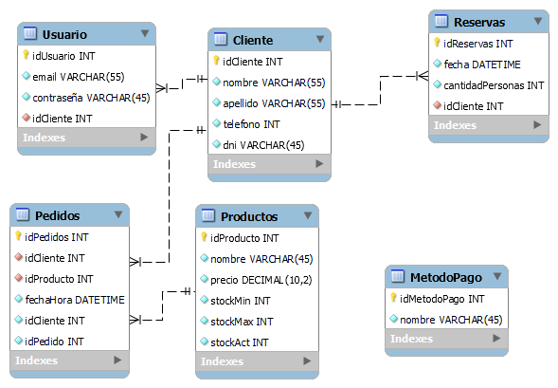

# SCRIPT DDL

USE bar;

-- MySQL Script generated by MySQL Workbench

-- Wed Oct 27 23:35:12 2021

-- Model: New Model Version: 1.0

-- MySQL Workbench Forward Engineering

SET @OLD_UNIQUE_CHECKS=@@UNIQUE_CHECKS, UNIQUE_CHECKS=0;

SET @OLD_FOREIGN_KEY_CHECKS=@@FOREIGN_KEY_CHECKS, FOREIGN_KEY_CHECKS=0;

SET @OLD_SQL_MODE=@@SQL_MODE, SQL_MODE='ONLY_FULL_GROUP_BY,STRICT_TRANS_TABLES,NO_ZERO_IN_DATE,NO_ZERO_DATE,ERROR_FOR_DIVISION_BY_ZERO,NO_ENGINE_SUBSTITUTION';

-- -----------------------------------------------------

-- Schema bar

-- -----------------------------------------------------

-- -----------------------------------------------------

-- Schema bar

-- -----------------------------------------------------

CREATE SCHEMA IF NOT EXISTS `bar` DEFAULT CHARACTER SET utf8 ;

USE `bar` ;

-- -----------------------------------------------------

-- Table `bar`.`Cliente`

-- -----------------------------------------------------

CREATE TABLE IF NOT EXISTS `bar`.`Cliente` (

`idCliente` INT NOT NULL AUTO_INCREMENT,

`nombre` VARCHAR(55) NOT NULL,

`apellido` VARCHAR(55) NOT NULL,

`telefono` VARCHAR(30) NOT NULL,

`dni` VARCHAR(45) NOT NULL,

PRIMARY KEY (`idCliente`))

ENGINE = InnoDB;

-- -----------------------------------------------------

-- Table `bar`.`Usuario`

-- -----------------------------------------------------

CREATE TABLE IF NOT EXISTS `bar`.`Usuario` (

`idUsuario` INT NOT NULL AUTO_INCREMENT,

`email` VARCHAR(55) NOT NULL,

`contraseña` VARCHAR(45) NOT NULL,

`idCliente` INT NOT NULL,

PRIMARY KEY (`idUsuario`),

INDEX `FK_Usuario_Cliente_idx` (`idCliente` ASC) VISIBLE,

CONSTRAINT `FK_Usuario_Cliente`

FOREIGN KEY (`idCliente`)

REFERENCES `bar`.`Cliente` (`idCliente`)

ON DELETE NO ACTION

ON UPDATE NO ACTION)

ENGINE = InnoDB;

-- -----------------------------------------------------

-- Table `bar`.`Reservas`

-- -----------------------------------------------------

CREATE TABLE IF NOT EXISTS `bar`.`Reservas` (

`idReservas` INT NOT NULL AUTO_INCREMENT,

`fecha` DATETIME NOT NULL,

`cantidadPersonas` INT NOT NULL,

`idCliente` INT NOT NULL,

PRIMARY KEY (`idReservas`),

INDEX `FK_Reservas_Cliente_idx` (`idCliente` ASC) VISIBLE,

CONSTRAINT `FK_Reservas_Cliente`

FOREIGN KEY (`idCliente`)

REFERENCES `bar`.`Cliente` (`idCliente`)

ON DELETE NO ACTION

ON UPDATE NO ACTION)

ENGINE = InnoDB;

-- -----------------------------------------------------

-- Table `bar`.`Productos`

-- -----------------------------------------------------

CREATE TABLE IF NOT EXISTS `bar`.`Productos` (

`idProducto` INT NOT NULL AUTO_INCREMENT,

`nombre` VARCHAR(45) NOT NULL,

`precio` DECIMAL(10,2) NOT NULL,

`stockMin` INT NOT NULL,

`stockMax` INT NOT NULL,

`stockAct` INT NOT NULL,

PRIMARY KEY (`idProducto`))

ENGINE = InnoDB;

-- -----------------------------------------------------

-- Table `bar`.`Pedidos`

-- -----------------------------------------------------

CREATE TABLE IF NOT EXISTS `bar`.`Pedidos` (

`idPedidos` INT NOT NULL AUTO_INCREMENT,

`idCliente` INT NOT NULL,

`idProducto` INT NOT NULL,

`fechaHora` DATETIME NOT NULL,

`idPedido` INT NOT NULL,

PRIMARY KEY (`idPedidos`),

INDEX `FK_Pedidos_Cliente_idx` (`idCliente` ASC) VISIBLE,

INDEX `FK_Pedidos_Productos_idx` (`idProducto` ASC) VISIBLE,

CONSTRAINT `FK_Pedidos_Cliente`

FOREIGN KEY (`idCliente`)

REFERENCES `bar`.`Cliente` (`idCliente`)

ON DELETE NO ACTION

ON UPDATE NO ACTION,

CONSTRAINT `FK_Pedidos_Productos`

FOREIGN KEY (`idProducto`)

REFERENCES `bar`.`Productos` (`idProducto`)

ON DELETE NO ACTION

ON UPDATE NO ACTION)

ENGINE = InnoDB;

-- -----------------------------------------------------

-- Table `bar`.`MetodoPago`

-- -----------------------------------------------------

CREATE TABLE IF NOT EXISTS `bar`.`MetodoPago` (

`idMetodoPago` INT NOT NULL AUTO_INCREMENT,

`nombre` VARCHAR(45) NOT NULL,

PRIMARY KEY (`idMetodoPago`))

ENGINE = InnoDB;

SET SQL_MODE=@OLD_SQL_MODE;

SET FOREIGN_KEY_CHECKS=@OLD_FOREIGN_KEY_CHECKS;

SET UNIQUE_CHECKS=@OLD_UNIQUE_CHECKS;

# CONSULTAS SQL SOLICITADAS EN BASE AL MODELO DE NEGOCIO

INSERT INTO cliente (nombre, apellido, telefono, dni) VALUES ('Juan', 'Fernandez','3514580206','12345600');

INSERT INTO usuario (email, contraseña, idCliente) VALUES ('juanfernan@gmail.com', '123456', 1);

SELECT * FROM usuario join cliente on usuario.idCliente = cliente.idCliente WHERE cliente.nombre = 'Juan' and contraseña = '123456';

INSERT INTO productos (nombre, precio, stockMin, stockMax,stockAct) VALUES ('picada', 1550, 1,20, 20);

UPDATE productos SET precio = 2000 WHERE idProducto = 1;

UPDATE productos SET precio = precio * 1.10 WHERE precio < 1000;

DELETE FROM productos WHERE idProducto = 15;