# 飞机大战任务2

## 任务要点

在游戏界面显示我方飞机，敌方飞机及相应子弹和音效

## 1.2 任务内容

* 在游戏下方显示我方飞机
* 在游戏上方随机出现敌方飞机
* 我方飞机不能越过窗口界面的范围
* 我方飞机的按上下左右键移动
* 游戏界面函数void playergame()

## 1.3 任务实现

**流程图：**

游戏界面

我方飞机出现

敌方飞机随机出现

通过虚拟键

我方飞机移动

**实现效果：**

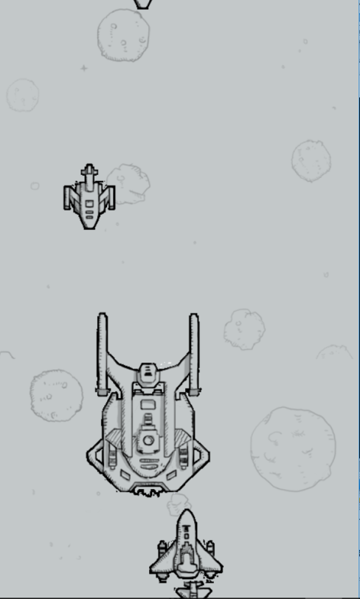

**核心代码：**

void playergame()//游戏主界面

{

//getgame();

initgraph(480,800);

mus[1].OpenFile("pic\\201.mp3");

Hero one;//定义一个英雄飞机

one.x=200;

one.y=678;

one.life=1;

one.speed=5;

Enemyhuge enemy_big[5];//5个大飞机

Enemymudium enemy_middle[10];//10个中飞机

Enemysmall enemy_little[20];//20个小飞机

enemyInitialization(enemy_big,enemy_middle,enemy_little);//敌机初始化

randomize();//随机数初始化

for(; is_run(); delay_fps(60))

{

if(mus[1].GetPlayStatus()==MUSIC_MODE_STOP)//

{

mus[1].Play(0);

}

cleardevice();

displayMap();

putimage_transparent(NULL,hero[0],one.x,one.y,0);

if(keystate(VK_UP)&&one.x>=0&&one.x<=380&&one.y>=0&&one.y<=700)//我方飞机向上移动

one.y-=one.speed;

else if(keystate(VK_DOWN)&&one.x>=0&&one.x<=380&&one.y>=0&&one.y<=700)//我方飞机向下移动

one.y+=one.speed;

else if(keystate(VK_LEFT)&&one.x>=0&&one.x<=380&&one.y>=0&&one.y<=700)//我方飞机向左移动

one.x-=one.speed;

else if(keystate(VK_RIGHT)&&one.x>=0&&one.x<=380&&one.y>=0&&one.y<=700)//我方飞机向右移动

one.x+=one.speed;

if(one.x<=0)

one.x+=1;

if(one.x>=380)

one.x-=1;

if(one.y<=0)

one.y+=1;

if(one.y>700)

one.y-=1;//我方飞机在窗口四周不能越界

//enemyAircraft(enemy_big,enemy_middle,enemy_little);

ege::putimage_transparent(NULL,enemy_small[0],enemy_little[0].x,enemy_little[0].y,0);

ege::putimage_transparent(NULL,enemy_small[1],enemy_little[1].x,enemy_little[1].y,0);

ege::putimage_transparent(NULL,enemy_mudium[0],enemy_middle[0].x,enemy_middle[0].y,0);

ege::putimage_transparent(NULL,enemy_huge[0],enemy_big[0].x,enemy_big[0].y,0);

ege::putimage_transparent(NULL,enemy_small[2],enemy_little[2].x,enemy_little[2].y,0);

ege::putimage_transparent(NULL,enemy_mudium[1],enemy_middle[1].x,enemy_middle[1].y,0);

ege::putimage_transparent(NULL,enemy_small[3],enemy_little[3].x,enemy_little[3].y,0);

for(int i=0;i<4;i++)

{

enemy_little[i].y+=enemy_little[i].speed;

}

for(int i=0;i<2;i++)

{

enemy_middle[i].y+=enemy_middle[i].speed;

}

enemy_big[0].y+=enemy_big[0].speed;

for(int i=0;i<4;i++)

{

if(enemy_little[i].y>800)

{

enemy_little[i].x=random(429*7)/7;

enemy_little[i].y=-random(400)-100;

}

}

for(int i=0;i<2;i++)

{

if(enemy_middle[i].y>800)

{

enemy_middle[i].x=random(412*6)/8;

enemy_middle[i].y=-random(700)-200;

}

}

if(enemy_big[0].y>800)

{

enemy_big[0].x=random(315*5)/5;

enemy_big[0].y=-random(800)-400;

}

}

mus[1].Close();

//delIMG();

}