# 飞机大战任务3

## 1.1 任务要点

我方飞机子弹出现和背景滚动

## 1.2 任务内容

* 让我方飞机子弹在飞机前面出现
* 让背景画面滚动增强游戏体验
* 滚动地图函数**void displayMap()**

## 1.3 任务实现

**流程图：**

背景滚动

子弹出现和移动

**实现效果：**

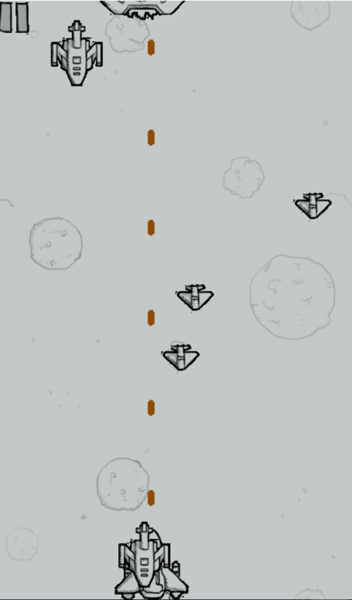

**核心代码：**

**void displayMap()//打印地图**

**{**

**putimage(0,g_y1,Map1);**

**putimage(0,g_y2,Map3);**

**g_y1=g_y1+g_speed;**

**g_y2=g_y2+g_speed;**

**if(g_y1==800)**

**g_y1=0;**

**if(g_y2==0)**

**g_y2=-800;**

**}**

void playergame()//游戏主界面

{

//getgame();

initgraph(480,800);

mus[1].OpenFile("pic\\201.mp3");

int intervaltime=0;

Hero one;//定义一个英雄飞机

one.x=200;

one.y=678;

one.life=1;

one.speed=5;

Bulletour bullet_our[20];

for(int i=0; i<20; i++)

{

bullet_our[i].speed=6;

bullet_our[i].life=0;

}

Enemyhuge enemy_big[5];//5个大飞机

Enemymudium enemy_middle[10];//10个中飞机

Enemysmall enemy_little[20];//20个小飞机

enemyInitialization(enemy_big,enemy_middle,enemy_little);//敌机初始化

randomize();//随机数初始化

initmouse();

for(; is_run(); delay_fps(60))

{

updatemouse();

if(mus[1].GetPlayStatus()==MUSIC_MODE_STOP)//

{

mus[1].Play(0);

}

cleardevice();

displayMap();

putimage_transparent(NULL,hero[0],one.x,one.y,0);

putimage_transparent(NULL,contin,0,0,0);

if((Mouse_X>=0&&Mouse_Y>=0&&Mouse_X<=42&&Mouse_Y<=45&&Mouse_Left==true && Mouse_Up==true)||keystate(VK_SPACE))

{

gamePause(&one,enemy_big,enemy_middle,enemy_little);

initmouse();

}

if(keystate(VK_UP)&&one.y>0)//我方飞机向上移动

one.y-=one.speed;

else if(keystate(VK_DOWN)&&one.y<700)//我方飞机向下移动

one.y+=one.speed;

else if(keystate(VK_LEFT)&&one.x>0)//我方飞机向左移动

one.x-=one.speed;

else if(keystate(VK_RIGHT)&&one.x<380)//我方飞机向右移动

one.x+=one.speed;

if(intervaltime>400)

intervaltime=0;

for(int i=0; i<20; i++)

{

if(bullet_our[i].life==0&&((intervaltime/20)-1==i))

{

bullet_our[i].x=one.x+45;

bullet_our[i].y=one.y-21;

bullet_our[i].life=1;

}

}

for(int i=0;i<20;i++)

{

if(bullet_our[i].life>0)

{

ege::putimage_transparent(NULL,bullets_ordinary[i],bullet_our[i].x,bullet_our[i].y,0);

bullet_our[i].y-=bullet_our[i].speed;

}

if(bullet_our[i].y<-21)

{

bullet_our[i].life=0;

}

}

enemyAircraft(enemy_big,enemy_middle,enemy_little);

if(enemy_little[0].life==1)

ege::putimage_transparent(NULL,enemy_small[0],enemy_little[0].x,enemy_little[0].y,0);

if(enemy_little[1].life==1)

ege::putimage_transparent(NULL,enemy_small[1],enemy_little[1].x,enemy_little[1].y,0);

if(enemy_middle[0].life==1)

ege::putimage_transparent(NULL,enemy_mudium[0],enemy_middle[0].x,enemy_middle[0].y,0);

if(enemy_big[0].life==1)

ege::putimage_transparent(NULL,enemy_huge[0],enemy_big[0].x,enemy_big[0].y,0);

if(enemy_little[2].life==1)

ege::putimage_transparent(NULL,enemy_small[2],enemy_little[2].x,enemy_little[2].y,0);

if(enemy_middle[1].life==1)

ege::putimage_transparent(NULL,enemy_mudium[1],enemy_middle[1].x,enemy_middle[1].y,0);

if(enemy_little[3].life==1)

ege::putimage_transparent(NULL,enemy_small[3],enemy_little[3].x,enemy_little[3].y,0);

/*for(int i=0;i<20;i++)

{

if(bullet_our[i].x>enemy_little[0].x&&bullet_our[i].x<enemy_little[0].x&&bull1)

}*/

for(int i=0; i<4; i++)

{

enemy_little[i].y+=enemy_little[i].speed;

}

for(int i=0; i<2; i++)

{

enemy_middle[i].y+=enemy_middle[i].speed;

}

enemy_big[0].y+=enemy_big[0].speed;

intervaltime++;

}

mus[1].Close();

//delIMG();

}