# 飞机大战任务4

## 1.1 任务要点

我方飞机子弹打到敌方飞机，敌方飞机爆炸。

## 1.2 任务内容

* 我方飞机子弹打到敌方飞机时，敌方飞机爆炸。

## 1.3 任务实现

**流程图：**

敌方飞机爆炸

子弹打中敌机后，每一次循环刷一次爆炸的图

刷完后，对打中的敌机重新刷新

**实现效果：**

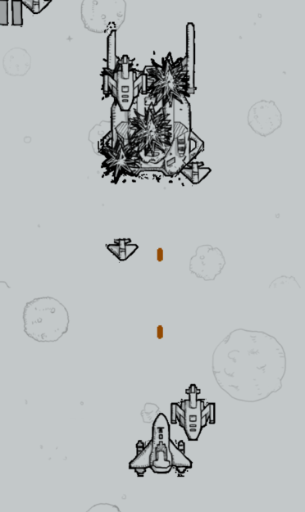

**核心代码：**

if(enemy_little[0].life==1)//每个敌方飞机存活打印和爆炸打印

ege::putimage_transparent(NULL,enemy_small[0],enemy_little[0].x,enemy_little[0].y,0);

else if(enemy_little[0].life==0)

{

ege::putimage_transparent(NULL,enemy_small_death[littledeath[0]],enemy_little[0].x,enemy_little[0].y,0);

littledeath[0]++;

enemy_little[0].deathtime--;

}

if(enemy_little[1].life==1)

ege::putimage_transparent(NULL,enemy_small[1],enemy_little[1].x,enemy_little[1].y,0);

else if(enemy_little[1].life==0)

{

ege::putimage_transparent(NULL,enemy_small_death[littledeath[1]],enemy_little[1].x,enemy_little[1].y,0);

littledeath[1]++;

enemy_little[1].deathtime--;

}

if(enemy_middle[0].life>=1)

ege::putimage_transparent(NULL,enemy_mudium[0],enemy_middle[0].x,enemy_middle[0].y,0);

else if(enemy_middle[0].life==0)

{

ege::putimage_transparent(NULL,enemy_mudium_death[middledeath[0]],enemy_middle[0].x,enemy_middle[0].y,0);

middledeath[0]++;

enemy_middle[0].deathtime--;

}

if(enemy_big[0].life>=1)

ege::putimage_transparent(NULL,enemy_huge[0],enemy_big[0].x,enemy_big[0].y,0);

else if(enemy_big[0].life==0)

{

ege::putimage_transparent(NULL,enemy_huge_death[bigdeath],enemy_big[0].x,enemy_big[0].y,0);

bigdeath++;

enemy_big[0].deathtime--;

}

if(enemy_little[2].life==1)

ege::putimage_transparent(NULL,enemy_small[2],enemy_little[2].x,enemy_little[2].y,0);

else if(enemy_little[2].life==0)

{

ege::putimage_transparent(NULL,enemy_small_death[littledeath[2]],enemy_little[2].x,enemy_little[2].y,0);

littledeath[2]++;

enemy_little[2].deathtime--;

}

if(enemy_middle[1].life>=1)

ege::putimage_transparent(NULL,enemy_mudium[1],enemy_middle[1].x,enemy_middle[1].y,0);

else if(enemy_middle[1].life==0)

{

ege::putimage_transparent(NULL,enemy_mudium_death[middledeath[1]],enemy_middle[1].x,enemy_middle[1].y,0);

middledeath[1]++;

enemy_middle[1].deathtime--;

}

if(enemy_little[3].life==1)

ege::putimage_transparent(NULL,enemy_small[3],enemy_little[3].x,enemy_little[3].y,0);

else if(enemy_little[3].life==0)

{

ege::putimage_transparent(NULL,enemy_small_death[littledeath[3]],enemy_little[3].x,enemy_little[3].y,0);

littledeath[3]++;

enemy_little[3].deathtime--;

}