example

2024-05-26

## Histogram

hist函数的基本语法是：hist(v, main, xlab, xlim, ylim, breaks, col, border)

参数的含义如下：

v：这是一个向量，包含了我们要为其创建直方图的数值。

main：这是图表的标题。 xlab：这是x轴的标签。

xlim：这是x轴的限制，是一个包含两个数字的向量，分别表示x轴的最小值和最大值。

ylim：这是y轴的限制，是一个包含两个数字的向量，分别表示y轴的最小值和最大值。

breaks：这是直方图的分箱规则。可以是一个数字（表示分箱的数量），也可以是一个向量（表示分箱的边界）。

col：这是直方图柱子的颜色。 border：这是直方图柱子边界的颜色。

data = rnorm(1000, 10, 2)  
hist(data, breaks = 10, col = "blue", main = "Histogram of data1", xlab = "Value",  
 ylab = "Frequency")

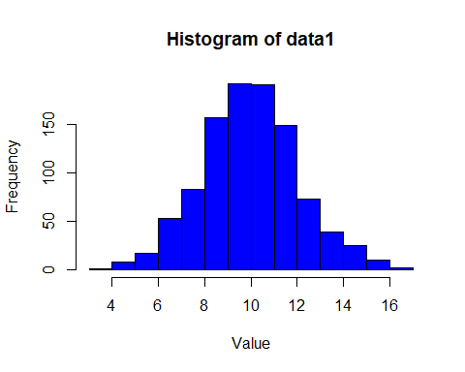

hist(data, breaks = c(0:20), col = "blue", main = "Histogram of data2", xlab = "Value",  
 ylab = "Frequency")

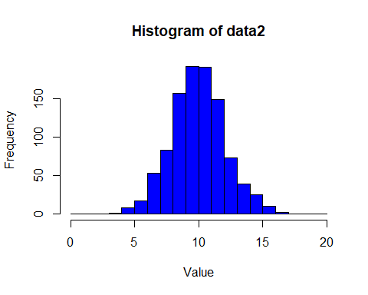

## tidyverse

### tidyr

gather()用于将宽格式的数据框转换为长格式的。

library(tidyr)  
data_wide <- data.frame(  
 country = c("USA", "Canada", "Mexico"),  
 year_2010 = c(300, 100, 200),  
 year_2011 = c(320, 110, 210)  
)  
print(data_wide)

## country year_2010 year_2011  
## 1 USA 300 320  
## 2 Canada 100 110  
## 3 Mexico 200 210

data_long <- gather(data_wide, key = "year", value = "value", year_2010:year_2011)  
print(data_long)

## country year value  
## 1 USA year_2010 300  
## 2 Canada year_2010 100  
## 3 Mexico year_2010 200  
## 4 USA year_2011 320  
## 5 Canada year_2011 110  
## 6 Mexico year_2011 210

spread()将长格式数据转换为宽格式数据。

data_long <- data.frame(  
 country = rep(c("USA", "Canada", "Mexico"), each = 2),  
 year = rep(c("2010", "2011"), times = 3),  
 value = c(300, 320, 100, 110, 200, 210)  
)  
print(data_long)

## country year value  
## 1 USA 2010 300  
## 2 USA 2011 320  
## 3 Canada 2010 100  
## 4 Canada 2011 110  
## 5 Mexico 2010 200  
## 6 Mexico 2011 210

data_wide <- spread(data_long, key = "year", value = "value")  
print(data_wide)

## country 2010 2011  
## 1 Canada 100 110  
## 2 Mexico 200 210  
## 3 USA 300 320

drop_na()移除包含NA值的行。

data <- data.frame(  
 id = 1:4,  
 value = c(10, NA, 30, NA)  
)  
print(data)

## id value  
## 1 1 10  
## 2 2 NA  
## 3 3 30  
## 4 4 NA

data_clean <- drop_na(data)  
print(data_clean)

## id value  
## 1 1 10  
## 2 3 30

fill()用上一个非NA值填充NA值。

data <- data.frame(  
 id = 1:5,  
 value = c(10, NA, NA, 20, NA)  
)  
print(data)

## id value  
## 1 1 10  
## 2 2 NA  
## 3 3 NA  
## 4 4 20  
## 5 5 NA

data_filled <- fill(data, value)  
print(data_filled)

## id value  
## 1 1 10  
## 2 2 10  
## 3 3 10  
## 4 4 20  
## 5 5 20

### dplyr

filter()用于根据特定列的条件筛选数据框中的行

library(dplyr)

##   
## Attaching package: 'dplyr'

## The following objects are masked from 'package:stats':  
##   
## filter, lag

## The following objects are masked from 'package:base':  
##   
## intersect, setdiff, setequal, union

data <- data.frame(  
 id = 1:5,  
 value = c(10, 20, 30, 40, 50),  
 name = c("a","b","c","d","e"),  
 sort = c(1, 1, 3, 2, 4)  
)  
print(data)

## id value name sort  
## 1 1 10 a 1  
## 2 2 20 b 1  
## 3 3 30 c 3  
## 4 4 40 d 2  
## 5 5 50 e 4

filtered_data <- filter(data, value > 20 & name=="e")  
print(filtered_data)

## id value name sort  
## 1 5 50 e 4

select()用于选择数据框中的特定列。

selected_data <- select(data, id)  
print(selected_data)

## id  
## 1 1  
## 2 2  
## 3 3  
## 4 4  
## 5 5

arrange()用于根据一个或多个列对数据框进行排序。如果你指定了多个列名，那么arrange函数会按照你指定的顺序对这些列进行排序。默认升序，desc() 降序

arranged_data <- arrange(data, desc(sort))  
print(arranged_data)

## id value name sort  
## 1 5 50 e 4  
## 2 3 30 c 3  
## 3 4 40 d 2  
## 4 1 10 a 1  
## 5 2 20 b 1

arranged_data <- arrange(data, desc(sort), desc(id))  
print(arranged_data)

## id value name sort  
## 1 5 50 e 4  
## 2 3 30 c 3  
## 3 4 40 d 2  
## 4 2 20 b 1  
## 5 1 10 a 1

mutate()用于在数据框中添加新列或修改现有列

mutated_data <- mutate(data, value2 = value * 2)  
print(mutated_data)

## id value name sort value2  
## 1 1 10 a 1 20  
## 2 2 20 b 1 40  
## 3 3 30 c 3 60  
## 4 4 40 d 2 80  
## 5 5 50 e 4 100

summary()用于对数据框中的数据进行汇总

summarised_data <- summary(data)  
print(summarised_data)

## id value name sort   
## Min. :1 Min. :10 Length:5 Min. :1.0   
## 1st Qu.:2 1st Qu.:20 Class :character 1st Qu.:1.0   
## Median :3 Median :30 Mode :character Median :2.0   
## Mean :3 Mean :30 Mean :2.2   
## 3rd Qu.:4 3rd Qu.:40 3rd Qu.:3.0   
## Max. :5 Max. :50 Max. :4.0

## ggplot2

### Scatter Plot with geom_point()

library(ggplot2)  
head(diamonds)

## # A tibble: 6 × 10  
## carat cut color clarity depth table price x y z  
## <dbl> <ord> <ord> <ord> <dbl> <dbl> <int> <dbl> <dbl> <dbl>  
## 1 0.23 Ideal E SI2 61.5 55 326 3.95 3.98 2.43  
## 2 0.21 Premium E SI1 59.8 61 326 3.89 3.84 2.31  
## 3 0.23 Good E VS1 56.9 65 327 4.05 4.07 2.31  
## 4 0.29 Premium I VS2 62.4 58 334 4.2 4.23 2.63  
## 5 0.31 Good J SI2 63.3 58 335 4.34 4.35 2.75  
## 6 0.24 Very Good J VVS2 62.8 57 336 3.94 3.96 2.48

# Scatter plot of 'price' vs 'carat' in the 'diamonds' dataset  
ggplot(diamonds, aes(x = carat, y = price)) +  
 geom_point() +  
 labs(title = "Scatter Plot of Price vs Carat",  
 x = "Carat",  
 y = "Price")

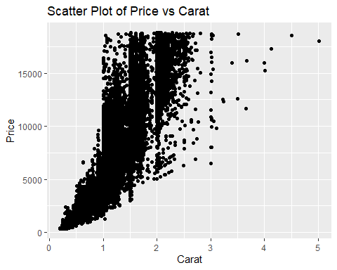

# Scatter plot with color aesthetic  
ggplot(mtcars, aes(x = wt, y = mpg, color = as.factor(cyl))) +  
 geom_point() +  
 labs(title = "Scatter Plot of MPG vs Weight by Cylinder",  
 x = "Weight (1000 lbs)",  
 y = "Miles per Gallon",  
 color = "Cylinders")

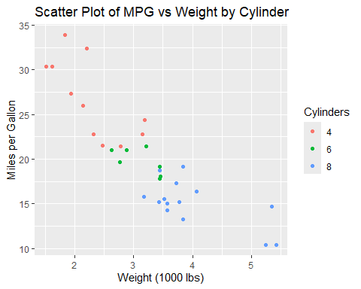

### Line Plot with geom_line()

# Line plot of 'price' over 'carat' in the 'diamonds' dataset  
ggplot(diamonds, aes(x = carat, y = price)) +  
 geom_line() +  
 labs(title = "Price Over Carat",  
 x = "Carat",  
 y = "Price")

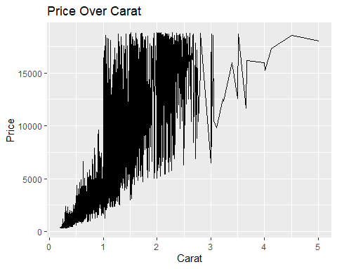

# Line plot of 'psavert' over time in the 'economics' dataset  
ggplot(economics, aes(x = date, y = psavert)) +  
 geom_line() +  
 labs(title = "Personal Savings Rate Over Time",  
 x = "Date",  
 y = "Personal Savings Rate")

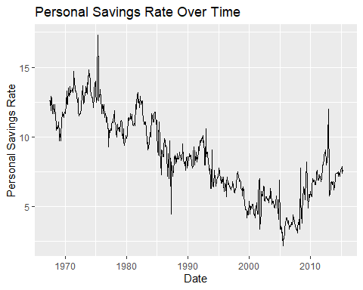

### Bar Plot with geom_bar()

# Bar plot of the 'cut' distribution in the 'diamonds' dataset  
ggplot(diamonds, aes(x = cut)) +  
 geom_bar() +  
 labs(title = "Bar Plot of Diamond Cut",  
 x = "Cut",  
 y = "Count")

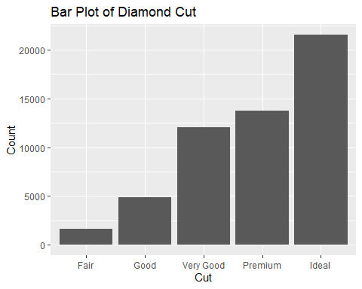

# Bar plot with fill aesthetic  
ggplot(mtcars, aes(x = as.factor(cyl), fill = as.factor(gear))) +  
 geom_bar(position = "dodge") +  
 labs(title = "Bar Plot of Cylinder Counts by Gear Type",  
 x = "Cylinders",  
 fill = "Gear Type")

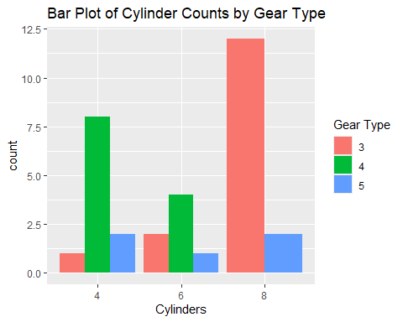

### Histogram with geom_histogram()

# Histogram of 'carat' in the 'diamonds' dataset  
ggplot(diamonds, aes(x = carat)) +  
 geom_histogram(binwidth = 0.1, color = "black") +  
 labs(title = "Histogram of Diamond Carat",  
 x = "Carat",  
 y = "Count")

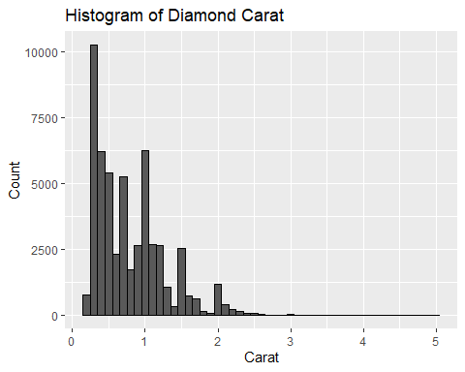

### Box Plot with geom_boxplot()

# Box plot of 'price' by 'cut' in the 'diamonds' dataset  
ggplot(diamonds, aes(x = cut, y = price))+  
 geom_boxplot() +  
 labs(title = "Box Plot of Price by Cut",  
 x = "Cut",  
 y = "Price")

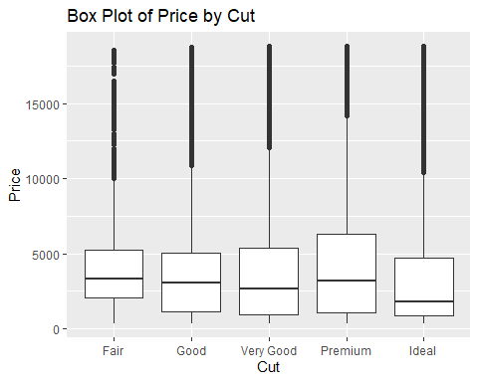

### Smoothing Line with geom_smooth()

# Line plot of 'psavert' over time in the 'economics' dataset  
ggplot(economics, aes(x = date, y = psavert)) +  
 geom_line() +  
 geom_smooth(method = "lm", color = "red", se = FALSE) +  
 labs(title = "Personal Savings Rate Over Time",  
 x = "Date",  
 y = "Personal Savings Rate")

## `geom_smooth()` using formula = 'y ~ x'

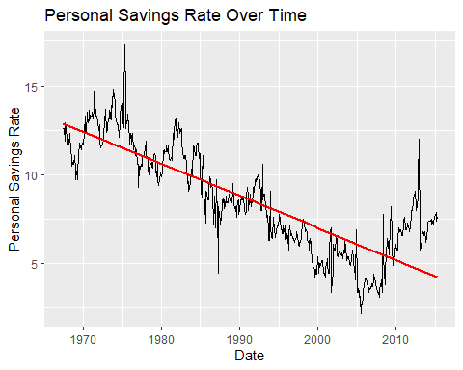

## Test

### 单样本t检验（One-Sample t-Test）

# 生成样本数据  
set.seed(123)  
sample_data <- rnorm(100, mean = 50, sd = 10)  
  
# 验证假设：样本正态性（Shapiro-Wilk检验）  
shapiro.test(sample_data)

##   
## Shapiro-Wilk normality test  
##   
## data: sample_data  
## W = 0.99388, p-value = 0.9349

# 单样本t检验  
t.test(sample_data, mu = 50)

##   
## One Sample t-test  
##   
## data: sample_data  
## t = 0.99041, df = 99, p-value = 0.3244  
## alternative hypothesis: true mean is not equal to 50  
## 95 percent confidence interval:  
## 49.09283 52.71528  
## sample estimates:  
## mean of x   
## 50.90406

### 独立样本t检验（Two-Sample t-Test）

# 生成样本数据  
set.seed(123)  
sample_data1 <- rnorm(50, mean = 50, sd = 10)  
sample_data2 <- rnorm(50, mean = 52, sd = 10)  
  
# 验证假设：样本正态性（Shapiro-Wilk检验）  
shapiro.test(sample_data1)

##   
## Shapiro-Wilk normality test  
##   
## data: sample_data1  
## W = 0.98928, p-value = 0.9279

shapiro.test(sample_data2)

##   
## Shapiro-Wilk normality test  
##   
## data: sample_data2  
## W = 0.99073, p-value = 0.9618

# 验证假设：样本方差相等（F检验）  
var.test(sample_data1, sample_data2)

##   
## F test to compare two variances  
##   
## data: sample_data1 and sample_data2  
## F = 1.0456, num df = 49, denom df = 49, p-value = 0.8766  
## alternative hypothesis: true ratio of variances is not equal to 1  
## 95 percent confidence interval:  
## 0.5933642 1.8425790  
## sample estimates:  
## ratio of variances   
## 1.04562

# 独立样本t检验  
t.test(sample_data1, sample_data2, var.equal = TRUE)

##   
## Two Sample t-test  
##   
## data: sample_data1 and sample_data2  
## t = -1.7036, df = 98, p-value = 0.09162  
## alternative hypothesis: true difference in means is not equal to 0  
## 95 percent confidence interval:  
## -6.7544625 0.5143682  
## sample estimates:  
## mean of x mean of y   
## 50.34404 53.46408

### 配对样本t检验（Paired-Sample t-Test）

# 生成样本数据  
set.seed(123)  
before <- rnorm(30, mean = 50, sd = 10)  
after <- before + rnorm(30, mean = 2, sd = 5)  
  
# 计算配对差值  
differences <- after - before  
  
# 验证假设：差值正态性（Shapiro-Wilk检验）  
shapiro.test(differences)

##   
## Shapiro-Wilk normality test  
##   
## data: differences  
## W = 0.98662, p-value = 0.9614

# 配对样本t检验  
t.test(before, after, paired = TRUE)

##   
## Paired t-test  
##   
## data: before and after  
## t = -3.7931, df = 29, p-value = 0.0006996  
## alternative hypothesis: true mean difference is not equal to 0  
## 95 percent confidence interval:  
## -4.450901 -1.332482  
## sample estimates:  
## mean difference   
## -2.891692

### 非参数检验（Non-Parametric Tests）

Wilcoxon符号秩检验（Wilcoxon Signed-Rank Test）

Mann-Whitney U检验（Mann-Whitney U Test）是两种常用的非参数检验，适用于不满足正态性假设的数据。

# Wilcoxon符号秩检验（配对数据或单样本）  
wilcox.test(before, after, paired = TRUE)

##   
## Wilcoxon signed rank exact test  
##   
## data: before and after  
## V = 68, p-value = 0.0003801  
## alternative hypothesis: true location shift is not equal to 0

wilcox.test(sample_data, mu = 50)

##   
## Wilcoxon signed rank test with continuity correction  
##   
## data: sample_data  
## V = 2763, p-value = 0.4142  
## alternative hypothesis: true location is not equal to 50

# Mann-Whitney U检验（非配对数据）  
wilcox.test(sample_data1, sample_data2, paired = FALSE)

##   
## Wilcoxon rank sum test with continuity correction  
##   
## data: sample_data1 and sample_data2  
## W = 995, p-value = 0.07935  
## alternative hypothesis: true location shift is not equal to 0