Docker Image Optimization and Best Practices

1. Introduction
Docker is a containerization platform that allows applications to run in isolated environments. Optimizing Docker images helps reduce size, improve performance, and speed up deployment.

2. Difference Between Image and Container
Image: A snapshot of an application and its environment.
Container: A running instance of an image.

3. Multi-stage Build Optimization
Multi-stage builds allow separating the build environment from the runtime environment.
Example Dockerfile:
# Build stage
FROM node:18 AS builder
WORKDIR /app
COPY package*.json ./
RUN npm install
COPY . .
RUN npm run build
# Production stage
FROM node:18-alpine
WORKDIR /app
COPY --from=builder /app/dist ./dist
COPY package*.json ./
RUN npm install --only=production
CMD ["node", "dist/index.js"]
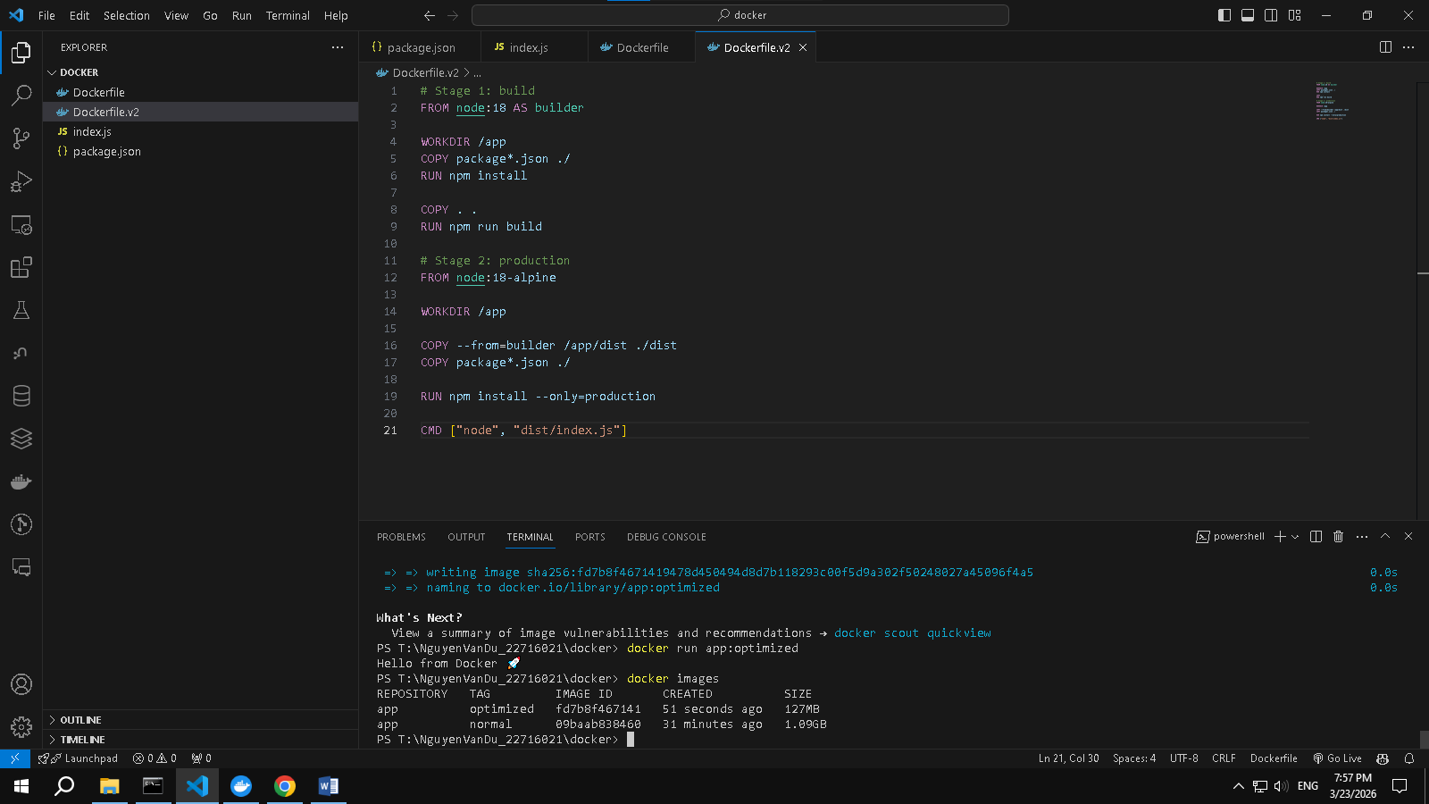

4. Benefits
- Smaller image size
- Faster deployment
- Better security

5. PostgreSQL Example Workflow
1. Pull PostgreSQL image
2. Run container
3. Insert data
4. Commit container to a new image
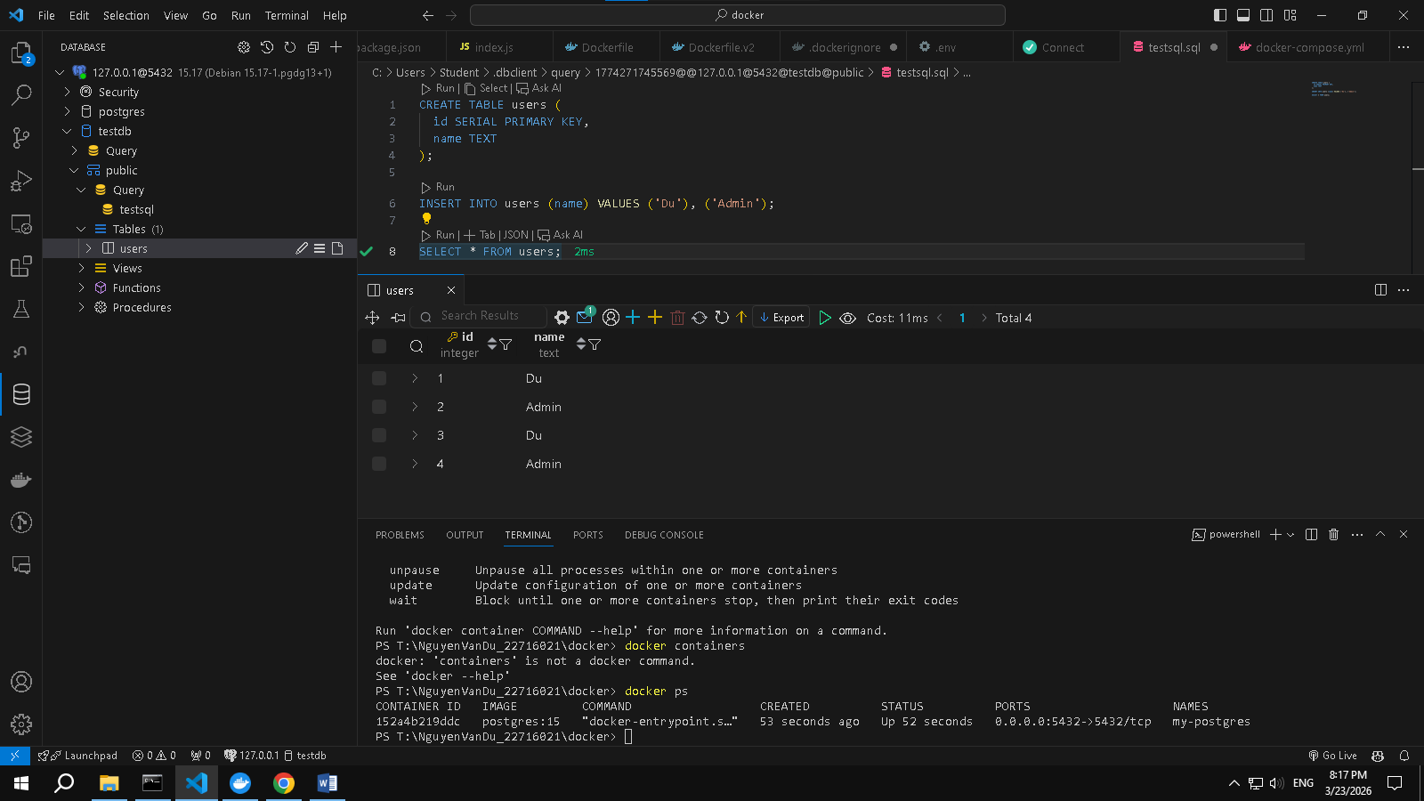

6. Best Practices for Reducing Image Size
- Use lightweight base images (Alpine)
- Use .dockerignore
- Avoid unnecessary files
- Clean cache
- Use multi-stage builds

7. Conclusion
Optimizing Docker images is essential for modern DevOps workflows. Multi-stage builds and proper image management significantly improve performance and scalability.

