CAPER: Code-Aware Paired-End Read Merging in DNA Data Storage
Jiyeon Park, Ha Hyeon Jeon, Jeong Wook Lee, Hosung Park

Supplementary Material

S1. Experimental information
The experimental procedures followed those described in [R1].

∙ Sequence design
Each DNA oligonucleotide comprised a 152-nt data-encoding region flanked by 26-nt forward and 21-nt reverse primer-binding regions, yielding a total length of 199 nt. RP1 and RPI1 were used for PCR amplification to incorporate Illumina-compatible adapter sequences and a sample index. The sequences are listed in Table S1.

Table S1. Sequence patterns used in DNA data storage experiments
Type | Sequence pattern
Forward primer  (26nt) | GTTCAGAGTTCTACAGTCCGACGATC
Reverse primer  (21nt) | TGGAATTCTCGGGTGCCAAGG
PCR primer RP1 | AATGATACGGCGACCACCGAGATCTACACGTTCAGAGTTCTACAGTCCGA
PCR primer RPI1 | CAAGCAGAAGACGGCATACGAGATCGTGATGTGACTGGAGTTCCTTGGCACCCGAGAATTCCA
Index adapter | ATCACG

∙ Synthesis
A pool of 18,000 distinct 199-nt DNA oligonucleotides was designed through the encoding process and synthesized by Twist Bioscience, with a total pool mass of 300 ng.

∙ PCR
The lyophilized oligo pool was reconstituted in nuclease-free water (Invitrogen) to a concentration of 25 ng/µL. PCR was performed using the reaction composition and thermocycling conditions listed in Tables S2 and S3, respectively. The PCR products were purified using 50 µL of AMPure XP beads (Beckman Coulter; 1× bead-to-sample volume ratio) and eluted in 20 µL of nuclease-free water.

Table S2. PCR experiment conditions
Oligo pool sample (25ng/ul) | 1µl (25ng)
RP1 primer(10uM) | 2.5µl
RPI1 primer(10uM) | 2.5µl
Q5 master mix* | 25µl
Nuclease free water | 19µl
Total | 50µl
* Q5® Hot Start High-Fidelity 2X Master Mix

Table S3. Thermocycling cycles of PCR
98°C | 98°C | 60°C | 72°C | 72°C
30sec | 10sec | 30sec | 30sec | 5min
* The highlighted area is repeated for 10 cycles

∙ Sequencing
The purified PCR products and PhiX Control v3 were denatured and diluted according to the Illumina protocol. The library was multiplexed with other samples and sequenced on an Illumina MiSeq using the MiSeq Reagent Kit v3 (600-cycle) at a final loading concentration of 10 pM. A 30% PhiX spike-in was included to increase sequence diversity and mitigate potential sequencing errors associated with the low-diversity DNA storage library, which contained 18,000 distinct oligonucleotides. For 150-bp paired-end sequencing, the run used a 151–6–151-cycle configuration, comprising 151 cycles for Read 1, 6 cycles for the index read, and 151 cycles for Read 2. The DNA storage library was pooled with other sample libraries for multiplexed sequencing in a single Illumina MiSeq run. Although reads were assigned to samples by their index sequences, reads from other samples may remain after index-based assignment; therefore, using the known reference sequences of all multiplexed samples, we excluded reads that were closer in edit distance to the reference of another sample than to those of this study.

S2. Data recovery workflow of DNA data storage
S2.1. Encoding
The encoding procedure was the same as that described in the main text and is illustrated in Figure S1. We followed the encoding framework used in [R1, R3], which is based on [R4], but imposed no sequence constraints on GC content or homopolymer length.
For LT encoding, the degree d, representing the number of source segments combined to generate an encoded droplet, was sampled from a robust soliton distribution with parameters c=0.025 and $δ$=0.001. For each droplet, a Mersenne Twister pseudo-random number generator (PRNG) was initialized using its 32-bit seed. A uniformly distributed random number was first generated and mapped to a degree using the cumulative degree distribution. Subsequently, d distinct source segments were selected uniformly at random, without replacement, from the 16,050 source segments. The selected 256-bit segments were combined by bitwise XOR to form the droplet payload. The 32-bit seed was prepended to the payload, enabling the decoder to reproduce both the degree and the selected source-segment indices using the same PRNG and sampling procedure.
For RS encoding, the concatenated seed and payload were treated as 36 symbols of 8 bits each. A systematic RS(38, 36) code over GF(2⁸), defined using the primitive polynomial (p(x)=x⁸+x⁴+x³+x²+1), generated two parity symbols, thereby protecting both the seed and the payload. These parity symbols were appended to produce a 304-bit sequence in the order of seed, payload, and RS parity. The sequence was then converted into a 152-nt oligo using the binary-to-base mapping described in the manuscript.
The non-constrained design was chosen because it is identical to the design of [R1], and [R2], which used the same experimental and encoding protocols, reported that a non-constrained pool performed better than a constrained pool. The sequence of seeds used to generate oligos could be reproduced given the pseudo-random number generator and its initial value.
The GC content of the resulting oligos ranged from 32.89% to 68.42%, with a mean of 50.02% and a median of 50.00%. The overall GC content of the pool was 50.02%. Of all oligos, 98.92% had GC contents between 40% and 60%, and 77.34% had GC contents between 45% and 55%. Figure S2 shows the distribution of the maximum homopolymer run length per oligo. The proportions of oligos with maximum homopolymer lengths of ≤3, ≤4, and ≤5 nt were 15.73%, 63.37%, and 89.34%, respectively. The longest observed homopolymer was 13 nt and occurred in one oligo.

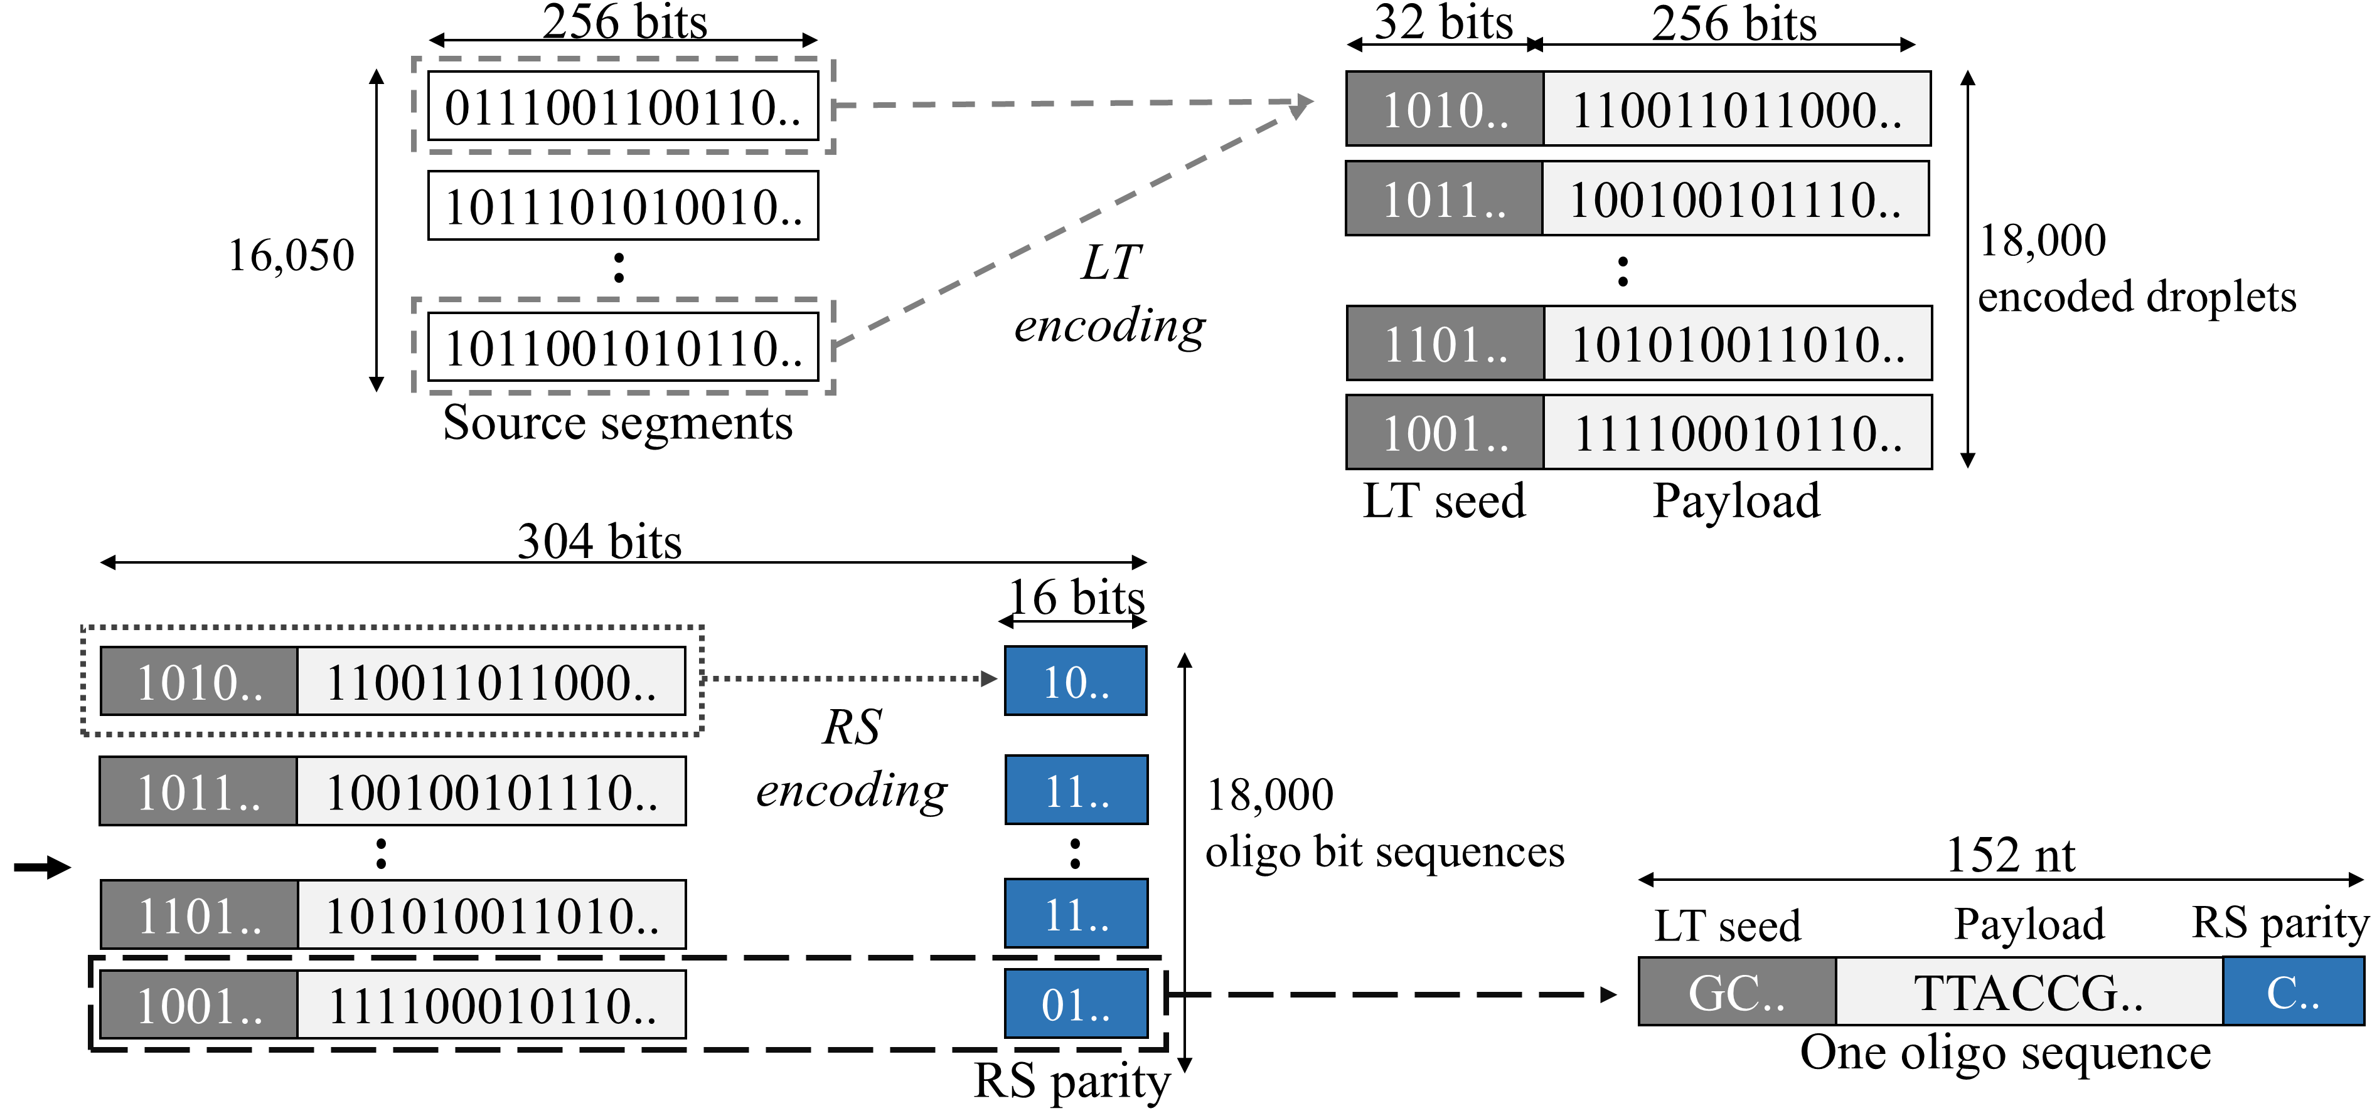
Figure S1. Encoding procedure (reproduced from Figure 1 of [R3] under CC BY 4.0)

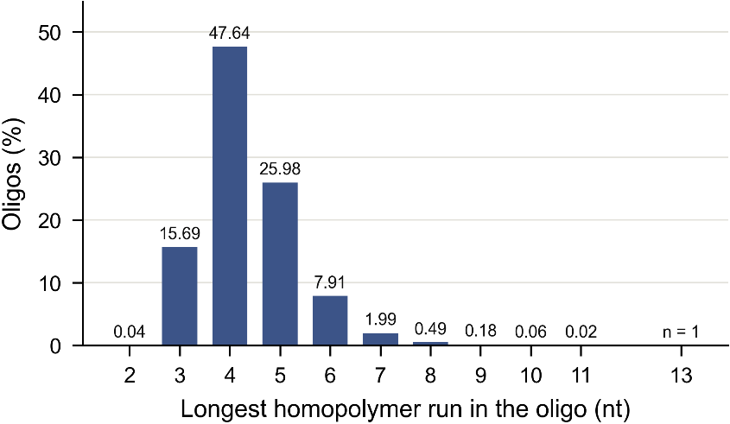
Figure S2. Distribution of the maximum homopolymer run length per oligo
S2.2. Sequence analysis
In DNA data storage, sequence analysis processes sequencing reads to generate sequences for decoding. Errors introduced during synthesis, PCR, and sequencing, together with variation in read coverage across oligos, can affect data recovery. Sequence analysis therefore manages read quality and integrates information from reads originating from the same oligo.
Depending on the workflow, this may include quality filtering and trimming to remove low-quality reads or bases, read merging to combine paired-end reads, length filtering to retain only reads matching the expected oligo length, sequence clustering to group similar reads, sequence alignment to identify corresponding positions, and consensus generation to infer a representative sequence from multiple reads.

S2.3. Decoding
In an inner–outer coding structure, the inner code applied to each oligo detects or corrects errors within that oligo, whereas the outer code spans multiple oligos and enables recovery of missing information. Once sequences passing the inner-code check are obtained, encoded oligos for which no valid sequence is available can be treated as erasures during outer decoding. In this study, the RS(38, 36) inner code was used for error detection, and sequences passing this check were supplied to the LT outer decoder.
Each LT-encoded droplet consists of the bitwise XOR of selected source segments. The decoder uses the seed carried by each droplet to reconstruct the list of source segments selected during encoding. Peeling decoding exploits these relationships by recovering a source segment from a droplet containing only one unresolved segment and iteratively propagating the recovered information to other droplets.
Specifically, previously recovered source segments are removed from a droplet by XORing them with its payload. If only one unresolved segment remains, the residual payload gives the value of that segment. The newly recovered segment is then removed from all other droplets containing it, potentially enabling further segment recovery. This process is repeated until no further updates are possible, after which the next valid droplet is introduced. Decoding terminates when all source segments have been recovered, allowing reconstruction of the original data. A decoding attempt is considered unsuccessful if unresolved segments remain after all available droplets have been processed.

S3. Sequence analysis tools and parameters
S3.1 Software versions and options
Table S4 summarizes the options used for the sequence analysis tools in this study. The read-merging tools are described in detail in the following section.

Table S4. Software tools, versions, and options used for sequence analysis
Tool | Purpose | Version | Used options
fastp [R5] | Adapter trimming | 0.21.0 | --adapter_sequence=<adapter pattern>  -G -Q -L
PEAR [R6] | Paired-end read merging | 0.9.11 | -p 0.01 (Default option of PEAR)
FLASH [R7] | Paired-end read merging | 1.2.11 | -x 0.4 -M 150
NGmerge [R8] | Paired-end read merging | 0.5 | -p 0.4
Starcode [R9] | Sequence clustering | 1.4 | -d 7 -s -q
CD-HIT  (CD-HIT-EST)  [R10] | Sequence clustering | 4.8.1 | -c 0.94 -n 8 -r 0 -g 1 -d 0 -M 0
MUSCLE [R11] | (Multiple)  Sequence alignment | 5.3 | -align <input FASTA> -output <output FASTA>

S3.2 Comparison of merging tools
All three merging methods reverse-complement R2, evaluate candidate ungapped overlaps with R1, and construct a single merged read from the selected overlap. The use of ungapped alignments is motivated by the rarity of insertion and deletion errors in Illumina sequencing [R7].
Matching bases in the overlap are retained, whereas mismatching bases are resolved using quality scores and method-specific tie-breaking rules. The methods differ primarily in overlap scoring and acceptance criteria, the handling of equal-quality mismatches, and merged quality-score assignment. We retained the selected and alternative bases, together with their input quality scores, at mismatch positions for use by CAPER. Table S5 summarizes the methods and parameters used in this study.

Table S5. Comparison of merging methods and parameters
Feature | PEAR | FLASH | NGmerge
Overlap scoring | Maximizes an assembly score incorporating base agreement, quality scores, and empirical base frequencies | Minimizes mismatch density: mismatch count divided by the smaller of the effective overlap length and the maximum-overlap parameter | Minimizes mismatch fraction: mismatch count divided by the effective overlap length
Merge acceptance criteria | Statistical test and minimum overlap and merged-read length requirements | Minimum overlap requirement and mismatch density at or below the threshold | Minimum overlap requirement and mismatch fraction at or below the threshold
Use of quality scores in overlap selection | Used in assembly scoring | Used to resolve density ties: the sum of the lower quality score at each mismatch is normalized by the same denominator; lower values are preferred | Not used; fraction ties favor the longest merged read
Minimum overlap | 10 nt | 10 nt | 20 nt
Maximum-overlap setting | No overlap-score normalization cap | 150 nt; longer overlaps are evaluated, but the scoring denominator is capped at 150 | No separate maximum-overlap parameter; default stitch-mode overlap range
Base selection at mismatches with unequal quality scores | Higher-quality base | Higher-quality base | Higher-quality base
Base selection at mismatches with equal quality scores | R2 base | R2 base | R1 base in the first half of the merged read;  R2 base in the second half
Merged quality score at matching positions | Q₁+Q₂ | max(Q₁,Q₂) | Empirical match matrix
Merged quality score at mismatching positions | max(Q₁,Q₂) | max(|Q₁ − Q₂|, 2) | Empirical mismatch matrix
Additional settings | p-value threshold: 0.01 | Maximum mismatch density: 0.40 | Maximum mismatch fraction: 0.40
Q₁ and Q₂ denote the Phred quality scores at corresponding positions in R1 and reverse-complemented R2. Base-selection and quality-score rules are shown for comparisons between called bases (A, C, G, and T). For FLASH and NGmerge, the effective overlap length excludes positions containing an N in either read.

- FLASH details
Mismatch density was calculated as the number of mismatches divided by the smaller of the effective overlap length and the maximum-overlap parameter. Positions containing an N in either read were excluded from both the mismatch count and the effective overlap length. Density ties were resolved using the sum of the lower quality score at each mismatch position, normalized by the same denominator, with lower values preferred.
The minimum overlap, maximum-overlap parameter, and maximum mismatch density were set to 10 nt, 150 nt, and 0.40, respectively. The maximum-overlap parameter limits the scoring denominator rather than imposing an absolute upper bound on the overlap length considered.

- NGmerge details
We followed the stitch-mode merging logic of NGmerge. Mismatch fractions were calculated using the effective overlap length, excluding positions containing an N. Among candidates satisfying the acceptance criteria, the candidate with the lowest mismatch fraction was selected. Ties were resolved in favor of the candidate producing the longest merged read.
The minimum overlap and maximum mismatch fraction were set to 20 nt and 0.40, respectively. Merged quality scores were determined using the empirical match and mismatch matrices loaded from qual_profile.txt (provided with NGmerge). When only one of the two bases was N, the base and quality score from the other read were retained.

- PEAR details
Candidate overlaps were evaluated using an assembly score incorporating base agreement, input quality scores, and empirical base frequencies estimated from the input data. The highest-scoring candidate was selected, and read pairs satisfying the statistical test and length criteria were merged.
The p-value threshold, minimum overlap, and minimum merged-read length were set to 0.01, 10 nt, and 50 nt, respectively. No maximum merged-read length was imposed. Quality-scaled scoring and test method 1 were used, and output quality scores were capped at 40.

- Selection of merging parameters
We evaluated the effect of merging parameters on data recovery using the Baseline-Naive workflow. The p-value threshold for PEAR’s statistical test was set to 0.001, 0.01 (default in PEAR), or 0.05. The maximum mismatch fraction was varied over 0.10, 0.20, 0.25 (default in FLASH), 0.30, 0.40, and 0.50 for FLASH and over 0.10 (default in NGmerge), 0.20, 0.30, 0.40, and 0.50 for NGmerge. For each setting, the number of successful decoding attempts out of 100 trials was compared at RSNs ranging from 75,000 to 86,000 in increments of 1,000.
PEAR produced identical decoding success counts across all three p-value thresholds at every RSN evaluated; therefore, its default threshold of 0.01 was retained. For FLASH and NGmerge, increasing the mismatch allowance modestly improved decoding success at some RSNs. Both tools produced identical decoding success counts at mismatch fractions of 0.40 and 0.50 across all evaluated RSNs (Table S6).
Analysis using all available read pairs also showed that a maximum mismatch fraction of 0.40 increased the number of reads exactly matching a reference oligo compared with the default settings (Table S7). Together, these results supported the selection of 0.40 for FLASH and NGmerge.

Table S6. Baseline-Naive decoding results across RSNs and merging parameters
RSN | PEAR |  |  | FLASH |  |  |  |  |  | NGmerge
param. | 0.001 | 0.01 | 0.05 | 0.1 | 0.2 | 0.25 | 0.3 | 0.4 | 0.5 | 0.1 | 0.2 | 0.3 | 0.4 | 0.5
75000 | 0 | 0 | 0 | 0 | 0 | 0 | 0 | 0 | 0 | 0 | 0 | 0 | 0 | 0
76000 | 5 | 5 | 5 | 3 | 3 | 4 | 4 | 5 | 5 | 2 | 3 | 3 | 4 | 4
77000 | 16 | 16 | 16 | 13 | 15 | 16 | 16 | 16 | 16 | 14 | 17 | 18 | 18 | 18
78000 | 38 | 38 | 38 | 35 | 36 | 37 | 38 | 38 | 38 | 37 | 40 | 40 | 40 | 40
79000 | 59 | 59 | 59 | 57 | 58 | 59 | 59 | 59 | 59 | 57 | 59 | 59 | 59 | 59
80000 | 73 | 73 | 73 | 70 | 71 | 71 | 73 | 73 | 73 | 70 | 70 | 70 | 70 | 70
81000 | 83 | 83 | 83 | 82 | 83 | 83 | 83 | 83 | 83 | 83 | 84 | 84 | 84 | 84
82000 | 90 | 90 | 90 | 88 | 89 | 90 | 90 | 90 | 90 | 88 | 89 | 90 | 90 | 90
83000 | 94 | 94 | 94 | 92 | 93 | 94 | 94 | 94 | 94 | 92 | 93 | 94 | 94 | 94
84000 | 95 | 95 | 95 | 94 | 94 | 95 | 95 | 95 | 95 | 96 | 97 | 98 | 98 | 98
85000 | 99 | 99 | 99 | 99 | 99 | 99 | 99 | 99 | 99 | 100 | 100 | 100 | 100 | 100
86000 | 100 | 100 | 100 | 100 | 100 | 100 | 100 | 100 | 100 | 100 | 100 | 100 | 100 | 100

Table S7. Numbers of reads exactly matching a reference oligo under default and selected merging parameters
Tool \ Parameter | Default | 0.40 | Increase
FLASH | 15,861,333 | 15,879,511 | 18,178
NGmerge | 15,865,400 | 15,887,997 | 22,597

S4. Error characteristics of DNA data storage
S4.1. Error estimation method
Errors were estimated by assigning each sequencing read to an original oligo sequence based on edit distance. The analysis included paired-end reads—R1 (forward) and R2 (reverse)—as well as merged reads generated using the merging tools. The original R1 and R2 reads were 151 nt long. Because previous studies have reported unreliable base calling in the final sequencing cycle [R12,R13], the final base of each read was removed, yielding 150-nt reads before adapter trimming.
Adapter trimming was performed on R1 and R2 using fastp. Its adapter-trimming algorithm was modified to initiate trimming when a candidate match to the adapter pattern described in Section S1 contained at least seven matching bases.
For each read, edit distances to all reference oligos were calculated, and the oligo with the minimum edit distance was selected. Ties were resolved by randomly selecting one of the equally close reference oligos. R1 and merged reads were compared with reference oligos in the forward orientation, whereas R2 reads were retained in their original orientation and compared with reverse-complemented reference oligos. Substitutions, insertions, and deletions were identified using the editops function in python-Levenshtein v0.20.9.
Because R1 and R2 reads were at most 150 nt long whereas the reference oligos were 152 nt long, the read-length limitation could appear as deletions in the alignment. For R1 and R2, deletion operations at the final two positions of the reference in the corresponding orientation were examined, and those attributed to the read-length limitation were excluded from the deletion count. All other deletion operations were retained. Reads for which trimming removed all bases were assigned 152 deletions.

S4.2. Sequenced read profiles
Table S8 lists the numbers of reads, and Table S9 their length distribution. Of the 21,242,782 read pairs, 84.0% were merged into TL reads by each tool, and 74.8% were TL-P reads. After adapter trimming, 89.0% of R1 and 89.5% of R2 reads remained 150 nt long. Among the merged reads, 92.1% (PEAR) were 152 nt long, and FLASH produced more reads of 158 nt or longer than the other tools.

Table S8. Read count distribution
Number of reads | R1 | R2 | PEAR | FLASH | NGmerge
Total reads | 21,242,782 | 21,242,782 | 19,369,708 | 19,385,637 | 19,253,386
TL reads | - | - | 17,849,007 | 17,841,874 | 17,842,026
TL-P reads | - | - | 15,880,027 | 15,879,512 | 15,888,002

Table S9. Read length distribution
Length | R1 | R2 | PEAR | FLASH | NGmerge
≤145 | 511,529 | 500,388 | 421,984 | 426,761 | 426,716
146 | 32,249 | 23,701 | 16,676 | 4 | 4
147 | 104,625 | 95,529 | 20,226 | 4 | 4
148 | 370,193 | 335,064 | 26,563 | 45 | 45
149 | 1,326,014 | 1,283,329 | 43,054 | 2,725 | 2,725
150 | 18,896,944 | 19,003,874 | 102,644 | 102,587 | 102,585
151 | - | - | 592,336 | 591,971 | 591,995
152 | - | - | 17,849,007 | 17,841,874 | 17,842,026
153 | - | - | 210,098 | 209,957 | 209,958
154 | - | - | 3,108 | 3,108 | 3,103
155 | - | - | 1,130 | 1,138 | 1,128
156 | - | - | 809 | 807 | 803
157 | - | - | 707 | 710 | 703
≥158 | - | - | 81,366 | 203,946 | 71,591
All trimmed | 1,228 | 897 | - | - | -

Figures S3 and S4 show the error rate at each position, defined as the number of errors at that position divided by the number of reads. In R1 and R2, substitutions occurred at a nearly constant rate of about 2.4–2.5 × 10⁻² per base along the read, whereas the rates rose at the last cycles (Fig. S3). In all reads, the deletion rate decreased along the read because reads shorter than 150 nt contribute deletions near their ends; in 150-nt reads, deletions and insertions remained at about 1 × 10⁻² per base. In merged reads, the substitution rate decreased to 0.9–2.4 × 10⁻³ per base, and in TL merged reads deletions and insertions decreased to about 1 × 10⁻⁵ per base (Fig. S4).

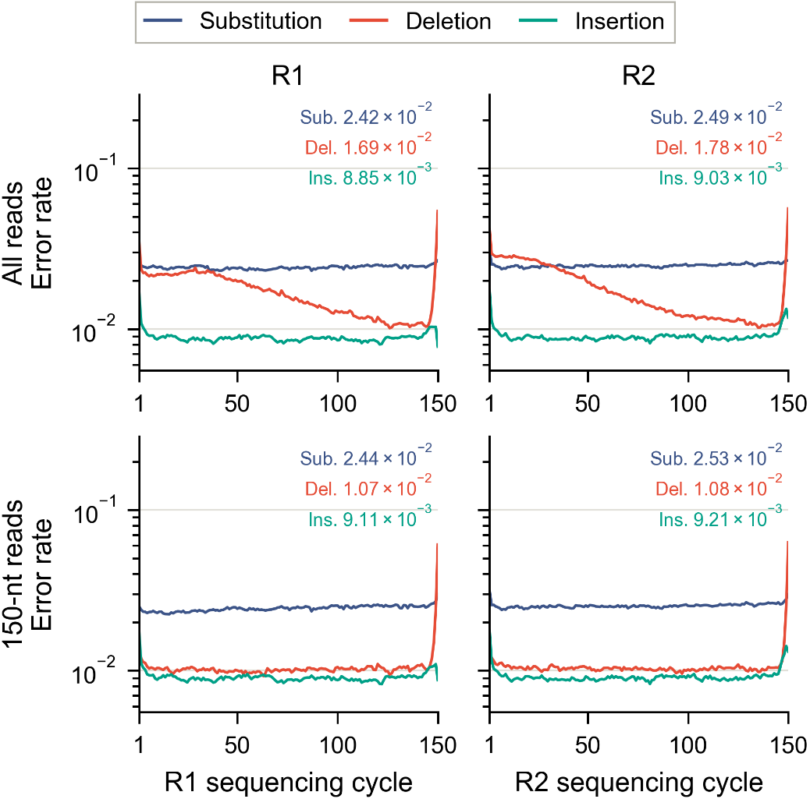
Figure S3. Per-cycle error rates of R1 and R2.
Top: all reads; bottom: reads that were 150 nt. Numbers give the per-base rates

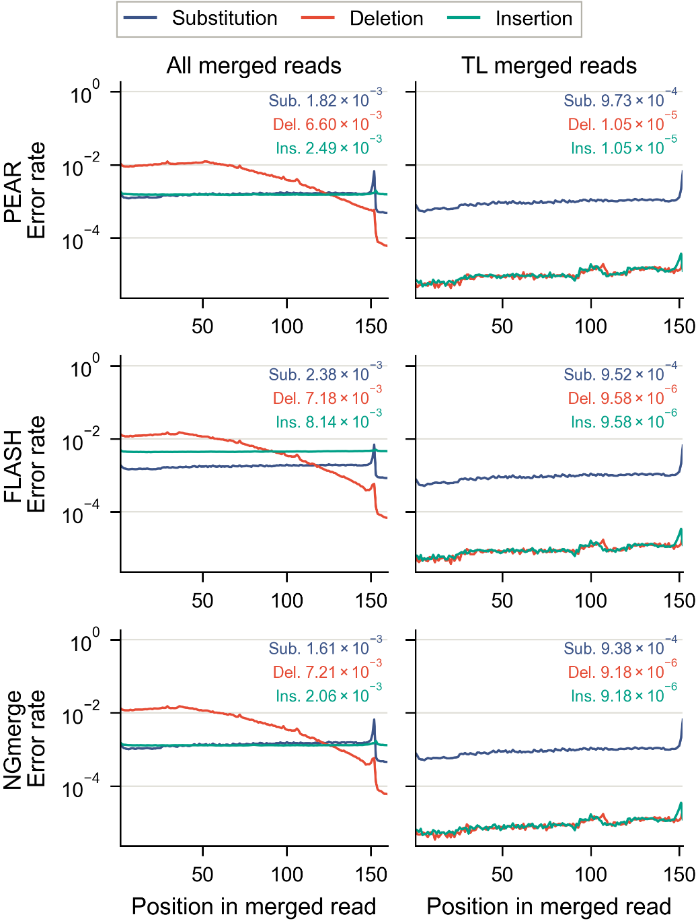
Figure S4. Per-position error rates of merged reads for each merging tool.
Left: all merged reads; right: TL merged reads

Figures S5–S8 show the edit distance between each merged read and its reference oligo. Of all merged reads, 81.9–82.5% were error-free and 12.4% had one error; of the TL reads, 89.0% were error-free. Among erroneous TL reads, 85.6–86.0% had a single error and 8.6% had two, so most erroneous TL reads differ from the oligo at only a few positions. The 10+ bar of all merged reads (2.5–3.2%) consists mainly of reads whose length differs from that of the oligo.
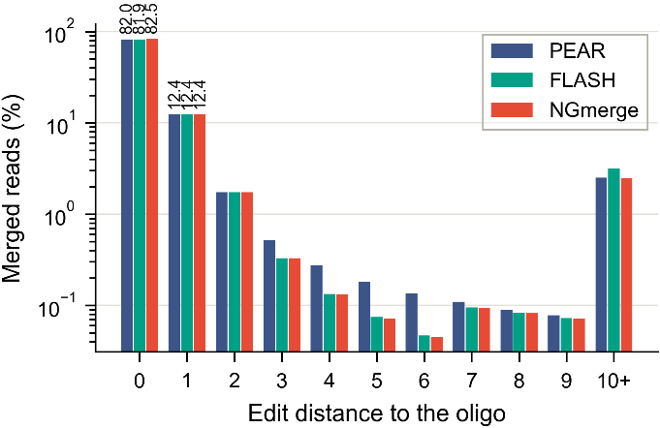
Figure S5. Edit-distance distribution of merged reads

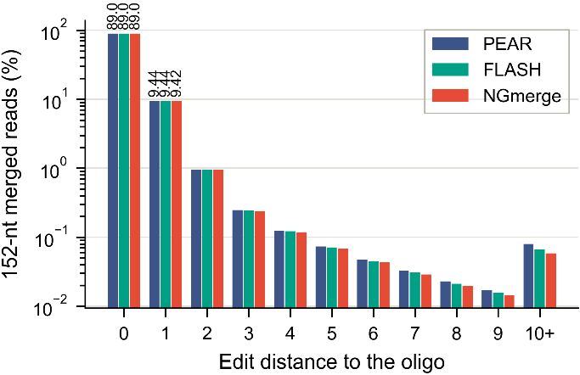
Figure S6. Edit-distance distribution of TL reads
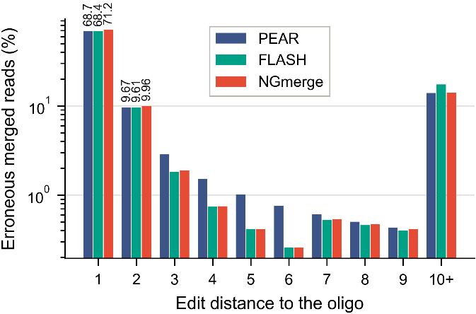
Figure S7. Edit-distance distribution of erroneous merged reads
(reads with at least one error, renormalized to 100%)

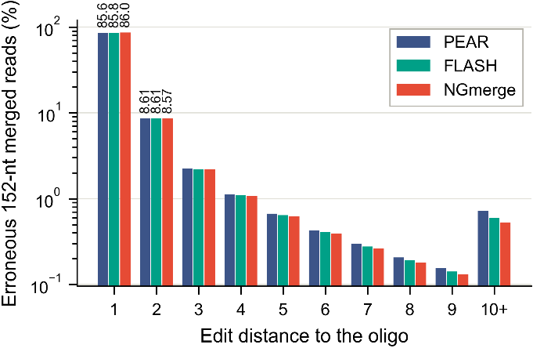
Figure S8. Edit-distance distribution of erroneous TL reads
Figure S9 compares the reported Q-score with the empirical Q-score, −10 log₁₀ of the observed substitution rate at each reported Q-score, using reads with substitutions only. For R1 and R2, the empirical Q-score followed the reported one up to about Q30 but stayed near Q33 for higher reported scores. For merged reads, FLASH and NGmerge lay above the diagonal at low reported Q-scores, close to it at around Q15, and below it at higher Q-scores, whereas PEAR assigned higher Q-scores than were observed over the whole range. The reported Q-scores thus deviate from the observed error rates in both directions, and substitutions occur even at high Q-scores, which motivates using them only to order and bound the candidates of CAPER.
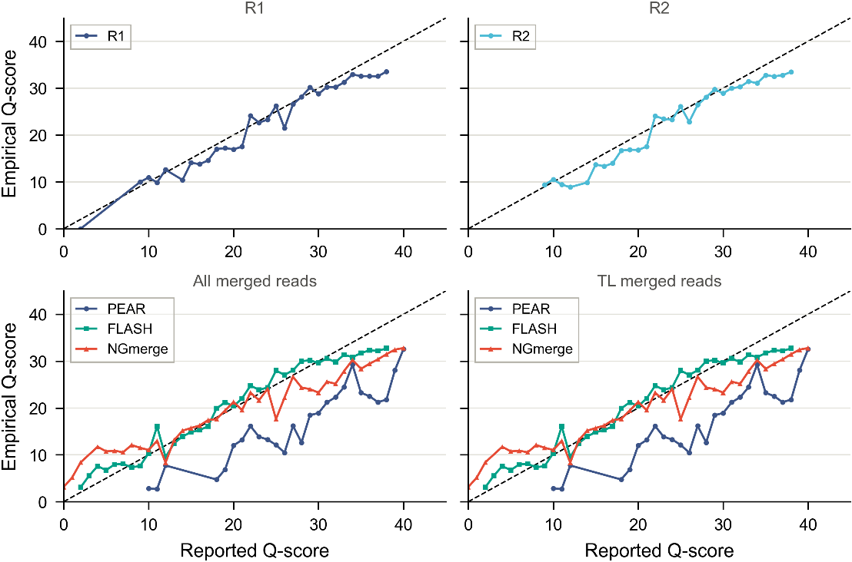
Figure S9. Reported versus empirical Q-scores for R1, R2, all merged reads, and TL merged reads. Only substitution-only reads were used; the dashed line marks perfect calibration

Figures S10 and S11 characterize the TL-F reads. In 67.5–68.0% of them, R1 and R2 agreed at every position of the overlap (Fig. S10), so read-level CAPER has no candidate position; these reads can be recovered only at the cluster level. In 15.6–16.0% of the TL-F reads, every error was at a mismatch where the discarded base was correct, so they can be fully restored by substitution (Fig. S11).

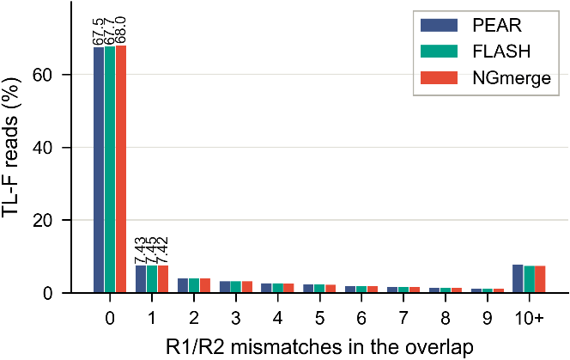
Figure S10. Number of R1–R2 mismatches in the overlap region of TL-F reads
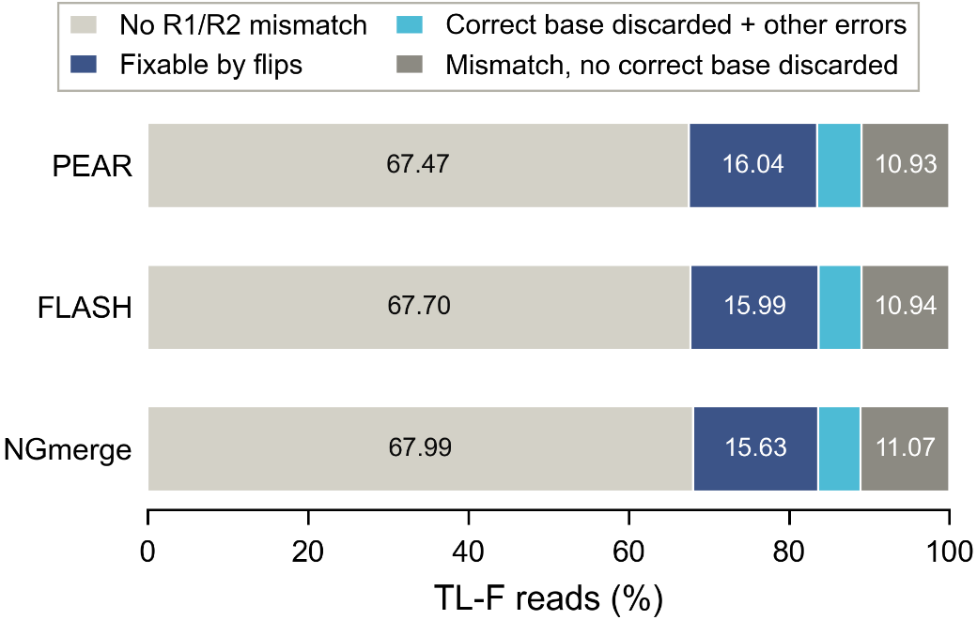
Figure S11. Classification of TL-F reads. No R1/R2 mismatch: R1 and R2 agree everywhere. Fixable by flips: every error lies at a mismatch whose discarded base is correct. Correct base discarded + other errors: some, but not all, errors are at such mismatches.
Mismatch, no correct base discarded: no error is at such a mismatch

S5. Parameter selection
The parameters of CAPER were selected by sweeping them on the same 100 trials. The read-level parameters (K, M, and Q_max) were evaluated with CAPER-Naive (PEAR) at RSN = 80,200, and the clustering parameters with Baseline-NTL and CAPER-NTL (DQ) at RSN = 78,000, where differences among settings remain visible. In each heatmap, the framed cell marks the selected setting and a dash marks a combination that was not evaluated. In the clustering heatmaps, “TL” denotes clustering of TL-F reads only, and ±L denotes inclusion of NTL reads within TL ± L nt. I2 and I3 recovery are expressed as percentages of the oligos missed by I1.
In the DQ mode, I2 recovery increased only slightly beyond K = M = 5 (4.43% versus 4.70% at K = M = 10; Fig. S12), whereas configurations with K ≥ 6 and M ≥ 2 caused incorrect decoding because an incorrect sequence passed error detection (Fig. 6a in the main text). In the EQ mode, decoding success (76–77 trials) and I2 recovery (1.38–1.57%) changed little with K and M and saturated at M ≥ 4 (Figs. S13 and S14), because positions with q_gap = 0 are few.
For each fixable TL-F read, we computed the rank of the deepest position that must be flipped in the search order (K needed), the number of positions to flip (M needed), and the sum of their q_gap (Q needed). In the EQ mode, K ≤ 5 and M ≤ 5 covered more than 99.6% of the fixable reads (Fig. S15). In the DQ mode, K ≤ 5, M ≤ 5, and Q ≤ 20 covered 90.5–90.9%, 97.5–98.1%, and 94.0–94.2%, respectively, for all three merging tools (Fig. S16).
With Starcode, decoding success of Baseline-NTL increased from 48 (TL only) to 58 at ±3 nt and saturated for edit-distance thresholds of 4 or more (Fig. S17); CD-HIT achieved more successes at the selected settings (60 versus 58 at ±5 nt; Fig. 6c in the main text). I3 recovery followed the same trend: 3.20% with CD-HIT 0.94 at ±5 nt and 3.29–3.33% at ±7–8 nt (Fig. S18), and 3.15% with Starcode (d = 7) at ±5 nt (Fig. S19).
For CAPER-NTL (DQ), decoding success reached 86 at ±3 nt or wider for CD-HIT identities of 0.90–0.95 and for Starcode thresholds of 5 or more, and did not increase further (Figs. S20 and S21). I2 and I3 together recovered 10.29% (CD-HIT 0.94) and 10.24% (Starcode, d = 7) at ±5 nt, and at most 10.47% at the widest settings (Figs. S22 and S23). The selected settings are therefore at the saturation point for both the baseline and CAPER.
To confirm that the choice of K does not depend on the merging tool, K was varied from 3 to 10 with M = min(K, 5) and without Q_max for all three tools (Fig. S24). All tools reached 87 successful trials at K = 5, and for every K ≥ 6, an incorrect sequence passed error detection and caused incorrect decoding (circles). I2 recovery increased only slowly beyond K = 5, whereas the number of error detections per trial grew from about 10⁴ to 3 × 10⁵.

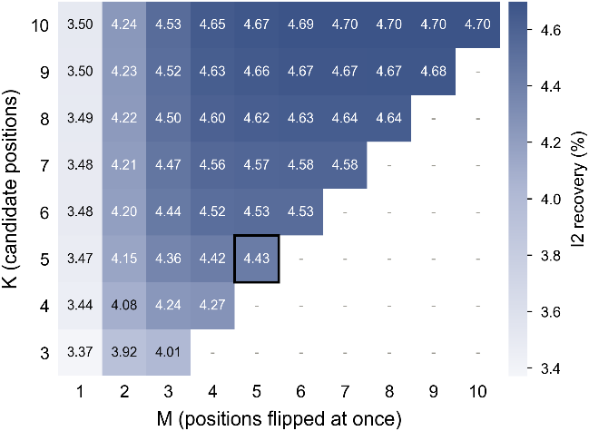
Figure S12. I2 recovery of CAPER-Naive (DQ, PEAR) for K and M at RSN = 80,200, without Q_{max}

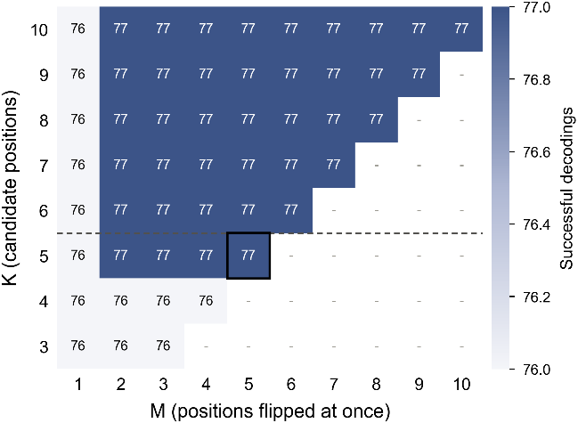
Figure S13. Decoding success of CAPER-Naive (EQ, PEAR) for K and M at RSN = 80,200, without Q_{max}

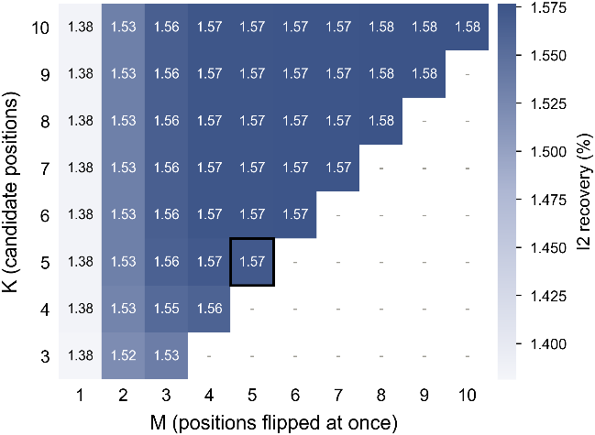
Figure S14. I2 recovery of CAPER-Naive (EQ, PEAR) for K and M at RSN = 80,200, without Q_{max}

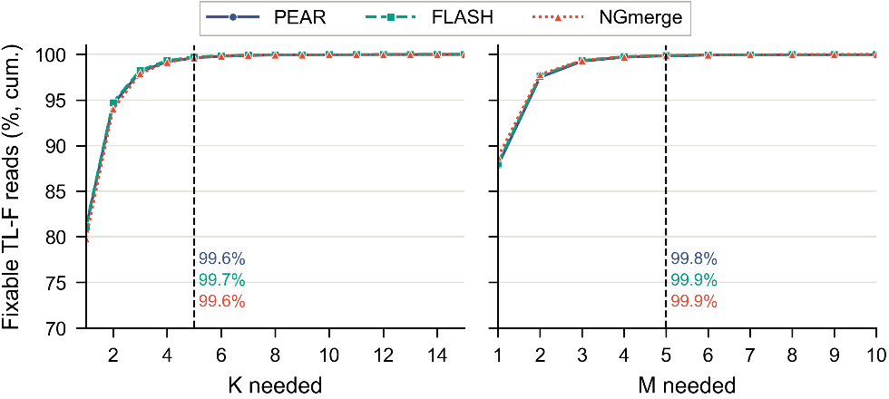
Figure S15. Cumulative distributions of K and M needed to restore fixable TL-F reads in the EQ mode. Dashed lines mark the selected values

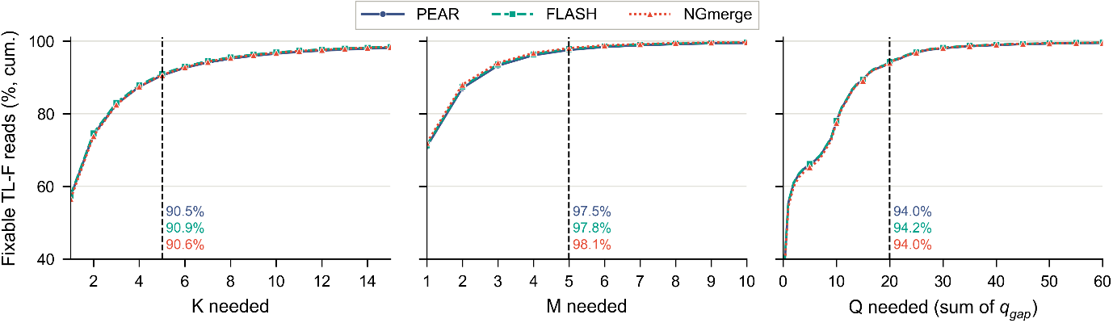
Figure S16. Cumulative distributions of K, M, and Q needed to restore fixable TL-F reads in the DQ mode. Dashed lines mark the selected values

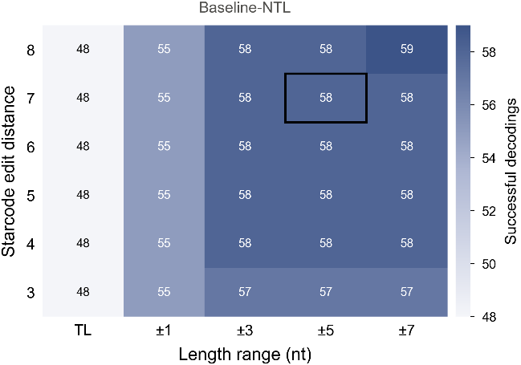
Figure S17. Decoding success of Baseline-NTL with Starcode at RSN = 78,000
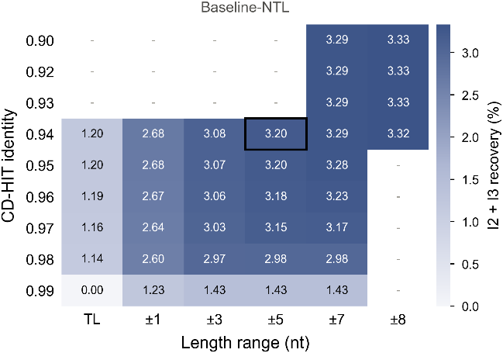
Figure S18. I3 recovery of Baseline-NTL with CD-HIT at RSN = 78,000
(I2 does not exist in Baseline-NTL)

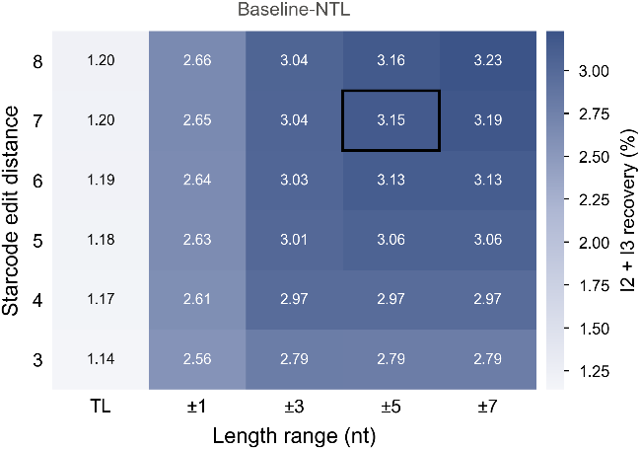
Figure S19. I3 recovery of Baseline-NTL with Starcode at RSN = 78,000
(I2 does not exist in Baseline-NTL)

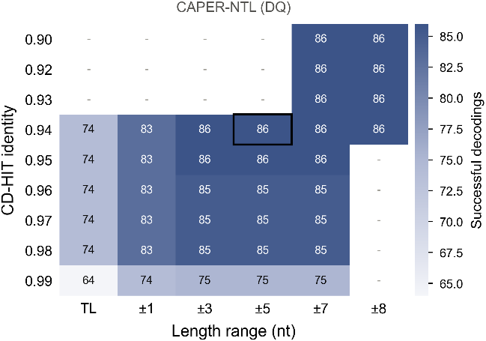
Figure S20. Decoding success of CAPER-NTL (DQ, PEAR) with CD-HIT at RSN = 78,000

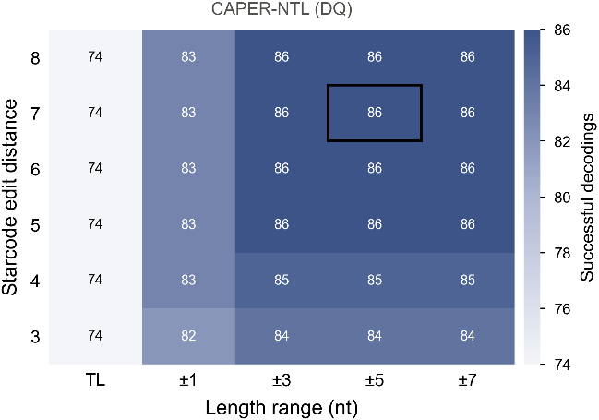
Figure S21. Decoding success of CAPER-NTL (DQ, PEAR) with Starcode at RSN = 78,000

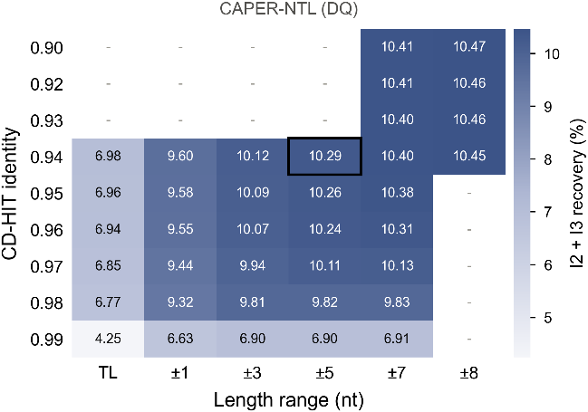
Figure S22. I2 + I3 recovery of CAPER-NTL (DQ, PEAR) with CD-HIT at RSN = 78,000

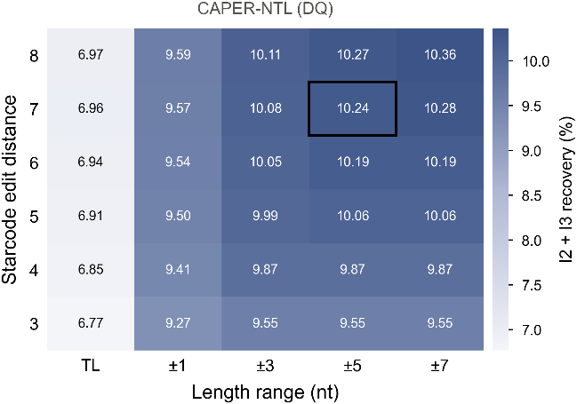
Figure S23. I2 + I3 recovery of CAPER-NTL (DQ, PEAR) with Starcode at RSN = 78,000

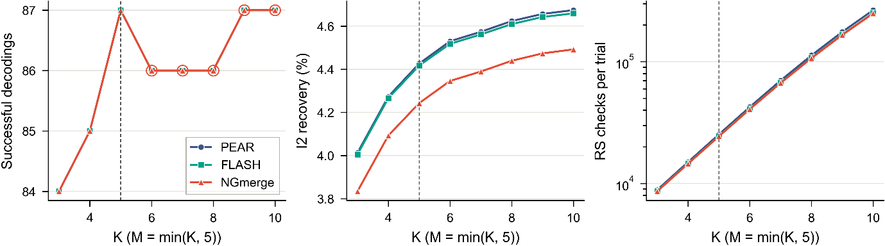
Figure S24. Effect of K for the three merging tools (CAPER-Naive, DQ, RSN = 80,200, M = min(K, 5)). Left: decoding success, where circles mark settings in which an incorrect sequence caused incorrect decoding; middle: I2 recovery; right: error detections per trial. The dashed line marks K = 5

S6. Data recovery analysis
Tables S10–S13 list the number of trials (of 100) that recovered the data at each RSN from 75,000 to the RSN at which all trials succeeded, in steps of 200. Tables S14–S17 give the mean numbers of oligos in I1, I2, and I3 at RSN = 80,200, and Tables S18–S21 the mean execution time per trial for each stage, measured with a single thread. Tables S22 and S23 summarize the paired statistical comparisons.

Table S10. Successful decoding trials of Baseline/CAPER-Naive
RSN | Baseline-Naive |  |  | CAPER-Naive (EQ) |  |  | CAPER-Naive (DQ)
RSN | PEAR | FLASH | NGmerge | PEAR | FLASH | NGmerge | PEAR | FLASH | NGmerge
75000 | 0 | 0 | 0 | 1 | 1 | 1 | 8 | 8 | 8
75200 | 1 | 1 | 0 | 2 | 2 | 2 | 9 | 9 | 9
75400 | 1 | 1 | 0 | 2 | 2 | 2 | 11 | 11 | 11
75600 | 3 | 3 | 2 | 5 | 5 | 5 | 12 | 12 | 12
75800 | 4 | 4 | 3 | 7 | 7 | 7 | 16 | 16 | 16
76000 | 5 | 5 | 4 | 8 | 8 | 8 | 18 | 18 | 18
76200 | 6 | 6 | 5 | 8 | 8 | 8 | 24 | 24 | 24
76400 | 9 | 9 | 9 | 12 | 12 | 12 | 31 | 31 | 31
76600 | 12 | 12 | 11 | 14 | 14 | 14 | 35 | 35 | 35
76800 | 14 | 14 | 14 | 20 | 20 | 20 | 41 | 41 | 41
77000 | 16 | 16 | 18 | 24 | 24 | 24 | 43 | 43 | 43
77200 | 19 | 19 | 23 | 32 | 32 | 32 | 47 | 47 | 47
77400 | 22 | 22 | 24 | 35 | 35 | 35 | 51 | 51 | 51
77600 | 29 | 29 | 28 | 39 | 39 | 39 | 55 | 55 | 55
77800 | 36 | 36 | 37 | 45 | 45 | 45 | 61 | 61 | 61
78000 | 38 | 38 | 40 | 49 | 49 | 49 | 64 | 64 | 64
78200 | 43 | 43 | 45 | 53 | 53 | 53 | 66 | 66 | 66
78400 | 50 | 50 | 49 | 57 | 57 | 57 | 69 | 69 | 69
78600 | 55 | 55 | 54 | 61 | 61 | 61 | 72 | 72 | 72
78800 | 58 | 58 | 56 | 62 | 62 | 62 | 73 | 73 | 73
79000 | 59 | 59 | 59 | 65 | 65 | 65 | 76 | 76 | 76
79200 | 62 | 62 | 61 | 67 | 67 | 67 | 80 | 80 | 80
79400 | 66 | 66 | 65 | 70 | 70 | 70 | 82 | 82 | 82
79600 | 69 | 69 | 67 | 72 | 72 | 72 | 86 | 86 | 86
79800 | 72 | 72 | 69 | 74 | 74 | 74 | 87 | 87 | 87
80000 | 73 | 73 | 70 | 75 | 75 | 75 | 87 | 87 | 87
80200 | 75 | 75 | 72 | 77 | 77 | 77 | 87 | 87 | 87
80400 | 76 | 76 | 73 | 78 | 78 | 78 | 87 | 87 | 87
80600 | 78 | 78 | 75 | 80 | 80 | 80 | 88 | 88 | 88
80800 | 82 | 82 | 82 | 84 | 84 | 84 | 91 | 91 | 91
81000 | 83 | 83 | 84 | 85 | 85 | 85 | 91 | 91 | 91
81200 | 85 | 85 | 84 | 87 | 87 | 87 | 92 | 92 | 92
81400 | 87 | 87 | 87 | 89 | 89 | 89 | 93 | 93 | 93
81600 | 88 | 88 | 88 | 90 | 90 | 90 | 93 | 93 | 93
81800 | 90 | 90 | 90 | 92 | 92 | 92 | 96 | 96 | 96
82000 | 90 | 90 | 90 | 92 | 92 | 92 | 96 | 96 | 96
82200 | 92 | 92 | 93 | 95 | 95 | 95 | 98 | 98 | 98
82400 | 93 | 93 | 93 | 96 | 96 | 96 | 99 | 99 | 99
82600 | 93 | 93 | 93 | 96 | 96 | 96 | 99 | 99 | 99
82800 | 93 | 93 | 93 | 96 | 96 | 96 | 99 | 99 | 99
83000 | 94 | 94 | 94 | 97 | 97 | 97 | 100 | 100 | 100
83200 | 94 | 94 | 95 | 97 | 97 | 97 | 100 | 100 | 100
83400 | 95 | 95 | 97 | 98 | 98 | 98 | 100 | 100 | 100
83600 | 95 | 95 | 97 | 98 | 98 | 98 | 100 | 100 | 100
83800 | 95 | 95 | 97 | 98 | 98 | 98 | 100 | 100 | 100
84000 | 95 | 95 | 98 | 98 | 98 | 98 | 100 | 100 | 100
84200 | 95 | 95 | 98 | 98 | 98 | 98 | 100 | 100 | 100
84400 | 96 | 96 | 99 | 99 | 99 | 99 | 100 | 100 | 100
84600 | 97 | 97 | 99 | 99 | 99 | 99 | 100 | 100 | 100
84800 | 97 | 97 | 99 | 99 | 99 | 99 | 100 | 100 | 100
85000 | 99 | 99 | 100 | 100 | 100 | 100 | 100 | 100 | 100
85200 | 100 | 100 | 100 | 100 | 100 | 100 | 100 | 100 | 100

Table S11. Successful decoding trials of Baseline-NTL (S – Starcode, C – CD-HIT)
RSN | PEAR+S | PEAR+C | FLASH+S | FLASH+C | NGmerge+S | NGmerge+C
75000 | 4 | 2 | 4 | 2 | 3 | 1
75200 | 5 | 3 | 5 | 3 | 4 | 1
75400 | 5 | 5 | 5 | 5 | 4 | 3
75600 | 6 | 7 | 7 | 7 | 5 | 4
75800 | 9 | 9 | 8 | 8 | 8 | 7
76000 | 12 | 12 | 10 | 10 | 12 | 10
76200 | 14 | 15 | 12 | 13 | 15 | 15
76400 | 17 | 19 | 15 | 17 | 19 | 19
76600 | 21 | 21 | 19 | 19 | 24 | 20
76800 | 27 | 28 | 25 | 26 | 28 | 25
77000 | 34 | 35 | 32 | 32 | 32 | 30
77200 | 41 | 42 | 41 | 40 | 38 | 35
77400 | 46 | 46 | 45 | 44 | 43 | 41
77600 | 51 | 51 | 50 | 49 | 48 | 46
77800 | 56 | 57 | 55 | 54 | 54 | 52
78000 | 58 | 60 | 57 | 58 | 59 | 60
78200 | 63 | 63 | 62 | 62 | 65 | 64
78400 | 68 | 68 | 67 | 67 | 66 | 65
78600 | 73 | 71 | 71 | 69 | 70 | 68
78800 | 74 | 72 | 72 | 70 | 70 | 68
79000 | 75 | 75 | 73 | 73 | 72 | 72
79200 | 77 | 78 | 75 | 76 | 76 | 77
79400 | 81 | 79 | 79 | 78 | 79 | 79
79600 | 84 | 81 | 83 | 81 | 82 | 82
79800 | 87 | 84 | 86 | 84 | 85 | 83
80000 | 87 | 85 | 86 | 85 | 85 | 83
80200 | 87 | 87 | 86 | 86 | 85 | 84
80400 | 90 | 89 | 88 | 88 | 87 | 86
80600 | 91 | 90 | 89 | 89 | 88 | 87
80800 | 94 | 91 | 93 | 91 | 93 | 90
81000 | 96 | 93 | 95 | 92 | 95 | 92
81200 | 96 | 94 | 95 | 93 | 95 | 93
81400 | 96 | 95 | 95 | 94 | 95 | 94
81600 | 96 | 95 | 95 | 94 | 95 | 94
81800 | 96 | 95 | 95 | 94 | 95 | 94
82000 | 96 | 95 | 95 | 94 | 95 | 94
82200 | 96 | 95 | 96 | 95 | 96 | 95
82400 | 96 | 95 | 96 | 95 | 98 | 97
82600 | 96 | 95 | 96 | 95 | 98 | 97
82800 | 96 | 95 | 96 | 95 | 98 | 97
83000 | 97 | 96 | 97 | 96 | 99 | 98
83200 | 97 | 96 | 97 | 96 | 99 | 98
83400 | 97 | 97 | 97 | 97 | 99 | 99
83600 | 97 | 97 | 97 | 97 | 99 | 99
83800 | 97 | 97 | 97 | 97 | 99 | 99
84000 | 97 | 97 | 97 | 97 | 99 | 99
84200 | 97 | 97 | 97 | 97 | 99 | 99
84400 | 98 | 98 | 98 | 98 | 99 | 99
84600 | 98 | 98 | 98 | 98 | 99 | 99
84800 | 98 | 98 | 98 | 98 | 99 | 99
85000 | 99 | 99 | 99 | 99 | 100 | 100
85200 | 100 | 100 | 100 | 100 | 100 | 100

Table S12. Successful decoding trials of CAPER-NTL (EQ) (S – Starcode, C – CD-HIT)
RSN | PEAR+S | PEAR+C | FLASH+S | FLASH+C | NGmerge+S | NGmerge+C
75000 | 26 | 27 | 22 | 23 | 22 | 23
75200 | 30 | 31 | 25 | 26 | 25 | 26
75400 | 36 | 37 | 31 | 32 | 31 | 32
75600 | 39 | 40 | 35 | 36 | 35 | 36
75800 | 42 | 43 | 38 | 39 | 38 | 39
76000 | 48 | 49 | 45 | 45 | 45 | 45
76200 | 51 | 52 | 49 | 49 | 50 | 50
76400 | 56 | 57 | 54 | 54 | 55 | 55
76600 | 61 | 61 | 59 | 59 | 60 | 60
76800 | 64 | 64 | 62 | 62 | 63 | 63
77000 | 67 | 67 | 66 | 66 | 67 | 67
77200 | 70 | 70 | 69 | 69 | 69 | 69
77400 | 71 | 71 | 70 | 70 | 70 | 70
77600 | 73 | 73 | 72 | 72 | 72 | 72
77800 | 79 | 79 | 77 | 77 | 77 | 77
78000 | 81 | 81 | 78 | 78 | 78 | 78
78200 | 84 | 84 | 82 | 82 | 82 | 82
78400 | 86 | 86 | 83 | 83 | 83 | 83
78600 | 88 | 88 | 85 | 85 | 85 | 85
78800 | 88 | 88 | 85 | 85 | 85 | 85
79000 | 90 | 90 | 87 | 87 | 87 | 87
79200 | 91 | 91 | 88 | 88 | 88 | 88
79400 | 93 | 93 | 91 | 91 | 91 | 91
79600 | 94 | 94 | 91 | 91 | 91 | 91
79800 | 95 | 95 | 92 | 92 | 92 | 92
80000 | 96 | 96 | 93 | 93 | 93 | 93
80200 | 97 | 97 | 94 | 94 | 94 | 94
80400 | 98 | 98 | 96 | 96 | 96 | 96
80600 | 98 | 98 | 96 | 96 | 96 | 96
80800 | 98 | 98 | 98 | 98 | 98 | 98
81000 | 100 | 100 | 100 | 100 | 100 | 100

Table S13. Successful decoding trials of CAPER-NTL (DQ) (S – Starcode, C – CD-HIT)
RSN | PEAR+S | PEAR+C | FLASH+S | FLASH+C | NGmerge+S | NGmerge+C
75000 | 38 | 39 | 35 | 36 | 36 | 37
75200 | 41 | 43 | 37 | 38 | 38 | 39
75400 | 43 | 45 | 39 | 40 | 40 | 41
75600 | 49 | 50 | 45 | 46 | 46 | 47
75800 | 54 | 55 | 50 | 51 | 51 | 52
76000 | 59 | 59 | 56 | 56 | 57 | 57
76200 | 63 | 63 | 60 | 60 | 61 | 61
76400 | 67 | 67 | 65 | 65 | 66 | 66
76600 | 72 | 72 | 70 | 70 | 71 | 71
76800 | 73 | 73 | 71 | 71 | 72 | 72
77000 | 74 | 74 | 72 | 72 | 73 | 73
77200 | 77 | 77 | 75 | 75 | 75 | 75
77400 | 79 | 79 | 77 | 77 | 77 | 77
77600 | 81 | 81 | 79 | 79 | 79 | 79
77800 | 84 | 84 | 83 | 83 | 83 | 83
78000 | 86 | 86 | 85 | 85 | 85 | 85
78200 | 88 | 88 | 87 | 87 | 87 | 87
78400 | 89 | 89 | 88 | 88 | 88 | 88
78600 | 91 | 91 | 90 | 90 | 90 | 90
78800 | 91 | 91 | 90 | 90 | 90 | 90
79000 | 94 | 94 | 93 | 93 | 93 | 93
79200 | 95 | 95 | 94 | 94 | 94 | 94
79400 | 97 | 97 | 96 | 96 | 96 | 96
79600 | 97 | 97 | 96 | 96 | 96 | 96
79800 | 97 | 97 | 96 | 96 | 96 | 96
80000 | 99 | 99 | 98 | 98 | 98 | 98
80200 | 100 | 100 | 99 | 99 | 99 | 99
80400 | 100 | 100 | 99 | 99 | 99 | 99
80600 | 100 | 100 | 99 | 99 | 99 | 99
80800 | 100 | 100 | 100 | 100 | 100 | 100

Table S14. Oligo recovery of Baseline/CAPER-Naive
RSN = 80,200 | Baseline-Naive |  |  | CAPER-Naive (EQ) |  |  | CAPER-Naive (DQ)
RSN = 80,200 | PEAR | FLASH | NGmerge | PEAR | FLASH | NGmerge | PEAR | FLASH | NGmerge
I1 | 16975 | 16974.8 | 16976.6 | 16975 | 16974.8 | 16976.6 | 16975 | 16974.8 | 16976.6
Not recovered by I1 | 1025.1 | 1025.2 | 1023.4 | 1025.1 | 1025.2 | 1023.4 | 1025.1 | 1025.2 | 1023.4
I2 | - | - | - | 16.1 | 16 | 14.2 | 44.4 | 44.3 | 42.4
I3 | - | - | - | - | - | - | - | - | -
* Tables S14–S17: values are means over 100 trials. “Not recovered by I1” is 18,000 (the number of oligos) minus I1, and I2 and I3 count oligos within it. For CAPER-Naive, the three merging tools gave identical decoding results although I2 differed among them

Table S15. Oligo recovery of Baseline-NTL
RSN = 80,200 | PEAR+S | PEAR+C | FLASH+S | FLASH+C | NGmerge+S | NGmerge+C
I1 | 16974.9 | 16974.9 | 16974.8 | 16974.8 | 16976.6 | 16976.6
Not recovered by I1 | 1025.1 | 1025.1 | 1025.2 | 1025.2 | 1023.4 | 1023.4
I2 | - | - | - | - | - | -
I3 | 33.8 | 34.1 | 31.3 | 31.7 | 31.1 | 31.6

Table S16. Oligo recovery of CAPER-NTL (EQ)
RSN = 80,200 | PEAR+S | PEAR+C | FLASH+S | FLASH+C | NGmerge+S | NGmerge+C
I1 | 16974.9 | 16974.9 | 16974.8 | 16974.8 | 16976.6 | 16976.6
Not recovered by I1 | 1025.1 | 1025.1 | 1025.2 | 1025.2 | 1023.4 | 1023.4
I2 | 16.1 | 16.1 | 16 | 16 | 14.2 | 14.2
I3 | 73.6 | 74 | 70.1 | 70.4 | 70.2 | 70.4

Table S17. Oligo recovery of CAPER-NTL (DQ)
RSN = 80,200 | PEAR+S | PEAR+C | FLASH+S | FLASH+C | NGmerge+S | NGmerge+C
I1 | 16974.9 | 16974.9 | 16974.8 | 16974.8 | 16976.6 | 16976.6
Not recovered by I1 | 1025.1 | 1025.1 | 1025.2 | 1025.2 | 1023.4 | 1023.4
I2 | 44.4 | 44.4 | 44.3 | 44.3 | 42.4 | 42.4
I3 | 63.5 | 63.9 | 60.2 | 60.5 | 60.3 | 60.6

Table S18. Execution time of Baseline/CAPER-Naive
RSN =  80,200 | Baseline-Naive |  |  | CAPER-Naive (EQ) |  |  | CAPER-Naive (DQ)
RSN =  80,200 | PEAR | FLASH | NGmerge | PEAR | FLASH | NGmerge | PEAR | FLASH | NGmerge
(Pre-)  Merging | 21.51 | 3.057 | 1.76 | 21.491 | 3.08 | 1.753 | 21.632 | 3.065 | 1.714
Error detection and  naive clustering | 0.212 | 0.175 | 0.174 | 0.206 | 0.177 | 0.173 | 0.202 | 0.174 | 0.172
Read-level CAPER | - | - | - | 0.007 | 0.006 | 0.006 | 0.026 | 0.024 | 0.023
Clustering and consensus | 0.014 | 0.012 | 0.012 | 0.019 | 0.017 | 0.017 | 0.018 | 0.017 | 0.017
Decoding | 0.197 | 0.19 | 0.195 | 0.195 | 0.195 | 0.2 | 0.197 | 0.199 | 0.196
Total | 21.937 | 3.433 | 2.14 | 21.918 | 3.475 | 2.149 | 22.076 | 3.479 | 2.123
* Tables S18–S21: Merging: read merging by each tool. Error detection and naive clustering: length filtering, error detection of all merged reads, and grouping of identical reads (I1). Read-level CAPER: candidate generation and error detection of the candidates (I2). Clustering and consensus: similarity-based clustering, multiple alignment, and consensus generation, including cluster-level CAPER (I3) for CAPER-NTL. Decoding: preparation of the input sequences and LT decoding. Read-level CAPER took 0.006–0.053 s per trial, whereas clustering and consensus took 17–25 s in the NTL pipelines and PEAR merging about 21.5 s.

Table S19. Execution time of Baseline-NTL
RSN =  80,200 | PEAR+S | PEAR+C | FLASH+S | FLASH+C | NGmerge+S | NGmerge+C
(Pre-)  Merging | 21.53 | 21.495 | 2.964 | 3.043 | 1.678 | 1.716
Error detection and  naive clustering | 0.315 | 0.31 | 0.275 | 0.266 | 0.244 | 0.246
Read-level CAPER | - | - | - | - | - | -
Clustering and consensus | 25.129 | 21.819 | 23.746 | 20.764 | 23.37 | 20.461
Decoding | 0.216 | 0.212 | 0.222 | 0.221 | 0.21 | 0.213
Total | 47.19 | 43.836 | 27.207 | 24.295 | 25.501 | 22.636

Table S20. Execution time of CAPER-NTL (EQ)
RSN =  80,200 | PEAR+S | PEAR+C | FLASH+S | FLASH+C | NGmerge+S | NGmerge+C
(Pre-)  Merging | 21.545 | 21.496 | 2.945 | 3.034 | 1.735 | 1.706
Error detection and  naive clustering | 0.3 | 0.309 | 0.25 | 0.251 | 0.239 | 0.233
Read-level CAPER | 0.031 | 0.032 | 0.025 | 0.025 | 0.023 | 0.022
Clustering and consensus | 23.653 | 20.512 | 22.169 | 19.437 | 22.13 | 19.313
Decoding | 0.229 | 0.228 | 0.229 | 0.228 | 0.228 | 0.224
Total | 45.758 | 42.577 | 25.617 | 22.976 | 24.355 | 21.498

Table S21. Execution time of CAPER-NTL (DQ)
RSN =  80,200 | PEAR+S | PEAR+C | FLASH+S | FLASH+C | NGmerge+S | NGmerge+C
(Pre-)  Merging | 21.545 | 21.549 | 3.022 | 3.046 | 1.71 | 1.722
Error detection and  naive clustering | 0.312 | 0.306 | 0.25 | 0.255 | 0.239 | 0.239
Read-level CAPER | 0.053 | 0.052 | 0.044 | 0.045 | 0.042 | 0.042
Clustering and consensus | 20.838 | 18.072 | 19.339 | 17.044 | 19.392 | 16.944
Decoding | 0.232 | 0.23 | 0.232 | 0.234 | 0.23 | 0.227
Total | 42.979 | 40.208 | 22.886 | 20.624 | 21.613 | 19.175

Table S22. Comparison of CAPER with its own baseline. CAPER-Naive is compared with Baseline-Naive (NGmerge), and CAPER-NTL with Baseline-NTL (NGmerge and CD-HIT)
Method | Merging + clustering | N | Reduction (%)  [95% CI] | Fewer / same / more | Per-trial saving (%)  [95% CI] | p_{Holm}
CAPER-Naive (EQ) | PEAR, FLASH, NGmergeª | 85,000 | 0.00  [0.00, 1.19] | 35 / 65 / 0 | 0.25  [0.00, 0.51] | 8.7 × 10⁻¹¹
CAPER-Naive (DQ) | PEAR, FLASH, NGmergeª | 83,000 | 2.35  [0.48, 3.29] | 76 / 24 / 0 | 1.39  [1.14, 1.65] | 1.0 × 10⁻¹³
CAPER-NTL (EQ) | PEAR + CD-HIT | 81,000 | 4.71  [1.70, 5.65] | 82 / 18 / 0 | 1.79  [1.53, 2.17] | 2.1 × 10⁻¹⁴
CAPER-NTL (EQ) | PEAR + Starcode | 81,000 | 4.71  [1.70, 5.65] | 82 / 18 / 0 | 1.79  [1.53, 2.17] | 2.1 × 10⁻¹⁴
CAPER-NTL (EQ) | FLASH + CD-HIT | 81,000 | 4.71  [1.70, 4.94] | 79 / 21 / 0 | 1.66  [1.41, 2.05] | 5.6 × 10⁻¹⁴
CAPER-NTL (EQ) | FLASH + Starcode | 81,000 | 4.71  [1.70, 4.94] | 79 / 21 / 0 | 1.66  [1.28, 2.05] | 5.6 × 10⁻¹⁴
CAPER-NTL (EQ) | NGmerge + CD-HIT | 81,000 | 4.71  [1.70, 4.94] | 79 / 21 / 0 | 1.66  [1.41, 2.05] | 5.6 × 10⁻¹⁴
CAPER-NTL (EQ) | NGmerge + Starcode | 81,000 | 4.71  [1.70, 4.94] | 79 / 21 / 0 | 1.66  [1.41, 2.05] | 5.6 × 10⁻¹⁴
CAPER-NTL (DQ) | PEAR + CD-HIT | 80,200 | 5.65  [2.91, 5.65] | 90 / 10 / 0 | 2.30  [1.92, 2.69] | 1.5 × 10⁻¹⁵
CAPER-NTL (DQ) | PEAR + Starcode | 80,200 | 5.65  [2.91, 5.65] | 90 / 10 / 0 | 2.30  [1.92, 2.69] | 1.5 × 10⁻¹⁵
CAPER-NTL (DQ) | FLASH + CD-HIT | 80,800 | 4.94  [2.91, 5.65] | 89 / 11 / 0 | 2.17  [1.79, 2.69] | 2.0 × 10⁻¹⁵
CAPER-NTL (DQ) | FLASH + Starcode | 80,800 | 4.94  [2.91, 5.65] | 89 / 11 / 0 | 2.17  [1.79, 2.56] | 2.0 × 10⁻¹⁵
CAPER-NTL (DQ) | NGmerge + CD-HIT | 80,800 | 4.94  [2.91, 5.65] | 89 / 11 / 0 | 2.30  [1.92, 2.69] | 2.0 × 10⁻¹⁵
CAPER-NTL (DQ) | NGmerge + Starcode | 80,800 | 4.94  [2.91, 5.65] | 89 / 11 / 0 | 2.30  [1.92, 2.69] | 2.0 × 10⁻¹⁵
ªThe three merging tools gave identical minimum RSNs in every trial, although the numbers of oligos recovered by I2 differed among the tools.
* All comparisons are paired over the same 100 trials; the baseline N is 85,000. N: minimum RSN at which all 100 trials recovered the data. Reduction: 1 − N/85,000, with the 95% CI from 10,000 paired bootstrap resamples; because N is set by the hardest trial, the bootstrap distribution is discrete and its upper bound can equal the observed value. Fewer/same/more: trials in which the method recovered the data with fewer, the same, or more reads than the baseline. Per-trial saving: Hodges–Lehmann estimate of the paired difference in the minimum RSN (N_{baseline} − N_{method}) with its Wilcoxon 95% CI, as a percentage of the mean baseline RSN. p_{Holm}: one-sided Wilcoxon signed-rank test (ties dropped) with Holm correction over the 18 comparisons of this table.

Table S23. Comparison of the CAPER-NTL methods with Baseline-Naive (NGmerge)
Method | Merging + clustering | N | Reduction (%)  [95% CI] | Fewer / same / more | Per-trial saving (%)  [95% CI] | p_{Holm}
CAPER-NTL (EQ) | PEAR + CD-HIT | 81,000 | 4.71  [2.88, 5.65] | 99 / 1 / 0 | 2.91  [2.53, 3.29] | 5.0 × 10⁻¹⁷
CAPER-NTL (EQ) | PEAR + Starcode | 81,000 | 4.71  [2.88, 5.65] | 99 / 1 / 0 | 2.91  [2.53, 3.29] | 5.0 × 10⁻¹⁷
CAPER-NTL (EQ) | FLASH + CD-HIT | 81,000 | 4.71  [2.88, 4.94] | 98 / 2 / 0 | 2.78  [2.40, 3.16] | 5.0 × 10⁻¹⁷
CAPER-NTL (EQ) | FLASH + Starcode | 81,000 | 4.71  [2.88, 4.94] | 98 / 2 / 0 | 2.78  [2.40, 3.16] | 5.0 × 10⁻¹⁷
CAPER-NTL (EQ) | NGmerge + CD-HIT | 81,000 | 4.71  [2.88, 4.94] | 98 / 2 / 0 | 2.78  [2.40, 3.16] | 5.0 × 10⁻¹⁷
CAPER-NTL (EQ) | NGmerge + Starcode | 81,000 | 4.71  [2.88, 4.94] | 98 / 2 / 0 | 2.78  [2.40, 3.16] | 5.0 × 10⁻¹⁷
CAPER-NTL (DQ) | PEAR + CD-HIT | 80,200 | 5.65  [4.08, 5.92] | 99 / 1 / 0 | 3.42  [2.91, 3.80] | 5.0 × 10⁻¹⁷
CAPER-NTL (DQ) | PEAR + Starcode | 80,200 | 5.65  [4.08, 5.92] | 99 / 1 / 0 | 3.29  [2.91, 3.80] | 5.0 × 10⁻¹⁷
CAPER-NTL (DQ) | FLASH + CD-HIT | 80,800 | 4.94  [3.12, 5.65] | 99 / 1 / 0 | 3.29  [2.91, 3.67] | 5.0 × 10⁻¹⁷
CAPER-NTL (DQ) | FLASH + Starcode | 80,800 | 4.94  [3.12, 5.65] | 99 / 1 / 0 | 3.16  [2.78, 3.67] | 5.0 × 10⁻¹⁷
CAPER-NTL (DQ) | NGmerge + CD-HIT | 80,800 | 4.94  [3.12, 5.65] | 99 / 1 / 0 | 3.29  [2.91, 3.80] | 5.0 × 10⁻¹⁷
CAPER-NTL (DQ) | NGmerge + Starcode | 80,800 | 4.94  [3.12, 5.65] | 99 / 1 / 0 | 3.29  [2.91, 3.80] | 5.0 × 10⁻¹⁷
* Columns as in Table S22. p_{Holm}: Holm correction over the 18 comparisons of this family, which also include the six comparisons of Baseline-NTL with Baseline-Naive (not shown).

Figure S25 shows the distribution of reads per oligo at RSN = 80,200. The mean coverage was 4.46 reads per oligo, but 2.69% of the oligos received no read and 5.69% no error-free read, compared with 1.16% expected from a Poisson distribution. These oligos must be recovered by the outer code.

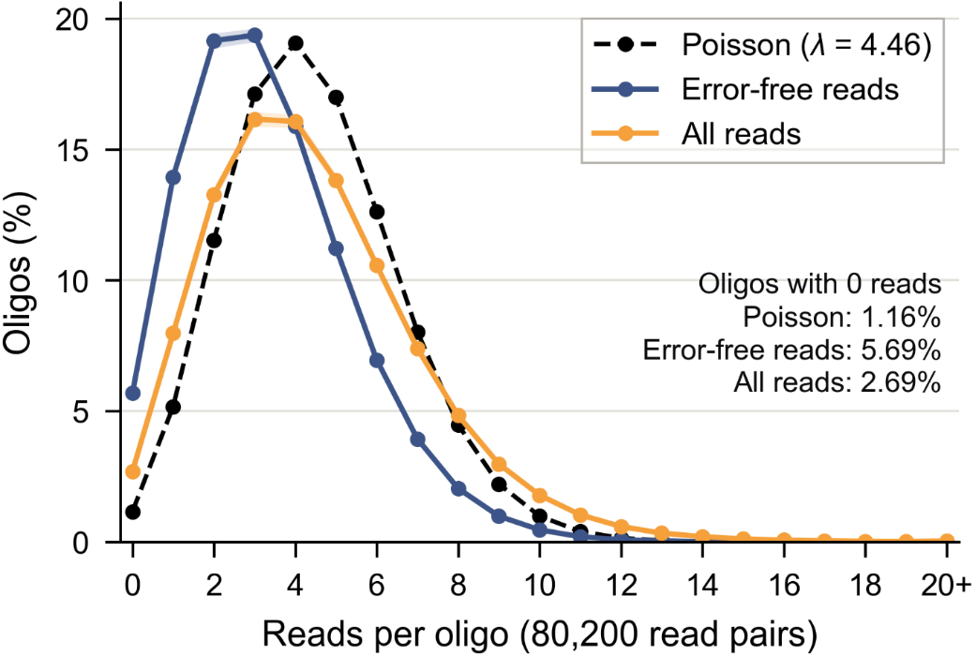
Figure S25. Distribution of reads per oligo at RSN = 80,200 (one draw per trial, 100 trials). Dashed line: Poisson distribution with the same mean.

References
[R1] J. Jeong, H. Park, H.-Y. Kwak et al., “Iterative soft decoding algorithm for DNA storage using quality score and redecoding,” IEEE Trans. NanoBiosci., vol. 23, no. 1, pp. 81–90, 2024.
[R2] J. Jeong, S.-J. Park, J.-W. Kim et al., “Cooperative sequence clustering and decoding for DNA storage system with fountain codes,” Bioinformatics, vol. 37, no. 19, pp. 3136–3143, 2021.
[R3] J. Park, H. H. Jeon, J. W. Lee, and H. Park, “Sequence analysis and decoding with extra low-quality reads for DNA data storage,” Bioinformatics, vol. 41, no. 6, p. btaf335, 2025.
[R4] Y. Erlich and D. Zielinski, “DNA Fountain enables a robust and efficient storage architecture,” Science, vol. 355, no. 6328, pp. 950–954, 2017.
[R5] S. Chen, Y. Zhou, Y. Chen, and J. Gu, “fastp: an ultra-fast all-in-one FASTQ preprocessor,” Bioinformatics, vol. 34, no. 17, pp. i884–i890, 2018.
[R6] J. Zhang, K. Kobert, T. Flouri, and A. Stamatakis, “PEAR: a fast and accurate Illumina Paired-End reAd mergeR,” Bioinformatics, vol. 30, no. 5, pp. 614–620, 2014.
[R7] T. Magoč and S. L. Salzberg, “FLASH: fast length adjustment of short reads to improve genome assemblies,” Bioinformatics, vol. 27, no. 21, pp. 2957–2963, 2011.
[R8] J. M. Gaspar, “NGmerge: merging paired-end reads via novel empirically-derived models of sequencing errors,” BMC Bioinformatics, vol. 19, no. 1, p. 536, 2018.
[R9] E. Zorita, P. Cuscó, and G. J. Filion, “Starcode: sequence clustering based on all-pairs search,” Bioinformatics, vol. 31, no. 12, pp. 1913-1919, 2015.
[R10] W. Li and A. Godzik, “Cd-hit: a fast program for clustering and comparing large sets of protein or nucleotide sequences,” Bioinformatics, vol. 22, no. 13, pp. 1658–1659, 2006.
[R11] R. C. Edgar, “Muscle5: High-accuracy alignment ensembles enable unbiased assessments of sequence homology and phylogeny,” Nat. Commun., vol. 13, no. 1, p. 6968, 2022.
[R12] F. Pfeiffer et al., “Systematic evaluation of error rates and causes in short samples in next-generation sequencing,” Sci. Rep., vol. 8, no. 1, Art. no. 10950, 2018.
[R13] G. Tan, L. Opitz, R. Schlapbach, et al., “Long fragments achieve lower base quality in Illumina paired-end sequencing,” Sci. Rep., vol. 9, no. 1, Art. no. 2856, 2019.

