CS5001: Coursework-02 REPORT

Overview
The main objective of this exercise is to work on creating unit tests by implementing business logic on a pre-existing framework.
This approach puts the Test-Driven Development (TDD) methodology into practice, writing tests before implementation to better rationale the code design (optional but recommended).
Thanks to this approach, it's possible to modify or refactor the code with confidence, knowing that if something breaks or is accidentally removed, the tests will detect it immediately and help maintain the project's stability.
In this practical I managed to complete all the main requirements. I implemented every class from the given interfaces and created a full set of unit tests using a TDD approach. The testing part became one of the strongest aspects of my work, since it helped me design and improve the code safely while keeping everything well structured.
Overall, the project works as expected and all tests pass successfully. If I had more time, I would focus on making the tests a bit cleaner and less repetitive, but I’m happy with the result and how the design and testing came together.

Design and Implementation
All implementation classes were based on the given interfaces, and the code was written incrementally, guided by the tests.
Each test helped define the expected behaviour before the actual implementation was written, making the design decisions more structured and intentional.
A key design choice was the use of a HashMap<String, IProductRecord> inside the VendingMachine class.
This allows each product lane (like “A1” or “B2”) to be stored and accessed efficiently by its code.
Compared to using arrays or lists, the HashMap provides faster lookups, prevents duplicate lane codes automatically, and works naturally with the interface methods that use String laneCode.
It also keeps the design flexible, as the number of products can grow dynamically without changing the data structure.
If an array or matrix had been used instead, the implementation would have been less practical.
With an array or list, each search would require iterating through all elements until the correct lane code was found, resulting in slower performance and more complex logic.
Using a matrix would have made the structure even harder to maintain, since it would require converting lane codes (for example, “A1”) into numerical coordinates, even though the interfaces are designed to work with strings.
The project is divided into four main implementation classes:
- VendingMachineProduct: Represents an individual product with a lane code and description.
- ProductRecord: Tracks stock and sales for one product and throws ProductUnavailableException when no items are left.
- VendingMachine: Manages all products and records using the HashMap, handling registration, restocking, and purchases.
- Factory: Implements the Singleton pattern and creates consistent instances of all other classes.

VendingMachineProduct
The VendingMachineProduct class represents a single product that can be stocked and sold in the vending machine. It stores two private fields: laneCode and description. The constructor validates both values to ensure data integrity. The laneCode must follow a specific format, one letter followed by one number (e.g. 'A1'), and the description cannot be empty or null. If any of these rules are broken, an IllegalArgumentException is thrown. Once created, the class provides simple getter methods (getLaneCode() and getDescription()) to access these values. The class is intentionally simple and has no business logic, as it only represents the data of a product.

ProductRecord
The ProductRecord class is responsible for keeping track of stock and sales for a specific product. It stores three private fields: vendingMachineProduct, numberAvailable, and numberOfSales. When a new ProductRecord is created, both counters start at zero, representing no initial stock and no sales. The getProduct() method returns the associated vendingMachineProduct, allowing other components (like VendingMachine) to access product details.
The getNumberOfSales() and getNumberAvailable() methods are simple getters that expose the current state of the counters. The addItem() method increases the numberAvailable count by one each time it is called. It does not include a maximum stock limit to allow flexibility in usage.
The buyItem() method implements the key logic of the class. It first checks whether there are available items. If the stock is zero, a ProductUnavailableException is thrown. If there is stock, numberAvailable is decreased by one, and numberOfSales is increased by one. This ensures consistent tracking of stock and sales. Overall, ProductRecord focuses only on inventory management, keeping the logic isolated from higher-level operations.
- Poner limite en numberAvailable
- Permitir que un prducto esté en dos code lanes

VendingMachine
The VendingMachine class acts as the central component of the system, managing multiple products and their records. Internally, it uses a HashMap<String, IProductRecord> to store all products, where the key is the laneCode (e.g. 'A1') and the value is the corresponding ProductRecord. This structure allows constant-time access and ensures lane codes are unique.
The registerProduct() method adds a new product to the machine. If a product with the same laneCode already exists, it throws a LaneCodeAlreadyInUseException. The unregisterProduct() method removes a product and throws a LaneCodeNotRegisteredException if the laneCode is not found.
The addItem() and buyItem() methods delegate to the corresponding ProductRecord, but they first check if the laneCode exists in the HashMap. If it does not, a LaneCodeNotRegisteredException is thrown. The getNumberOfProducts(), getTotalNumberOfItems(), getNumberOfItems(), and getNumberOfSales() methods are used to retrieve metrics about the machine’s contents and performance. In addition, the machine enforces a maximum stock limit per product lane, which simulates the physical restriction of a real vending machine — a lane cannot hold more items than it physically fits. When this limit is reached, no more items can be added, and an IllegalStateException is thrown if a further addition is attempted.
The getMostPopular() method loops through all product records and returns the product with the highest number of sales. If the machine has no products, it throws a LaneCodeNotRegisteredException. This class encapsulates all management logic, while ProductRecord handles item-level details.

Factory
The Factory class implements the Singleton and Factory patterns. It ensures that only one instance of the Factory exists at any time by using a private static field and a private constructor. The getInstance() method returns this single instance. This design avoids unnecessary duplication and ensures consistent object creation throughout the program.
The Factory provides three creation methods: makeVendingMachineProduct(), makeProductRecord(), and makeVendingMachine(). Each of these returns a new instance of the respective implementation class. This keeps the code modular, since object creation is centralised in one place. The Factory serves as a bridge between the interface definitions and their concrete implementations, maintaining consistency and supporting the overall object-oriented structure of the project.

Running the Program
The program can be compiled and tested directly using the provided Makefile.
All the required JUnit 5 libraries were downloaded from Studres, using the Test folder available at:
https://studres.cs.st-andrews.ac.uk/CS5001/Coursework/p2-oo-testing/Tests/
Once the folder is downloaded and placed at the root of the project, the program can be compiled and tested by running make test
This command automatically compiles all source files inside the src directory and executes all JUnit 5 test classes.
The results of the tests are displayed in the console, showing which tests passed or failed.
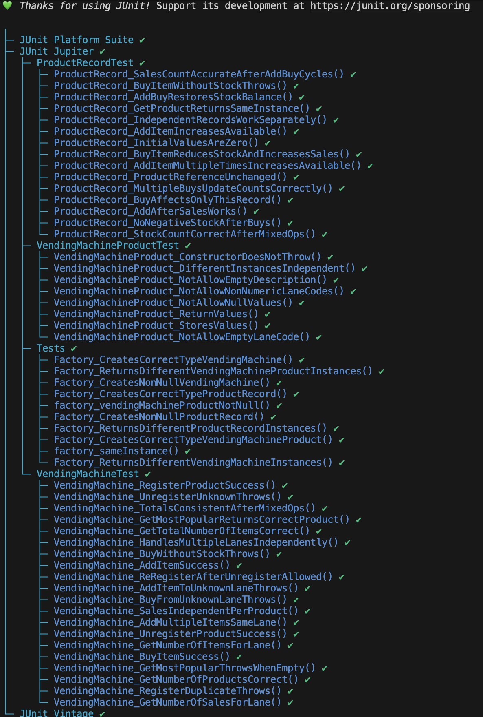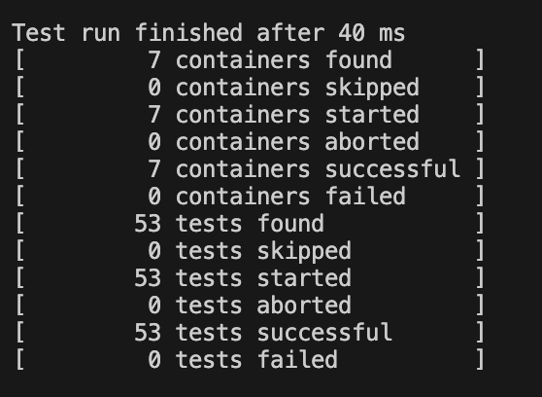

Testing
I followed a test-driven approach, starting with a few basic tests that described what each class was supposed to do before writing the actual code. Once those tests were in place, I worked on the implementation step by step until everything passed.
The tests are divided into four groups, one for each main class: VendingMachineProduct, ProductRecord, VendingMachine, and Factory. Each group begins with simple, basic checks and then adds more complex or unusual cases. For example, I tested what happens when trying to buy an item without stock, when registering the same product twice, or when calling methods on unregistered lane codes.
VendingMachineProductTest.java Test from the VendingMachineProduct class
VendingMachine Test from the VendingMachine class
ProductRecord Test from the ProductRecord class
Tests.java Test from the Factory class
I also added a few integration tests, where several actions happen in sequence (like register → add → buy → unregister) to make sure the system behaves correctly as a whole.
All tests were written in JUnit 5 and run using the command make test.
Every single test passed in the final version, showing that the program behaves correctly in both normal and exceptional situations.

VendingMachineProduct.java
The class represents a single product type in a vending machine, identified by a lane code (e.g. "A1").
Validation ensures that each product has a valid lane code ([Letter][Number]) and a non-empty description.
This prevents invalid product creation and enforces data consistency.
- Checks that constructor stores lane code and description correctly.
- Ensures getters return consistent values.
- Verifies independent state between different instances.
- Confirms valid input does not throw exceptions.
- Throws exception for invalid lane codes (non letter+number).
- Throws exception for empty lane code.
- Throws exception for empty description.
- Throws exception for null lane code or description.

ProductRecord.java
The class records stock and sales information for a single product line.
Each ProductRecord keeps its own independent counts and throws a ProductUnavailableException when a product is unavailable.
This separation allows the vending machine to manage multiple products easily.
- Initializes with zero stock and sales.
- Increases available count when adding one item.
- Increases available count correctly after multiple additions.
- Reduces stock and increases sales after a purchase.
- Throws ProductUnavailableException when buying with no stock.
- Updates stock and sales correctly after multiple purchases.
- Returns the same product instance as in constructor.
- Prevents negative stock after purchases.
- Keeps accurate sales count after multiple add–buy cycles.
- Maintains correct stock after mixed add and buy operations.
- Works independently for different records.
- Allows adding stock again after sales.
- Keeps original product reference unchanged.
- Purchase affects only this record, not others.
- Add and buy sequence restores stock balance.

VendingMachine.java
The vending machine uses a HashMap<String, IProductRecord> to store and manage products. Each lane code is used as a unique key linked to a product record that tracks stock and sales.
- Registers a new product successfully.
- Throws LaneCodeAlreadyInUseException when registering the same product twice.
- Unregisters a registered product correctly.
- Throws LaneCodeNotRegisteredException when unregistering an unregistered product.
- Adds item to a registered lane successfully.
- Throws LaneCodeNotRegisteredException when adding to an unknown lane.
- Allows multiple items to be added to the same lane.
- Buys an item successfully and updates counts.
- Throws LaneCodeNotRegisteredException when buying from an unknown lane.
- Throws ProductUnavailableException when buying with no stock.
- Returns correct number of registered products.
- Returns correct total number of items in the machine.
- Returns correct number of items for a given lane.
- Returns correct number of sales for a given lane.
- Tracks sales independently for each product.
- Returns the most popular product (highest sales).
- Throws LaneCodeNotRegisteredException when calling getMostPopular() with no products.
- Allows re-registering a product after it has been unregistered.
- Maintains consistent totals after mixed add and buy operations.
- Handles multiple lanes independently without interference.
- Stops adding items when reaching the maximum stock limit.
- Throws IllegalStateException when trying to add items beyond the stock limit.
- Works correctly with a custom stock limit.

Factory.java
The factory class follows the Singleton pattern, ensuring that only one instance of Factory exists.
It centralizes object creation for VendingMachineProduct, ProductRecord, and VendingMachine, promoting modularity and separation of concerns.
- Returns the same instance every time (singleton).
- Creates non-null VendingMachineProduct objects.
- Creates non-null ProductRecord objects.
- Creates non-null VendingMachine objects.
- Produces VendingMachineProduct instances of correct type.
- Produces ProductRecord instances of correct type.
- Produces VendingMachine instances of correct type.
- Returns different VendingMachineProduct instances on separate calls.
- Returns different ProductRecord instances on separate calls.
- Returns different VendingMachine instances on separate calls.

