00000000 4D 5A 90 00 03 00 00 00 04 00 00 00 FF FF 00 00 MZ?.........ÿÿ.. | MZ Header
00000010 B8 00 00 00 00 00 00 00 40 00 00 00 00 00 00 00 ,.......@.......
00000020 00 00 00 00 00 00 00 00 00 00 00 00 00 00 00 00 ................
00000030 00 00 00 00 00 00 00 00 00 00 00 00 B8 00 00 00 ............,... | Address of the COFF Header
00000040 0E 1F BA 0E 00 B4 09 CD 21 B8 01 4C CD 21 54 68 .º..'.I!,.LI!Th
00000050 69 73 20 70 72 6F 67 72 61 6D 20 63 61 6E 6E 6F is program canno
00000060 74 20 62 65 20 72 75 6E 20 69 6E 20 44 4F 53 20 t be run in DOS
00000070 6D 6F 64 65 2E 0D 0D 0A 24 00 00 00 00 00 00 00 mode....$.......
00000080 27 18 30 DD 63 79 5E 8E 63 79 5E 8E 63 79 5E 8E '.0Ycy^?cy^?cy^?
00000090 E8 F2 5B 8F 62 79 5E 8E E8 F2 A1 8E 62 79 5E 8E èò[?by^?èò¡?by^?
000000A0 E8 F2 5C 8F 62 79 5E 8E 52 69 63 68 63 79 5E 8E èò\?by^?Richcy^?
000000B0 00 00 00 00 00 00 00 00 50 45 00 00 64 86 03 00 ........PE..d?.. | COFF Header AMD64 3 Sections
000000C0 F6 7D 76 69 00 00 00 00 00 00 00 00 F0 00 23 00 ö}vi........d.#. | Date Optional header size
000000D0 0B 02 0E 32 00 02 00 00 00 04 00 00 00 00 00 00 ...2............ | Optional header PE32+
000000E0 00 10 00 00 00 10 00 00 00 00 00 40 01 00 00 00 ...........@....
000000F0 00 10 00 00 00 02 00 00 06 00 00 00 00 00 00 00 ................
00000100 06 00 00 00 00 00 00 00 00 40 00 00 00 04 00 00 .........@......
00000110 00 00 00 00 03 00 20 81 00 00 10 00 00 00 00 00 ...... ?........
00000120 00 10 00 00 00 00 00 00 00 00 10 00 00 00 00 00 ................
00000130 00 10 00 00 00 00 00 00 00 00 00 00 10 00 00 00 ................ | Heap, #of RVA
00000140 00 00 00 00 00 00 00 00 00 00 00 00 00 00 00 00 ................
00000150 00 30 00 00 E0 01 00 00 00 00 00 00 00 00 00 00 .0..à...........
00000160 00 00 00 00 00 00 00 00 00 00 00 00 00 00 00 00 ................
00000170 00 20 00 00 70 00 00 00 00 00 00 00 00 00 00 00 . ..p...........
00000180 00 00 00 00 00 00 00 00 00 00 00 00 00 00 00 00 ................
00000190 00 00 00 00 00 00 00 00 00 00 00 00 00 00 00 00 ................
000001A0 00 00 00 00 00 00 00 00 00 00 00 00 00 00 00 00 ................
000001B0 00 00 00 00 00 00 00 00 00 00 00 00 00 00 00 00 ................ | End of optional header
000001C0 2E 74 65 78 74 00 00 00 06 00 00 00 00 10 00 00 .text........... | Sections headers: text=CODE:RO exe
000001D0 00 02 00 00 00 04 00 00 00 00 00 00 00 00 00 00 ................
000001E0 00 00 00 00 20 00 00 60 2E 72 64 61 74 61 00 00 .... ..`.rdata.. | Rdata= constants readonly : no exe
000001F0 8C 01 00 00 00 20 00 00 00 02 00 00 00 06 00 00 ?.... ..........
00000200 00 00 00 00 00 00 00 00 00 00 00 00 40 00 00 40 ............@..@
00000210 2E 72 73 72 63 00 00 00 E0 01 00 00 00 30 00 00 .rsrc...à....0.. | Resources= readonly : no execute
00000220 00 02 00 00 00 08 00 00 00 00 00 00 00 00 00 00 ................
00000230 00 00 00 00 40 00 00 40 00 00 00 00 00 00 00 00 ....@..@........
00000240 00 00 00 00 00 00 00 00 00 00 00 00 00 00 00 00 ................
00000250 00 00 00 00 00 00 00 00 00 00 00 00 00 00 00 00 ................
00000260 00 00 00 00 00 00 00 00 00 00 00 00 00 00 00 00 ................
00000270 00 00 00 00 00 00 00 00 00 00 00 00 00 00 00 00 ................
00000280 00 00 00 00 00 00 00 00 00 00 00 00 00 00 00 00 ................
00000290 00 00 00 00 00 00 00 00 00 00 00 00 00 00 00 00 ................
000002A0 00 00 00 00 00 00 00 00 00 00 00 00 00 00 00 00 ................
000002B0 00 00 00 00 00 00 00 00 00 00 00 00 00 00 00 00 ................
000002C0 00 00 00 00 00 00 00 00 00 00 00 00 00 00 00 00 ................
000002D0 00 00 00 00 00 00 00 00 00 00 00 00 00 00 00 00 ................
000002E0 00 00 00 00 00 00 00 00 00 00 00 00 00 00 00 00 ................
000002F0 00 00 00 00 00 00 00 00 00 00 00 00 00 00 00 00 ................
00000300 00 00 00 00 00 00 00 00 00 00 00 00 00 00 00 00 ................
00000310 00 00 00 00 00 00 00 00 00 00 00 00 00 00 00 00 ................
00000320 00 00 00 00 00 00 00 00 00 00 00 00 00 00 00 00 ................
00000330 00 00 00 00 00 00 00 00 00 00 00 00 00 00 00 00 ................
00000340 00 00 00 00 00 00 00 00 00 00 00 00 00 00 00 00 ................
00000350 00 00 00 00 00 00 00 00 00 00 00 00 00 00 00 00 ................
00000360 00 00 00 00 00 00 00 00 00 00 00 00 00 00 00 00 ................
00000370 00 00 00 00 00 00 00 00 00 00 00 00 00 00 00 00 ................
00000380 00 00 00 00 00 00 00 00 00 00 00 00 00 00 00 00 ................
00000390 00 00 00 00 00 00 00 00 00 00 00 00 00 00 00 00 ................
000003A0 00 00 00 00 00 00 00 00 00 00 00 00 00 00 00 00 ................
000003B0 00 00 00 00 00 00 00 00 00 00 00 00 00 00 00 00 ................
000003C0 00 00 00 00 00 00 00 00 00 00 00 00 00 00 00 00 ................
000003D0 00 00 00 00 00 00 00 00 00 00 00 00 00 00 00 00 ................
000003E0 00 00 00 00 00 00 00 00 00 00 00 00 00 00 00 00 ................
000003F0 00 00 00 00 00 00 00 00 00 00 00 00 00 00 00 00 ................
00000400 B8 42 00 00 00 C3 00 00 00 00 00 00 00 00 00 00 ,B...A.......... | This is the code!!
00000410 00 00 00 00 00 00 00 00 00 00 00 00 00 00 00 00 ................
00000420 00 00 00 00 00 00 00 00 00 00 00 00 00 00 00 00 ................
00000430 00 00 00 00 00 00 00 00 00 00 00 00 00 00 00 00 ................
00000440 00 00 00 00 00 00 00 00 00 00 00 00 00 00 00 00 ................
00000450 00 00 00 00 00 00 00 00 00 00 00 00 00 00 00 00 ................
00000460 00 00 00 00 00 00 00 00 00 00 00 00 00 00 00 00 ................
00000470 00 00 00 00 00 00 00 00 00 00 00 00 00 00 00 00 ................
00000480 00 00 00 00 00 00 00 00 00 00 00 00 00 00 00 00 ................
00000490 00 00 00 00 00 00 00 00 00 00 00 00 00 00 00 00 ................
000004A0 00 00 00 00 00 00 00 00 00 00 00 00 00 00 00 00 ................
000004B0 00 00 00 00 00 00 00 00 00 00 00 00 00 00 00 00 ................
000004C0 00 00 00 00 00 00 00 00 00 00 00 00 00 00 00 00 ................
000004D0 00 00 00 00 00 00 00 00 00 00 00 00 00 00 00 00 ................
000004E0 00 00 00 00 00 00 00 00 00 00 00 00 00 00 00 00 ................
000004F0 00 00 00 00 00 00 00 00 00 00 00 00 00 00 00 00 ................
00000500 00 00 00 00 00 00 00 00 00 00 00 00 00 00 00 00 ................
00000510 00 00 00 00 00 00 00 00 00 00 00 00 00 00 00 00 ................
00000520 00 00 00 00 00 00 00 00 00 00 00 00 00 00 00 00 ................
00000530 00 00 00 00 00 00 00 00 00 00 00 00 00 00 00 00 ................
00000540 00 00 00 00 00 00 00 00 00 00 00 00 00 00 00 00 ................
00000550 00 00 00 00 00 00 00 00 00 00 00 00 00 00 00 00 ................
00000560 00 00 00 00 00 00 00 00 00 00 00 00 00 00 00 00 ................
00000570 00 00 00 00 00 00 00 00 00 00 00 00 00 00 00 00 ................
00000580 00 00 00 00 00 00 00 00 00 00 00 00 00 00 00 00 ................
00000590 00 00 00 00 00 00 00 00 00 00 00 00 00 00 00 00 ................
000005A0 00 00 00 00 00 00 00 00 00 00 00 00 00 00 00 00 ................
000005B0 00 00 00 00 00 00 00 00 00 00 00 00 00 00 00 00 ................
000005C0 00 00 00 00 00 00 00 00 00 00 00 00 00 00 00 00 ................
000005D0 00 00 00 00 00 00 00 00 00 00 00 00 00 00 00 00 ................
000005E0 00 00 00 00 00 00 00 00 00 00 00 00 00 00 00 00 ................
000005F0 00 00 00 00 00 00 00 00 00 00 00 00 00 00 00 00 ................
00000600 00 00 00 00 F6 7D 76 69 00 00 00 00 02 00 00 00 ....ö}vi........ | constants
00000610 65 00 00 00 90 20 00 00 90 06 00 00 00 00 00 00 e...? ..?.......
00000620 F6 7D 76 69 00 00 00 00 0C 00 00 00 14 00 00 00 ö}vi............
00000630 F8 20 00 00 F8 06 00 00 00 00 00 00 F6 7D 76 69 o ..o.......ö}vi
00000640 00 00 00 00 0D 00 00 00 80 00 00 00 0C 21 00 00 ........?....!..
00000650 0C 07 00 00 00 00 00 00 F6 7D 76 69 00 00 00 00 ........ö}vi....
00000660 0E 00 00 00 00 00 00 00 00 00 00 00 00 00 00 00 ................
00000670 18 00 00 00 03 80 03 80 00 00 00 00 00 00 00 00 .....?.?........
00000680 88 20 00 00 08 00 00 00 00 10 00 00 06 00 00 00 ? ..............
00000690 52 53 44 53 0C 22 62 CD 48 73 9A 44 8A 1F BA B9 RSDS."bIHs?D?º1
000006A0 71 CC 37 FB 01 00 00 00 43 3A 5C 6D 79 66 69 6C qI7û....C:\myfil
000006B0 65 73 5C 70 72 65 73 65 6E 74 61 74 69 6F 6E 73 es\presentations
000006C0 5C 43 72 65 65 72 5F 75 6E 5F 65 78 65 5C 43 6F \Creer_un_exe\Co
000006D0 64 65 5C 50 72 6F 6A 65 63 74 31 5C 78 36 34 5C de\Project1\x64\
000006E0 6D 69 6E 69 6D 61 6C 5C 50 72 6F 6A 65 63 74 31 minimal\Project1
000006F0 2E 70 64 62 00 00 00 00 00 00 00 00 01 00 00 00 .pdb............
00000700 00 00 00 00 00 00 00 00 00 00 00 00 47 43 54 4C ............GCTL
00000710 00 10 00 00 06 00 00 00 2E 74 65 78 74 24 6D 6E .........text$mn
00000720 00 00 00 00 00 20 00 00 70 00 00 00 2E 72 64 61 ..... ..p....rda
00000730 74 61 00 00 70 20 00 00 20 00 00 00 2E 72 64 61 ta..p .. ....rda
00000740 74 61 24 76 6F 6C 74 6D 64 00 00 00 90 20 00 00 ta$voltmd...? ..
00000750 FC 00 00 00 2E 72 64 61 74 61 24 7A 7A 7A 64 62 ü....rdata$zzzdb
00000760 67 00 00 00 00 30 00 00 60 00 00 00 2E 72 73 72 g....0..`....rsr
00000770 63 24 30 31 00 00 00 00 60 30 00 00 80 01 00 00 c$01....`0..?...
00000780 2E 72 73 72 63 24 30 32 00 00 00 00 00 00 00 00 .rsrc$02........
00000790 00 00 00 00 00 00 00 00 00 00 00 00 00 00 00 00 ................
000007A0 00 00 00 00 00 00 00 00 00 00 00 00 00 00 00 00 ................
000007B0 00 00 00 00 00 00 00 00 00 00 00 00 00 00 00 00 ................
000007C0 00 00 00 00 00 00 00 00 00 00 00 00 00 00 00 00 ................
000007D0 00 00 00 00 00 00 00 00 00 00 00 00 00 00 00 00 ................
000007E0 00 00 00 00 00 00 00 00 00 00 00 00 00 00 00 00 ................
000007F0 00 00 00 00 00 00 00 00 00 00 00 00 00 00 00 00 ................
00000800 00 00 00 00 00 00 00 00 00 00 00 00 00 00 01 00 ................ | resources
00000810 18 00 00 00 18 00 00 80 00 00 00 00 00 00 00 00 .......?........
00000820 00 00 00 00 00 00 01 00 01 00 00 00 30 00 00 80 ............0..?
00000830 00 00 00 00 00 00 00 00 00 00 00 00 00 00 01 00 ................
00000840 09 04 00 00 48 00 00 00 60 30 00 00 7D 01 00 00 ....H...`0..}...
00000850 00 00 00 00 00 00 00 00 00 00 00 00 00 00 00 00 ................
00000860 3C 3F 78 6D 6C 20 76 65 72 73 69 6F 6E 3D 27 31 <?xml version='1
00000870 2E 30 27 20 65 6E 63 6F 64 69 6E 67 3D 27 55 54 .0' encoding='UT
00000880 46 2D 38 27 20 73 74 61 6E 64 61 6C 6F 6E 65 3D F-8' standalone=
00000890 27 79 65 73 27 3F 3E 0D 0A 3C 61 73 73 65 6D 62 'yes'?>..<assemb
000008A0 6C 79 20 78 6D 6C 6E 73 3D 27 75 72 6E 3A 73 63 ly xmlns='urn:sc
000008B0 68 65 6D 61 73 2D 6D 69 63 72 6F 73 6F 66 74 2D hemas-microsoft-
000008C0 63 6F 6D 3A 61 73 6D 2E 76 31 27 20 6D 61 6E 69 com:asm.v1' mani
000008D0 66 65 73 74 56 65 72 73 69 6F 6E 3D 27 31 2E 30 festVersion='1.0
000008E0 27 3E 0D 0A 20 20 3C 74 72 75 73 74 49 6E 66 6F '>.. <trustInfo
000008F0 20 78 6D 6C 6E 73 3D 22 75 72 6E 3A 73 63 68 65 xmlns="urn:sche
00000900 6D 61 73 2D 6D 69 63 72 6F 73 6F 66 74 2D 63 6F mas-microsoft-co
00000910 6D 3A 61 73 6D 2E 76 33 22 3E 0D 0A 20 20 20 20 m:asm.v3">..
00000920 3C 73 65 63 75 72 69 74 79 3E 0D 0A 20 20 20 20 <security>..
00000930 20 20 3C 72 65 71 75 65 73 74 65 64 50 72 69 76 <requestedPriv
00000940 69 6C 65 67 65 73 3E 0D 0A 20 20 20 20 20 20 20 ileges>..
00000950 20 3C 72 65 71 75 65 73 74 65 64 45 78 65 63 75 <requestedExecu
00000960 74 69 6F 6E 4C 65 76 65 6C 20 6C 65 76 65 6C 3D tionLevel level=
00000970 27 61 73 49 6E 76 6F 6B 65 72 27 20 75 69 41 63 'asInvoker' uiAc
00000980 63 65 73 73 3D 27 66 61 6C 73 65 27 20 2F 3E 0D cess='false' />.
00000990 0A 20 20 20 20 20 20 3C 2F 72 65 71 75 65 73 74 . </request
000009A0 65 64 50 72 69 76 69 6C 65 67 65 73 3E 0D 0A 20 edPrivileges>..
000009B0 20 20 20 3C 2F 73 65 63 75 72 69 74 79 3E 0D 0A </security>..
000009C0 20 20 3C 2F 74 72 75 73 74 49 6E 66 6F 3E 0D 0A </trustInfo>..
000009D0 3C 2F 61 73 73 65 6D 62 6C 79 3E 0D 0A 00 00 00 </assembly>.....
000009E0 00 00 00 00 00 00 00 00 00 00 00 00 00 00 00 00 ................
000009F0 00 00 00 00 00 00 00 00 00 00 00 00 00 00 00 00 ................

If we use a library (Kernel32.DLL) it becomes much more complex (with more segments:

Text: code
idata: import directory (info about the DLLs)
rdata: Readonly data : constants
data: initialized var
pdata: exceptions info

https://0xdarkvortex.dev/windows-shellcoding-x86-hunting-kernel32-dll-part-1/
https://0xdarkvortex.dev/windows-shellcoding-x86-calling-functions-in-kernel32-dll-part-2/

calling Kernel32
- Find the loading order of Kernel32.dll
- Find the address of Kernel32.dll
- Find the address of GetComputerNameA
- Load the Arguments of GetComputerNameA on stack
- Call the GetComputerNameA function pointer

TEB (Thread Environment Block) and PEB (Process Environment Block).
https://learn.microsoft.com/en-us/windows/win32/api/winternl/ns-winternl-teb

- PEB is located at offset 0x030 from the main the File Segment register
- LDR is located at offset PEB + 0x00C
- InMemoryOrderModuleList is located at offset LDR + 0x014
- First module Entry is the exe itself
- Second module Entry is ntdll.dll
- Third module Entry is kernel32.dll
- Fourth module Entry is Kernelbase.dll

finding the address of the functions(known as DLL symbols) within the Kernel32.dll and calling them by supplying the arguments. One of the methods of calling these symbols is by using LoadLibraryA to find the address of these symbols from Kernel32.dll

ou bien

- Find the base address of kernel32.dll using the PEB
2 - Find the GetProcAddress by looking on the export table
3 - Finally calling GetProcAddress(GetModuleHandle(TEXT("kernel32.dll")),"LoadLibraryA") .
https://stackoverflow.com/questions/55634021/how-can-i-dynamically-call-loadlibrarya-directly-form-assembly-x86

https://ian.nl/blog/finding-kernel32-shellcode#full-assembly-code to get kernel32
https://rootfu.in/how-to-part-1-find-dllbase-address-from-peb-in-x64-assembly/
https://cocomelonc.github.io/tutorial/2021/10/30/windows-shellcoding-2.html

https://www.ired.team/offensive-security/code-injection-process-injection/finding-kernel32-base-and-function-addresses-in-shellcode
.386
.model flat, stdcall
.stack 4096
assume fs:nothing

.code
main proc
; form new stack frame
push ebp
mov ebp, esp

; allocate local variables and initialize them to 0
sub esp, 1ch
xor eax, eax
mov [ebp - 04h], eax ; will store number of exported functions
mov [ebp - 08h], eax ; will store address of exported functions addresses table
mov [ebp - 0ch], eax ; will store address of exported functions name table
mov [ebp - 10h], eax ; will store address of exported functions ordinal table
mov [ebp - 14h], eax ; will store a null terminated byte string WinExec
mov [ebp - 18h], eax ; will store address to WinExec function
mov [ebp - 1ch], eax ; reserved

; push WinExec to stack and save it to a local variable
push 00636578h ; pushing null,c,e,x
push 456e6957h ; pushing E,n,i,W
mov [ebp - 14h], esp ; store pointer to WinExec

; get kernel32 base address
mov eax, [fs:30h] ; Pointer to PEB (https://en.wikipedia.org/wiki/Win32_Thread_Information_Block)
mov eax, [eax + 0ch] ; Pointer to Ldr
mov eax, [eax + 14h] ; Pointer to InMemoryOrderModuleList
mov eax, [eax] ; this program's module
mov eax, [eax] ; ntdll module
mov eax, [eax -8h + 18h] ; kernel32.DllBase

; kernel32 base address
mov ebx, eax ; store kernel32.dll base address in ebx

; get address of PE signature
mov eax, [ebx + 3ch] ; 0x3c into the image - RVA of PE signature
add eax, ebx ; address of PE signature: eax = eax + kernel32 base -> eax = 0xf8 + kernel32 base

; get address of Export Table
mov eax, [eax + 78h] ; 0x78 bytes after the PE signature is an RVA of Export Table
add eax, ebx ; address of Export Table = Export Table RVA + kernel32 base

; get number of exported functions
mov ecx, [eax + 14h]
mov [ebp - 4h], ecx ; store number of exported functions

; get address of exported functions table
mov ecx, [eax + 1ch] ; get RVA of exported functions table
add ecx, ebx ; get address of exported functions table
mov [ebp - 8h], ecx ; store address of exported functions table

; get address of name pointer table
mov ecx, [eax + 20h] ; get RVA of Name Pointer Table
add ecx, ebx ; get address of Name Pointer Table
mov [ebp - 0ch], ecx ; store address of Name Pointer Table

; get address of functions ordinal table
mov ecx, [eax + 24h] ; get RVA of functions ordinal table
add ecx, ebx ; get address of functions ordinal table
mov [ebp - 10h], ecx ; store address of functions ordinal table

; loop through exported function name pointer table and find position of WinExec
xor eax, eax
xor ecx, ecx

findWinExecPosition:
mov esi, [ebp - 14h] ; esi = pointer to WinExec
mov edi, [ebp - 0ch] ; edi = pointer to exported function names table
cld ; https://en.wikipedia.org/wiki/Direction_flag
mov edi, [edi + eax*4] ; get RVA of the next function name in the exported function names table
add edi, ebx ; get address of the next function name in the exported function names table

mov cx, 8 ; tell the next-comparison instruction to compare first 8 bytes
repe cmpsb ; check if esi == edi

jz WinExecFound
inc eax ; increase the counter
cmp eax, [ebp - 4h] ; check if we have looped over all the exported function names
jne findWinExecPosition

WinExecFound:
mov ecx, [ebp - 10h] ; ecx = ordinal table
mov edx, [ebp - 8h] ; edx = export address table

; get address of WinExec ordinal
mov ax, [ecx + eax * 2] ; get WinExec ordinal
mov eax, [edx + eax * 4]; get RVA of WinExec function
add eax, ebx ; get VA of WinExec

jmp InvokeWinExec

InvokeWinExec:
xor edx, edx ; null byte
push edx
push 636c6163h ; push calc on the stack
mov ecx, esp ; ecx = calc

push 10 ; uCmdSHow = SW_SHOWDEFAULT
push ecx ; lpCmdLine = calc
call eax ; call WinExec

; clear stack
add esp, 1ch ; local variables
add esp, 0ch ; pushes for ebp and WinExec
add esp, 4h ; pushes for WinExec invokation
pop ebp
ret
main endp
end main

les segments:
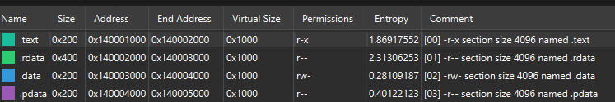

Import Table
The Import Table is actually called "Import Directory Table" and contains entries for every DLL which is loaded by the executable. Each entry contains, among other, Import Lookup Table (ILT) and Import Address Table (IAT)
To quote from the PE format specs about Import Directory Table:
Import Directory Table
The import information begins with the import directory table, which describes the remainder of the import information. The import directory table contains address information that is used to resolve fixup references to the entry points within a DLL image. The import directory table consists of an array of import directory entries, one entry for each DLL to which the image refers. The last directory entry is empty (filled with null values), which indicates the end of the directory table. Each import directory entry has the following format:
Offset Size Field
0 4 Import Lookup Table RVA
4 4 Time/Date Stamp
8 4 Forwarder Chain
12 4 Name RVA
16 4 Import Address Table RVA

Import Address Table
The Import Address Table is comprised of function pointers, ans is used to get the addresses of functions when the DLLs are loaded. A compiled application was designed so that all API calls will not use direct hardcoded addresses but rather work through a function pointer. The pointer table can be accessed in several ways -- either directly by a call to [pointer address] or by the "Import Lookup Table" and the "Hint/Name Table".
Let's quote again from the PE specs about the "Import Address Table":
Import Address Table
The structure and content of the import address table are identical to those of the import lookup table, until the file is bound. During binding, the entries in the import address table are overwritten with the 32-bit (for PE32) or 64-bit (for PE32+) addresses of the symbols that are being imported. These addresses are the actual memory addresses of the symbols, although technically they are still called "virtual addresses." The loader typically processes the binding.

References:
- PE Format specifications
- Understanding the Import Address Table
- Wikipedia: Portable Executable
- SO answer
Share
Improve this answer
Follow
edited Jun 15, 2020 at 12:30



evandrix
12511 silver badge44 bronze badges
answered Nov 30, 2017 at 15:18



Megabeets
9,03922 gold badges2626 silver badges4848 bronze badges
Add a comment
10
First, beside “yours” two tables, I introduce a third one, the Import Lookup Table.
Side by side with the Import Address Table, these two tables look like in this simplified picture:
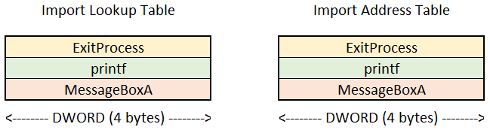
This picture shows the situation in your executable file on disk. They are totally identical, with the exactly same lists of the API function names (more precisely, pointers to the displayed names), in the exactly same order.

Now, the loader loads your executable and maps all required DLLs (Dynamic-Link Libraries) into your virtual memory space.
After finishing it and some calculations, the loader already knows addresses of all your imported functions.
So it replaces the names of your imported functions in the second table (Import Address Table) with their addresses, and the situation in memory becomes different:
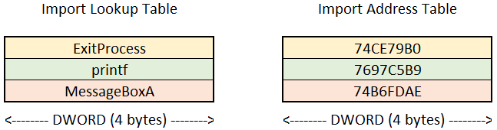

On the other hand, the Import Table, more precisely Import Directory Table, is a gateway to these 2 tables.
It is an array (a table) of entries, one entry (a row) for every imported library.
A simplified picture of it is here:
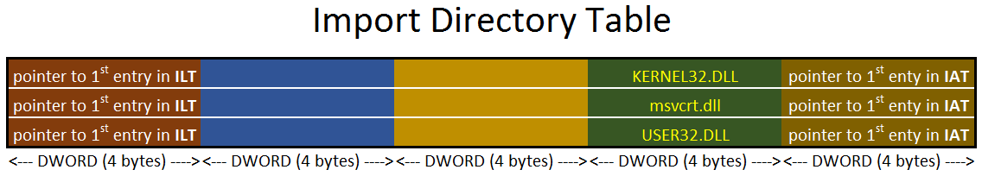
Every row consist of 5 double words (pointers). Important are only 3 of them, the first (a pointer to the ILT), the last (a pointer to the IAT), and the last but one (identifying the row by the name of DLL; so it's a pointer to the DLL's name in the fourth involved table, the Hint/Name Table).
So its cooperation with other two tables looks like this:
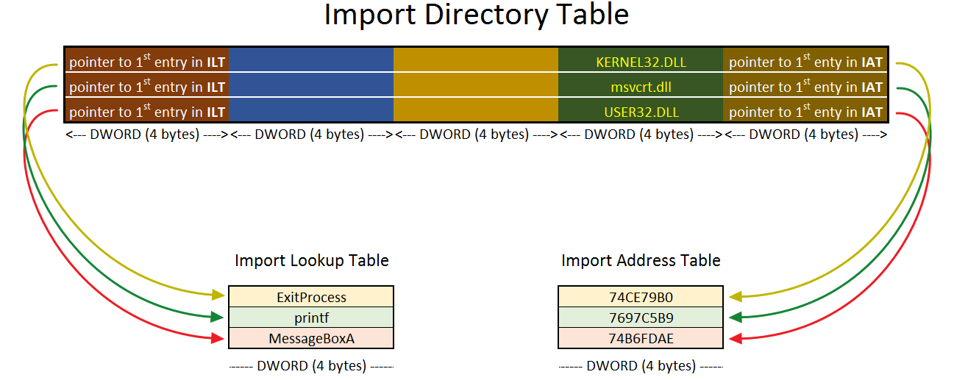
(I omitted the fourth table, the mentioned Hint/Name Table with names of all imported functions and names of all imported libraries, too.)

