Program Structure

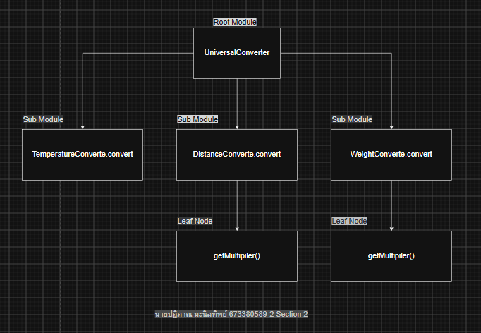

Top-down Integration
Unit under test | List of Stubs/Drivers | result | Stub’s return value | Expected results | Actual results | Pass/Fail/No run
UniversalConverter | StubDistanceConverter | convert(5.0, "km", "m") | 5000.0 | 5000.0 | 5000.0 | Pass
UniversalConverter | StubWeightConverter | convert(2.0, "kg", "lbs") | 4.410 | 4.410 | 4.410 | Pass
UniversalConverter | StubTemperatureConverter | convert(100.0, "C", "F") | 212.0 | 212.0 | 212.0 | Pass
UniversalConverter + DistanceConverter (real) | Driver only (no stub) | convert(5.0, "Distance", "kilometer", "meter") | N/A | 5000.0 | 5000.0 | Pass
UniversalConverter + DistanceConverter (real) | Driver only (no stub) | convert(1000.0, "Distance", "meter", "kilometer") | N/A | 1.0 | 1.0 | Pass
UniversalConverter + WeightConverter (real) | Driver only (no stub) | convert(2.0, "Weight", "kilogram", "gram") | N/A | 2000.0 | 0.002 | Fail (defect: multiplier = 1.0/1000 instead of 1000)
UniversalConverter + WeightConverter (real) | Driver only (no stub) | convert(1.0, "Weight", "kilogram", "lbs") | N/A | 2.205 | 2.205 | Pass
UniversalConverter + TemperatureConverter (real) | Driver only (no stub) | convert(100.0, "Temperature", "C", "F") | N/A | 212.0 | 132.0 | Fail (defect: integer division 9/5 = 1)
UniversalConverter + TemperatureConverter (real) | Driver only (no stub) | convert(212.0, "Temperature", "F", "C") | N/A | 100.0 | 0.0 | Fail (defect: integer division 5/9 = 0)
UniversalConverter + TemperatureConverter (real) | Driver only (no stub) | convert(0.0, "Temperature", "C", "K") | N/A | 273.15 | 273.15 | Pass

Bottom-up Integration
Unit under test | List of Stubs/Drivers | result | Stub’s return value | Expected results | Actual results | Pass/Fail/No run
DistanceConverter | Driver | getMultiplier("kilometer", "meter") | N/A | 1000.0 | 1000.0 | Pass
DistanceConverter | Driver | getMultiplier("mile", "kilometer") | N/A | 1.609 | 1.609 | Pass
WeightConverter | Driver | getMultiplier("kilogram", "gram") | N/A | 1000.0 | 0.001 | Fail (defect: multiplier = 1.0/1000 instead of 1000)
WeightConverter | Driver | getMultiplier("lbs", "ounce") | N/A | 16.0 | 16.0 | Pass
DistanceConverter | Driver | convert(10.0, "meter", "kilometer") | N/A | 0.01 | 0.01 | Pass
WeightConverter | Driver | convert(2.0, "lbs", "ounce") | N/A | 32.0 | 32.0 | Pass
TemperatureConverter | Driver | convert(0.0, "C", "K") | N/A | 273.15 | 273.15 | Pass
TemperatureConverter | Driver | convert(100.0, "C", "F") | N/A | 212.0 | 132.0 | Fail (defect: integer division 9/5 = 1)
UniversalConverter | Driver | convert(2.0, "Distance", "kilometer", "mile") | N/A | 1.242 | 1.242 | Pass
UniversalConverter | Driver | convert(10.0, "Weight", "lbs", "ounce") | N/A | 160.0 | 160.0 | Pass

