**TASK 1.2 (SQL-Oracle):**

**Stage 1:**

* **Construct an ER-Diagram for the above-mentioned Requirement**

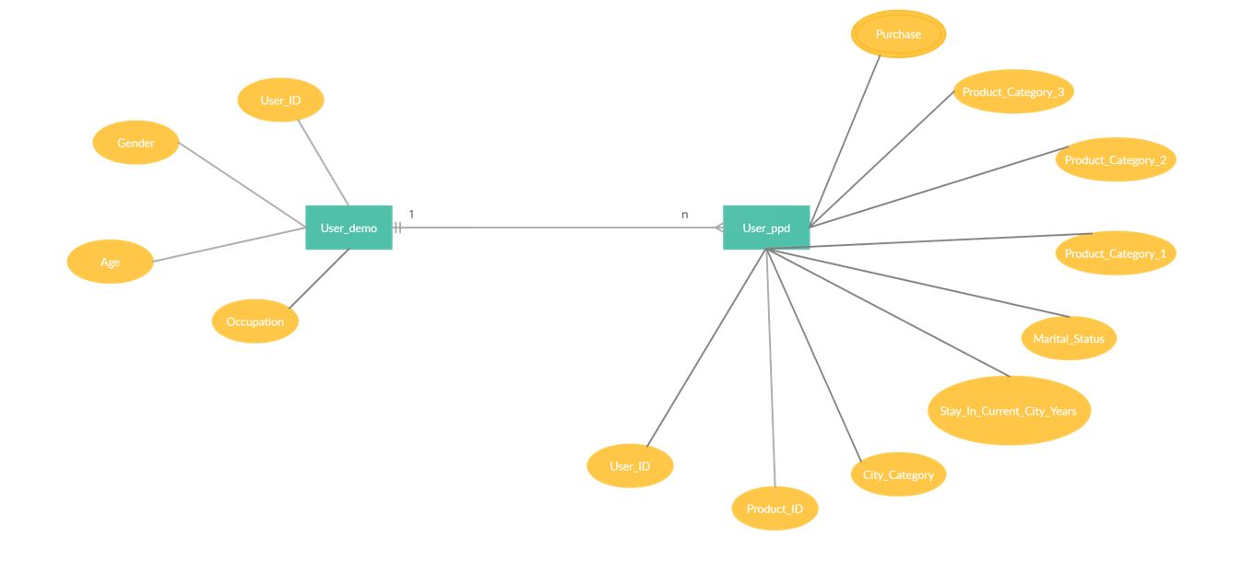

E-R DIAGRAM

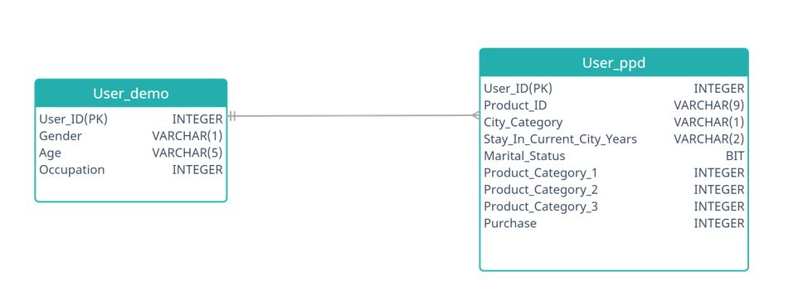

* **Construct Tables as per the ER-Diagram.**

-Create table user_demo from user_demographics dataset.

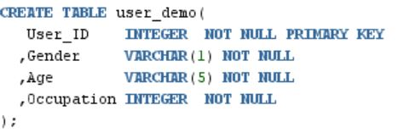

-Create table user_ppd from user_product_purchase_details dataset.

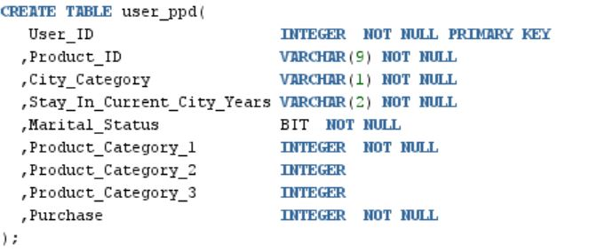

* **Identify the relationships between tables and use appropriate standards for the same where applicable**
* **Insert the appropriate data into the identified tables from the sample dataset provided.**

-Inset data into table user_demo.

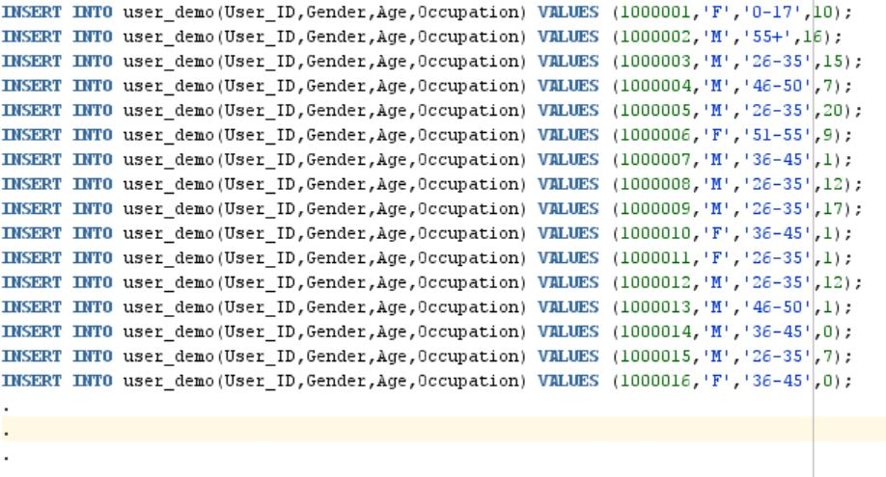

-Insert data into user_ppd table.

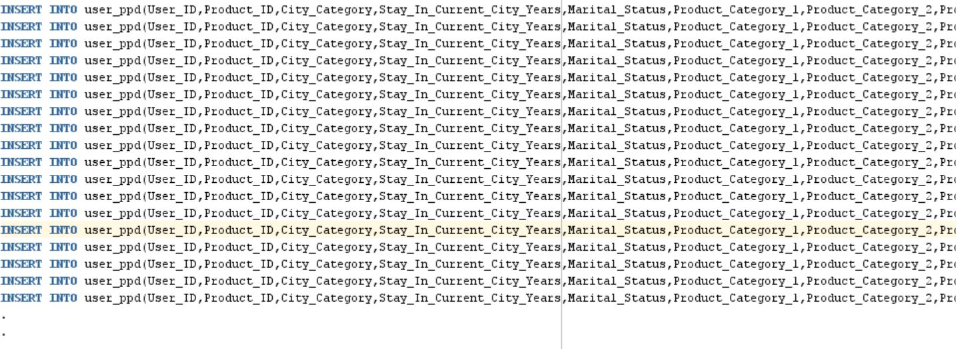

**Stage 2:**

**Write SQL queries for below**

* Print tables user_demo and user_ppd

**INPUT:**

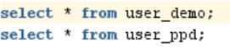

**OUTPUT:**

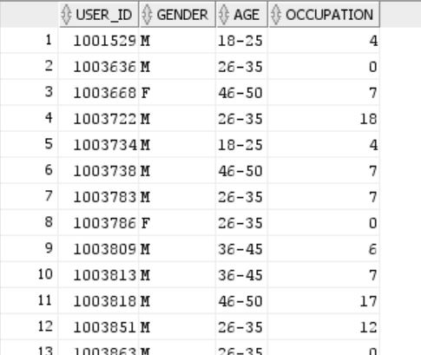

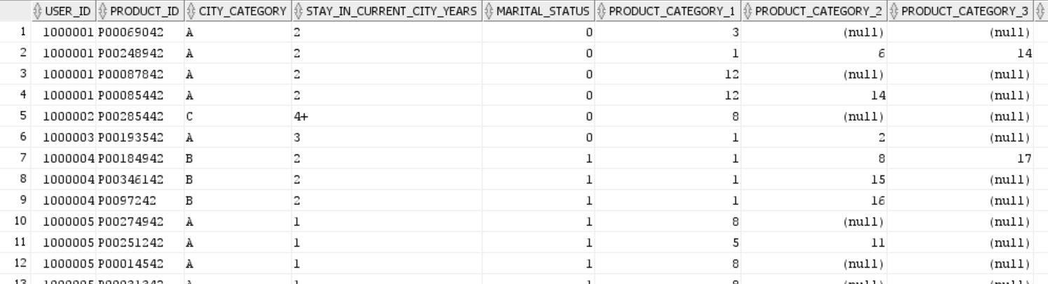

**1)TOP 50 best selling products**

**INPUT:**

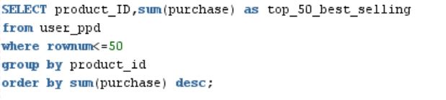

**OUTPUT:**

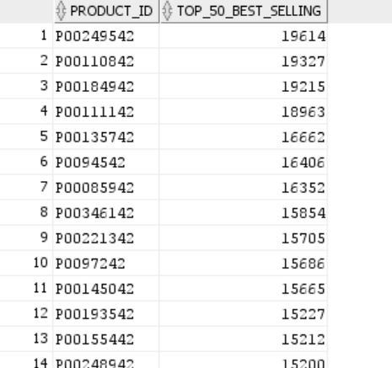

**2) TOP best selling product categories**

**INPUT:**

**OUTPUT:**

**3) count_sales by gender**

**INPUT:**

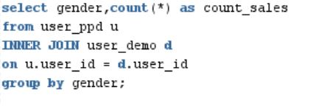

**OUTPUT:**

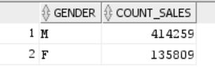

**4) Favourite products by gender(Female)**

**INPUT:**

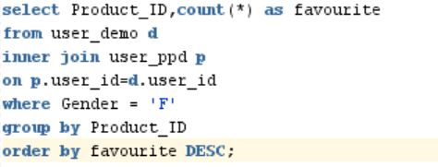

**OUTPUT:**

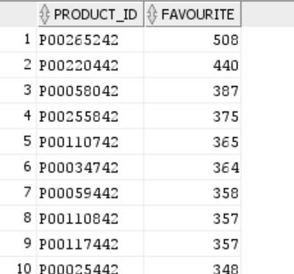

**5) Favourite products by gender(male)**

**INPUT:**

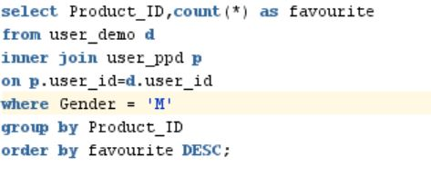

**OUTPUT:**

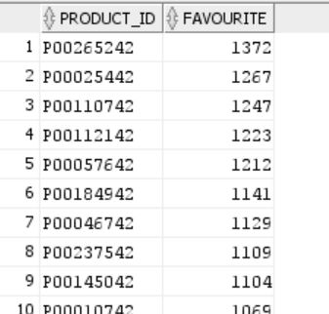

**6) sales_volume by occupation**

**INPUT:**

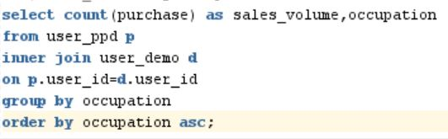

**OUTPUT:**

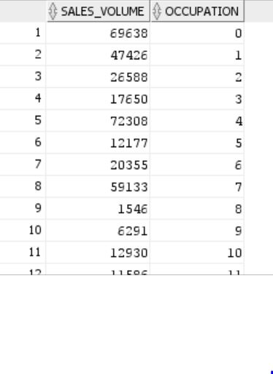

**7)sales_volume by age**

**INPUT:**

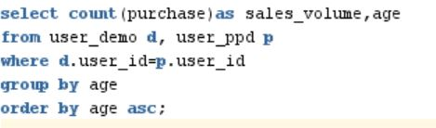

**OUTPUT:**

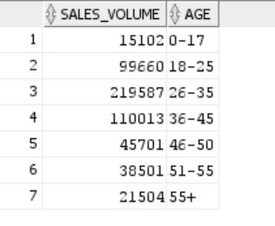

**8)sales_volume by city category**

**INPUT:**

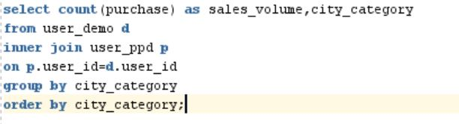

**OUTPUT:**

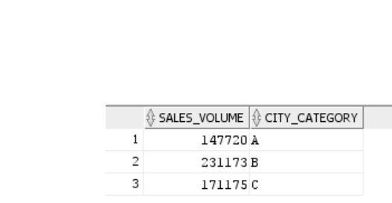

**9)sales_volume by stay in city years**

**INPUT:**

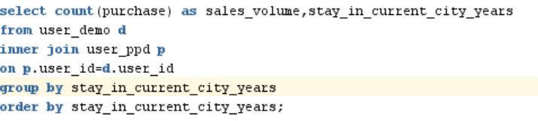

**OUTPUT:**

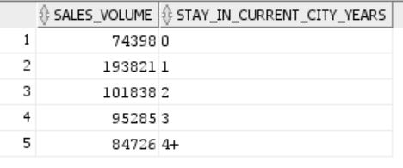

**10)sales_volume by Marital_Status**

**INPUT:**

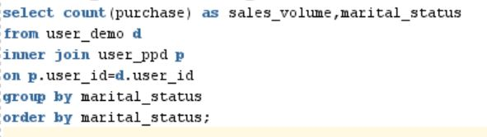

**OUTPUT:**

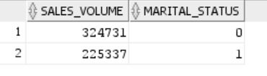

**11)purchase amount by age and gender**

**INPUT:**

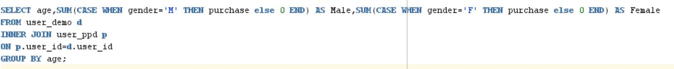

**OUTPUT:**

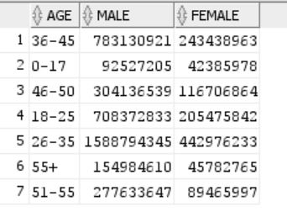

**12)purchase amount by age, gender and marital_status**

**INPUT:**

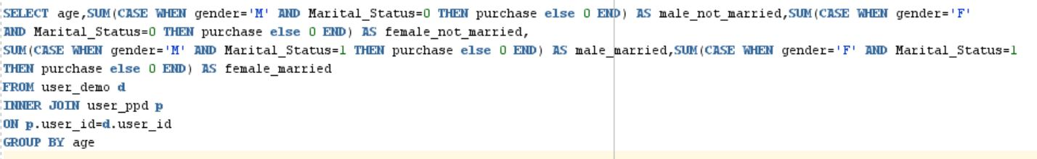

**OUTPUT:**

