**WEEK-3**

**GIT**

**Excrecise-1**

**Commands-**

* **mkdir GitDemo**
* **cd GitDemo**
* **git init -b main**
* **code welcome.txt//opens vscode**
* **ls**
* **git add welcome.txt**
* **git commit -m "Add welcome1.txt"**
* **git remote add origin https://github.com/PPravalika17/GitDemo.git**
* **git push -u origin master**

**welcome.txt**

hello,all

**OUTPUT-**

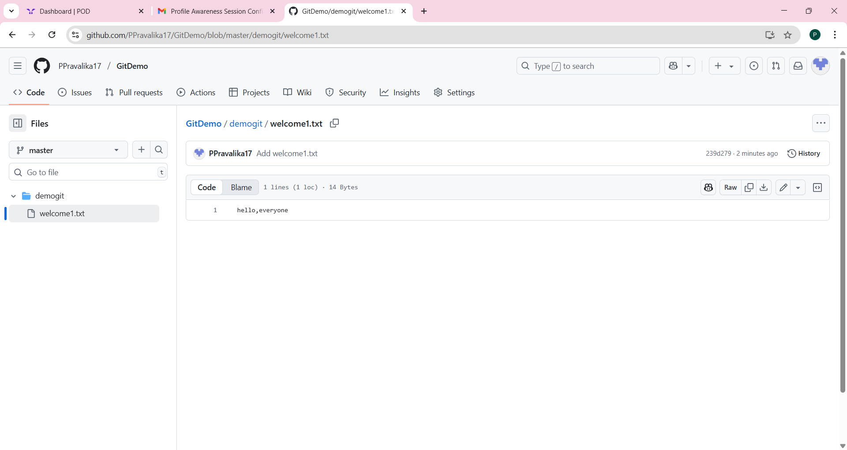

**Exercise-2**

**Commands-**

* **echo "This is a log file" > debug.log**
* **mkdir logs**
* **echo "samplelog">logs/app.log**
* **code .gitignore**
* **.gitignore**

**\*.log**

**logs/**

* **git add .gitignore**
* **git commit -m "Add .gitignore to ignore .log files and logs folder"**
* **git status**

**To verify**

git check-ignore debug.log

git check-ignore logs/app.log

**OUTPUT-**

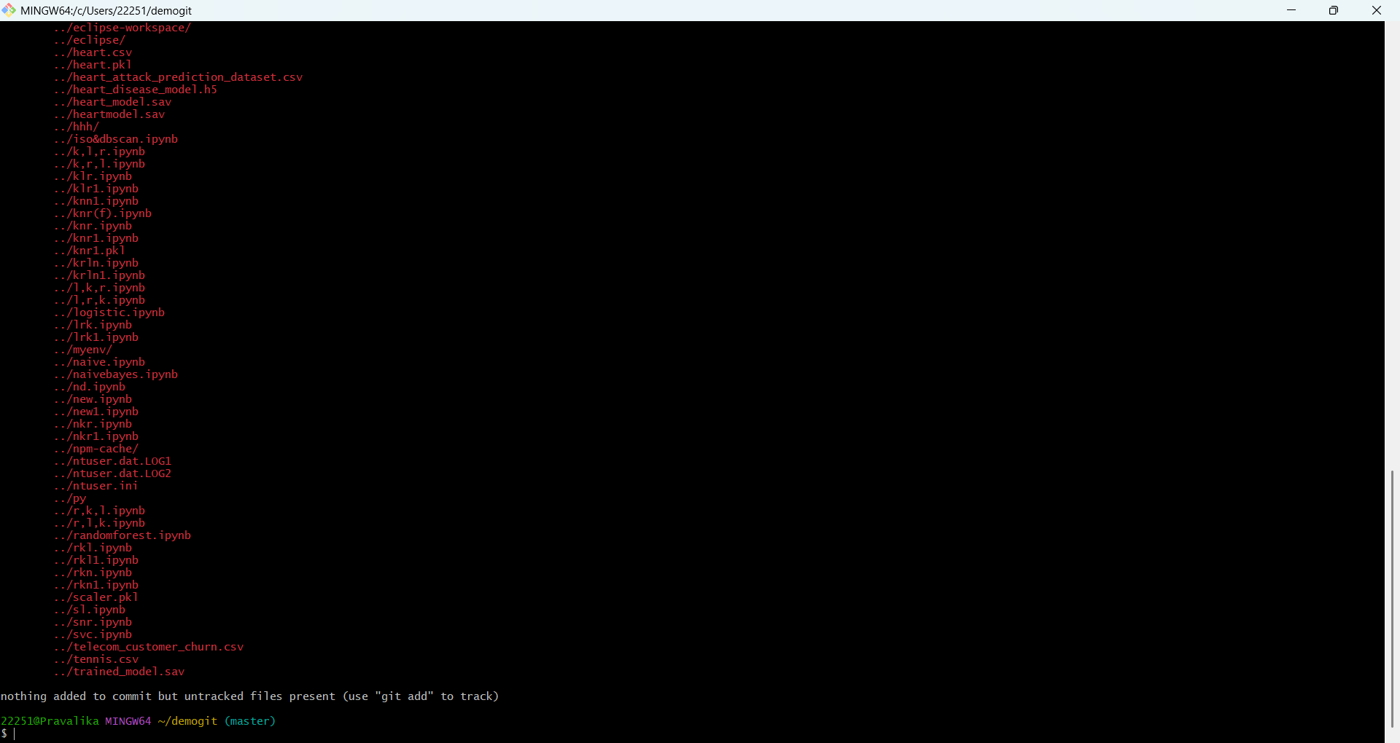

**Exercise-3**

**Commands-**

* **git branch GitNewBranch**
* **git branch -a**
* **git checkout GitNewBranch**
* **echo "This is a new feature file" > feature.txt**
* **git add feature.txt**
* **git commit -m "Add feature.txt on GitNewBranch"**
* **git status**
* **git checkout master**
* **git diff master..GitNewBranch**
* **git difftool master..GitNewBranch**
* **git merge GitNewBranch**
* **git log --oneline --graph --decorate**
* **git branch -d GitNewBranch**
* **git status**
* **git branch -a**

**OUTPUT-**

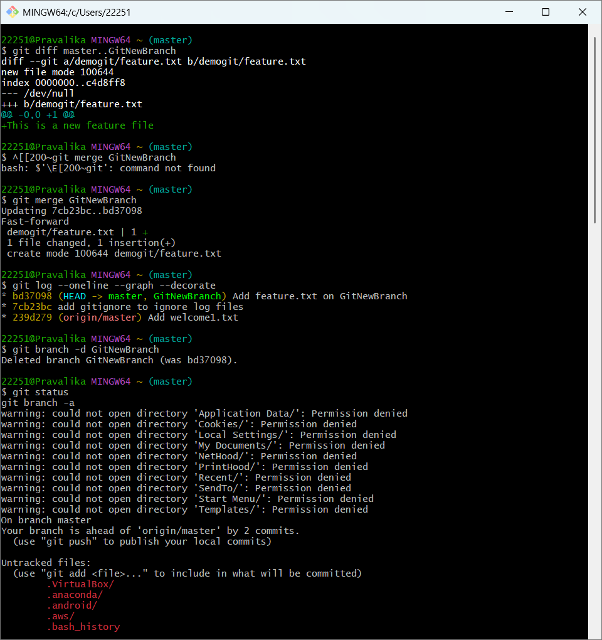

**Exercise-4**

**Commands-**

* **git status**
* **git branch GitWork**
* **git checkout GitWork**
* **echo "<hello>Branch version</hello>" > hello.xml**
* **git status**
* **git add hello.xml**
* **git commit -m "Add hello.xml in GitWork branch"**
* **git checkout master**
* **echo "<hello>Master version</hello>" > hello.xml**
* **git add hello.xml**
* **git commit -m "Add hello.xml in master branch"**
* **git log --oneline --graph --decorate --all**
* **git diff master..GitWork**
* **git difftool master..GitWork**
* **git merge GitWork**
* **git add hello.xml**
* **git commit -m "Resolved merge conflict between master and GitWork"**
* **git status**
* **echo "*.orig" >> .gitignore**
* **git add .gitignore**
* **git commit -m "Add backup files to .gitignore"**
* **git branch -a**
* **git branch -d GitWork**
* **git log --oneline --graph –decorate**

**OUTPUT-**

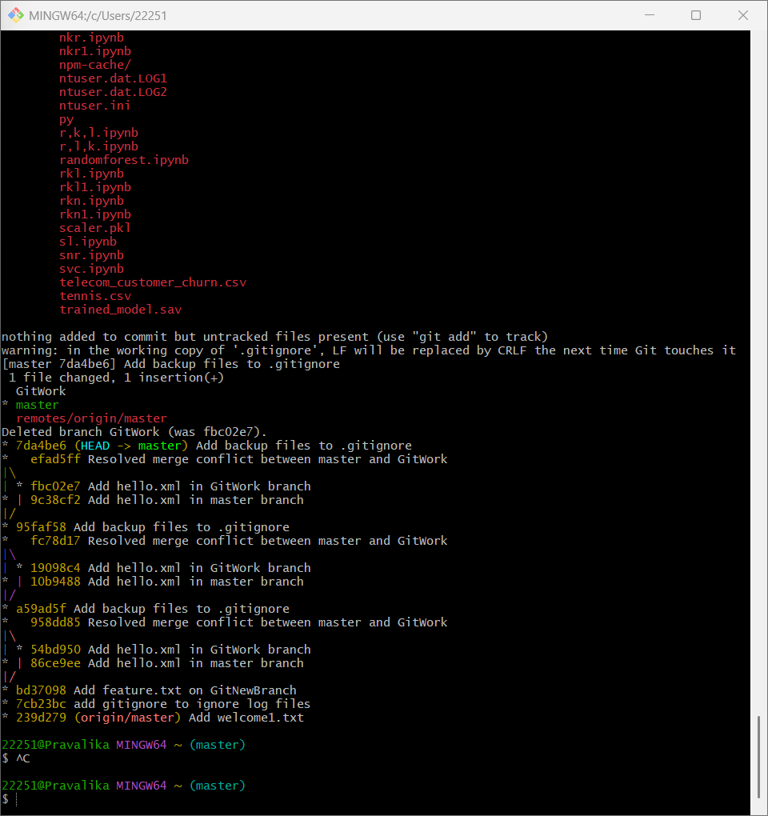

**Exercise-5**

**Commands-**

* **git status**
* **git branch -a**
* **git pull origin master**
* **git push origin master**

**OUTPUT-**

