**WEEK-6**

**REACT**

**Exercise-1**

**Steps-**

**npm install -g create-react-app**

**npx create-react-app myfirstreact**

**cd myfirstreact**

**Code-**

***App.js***

import './App.css';

function App() {

  return (

    <h1>Welcome to the first session of React</h1>

  );

}

export default App;

**Output-**

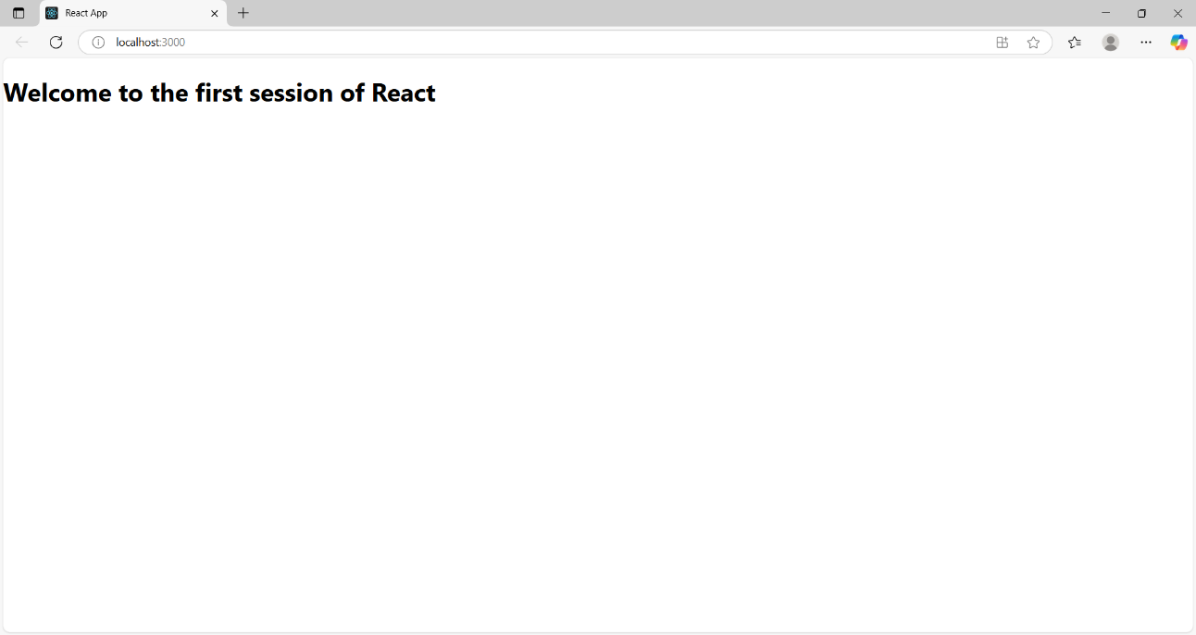

**Exercise-2**

**Code-**

* **Components/Home.js**

import React, { Component } from 'react';

class Home extends Component {

constructor() {

super();

}

render() {

return (

<div>

<h2>Welcome to the Home page of Student Management Portal</h2>

</div> );

}

}

export default Home;

* **Components/About.js**

import React, { Component } from 'react';

class About extends Component {

constructor() {

super();

}

render() {

return (

<div>

<h2>Welcome to the About page of the Student Management Portal</h2>

</div>);

}

}

export default About;

* **Components/Contact.js**

import React, { Component } from 'react';

class Contact extends Component {

constructor() {

super();

}

render() {

return (

<div>

<h2>Welcome to the Contact page of the Student Management Portal</h2>

</div>

);

}

}

export default Contact;

**App.js**

import React from 'react';

import './App.css';

import Home from './Components/Home';

import About from './Components/About';

import Contact from './Components/Contact';

function App() {

return (

<div className="App">

<Home />

<About />

<Contact />

</div>

);}

export default App;

**Output-**

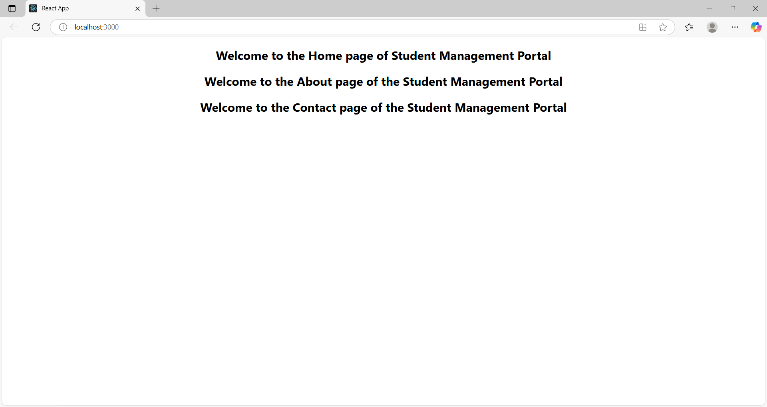

**Exercise-3**

**Code-**

**CalculateScore.js**

import React from 'react';

import '../mystyle.css';

function CalculateScore(props) {

  const { name, school, total, goal } = props;

  const average = total / goal;

  return (

    <div className="score-container">

      <h2>Student Score Report</h2>

      <p><strong>Name:</strong> {name}</p>

      <p><strong>School:</strong> {school}</p>

      <p><strong>Total Marks:</strong> {total}</p>

      <p><strong>Number of Subjects:</strong> {goal}</p>

      <p><strong>Average Score:</strong> {average.toFixed(2)}</p>

    </div>

  );

}

export default CalculateScore;

**mystyle.css**

.score-container {

  margin: 20px auto;

  padding: 20px;

  border: 2px solid #4CAF50;

  border-radius: 10px;

  width: 50%;

  background-color: #f0f9f0;

  font-family: Arial, sans-serif;

  text-align: left;

}

.score-container h2 {

  color: #2e7d32;

  text-align: center;

}

.score-container p {

  font-size: 16px;

  line-height: 1.5;

}

**App.js**

import React from 'react';

import './App.css';

import CalculateScore from './Components/CalculateScore';

function App() {

  return (

    <div className="App">

      <CalculateScore

        name="Pravalika"

        school="ABC Public School"

        total={450}

        goal={5}

      />

    </div>

  );

}

export default App;

**Output-**

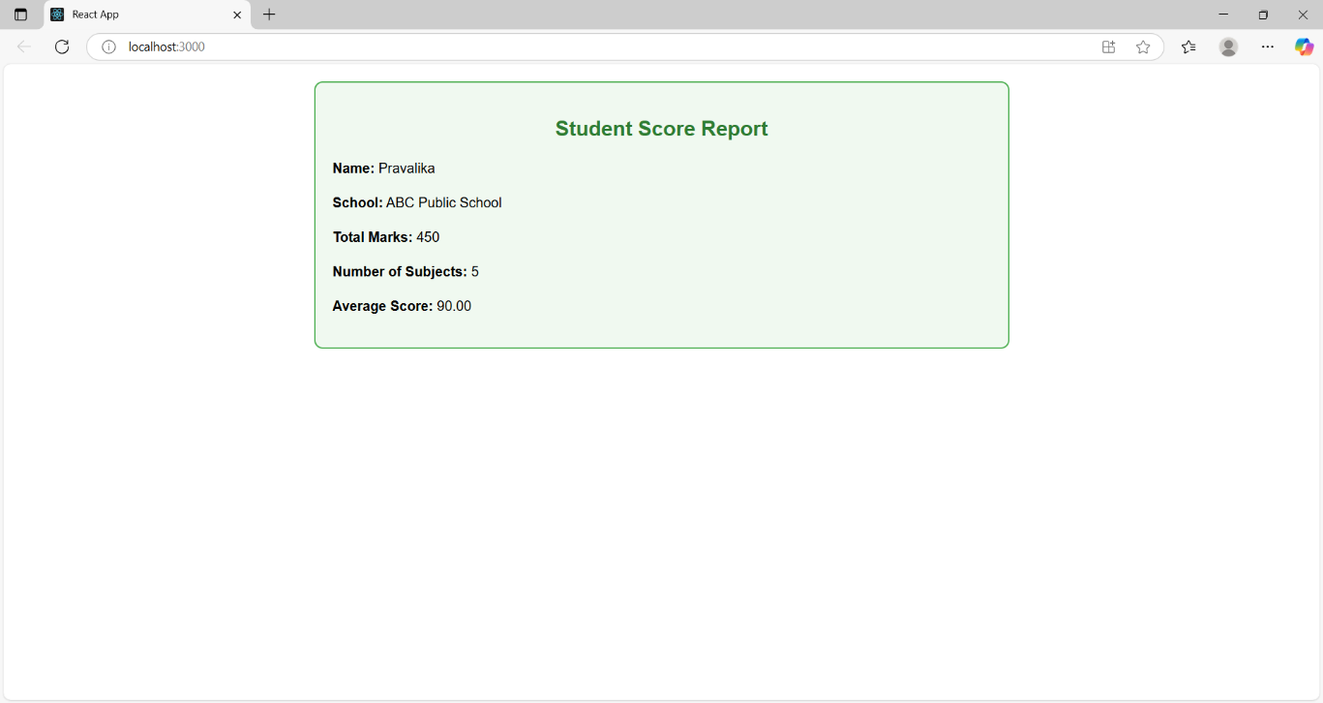

**Exercise-4**

**Code-**

**Post.js**

class Post {

constructor(userId, id, title, body) {

this.userId = userId;

this.id = id;

this.title = title;

this.body = body;

}

}

export default Post;

**Posts.js**

import React, { Component } from 'react';

import Post from './Post';

class Posts extends Component {

constructor(props) {

super(props);

this.state = {

posts: [],

error: null

};

}

loadPosts = () => {

fetch('https://jsonplaceholder.typicode.com/posts')

.then(response => response.json())

.then(data => {

const postsList = data.map(

post => new Post(post.userId, post.id, post.title, post.body)

);

this.setState({ posts: postsList });

})

.catch(error => {

this.setState({ error });

});

};

componentDidMount() {

this.loadPosts();

}

componentDidCatch(error, info) {

alert('An error occurred: ' + error);

}

render() {

const { posts } = this.state;

return (

<div style={{ padding: '20px' }}>

<h2>Blog Posts</h2>

{posts.length === 0 ? (

<p>Loading...</p>

) : (

posts.map(post => (

<div key={post.id} style={{ marginBottom: '20px' }}>

<h3>{post.title}</h3>

<p>{post.body}</p>

</div>

))

)}

</div>

);

}

}

export default Posts;

**App.js**

import React from 'react';

import './App.css';

import Posts from './Posts';

function App() {

  return (

    <div className="App">

      <Posts />

    </div>

  );

}

export default App;

**Output-**

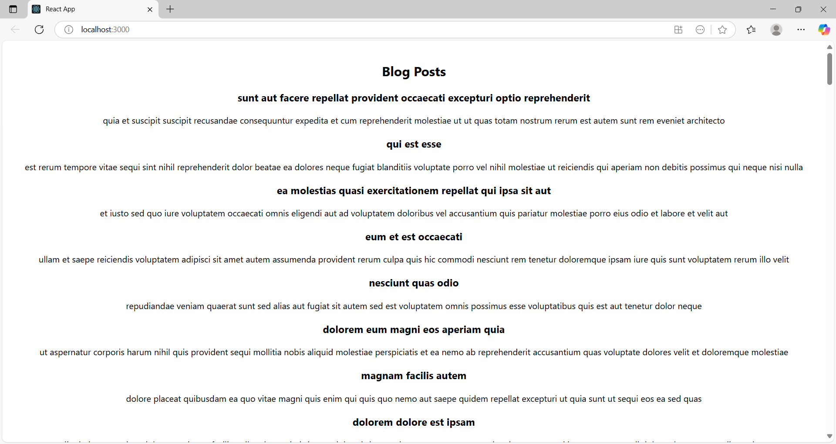

**Exercise-5**

**Code-**

**CohortDetails.module.css**

.box {

  width: 300px;

  display: inline-block;

  margin: 10px;

  padding: 10px 20px;

  border: 1px solid black;

  border-radius: 10px;

}

dt {

  font-weight: 500;

}

**CohortDetails.js**

import React from 'react';

import styles from './CohortDetails.module.css';

const CohortDetails = ({ cohort }) => {

  return (

    <div className={styles.box}>

      <h3 style={{ color: cohort.status === 'ongoing' ? 'green' : 'blue' }}>

        {cohort.name}

      </h3>

      <dl>

        <dt>Status:</dt>

        <dd>{cohort.status}</dd>

        <dt>Start Date:</dt>

        <dd>{cohort.startDate}</dd>

        <dt>End Date:</dt>

        <dd>{cohort.endDate}</dd>

      </dl>

    </div>

  );

};

export default CohortDetails;

**Output-**

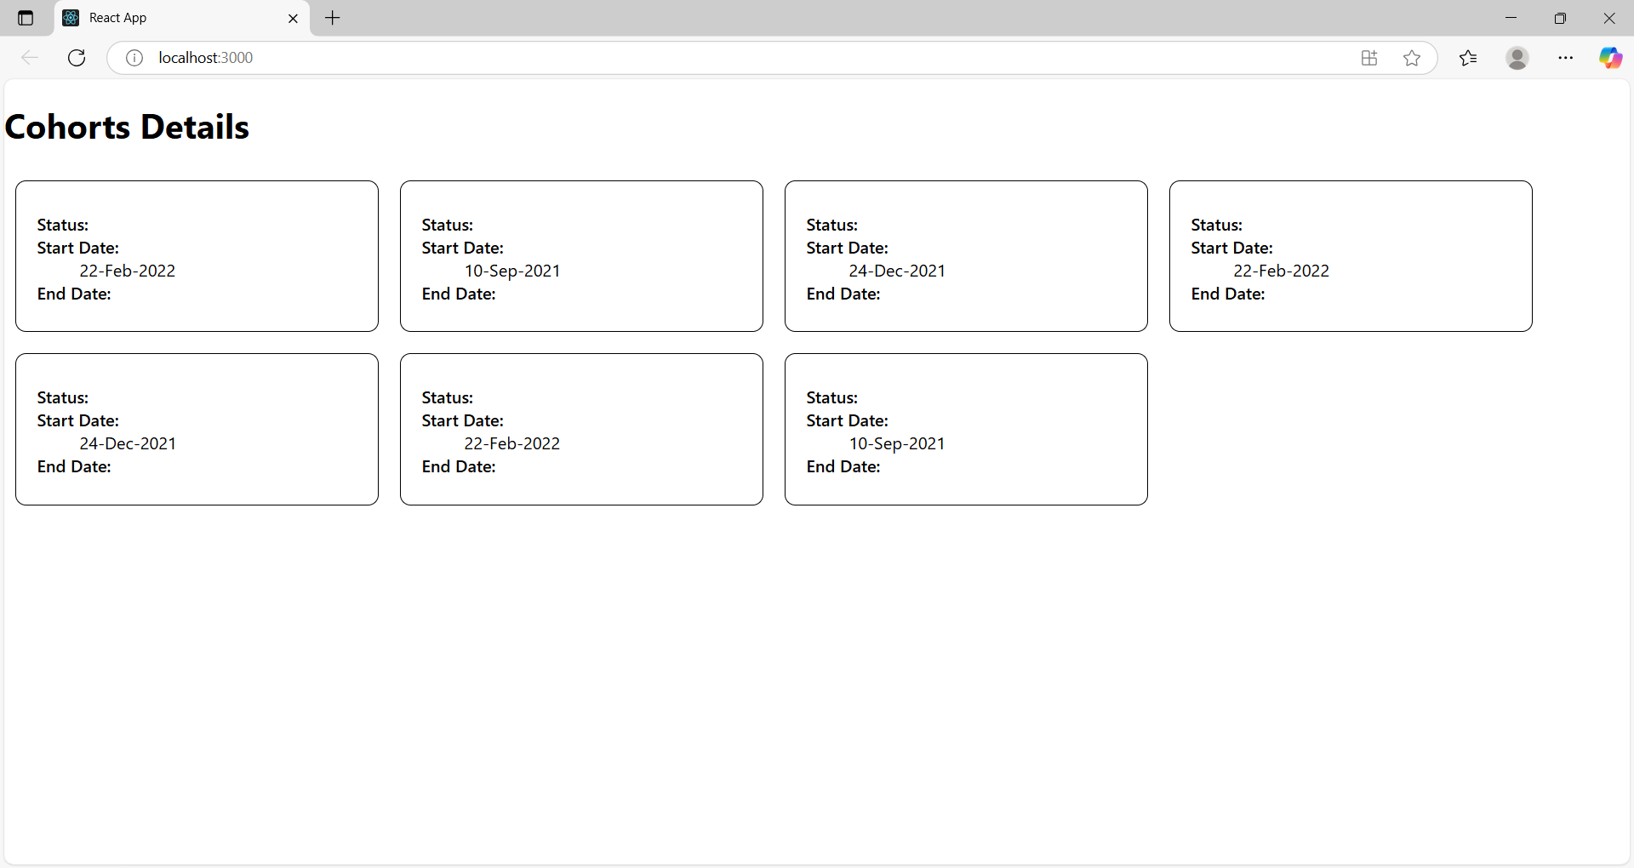

**Exercise-6**

**Code-**

**Trainer.js**

class Trainer {

constructor(trainerId, name, email, phone, technology, skills) {

this.trainerId = trainerId;

this.name = name;

this.email = email;

this.phone = phone;

this.technology = technology;

this.skills = skills;

}

}

export default Trainer;

**TrainersMock.js**

import Trainer from "./Trainer";

const trainers = [

new Trainer(1, "Alice", "alice@example.com", "9876543210", "React", ["JS", "Hooks", "Routing"]),

new Trainer(2, "Bob", "bob@example.com", "9123456780", "Node.js", ["Express", "MongoDB", "APIs"]),

new Trainer(3, "Charlie", "charlie@example.com", "9988776655", "Python", ["Flask", "Django", "Pandas"]),

];

export default trainers;

**TrainerList.js**

import React from "react";

import { Link } from "react-router-dom";

const TrainerList = ({ trainers }) => {

return (

<div>

<h2>Trainer List</h2>

<ul>

{trainers.map((trainer) => (

<li key={trainer.trainerId}>

<Link to={`/trainer/${trainer.trainerId}`}>{trainer.name}</Link>

</li>

))}

</ul>

</div>

);

};

export default TrainerList;

**Home.js**

import React from "react";

const Home = () => {

return (

<div>

<h1>Welcome to Trainers Portal</h1>

<p>This app maintains a list of trainers and their skills.</p>

</div>

);

};

export default Home;

**App.js**

import React from "react";

import { BrowserRouter, Routes, Route, Link } from "react-router-dom";

import Home from "./Home";

import TrainerList from "./TrainerList";

import TrainerDetail from "./TrainerDetail";

import trainers from "./TrainersMock";

function App() {

return (

<BrowserRouter>

<nav>

<Link to="/">Home</Link> | <Link to="/trainers">Trainers</Link>

</nav>

<hr />

<Routes>

<Route path="/" element={<Home />} />

<Route path="/trainers" element={<TrainerList trainers={trainers} />} />

<Route path="/trainer/:id" element={<TrainerDetail />} />

</Routes>

</BrowserRouter>

);

}

export default App;

**TrainerDetail.js**

import React from "react";

import { useParams } from "react-router-dom";

import trainers from "./TrainersMock";

const TrainerDetail = () => {

const { id } = useParams();

const trainer = trainers.find((t) => t.trainerId.toString() === id);

if (!trainer) return <p>Trainer not found!</p>;

return (

<div>

<h2>Trainer Details</h2>

<p><strong>ID:</strong> {trainer.trainerId}</p>

<p><strong>Name:</strong> {trainer.name}</p>

<p><strong>Email:</strong> {trainer.email}</p>

<p><strong>Phone:</strong> {trainer.phone}</p>

<p><strong>Technology:</strong> {trainer.technology}</p>

<p><strong>Skills:</strong> {trainer.skills.join(", ")}</p>

</div>

);

};

export default TrainerDetail;

**Output-**

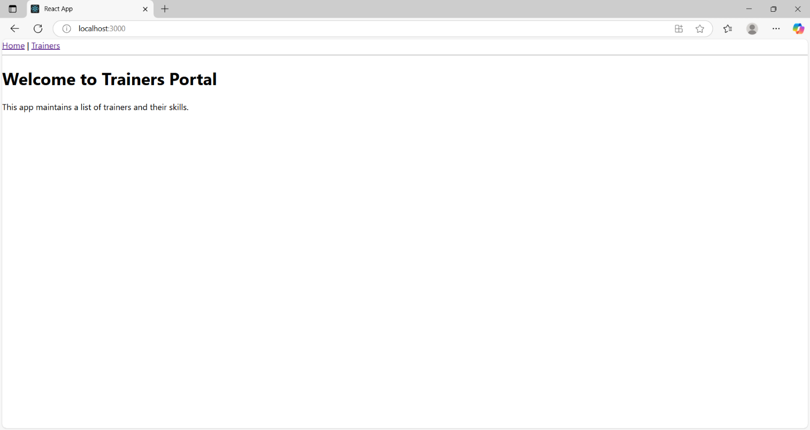 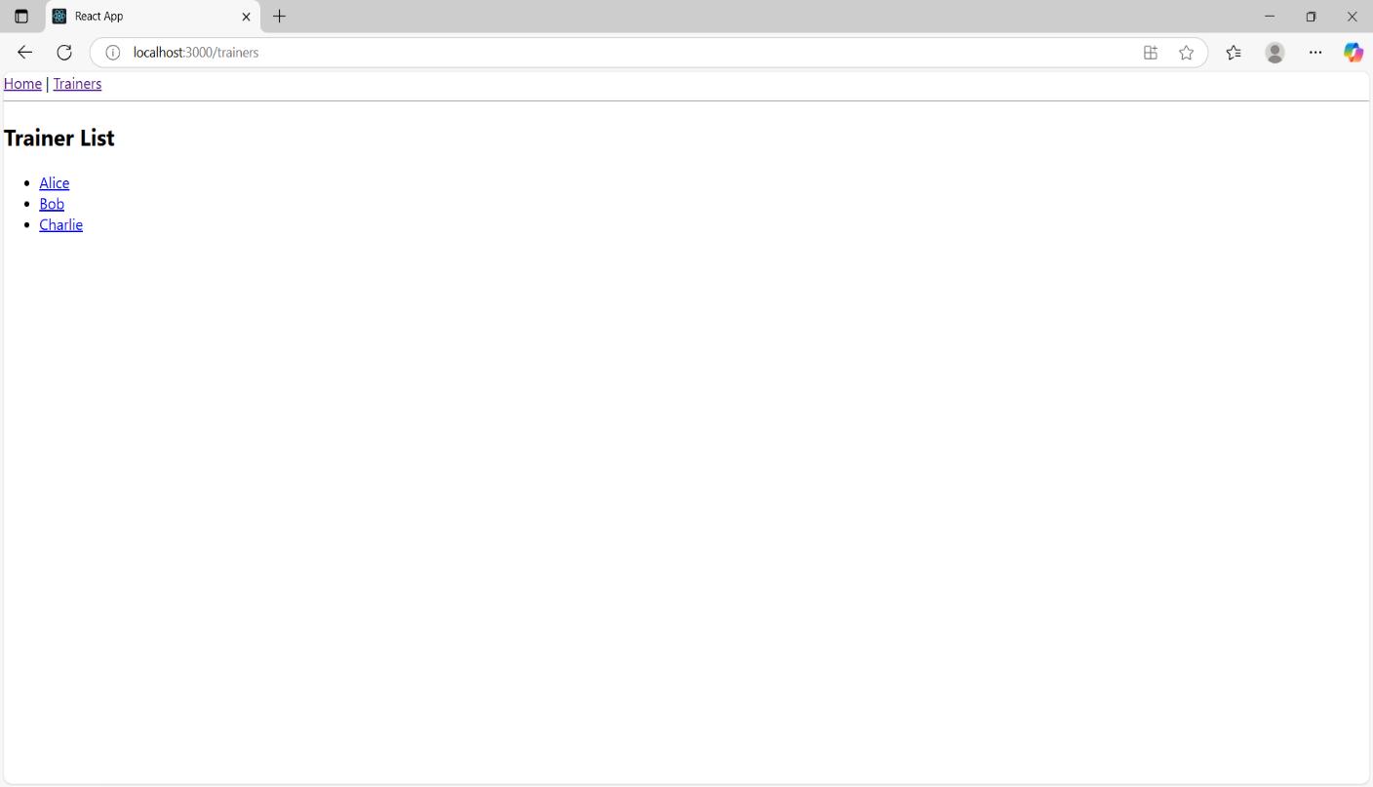

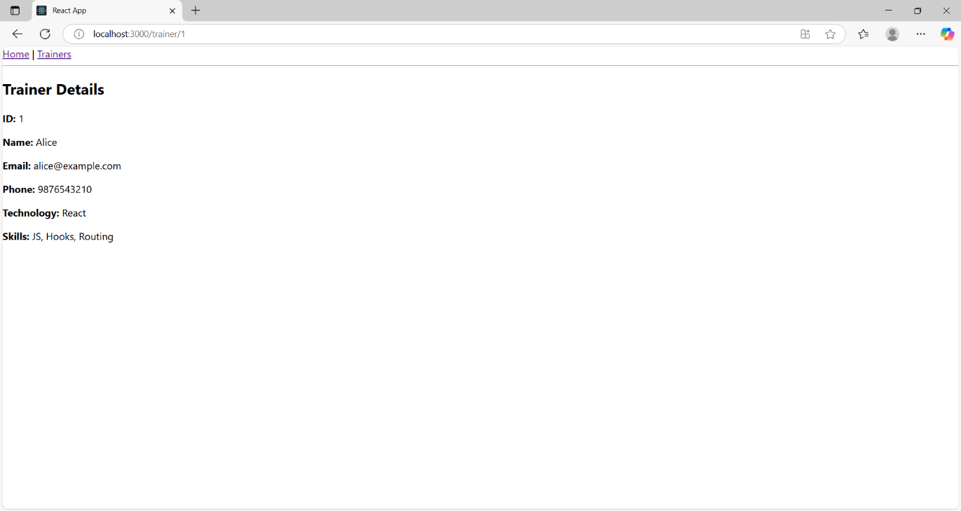

Exercise-7

Code-

**Cart.js**

import React from "react";

class Cart extends React.Component {

render() {

return (

<div>

<h3>Item: {this.props.itemname}</h3>

<p>Price: ₹{this.props.price}</p>

<hr />

</div>

);

}

}

export default Cart;

**OnlineShopping.js**

import React from "react";

import Cart from "./Cart";

class OnlineShopping extends React.Component {

render() {

const cartItems = [

{ itemname: "Laptop", price: 60000 },

{ itemname: "Smartphone", price: 20000 },

{ itemname: "Shoes", price: 2500 },

{ itemname: "Book", price: 500 },

{ itemname: "Backpack", price: 1500 }

];

return (

<div>

<h1>Online Shopping Cart</h1>

{cartItems.map((item, index) => (

<Cart key={index} itemname={item.itemname} price={item.price} />

))}

</div>

);

}

}

export default OnlineShopping;

**App.js**

import React from "react";

import OnlineShopping from "./OnlineShopping";

function App() {

return (

<div>

<OnlineShopping />

</div>

);

}

export default App;

**Output-**

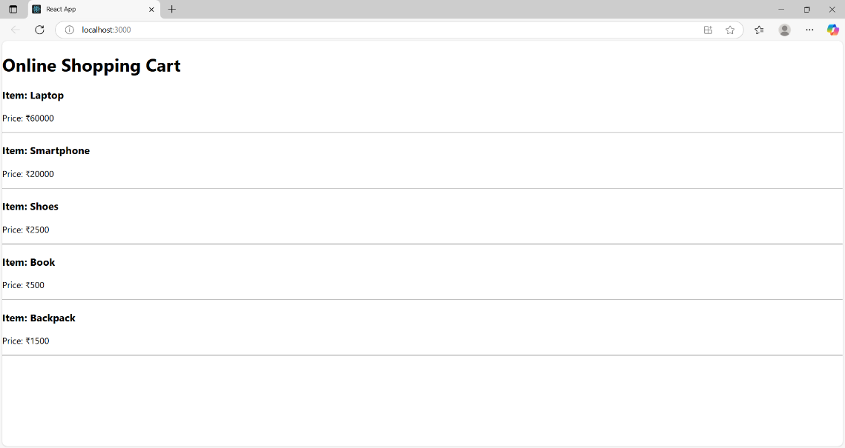

**Exercise-8**

**Code-**

**CountPeople.js**

import React, { Component } from 'react';

class CountPeople extends Component {

constructor(props) {

super(props);

this.state = {

entryCount: 0,

exitCount: 0

};

}

UpdateEntry = () => {

this.setState(prevState => ({

entryCount: prevState.entryCount + 1

}));

};

UpdateExit = () => {

this.setState(prevState => ({

exitCount: prevState.exitCount + 1

}));

};

render() {

return (

<div style={{ textAlign: 'center', marginTop: '50px' }}>

<h1>Mall Entry/Exit Counter</h1>

<p><strong>People Entered:</strong> {this.state.entryCount}</p>

<p><strong>People Exited:</strong> {this.state.exitCount}</p>

<button onClick={this.UpdateEntry} style={{ marginRight: '10px' }}>

Login

</button>

<button onClick={this.UpdateExit}>Exit</button>

</div>

);

}

}

export default CountPeople;

**App.js**

import React from 'react';

import CountPeople from './CountPeople';

function App() {

return (

<div>

<CountPeople />

</div>

);

}

export default App;

**Output-**

