**WEEK-7**

**REACT**

**Exercise-9:**

**.components/ListofPlayers.js**

import React from 'react';

const ListofPlayers = () => {

const players = [

{ name: "Virat", score: 85 },

{ name: "Rohit", score: 45 },

{ name: "Dhoni", score: 90 },

{ name: "Rahul", score: 60 },

{ name: "Bumrah", score: 40 },

{ name: "Ashwin", score: 75 },

{ name: "Jadeja", score: 55 },

{ name: "Gill", score: 80 },

{ name: "Surya", score: 35 },

{ name: "Pandya", score: 70 },

{ name: "Shami", score: 50 }

];

const lowScorers = players.filter(player => player.score < 70); // Arrow function

const allPlayers = players.map((player, index) => (

<li key={index}>{player.name} - {player.score}</li>

));

const lowScorersList = lowScorers.map((player, index) => (

<li key={index}>{player.name} - {player.score}</li>

));

return (

<div>

<h2>All Players</h2>

<ul>{allPlayers}</ul>

<h2>Players with score below 70</h2>

<ul>{lowScorersList}</ul>

</div>

);

};

export default ListofPlayers;

**.components/IndianPlayers.js**

import React from 'react';

const IndianPlayers = () => {

const players = ["Kohli", "Rohit", "Rahul", "Dhawan", "Iyer", "Gill", "Pant", "Ashwin"];

const oddTeam = players.filter((_, index) => index % 2 !== 0);

const evenTeam = players.filter((_, index) => index % 2 === 0);

const [captain, viceCaptain, ...others] = players;

const T20players = ["Kohli", "Rohit"];

const RanjiTrophy = ["Pujara", "Saha"];

const allIndianPlayers = [...T20players, ...RanjiTrophy];

return (

<div>

<h2>Team Destructuring</h2>

<p>Captain: {captain}</p>

<p>Vice Captain: {viceCaptain}</p>

<p>Others: {others.join(", ")}</p>

<h2>Even Team</h2>

<ul>{evenTeam.map((player, i) => <li key={i}>{player}</li>)}</ul>

<h2>Odd Team</h2>

<ul>{oddTeam.map((player, i) => <li key={i}>{player}</li>)}</ul>

<h2>Merged Players (T20 + Ranji)</h2>

<ul>{allIndianPlayers.map((player, i) => <li key={i}>{player}</li>)}</ul>

</div>

);

};

export default IndianPlayers;

**App.js**

import React from 'react';

import ListofPlayers from './components/ListofPlayers';

import IndianPlayers from './components/IndianPlayers';

function App() {

const flag = true;

return (

<div className="App">

<h1> Cricket App</h1>

{flag ? <ListofPlayers /> : <IndianPlayers />}

</div>

);

}

export default App;

**OUTPUT-**

**When flag=true When flag=false**

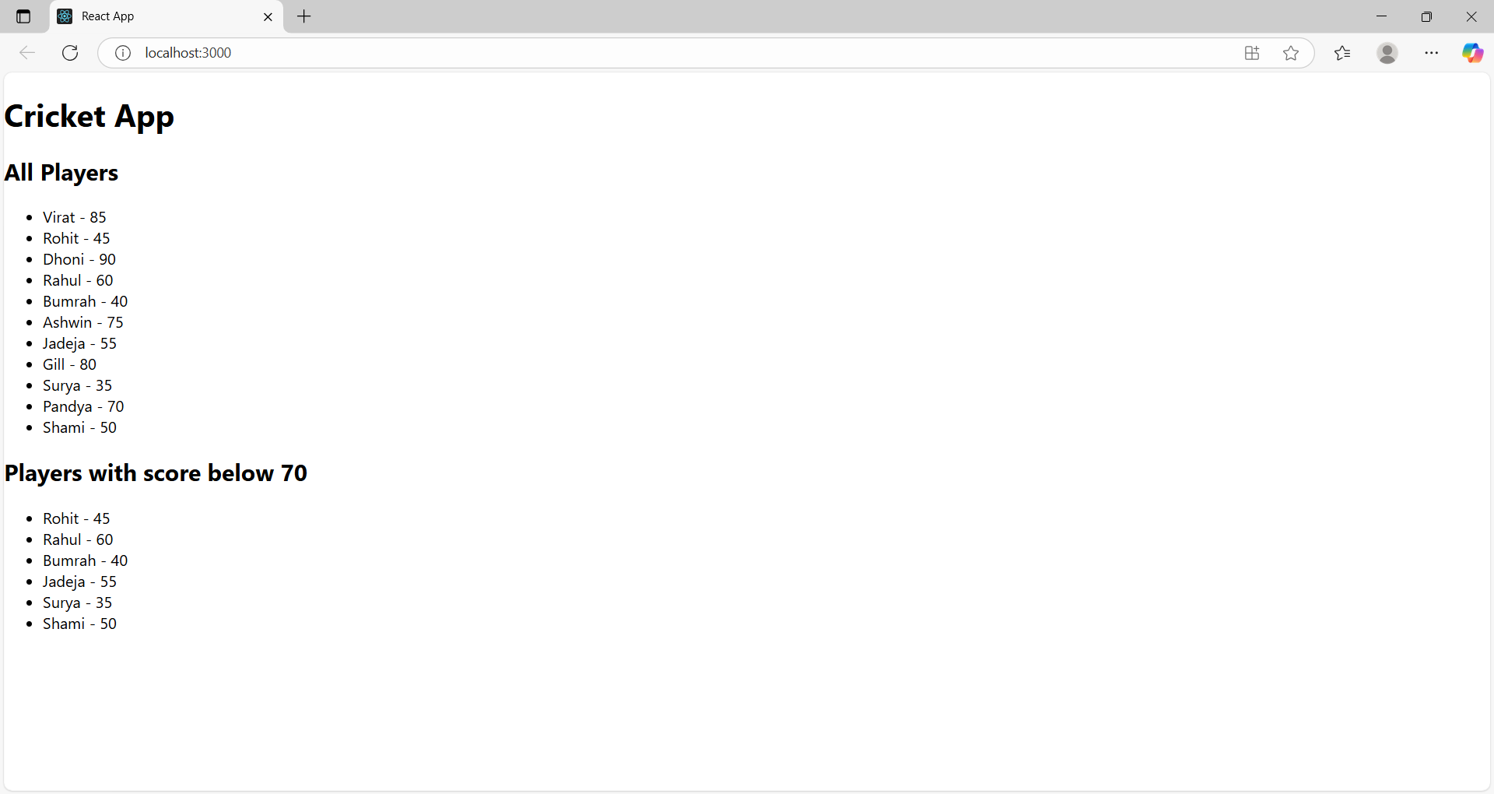 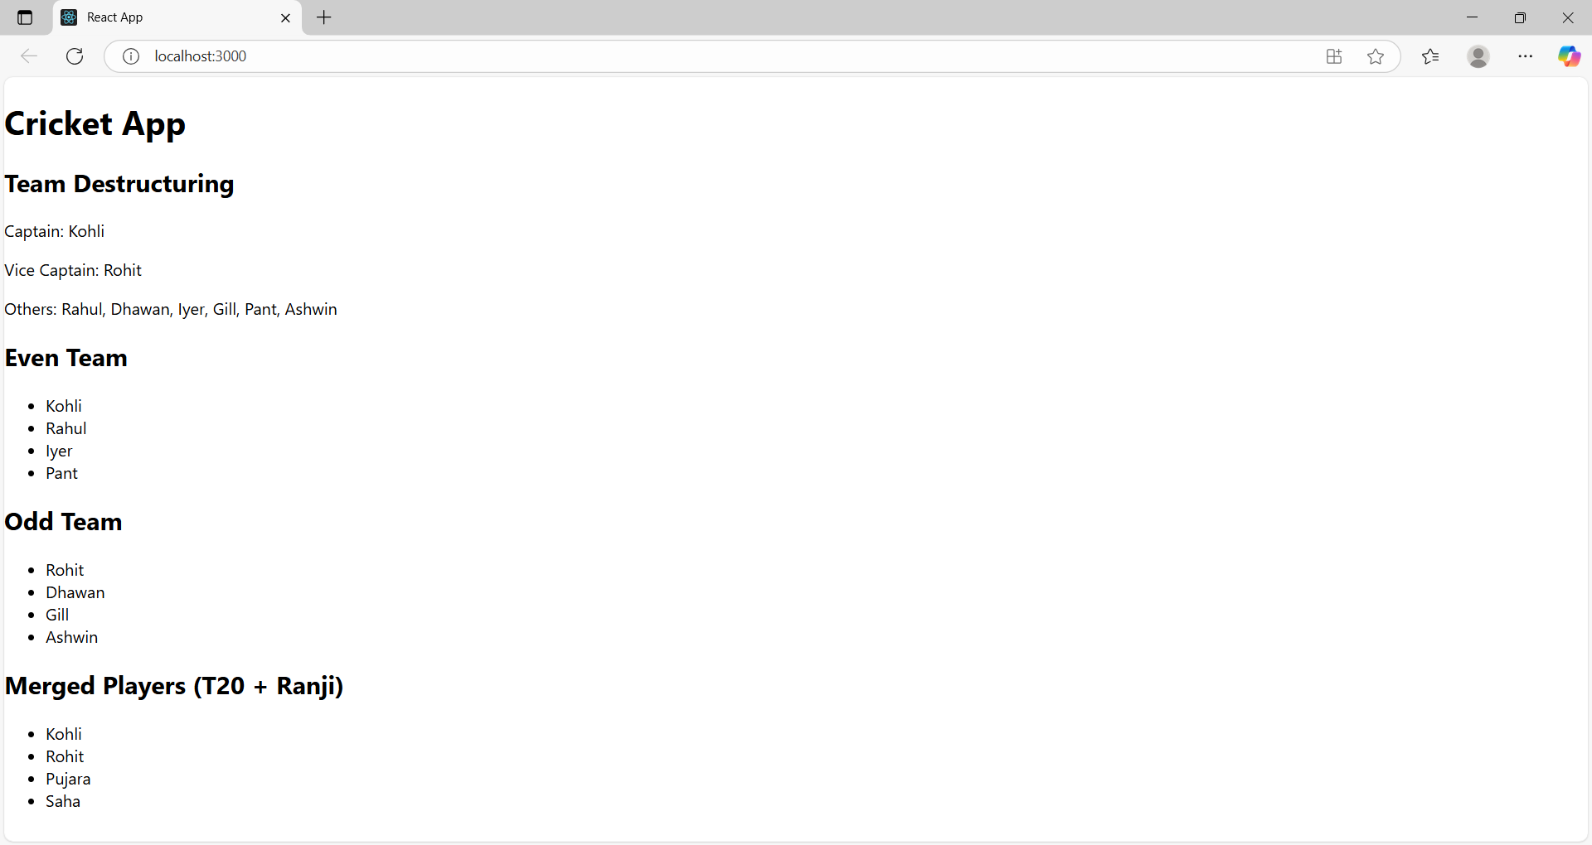

**Exercise-10:**

**App.js**

import React from 'react';

import './App.css';

function App() {

  const heading = <h1> Office Space Rental App</h1>;

  const imageUrl = "https://via.placeholder.com/600x300?text=Office+Space";

  const office = {

    name: "Elite Business Center",

    rent: 50000,

    address: "Banjara Hills, Hyderabad"

  };

 const officeList = [  {

    name: "Elite Business Center",

    rent: 50000,

    address: "Banjara Hills, Hyderabad",

    image: "https://images.unsplash.com/photo-1593642532400-2682810df593?auto=format&fit=crop&w=800&q=80"

  },{

    name: "Prime Work Hub",

    rent: 45000,

    address: "Madhapur, Hyderabad",

    image: "https://images.unsplash.com/photo-1524758631624-e2822e304c36?auto=format&fit=crop&w=800&q=80"

  }];

  return (

    <div style={{ padding: "20px", fontFamily: "Arial" }}>

      {heading}

      <img src={imageUrl} alt="Office" style={{ width: "100%", height: "auto", borderRadius: "8px" }} />

      <h2 style={{ marginTop: "20px" }}>Featured Office</h2>

      <div style={{ marginBottom: "20px" }}>

        <p><strong>Name:</strong> {office.name}</p>

        <p><strong>Rent:</strong> ₹{office.rent}</p>

        <p><strong>Address:</strong> {office.address}</p>

      </div>

      <h2>Available Offices</h2>

      {officeList.map((item, index) => {

        const rentStyle = {

          color: item.rent >= 60000 ? "green" : "red",

          fontWeight: "bold"

        };

        return (

          <div key={index}

            <p><strong>Name:</strong> {item.name}</p>

            <p><strong>Rent:</strong> <span style={rentStyle}>₹{item.rent}</span></p>

            <img

  src={item.image}

  alt={item.name}

  style={{ width: "10%", borderRadius: "6px", marginBottom: "10px" }}

/>        <p><strong>Address:</strong> {item.address}</p>

          </div>

    ); })}

    </div>

  );}

export default App;

**OUTPUT:**

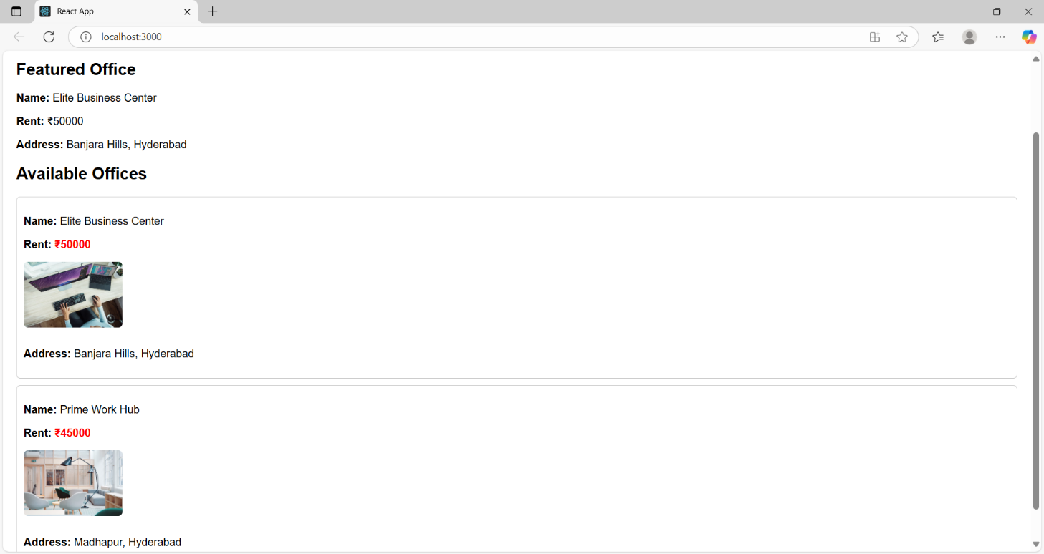

**Exercise-11:**

**.components/Counter.js**

import React, { Component } from 'react';

class Counter extends Component {

constructor(props) {

super(props);

this.state = {

count: 0

};

this.handleIncrement = this.handleIncrement.bind(this);

handleIncrement() {

this.setState({ count: this.state.count + 1 });

this.sayHello();

}

sayHello() {

console.log("Hello! This is an increment action.");

}

handleDecrement = () => {

this.setState({ count: this.state.count - 1 });

};

sayWelcome = (message) => {

alert(`Say Welcome: ${message}`);

};

handleSyntheticEvent = (event) => {

alert("I was clicked");

console.log("Synthetic Event:", event); // React synthetic event object

};

render() {

return (

<div style={{ marginBottom: "30px" }}>

<h2>Counter Example</h2>

<p>Count: {this.state.count}</p>

<button onClick={this.handleIncrement}>Increment</button>{' '}

<button onClick={this.handleDecrement}>Decrement</button>{' '}

<button onClick={() => this.sayWelcome("Welcome")}>Say Welcome</button>{' '}

<button onClick={this.handleSyntheticEvent}>OnPress</button>

</div>

);

}

}

export default Counter;

**.components/CurrencyConvertor.js**

import React, { useState } from 'react';

const CurrencyConvertor = () => {

const [rupees, setRupees] = useState('');

const [euros, setEuros] = useState(null);

const handleSubmit = (e) => {

e.preventDefault(); // Prevent default form submission

const conversionRate = 0.011; // Example: 1 INR = 0.011 EUR

setEuros((parseFloat(rupees) * conversionRate).toFixed(2));

};

return (

<div>

<h2>Currency Convertor</h2>

<form onSubmit={handleSubmit}>

<label>

Enter Amount in Rupees:

<input

type="number"

value={rupees}

onChange={(e) => setRupees(e.target.value)}

style={{ marginLeft: "10px" }}

/>

</label>

<button type="submit" style={{ marginLeft: "10px" }}>

Convert

</button>

</form>

{euros !== null && (

<p>Converted Amount in Euros: <strong>€{euros}</strong></p>

)}

</div>

);

};

export default CurrencyConvertor;

**App.js**

import React from 'react';

import Counter from './components/Counter';

import CurrencyConvertor from './components/CurrencyConvertor';

function App() {

return (

<div className="App" style={{ padding: '20px', fontFamily: 'Arial' }}>

<h1>🎯 Event Handling in React</h1>

<Counter />

<CurrencyConvertor />

</div>

);

}

export default App;

**OUTPUT-**

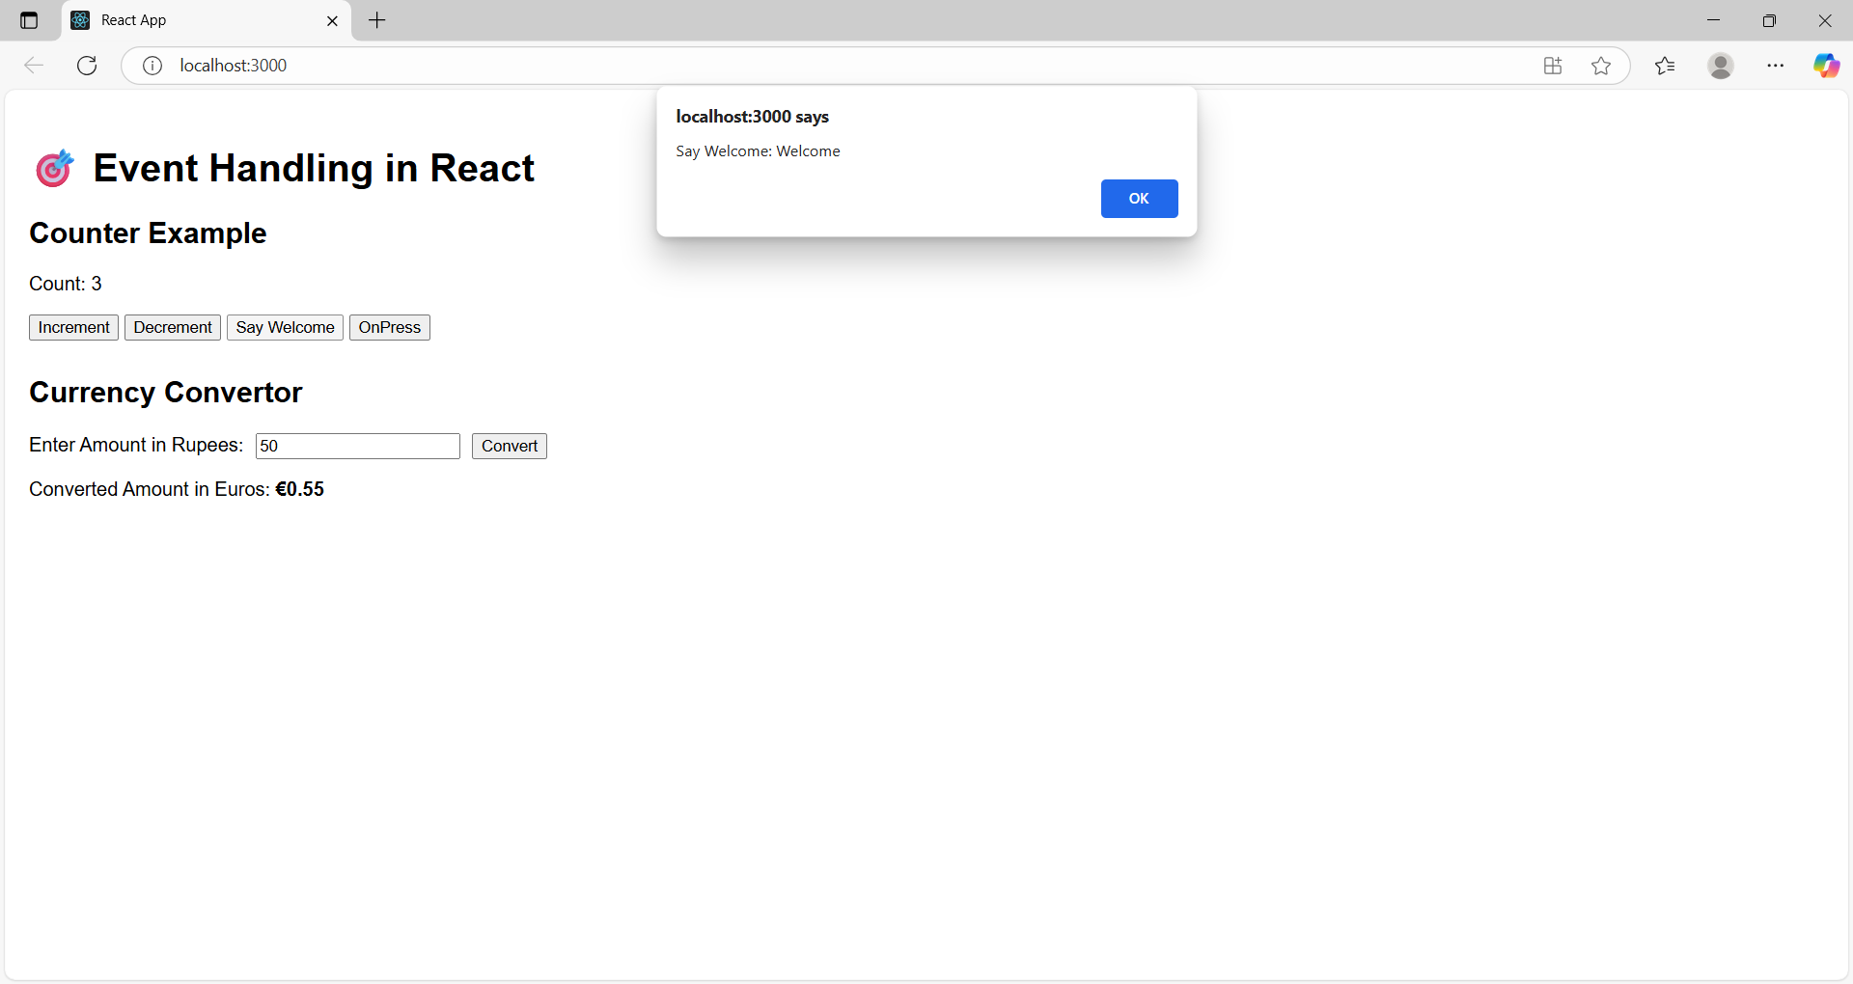

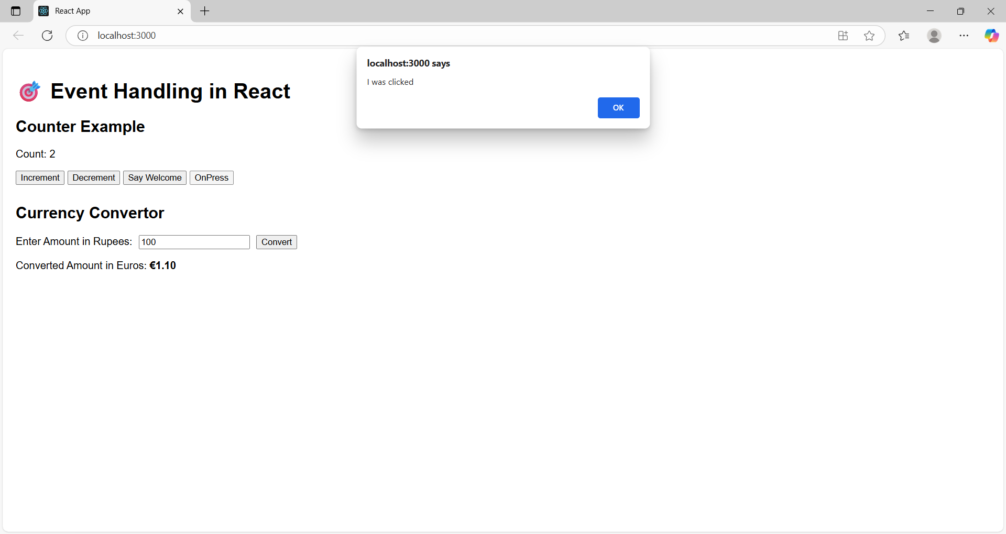

**Exercise-12:**

**GuestPage.js**

import React from 'react';

const GuestPage = () => {

return (

<div>

<h2>Welcome, Guest!</h2>

<p>You can browse flights, but please log in to book tickets.</p>

<ul>

<li>✈️ Hyderabad → Delhi (8:00 AM)</li>

<li>✈️ Chennai → Mumbai (9:30 AM)</li>

<li>✈️ Bangalore → Kolkata (7:15 PM)</li>

</ul>

</div>

);

};

export default GuestPage;

**UserPage.js**

import React from 'react';

const UserPage = () => {

const handleSubmit = (e) => {

e.preventDefault();

alert("Ticket booked successfully!");

};

return (

<div>

<h2>Welcome, User!</h2>

<p>You can now book your tickets:</p>

<form onSubmit={handleSubmit}>

<label>

Select Flight:

<select>

<option>Hyderabad → Delhi</option>

<option>Chennai → Mumbai</option>

<option>Bangalore → Kolkata</option>

</select>

</label>

<br /><br />

<label>

Passenger Name:

<input type="text" placeholder="Enter name" />

</label>

<br /><br />

<button type="submit">Book Ticket</button>

</form>

</div>

);

};

export default UserPage;

**App.js**

import React, { useState } from 'react';

import GuestPage from './components/GuestPage';

import UserPage from './components/UserPage';

function App() {

const [isLoggedIn, setIsLoggedIn] = useState(false);

let page;

if (isLoggedIn) {

page = <UserPage />;

} else {

page = <GuestPage />;

}

return (

<div style={{ padding: "20px", fontFamily: "Arial" }}>

<h1> Ticket Booking App</h1>

<div>

{isLoggedIn ? (

<button onClick={() => setIsLoggedIn(false)}>Logout</button>

) : (

<button onClick={() => setIsLoggedIn(true)}>Login</button>

)}

</div>

<hr />

{page}

</div>

);

}

export default App;

**OUTPUT:**

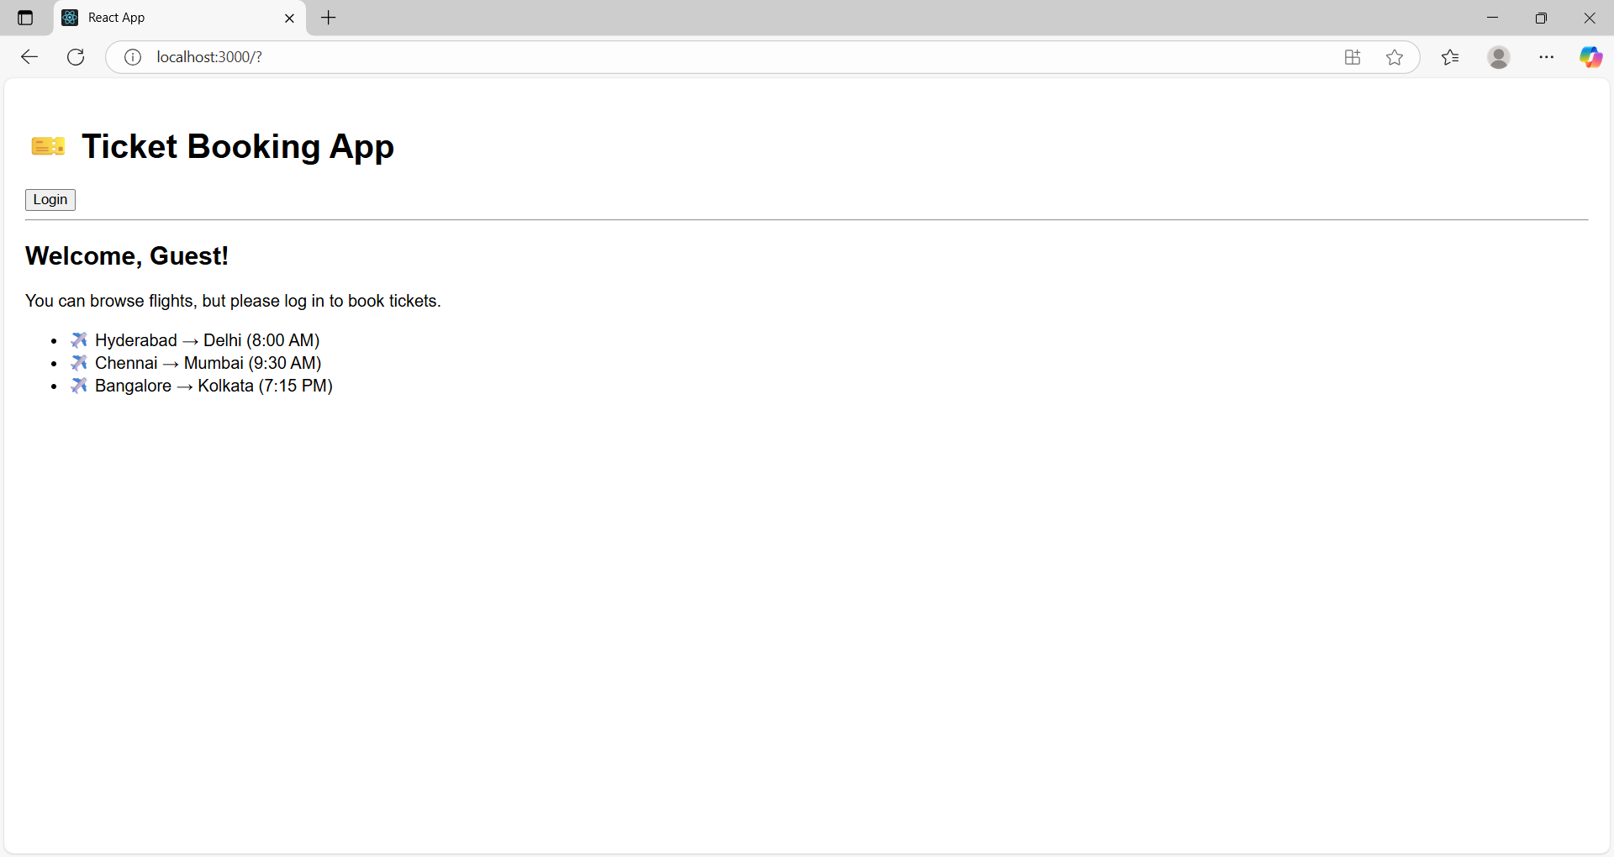

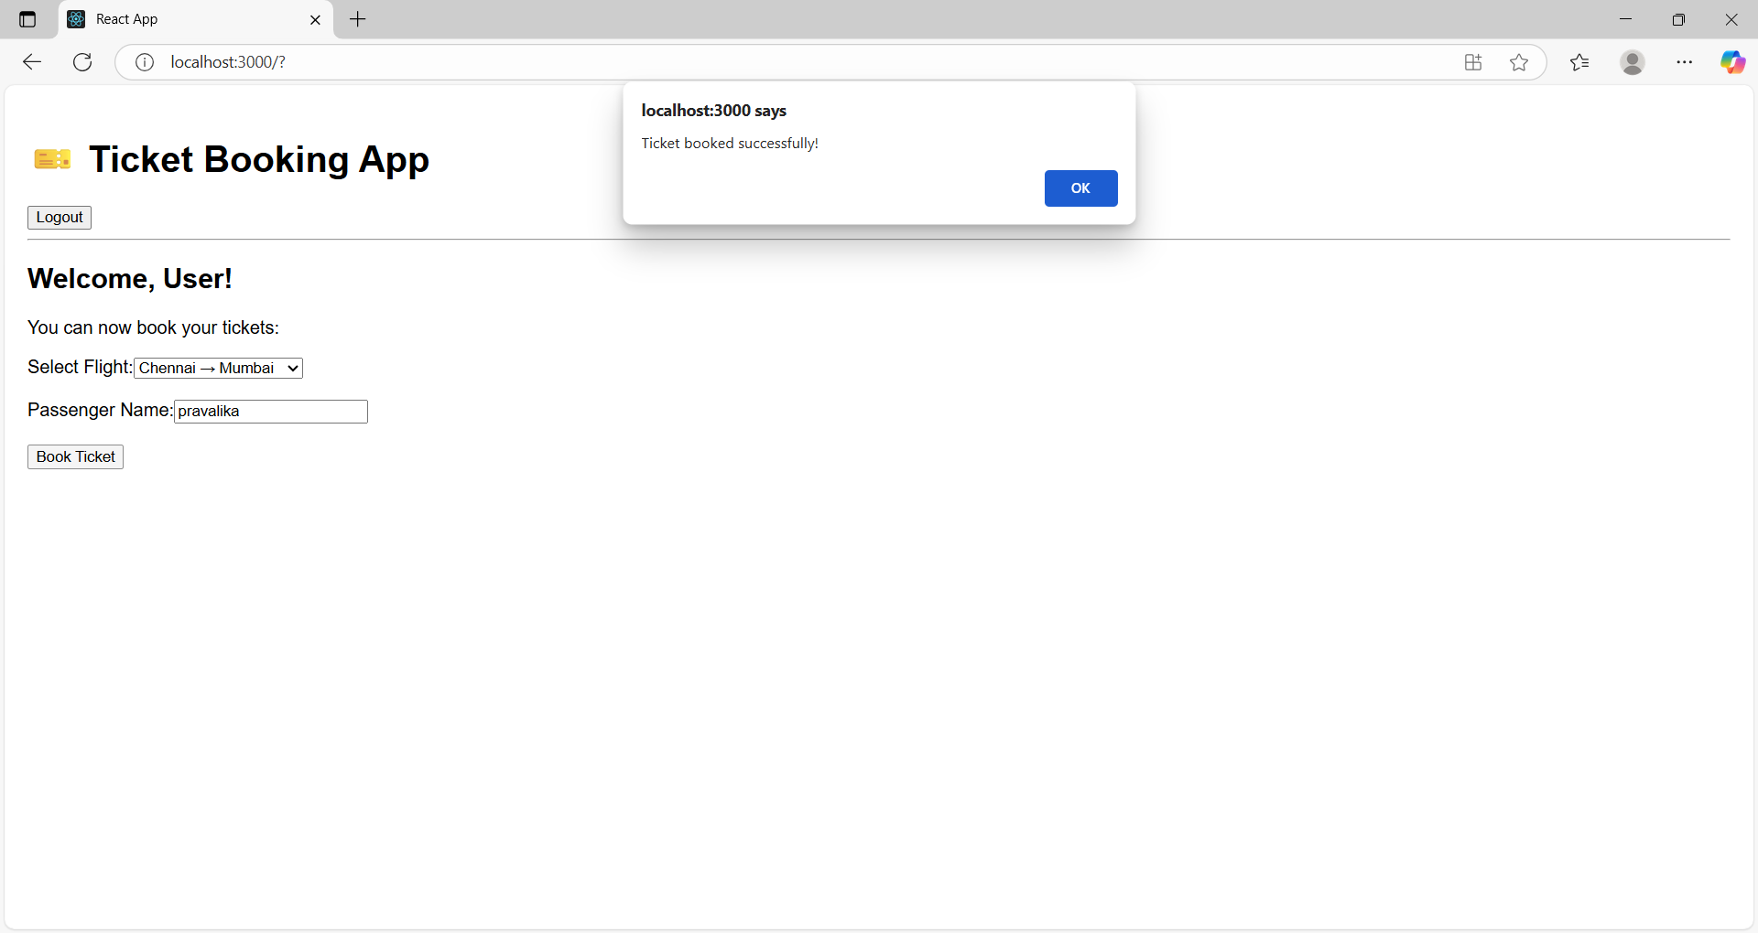

**Exercise-13:**

**App.js**

import React, { useState } from 'react';

import BookDetails from './components/BookDetails';

import BlogDetails from './components/BlogDetails';

import CourseDetails from './components/CourseDetails';

function App() {

const [selected, setSelected] = useState("none");

return (

<div style={{ padding: 20 }}>

<h1>📚 Blogger App</h1>

<select onChange={(e) => setSelected(e.target.value)}>

<option value="none">-- Select Section --</option>

<option value="books">Book Details</option>

<option value="blogs">Blog Details</option>

<option value="courses">Course Details</option>

</select>

<hr />

{selected === "none" && <p>Please select a section</p>}

{selected === "books" ? <BookDetails /> :

selected === "blogs" ? <BlogDetails /> :

selected === "courses" ? <CourseDetails /> : null}

</div>

);

}

export default App;

**BookDetails.js**

const books = [

{ id: 1, title: "Atomic Habits", author: "James Clear" },

{ id: 2, title: "Ikigai", author: "Héctor García" },

];

const BookDetails = () => {

return (

<div>

<h2>📖 Book List</h2>

<ul>

{/* React Map with Keys */}

{books.map(book => (

<li key={book.id}>

<strong>{book.title}</strong> by {book.author}

</li>

))}

</ul>

</div>

);

};

export default BookDetails;

**BlogDetails.js**

const BlogDetails = () => {

const isLoggedIn = true;

return (

<div>

<h2>📝 Blog Articles</h2>

{isLoggedIn && <p>Welcome back, here are your saved blogs:</p>}

<ul>

{["React Basics", "Advanced React", "JSX vs HTML"].map((title, index) => (

<li key={index}>{title}</li>

))}

</ul>

</div>

);

};

export default BlogDetails;

**CourseDetails.js**

import React from 'react';

const CourseDetails = () => {

const courses = [

{ id: 1, name: "ReactJS", duration: "4 weeks" },

{ id: 2, name: "NodeJS", duration: "6 weeks" },

{ id: 3, name: "MongoDB", duration: "3 weeks" },

];

return (

<div>

<h2>🎓 Course Details</h2>

<ul>

{courses.map(course => (

<CourseItem key={course.id} course={course} />

))}

</ul>

</div>

);

};

const CourseItem = ({ course }) => {

return (

<li>

{course.name} - <em>{course.duration}</em>

</li>

);

};

export default CourseDetails;

**OUTPUT:**

