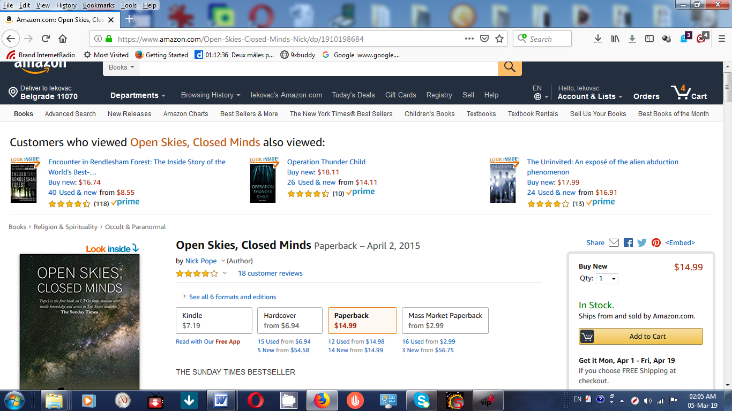

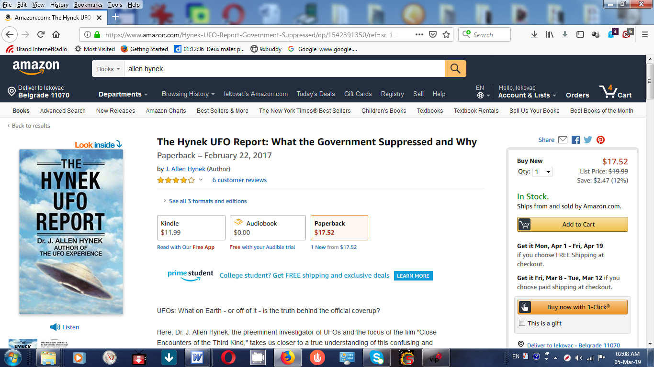

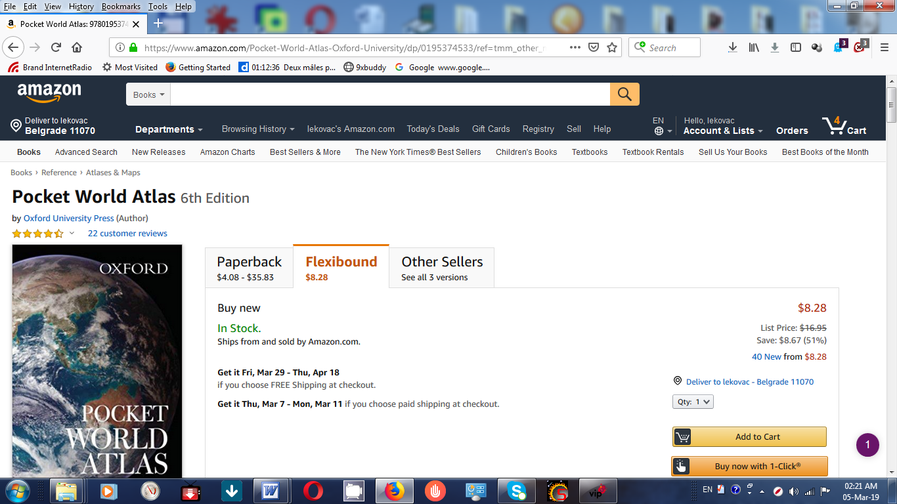

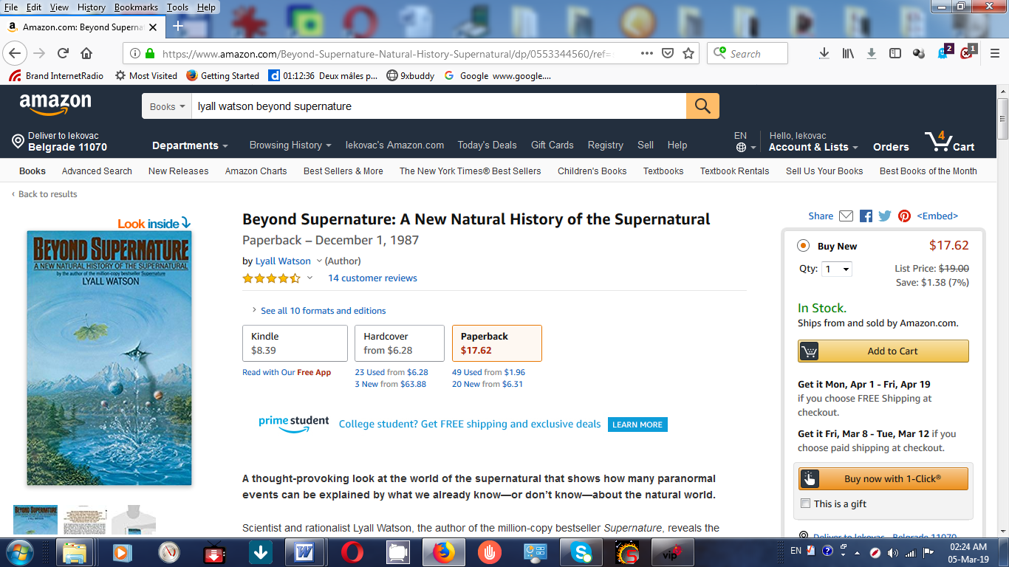
Amazon.com Today's Deals Gift Cards Sell Registry Help Disability Customer Support
Books Advanced Search New Releases Amazon Charts Best Sellers & More The New York Times® Best Sellers Children's Books Textbooks Textbook Rentals Sell Us Your Books Best Books of the Month Kindle eBooks
‹ Return to product information Have one to sell? Every purchase on Amazon.com is protected by an A-to-z guarantee. Feedback on this page? Tell us what you think

Hyperspace (Paperback)
by Michio Kaku (Author)
4.8 out of 5 stars 10 customer reviews Share
Price + Shipping
Condition (Learn more)
Delivery
Seller Information
Buying Options

$17.92
New
- Arrives between Mar. 25 - April 9.
- Ships from United Kingdom. Learn more about import fees and international shipping time.
- Shipping rates and return policy. m

