**DATA DICTIONARY**

|  |  |  |  |
| --- | --- | --- | --- |
| **NAME** | **ALIAS** | **WHERE USED** | **DESCRIPTION** |
| User Credentials | Login/Register | During the registration and login. | Whenever a new user registers on the website he gets a new login ID and password (That they choose), and their information gets stored in the dataset.  Whenever an already registered user logs in the credentials are matched form here. |
| Donation | Donation | Whenever a new donation is made. | Whenever some donation is made, it is recorded in the donation database. |
| Suggestion | Suggestion | When any registered/unregistered user fills the suggestion form. | Whenever any registered/unregistered user gives any suggestion by filling the suggestion form the form’s data is stored here on submission. The admin can access the suggestions. |

**DATA FLOW DIAGRAMS**

**LEVEL-0**

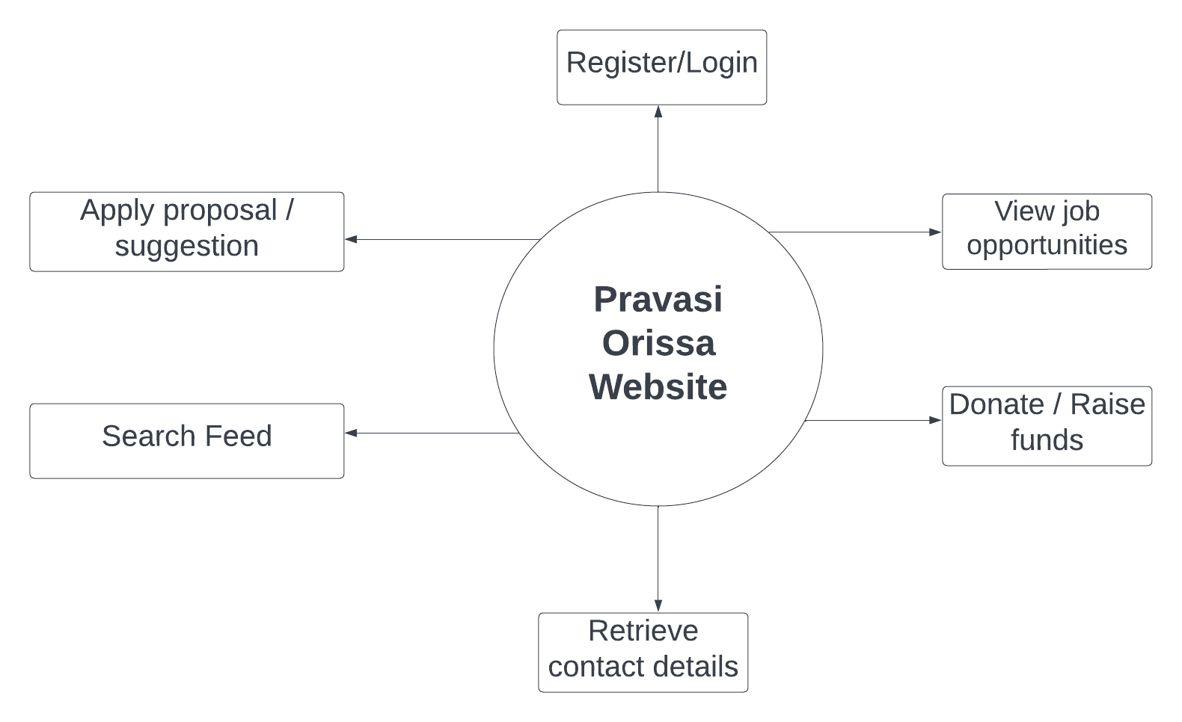

**LEVEL-1**

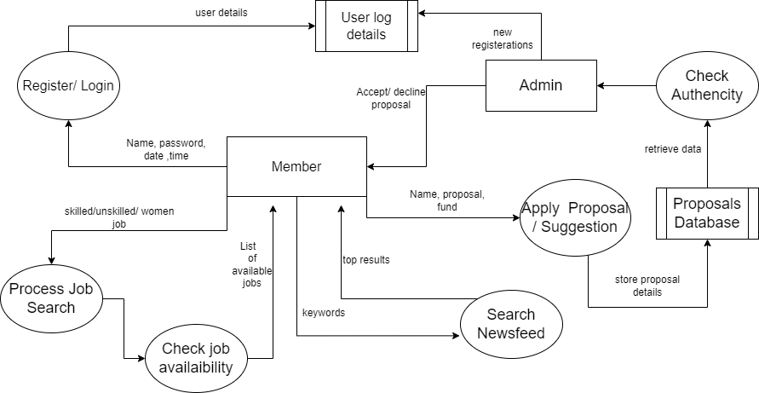

**ER-DIAGRAM**

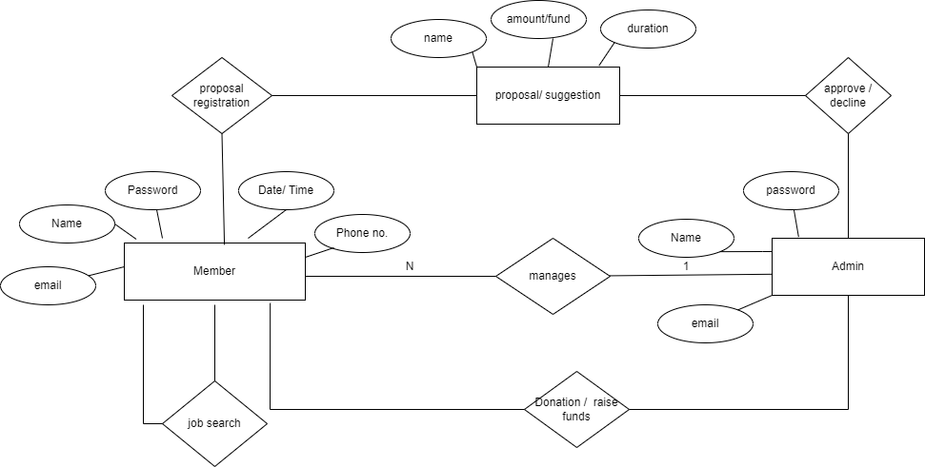

**DATABASE DESIGN**

**User Credential Database**

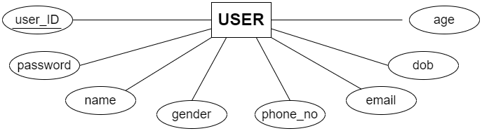

|  |  |  |  |  |  |  |  |
| --- | --- | --- | --- | --- | --- | --- | --- |
| user_ID | password | name | gender | phone_no | email | dob | age |

**Donation Database**

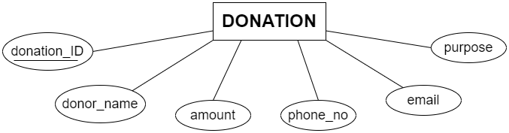

|  |  |  |  |  |  |
| --- | --- | --- | --- | --- | --- |
| donation_id | donor_name | amount | phone_no | email | purpose |

**Suggestion Database**

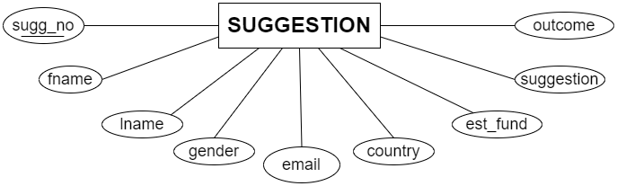

|  |  |  |  |  |  |  |  |  |
| --- | --- | --- | --- | --- | --- | --- | --- | --- |
| sugg_no | fname | lname | gender | email | country | est_fund | suggestion | outcome |

**DATABASE SCHEMAS**

A database schema is the skeleton structure that represents the logical view of the entire database. It defines how the data is organized and how the relations among them are associated. It formulates all the constraints that are to be applied on the data.

A database schema defines its entities and the relationship among them. It contains a descriptive detail of the database, which can be depicted by means of schema diagrams. It’s the database designers who design the schema to help programmers understand the database and make it useful.

**User Credential Database**

**Table Name:** user_credentials

**Primary Key:** user_ID

**Description:** User login and other mandatory credentials are stored here.

|  |  |  |  |  |
| --- | --- | --- | --- | --- |
| **S.No.** | **Field Name** | **Data Type** | **Constraints** | **Description** |
| 1. | user_ID | INTEGER | PRIMARY KEY | Unique User ID for already registered users. |
| 2. | password | VARCHAR(20) | NOT NULL | Unique Password chosen by the User. |
| 3. | name | VARCHAR(20) | NOT NULL | Name of the user. |
| 4. | gender | RADIO BUTTON | NOT NULL | Gender of the user. |
| 5. | phone_no | NUMBER | NOT NULL | Phone number of the user. |
| 6. | email | VARCHAR(20) | NOT NULL | Email ID of the user. |
| 7. | dob | DATE | NOT NULL | User’s Date of Birth. |
| 8. | age | INTEGER | NOT NULL | User’s age. |

**Donation Database**

**Table Name:** donation_record

**Primary Key:** donation_ID

**Description:** To store records of donations made on website.

|  |  |  |  |  |
| --- | --- | --- | --- | --- |
| **S.No.** | **Field Name** | **Data Type** | **Constraints** | **Description** |
| 1. | donation_ID | INTEGER | PRIMARY KEY | Unique donation ID provided for every donation made. |
| 2. | Donor_name | VARCHAR(20) | NOT NULL | Name of person or organisation that donated. |
| 3. | Amount | DOUBLE | NOT NULL | Donation amount. |
| 4. | Phone_no | NUMBER | NOT NULL | Contact Number of person or organisation donating. |
| 5. | email | VARCHAR(20) | NOT NULL | Email ID of person or organisation donating. |
| 6. | purpose | VARCHAR(15) | NULL | Purpose of Donation (Education, Women Health, etc.) . |

**Suggestion Database**

**Table Name:** suggestion_record

**Primary Key:** sugg_no

**Description:** To store the records of suggestions accepted on website.

|  |  |  |  |  |
| --- | --- | --- | --- | --- |
| **S.No.** | **Field Name** | **Data Type** | **Constraints** | **Description** |
| 1. | sugg_no | INTEGER() | PRIMARY KEY | Unique suggestion number provided. |
| 2. | fname | VARCHAR(10) | NOT NULL | First Name of person who has filled the suggestion form. |
| 3. | lname | VARCHAR(10) | NOT NULL | Last name of person who has filled the suggestion form. |
| 4. | gender | RADIO BUTTON | NOT NULL | Gender of the person. |
| 5. | email | VARCHAR(20) | NOT NULL | Email ID of person who filled the suggestion form. |
| 6. | country | DROPDOWN | NOT NULL | Country of person who filled the suggestion form. |
| 7. | est_fund | FLOAT | NOT NULL | Estimated Fund. |
| 8. | suggestions | TEXT | NOT NULL | Suggestion of the person. |
| 9. | outcome | TEXT | NOT NULL | Outcome. |

**TIMELINE CHART**

