A PROJECT REPORT ON

POST QUANTUM ATTESTATION AND INTRUSION AWARE CAN FD NETWORKING
SELECTIVE RECOVERY AND EDGE ANOMALY DETECTION
Submitted in partial fulfilment of the requirements for the award of the degree of
BACHELOR OF TECHNOLOGY IN
[PROGRAM NAME WITH SPECIALIZATION]
[TEAM MEMBER 1 NAME] ([REGISTER NUMBER])
[TEAM MEMBER 2 NAME] ([REGISTER NUMBER])
[TEAM MEMBER 3 NAME] ([REGISTER NUMBER])

SCHOOL OF COMPUTER SCIENCE AND ENGINEERING
VELLORE INSTITUTE OF TECHNOLOGY
CHENNAI
[MONTH YEAR]

TITLE PAGE

POST QUANTUM ATTESTATION AND INTRUSION AWARE CAN FD NETWORKING
SELECTIVE RECOVERY AND EDGE ANOMALY DETECTION
BCE497J PROJECT REPORT
Bachelor of Technology in
[PROGRAM NAME WITH SPECIALIZATION]
Submitted by
[TEAM MEMBER 1 NAME] ([REGISTER NUMBER])
[TEAM MEMBER 2 NAME] ([REGISTER NUMBER])
[TEAM MEMBER 3 NAME] ([REGISTER NUMBER])
Individual report of [CANDIDATE NAME] ([REGISTER NUMBER])
Under the guidance of [GUIDE NAME]
[GUIDE DESIGNATION]
SCHOOL OF COMPUTER SCIENCE AND ENGINEERING
VELLORE INSTITUTE OF TECHNOLOGY CHENNAI
[MONTH YEAR]

DECLARATION
I, [CANDIDATE NAME] ([REGISTER NUMBER]), declare that the project report entitled “Post Quantum Attestation and Intrusion Aware CAN FD Networking: Selective Recovery and Edge Anomaly Detection” submitted for the award of Bachelor of Technology in [PROGRAM NAME WITH SPECIALIZATION] at Vellore Institute of Technology, Chennai, is a record of work carried out under the supervision of [GUIDE NAME], [GUIDE DESIGNATION].
I further declare that the work reported in this report has not been submitted, and will not be submitted, either in part or in full, for the award of any other degree or diploma in this institute or another institution.
Place: Chennai
Date: [DATE]
Signature of the candidate: ____________________
[CANDIDATE NAME]
Declaration retained as an unsigned submission form pending candidate confirmation.

CERTIFICATE
This is to certify that the report entitled “Post Quantum Attestation and Intrusion Aware CAN FD Networking: Selective Recovery and Edge Anomaly Detection” is prepared and submitted by [CANDIDATE NAME] ([REGISTER NUMBER]) to Vellore Institute of Technology, Chennai, in partial fulfilment of the requirements for the award of Bachelor of Technology in [PROGRAM NAME WITH SPECIALIZATION], under the guidance of [GUIDE NAME].
Certification of the work, compliance with University requirements and acceptance for submission are subject to review and signature by the authorized guide and examiners.
Signature of guide: ____________________
Name: [GUIDE NAME AND DESIGNATION]
Date: [DATE]
Examiner 1: ____________________ Examiner 2: ____________________
Names: [EXAMINER NAMES]
Dates: [DATES]
Approved by the Head of Department
[PROGRAM NAME WITH SPECIALIZATION]
[HOD NAME]
Signature: ____________________ Date: [DATE]
[SCHOOL SEAL]

ABSTRACT
This project studies post-quantum ECU attestation, reliable transport of a large protected object and layered intrusion detection for CAN-FD networks. A 2,420-byte ML-DSA-44 signature and 16-byte Ascon tag form a 2,436-byte protected object, fragmented into 41 payloads with a 4-byte transport header and 60-byte data region. A missing-frame bitmap supports selective retransmission over at most three recovery rounds. Runtime checks combine authenticated framing, replay control, discrete invariants and a 14-dimensional LSTM autoencoder. The study reviews existing code and archived artifacts rather than generating new measurements. In the manifest-anchored software-laboratory archive, all twenty canonical omission trials report successful recovery, with scenario means of 20.878–33.275 ms; selected negative cases exceed the experimental 50 ms budget. Saved IDS evaluations show that high ROC-AUC can coexist with zero recall or excessive false-positive rates at deployed thresholds. Actual committed ONNX files occupy 108,879 bytes in FP32 and 39,254 bytes in dynamic INT8. Conflicting metadata, deterministic benchmark keys and software timing limit broader claims. The contribution is an inspectable architecture and qualified evaluation, with secure lifecycle integration, calibrated detection and physical CAN-FD validation remaining future work.
Keywords: CAN-FD; ML-DSA-44; Ascon-AEAD128; selective recovery; intrusion detection; federated learning.

ACKNOWLEDGEMENT
I express my gratitude to [GUIDE NAME], [GUIDE DESIGNATION], School of Computer Science and Engineering, Vellore Institute of Technology, Chennai, for guidance and review of this project.
I thank the faculty and staff of the School of Computer Science and Engineering for academic support. I acknowledge the contributions of my project team members, [TEAM MEMBER NAMES], and the published standards, open-source implementations and ROAD dataset on which this research builds.
I thank my family and friends for their support. Specific personal acknowledgements may be completed by the candidate before submission.
Place: Chennai
Date: [DATE]
[CANDIDATE NAME]

CONTENTS
CHAPTER 1 INTRODUCTION 11
CHAPTER 2 BACKGROUND AND RELATED WORK 14
CHAPTER 3 ARCHITECTURE AND SECURITY PROTOCOL 17
CHAPTER 4 TRANSPORT AND RECOVERY 22
CHAPTER 5 INTRUSION DETECTION AND FEDERATED LEARNING 26
CHAPTER 6 IMPLEMENTATION AND EXPERIMENTAL METHOD 33
CHAPTER 7 RESULTS AND DISCUSSION 37
CHAPTER 8 CONCLUSION AND FUTURE WORK 42
REFERENCES 45
APPENDIX 1 FAULT RECOVERY DATA DICTIONARY 47
APPENDIX 2 ARCHIVED RUN REGISTER 55
APPENDIX 3 FIGURE INTERPRETATION 59
APPENDIX 4 REPRODUCIBILITY AND TRACEABILITY 64

LIST OF FIGURES
Figure 3.1 Four-domain CISG architecture 18
Figure 5.1 Layered IDS design 27
Figure A3.1 Four-phase methodology 59
Figure A3.2 Integration blueprint 60
Figure A3.3 Attack-routing design 61
Figure A3.4 Masquerade decision view 62
Figure A3.5 Historical training loss 63

LIST OF TABLES
Table 1 Abbreviations used in this report 10
Table 2 Objectives And Scope 12
Table 3 Related Work And Design Basis 14
Table 4 Phase Boundaries And Responsibilities 19
Table 5 Runtime Frames And Trusted State 21
Table 6 Fragmentation Algorithm 22
Table 7 Missing Frame Bitmap And Selective Recovery 23
Table 8 Failure States And Admission Policy 24
Table 9 Feature Pipeline And Calibration 28
Table 10 Accepted History And Buffer Quarantine 29
Table 11 Onnx Artifacts And Runtime Claims 30
Table 12 Federated Training Design 31
Table 13 Federated Generalization And False Alarms 32
Table 14 Laboratory Orchestration 33
Table 15 Running And Collecting Evidence 34
Table 16 Canonical Transport Results 37
Table 17 Negative Cases And Observational Runs 38
Table 18 Wire Attack Observations 39
Table 19 Ids Operating Point Results 40
Table 20 Archived run rows 1 to 8 55
Table 21 Archived run rows 9 to 16 56
Table 22 Archived run rows 17 to 24 57
Table 23 Archived run rows 25 to 31 58
Table 24 Reproducibility And Traceability 64
Table 25 Figure And Claim Reconciliation 66

SYMBOLS ABBREVIATIONS AND NOMENCLATURE
Table 1 Abbreviations used in this report
Term | Meaning
AEAD | Authenticated encryption with associated data
CAN-FD | Controller Area Network with Flexible Data Rate
CISG | Central in-vehicle security gateway
ECU | Electronic control unit
FedAvg | Federated averaging
FTTI | Fault tolerant time interval
HKDF | HMAC-based key derivation function
IDS | Intrusion detection system
LSTM | Long short-term memory
ML-DSA | Module-lattice-based digital signature algorithm
NACK | Negative acknowledgement
ONNX | Open Neural Network Exchange
PAO | Protected attestation object
PMU | Performance monitoring unit
PUF | Physical unclonable function
ROAD | Real ORNL Automotive Dynamometer
ROC-AUC | Area under receiver operating characteristic curve
ZOH | Zero-order hold

CHAPTER 1
INTRODUCTION

1.1 INTRODUCTION AND PROBLEM
In-vehicle networks carry measurements, commands and diagnostics among electronic control units (ECUs). The project considers four logical domains—powertrain, chassis, body and comfort, and infotainment—with a central in-vehicle security gateway (CISG). CAN identifiers support arbitration and application routing; they do not by themselves establish the identity or integrity of a sender. A security design must therefore address both unauthorized injection and apparently valid messages produced by a compromised enrolled node.
The project combines post-quantum boot attestation, authenticated runtime traffic, bounded selective retransmission and an intrusion detection system (IDS). These mechanisms address different failure modes. A lattice signature authenticates an attestation transcript, authenticated encryption detects message modification, recovery handles omitted fragments, and physical consistency checks seek attacks that remain cryptographically valid.
This report documents an implemented research prototype and its archived evidence. The principal result is a recoverable attestation transport and a layered detection design. The repository does not establish production readiness, vehicle-level functional safety certification, or timing guarantees on automotive hardware. Those distinctions determine how the results are interpreted.

1.2 OBJECTIVES AND SCOPE
The first objective is to make a large post-quantum attestation object transportable within CAN-FD payload limits. The second is to recover spatially localized loss without restarting the entire object. The third is to reject malformed, replayed and unauthenticated runtime messages before they influence model state. The fourth is to study the portability and calibration of an anomaly detector under heterogeneous driving conditions.
The implemented and archived components span Phase 1 cryptographic and frame definitions, Phase 2 transport simulation and IDS experiments, Phase 3 orchestration and data contracts, and a Phase 4 hardware plan. Software provisioning substitutes for physical PUF enrollment in the laboratory. ROAD-derived experiments are secondary dataset evidence; they are not recordings from this project’s own vehicle.
The evaluation uses existing files only. No benchmark is rerun, no synthetic measurement is introduced, and no missing value is imputed as an observation. Analytical predictions remain explicitly labeled. Candidate identity, degree specialization, guide, submission date and signatures remain placeholders until confirmed.
Table 2 Objectives And Scope
Objective | Evidence or boundary
Recover large objects | 41 indexed fragments; bitmap recovery
Reject wire abuse | Archived replay, tag, header and flood decisions
Detect semantic abuse | ROAD-based saved IDS evaluations
Assess embedded feasibility | Artifact sizes and historical development timings
Establish vehicle safety | Outside demonstrated scope

1.3 CONTRIBUTIONS AND RESEARCH QUESTIONS
The engineering contribution is the integration of a fixed-size fragmentation protocol with a layered admission path and an inspectable evidence contract. The 60/4 partition reserves four bytes for transport state and sixty bytes for protected-object data. A 64-bit missing-frame bitmap represents all forty-one fragments, making the recovery request compact and independent of the object contents.
The research questions are whether localized omission can be recovered without full retransmission, whether cryptographic rejection can be separated from stateful anomaly detection, and whether federated adaptation improves consistency across driving partitions without creating unacceptable false alarms. A fourth question concerns evidence quality: whether recorded timing, model metadata and build provenance support the claims attached to them.
The results answer these questions unevenly. The archived canonical omission trials recover successfully. The saved detection artifacts show that score ranking and operating-threshold quality can diverge sharply. Provenance checks also identify conflicting result collections and historical metadata. These are technical findings, rather than grounds for silently choosing the most favorable numbers.

CHAPTER 2
BACKGROUND AND RELATED WORK

2.1 RELATED WORK AND DESIGN BASIS
ML-DSA is standardized in NIST FIPS 204 (2024). ML-DSA-44 uses a 2,420-byte signature, making direct placement in a single CAN-FD frame impossible. The project uses signatures at enrollment or admission rather than attaching a lattice signature to every runtime message. Ascon-AEAD128 is standardized in NIST SP 800-232 (2025) and provides authenticated encryption for constrained-device designs. Neither standard certifies this project’s protocol composition (NIST, 2024, 2025).
HKDF separates extraction of pseudorandom key material from expansion into context-bound keys. A bootstrap design can use HKDF-SHA256 with enrollment material and session context, but security depends on entropy, separation and lifecycle management; calling HKDF alone does not create a fresh secret (Krawczyk & Eronen, 2010).
CAN response-time analysis must include arbitration, blocking, higher-priority interference and transmission costs. Davis et al. (2007) show why simplified schedulability arguments can be unsound. This report therefore does not equate observed laboratory means with worst-case response times.
Table 3 Related Work And Design Basis
Source | Role in this project
FIPS 204 | Signature algorithm and parameter sizes
SP 800-232 | Ascon-AEAD128 specification
RFC 5869 | Bootstrap key derivation design
Davis et al. (2007) | Limits of simplified timing analysis

2.2 DATASET AND FEDERATED LEARNING CONTEXT
The Real ORNL Automotive Dynamometer (ROAD) dataset contains over 3.5 hours of one vehicle’s CAN data. Its publication distinguishes real recorded attack activity from simulated masquerade constructions. Using ROAD supports realistic signal relationships, but it does not establish performance across manufacturers, vehicle platforms or every attack family (Verma et al., 2024).
Federated averaging aggregates locally trained model parameters in proportion to client sample counts. The project applies this idea to five heterogeneous partitions of ROAD ambient data. The partitions emulate client silos within a training experiment; they are not five independently instrumented vehicles. The distinction matters when interpreting fleet generalization or privacy claims (McMahan et al., 2017).
Cryptographic authentication and anomaly detection are complementary. A compromised legitimate ECU can possess valid keys while transmitting physically implausible values. Conversely, a cryptographically invalid frame can be rejected without invoking a learned detector. Evaluating both cases together under a single accuracy figure would obscure their different assumptions and denominators.

2.3 THREAT MODEL AND ASSUMPTIONS
The design distinguishes an unenrolled injector, a network fault source, and a compromised enrolled sender. The injector may replay observed frames, forge tags, spoof logical-domain fields or flood a segment. The fault source deliberately omits selected fragments or recovery controls. The enrolled attacker motivates invariant and kinematic checks because authentication alone cannot establish truthfulness of sensor data.
The central gateway and enrollment authority are trusted in the architecture. The fault relay is a laboratory instrument and should not possess application keys. Management HTTP and experiment commands are orchestration channels, not evidence of a CAN security protocol. Isolation of that management plane is an implementation requirement, not a property of CAN identifiers.
The current C++ benchmark source contains deterministic challenge generation and fixed test-key use. These choices constrain security claims for that execution path. The conceptual enrollment and fresh-key architecture must not be presented as fully realized by every revision of the benchmark. Physical key extraction, adversarial gateway compromise, electromagnetic fault physics and secure boot hardware are outside the demonstrated experiment.

CHAPTER 3
ARCHITECTURE AND SECURITY PROTOCOL

3.1 SYSTEM ARCHITECTURE
The CISG terminates each logical domain independently. In the intended path, an ECU responds to a boot challenge with a signed transcript protected under a bootstrap key. After complete reassembly, the gateway verifies the authenticated-encryption tag and signature before operational admission. Runtime messages then pass wire integrity checks, semantic invariants and an anomaly detector where appropriate.
The Docker laboratory separates ECU, gateway, relay and controller roles into services. Linux SocketCAN and vxcan provide a software networking path for CAN frames. A vxcan link does not reproduce transceiver voltage, arbitration on a physical wire, oscillator drift, electromagnetic interference or a hardware receive timestamp. Deliberate omissions emulate transport loss; their names do not prove the physics of an inductive relay or alternator.
Figure 3.1 reproduces the supplied four-domain design view. The domains are architectural partitions; the current compose file and namespace topology remain the authority for runtime isolation. Earlier explanatory diagrams and README statements must be checked against the selected implementation revision.
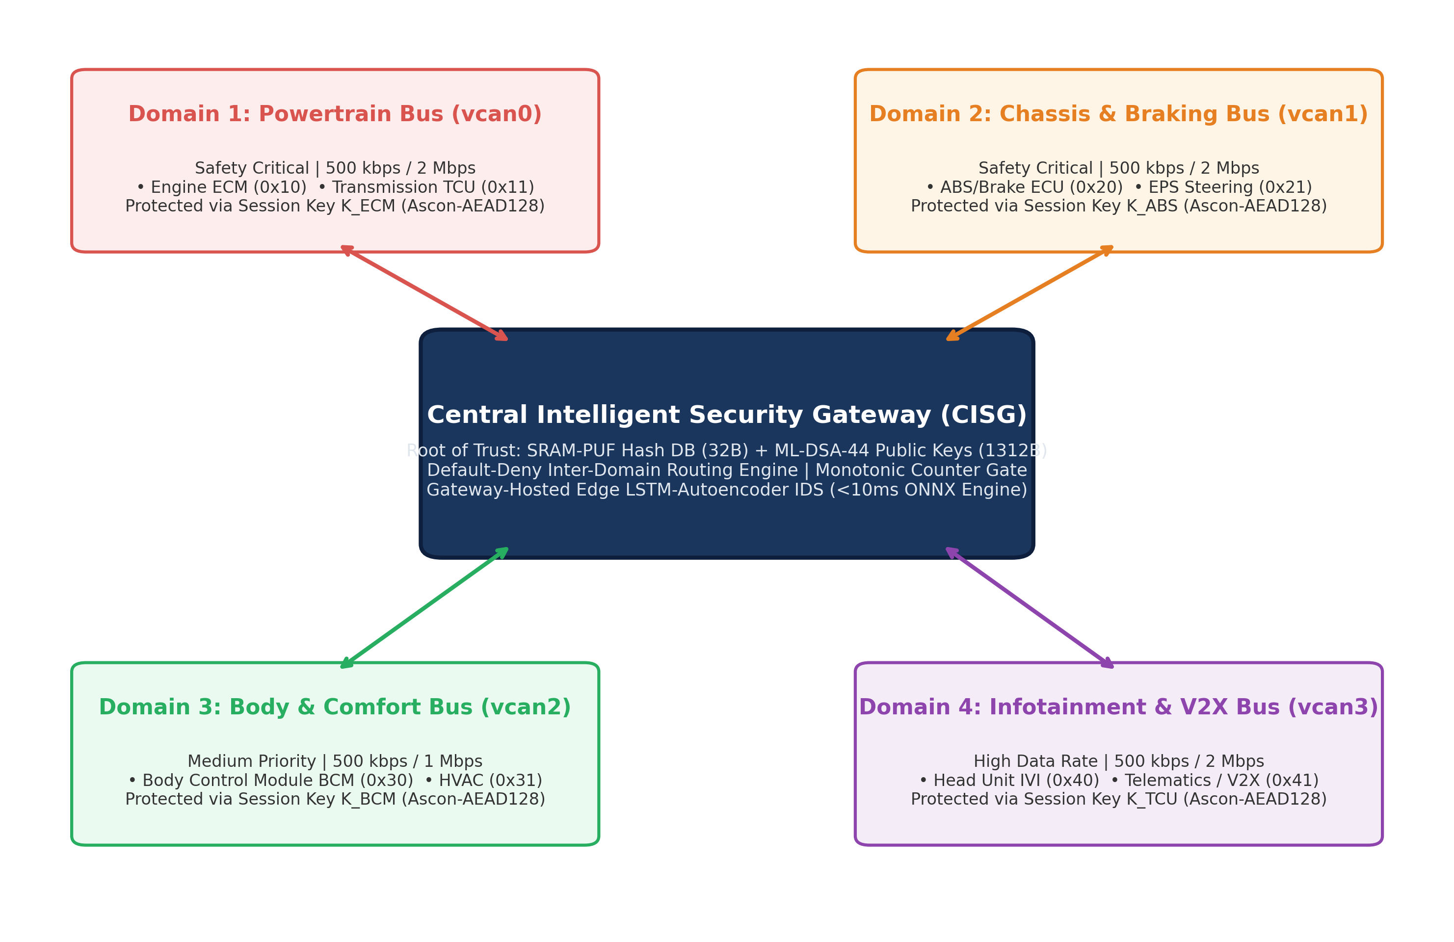
Figure 3.1 Four-domain CISG design view reproduced from the supplied figure document. Physical vehicle topology is proposed; laboratory links are virtual.

3.2 PHASE BOUNDARIES AND RESPONSIBILITIES
Phase 1 defines the cryptographic primitives, challenge and protected-frame formats, attestation wrapping and feature extraction. Its Python canfd_schema.py provides an explicit indexed-fragment header and runtime payload structure. These definitions are useful reference semantics even when another language implements the execution path.
Phase 2 contains the simulation contract, red-team modules, baseline LSTM, ONNX export and federated learning artifacts. Its work products demonstrate algorithmic behavior and dataset evaluation. Phase 3 adds the orchestration laboratory, strict CSV contracts and aggregate analysis. Phase 4 is a hardware validation plan rather than a completed measurement campaign.
Kunal’s transport deliverables are governed by Phase 3/README.md, the sample_fault_recovery_runs.csv output template and contract_validator.py, with data_contract_schemas.json available as a dependency. CPU profiling and aggregate synthesis are separate responsibilities. Maintaining this separation prevents a simulation row from being mistaken for a PMU observation or a packet-capture row.
Table 4 Phase Boundaries And Responsibilities
Area | Primary repository location
Cryptography and byte formats | Phase 1/CAN FD/Crypto Code
Simulation and attacks | Phase 2/Simulation; Phase 2/Red Team
Model artifacts | Phase 2/IDS
Orchestration | Phase 3/DockerLab
Data validation | Phase 3/Code; Phase 3/config

3.3 ATTESTATION AND KEY LIFECYCLE
The architectural sequence starts with enrollment of a signature identity and bootstrap provisioning material. A challenge and session identifier bind an attestation response to a boot attempt. The ECU signs a canonical transcript containing its measured software identity and session context. The gateway should compare that measurement with an authorized enrollment value, not silently replace the expected value after a failure.
The protected attestation object in the frame design is the 2,420-byte signature ciphertext plus a 16-byte Ascon tag. The software measurement and transcript context are reconstructed or supplied separately for verification; this 2,436-byte length should not be described as a complete transmitted firmware image or a general certificate chain.
After verification, the intended protocol wraps a fresh operational key under the bootstrap key. A secure implementation must enforce nonce uniqueness per key and prevent replay across boot sessions. ML-DSA signing is not a key exchange mechanism and does not itself provide forward secrecy. The fixed-key and deterministic-nonce benchmark path requires correction and dedicated lifecycle validation before deployment claims are appropriate.

3.4 RUNTIME FRAMES AND TRUSTED STATE
The Phase 1 protected runtime frame is 64 bytes: an 8-byte clear header, 40 bytes of encrypted telemetry and a 16-byte authentication tag. The header carries version/type, sender ECU, domain, flags and a 32-bit big-endian counter. Authentication binds relevant header context to the ciphertext. The receiver should reject an invalid header or stale counter before committing replay state.
The 40-byte payload contains seven float32 values, two uint16 wheel speeds, an int16 temperature, a uint16 gear field and a uint32 diagnostic field. That representation is a project-specific telemetry mapping, not an OEM database definition. Recorded ROAD signals must be mapped and scaled explicitly before model inference.
A counter observation must not become trusted merely because it is large. Otherwise a forged high-counter frame could prevent acceptance of later legitimate traffic. Similarly, an unauthenticated sample must not update the learned detector’s input history. The architecture separates parsing, authentication, replay-state commit and accepted-sample commit so these obligations can be evaluated independently.
Table 5 Runtime Frames And Trusted State
Bytes | Runtime reference meaning
0–3 | Version/type, ECU, domain, flags
4–7 | Monotonic counter, big-endian
8–47 | Encrypted telemetry, 40 bytes
48–63 | Ascon tag, 16 bytes

CHAPTER 4
TRANSPORT AND RECOVERY

4.1 FRAGMENTATION ALGORITHM
Let P be the protected attestation length and q the fragment payload capacity. The frame count is N = ceil(P/q). With P = 2,436 and q = 60, N = 41. Frames 0 through 39 each contain 60 object bytes. Frame 40 contains the final 36 object bytes followed by 24 padding bytes. Each frame has a 4-byte transport header and a 64-byte CAN-FD payload.
The reference IndexedAttestationFrame header is session ID, frame index, total frame count and control flags, each one byte. Some supplied schematic pages show an earlier interpretation of those bytes; the implementation’s header format >BBBB is the authority for this report. The one-byte transport session field is a shortened identifier and requires unambiguous association with full session context at the receiver.
The initial CAN data-field volume is 41 × 64 = 2,624 bytes. Protected-object efficiency is 2,436/2,624 = 92.835%. This ratio excludes arbitration, CRC, stuffing, acknowledgement and inter-frame spacing. Calling it physical-wire utilization or application sensor goodput would be incorrect.
Table 6 Fragmentation Algorithm
Quantity | Value
Signature | 2,420 bytes
Tag | 16 bytes
Protected object | 2,436 bytes
Data per fragment | 60 bytes
Fragment count | 41
Initial data-field bytes | 2,624
Final padding | 24 bytes

4.2 MISSING FRAME BITMAP AND SELECTIVE RECOVERY
The receiver maintains a received-fragment set indexed from zero. A recovery bitmap sets bit i when fragment i is missing. For the relay-spike indices 14, 15 and 16, the mask is (1 << 14) | (1 << 15) | (1 << 16) = 0x000000000001c000. The NACK is carried on CAN ID 0x201. Hexadecimal serialization should retain the required 0x prefix and sixteen hex digits.
An ECU retransmits only requested fragments. The receiver verifies session association and bounds before placing data into the reassembly buffer. Duplicate fragments should not increase the count of unique recovered fragments. A late fragment from an older session must not satisfy a missing bit in the current object.
The experiment limits recovery to three rounds. A bounded retry policy provides a deterministic upper bound on the number of recovery attempts, but not a hard execution-time guarantee under arbitrary operating-system scheduling or bus interference. Persistent loss and missing recovery controls must terminate with distinct status codes so their causes remain visible.
Table 7 Missing Frame Bitmap And Selective Recovery
Canonical scenario | Drop string
Clean bus | NONE; burst length 0
Single omission | 12
Late omission | 38
Relay-spike abstraction | 14;15;16
Alternator-burst abstraction | 20;21;22;23;24;25;26;27

4.3 FAILURE STATES AND ADMISSION POLICY
The required statuses are SUCCESS, ERR_RETRY_EXHAUSTION, ERR_TIMEOUT_NACK_WAIT and ERR_CRYPTO_TAG_MISMATCH. The repository additionally records ERR_HEADER_OUT_OF_RANGE for malformed transport state. These are application logger labels used by the project; they are not universal status codes prescribed by ISO 26262.
The experiment compares recorded completion time with a 50,000 microsecond budget. A budget breach should inhibit operational admission according to the configured policy. That policy is an experimental design choice. ISO 26262 defines a functional-safety framework and item-dependent timing concepts; it does not assign a universal 50 ms value to every ECU handshake.
The archived loss-exhaustion and NACK-timeout rows complete after roughly 94 and 91 ms respectively. Their error reporting demonstrates termination behavior, but does not prove transition to an actual vehicle safe state within 50 ms. A logger field such as FALLBACK_LOCKDOWN describes a software state label. Vehicle-level safety requires a hazard analysis, an allocated fault-handling budget, actuator behavior and hardware validation.
Table 8 Failure States And Admission Policy
Status | Interpretation
SUCCESS | Object recovered and accepted by run logic
ERR_RETRY_EXHAUSTION | Bounded retransmission attempts exhausted
ERR_TIMEOUT_NACK_WAIT | Expected recovery control not received
ERR_CRYPTO_TAG_MISMATCH | AEAD verification failed
ERR_HEADER_OUT_OF_RANGE | Transport header rejected

4.4 TIMING AND SCHEDULABILITY MODEL
A CAN-FD transmission-time estimate separates nominal-rate bits from data-rate bits: C = b_nom/R_nom + b_data/R_data. The model must specify frame format, stuffing assumptions, BRS behavior and inter-frame costs. Sleeping for a modeled frame duration on vxcan does not turn a virtual link into a physical CAN-FD controller.
For a complete transfer, latency includes admission setup, fragment transmission, receiver scheduling, recovery request delay, retransmission, cryptographic verification and policy evaluation. Measurements should identify their exact start and stop events. In the current C++ controller path, preparing the ECU before starting the gateway run can exclude work or admit early traffic; that timing boundary must be corrected before new end-to-end claims.
A formal response-time study additionally requires message priorities, release jitter, blocking and interference from the complete traffic set. The recurrence must use an appropriate CAN/CAN-FD scheduling model and demonstrate convergence or deadline failure. The archived analytical studies are useful exploration, but are not measurements of the deployed vehicle or a proof based solely on average utilization (Davis et al., 2007).

CHAPTER 5
INTRUSION DETECTION AND FEDERATED LEARNING

5.1 LAYERED INTRUSION DETECTION
Tier 1 rejects invalid framing, authentication failures, replay and excessive injection rates. Tier 1.5 evaluates discrete semantic invariants, such as consistency of a reverse-light state with the relevant operating state. Tier 2 evaluates continuous physical relationships using an LSTM autoencoder over a sequence window. This ordering reserves model inference for traffic that has passed lower-cost admissibility checks.
A sequence model can flag an unusual but benign operating condition as well as an attack. It therefore needs calibration on representative clean data and evaluation at a declared threshold. Receiver operating characteristic area under the curve (ROC-AUC) measures score ranking across thresholds; it does not establish good performance at the deployed threshold.
Figure 5.1 is the supplied tiered design view. Its placement of stateful learning after wire checks is the relevant architectural idea. Numeric performance labels in historical design illustrations are not treated as current benchmark measurements.
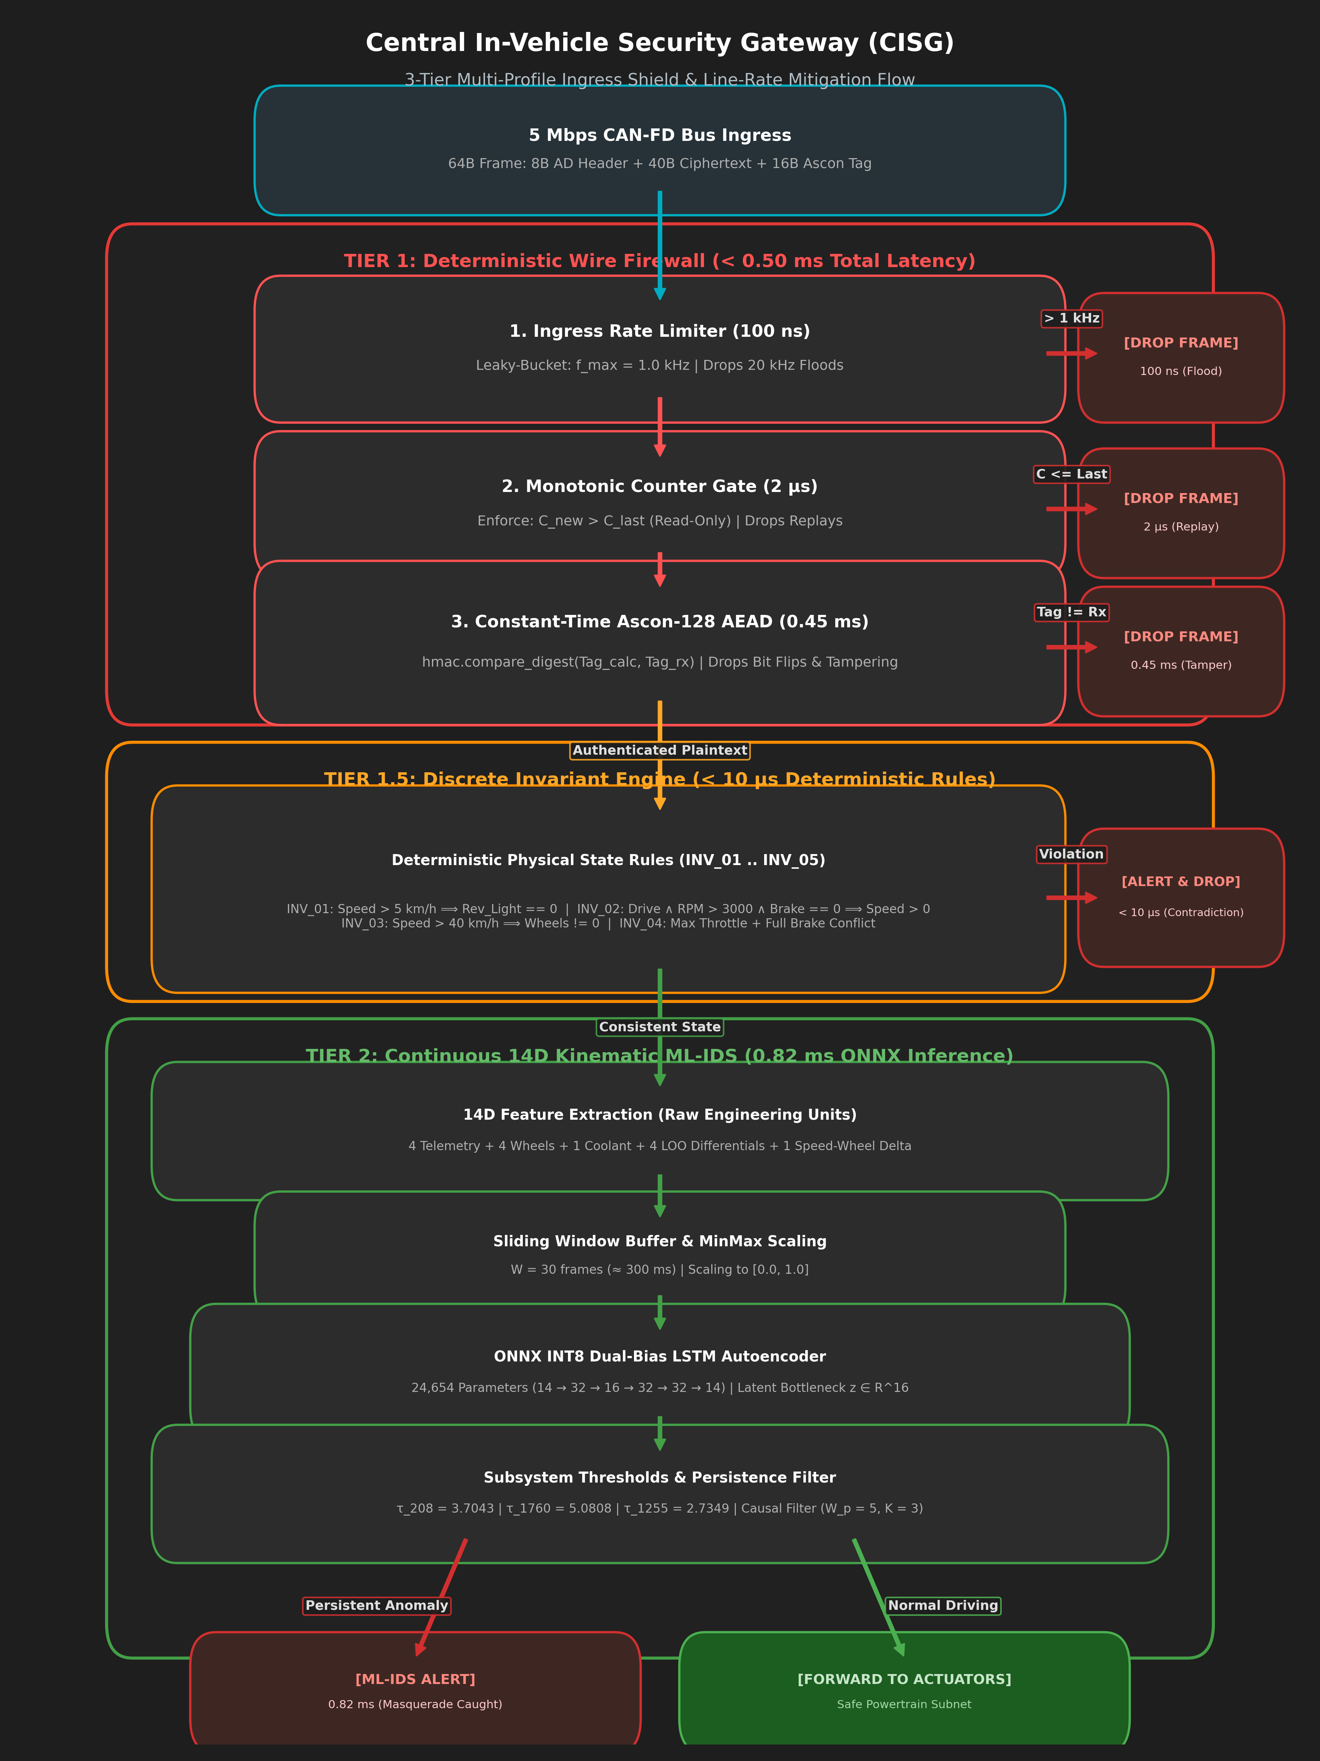
Figure 5.1 Supplied CISG tiered IDS design view. It describes intended processing order; it is not evidence of timing or safety certification.

5.2 FEATURE PIPELINE AND CALIBRATION
The saved detector is described as a 14-dimensional physical-kinematics LSTM autoencoder. A window contains 30 steps. Feature extraction must use the saved scaler configuration, feature order and subsystem mapping. Mixing header/counter features with physical signals can reward detection of easy wire artifacts while obscuring the harder authenticated masquerade case.
The stored threshold configuration uses subsystem-specific P99.5 values: approximately 3.7043 for CAN ID 208, 5.0808 for 1760 and 2.7349 for 1255, with a global value of 3.6985. These thresholds are tied to that saved feature and residual pipeline. They cannot be reused after changing scaling, model weights, window alignment or channel semantics without recalibration.
The evaluation should preserve train, calibration and attack partitions independently. Temporal windows that overlap across partitions can leak information even when raw row indexes differ. An operational report should record the number of clean and attack windows, confusion counts, threshold and event-alignment rule. Saved aggregate metrics without those counts are secondary evidence and should not be promoted to a fleet-wide guarantee.
Table 9 Feature Pipeline And Calibration
Item | Saved setting
Feature dimension | 14
Window length | 30 steps
Speed subsystem threshold | 3.70434594
Wheel-speed threshold | 5.08081532
Coolant threshold | 2.73491740
Global threshold | 3.69849396

5.3 ACCEPTED HISTORY AND BUFFER QUARANTINE
A naive rolling buffer retains an anomalous sample after the attack has ended. With a 30-step window, one accepted bad sample may remain in as many as 29 subsequent windows. This explains the mechanism of post-attack smearing without implying that every model will actually produce 29 false alarms.
The proposed quarantine policy evaluates a candidate against trusted history and commits the candidate only after acceptance. A zero-order hold or equivalent state-preserving substitution can maintain a fixed input shape during rejection. The policy must define what happens during sustained rejection, initialization, legitimate rapid transients and missing data; otherwise holding old values can conceal real changes.
The saved comparative benchmark contains three ROAD scenarios. Post-attack smearing counts change from 29, 29 and 17 to zero, while total false-positive rates remain 1.18%, 2.20% and 0.00% in the quarantine mode. Thus zero post-attack smearing in these rows is not a zero false-positive guarantee. The CSV’s ASIL_D_Status label is not accepted as evidence of certification.
Table 10 Accepted History And Buffer Quarantine
Scenario | FPR before | FPR after | Smearing before/after
Speedometer | 1.21% | 1.18% | 29 / 0
Wheel speed | 2.94% | 2.20% | 29 / 0
Coolant | 0.46% | 0.00% | 17 / 0

5.4 ONNX ARTIFACTS AND RUNTIME CLAIMS
The actual committed baseline ONNX artifacts are 108,879 bytes for FP32 and 39,254 bytes for dynamic INT8. This is a 63.95% reduction in file bytes for the inspected files. Historical onnx_export_metadata.json instead reports 50.44 KB and 72.86 KB; those values do not describe the current files and are not used as current artifact sizes.
The real_telemetry_onnx_evaluation.json artifact reports development-host means of 1.484 ms for eager PyTorch, 0.159 ms for ONNX FP32 and 0.198 ms for ONNX INT8. These figures describe a historical single-window evaluation. The same file explicitly calls its Raspberry Pi 4 tail-latency figures simulated. They cannot be described as measured target-board execution.
INT8 reduces the inspected file size but is slower than FP32 in that historical development evaluation. Quantization therefore has separate storage, numeric and runtime tradeoffs. One reported wheel-speed decision differs between INT8 and its reference among 5,000 evaluated windows; a broad claim of complete decision equivalence is unsupported.
Table 11 Onnx Artifacts And Runtime Claims
Metric | FP32 | Dynamic INT8
Current artifact bytes | 108,879 | 39,254
Historical development mean | 0.159 ms | 0.198 ms
Historical development p99 | 0.268 ms | 0.357 ms
Wheel-speed decision flips | 0 | 1

5.5 FEDERATED TRAINING DESIGN
The stored federated-learning metadata defines five clients, ten rounds, two local epochs per round, batch size 2,048 and learning rate 0.001. Each client partition contains 100,000 rows split into 80,000 training and 20,000 local test rows. The setup is a controlled multi-silo simulation using Flower NumPyClient and explicit server FedAvg.
For client k with n_k training samples and parameter vector w_k, weighted averaging forms w_next = sum_k (n_k / sum_j n_j) w_k. Uniform client sizes make these weights equal in the recorded setup. This averaging equation describes the aggregation operation; it does not guarantee convergence, privacy or resistance to poisoned client updates.
The metadata also separates round-validation captures, a 40,000-row benign calibration suite and a 30,000-row held-out reverse-domain partition. Those names document intended separation. A full reproduction must verify file hashes and window-level disjointness rather than relying solely on a metadata assertion.
Table 12 Federated Training Design
Setting | Recorded value
Client silos | 5
Communication rounds | 10
Local epochs | 2
Batch size | 2,048
Learning rate | 0.001
Per-silo split | 80,000 train / 20,000 test

5.6 FEDERATED GENERALIZATION AND FALSE ALARMS
The cross-silo matrix reports a held-out fleet MSE of 0.003948 for the global federated model. The five local-model values are 0.002710, 0.007358, 0.040995, 0.007360 and 0.007256. The global model improves on four locals but is worse than the highway local on this particular held-out partition. This supports a heterogeneous tradeoff rather than universal dominance.
The saved federated attack benchmark reports ROC-AUC values near one, yet filtered false-positive rates of 97.775% for speedometer spoofing and 99.539% for wheel-speed spoofing. At those operating thresholds the detector is unsuitable for direct operational blocking. AUC can remain high when threshold calibration is poor; the two observations are not contradictory.
The coolant row reports filtered recall 95.35%, filtered FPR 1.382% and filtered F1 0.9425. These results demonstrate why each scenario and operating point must be disclosed. The CSV’s generic PASS label does not override its numeric metrics. Secure aggregation, poisoning defenses and production model-update governance are not established by the saved FedAvg experiment.
Table 13 Federated Generalization And False Alarms
Attack | ROC-AUC | Filtered recall | Filtered FPR
Speedometer | 0.9995 | 100.00% | 97.775%
Wheel speed | 0.9999 | 100.00% | 99.539%
Coolant | 0.9999 | 95.35% | 1.382%

CHAPTER 6
IMPLEMENTATION AND EXPERIMENTAL METHOD

6.1 LABORATORY ORCHESTRATION
The current Dockerfile builds an Ubuntu 22.04 image with C++17 components, liboqs 0.12.0 and ONNX Runtime 1.20.1. The compose image is pqc-can-lab:cpp17. The repository also retains a Python orchestration and execution path, so the language and engine must be recorded for every experiment rather than inferred from the latest README.
The services include relay, gateway, domain ECUs, controller and observability components. The relay injects controlled omissions and the controller coordinates scenarios. The dashboard visualizes process events. Management messages, container logs and CAN receive observations serve different purposes; dashboard animation alone is not a network capture or a cryptographic verification record.
The current compose file exposes management services and grants capabilities including NET_ADMIN and PERFMON to application services. Earlier claims of a minimal-capability or localhost-only management boundary do not describe every current service declaration. The report treats the setup as a research laboratory and records configuration hardening as future work.
Table 14 Laboratory Orchestration
Component | Role
ECU nodes | Attestation and diagnostic producer
Relay | Domain forwarding and omission injection
Gateway | Reassembly and security admission
Controller | Scenario scheduling and CSV export
Observer and logs | Independent and process-level evidence

6.2 RUNNING AND COLLECTING EVIDENCE
From the repository root, the documented launcher commands are python3 "Phase 3/DockerLab/lab.py" up followed by python3 "Phase 3/DockerLab/lab.py" run. The launcher also provides status, logs, validate, observe and down. The dashboard is documented at http://localhost:8088 and the optional Grafana view at http://localhost:3000.
The host requires Linux Docker Engine, Docker Compose and kernel CAN_RAW and VXCAN support. Containers share the host kernel; selecting another base distribution cannot add a missing CAN kernel module. Before a research rerun, record the selected engine, Git revision, image digest, kernel, CPU, dependency versions and the start/stop event definitions.
The output directory must be archived as one immutable bundle containing the run CSV, manifest, raw event logs, arrival evidence and profiling availability. A run should not be relabeled as hardware-measured simply because modeled baud-rate fields are present. This report does not assert that these commands were executed during document preparation.
Table 15 Running And Collecting Evidence
Command suffix | Purpose
up | Build and initialize documented lab
run | Execute configured scenario suite
status / logs | Inspect service state and stdout
validate | Check saved output evidence
observe | Start optional observability stack
down | Stop project services

6.3 DATA CONTRACT AND VALIDATION
The transport handoff is a 40-column CSV with a prescribed column order. It records scenario identity, injection configuration, recovery rounds, bitmaps, per-round requested and recovered counts, traffic totals, latency, terminal status and admission-state labels. Semicolon-delimited spatial indices are strings inside a CSV field; commas must not be substituted because they change CSV structure unless quoted and still violate the prescribed syntax.
The validator loads Phase 3/config/data_contract_schemas.json relative to its own location. Importantly, running python3 "Phase 3/Code/contract_validator.py" by itself only initializes the validator and prints contract names in the inspected revision. To validate a generated file, the caller must invoke DataContractValidator.validate_csv with contract name fault_recovery_runs and the target path, or use the lab’s validation command.
Schema validity demonstrates shape and value constraints. It cannot prove that measurements are genuine, that counters were available, that a safe state was achieved, or that a timestamp was generated by a physical controller. Contract validation and provenance validation are separate obligations. Appendix 1 documents all forty columns in their authoritative order.

6.4 EVIDENCE SELECTION AND PROVENANCE
The primary descriptive transport dataset is Phase 3/DockerLab/simulation_results/fault_recovery_runs.csv, containing 31 rows. Its SHA-256 is 49f1ec247961fa03d7cadf378e6c57e4fb19b4861c7177e79bd4f0e320a1e56b, matching the adjacent manifest entry. The manifest identifies a Python 3.10.12 experiment profile, Linux kernel 6.18.42-1-lts and a software SocketCAN/vxcan transport. This is archived evidence, not a new run of current C++ HEAD.
The separate Phase 3/data/fault_recovery_runs.csv has 35 rows and SHA-256 93dddec9f3fd0f08f82a816691d70ed05c0e7ea207cd694d00c14646da41bb2a. It includes additional protocol rows and different timings. Those rows are not pooled with the manifest-anchored 31-row laboratory collection. The supplied old plots and performance narrative are likewise not substituted for the selected CSV.
The manifest reports PMU permission/unavailability and zero arrival rows while other files contain populated profiling or reconstructed latency records. Consequently, this report does not infer hardware counter measurements or a complete raw receive capture from the existence of those CSVs. Matching a run-CSV hash supports file association; it is not independent proof of every field’s semantics.

CHAPTER 7
RESULTS AND DISCUSSION

7.1 CANONICAL TRANSPORT RESULTS
Table 16 summarizes the first twenty rows of the manifest-anchored laboratory CSV. Each of the five canonical scenarios has four repeated observations. All twenty rows report SUCCESS and no violation of the configured 50 ms budget. Means and sample standard deviations are recalculated directly from end_to_end_latency_us, converted to milliseconds.
The clean mean is 20.878 ms. Single-frame, late-frame, relay-spike and alternator-burst means are 30.432, 31.368, 31.913 and 33.275 ms respectively. Relay-spike observations have the largest dispersion among these groups, with a sample standard deviation of 7.100 ms. Four trials per group are insufficient to estimate rare-event tails or a worst-case execution bound.
The canonical scenario names denote deliberate fragment omissions. They do not establish a measured EMI waveform or a real alternator experiment. Successful reassembly under these omission patterns supports selective recovery behavior in the archived software laboratory. It does not establish safety integrity level, physical bus arbitration performance or timing portability to a microcontroller.
Table 16 Canonical Transport Results
Scenario | n | Mean ms | Sample SD ms
Clean | 4 | 20.878 | 0.921
Single drop | 4 | 30.432 | 1.480
Late drop | 4 | 31.368 | 1.575
Relay spike | 4 | 31.913 | 7.100
Alternator burst | 4 | 33.275 | 4.064

7.2 NEGATIVE CASES AND OBSERVATIONAL RUNS
Rows 21–24 exercise persistent omission, missing NACK delivery, cryptographic corruption and malformed transport state. Their recorded terminal statuses are retry exhaustion, NACK timeout, tag mismatch and header out-of-range. The corresponding latencies are 93.989, 90.714, 30.076 and 60.376 ms. Three exceed the configured 50 ms budget.
Row 25 records a successful header-probe recovery at 36.721 ms. Rows 26–30 are labeled Monte Carlo Loss Sweep and report successful completion from 16.673 to 46.099 ms. Their repeated configuration and the timing-boundary concerns prevent treating them as an independently seeded reliability study. Row 31 is a separate clean setup observation at 28.889 ms and is excluded from the four-trial canonical clean group.
The correct conclusion is bounded functional recovery and differentiated failure reporting in the selected archive. It is not “all thirty-one runs meet the budget.” Failed authentication and failure to finish within the budget remain visible even when a harness considers the expected negative test to have passed.
Table 17 Negative Cases And Observational Runs
CSV row | Terminal status | Latency ms
21 | ERR_RETRY_EXHAUSTION | 93.989
22 | ERR_TIMEOUT_NACK_WAIT | 90.714
23 | ERR_CRYPTO_TAG_MISMATCH | 30.076
24 | ERR_HEADER_OUT_OF_RANGE | 60.376
25 | SUCCESS | 36.721

7.3 WIRE ATTACK OBSERVATIONS
The archived manifest records one replay, one forged-tag injection and one spoofed-domain injection. Their observed events are replay_rejected, runtime_tag_rejected and header_rejected respectively. The flood test records 300 transmitted frames and 202 rate_limit_rejected events. A 202/300 rejection fraction is 67.33%; it is not 100% rejection of every flooded frame.
All four manifest attack entries report zero other-domain receive observations. This is useful evidence for the tested topology and interval, but it does not prove that every current compose configuration enforces isolation or that all possible cross-domain attacks are blocked. The record should be read together with raw observer coverage and the selected network namespace topology.
The attack checks are deterministic probes with very small sample sizes. No ROC curve, vehicle-wide false-positive rate or statistical detection guarantee is derived from them. The high-level security property depends on authenticated state commit and fresh keys, which require separate review of the actual execution engine.
Table 18 Wire Attack Observations
Probe | Injected | Recorded rejection event count
Replay | 1 | 1
Forged tag | 1 | 1
Spoofed domain | 1 | 1
Flood | 300 | 202

7.4 IDS OPERATING POINT RESULTS
The master_3tier_real_benchmark_leaderboard.csv records ONNX FP32 speedometer recall of 99.90% and FPR of 0.141%, but wheel-speed and coolant recall of 0.00% at the saved operating points. Their ROC-AUC values are 0.9961 and 0.9988. The numerical rows contradict any interpretation that all three attacks are reliably detected at those thresholds.
The invariant-gate rows vary too: reverse-light-off variants report recall of 100.00%, 84.94% and 85.70%. The architecture offers a useful separation of discrete and continuous checks, but aggregate “PASS” tags hide these differences. A research paper must report thresholded metrics alongside ranking metrics and state the evaluation source.
The standalone ONNX export evaluation reports near-perfect AUC on a selected 5,000-window-per-scenario test and one INT8 wheel-speed decision flip. The different evaluation files are not merged because they use different scopes and potentially different calibration pipelines. A future reproducible run should reconcile weights, scaler, threshold, labels and split hashes in one manifest.
Table 19 Ids Operating Point Results
ONNX FP32 scenario | ROC-AUC | Recall | FPR
Speedometer | 0.9995 | 99.90% | 0.141%
Wheel speed | 0.9961 | 0.00% | 0.000%
Coolant | 0.9988 | 0.00% | 0.000%

7.5 ANALYTICAL STUDIES AND THEIR LIMITS
Phase 3/data/transport_protocol_benchmark_data.csv and provenance_metadata.json describe a separate analytical transport study. The metadata specifies seed 42, 10,000 trials per point, eleven loss points and three bitrate regimes. These model results explore protocol behavior under declared assumptions; they are not raw SocketCAN observations or measurements from CAN transceivers.
Protocol efficiency comparisons must hold the protected-object length, control accounting, retry policy and wire-cost model constant. For the proposed initial transfer, 92.835% is a data-field efficiency. A comparison with whole-object retransmission depends on the probability of object failure and the model of correlated loss. There is no context-free overhead reduction percentage valid for every channel.
The supplied analytical figures include platform scaling, schedulability and boot-storage predictions. They are excluded from the paper’s empirical claims where target-board measurements and complete task-set assumptions are absent. Their appropriate role is to motivate a hardware validation plan and identify parameters that need measurement, rather than to certify deadlines.

CHAPTER 8
CONCLUSION AND FUTURE WORK

8.1 VALIDITY AND SECURITY LIMITATIONS
The first limitation is provenance drift. The current checkout contains different result sets, source revisions and metadata values. This report anchors each quantitative statement to a named artifact and avoids treating the archived Python profile as a measurement of current C++ execution. No new experiments were run for the manuscript.
The second limitation is measurement scope. Kernel software timestamps, process clocks and modeled frame delays are not hardware timestamps or physical serialization measurements. The archived PMU probe reports unavailability. Claims about cycles, cache misses, zero major faults, fixed microsecond verification time or Cortex-A72 execution therefore require new raw measurements with a reproducible environment.
The third limitation is protocol realization. Fixed benchmark keys, deterministic challenge generation, possible nonce reuse, management exposure and an in-process fallback path prevent a blanket claim of production-secure orchestration. These limitations do not invalidate the frame arithmetic or the usefulness of the architecture, but they limit what the prototype demonstrates. A complete security argument must bind the selected engine to an audited key lifecycle.

8.2 HARDWARE VALIDATION AND FUTURE WORK
A hardware campaign should use CAN-FD-capable controllers and transceivers, terminated physical domains, an independent bus analyzer and synchronized measurement boundaries. It should record arbitration interference, error frames, bus-off behavior and recovery timing under controlled load. Vehicle or dynamometer attack work requires an isolated bench and a defined safety procedure; the present archive is a software laboratory.
The cryptographic path should replace deterministic benchmark material with enrolled per-ECU secrets, context-separated derivation, unique nonces and durable anti-replay state. The C++ prepare/run race should be removed before measuring the entire handshake. The image digest, source hashes and raw observations should be generated together and stored as an immutable run bundle.
The IDS campaign should recalibrate thresholds using disjoint clean data, evaluate unseen operating conditions and report confusion counts and false alarms per unit time. Federated learning should be compared against local and centrally trained baselines at matched operating points, followed by poisoning and update-integrity studies. Any ISO 26262 claim would require an item definition, hazard analysis, allocated safety requirements and independent evidence beyond these experiments.

8.3 CONCLUSION
The project demonstrates a technically coherent architecture for separating boot identity, reliable object transport and runtime anomaly detection. The 2,436-byte protected object fits into forty-one indexed CAN-FD payloads, and a compact missing-frame bitmap permits selective recovery. The archived canonical trial groups all report successful recovery, with mean completion times from 20.878 to 33.275 ms in the selected software laboratory.
The saved negative tests reveal budget breaches and distinct failure causes. The IDS evidence reveals a second important result: high ROC-AUC does not ensure useful recall or false-positive behavior at a chosen threshold. The inspected INT8 artifact is smaller than FP32, but historical development-host timings do not show an INT8 speed advantage. These findings identify concrete engineering choices for the next iteration.
The academic objectives are met at the level of an integrated design, inspectable software artifacts and a qualified analysis of existing observations. Hardware timing, secure production provisioning, cross-vehicle detection generalization and functional-safety assurance remain open. The most defensible next step is a unified reproducible run with corrected lifecycle and timing boundaries, followed by physical CAN-FD validation.

REFERENCES
National Institute of Standards and Technology. (2024). Module-lattice-based digital signature standard (FIPS 204). https://doi.org/10.6028/NIST.FIPS.204
National Institute of Standards and Technology. (2025). Ascon-based lightweight cryptography standards for constrained devices (SP 800-232). https://doi.org/10.6028/NIST.SP.800-232
Krawczyk, H., & Eronen, P. (2010). HMAC-based extract-and-expand key derivation function (HKDF) (RFC 5869). RFC Editor. https://doi.org/10.17487/RFC5869
Verma, M. E., Bridges, R. A., Iannacone, M. D., Hollifield, S. C., Moriano, P., Hespeler, S. C., Kay, B., & Combs, F. L. (2024). A comprehensive guide to CAN IDS data and introduction of the ROAD dataset. PLOS ONE, 19(1), e0296879. https://doi.org/10.1371/journal.pone.0296879
McMahan, B., Moore, E., Ramage, D., Hampson, S., & Agüera y Arcas, B. (2017). Communication-efficient learning of deep networks from decentralized data. Proceedings of Machine Learning Research, 54, 1273–1282. https://proceedings.mlr.press/v54/mcmahan17a.html

REFERENCES CONTINUED
Davis, R. I., Burns, A., Bril, R. J., & Lukkien, J. J. (2007). Controller Area Network (CAN) schedulability analysis: Refuted, revisited and revised. Real-Time Systems, 35, 239–272. https://doi.org/10.1007/s11241-007-9012-7
International Organization for Standardization. (2018). Road vehicles—Functional safety—Part 1: Vocabulary (ISO 26262-1:2018). https://www.iso.org/obp/ui/#iso:std:iso:26262:-1:ed-2:v1:en
The Linux Kernel Development Community. (n.d.). SocketCAN—Controller Area Network. https://docs.kernel.org/networking/can.html
PQC with IDS for CAN bus project team. (2026). Project implementation and archived experimental artifacts (Git revision 0fd01df). Repository: https://github.com/PQC-with-IDS-for-CAN-bus/PQC-with-IDS-for-CAN-bus.
The supplied paper_corrected.pdf and IEEE_Conference_Paper_Figures_and_Descriptions.docx were used as internal project source documents. Images reproduced in this report come from the latter. Their authorship and any third-party permissions must be confirmed by the project team before external publication.

APPENDIX 1
FAULT RECOVERY DATA DICTIONARY
Authoritative source: Phase 3/config/data_contract_schemas.json, contract fault_recovery_runs. The order below is the required CSV header order. Units and allowed values are schema requirements, not measurements.

1. run_id
Unique trial identifier (UUIDv4 or sequential integer)
Type: string; nullable: False. Constraint: ^([0-9a-f]{8}-[0-9a-f]{4}-4[0-9a-f]{3}-[89ab][0-9a-f]{3}-[0-9a-f]{12}|[0-9]+)$.

2. trial_idx
Sequential trial index within a scenario sweep (0 to N_trials-1)
Type: uint32; nullable: False. Constraint: {'min': 0}.

3. scenario_id
Project-defined test scenario ID (1-5 for canonical scenarios, 0 for Monte Carlo sweeps)
Type: uint16; nullable: False. Constraint: {'min': 0, 'max': 99}.

4. scenario_name
Canonical human-readable scenario name
Type: string; nullable: False. Allowed: Clean Bus (Nominal), Isolated Single Frame Drop, Late-Sequence Frame Drop, Inductive Relay Transient Spike, Alternator Commutation Burst, Monte Carlo Loss Sweep.

5. protocol_name
Transport protocol under evaluation
Type: string; nullable: False. Allowed: SIXTY_FOUR_BLOCK, ISO_TP_15765_2, CASTIGLIONE_NATIVE, CASTIGLIONE_SCALED.

APPENDIX 1 CONTINUED
COLUMNS 6 TO 10
Authoritative source: Phase 3/config/data_contract_schemas.json, contract fault_recovery_runs. The order below is the required CSV header order. Units and allowed values are schema requirements, not measurements.

6. bitrate_regime
Physical bus speed configuration
Type: string; nullable: False. Allowed: CASTIGLIONE_1MBPS, PROD_CANFD_2MBPS, HIGHPERF_CANFD_5MBPS.

7. nominal_baud

Type: uint32; nullable: False. Unit: bits_per_second. Constraint: {'allowed': [500000, 1000000]}.

8. data_baud

Type: uint32; nullable: False. Unit: bits_per_second. Constraint: {'allowed': [1000000, 2000000, 5000000]}.

9. fault_model
Project fault-injection category. Scenario names describe controlled omissions, not measured electromagnetic waveforms.
Type: string; nullable: False. Allowed: NOMINAL_CLEAN, SINGLE_FRAME_DROP, LATE_SEQUENCE_DROP, BURST_FRAME_DROP, GILBERT_ELLIOTT_BURST, BERNOULLI_RANDOM, PAYLOAD_BIT_FLIP, NACK_CONTROL_FRAME_DROP.

10. injected_dropped_frame_indices
Semicolon-delimited list of targeted frame indices (e.g. '14;15;16'), or 'NONE' for clean bus
Type: string; nullable: False. Constraint: ^(NONE|[0-9]+(;[0-9]+)*)$.

APPENDIX 1 CONTINUED
COLUMNS 11 TO 15
Authoritative source: Phase 3/config/data_contract_schemas.json, contract fault_recovery_runs. The order below is the required CSV header order. Units and allowed values are schema requirements, not measurements.

11. burst_length
Number of consecutive dropped frames in the burst (0 for clean, 1 for single, 3/8 for bursts)
Type: uint16; nullable: False. Unit: frames. Constraint: {'min': 0, 'max': 41}.

12. channel_loss_rate_p
Applied channel loss probability for Monte Carlo sweeps (0.00 for deterministic scenarios)
Type: float64; nullable: False. Constraint: {'min': 0.0, 'max': 1.0}.

13. payload_corruption_injected
Whether a bit-flip was injected into the payload to test Ascon-AEAD128 tag verification failure (separate from frame drop)
Type: boolean; nullable: False.

14. recovery_success
High-level session completion flag (True = payload reassembled and cryptographically verified)
Type: boolean; nullable: False.

15. recovery_rounds
Number of retransmission cycles executed (0 = clean first-pass, 1-3 for retry rounds)
Type: uint8; nullable: False. Constraint: {'min': 0, 'max': 3}.

APPENDIX 1 CONTINUED
COLUMNS 16 TO 20
Authoritative source: Phase 3/config/data_contract_schemas.json, contract fault_recovery_runs. The order below is the required CSV header order. Units and allowed values are schema requirements, not measurements.

16. retransmit_policy
Recovery mechanism type used by the protocol under test
Type: string; nullable: False. Allowed: selective_nack_bitmap, full_sequence_abort, full_sequence_restart.

17. nack_frames_issued_count
Total NACK or Flow Control frames transmitted across all retry rounds
Type: uint8; nullable: False. Constraint: {'min': 0, 'max': 3}.

18. nack_bitmaps_issued_hex
Semicolon-delimited hexadecimal 64-bit NACK bitmaps transmitted per round (e.g. '0x0000000000041000;0x0000000000040000'). Only applicable to SIXTY_FOUR_BLOCK protocol.
Type: string; nullable: False. Constraint: ^(N_A|0x[0-9A-Fa-f]{16}(;0x[0-9A-Fa-f]{16})*)$.

19. round_1_requested_frames
Missing frames requested in Round 1 NACK
Type: uint16; nullable: False. Constraint: {'min': 0, 'max': 41}.

20. round_1_recovered_frames
Retransmitted frames successfully received in Round 1
Type: uint16; nullable: False. Constraint: {'min': 0, 'max': 41}.

APPENDIX 1 CONTINUED
COLUMNS 21 TO 25
Authoritative source: Phase 3/config/data_contract_schemas.json, contract fault_recovery_runs. The order below is the required CSV header order. Units and allowed values are schema requirements, not measurements.

21. round_2_requested_frames

Type: uint16; nullable: False. Constraint: {'min': 0, 'max': 41}.

22. round_2_recovered_frames

Type: uint16; nullable: False. Constraint: {'min': 0, 'max': 41}.

23. round_3_requested_frames

Type: uint16; nullable: False. Constraint: {'min': 0, 'max': 41}.

24. round_3_recovered_frames

Type: uint16; nullable: False. Constraint: {'min': 0, 'max': 41}.

25. initial_frames_sent
Data frames transmitted in initial burst (41 for 60/4, 39 for ISO-TP, 12 for Castiglione native)
Type: uint16; nullable: False. Constraint: {'min': 1, 'max': 255}.

APPENDIX 1 CONTINUED
COLUMNS 26 TO 30
Authoritative source: Phase 3/config/data_contract_schemas.json, contract fault_recovery_runs. The order below is the required CSV header order. Units and allowed values are schema requirements, not measurements.

26. retransmitted_frames_count
Total data frames resent across all retry rounds
Type: uint16; nullable: False. Constraint: {'min': 0}.

27. control_frames_count
Total control frames on wire (NACK + Flow Control + Restart NACK)
Type: uint16; nullable: False. Constraint: {'min': 0}.

28. total_frames_on_wire
Total frames put on wire (initial + retransmit + control)
Type: uint32; nullable: False. Constraint: {'min': 1}.

29. total_wire_bytes
Byte-count field. The selected archive records CAN data-field accounting; physical-wire bytes are not demonstrated.
Type: uint32; nullable: False. Unit: bytes. Constraint: {'min': 1}.

30. goodput_efficiency_pct
Application goodput = (application_payload_bytes / total_wire_bytes) * 100.0
Type: float64; nullable: False. Unit: percentage. Constraint: {'min': 0.0, 'max': 100.0}.

APPENDIX 1 CONTINUED
COLUMNS 31 TO 35
Authoritative source: Phase 3/config/data_contract_schemas.json, contract fault_recovery_runs. The order below is the required CSV header order. Units and allowed values are schema requirements, not measurements.

31. end_to_end_latency_us
Total elapsed turnaround latency from Frame 0 Tx to complete payload assembly
Type: float64; nullable: False. Unit: microseconds. Constraint: {'min': 0.0}.

32. nominal_clean_time_us
Theoretical or empirical baseline duration under clean bus (0% loss)
Type: float64; nullable: False. Unit: microseconds. Constraint: {'min': 0.0}.

33. recovery_overhead_latency_us
Pure empirical time cost of fault recovery = end_to_end_latency - nominal_clean_time
Type: float64; nullable: False. Unit: microseconds. Constraint: {'min': 0.0}.

34. nack_turnaround_time_us
Delay from NACK Tx to receipt of first retransmitted frame
Type: float64; nullable: True. Unit: microseconds. Constraint: {'min': 0.0}.

35. retry_exhaustion_flag
True if maximum retries (K_retry = 3) were exhausted without complete assembly
Type: boolean; nullable: False.

APPENDIX 1 CONTINUED
COLUMNS 36 TO 40
Authoritative source: Phase 3/config/data_contract_schemas.json, contract fault_recovery_runs. The order below is the required CSV header order. Units and allowed values are schema requirements, not measurements.

36. termination_status_code
Project terminal outcome label. These are application codes, not ISO-defined status codes.
Type: string; nullable: False. Allowed: SUCCESS, ERR_RETRY_EXHAUSTION, ERR_TIMEOUT_NACK_WAIT, ERR_TIMEOUT_FLOW_CONTROL, ERR_CRYPTO_TAG_MISMATCH, ERR_CRYPTO_SIG_INVALID, ERR_HEADER_OUT_OF_RANGE, ERR_SOCKET_BUFFER_OVERFLOW, ERR_BUS_OFF.

37. iso26262_failure_classification
Project failure-classification field. Name retained for compatibility; its taxonomy is not independently certified.
Type: string; nullable: False. Allowed: SAFE_TRANSMISSION, RECOVERED_FAULT, INFORMATION_LOSS_OMISSION, PROTOCOL_ABORT_TIMEOUT, CORRUPTED_FRAME_REJECTED.

38. ftti_budget_us
Configured experimental timing budget in microseconds. The 50,000 value is a project choice, not a universal ASIL-D requirement.
Type: float64; nullable: False. Unit: microseconds. Constraint: {'min': 0.0}.

39. ftti_violation_flag
True when recorded end-to-end latency exceeds the configured experimental budget; this alone is not a vehicle safety-goal determination.
Type: boolean; nullable: False.

40. safety_state_achieved
Software state label after fault handling; it does not establish a vehicle-level safe state.
Type: string; nullable: False. Allowed: OPERATIONAL, SAFE_FALLBACK, UNRECOVERED_HAZARD.

APPENDIX 2
ARCHIVED RUN REGISTER
Source: DockerLab/simulation_results/fault_recovery_runs.csv. Row numbers below count data rows, excluding the header. Latencies are converted from microseconds to milliseconds without changing the underlying observations.
Table 20 Archived run rows 1 to 8
Row | Scenario | Latency ms | Status
1 | Clean Bus (Nominal) | 19.545 | SUCCESS
2 | Clean Bus (Nominal) | 21.544 | SUCCESS
3 | Clean Bus (Nominal) | 20.981 | SUCCESS
4 | Clean Bus (Nominal) | 21.441 | SUCCESS
5 | Isolated Single Frame Drop | 31.229 | SUCCESS
6 | Isolated Single Frame Drop | 31.770 | SUCCESS
7 | Isolated Single Frame Drop | 30.330 | SUCCESS
8 | Isolated Single Frame Drop | 28.398 | SUCCESS

Run identifiers and injection strings are preserved in the source CSV. Use the row number and manifest-matching SHA-256 to associate each entry with its complete record.

APPENDIX 2 CONTINUED
ROWS 9 TO 16
Source: DockerLab/simulation_results/fault_recovery_runs.csv. Row numbers below count data rows, excluding the header. Latencies are converted from microseconds to milliseconds without changing the underlying observations.
Table 21 Archived run rows 9 to 16
Row | Scenario | Latency ms | Status
9 | Late-Sequence Frame Drop | 31.653 | SUCCESS
10 | Late-Sequence Frame Drop | 33.420 | SUCCESS
11 | Late-Sequence Frame Drop | 30.653 | SUCCESS
12 | Late-Sequence Frame Drop | 29.745 | SUCCESS
13 | Inductive Relay Transient Spike | 39.954 | SUCCESS
14 | Inductive Relay Transient Spike | 34.958 | SUCCESS
15 | Inductive Relay Transient Spike | 23.556 | SUCCESS
16 | Inductive Relay Transient Spike | 29.183 | SUCCESS

Run identifiers and injection strings are preserved in the source CSV. Use the row number and manifest-matching SHA-256 to associate each entry with its complete record.

APPENDIX 2 CONTINUED
ROWS 17 TO 24
Source: DockerLab/simulation_results/fault_recovery_runs.csv. Row numbers below count data rows, excluding the header. Latencies are converted from microseconds to milliseconds without changing the underlying observations.
Table 22 Archived run rows 17 to 24
Row | Scenario | Latency ms | Status
17 | Alternator Commutation Burst | 39.258 | SUCCESS
18 | Alternator Commutation Burst | 31.589 | SUCCESS
19 | Alternator Commutation Burst | 32.040 | SUCCESS
20 | Alternator Commutation Burst | 30.213 | SUCCESS
21 | Isolated Single Frame Drop | 93.989 | ERR_RETRY_EXHAUSTION
22 | Isolated Single Frame Drop | 90.714 | ERR_TIMEOUT_NACK_WAIT
23 | Clean Bus (Nominal) | 30.076 | ERR_CRYPTO_TAG_MISMATCH
24 | Clean Bus (Nominal) | 60.376 | ERR_HEADER_OUT_OF_RANGE

Run identifiers and injection strings are preserved in the source CSV. Use the row number and manifest-matching SHA-256 to associate each entry with its complete record.

APPENDIX 2 CONTINUED
ROWS 25 TO 31
Source: DockerLab/simulation_results/fault_recovery_runs.csv. Row numbers below count data rows, excluding the header. Latencies are converted from microseconds to milliseconds without changing the underlying observations.
Table 23 Archived run rows 25 to 31
Row | Scenario | Latency ms | Status
25 | Clean Bus (Nominal) | 36.721 | SUCCESS
26 | Monte Carlo Loss Sweep | 35.251 | SUCCESS
27 | Monte Carlo Loss Sweep | 16.673 | SUCCESS
28 | Monte Carlo Loss Sweep | 46.099 | SUCCESS
29 | Monte Carlo Loss Sweep | 36.499 | SUCCESS
30 | Monte Carlo Loss Sweep | 39.651 | SUCCESS
31 | Clean Bus (Nominal) | 28.889 | SUCCESS

Run identifiers and injection strings are preserved in the source CSV. Use the row number and manifest-matching SHA-256 to associate each entry with its complete record.

APPENDIX 3
FIGURE INTERPRETATION

METHODOLOGY
The figure connects cryptographic/frame design, attack and IDS studies, orchestration analysis and planned hardware validation. It is used as a project organization diagram, not as proof that every work package has achieved its targets.
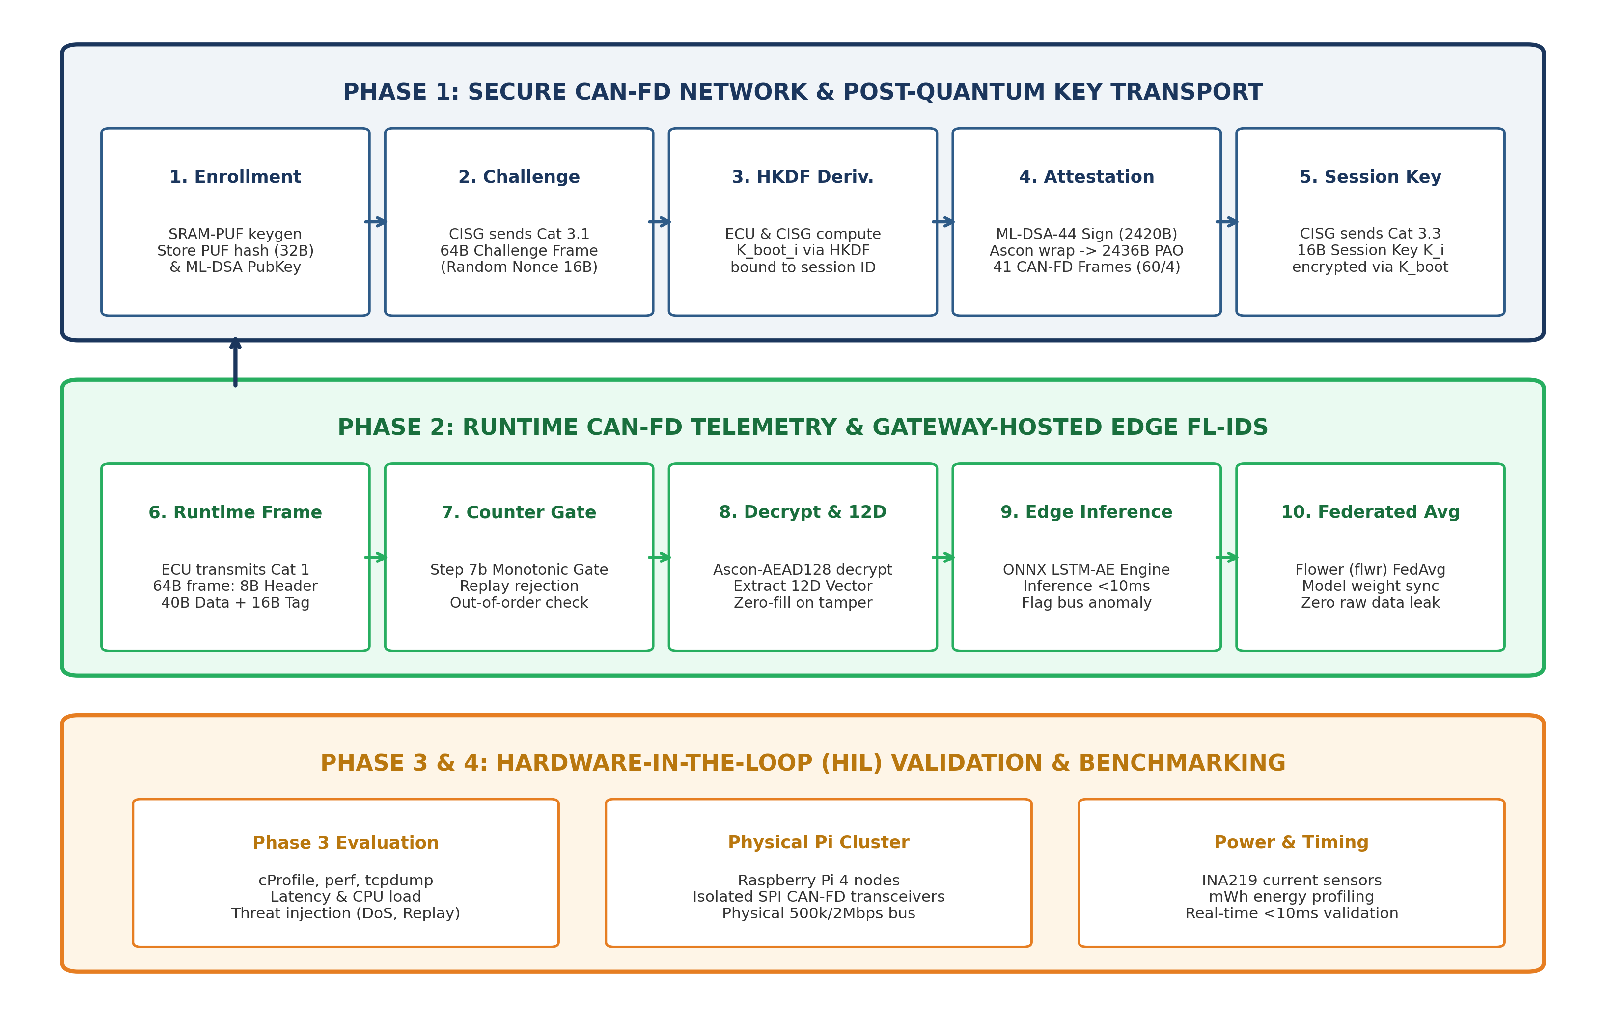
Figure A3.1 Supplied four-phase methodology. Phases describe the project work plan; Phase 4 hardware validation is not reported as completed.

APPENDIX 3 CONTINUED
INTEGRATION BLUEPRINT

INTEGRATION BLUEPRINT
The pipeline shows how enrollment, transport, routing and detection are intended to interact. Each boundary requires an implementation-specific check: fresh session material, authenticated state commit, model input semantics and event provenance. A visual sequence alone does not verify those conditions.
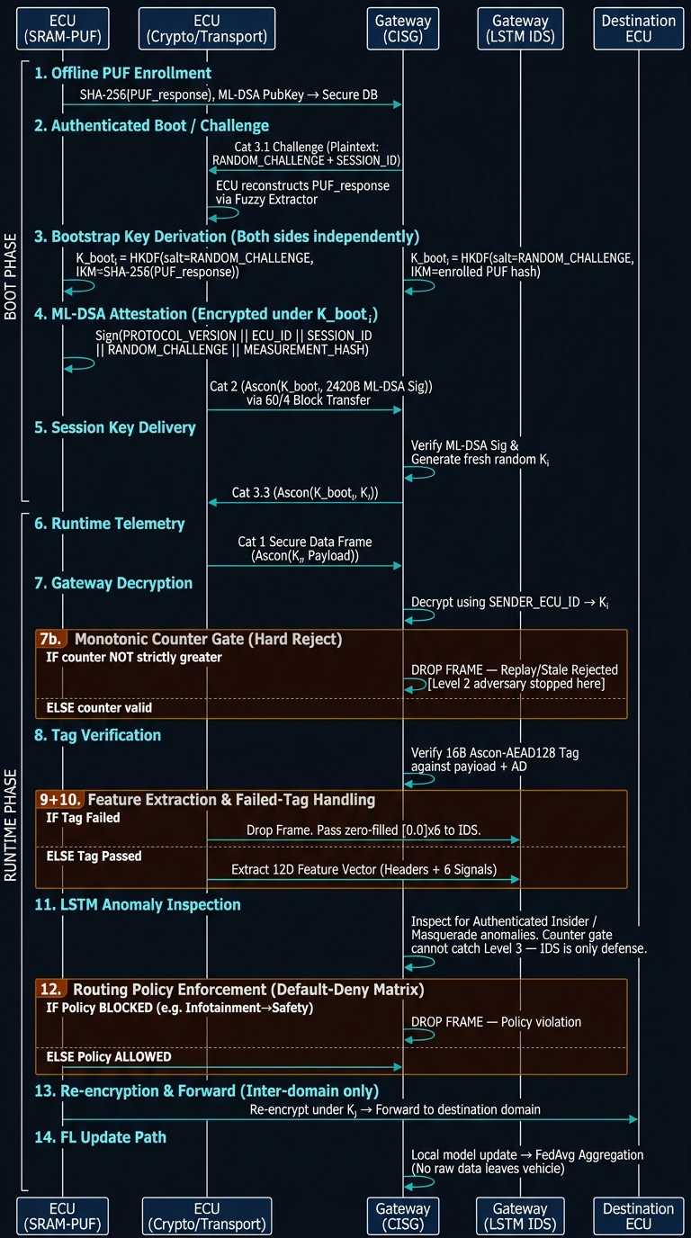
Figure A3.2 Supplied integration blueprint. This is a design roadmap; current C++ benchmark realization has lifecycle and timing limitations documented in Chapters 6–8.

APPENDIX 3 CONTINUED
ATTACK ROUTING

ATTACK ROUTING
Wire attacks exercise authentication, replay and rate controls. Discrete semantic abuse motivates invariant checks. Continuous authenticated masquerades motivate a physical-signal model. The observed rejection counts in Chapter 7 refer only to the archived probes, not every branch shown here.
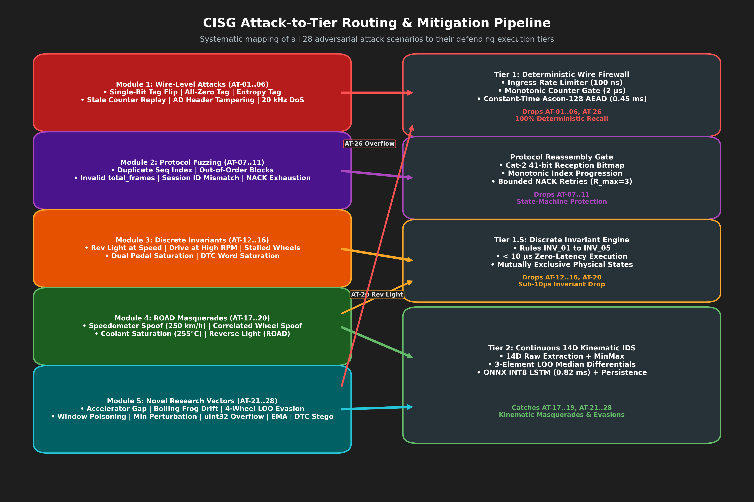
Figure A3.3 Supplied attack-routing design view. It classifies attacks by the gate that is intended to detect them.

APPENDIX 3 CONTINUED
MASQUERADE ANALYSIS

MASQUERADE ANALYSIS
A legitimate cryptographic identity can still transmit false values. An invariant can detect an impossible discrete relation without relying on an autoencoder, while a continuous relationship may require a sequence model. Threshold selection and benign operating diversity remain essential.
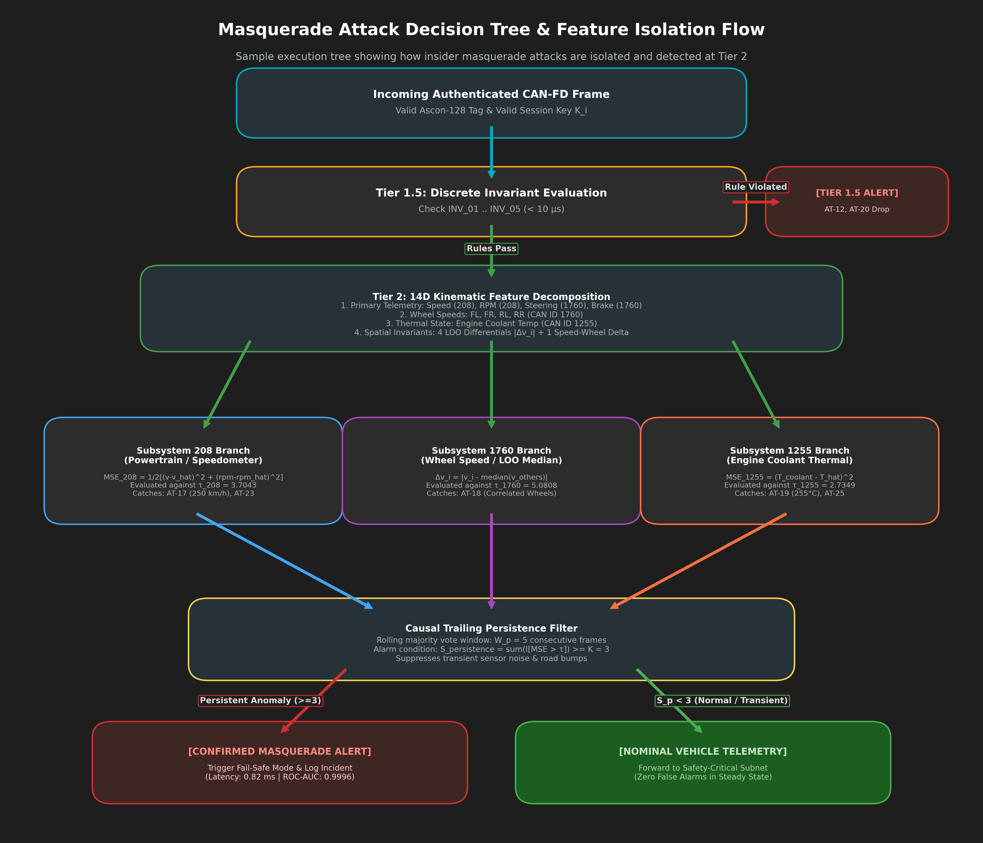
Figure A3.4 Supplied masquerade decision view. It motivates separation of discrete invariants and continuous kinematic residuals.

APPENDIX 3 CONTINUED
TRAINING LOSS

TRAINING LOSS
A decreasing reconstruction loss documents optimization on a training partition. It does not by itself establish anomaly detection quality, unseen-domain recall, threshold calibration or robustness to compromised clients. The numeric evaluation tables in Chapter 7 remain the source for operating-point conclusions.
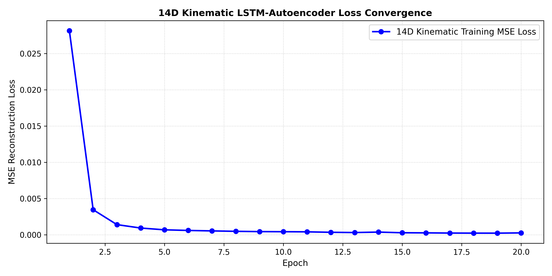
Figure A3.5 Supplied baseline training-loss illustration. Historical training output; no new training was performed for this report.

APPENDIX 4
REPRODUCIBILITY AND TRACEABILITY
The document preparation inspected existing files at Git revision 0fd01df. This revision identifies the reviewed code snapshot, not the revision that necessarily generated every archived artifact. Preserve the original inputs and evidence bundle when making a new run.
Table 24 Reproducibility And Traceability
Artifact | Interpretation
DockerLab/simulation_results/fault_recovery_runs.csv | 31-row manifest-associated archive; descriptive transport source
Phase 3/data/fault_recovery_runs.csv | 35-row separate collection; not pooled
onnx_export_metadata.json | Historical sizes disagree with current files
real_telemetry_onnx_evaluation.json | Historical development metrics; Pi values simulated
fl_attack_benchmark_results.csv | Scenario-specific FL metrics, including high FPR
perf_probe.txt / manifest | PMU unavailable; hardware counters not substantiated

Run CSV SHA-256: 49f1ec247961fa03d7cadf378e6c57e4fb19b4861c7177e79bd4f0e320a1e56b

APPENDIX 4 CONTINUED
VALIDATING A GENERATED CSV
The following code invokes the actual validator API. Replace the target path only with the real output file to be checked. A successful result proves schema compliance, not measurement authenticity.
import importlib.util
from pathlib import Path
p = Path("Phase 3/Code/contract_validator.py")
spec = importlib.util.spec_from_file_location("validator", p)
module = importlib.util.module_from_spec(spec)
spec.loader.exec_module(module)
validator = module.DataContractValidator()
ok, errors = validator.validate_csv(
"fault_recovery_runs",
"Phase 3/DockerLab/simulation_results/fault_recovery_runs.csv",
)
for error in errors:
print(error)
raise SystemExit(0 if ok else 1)
Do not edit a recorded measurement to satisfy a schema bound. Investigate the producer, units, clock scope or profile mismatch and retain the original observation. Missing PMU data should remain unavailable rather than being replaced by plausible counters.

APPENDIX 4 CONTINUED
FIGURE AND CLAIM RECONCILIATION
Table 25 Figure And Claim Reconciliation
Earlier claim or visual | Treatment in these documents
Universal ASIL-D 50 ms deadline | Experimental budget only; no certification claim
Nanosecond hardware timestamps | Software/kernel timing only unless separately proven
100% attack mitigation | Probe counts and flood denominator disclosed
Every IDS scenario passes | Actual recall and FPR reported
Quantization always faster | File size and historical speed separated
Raspberry Pi execution measured | Historical file explicitly says simulated
PUF hardware enrollment validated | Software provisioning / proposed hardware only
Old all-runs latency plots | Replaced by recalculated archive tables
40/60-byte header ambiguities | Reference class field ordering documented

Selected images are reproduced from the supplied figure DOCX, with scope stated in captions. Earlier empirical plots carrying unsupported safety annotations are intentionally not used as current results. No generated decorative images or synthetic data were added.

