⚡CircuitView : Smart CSV Visualization Tool

Project Type: CSV to graphical representation
Institution: AISSMS Institute of Information Technology
Department: Electrical Engineering
Subject: Electrical Measurements [ELPCC303 – Sem III]
Team Members:
- Snehal Jagtap (PRN: 24510052)
- Kanak Jaiswal (PRN: 24510054)
- Shreyash Kamthe (PRN: 24510059)
- Parth Shah (PRN: 24510091)
Under the Guidance of:
Prof. Saba Shaikh & Prof. Sachin Shelar

🔗 Live Project Link
https://9000-firebase-studio-1761844724814.cluster-c36dgv2kibakqwbbbsgmia3fny.cloudworkstations.dev

🔍 Project Overview
CircuitView is an interactive web-based tool that transforms raw electrical data stored in CSV format into clear, meaningful graphical visualizations.
It automates the process of reading, parsing, and visualizing large datasets containing voltage, current, power, and power factor readings. Users can upload CSV files, select desired parameters, and instantly generate graphs with accurate units and time-based trends.
The project improves data analysis in laboratories and industries by providing an intuitive, time-efficient, and visually rich interface that bridges the gap between raw data and engineering insights.

🧠 Key Features
📂 Upload CSV files containing electrical measurement data
📊 Generate interactive line, bar, or area graphs
🔍 Compare multiple parameters on a single chart
⏱️ Automatic conversion of timestamps to IST
💡 Real-time rendering using Recharts / Chart.js
🎨 Clean UI with professional color scheme (white, navy, gold)
📥 Option to download or filter analyzed data
☁️ Hosted on Firebase for accessibility

⚙️ Technologies Used :
Frontend: React.js + TypeScript + Material UI
Chart Rendering: Chart.js
Styling: Tailwind CSS
Hosting: Firebase

🧰 Installation & Setup
Follow these steps to set up and run the project locally:
- Clone the repository :
- Install dependencies :
- Start the development server :
- Deploy on Firebase :
  - Login to your 🔥Firebase account.
  - Select “Deploy Existing Project.”
  - Upload the 🏗️ build folder.

📸 Screenshots / Output Preview:
- Dashboard :

- Light Theme :
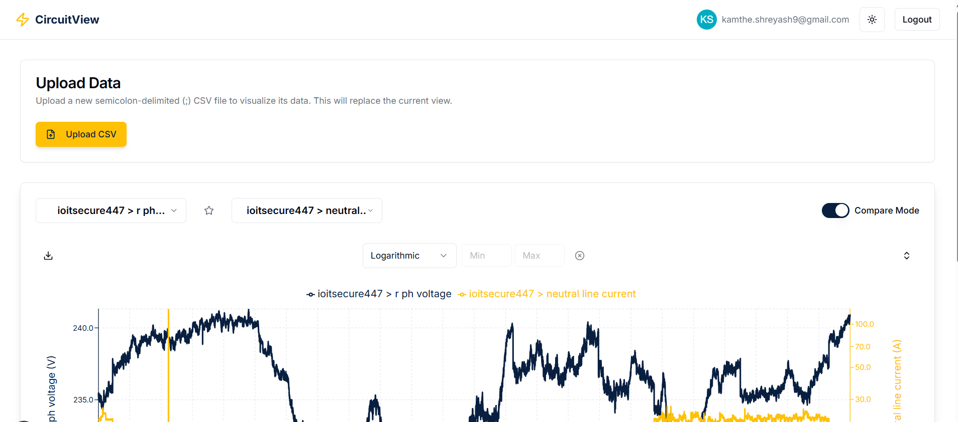
- Dark Theme :
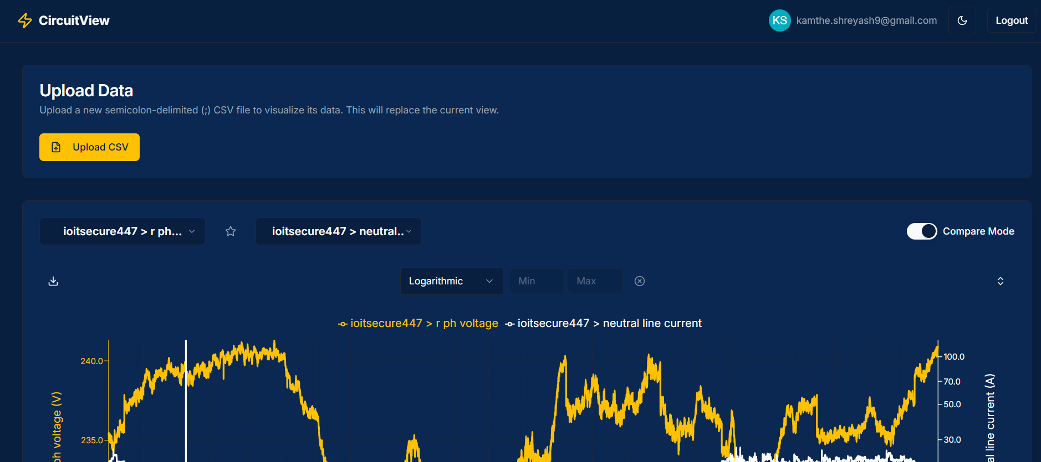

- Graphs & Favorites :
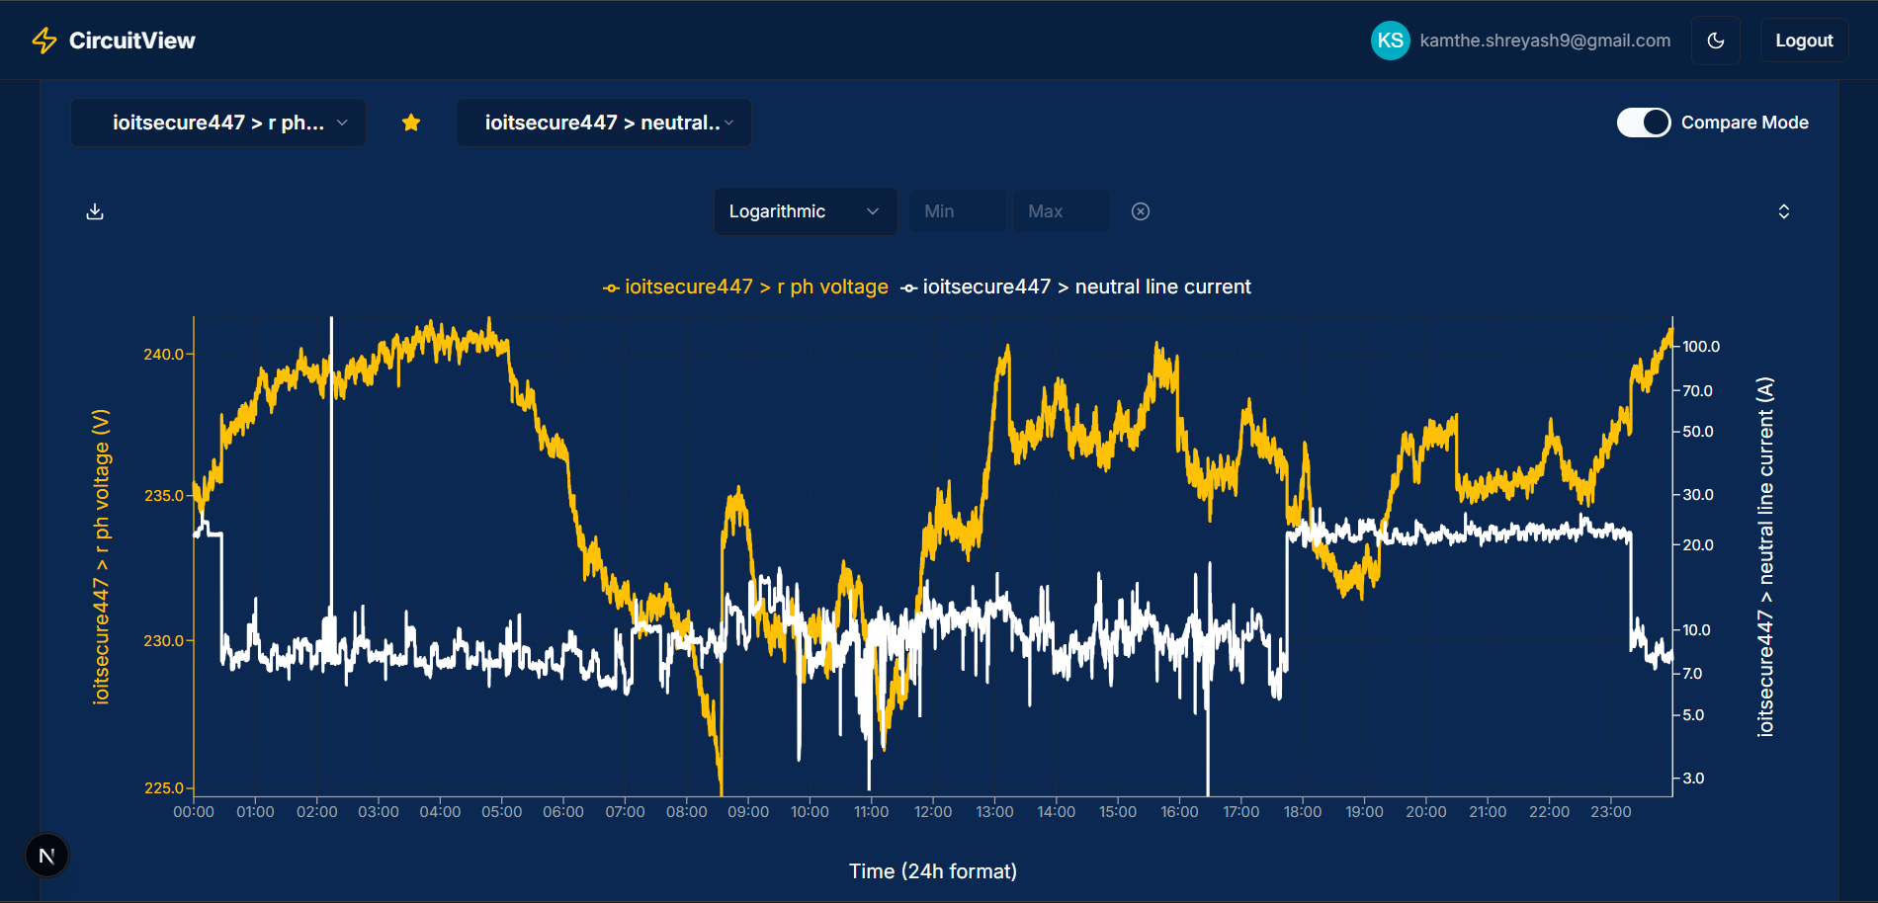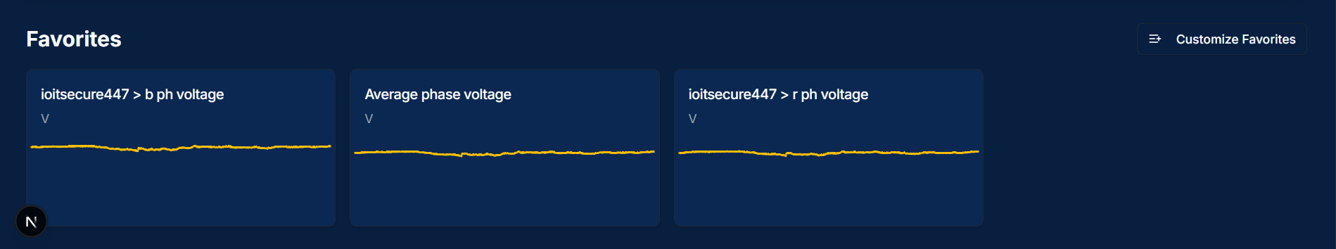

👩‍💻 Contribution Breakdown
Sr. No. | Member Name | Contribution
1 | Snehal Jagtap | UI Design, CSV Integration
2 | Kanak Jaiswal | Graph Rendering & Data Processing
3 | Shreyash Kamthe | Testing & Documentation
4 | Parth Shah | Deployment & Debugging

🧾 Conclusion
The CSV to Graphical Representation project fulfills its goal of transforming raw CSV datasets into insightful, real-time graphical visualizations. By leveraging modern web technologies, it automates manual analysis, improves accuracy, and enhances usability for students and engineers alike.
Future enhancements include AI-driven anomaly detection, IoT data streaming, and integration with cloud-based analytics tools — making this project a solid foundation for smart electrical data visualization systems.

