Freight Rate Prediction — Machine Learning Assessment

1. Executive Summary
This project predicts freight load rates (posted_rate in USD) from shipment attributes. The development dataset contains 48,000 labeled loads (Jan–Oct 2025); the final inference holdout contains 12,000 unlabeled loads (Nov–Dec 2025).
The final model is HistGradientBoostingRegressor with feature set Q and a log1p target transform. Development chronological validation MAE is 106.83 (primary split) and 113.29 (sensitivity split). These are NOT Nov–Dec holdout scores — validation.csv has no local ground truth.
Final predictions were generated for all 12,000 holdout loads and passed score.py format validation (exit code 0). Official accuracy, if any, is determined by Spotter after external submission.

2. Problem Definition
- Input: load attributes (distance, equipment, weight, market context, etc.)
- Target: posted_rate (USD freight rate)
- Identifier: load_id (TR-* train, TE-* validation) — never used as a feature
- Task: regression — predict posted_rate for each validation load
- Final holdout: validation.csv (12,000 rows, Nov–Dec 2025, no labels locally)

3. Dataset Overview
File | Rows | Period | Labels
train-test.csv | 48,000 | Jan–Oct 2025 | posted_rate present
validation.csv | 12,000 | Nov–Dec 2025 | unlabeled holdout
validation_predictions.csv | 12,000 | Nov–Dec 2025 | model output
Key columns:
Column | Role
distance | Numeric — strongest predictor (r ≈ 0.91)
equipment | Categorical — Dry Van, Reefer, Flatbed
weight | Numeric — missing/negative values require cleaning
market_index | Numeric — tested but excluded from final model
quote_signal | Numeric — retained in final feature set Q
date | Used for preprocessing; not in final Q features

4. Exploratory Data Analysis
posted_rate is right-skewed (mean $2,374 vs median $2,031) with a heavy upper tail driven by legitimate long-haul loads. Distance dominates the linear relationship with target. Equipment types show different rate levels (Reefer highest on average). market_index shows temporal drift across the full training period but Sep–Oct training aligns with Nov–Dec validation regime.
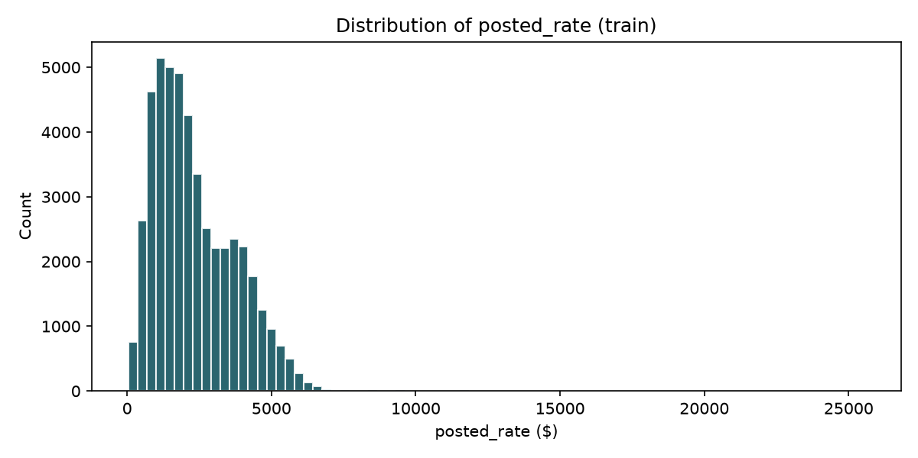
Figure 1: posted_rate distribution
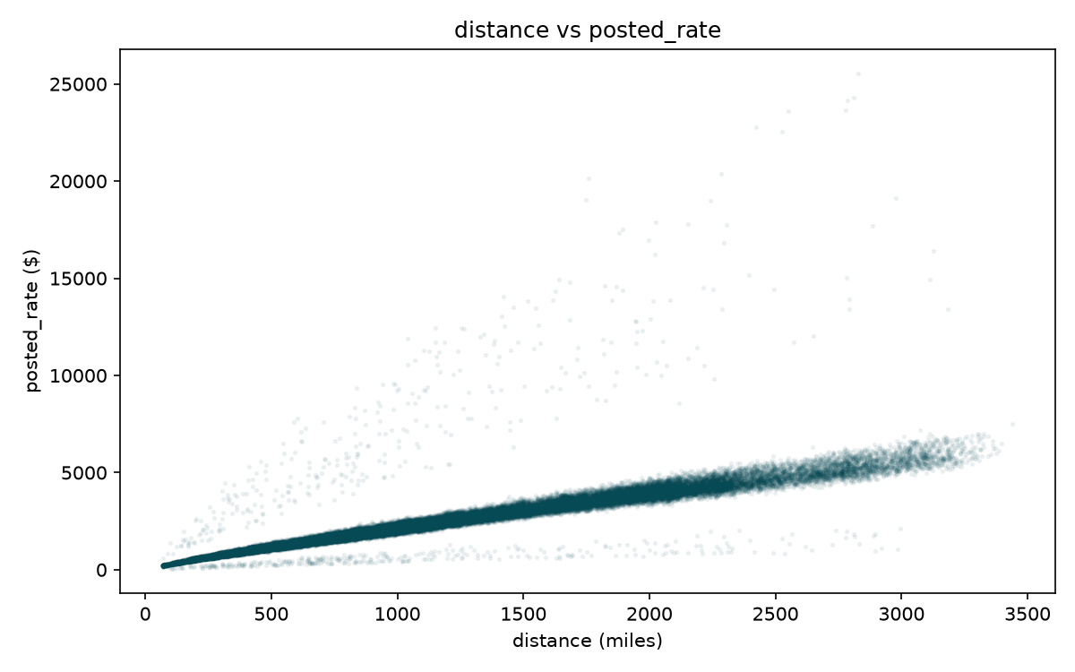
Figure 2: Distance vs posted_rate
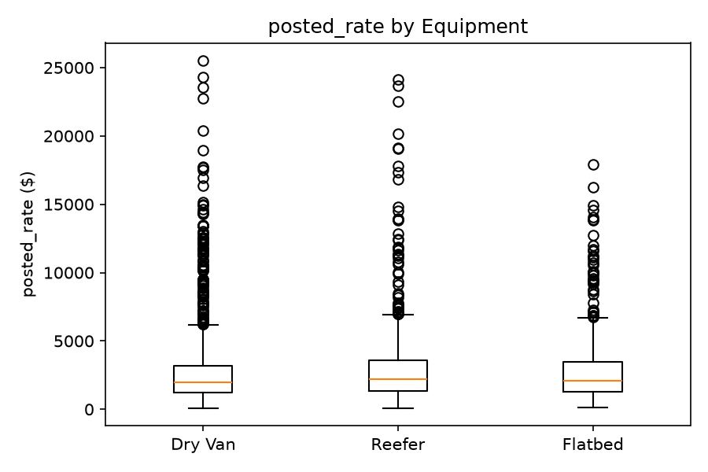
Figure 3: Rate by equipment type
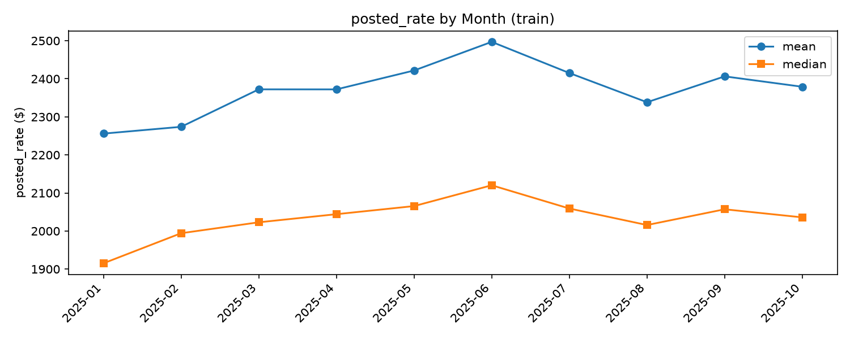
Figure 4: Monthly target behavior

5. Data Quality
Missing weight: 300 train / 165 validation rows. Negative weight: 292 train / 145 validation — treated as invalid and converted to missing.
Weight imputation: equipment median with global median fallback (fit on training fold only; full Jan–Oct for final model).
Missing market_index: 374 train / 249 validation. Imputed by month during preprocessing, but raw market_index was excluded from the final model after harming validation performance.
Unseen cities: 8 cities appear in validation but not training (~6% of rows). Final feature set Q avoids city/route identity, using equipment + distance + quote_signal instead.

6. Feature Engineering — Final Feature Set Q
Feature | Rationale
distance | Primary rate driver
log_distance | Nonlinear distance scaling
distance_bin | Bucketed distance effects
weight / weight_is_missing | Load size signal with missingness indicator
quote_signal | Strongest additive feature in ablation (+9 MAE improvement vs base)
equipment | Equipment-type rate differences (3 levels)
Excluded after testing: raw market_index (+23 MAE when added), route/city OHE, geographic extras (FULL set had +22 sensitivity gap).

7. Validation Strategy
Split | Train | Validate | Purpose
Primary | Jan–Aug 2025 | Sep–Oct 2025 | Main model selection
Sensitivity | Jan–Sep 2025 | Oct 2025 | Stability check
Random shuffling was avoided to simulate forecasting future periods. All preprocessing statistics are fit on the training fold only. validation.csv was never used for tuning.

8. Model Experiments
Primary split MAE unless noted (Phase 2–3 development validation):
Model / Config | Primary MAE | Sensitivity MAE | Phase
Global median | 1148.92 | 1146.79 | Phase 2
Distance linear | 196.95 | 192.77 | Phase 2
Distance + equipment linear | 155.68 | 157.47 | Phase 2
Ridge (FULL features) | 148.06 | 148.92 | Phase 2
HistGB FULL normal | 129.69 | 151.99 | Phase 2
ExtraTrees FULL | 142.86 | 146.42 | Phase 2
HistGB FULL log1p | 118.83 | 115.45 | Phase 3
HistGB Q normal | 118.95 | 123.91 | Phase 3
HistGB Q log1p (final) | 106.83 | 113.29 | Phase 3.5

9. Final Model Selection
Selected: HistGradientBoostingRegressor + feature set Q + log1p target.
- Strongest development MAE on both chronological splits
- Stable sensitivity performance (gap +6.5 vs +22 for FULL normal)
- Improved long-haul MAE vs alternatives
- Simple feature set — no target encoding, no route OHE
- Leakage-safe preprocessing
Hyperparameters: max_depth=6, l2_regularization=0.1, learning_rate=0.08, max_iter=300, random_state=42

10. Error Analysis
Long-haul loads (2000+ miles) remain the hardest segment — systematic underprediction persists on top-1% and rate>$5,000 loads. Reefer equipment shows slightly higher residuals. log1p improves overall MAE but does not eliminate tail bias.

11. Final Training
Final model trained on all 48,000 Jan–Oct labeled rows. validation.csv not used for fitting. Target: log1p(posted_rate); predictions: expm1(model output).

12. Final Predictions
12,000 Nov–Dec predictions in validation_predictions.csv. Distribution summary (not accuracy metrics):
Statistic | Value
Mean | $2,345.93
Median | $2,026.45
Min | $210.94
Max | $6,548.41
Invalid predictions | 0

13. Official score.py Validation
Command: python score.py --predictions validation_predictions.csv --december-predictions december-chart-inputs.csv
Exit code: 0. score.py validates file format and generates the December chart. It does NOT compute prediction accuracy.
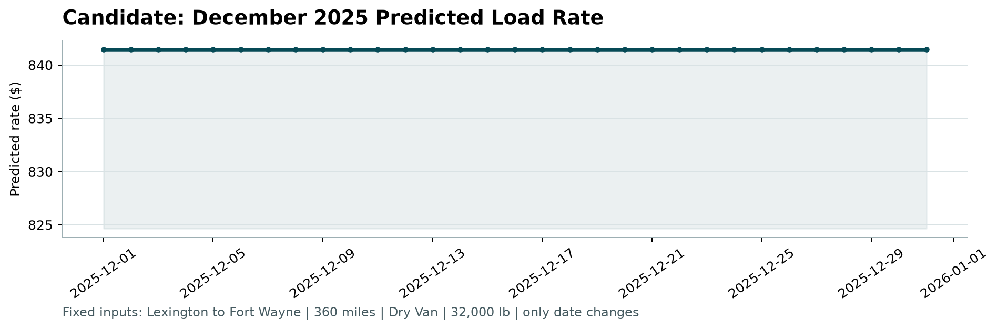
Figure 5: Fixed December 2025 Candidate Prediction — flat at $841.48 because feature set Q excludes calendar features; only date changes in the scenario.

14. Limitations
- No local ground truth for Nov–Dec holdout
- Official Spotter metric unavailable locally
- Long-tail underprediction remains
- CatBoost not evaluated (not installed in environment)
- Development MAE may differ from final holdout performance

15. Reproducibility
Setup:
- python -m venv venv
- .\venv\Scripts\Activate.ps1
- python -m pip install -r requirements.txt
Pipeline commands:
- python scripts/run_phase1_eda.py
- python scripts/run_phase2_validation.py
- python scripts/run_phase3.py
- python scripts/run_phase3_verification.py
- python scripts/train_final.py
- python score.py --predictions validation_predictions.csv --december-predictions december-chart-inputs.csv
Report generation (optional): pip install python-docx && python scripts/generate_report.py

16. Conclusion
HistGradientBoosting with feature set Q and log1p target was selected through leakage-safe chronological validation. Final Nov–Dec predictions were generated and passed score.py validation. External Spotter evaluation determines any official accuracy.

