

Faculty of Computing and Informatics (FCI)

Multimedia University

Cyberjaya

**TSN 2201**

**Computer Network Assignment**

**Semester 2, 2019/2020**

*Submitted To - Mr.Ng Keng Hoong*

*Tutorial Section: TT02*

|  |  |
| --- | --- |
| **Student Name** | **Student ID** |
| Lou Jia Yu | 1161104266 |
| Perivitta Rajendran | 1171101579 |

Network Design and Description

Network design for the Ministry of Primary Industries with a total number of 220 employees and 45.46.70.0/23 will be assigned as it’s the major IP address.

Network Performance

|  |  |  |
| --- | --- | --- |
| Divison | Number of Employees | Location |
| Account | 36 | Kajang |
| Information Management | 17 | Kuching |
| Human Resource | 18 | Putrajaya |
| Administration & Finance Management | 45 | Kota Kinabalu |
| Innovation Promotion | 15 | Kota Bahru |
| Strategic Planning and International | 14 | Putrajaya |
| Legal Unit | 10 | Kota Kinabalu |
| Corporate Communication Unit | 65 | Kuala Lumpur |

VLSM Subnetting

|  |  |  |  |  |  |  |  |
| --- | --- | --- | --- | --- | --- | --- | --- |
| **Subnet Name** | **Needed Size** | **Allocated Size** | **Network Address** | **Mask** | **Subnet Mask** | **Assignable Range** | **Broadcast** |
| Corporate Communication Unit | 65 | 126 | 45.46.70.0 | /25 | 255.255.255.128 | 45.46.70.1 - 45.46.70.126 | 45.46.70.127 |
| Administration & Finance Management | 45 | 62 | 45.46.70.128 | /26 | 255.255.255.192 | 45.46.70.129 - 45.46.70.190 | 45.46.70.191 |
| Account | 36 | 62 | 45.46.70.192 | /26 | 255.255.255.192 | 45.46.70.193 - 45.46.70.254 | 45.46.70.255 |
| Human Resource | 18 | 30 | 45.46.71.0 | /27 | 255.255.255.224 | 45.46.71.1 - 45.46.71.30 | 45.46.71.31 |
| Information Management | 17 | 30 | 45.46.71.32 | /27 | 255.255.255.224 | 45.46.71.33 - 45.46.71.62 | 45.46.71.63 |
| Innovation Promotion | 15 | 30 | 45.46.71.64 | /27 | 255.255.255.224 | 45.46.71.65 - 45.46.71.94 | 45.46.71.95 |
| Strategic Planning and International | 14 | 14 | 45.46.71.96 | /28 | 255.255.255.240 | 45.46.71.97 - 45.46.71.110 | 45.46.71.111 |
| Legal Unit | 10 | 14 | 45.46.71.112 | /28 | 255.255.255.240 | 45.46.71.113 - 45.46.71.126 | 45.46.71.127 |
| Server | 8 | 14 | 45.46.71.128 | /28 | 255.255.255.240 | 45.46.71.129 - 45.46.71.142 | 45.46.71.143 |
| Putrajaya-Kajang | 2 | 2 | 45.46.71.144 | /30 | 255.255.255.252 | 45.46.71.145 - 45.46.71.146 | 45.46.71.147 |
| Kajang-Kota Bahru | 2 | 2 | 45.46.71.148 | /30 | 255.255.255.252 | 45.46.71.149 - 45.46.71.150 | 45.46.71.151 |
| Kota Bahru-Kota Kinabalu | 2 | 2 | 45.46.71.152 | /30 | 255.255.255.252 | 45.46.71.153 - 45.46.71.154 | 45.46.71.155 |
| Kota Kinabalu-Kuching | 2 | 2 | 45.46.71.156 | /30 | 255.255.255.252 | 45.46.71.157 - 45.46.71.158 | 45.46.71.159 |
| Putrajaya-Kuala Lumpur | 2 | 2 | 45.46.71.160 | /30 | 255.255.255.252 | 45.46.71.161 - 45.46.71.162 | 45.46.71.163 |

Design Justification

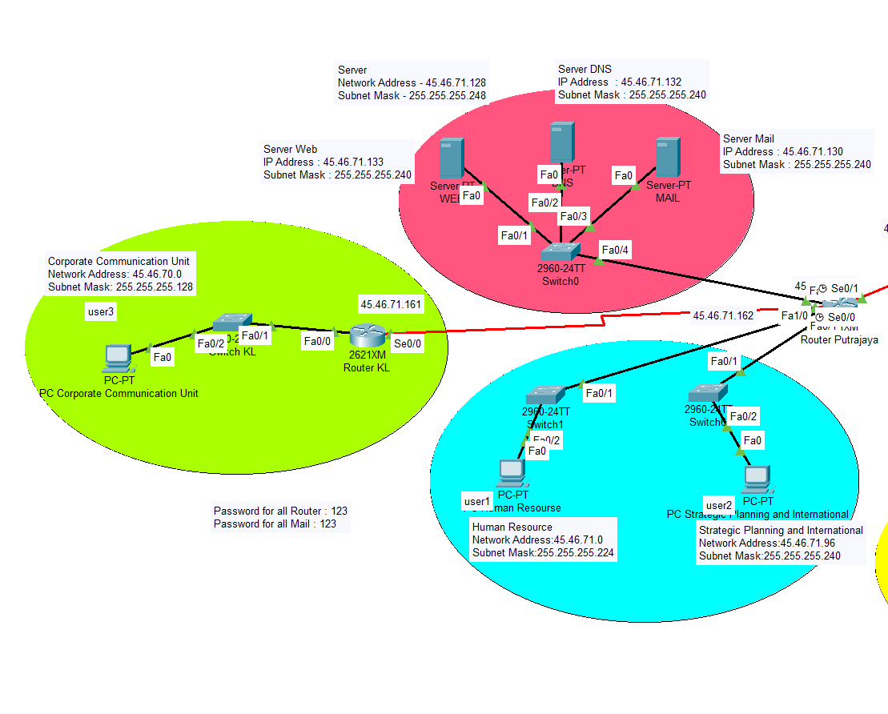

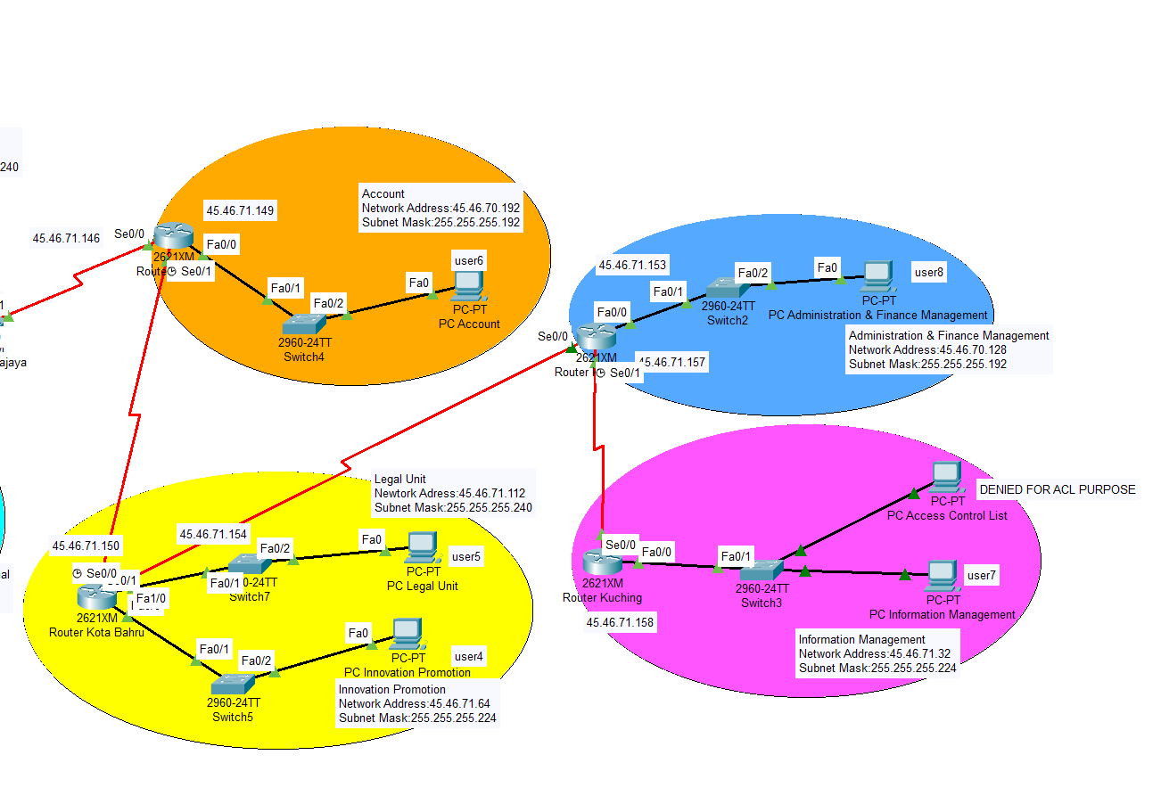

IP Address for PCs and Servers

|  |  |  |  |  |
| --- | --- | --- | --- | --- |
| **No** | **Description** | **IP Address** | **Default Gateway** | **Email Address** |
| 1 | PC-Human Resource | 45.46.71.2 | 45.46.71.1 | user1@mpi.com.my |
| 2 | PC-Strategic Planning and International | 45.46.71.98 | 45.46.71.97 | user2@mpi.com.my |
| 3 | PC-Corporate Communication Unit | 45.46.70.2 | 45.46.70.1 | user3@mpi.com.my |
| 4 | PC-Innovation Promotion | 45.46.71.66 | 45.46.71.65 | user4@mpi.com.my |
| 5 | PC-Legal Unit | 45.46.71.114 | 45.46.71.113 | user5@mpi.com.my |
| 6 | PC-Information Management | 45.46.70.194 | 45.46.70.193 | user6@mpi.com.my |
| 7 | PC-Administration & Finance Management | 45.46.71.34 | 45.46.71.33 | user7@mpi.com.my |
| 8 | PC-Access Control List | 45.46.71.35 | 45.46.71.33 | denied@mpi.com.my |
| 8 | DNS-Server | 45.46.71.133 | 45.46.71.129 | www.ministry.com |
| 9 | Web-Server | 45.46.71.132 | 45.46.71.129 | www.mpi.co |
| 10 | Email-Server | 45.46.71.130 | 45.46.71.129 | mpi.com.my |

IP Address for Routers

|  |  |  |  |  |
| --- | --- | --- | --- | --- |
| No | Description | Fast Ethernet/Serial Ethernet | IP Address | Cable Type |
| 1 | Putrajaya | Fa0/0 | 45.46.71.129 | Copper-Straight-Through |
| Fa0/1 | 45.46.71.1 |
| Se0/0 | 45.46.71.162 |
| Se0/1 | 45.46.71.145 | Serial DTE |
| Fa1/0 | 45.46.71.97 |
| 2 | Kuala Lumpur | Fa0/0 | 45.46.70.1 | Copper-Straight-Through |
| Se0/0 | 45.46.71.161 | Serial DTE |
| 3 | Kajang | Fa0/0 | 45.46.70.193 | Copper-Straight-Through |
| Se0/0 | 45.46.71.146 | Serial DTE |
| Se0/1 | 45.46.71.149 |  |
| 4 | Kota Bahru | Fa0/0 | 45.46.71.65 | Copper-Straight-Through |
| Fa1/0 | 45.46.71.113 |
| Se0/0 | 45.46.71.154 | Serial DTE |
| Se0/1 | 45.46.71.150 |
| 5 | Kinabalu | Fa0/0 | 45.46.70.129 | Copper-Straight-Through |
| Se0/0 | 45.46.71.153 | Serial DTE |
| Se0/1 | 45.46.71.157 |
| 6 | Kuching | Fa0/0 | 45.46.71.33 | Copper-Straight-Through |
| Se0/0 | 45.46.71.158 | Serial DTE |

Network Performance

* Routing Information Protocol (RIP)
  + RIP protocol only has a limitation of 15 hops maximum to avoid “count to infinity” problem, which will limit the expansion of the network in the future.
* Purpose of Servers
  + DNS: The Domain Name System consists of domain names that can be accessible to all Users. Servers are used to connect all the Internet Protocol (IP) addresses with the DNS.
  + Email: Servers are more reliable and highly secured to email within a network. Which means the results will be retrieved in split-seconds, once the email is transferred from one subnetwork to another. There will not be any internet slowdown or network disruptions during the transferring process.
  + Web servers: A Web server is a program that allows users to access information within the internet. Having a server provides better security and protection of information from prying eyes.
* Pros and cons of implementing 3 different servers
  + For a better backup system, having three servers allows better data recovery in case of a virus or malware which might cause, if any one of the servers to be affected, having multiple servers causes the data to be stored in multiple locations.
  + Fast browsing. For example, having three servers will divide the tasks among them by loading in three ways during downloads as a result faster internet speed is gained.
  + High Cost. For example, if there are many servers in a design protocol then the price of servers will be high. Based on our design, having multiple servers can also be beneficial where it will be highly secured, and that is why 3 servers were implemented.
* VLANs
  + The Ministry of Primary Industries is not using any VLANs because VLANs have high risks of virus issues because one infected system may spread a virus through the whole logical network. Additional routers are needed to control the loadout.
* Wide Area Network (WAN)
  + WAN has the ability to cover large geographical areas. The network is more centralized as a result of updates, files and data can be transferred instantly. One of the key advantages is high bandwidth which distributed workload and decreases travel charges.

Network Security (Password)

We have added passwords for all the routers and web browsers as well. The password that we have set for the routers is 123. We decided to add a password because it could enhance the ministry department’s security.