**Do we have it?**

1. Which platform has highest Leads and Leads/Ad ratio
2. Channel groupings (Leads and Leads/Ad ratio by platform)

(bar stack or bar plot) **Split the traffic by app and web**

1. Which vertical has highest Leads/Ad ratio and Leads(optional)
2. Seller type breakdown for each vertical
3. Reply type breakdown for each vertical(**Avg Leads only)**
4. Subcategory wise breakdown
5. Region wise breakdown

**Average - sum of leads / days-months**

**Leads per ad - sum of leads / ad id count**

**Exploratory Data Analysis on Leads Dataset.**

**1.1 Which platform has the highest leads ?**

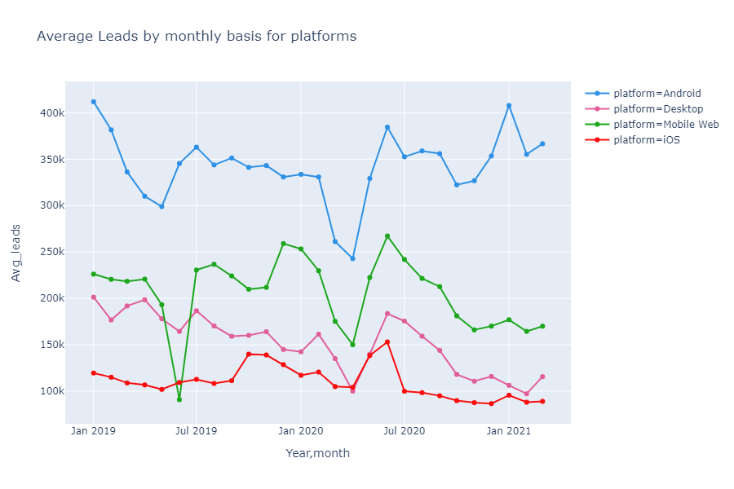

The figure above shows the average leads by monthly basis for all the platforms. Overall, Android has the highest average leads with over 411.9982k in January 2019 whereas the second highest was in January 2021 with a value of 407.9051k . When we look at the lowest leads, ‘iOS’ has less than 200k of average leads starting from January 2019 until January 2020 whereas ‘Desktop’ had a decrease in leads in May 2019. Not only that, in ‘April 2020’ there was a huge dropout for all the four platforms due to covid19. In terms of percentage table, ‘Android has 58.94% of total leads and the lowest percentage (17.16%) is for ‘Mobile Web’. After some further expansion to understand which operating system makes ‘Mobile Web’ to have the highest visitor count and we found out that the operating system ‘Android’ has the highest count under its subcategory and secondly ’iOS’. According to the parent platform ‘Mobile Web’, it has more subcategories beneath it. For the remaining subcategories under ‘Mobile Web’ have lower count of visitors which makes the average leads to be lesser..

Percentage Table:

|  |  |
| --- | --- |
| Platform | Percentage (%) |
| Android | 58.94% |
| Desktop | 23.63% |
| iOS | 33.07% |
| Mobile Web | 17.67% |

Supporting Diagram

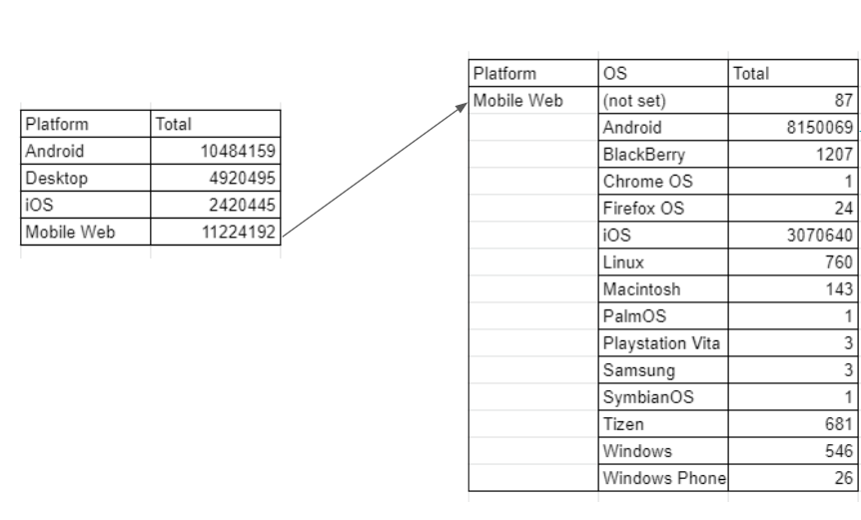

|  |  |  |
| --- | --- | --- |
| *Platform* | *OS* | Total |
| Android | Android | 10484159 |

**1.2 Which platform has the highest leads per ad ratio**

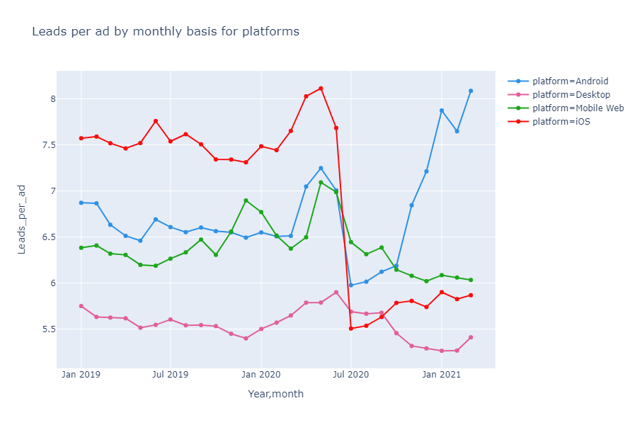

The figure above shows the leads per ad by monthly basis for platforms. As for this line plot, iOS overtook Android from January 2019 until June 2020 and then after a very big dropout from iOS, Android managed to increase back again starting from July 2020 to March 2021. The highest leads is given by IOS on ‘May 2020’, with the value of 8.113256 leads per ad whereas ‘Desktop’ still maintains to be at the lowest peak with a value less than 6 leads per ad. As for the percentage table, ‘Android’ is still in the highest rank with 54.65% whereas ‘Mobile Web’ with 33.17% of leads per ad in total.

*Percentage table:*

|  |  |
| --- | --- |
| Platform | Percentage (%) |
| Android | 54.65% |
| Desktop | 27.57% |
| iOS | 17.18% |
| Mobile Web | 33.93% |

**2.1 Which channel_grouping has the highest leads ? Web or App ?**

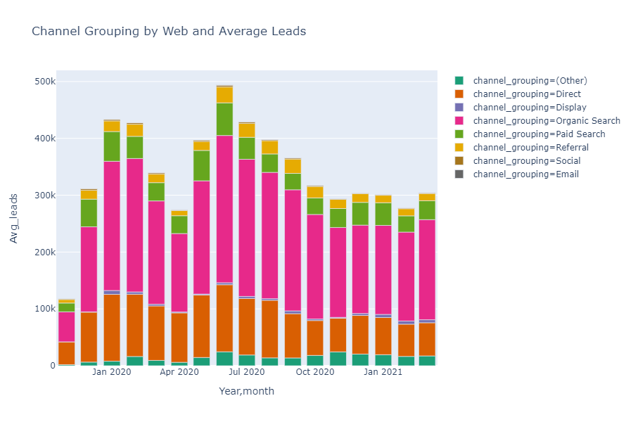

The figure above shows the average leads by monthly basis for channel groupings Web (Mobile Web and Desktop). As for the stacked barplot, ‘Organic search’ is the most preferred channel whereas the least preferred channel is ‘Email’. The highest average lead was in June 2020 for channel group ‘Organic-search’ with the value of 329.6594k and the least is for ‘Email’ with a value of 23.23139k.

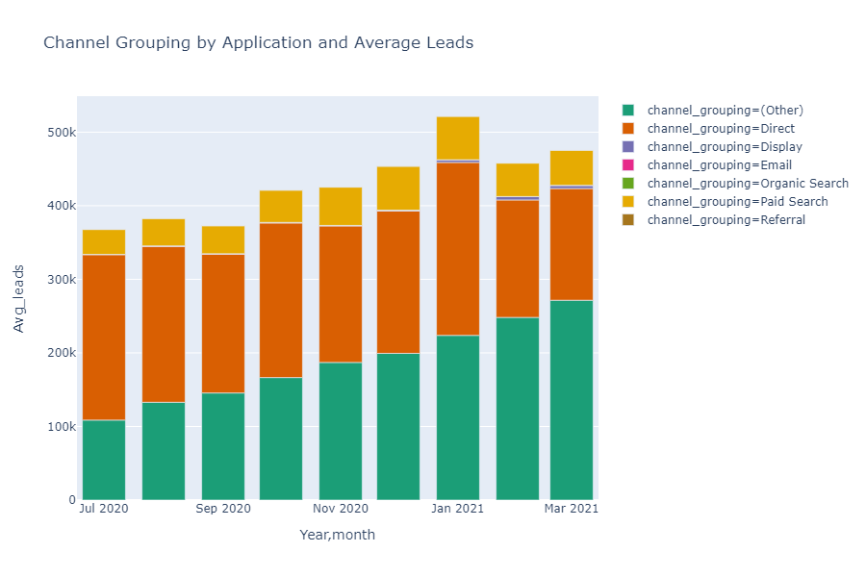

The figure above shows the average leads by monthly basis for channel groupings under Applications (Android and iOS). As for the stacked barplot, ‘Direct’ and ‘Other’ are almost having similar average leads that makes both of them to be the most preferred channel whereas the least preferred channel is ‘Email’ and ‘Referral’. The highest average lead was in January 2021 for channel group ‘Direct’ and ‘Other’ with the value of 235.0389k and 223.8155k. Overall, the growth of average leads for channel grouping ‘Other’ has been constantly increasing from July 2020 until March 2021.

*The table below shows the average leads for Applications as the highest for ‘Direct’ and for ‘Web’, highest is ‘Organic search’.*

|  |  |  |  |  |
| --- | --- | --- | --- | --- |
| channel_grouping | Android | Desktop | iOS | Mobile Web |
| (Other) | 174470.0557 | 9277.680867 | 12094.34387 | 6629.185568 |
| Direct | 121437.2549 | 36977.62693 | 74732.73631 | 51984.70871 |
| Display | 2747.034323 | 1351.737415 |  | 2183.84341 |
| Email | 374.5902295 | 96.48537959 |  | 59.85787808 |
| Organic Search | 9.570295609 | 75080.16139 |  | 119797.4137 |
| Paid Search | 43374.49229 | 13817.73012 | 2901.773172 | 25897.47432 |
| Referral | 32.97316076 | 6392.933651 |  | 11950.47425 |
| Social |  | 682.5868051 |  | 1203.458829 |

**3.1 Which vertical has the highest leads**

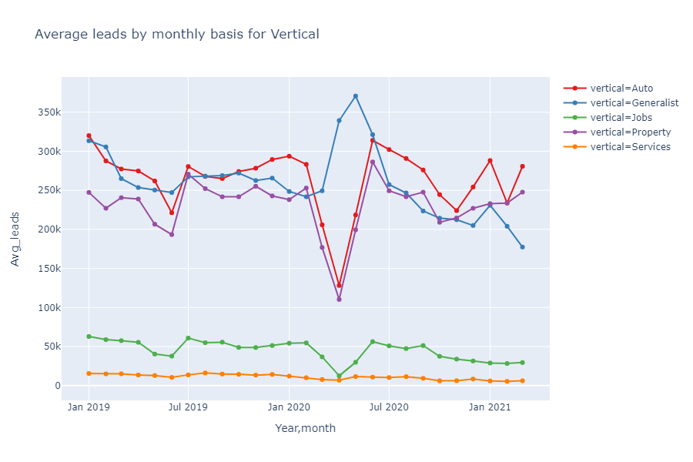

The figure above shows the average leads by monthly basis for verticals. Overall, the highest average lead is given by ‘Generalist’ with the value of 370.6266k in May 2020 whereas the lowest is from the vertical ‘Services’ with less than 25k leads in average. On February 2020 vertical ‘Auto’ and ‘Property’ started decreasing with the lowest Average leads except for ‘Generalist’ because it had overtaken ‘Auto’ and ‘Property’ starting from March 2020 until June 2020, after that, both property and Auto managed to increase back again until March 2021 whereas ‘Generalist’ continues to drop. According to the percentage table, the most occupied vertical is for ‘Auto’ with a percentage of 61.22% and the least is for ‘Services’ with the percentage of ‘9.45%’.

*Percentage table:*

|  |  |
| --- | --- |
| Verticals | Percentage (%) |
| Services | 2.25% |
| Property | 53.62% |
| Jobs | 9.45% |
| Generalist | 56.47% |
| Auto | 61.22% |

**3.2 Which vertical has the highest leads/ad ratio**

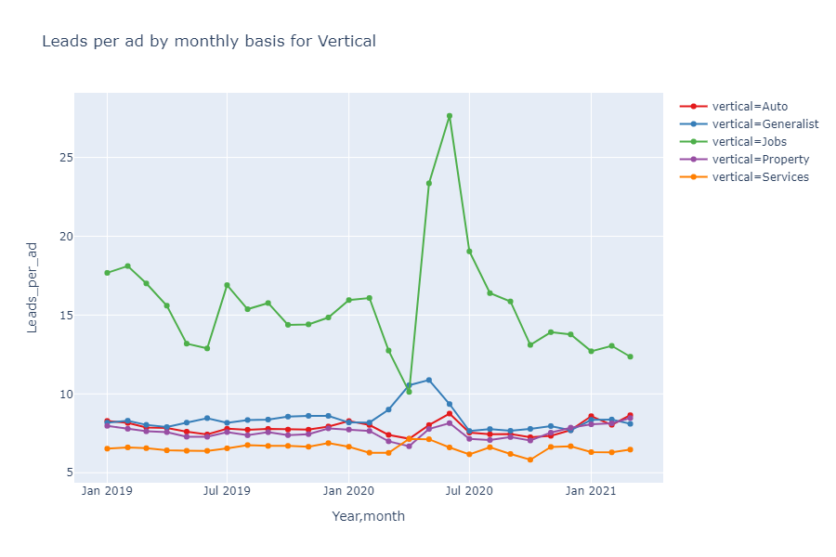

The figure above shows the relationship between leads per ad by monthly basis for verticals. As for the vertical ‘Job’, it carries about 27.64011k of leads per ad on June 2020, whereas the least leads per ad was on ‘April 2020’. Starting from January 2021, there are only three verticals increasing constantly except for ‘Generalist’ and ‘Jobs’ . The percentage table shows the values of ‘Auto’ is the highest with 62.84% whereas the least is for ‘Services’ with the percentage of 2.83%.

Percentage table:

|  |  |
| --- | --- |
| Verticals | Percentage (%) |
| Auto | 62.84% |
| Generalist | 55.22% |
| Jobs | 5.10% |
| Property | 56.86% |
| Services | 2.83% |

*Total number of visitors*

|  |  |
| --- | --- |
| *Vertical* | Visitor count |
| Auto | 11885360 |
| Generalist | 8339386 |
| Jobs | 1853989 |
| Property | 7343918 |
| Services | 448028 |

**4.1 Seller Type breakdown by verticals**

*4.1.1 Seller type breakdown by vertical - auto*

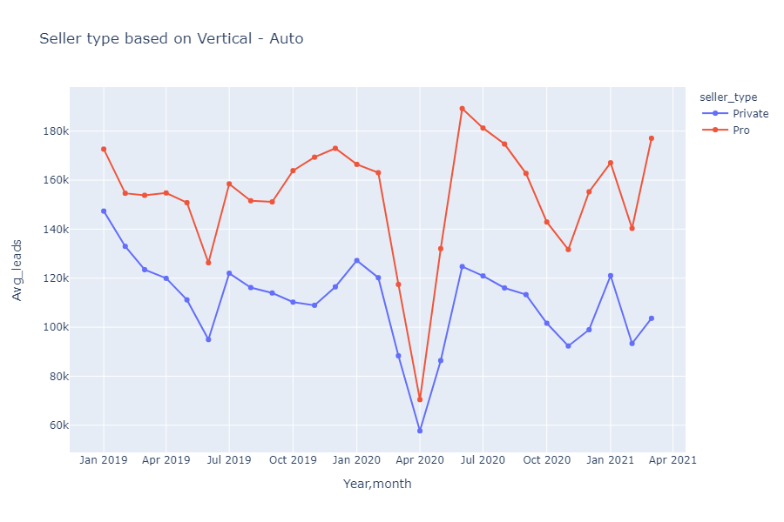

The line chart above shows the seller type breakdown by vertical ‘Auto’. Overall, the seller type ‘Pro’ has more average leads compared to ‘Private’ with the value of 189k.1916k. In this case, starting from January 2020, both the seller type decreased with the lowest average leads of 57.7088k and for ‘Pro’, 70.45811k. When we look at February 2021, both the seller types continue to grow higher.

*4.1.2 Seller type breakdown by vertical - generalist*

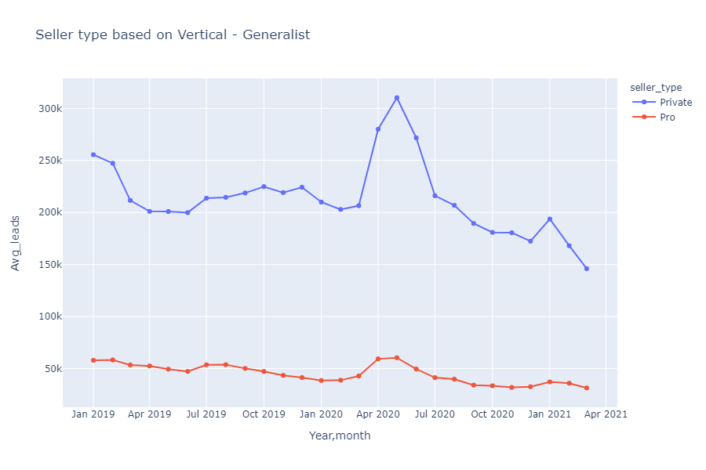

The line chart above shows the seller type breakdown by vertical ‘Generalist’ and the seller type ‘private’ has the most average leads with the value of 310.2521k on ‘May 2020’ but starting from January 2021 both the seller type continues to drop with the lowest values.

*4.1.3 Seller type breakdown by vertical - jobs*

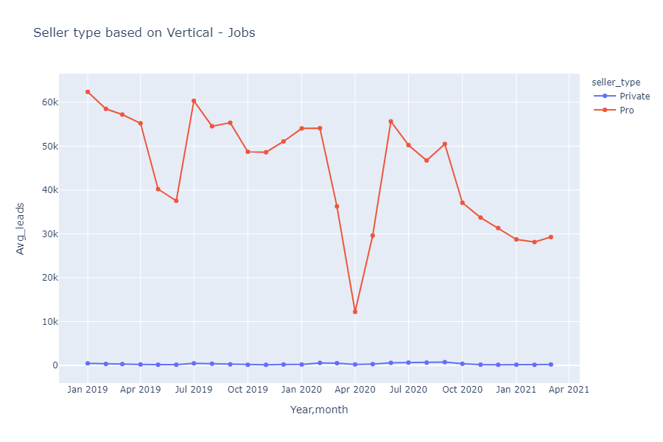

The line chart above shows the seller type breakdown by vertical ‘Jobs’ and the seller type ‘Pro’ has the highest value with average leads of 62.36526k in January 2019 whereas ‘Private’ has very low average leads, about 2 times lower than the ‘Pro’ seller type. Starting from February 2021 there is a slight growth on average leads for ‘Pro’ seller type whereas the ‘Private’ seller type increased on March 2021

4.1.4 Seller type breakdown by vertical - services

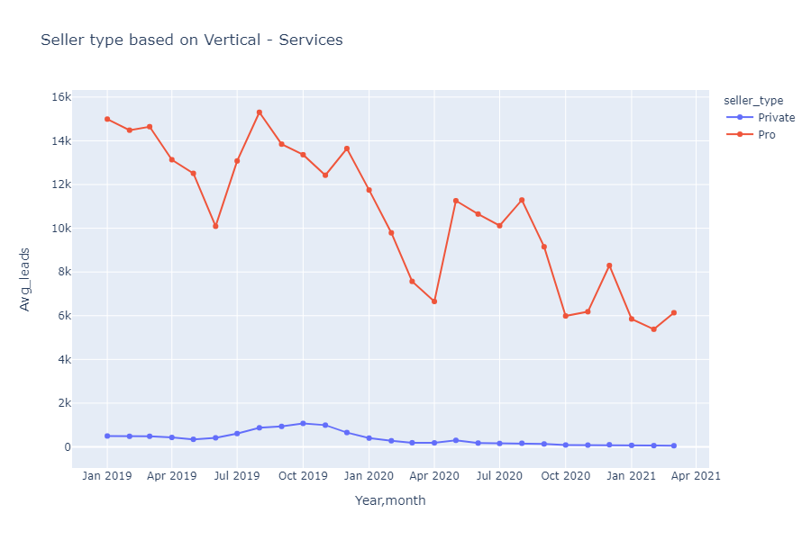

The line chart above shows the seller type breakdown by vertical ‘Services’ and the seller type ‘Pro’ is having the highest value of 15.30434k whereas the ‘Private’ seller type constantly increased from May 2019 until November 2019 and then it started decreasing back to less than 2k of average leads. On april 2020, there’s a dropout from both the seller types but for ‘Pro’ seller type there is a constant increment and decrement compared to seller type ‘Private’

*4.1.5 Seller type breakdown by vertical - property*

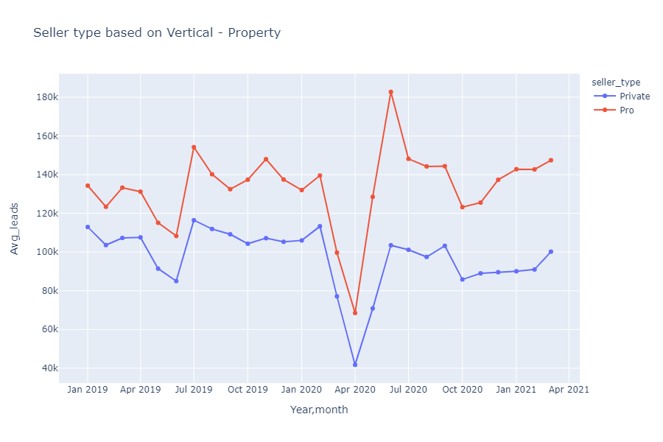

The line chart above shows the seller type breakdown by vertical ‘Property’ and the seller type for ‘Pro’ is carrying the highest average leads with the value of 182.7568k. But both this seller types, increases and decreases at the same time but the only difference is the average leads. Overall, both seller types had dropdowns in April 2020 and it started rising back again, however there is some dropdown back to back on 2020 but in the year 2021, it managed to rise back again.

Overall, the count of ‘Private’ seller types is higher than ‘Pro’ seller type when we sum up the entire table on all the verticals. But for the ‘Private’ seller type, it has about two times higher counts than the ‘Pro’ seller type when it comes to the vertical ‘Generalist’ and for the remaining verticals, ‘Private’ seller type still maintains to be lower than ‘Pro’.

|  |  |  |
| --- | --- | --- |
| Verticals | Seller Type | Visitor Count |
| Auto | Private | 73194970 |
| Auto | Pro | 111189436 |
| Generalist | Private | 142545824 |
| Generalist | Pro | 31795706 |
| Jobs | Private | 245976 |
| Jobs | Pro | 27595665 |
| Property | Private | 66565978 |
| Property | Pro | 97444359 |
| Services | Private | 258335 |
| Services | Pro | 7404365 |

|  |  |
| --- | --- |
| Seller type | Sum |
| Private | 282811083 |
| Pro | 275429531 |

Percentage table:

|  |  |  |
| --- | --- | --- |
| Vertical | Seller type | Percentage (%) |
| Auto | Private | 48.3% |
|  | Pro | 68.8% |
| Generalist | Private | 89.3% |
|  | Pro | 18.71% |
| Jobs | Private | 0.13% |
|  | Pro | 18% |
| Property | Private | 42.5% |
|  | Pro | 60.07% |
| Services | Private | 0.13% |
|  | Pro | 4.17% |

**4.2 Seller type breakdown by vertical [Ad Ratio]**

*4.2.1 Seller type breakdown by vertical - auto [ad ratio]*

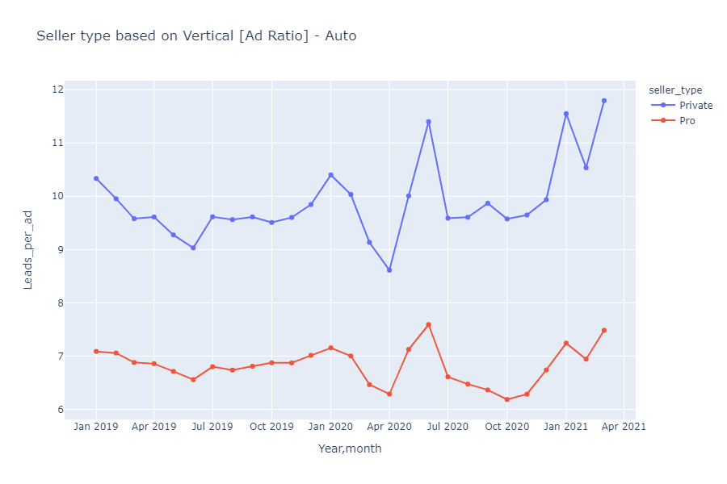

The line chart above shows the leads per ad and seller type breakdown by vertical ‘Auto’ and for the highest lead per ad, is given by the seller type private with the highest values of 11.79472k in March 2021 whereas the lowest point is given by ‘Pro’ within the range of 6 to 7.6 leads per ad.

*4.2.2 Seller type breakdown by vertical - generalist [ad ratio]*

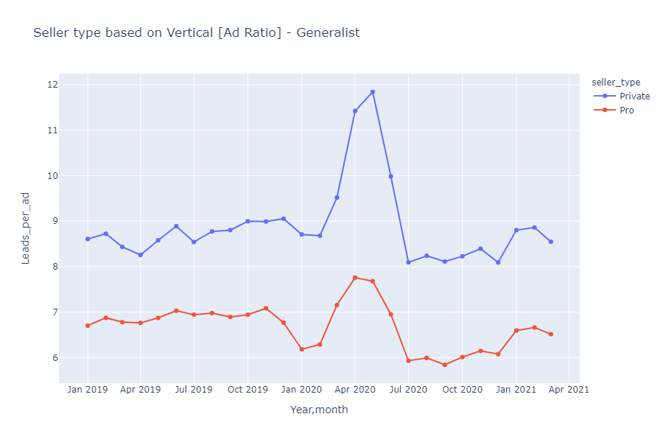

The line chart above shows the leads per ad and seller type breakdown by vertical ‘Generalist’ and the seller type ‘Private’ has the highest leads per ad with the value of 11.84207. But starting from January 2021 both the seller type ‘Pro’ and ‘Private’ started decreasing with the range of 6 to 7 leads per ad (Pro) and 8 to 9 leads per ad for ‘Private’.

*4.2.3 Seller type breakdown by vertical - jobs [ad ratio]*

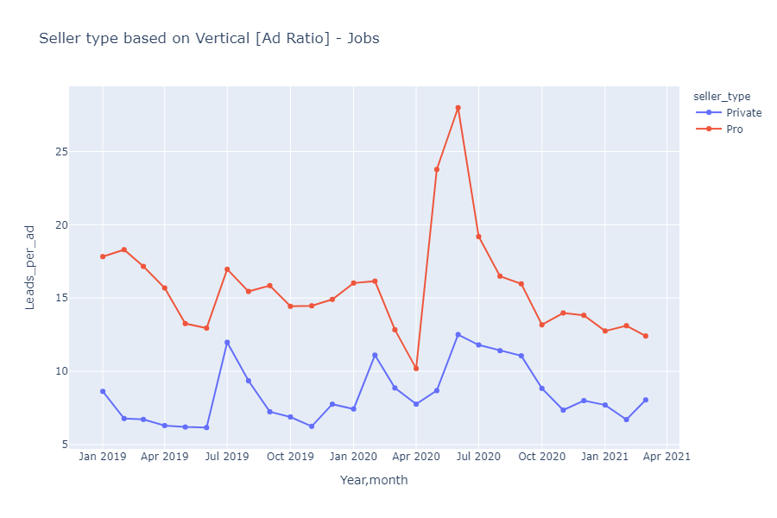

The line chart above shows the leads per ad and seller type breakdown by vertical ‘Jobs’ and the seller type ‘Pro’ continues to have the highest leads per ad with the value of 27.98985. Besides that, starting from February 2021, seller type ‘Pro’ continues to decrease whereas ‘Private’ seller type increases after a fallout.

*4.2.4 Seller type breakdown by vertical - services [ad ratio]*

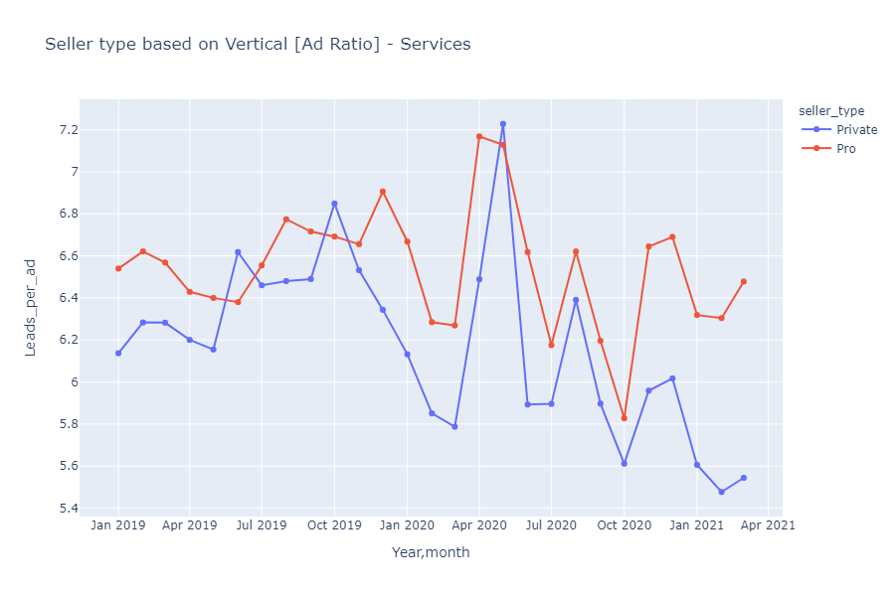

The line chart above shows the leads per ad and seller type breakdown by vertical ‘Services’ and the both the seller type are almost having the similar range of leads per ad within the scale of 6 to 7 leads per ad. But at some point seller type ‘Private’ overtakes ‘Pro’ by an additional 0.2 leads in May 2020. Not only that, both the seller types have similar ups and downs in terms of leads per ad except in June 2019 and October 2019 where ‘Private’ overtakes ‘Pro’.

*4.3.5 Seller type breakdown by vertical - property [ad ratio]*

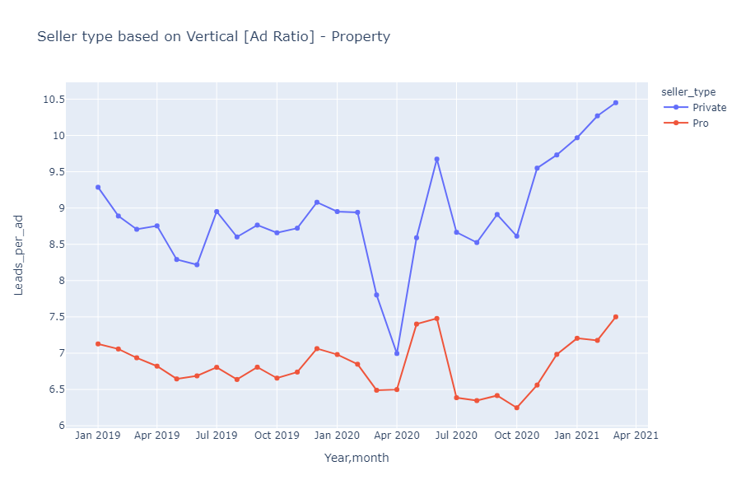

The line chart above shows the leads per ad and seller type breakdown by vertical ‘Property’ and seller type ‘Private’ and ‘Pro’ constantly increasing from October 2020 until March 2021. Overall, the leads per ad by ‘Private’ is the highest on March 2021 with the value of 10.45082. From the percentage table breakdown, ‘Auto’ continues to have highest leads per ad compared to the remaining verticals with a value of 38.82% for ‘Private’ and 81.43% for ’Pro’ whereas the least leads per ad is for the vertical ‘Services’ with a value of 0.17% for ‘Private’ and 5.24% for ’Pro’ seller types.

Percentage table:

|  |  |  |
| --- | --- | --- |
| Vertical | Seller type | Percentage |
| Auto | Private | 38.82% |
|  | Pro | 81.43% |
| Generalist | Private | 82.69% |
|  | Pro | 23% |
| Jobs | Private | 0.12% |
|  | Pro | 9.62% |
| Property | Private | 37.75% |
|  | Pro | 71.05% |
| Services | Private | 0.17% |
|  | Pro | 5.24% |

**5.1 Reply type breakdown by verticals**

*5.1.1 Reply_type breakdown by verticals - auto*

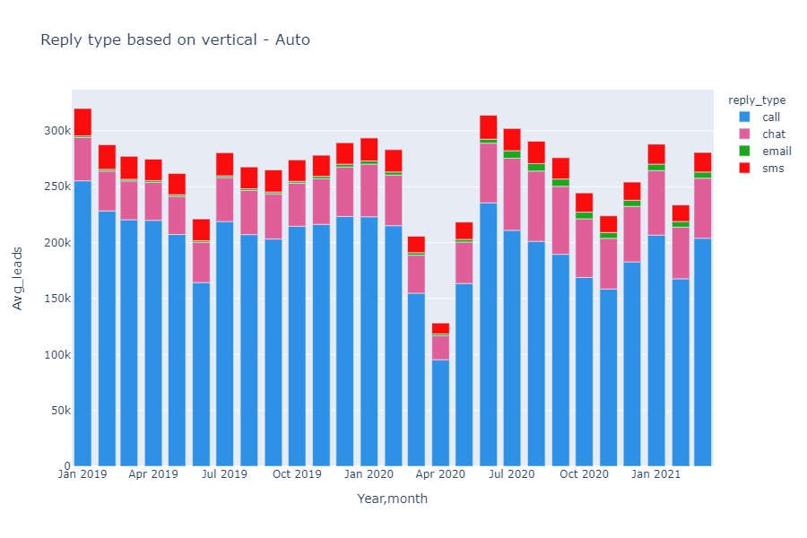

The figure above shows the reply type breakdown by vertical ‘Auto’. The reply type, ‘Call’ has up to an average of 250k leads in total compared to the remaining reply types. The least preferred reply type is ‘email’ where it only has about less than 7000 leads in average. Overall, the highest number of average leads was in January 2019 where there’s about over 300k’s of leads. In April 2020 the leads on average were low for all the five reply types.

*5.1.2 Reply_type breakdown by verticals - generalist*

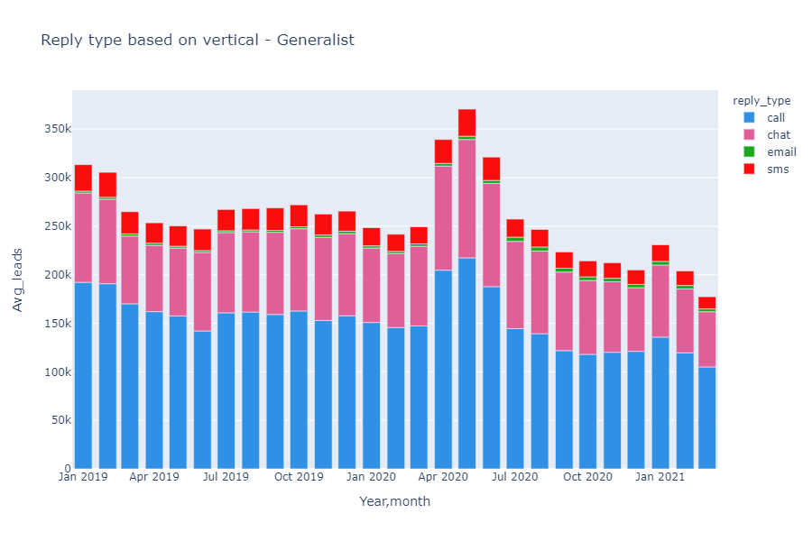

The figure above shows the reply type breakdown by vertical ‘Generalist’. The reply type, ‘call’ continues to have the highest average leads with over 217.4204k in May 2020 and reply type ‘chat’ is also carrying the highest number average leads and it has about 121.8815k. In February 2020 until May 2020, there was an increase in leads and after June 2020 onwards it started having lower leads.

*5.1.3 Reply_type breakdown by verticals - jobs*

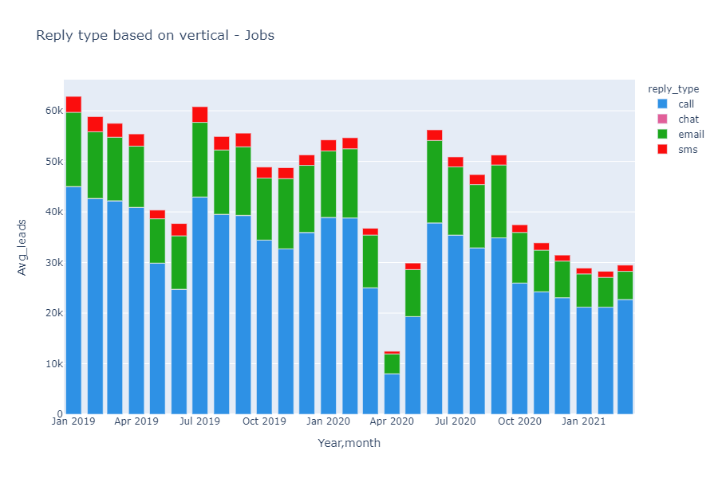

The figure above shows the reply type breakdown by vertical ‘Jobs’. According to the breakdown of reply types, ‘call’ has the highest number of average leads with the value of 44,96143k. Secondly, this vertical also has more users who prefer the reply type, ‘email’ for Job applications and the least preferred reply type is ‘chat’ and ‘sms’.

*5.1.4 Reply_type breakdown by verticals - services*

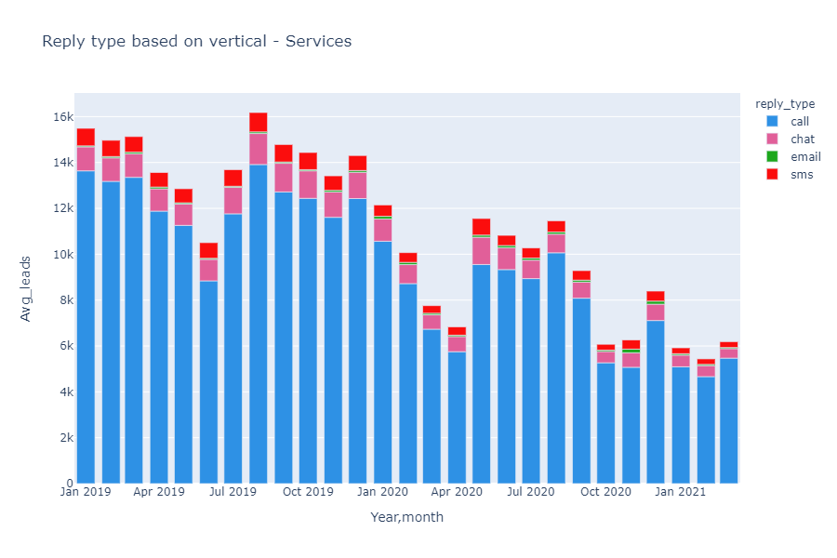

The figure above shows the reply type breakdown by vertical ‘Services’. According to the stacked bar plot, reply type, ‘call’ has the highest average leads with around 14k and reply type ‘email’ is the least preferred.

*5.1.5 Reply_type breakdown by verticals - property*

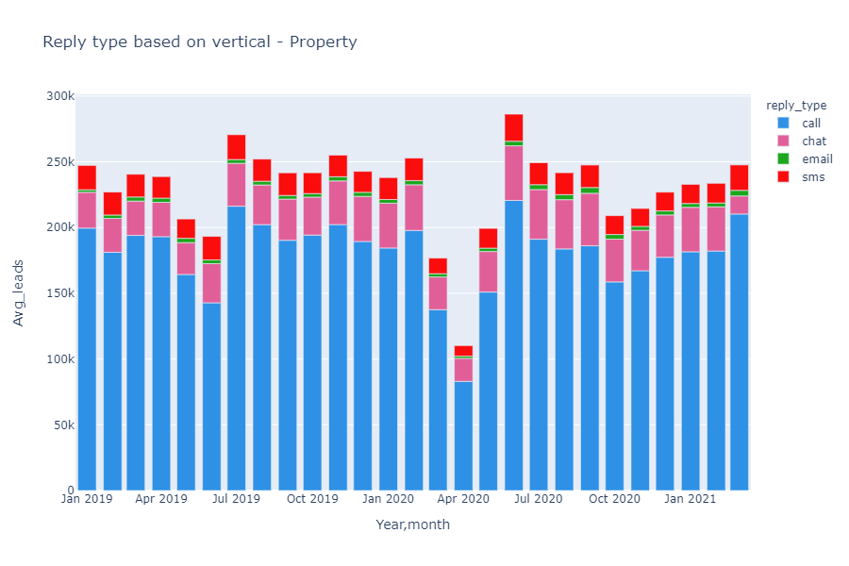

The figure above shows the reply type breakdown by vertical ‘Property’. According to the diagram, reply type, ‘call’ , carries the highest leads within the range of 100k to 200k of leads in total. Not only that, the least preferred reply type is ‘email’ with a value of less than 4500 average leads.

Percentage table:

|  |  |
| --- | --- |
| Reply_type | Percentage (%) |
| call | 74.44% |
| chat | 33.12% |
| email | 3.33% |
| sms | 11.39% |

|  |  |
| --- | --- |
| *reply_type* | Counts of visitors |
| call | 23723660 |
| chat | 9478547 |
| email | 2904647 |
| sms | 2812140 |

**6.0 Subcategory wise breakdown by visitor count**

The table below shows the comparison of average visitor count starting from 2019 to 2021. The contents highlighted in blue are constantly increasing for all three years but the contents that are not highlighted, are having slight decrement on the yearly average.

|  |  |  |  |
| --- | --- | --- | --- |
| *subcategory* | 2019 | 2020 | 2021 |
| Accessories for Phones & Gadgets | 10.10136986 | 236.2622951 | 278.5666667 |
| Accommodation & Homestays | 37.06849315 | 225.4180328 | 127.5777778 |
| Apartments | 273.2136986 | 5146.330601 | 6684.711111 |
| Bags & Wallets | 12.3890411 | 227.7131148 | 406.8222222 |
| Bed & Bath | 7.271232877 | 122.3333333 | 142.4222222 |
| Business for Sale | 11.16986301 | 177.0983607 | 171.6444444 |
| Cameras & Photography | 28.74794521 | 383.3852459 | 379.9111111 |
| Car Accessories & Parts | 241.4054795 | 3653.038251 | 4141.811111 |
| Cars | 716.9835616 | 14144.01639 | 20401.22222 |
| Clothes | 12.47123288 | 289.1311475 | 287.0777778 |
| Commercial Properties | 30.50410959 | 772.8497268 | 986.3333333 |
| Commercial Vehicle & Boats | 37.10410959 | 684.6092896 | 941.7111111 |
| Computers & Accessories | 53.47671233 | 1447.087432 | 2412.522222 |
| Food | 9.684931507 | 230.1502732 | 184.6888889 |
| Furniture & Decoration | 49.46575342 | 1176.29235 | 1648.6 |
| Games & Consoles | 44.27945205 | 881.8961749 | 1143.511111 |
| Garden Items | 10.88767123 | 226.9617486 | 248.9222222 |
| Health & Beauty | 10.95068493 | 373.0027322 | 207 |
| Hobby & Collectibles | 23.29041096 | 377.3961749 | 383.0555556 |
| Home Appliances & Kitchen | 63.56986301 | 1349.060109 | 1566.088889 |
| Houses | 358.1123288 | 6885.297814 | 8943.533333 |
| Jobs | 336.0027397 | 3936.557377 | 3228.533333 |
| Land | 60.47123288 | 1362.877049 | 1535.066667 |
| Mobile Phones & Gadgets | 337.1972603 | 5736.814208 | 7300.855556 |
| Moms & Kids | 16.35890411 | 263.3415301 | 314.8111111 |
| Motorcycle Accessories & Parts | 44.99178082 | 819.0163934 | 930.2888889 |
| Motorcycles | 224.2383562 | 4705.718579 | 6573.033333 |
| Music Instruments | 9.802739726 | 183.9672131 | 182.3666667 |
| Music/Movies/Books/Magazines | 2.575342466 | 55.32786885 | 48.04444444 |
| Other Accessories & Parts | 3.539726027 | 60.2704918 | 66.87777778 |
| Others | 11.56164384 | 182.2513661 | 148.9444444 |
| Pets | 87.47945205 | 2070.73224 | 3020.833333 |
| Professional/Business Equipment | 16.77260274 | 305.8715847 | 326.6666667 |
| Rooms | 204.060274 | 2004.576503 | 2117.877778 |
| Services | 31.93150685 | 466.5765027 | 489.4666667 |
| Shoes | 18.45753425 | 326.3606557 | 321.8111111 |
| Sports & Outdoors | 40.98356164 | 1050.103825 | 1188.766667 |
| Textbooks | 0.5123287671 | 8.571038251 | 10.33333333 |
| Tickets & Vouchers | 1.953424658 | 15.18579235 | 6.577777778 |
| Tours and Holidays | 4.243835616 | 33.77322404 | 12.87777778 |
| TV/Audio/Video | 59.43561644 | 841.4180328 | 966.4555556 |
| Watches & Fashion Accessories | 27.46575342 | 628.1010929 | 643.6555556 |
| Wedding | 1.767123288 | 16.8579235 | 12.77777778 |

***Total count of visitors based on subcategory for the last five months***

The table below shows how the count of visitors plays a major role in increasing the leads for each subcategory.

|  |  |  |  |  |  |
| --- | --- | --- | --- | --- | --- |
| *Year* | 2020 | | 2021 | | |
| *subcategory* | 11 | 12 | 1 | 2 | 3 |
| Accessories for Phones & Gadgets | 9903 | 9450 | 10283 | 8035 | 6753 |
| Accommodation & Homestays | 2756 | 9017 | 4234 | 2159 | 5089 |
| Apartments | 192438 | 200105 | 205578 | 185880 | 210166 |
| Bags & Wallets | 6406 | 12771 | 15918 | 11117 | 9579 |
| Bed & Bath | 4406 | 4485 | 5066 | 4067 | 3685 |
| Business for Sale | 5574 | 6083 | 5890 | 4401 | 5157 |
| Cameras & Photography | 12912 | 13426 | 13005 | 9334 | 11853 |
| Car Accessories & Parts | 126062 | 137814 | 138463 | 108538 | 125762 |
| Cars | 552661 | 630556 | 667871 | 499487 | 668752 |
| Clothes | 9890 | 10865 | 10201 | 7970 | 7666 |
| Commercial Properties | 29063 | 31506 | 28263 | 25518 | 34989 |
| Commercial Vehicle & Boats | 27789 | 29486 | 28136 | 26273 | 30345 |
| Computers & Accessories | 62719 | 57203 | 84246 | 72378 | 60503 |
| Food | 11112 | 9795 | 6601 | 5650 | 4371 |
| Furniture & Decoration | 48537 | 47012 | 52188 | 46812 | 49374 |
| Games & Consoles | 37110 | 35245 | 42091 | 31039 | 29786 |
| Garden Items | 7243 | 7311 | 7276 | 7184 | 7943 |
| Health & Beauty | 10169 | 7234 | 7637 | 5699 | 5294 |
| Hobby & Collectibles | 12436 | 13420 | 13204 | 10851 | 10420 |
| Home Appliances & Kitchen | 49891 | 45213 | 49909 | 45263 | 45776 |
| Houses | 258416 | 277580 | 278045 | 256059 | 270814 |
| Jobs | 121836 | 115438 | 102718 | 88335 | 99515 |
| Land | 45605 | 48720 | 49102 | 43600 | 45454 |
| Mobile Phones & Gadgets | 233374 | 225189 | 257727 | 202285 | 197065 |
| Moms & Kids | 8758 | 10841 | 11528 | 9061 | 7744 |
| Motorcycle Accessories & Parts | 31793 | 30979 | 32215 | 26955 | 24556 |
| Motorcycles | 182076 | 188034 | 214162 | 176758 | 200653 |
| Music Instruments | 6296 | 6108 | 6771 | 4826 | 4816 |
| Music/Movies/Books/Magazines | 1627 | 2299 | 1806 | 1330 | 1188 |
| Other Accessories & Parts | 2159 | 2517 | 2361 | 1889 | 1769 |
| Others | 4985 | 5248 | 4858 | 4370 | 4177 |
| Pets | 94728 | 91937 | 94772 | 90830 | 86273 |
| Professional/Business Equipment | 9817 | 10715 | 9972 | 9262 | 10166 |
| Rooms | 55480 | 61788 | 61501 | 59791 | 69317 |
| Services | 14047 | 15008 | 14116 | 13881 | 16055 |
| Shoes | 11160 | 11301 | 11340 | 8331 | 9292 |
| Sports & Outdoors | 46134 | 45172 | 38526 | 33618 | 34845 |
| Textbooks | 229 | 253 | 333 | 269 | 328 |
| Tickets & Vouchers | 386 | 538 | 231 | 146 | 215 |
| Tours and Holidays | 309 | 901 | 472 | 223 | 464 |
| TV/Audio/Video | 30803 | 28891 | 34141 | 27657 | 25183 |
| Watches & Fashion Accessories | 21966 | 22223 | 22137 | 17802 | 17990 |
| Wedding | 361 | 451 | 409 | 297 | 444 |

***The first 3 subcategories with the highest average leads***

|  |  |  |  |  |
| --- | --- | --- | --- | --- |
| *subcategory* | 2019 | 2020 | 2021 |  |
| Apartments | 89930.12153 | 83713.53929 | 91808.62215 |  |
| Cars | 151289.7107 | 148532.6066 | 170124.1598 |  |
| Houses | 83690.71193 | 86256.57142 | 97533.95381 |  |

***Cars***

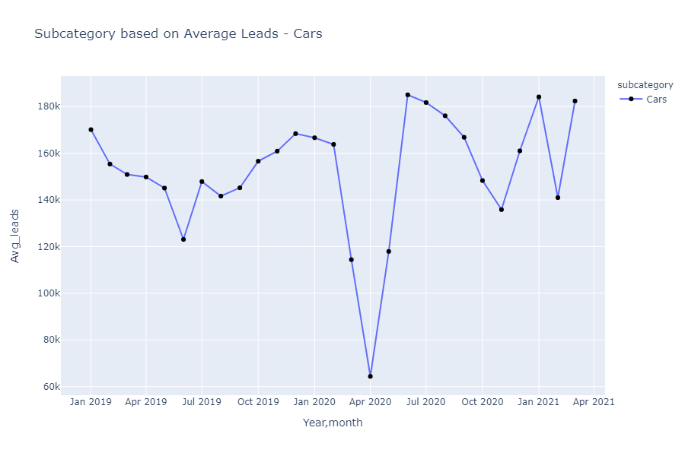

***Houses***

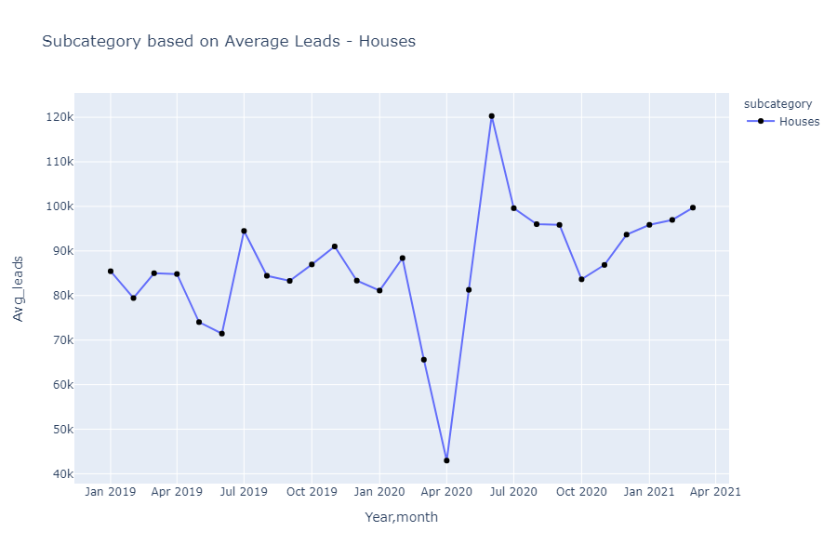

***Apartments***

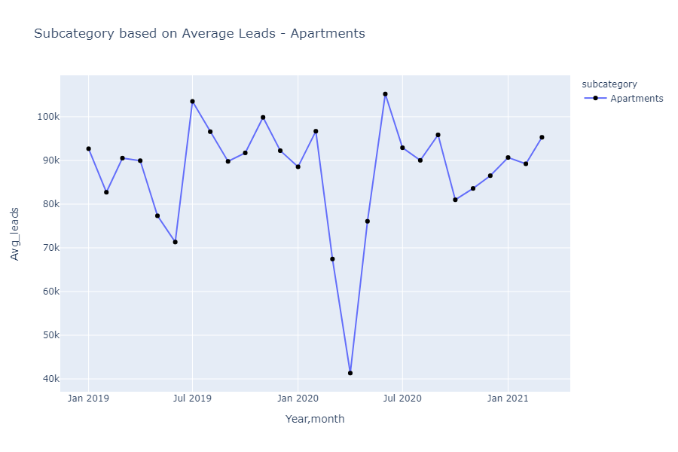

***The least popular subcategories with Average Leads***

|  |  |  |  |
| --- | --- | --- | --- |
| *subcategory* | 2019 | 2020 | 2021 |
| Textbooks | 146.5695996 | 126.8410834 | 68.73739316 |
| Tickets & Vouchers | 267.6794161 | 120.6117125 | 44.31033455 |
| Wedding | 313.2232865 | 157.636632 | 83.91119247 |

***Textbooks***

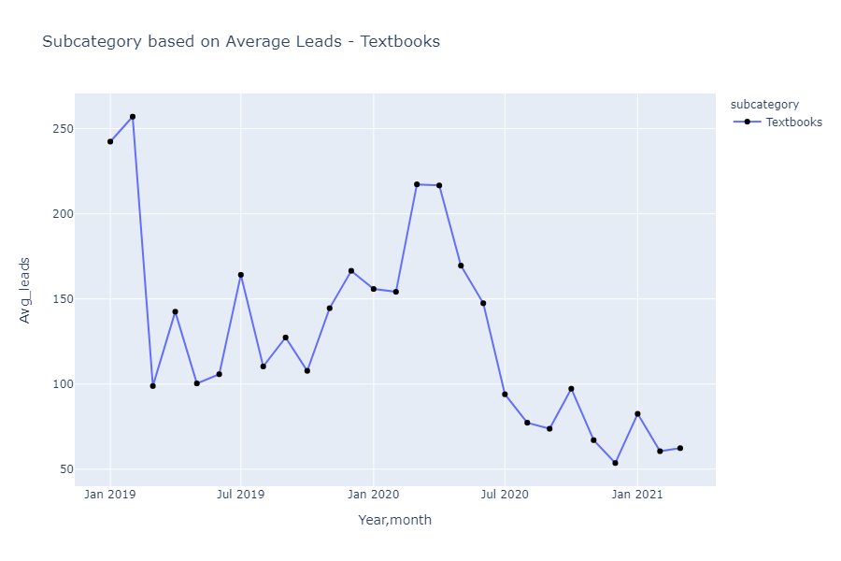

***Tickets and vouchers***

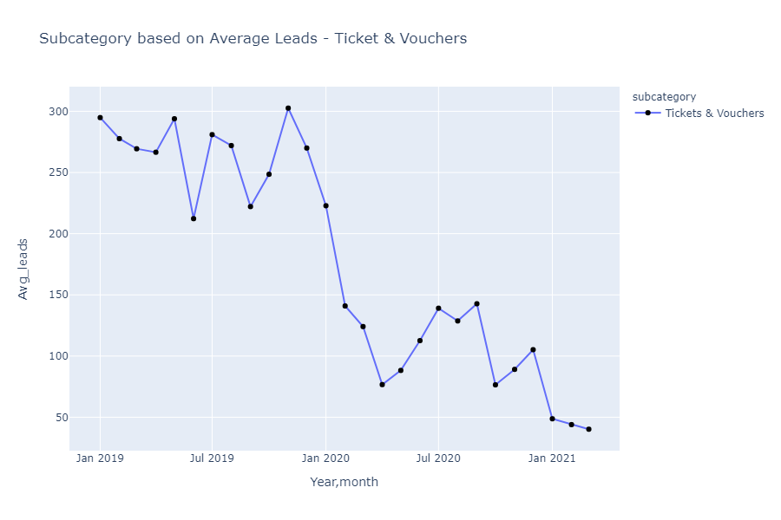

***Wedding***

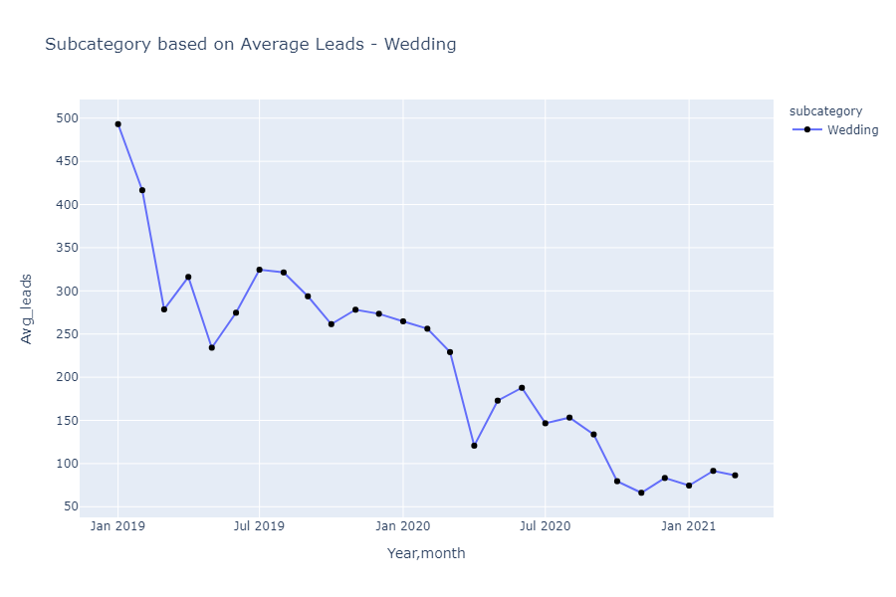

***The first 3 subcategories with Average Leads per ad ratio***

|  |  |  |  |
| --- | --- | --- | --- |
| *subcategory* | 2019 | 2020 | 2021 |
| Apartments | 6044.371233 | 5609.226776 | 5522.372222 |
| Cars | 9543.253425 | 9509.265027 | 9748.027778 |
| Houses | 5485.971233 | 5596.117486 | 5639.961111 |

***Cars***

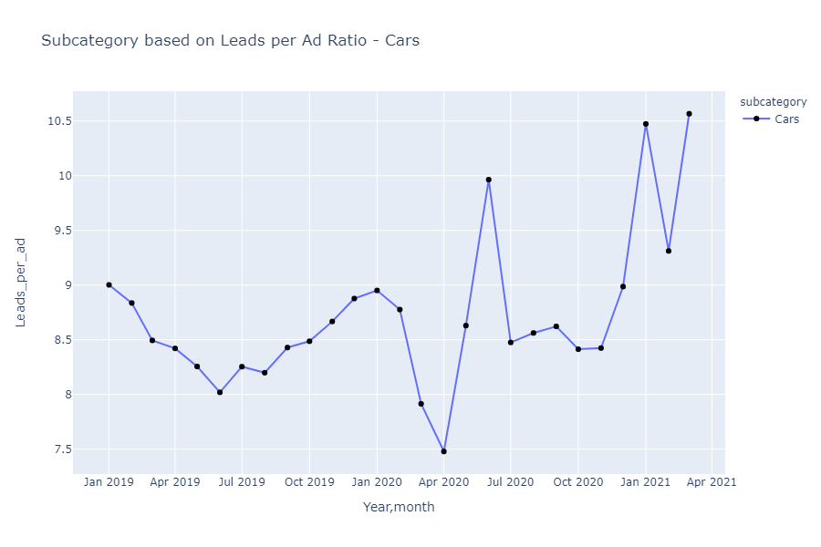

***Houses***

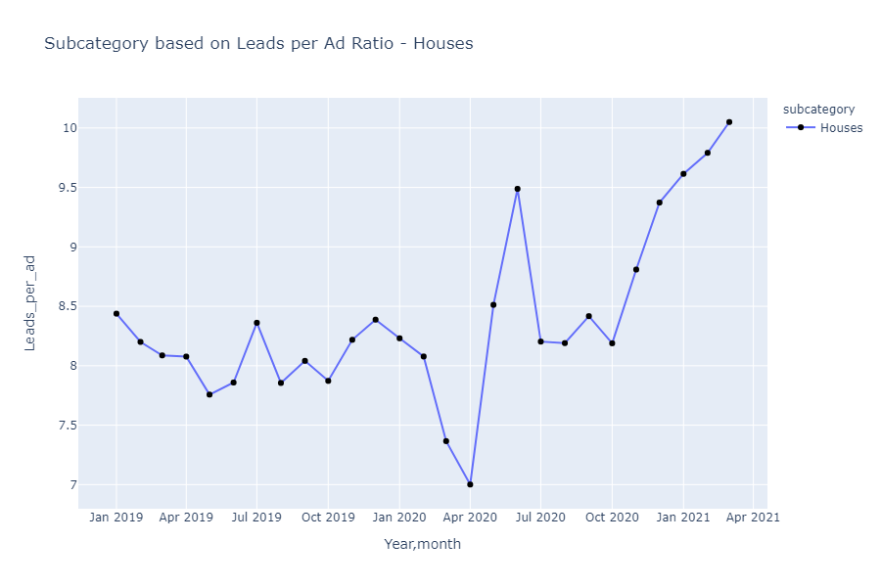

***Apartments***

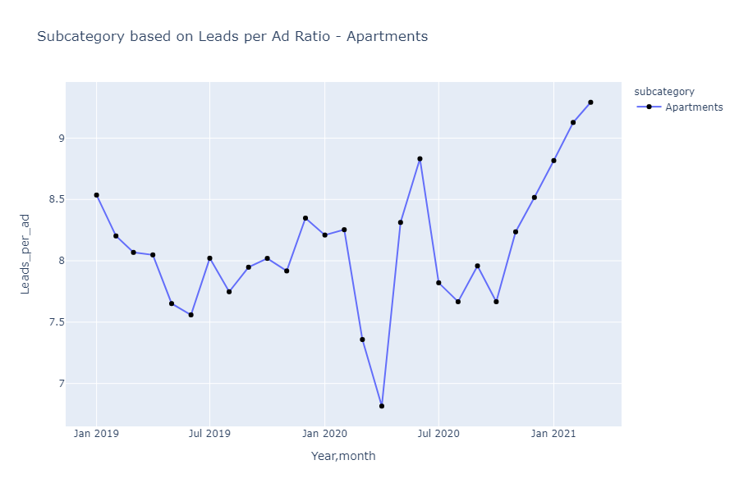

***The least popular region with Average Leads per ad ratio***

|  |  |  |  |
| --- | --- | --- | --- |
| *subcategory* | 2019 | 2020 | 2021 |
| Textbooks | 15.29586777 | 13.49172185 | 8.214814815 |
| Tickets & Vouchers | 18.83150685 | 10.18834081 | 5.646153846 |
| Wedding | 27.25205479 | 14.32421341 | 8.376404494 |

***Textbooks***

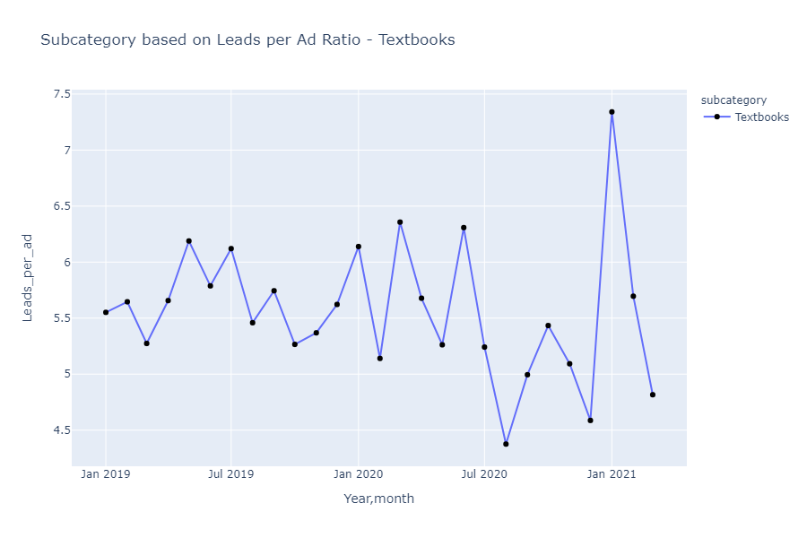

***Tickets and vouchers***

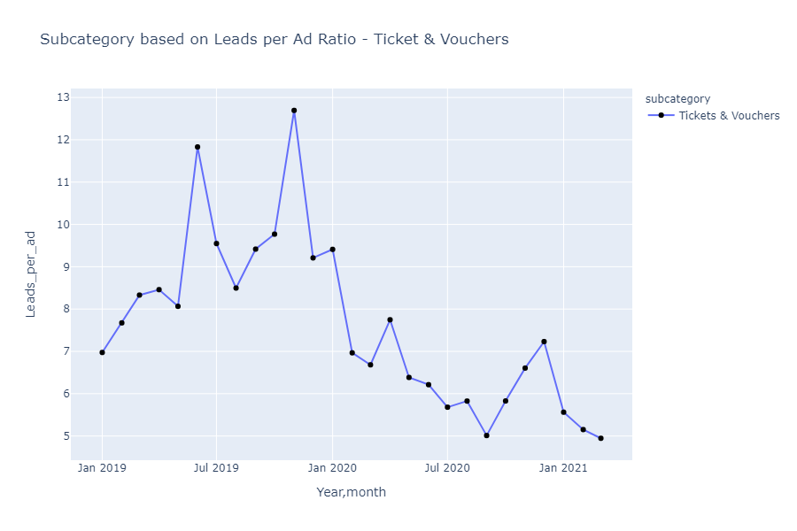

***Wedding***

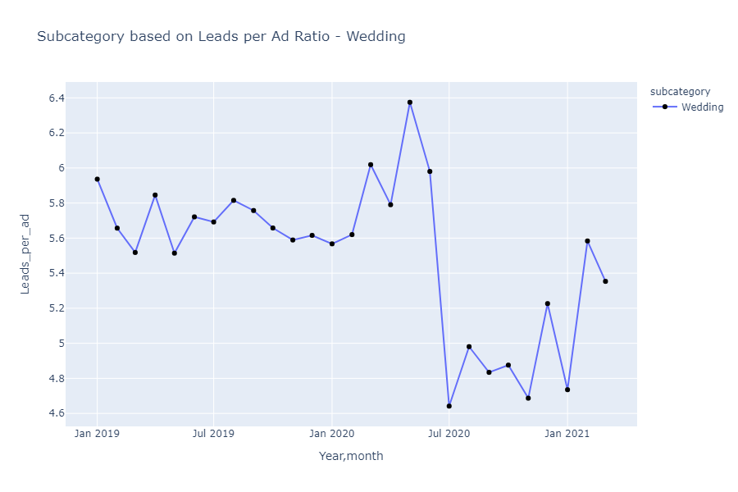

***7.0*  Region wise breakdown by visitor count**

The table below shows the comparison of average visitor count starting from 2019 to 2021. The contents highlighted in blue are constantly increasing for all three years but the content in red is the least average count on the yearly average.

|  |  |  |  |
| --- | --- | --- | --- |
| *region* | 2019 | 2020 | 2021 |
| Johor | 381.1589041 | 6772.748634 | 8521.7 |
| Kedah | 177.9150685 | 3236.740437 | 4179.733333 |
| Kelantan | 200.9041096 | 3426.647541 | 4345.988889 |
| Kuala Lumpur | 739.1260274 | 12710.43169 | 15255.06667 |
| Labuan | 3.339726027 | 52.96994536 | 66.93333333 |
| Melaka | 136.4876712 | 2285.920765 | 2864.766667 |
| N. Sembilan | 149.1068493 | 2710.743169 | 3455.933333 |
| Pahang | 120.2876712 | 2019.456284 | 2492.711111 |
| Penang | 241.9835616 | 5020.631148 | 6551.855556 |
| Perak | 181.7561644 | 3308.967213 | 4297.044444 |
| Perlis | 20.19178082 | 329.0382514 | 380.5666667 |
| Putrajaya | 27.75068493 | 484.8251366 | 559.4555556 |
| Sabah | 170.8931507 | 3202.934426 | 4596.177778 |
| Sarawak | 77.03287671 | 1532.36612 | 1987.211111 |
| Selangor | 1172.657534 | 20682.81967 | 25957.05556 |
| Terengganu | 135.6164384 | 2114.087432 | 2626.4 |

***Total count of visitors based on region for the last five months***

The table below shows how the count of visitors plays a major role in increasing the leads for each region.

|  |  |  |  |  |  |
| --- | --- | --- | --- | --- | --- |
| Year | 2020 |  | 2021 |  |  |
| *Region* | 11 | 12 | 1 | 2 | 3 |
| Johor | 250984 | 268115 | 278800 | 231041 | 257112 |
| Kedah | 123508 | 134213 | 146850 | 110832 | 118494 |
| Kelantan | 129868 | 137394 | 146380 | 119764 | 124995 |
| Kuala Lumpur | 465642 | 497873 | 496418 | 398319 | 478219 |
| Labuan | 1777 | 1758 | 2085 | 2011 | 1928 |
| Melaka | 85164 | 91263 | 95056 | 76812 | 85961 |
| N. Sembilan | 98623 | 103982 | 114320 | 93882 | 102832 |
| Pahang | 78784 | 80575 | 83828 | 67624 | 72892 |
| Penang | 191997 | 203368 | 210509 | 173257 | 205901 |
| Perak | 121542 | 133869 | 146972 | 115658 | 124104 |
| Perlis | 12826 | 12867 | 13625 | 9855 | 10771 |
| Putrajaya | 17706 | 17976 | 18818 | 15326 | 16207 |
| Sabah | 126246 | 134222 | 154725 | 123363 | 135568 |
| Sarawak | 59724 | 60308 | 65957 | 52611 | 60281 |
| Selangor | 761192 | 794702 | 823848 | 705938 | 806349 |
| Terengganu | 77240 | 81587 | 88342 | 71851 | 76183 |

***The first 3 region with highest Average Leads***

|  |  |  |  |
| --- | --- | --- | --- |
| *Region* | 2019 | 2020 | 2021 |
| Kuala Lumpur | 156451.4418 | 138954.8095 | 126386.4731 |
| Johor | 83936.08346 | 76620.89053 | 69552.6415 |
| Selangor | 261491.8415 | 244024.2522 | 241718.1408 |

***Selangor***

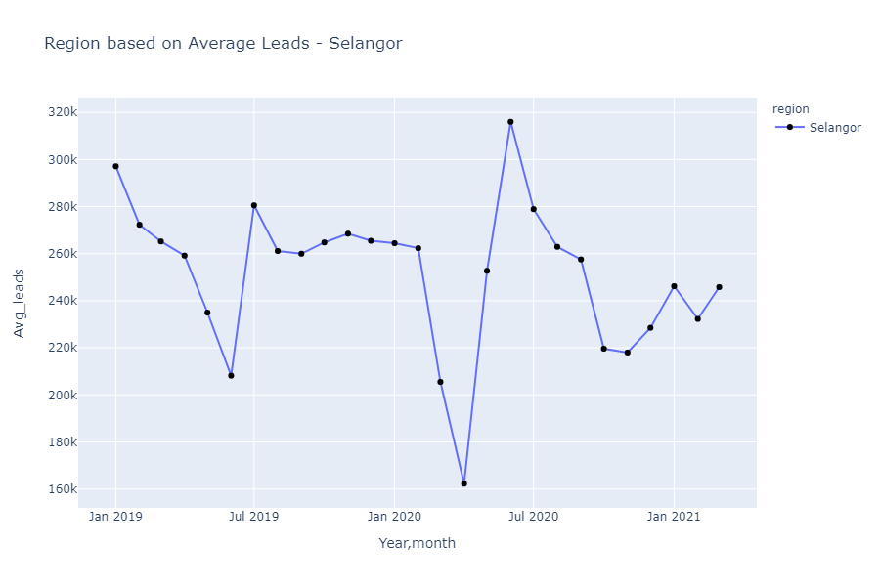

***Kuala Lumpur***

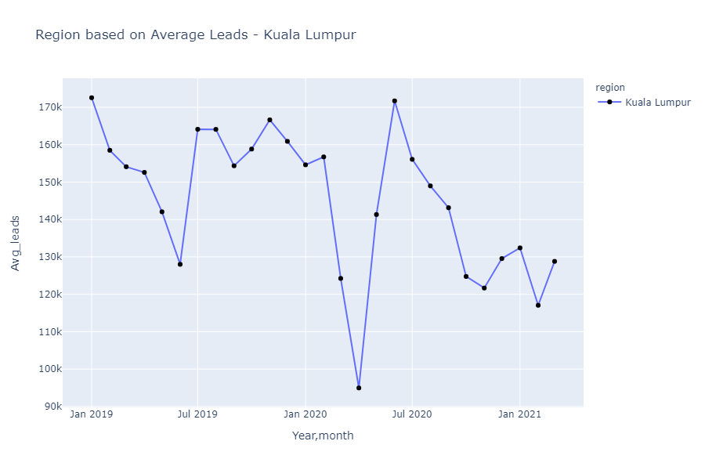

***Johor***

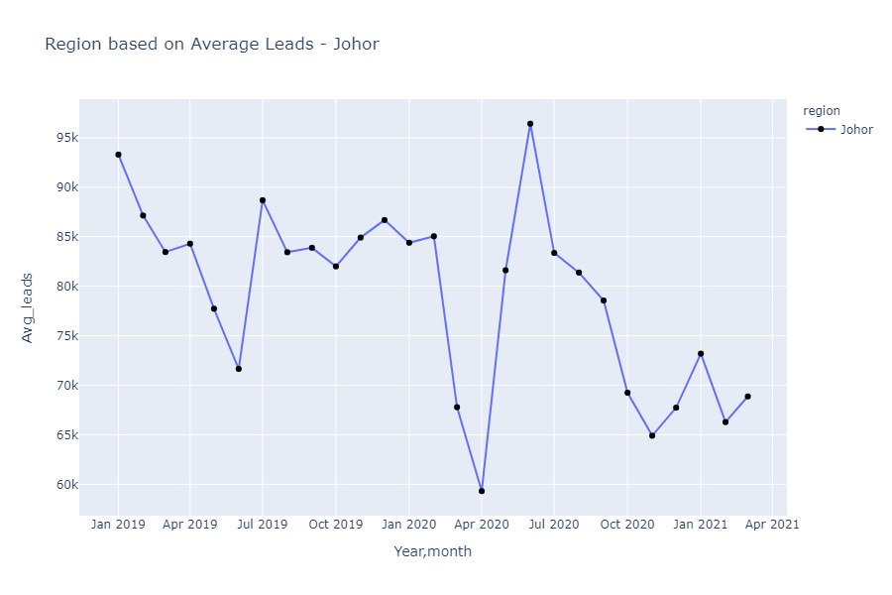

***The least popular region with lowest Average Leads***

|  |  |  |  |
| --- | --- | --- | --- |
| *Region* | 2019 | 2020 | 2021 |
| Labuan | 428.9993705 | 408.5507346 | 409.5991901 |
| Perlis | 3057.82815 | 2940.130524 | 2495.981917 |
| Putrajaya | 4955.688799 | 4435.640646 | 4161.146758 |

***Labuan***

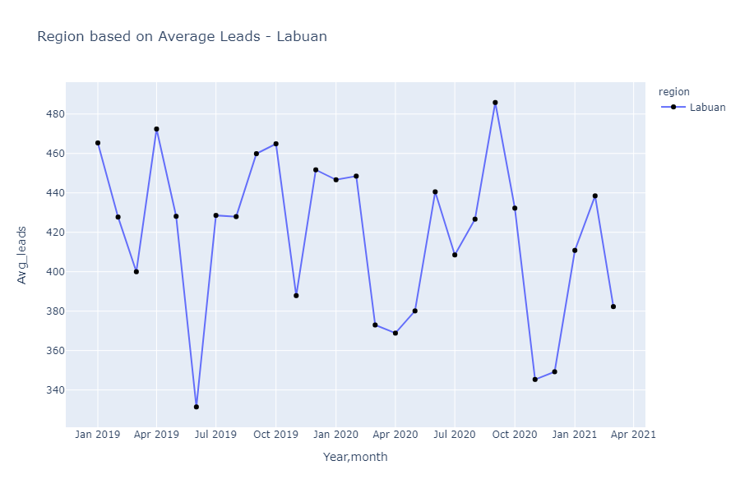

***Perlis***

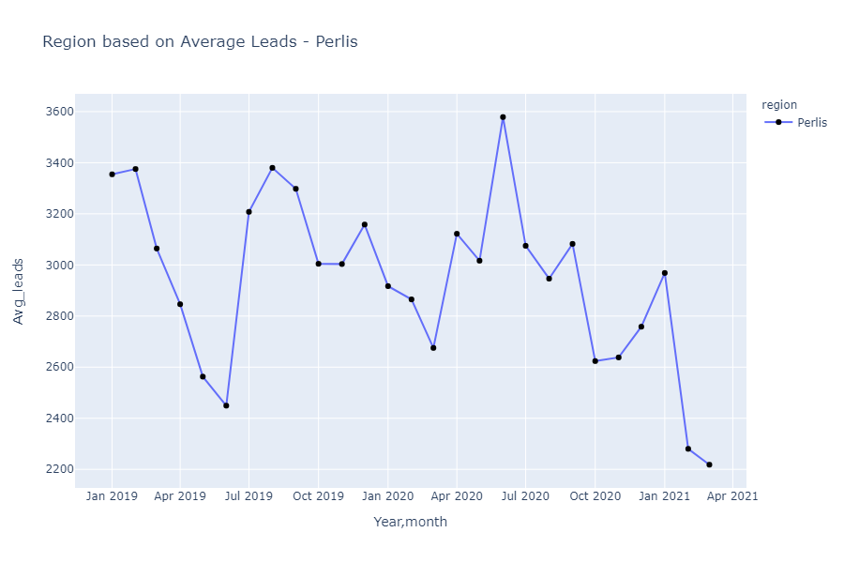

***Putrajaya***

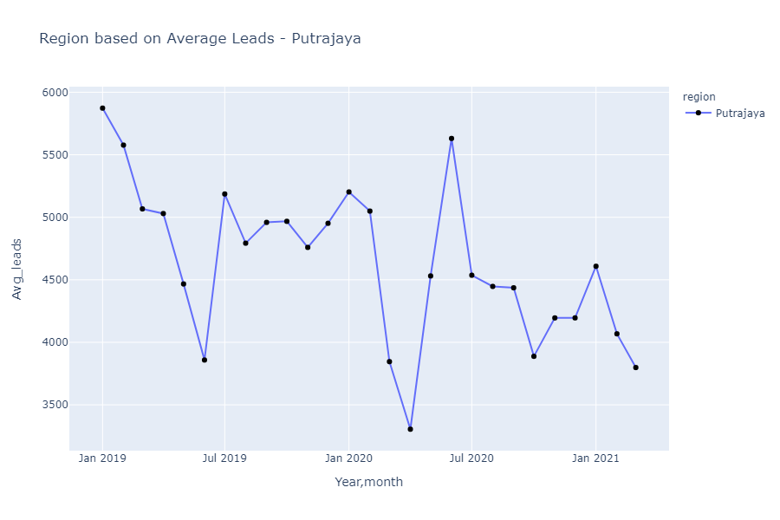

***The first 3 region with Average Leads per ad ratio***

|  |  |  |  |
| --- | --- | --- | --- |
| *region* | 2019 | 2020 | 2021 |
| Kuala Lumpur | 9517.876712 | 8571.277322 | 7688.133333 |
| Johor | 5298.746575 | 4841.422131 | 4345.694444 |
| Selangor | 16401.28219 | 15318.11202 | 14363.26667 |

***Selangor***

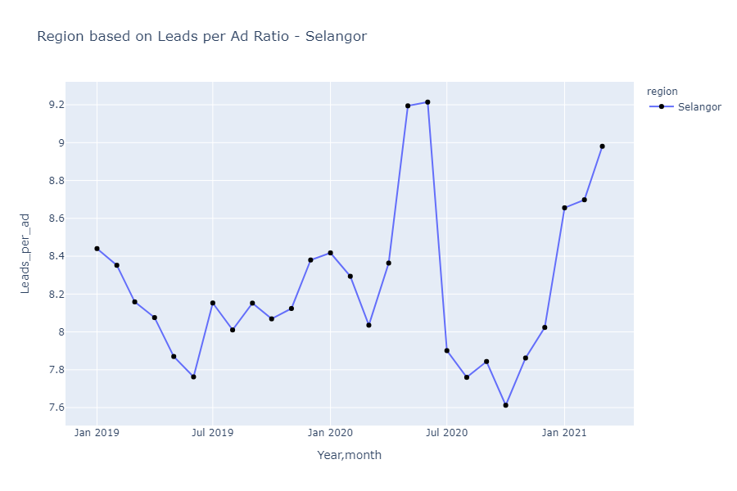

***Kuala Lumpur***

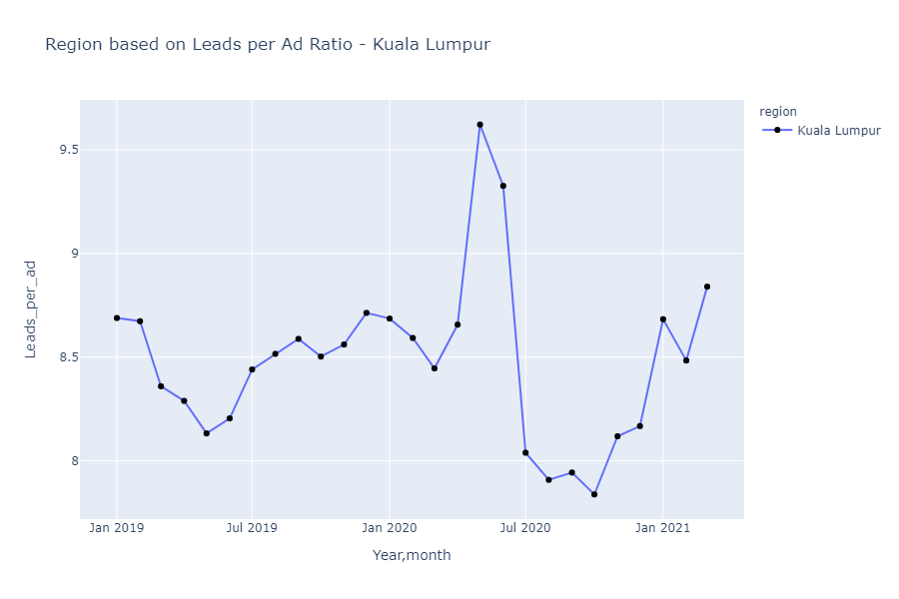

***Johor***

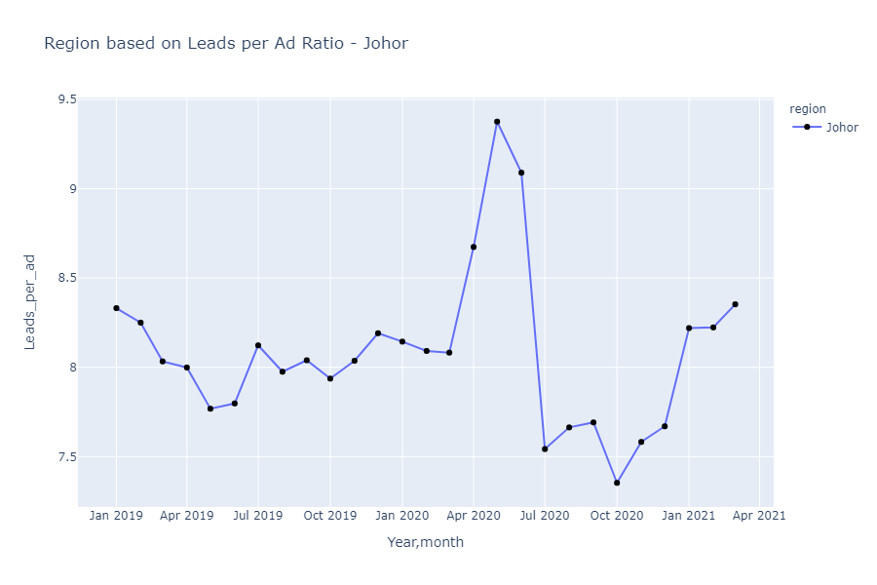

***The least popular region with Average Leads per ad ratio***

|  |  |  |  |
| --- | --- | --- | --- |
| *region* | 2019 | 2020 | 2021 |
| Labuan | 29.45342466 | 28.12859097 | 27.16111111 |
| Perlis | 192.539726 | 171.0765027 | 144.8333333 |
| Putrajaya | 310.5835616 | 272.5396175 | 252.6277778 |

***Labuan***

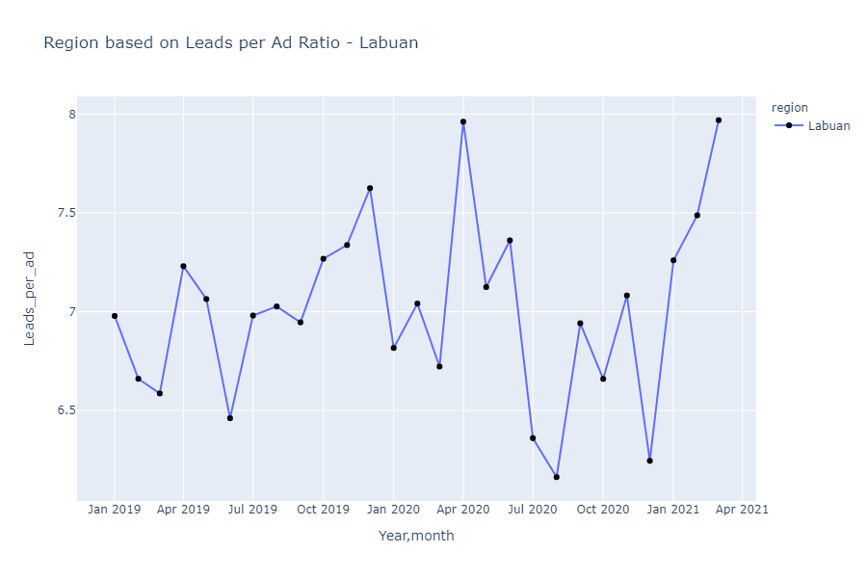

***Perlis***

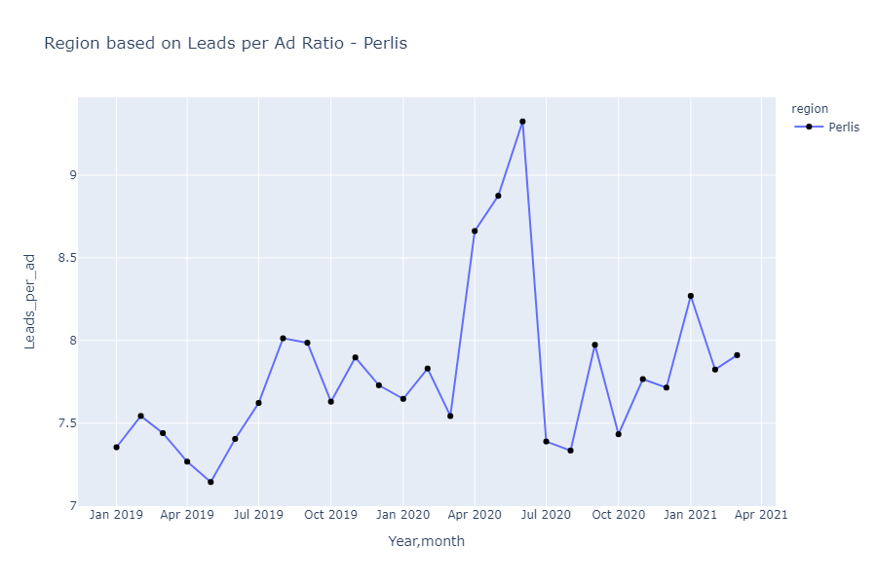

***Putrajaya***

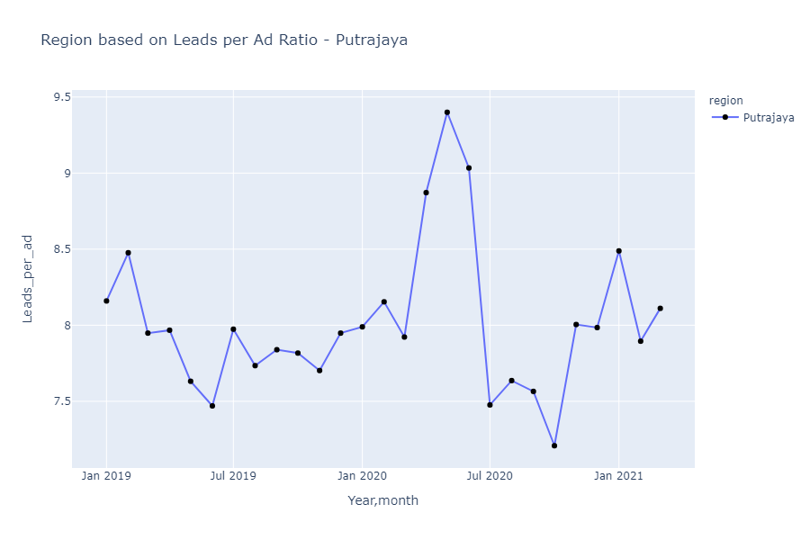

***Summary***

Overall, the leads increase when the count of visitors/ browsers are high. For instance, if there are less visitors then the number of leads also decreases. Besides that, the most preferred platform is ‘Android’ as it has the highest count of users with Android devices. Next, the most visited vertical with the highest number of average leads is from vertical ‘Auto’ whereas the least number of visitors and leads is from vertical ‘Services’. Not only that, the highest number of leads is mostly occupied under seller type (Private and Pro- under vertical Auto and Generalist) and for reply type (call).