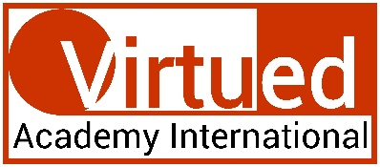
This certificate is granted to

Tyler Procko
in recognition of completing the Virtued Academy International’s

Certification in Editing and Proofreading
 | 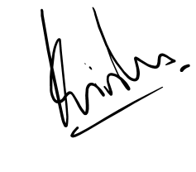  PROF KRISHNA N SHARMA  Course Coordinator |  | DATE: November 11, 2022
 | Note: This certificate is valid only with Udemy's certificate of completion. In absence of Udemy's certificate, this certification shall be considered null and void.

