**Implementation:**

**FM Radio Receiver**

**with**

**Capacitive-Touch Interface**

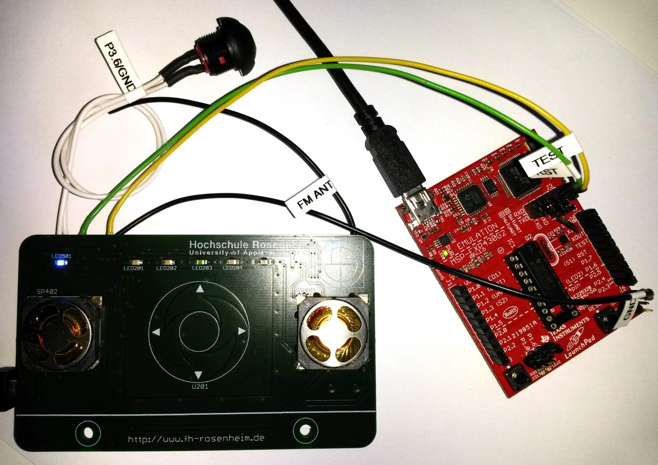

**[VERSION MANAGEMENT]**

Stand: 19.12.2018

Overview

1 Preface 3

1.1 Initial Situation and Motivation 3

1.2 Objective of Development 3

2 Tools for the Implementation 4

2.1 PCB Integrating MSP430, Touch Interface and FM Radio Chip 4

2.1.1 Assembly of the FM Radio Board 5

2.1.2 Interfaces on the Board 7

2.1.3 Embedded Controller und FM Radio Chip 8

2.2 MSP-EXP430G2 LaunchPad 11

2.3 MSP430 Capacitive Touch BoosterPack 11

2.4 Code Composer Studio IDE 12

3 Flow Chart of the Basic Implementation Steps 12

3.1 Import and Deploy the Legacy FM Radio Code 14

3.1.1 Import CCS Project 14

3.1.2 Compile Code and Deploy Application on the Target 15

3.1.3 Debug Application on the Target 15

3.1.4 Resources Needed by the Legacy FM Radio Code 16

3.2 Launch Capacitive Touch BoosterPack with MSP430G2452 16

3.3 Launch Capacitive Touch BoosterPack with MSP430G2553 16

3.4 Touch-Wheel on the New Radio Board 18

4 Integration and Improvement of Code Snippets 18

4.1 MSP430G2553 Controller 18

4.2 Si4735-D60 Integrated FM Radio 18

4.3 TPA302D Headphone Amplifier 19

4.4 Capacitive Touch Pad and LEDs 20

5 Use Cases for the Software Design 20

6 Integration of all Modules for this Specific Application 20

7 2 b done … 20

8 Links and Other Sources 20

# Preface

## Initial Situation and Motivation

The output of a former student’s team project work is the hardware and software design for a microcontroller-based FM radio receiver **[QUELLEN]**. This device served as an example application in one of Rosenheim’s University of Applied Sciences’ lab courses called Leiterplattentechnik Praktikum/Printed Circuit Board (PCB) Technology. Here, students can learn about basic approaches and crucial issues when designing and assembling printed circuit boards. At the end of the course, the participants assemble the SMD parts of the radio board with a manual placing machine.

As major drawback, the device is designed in a header board style for the MSP-EXP430G2 LaunchPad. Because of this, most of the participants – some already have one initially needed for the Microcomputer Technology Lab - have to purchase the LaunchPad in order to be able to operate the FM radio. Undesirable are the costs which have to be borne by the students on the one hand and the inconvenient form factor on the other.

For future Circuit Board Technology lab courses, the MSP430G2553 microcontroller will be integrated on one board, i.e. PCB, with the integrated FM radio because of the following benefits:

* cost efficiency
* demonstrate reflow process for two layered PCBs  
  (the original projects’ design is relatively simple and on a single layered board)
* revision of the complete hardware design and software architecture  
  (there is a not reproducable bug when powering up the device that makes it not work sometimes)

The MSP integration with Capacitive Touch control as wells as hardware and software design revision is covered by this document.

## Objective of Development

The development objective is to have nice and a well working device at the end of the process with the following features:

* Capacitive Touch Wheel interface for volume and frequency selection
* LED array for rough frequency and volume signaling
* reflow capable SMD speakers for direct audio output in addition to the 3.5mm jack for headphone or power amplifier connection
* wire clip for FM antenna
* UART to USB bridge for PC connection and data transfer  
  (e.g. Media Player control with Capacitive Touch Wheel)

To achieve this, basically two software examples - one for controlling the integrated FM radio chip and one for the Capacitive Touch Wheel **[QUELLEN]** – have to be revised and merged. Controlling the LED array as well as the serial I²C interface has to be seen as standard application. Therefore, the focus in this document will be held on the two modules mentioned first.

# Tools for the Implementation

## PCB Integrating MSP430, Touch Interface and FM Radio Chip

As a hardware basis, Stefan Kipfelsberger, staff member of Rosenheim’s University of Applied Sciences, created a re-design of the radio board, which integrates the modules mentioned above. It was manufactured by BETA Layout Ltd., who provides an online Printed Circuit Board service called PCB-POOL **[QUELLE]**. Figure 1 and Figure 2 are showing pictures of the PCB sent by BETA Layout during the manufacturing process.

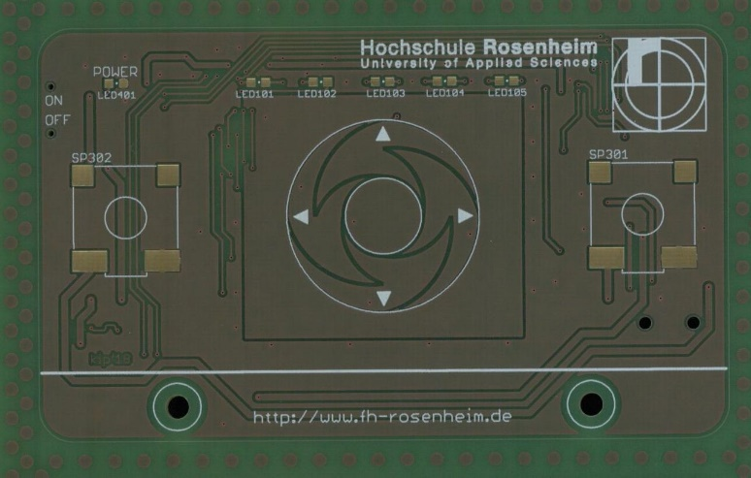

Figure 1: Top side of the blank target PCB

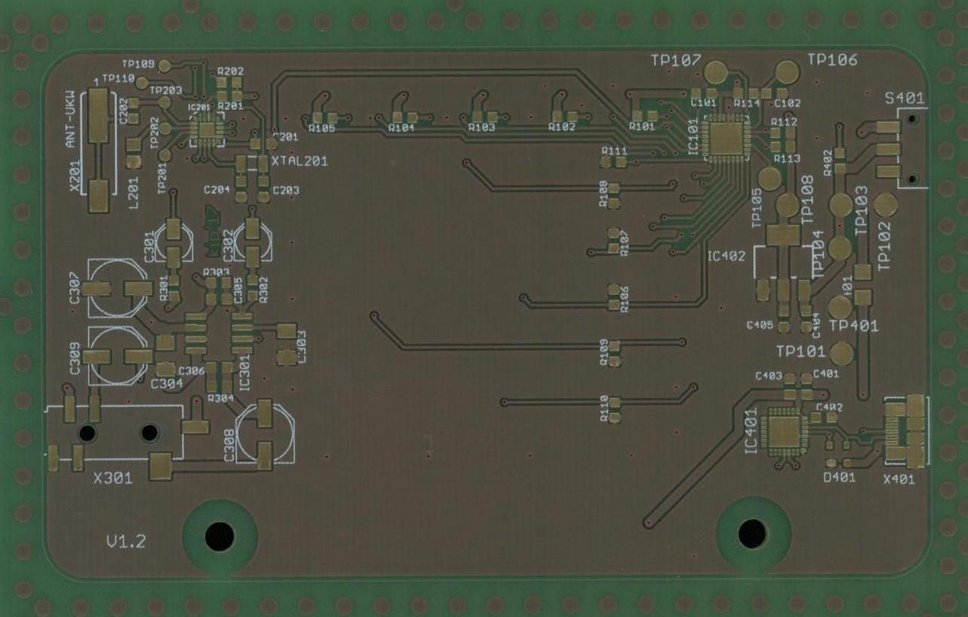

Figure 2: Bottom side of the blank target PCB

At the end of the lab course, this board will be assembled with the corresponding electronic parts. As it is meant to demonstrate SMD technology, all parts have been selected to meet reflow soldering requirements. But before putting it into the reflow oven, the surface mount parts have to be positioned correctly using as special manual placing machine.

### Assembly of the FM Radio Board

PCB-POOL delivers a free stencil for applying the solder paste on the PCB.

[BILD PASTENDRUCK]

After this step, i.e. putting the solder paste on the PCB pads, the parts are placed using a manual assembling machine depicted in Figure 3.

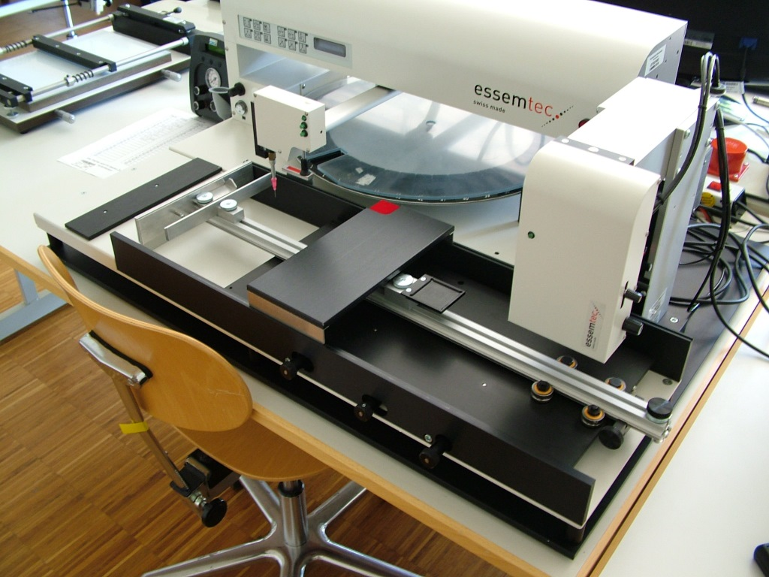

Figure 3: essesmtec’s manual PCB/SMD placer

Figure 4 shows the placing of an SMD resistor on the radio board.

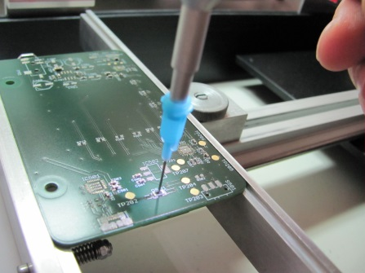

Figure 4: Placing of a SMD resistor (size 0603, with length 0.06’’ and width 0.03’’)

After part placement and reflow soldering on both sides of the PCB, the printed circuit assembly (PCA) is ready for the mandatory function test of all modules on the board. Figure 5 and Figure 6 show the finalized hardware for this development process.

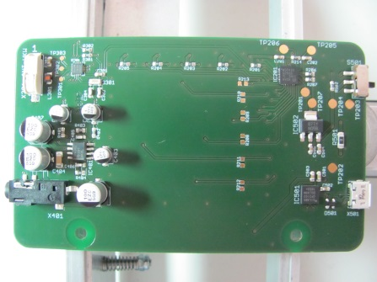

Figure 5: Bottom side of the Radio Board PCA

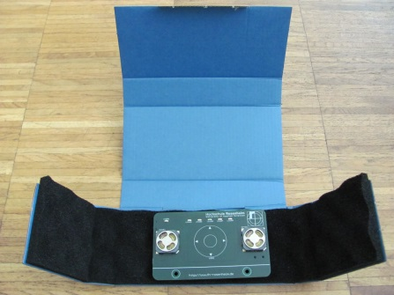

Figure 6: Top side of the PCA in special package for static sensitive devices (ESD protection)

### Interfaces on the Board

As already mentioned in section 1.2 , the newly designed FM Radio Board implements the following interfacing features. Table 1 lists all interfaces with its’ corresponding microcontroller pins (see Table 1) and, where required, other connected devices on the Radio Board.

| **Interface** | **Purpose** | **Direction** | **Connected Device** | **MSP430 Pins** |
| --- | --- | --- | --- | --- |
| Micro USB (Female Connector) | USB to UART Bridge  Power Supply (5V and 3.3V) | IN/OUT  IN | CP2102-GM  LM1117IMP-3.3, (all 5V ICs) | 4 (D+) 5 (D-)  VIN |
| FM Antenna (Clip) | Radio Antenna | IN | SI4735-D60-GM | 8 (FMI) |
| Capacitive Touch Wheel | User Inputs | IN | MSP430G2553 | 9 (P2.0; surr. area) 10 (P2.1; LEFT) 11 (P2.2; DOWN)) 15 (P2.3; RIGHT) 16 (P2.4; UP)) 17 (P2.5; CENTER) |
| Push Button (TP105) | Debug Input | IN | MSP430G2553 | 19 (P3.6) |
| Spy-Bi-Wire (Pad TP106 Pad TP107) | Deploy and Debug | IN/OUT | MSP430G2553 | 23 (RST) 24 (TEST ) |
| Speakers, 3.5mm Jack Plug | Audio Output | OUT | TPA302 | 1 (OUT1/VO1) 2 (OUT2/VO2) |
| LED201 LED202 LED203 LED204 LED205 | User Signalling | OUT | MSP430G2553 | 7 (P3.0) 6 (P3.1) 12 (P3.2) 13 (P3.3) 14 (P3.4) |

Table 1: Hardware Interfaces of the FM Radio Board

### Embedded Controller und FM Radio Chip

The two main components on the PCB are the embedded controller MSP430G2553 and the Integrated FM Radio Si4735-D60. This section provides a basic description of these devices as well as appropriate resources for finding definite information about product features, electrical characteristics, and I/O options.

Mixed Signal Processor MSP430G2553

This member of the MSP430 ultra-low power microcontroller product family is mainly designed for mobile measurement applications or portable products on the consumer market. The features most important for the application covered in this document are [Information taken from device datasheet **QUELLE**]:

* Low supply voltage range: 1.8V ... 3.6V
* Ultra-low power consumption (active mode: 230µA @ 1MHz, standby: 0.5µA)
* Internal clock module for up to 16MHz cycles
* Two 16-bit timer modules
* Capacitive Touch enabled pins
* UART and I²C serial interfaces
* 10-bit 200kS/s ADC
* 16KB Flash
* 512B RAM

The pin description of the device that comes in a 32-pin QFN package (other housing options are PDIP, TSSOP) is shown in Figure 7.

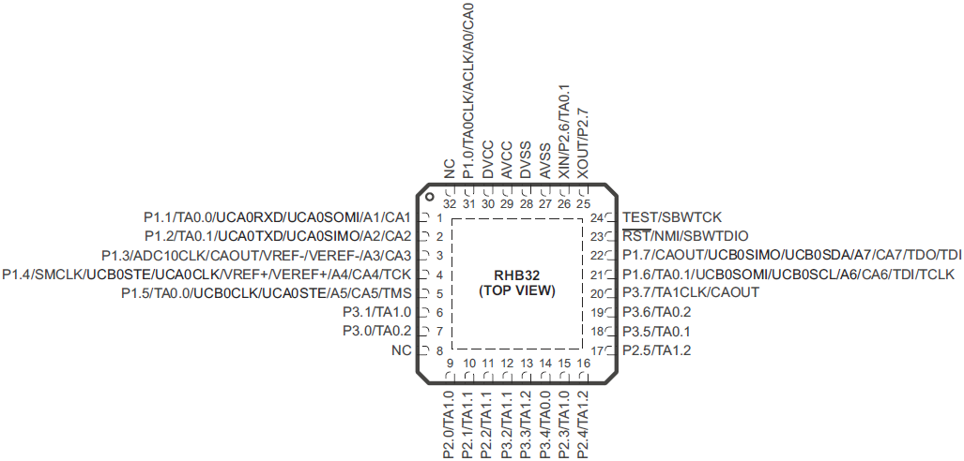

Figure 7: Pin assignment of the MSP430G2553 controller in a QFN package **[QUELLE]**

Beneath the device’s datasheet containing detailed technical specifications of all hardware resources (**[QUELLE]**, approx. 70 pages), general device family information like ADC control, I²C communication approaches or descriptions of all control registers assigned to the various resources are given in great detail in the MSP430x2xx Family User’s Guide (**[QUELLE]**, approx. 660 pages).

**Si4735-D60 Digital CMOS AM/FM Radio Receiver IC**

Another essential document for the development process describing detailed programming options which has a link in the device’s datasheet (**[QUELLE]**, approx. 40 pages) is the Si47xx Programming Guide (**[QUELLE]**, approx. 300 pages). Integrating the information given in this document in ANSI C code for the MSP430 controller with great care is one of the most crucial parts.

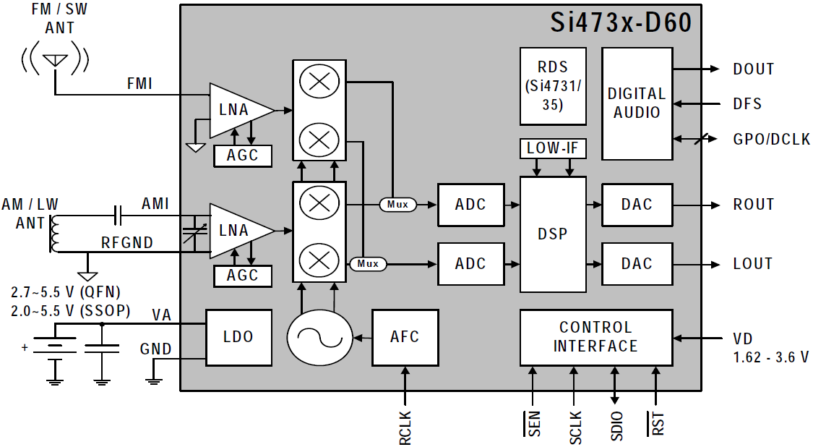

Figure 8: Block Diagram of the Integrated FM Radio Chip Si4735-D60 (**[QUELLE]**)

## MSP-EXP430G2 LaunchPad

This LaunchPad (further referred as MSP430 LaunchPad) is a cost efficient and easy to use development board for many devices from the MSP430 family. During the implementation process, the LaunchPad mainly serves two purposes:

* Getting started with capacitive touch applications using the Capacitive Touch BoosterPack development tool (**[QUELLE]**)
* The on-board Spy-Bi-Wire interface (see green marking in Figure 9 and title page of this document) is used for programming - i.e. flashing - and debugging of the Radio Board. The signals provided via the jumpers RST and TEST can be disconnected from the controller plugged in the DIP socket of the LaunchPad and connected to TP205 and TP206 on the Radio Board (see Table 1).

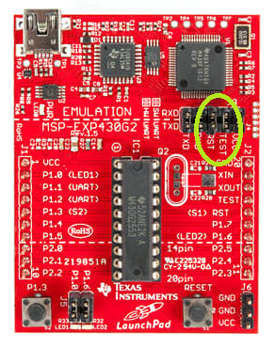

Figure 9: MSP-EXP430G2 LaunchPad Development Kit

## MSP430 Capacitive Touch BoosterPack

For the MSP-EXP430G2 LaunchPad, a wide variety of so-called BoosterPacks are available that fit into the two female 10-pin headers located on the edges of the LaunchPad. They bring e.g. wireless connectivity, power amplification, SD card handling and many more hardware expansions.

When it comes to understanding capacitive touch (further referred as cap touch) applications with an MSP430 device, the Capacitive Touch BoosterPack (**[QUELLE]**) provided by Texas Instruments (further referred to as TI) serves as a convenient starting point. TI delivers demo applications for the MSP430G2452 controller, which is very similar to the MSP430G2553 that is the target microcontroller described in this document.

Figure 10 shows the hardware setup for the cap touch module development of the FM Radio project. As all documentation sources of the BoosterPack are available - here especially the PCB layout files - in order to avoid time consuming layout tests for the touch sensor itself, the design of this development kits’ will serve as touch interface of the FM Radio Board.

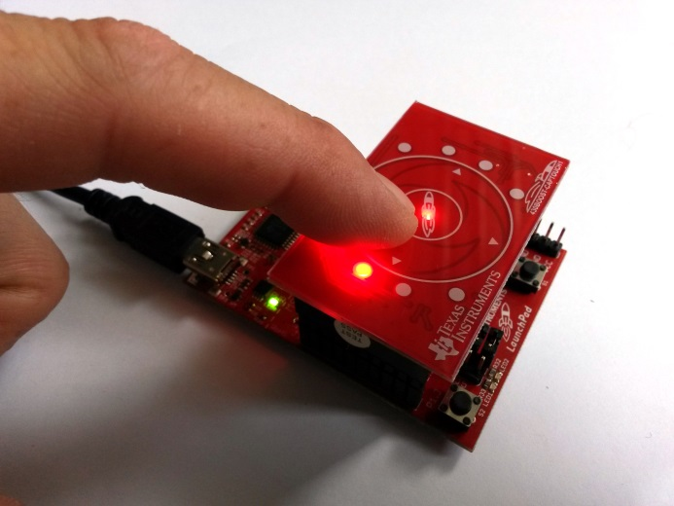

Figure 10: Capacitive Touch BoosterPack plugged onto the MSP-EXP430G2 LaunchPad

## Code Composer Studio IDE

For the software development of the FM Radio project, TI’s Eclipse-based freeware IDE Code Composer Studio (CCS) is used. The IDE version downloaded at the starting point of this project (October 25th 2017) CCSv7 (7.3.0.00019).

For further information



Figure 11: CCSv7 Startup Screen

# Flow Chart of the Basic Implementation Steps

In this chapter, the basic sequence steps during the implementation …

* Launch of the Legacy Code Project with the FM Radio Headerboard on the new target Hardware  
  (Radio-Chip, Audio-Ausgabe über Kopfhörer und auch über integrierte Lautsprecher)  
  **LÄUFT BEREITS!**
* CapacitiveTouch BoosterPack with MSP430G2452IN20  
  **LÄUFT BEREITS!**
* Capacitive TouchBooster Pack with MSP430G2553IN20  
  **LÄUFT BEREITS!**
* Bring the Touch Wheel on the New Radio Board into service
* Bring LEDs into service (für Benutzer: Sendersuchlauf, Sender hoch/runter signalisieren)
* Integrate all Modules in the New Code Project

## Import and Deploy the Legacy FM Radio Code

### Import CCS Project

The first code project to be imported is the user experience example application that comes with the Capacitive Touch Booster Pack 430BOOST-CAPTOUCH1 called CapTouch_BoosterPack_UserExperience.

import project called Programm Headerboard on the new Radio Board.

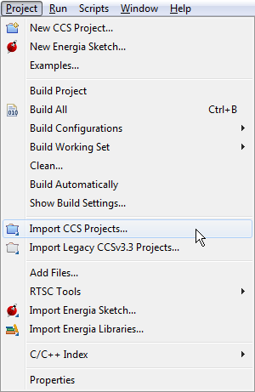

Figure 12: CCS Menu Item for Import of an Existing Project

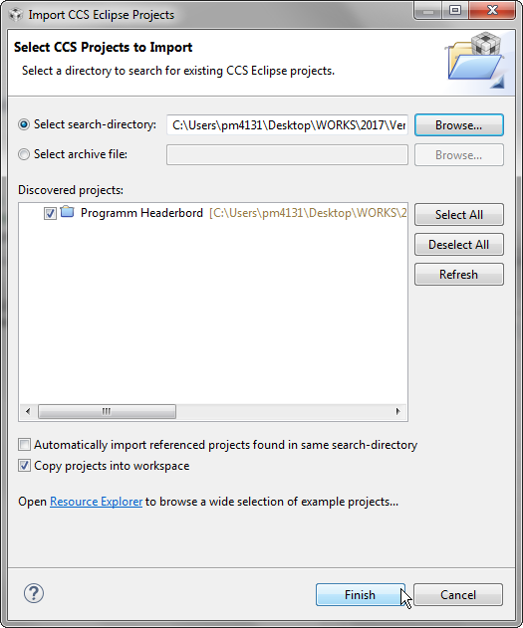

Figure 13: Select the Legacy Headerboard Project for CCS Import

rename:

LegacyFMradioBoard

### Compile Code and Deploy Application on the Target

remove jumpers J3 labelled TEST and RST on LaunchPad

connect Spy-Bi-Wire interface of new Radio Board with TEST and RST pins of the emulator side of the LaunchPad.

code size (project *Programm Headerbord*):

MSP430: Flash/FRAM usage is 3362 bytes. RAM usage is 226 bytes.

### Debug Application on the Target

### Resources Needed by the Legacy FM Radio Code

|  |  |  |  |
| --- | --- | --- | --- |
| Hardware Resource | Defined in msp430g2553.h | Required for: | Setting of the Resource |
| system clock |  |  |  |
| timer |  |  |  |
| I²C interface (USCI) |  |  |  |
|  |  |  |  |
|  |  |  |  |
|  |  |  |  |

## Launch Capacitive Touch BoosterPack with MSP430G2452

import user experience project for 430BOOST-CAPTOUCH1 called CapTouch_BoosterPack_UserExperience.

## Launch Capacitive Touch BoosterPack with MSP430G2553

… läuft

**replace target configuration file:** MSP430G2452.ccxml → MSP430G2553.ccxml

delete MSP430G2452.ccxml, then …

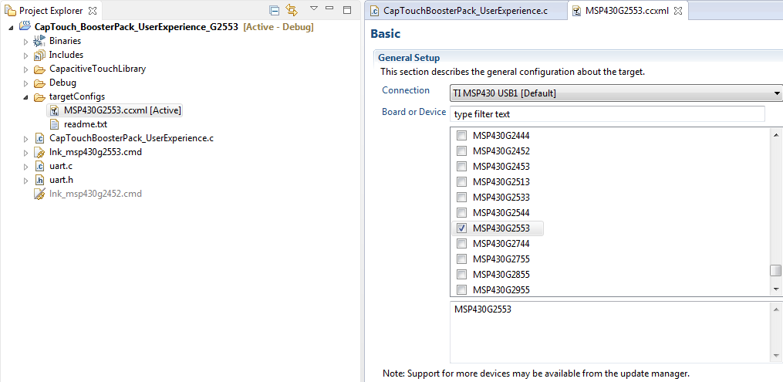

Figure 14: Setup Target Configuration File for the MSP430G2552 in the Project

**replace linker command file** (memory map): lnk_msp430g2553.cmd → lnk_msp430g2553.cmd

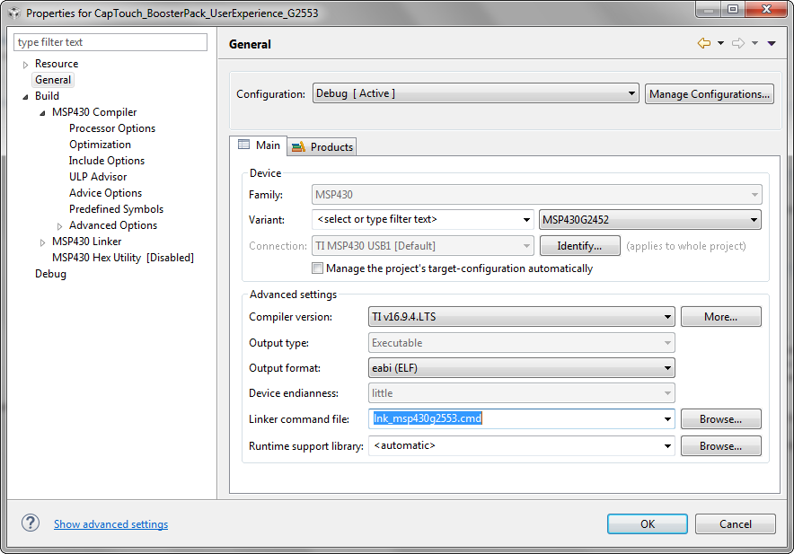

Figure 15: Change the Linker Command File (Memory Map) to meet MSP430G2553 Resources

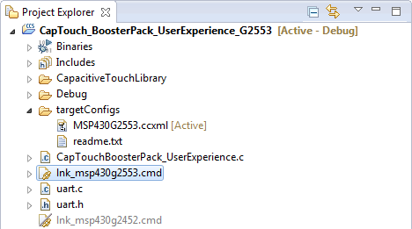

Figure 16: Linker and Target Configuration File in the New Code Project Tree

after deploy:

**code size (project *CapTouch_BoosterPack_UserExperience_G2553*):**  
MSP430: Flash/FRAM usage is 4042 bytes. RAM usage is 112 bytes. ✔

little add-on:

user experience with PC GUI

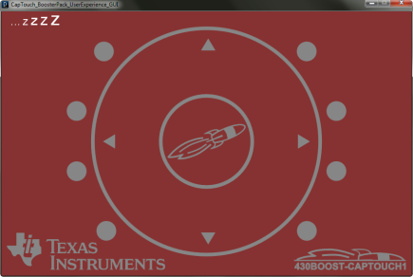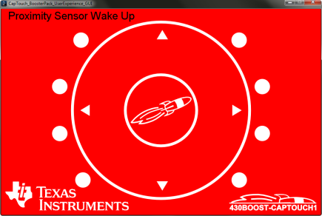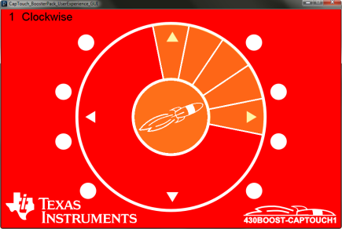

## Touch-Wheel on the New Radio Board

... works, just changed target configuration file and linker command file (memory map) to fit the resources rgovided by the MSP43G2553 target

# Integration and Improvement of Code Snippets

There are basically four modules which have to communicate and interoperate in a way defined by the corresponding device datasheets and other hardware documentation:

* The MSP430 controller
* Capacitive Touch Pad for user inputs
* Integrated FM Radio Chip
* Headphone Amplifier

These drivers, communication protocols respectively, have to be designed in a way which ensures easy understanding and re-using of the code. To get a definite idea of these modules, device datasheets provide the desired information and therefore have to be studied first and foremost

## MSP430G2553 Controller

The MSP430 is used basically for communication issues with the Si4735 Integrated FM Radio over the I²C bus in this application. Furthermore ... For prober operation, for GPIO configuration and timing settings and clock ...

## Si4735-D60 Integrated FM Radio

Proper initialisation steps ...

a few timing requirements during the start-up proces have to be taken into consideration

Power Supply Powerup Rise Time VDDRISE 10 — — μs

Table 3. Reset Timing Characteristics1,2,3

(VA = 2.7 to 5.5 V, VD = 1.62 to 3.6 V, TA = ¡V20 to 85 ¢XC)

Parameter Symbol Min Typ Max Unit

RST Pulse Width and GPO1, GPO2/INT Setup to RST„^ƒ¤ tSRST 100 ¡X ¡X £gs

GPO1, GPO2/INT Hold from RST„^ tHRST 30 ¡X ¡X ns

RST Pulse Release time before VDD/VIO turn off tRRST 30 ¡X ¡X ns

Important Notes:

1. When selecting 2-wire mode, the user must ensure that a 2-wire start condition (falling edge of SDIO while SCLK is

high) does not occur within 300 ns before the rising edge of RST.

2. When selecting 2-wire mode, the user must ensure that SCLK is high during the rising edge of RST, and stays high until

after the first start condition.

3. When selecting 3-wire mode, the user must ensure that a rising edge of SCLK does not occur within 300 ns before the

rising edge of RST.

4. If GPO1 and GPO2 are actively driven by the user, then minimum tSRST is only 30 ns. If GPO1 or GPO2 is hi-Z, then

minimum tSRST is 100 £gs, to provide time for on-chip 1 MƒÇ devices (active while RST is low) to pull GPO1 high and

GPO2 low.

5. RST must be held low for at least 100 £gs after all voltage supplies have been ramped up.

6. RST needs to be asserted (pulled low) prior to any supply voltage being ramped down.

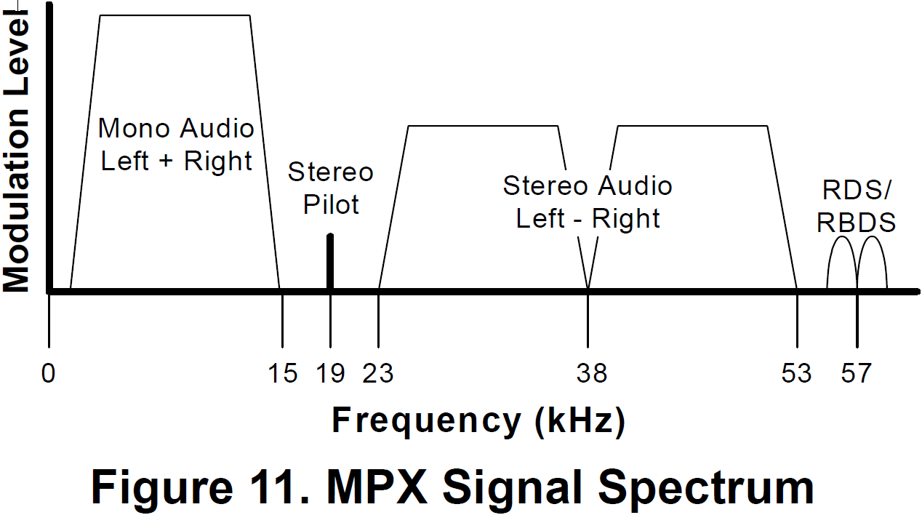

## TPA302D Headphone Amplifier

...

## Capacitive Touch Pad and LEDs

... develop most propable use cases ...

# Use Cases for the Software Design

# Integration of all Modules for this Specific Application

# 2 b done …

* Use the … interrupt of the radio chip to indicate, when a station has been found in scan mode
* Make use of convenient sleep modes
* Adjust the Touch Interface in a way to be capable of multiple turns for volume adjustment (more intuitive user interface)
* Implement the UART to USB connection for Touch Interface usage as e.g. media player control on the PC

# Links and Other Sources

<http://www.ti.com/tool/430BOOST-SENSE1>  
(Texas Instruments, Capacitive Touch BoosterPack, product page)

<http://www.ti.com/tool/MSP-EXP430G2>  
(Texas Instruments, MSP430 LaunchPad Value Line Development kit, product page)

<http://www.ti.com/tool/CCSTUDIO>  
(Texas Instruments, Code Composer Studio Integrated )

<http://processors.wiki.ti.com/index.php/Download_CCS>  
(Texas Instruments Wiku, CCSv7, product page)

<https://www.silabs.com/documents/public/application-notes/AN332.pdf>  
(SILICON LABS, Si47xx Programming Guide, AN332, Rev 0.7, 2011)

<https://www.silabs.com/documents/public/data-sheets/Si4730-31-34-35-D60.pdf>  
(SILICON LABS, datasheet BROADCAST AM/FM/SW/LW RADIO RECEIVER, Rev 1.3, 2013)