TECHNICAL UNIVERSITY OF MOLDOVA
Faculty of Computers, Informatics and Microelectronics
Department of Software Engineering and Automation
REPORT
on laboratory work no. 4
Course: Operating Systems
Topic: The xv6 Shell from the Outside
Done by: st. gr. FAF-241, Igor Boltunov
Checked by: ______________________
Chișinău, 2026

Purpose of the work
The purpose of this work is to use the xv6 shell side by side with bash and to find out, by experiment, what a shell must do and what bash adds on top of it; to write a small program that prints the arguments it receives, which shows who expands * and who removes quotes; and to read the source of the xv6 shell (user/sh.c). At the start I make sure that the sleep program from Lab 2 builds on the current xv6.
Environment: xv6-riscv built from source on Arch-based CachyOS with riscv64-elf-gcc and QEMU (qemu-system-riscv64). The tree is in ~/ExtraHome/OS_Labs/os-lab2/xv6-riscv. The Linux side was run in bash. To make the xv6 experiments repeatable, the commands were sent to the xv6 console by a script through QEMU’s serial input; the xv6 transcripts below are the real console output of these sessions.

Part 1. Fix sleep for the current xv6

Work done
In 2025 the xv6 authors renamed the system call sleep() to pause(). The grep in user/user.h shows that my tree declares only pause (line 25) and no sleep, so the call in user/sleep.c has to be pause(). I had already made this change in Lab 2, when the first build failed with “implicit declaration of function sleep”. The line $U/_sleep\ is in UPROGS in the Makefile (line 136; each UPROGS line starts with a tab and ends with a backslash). After make qemu, sleep 20 pauses and returns to the prompt, and sleep without an argument prints the usage message.
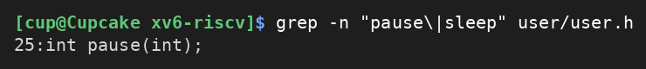
Figure 1.1 – The grep result in user.h
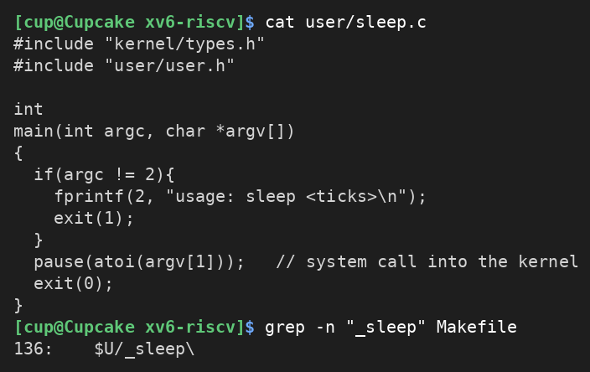
Figure 1.2 – The updated sleep.c and its line in the Makefile
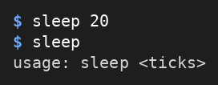
Figure 1.3 – sleep running in xv6, with and without an argument

Part 2. bash versus the xv6 shell

Work done
I ran every command of the lab twice: once in bash in an empty test folder that contains a file named README (~/shtest), and once at the $ prompt of xv6. The results are in the table and in the figures below.
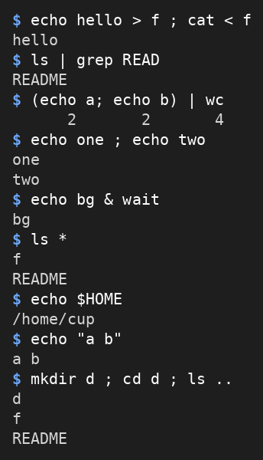
Figure 2.1 – The commands run in bash
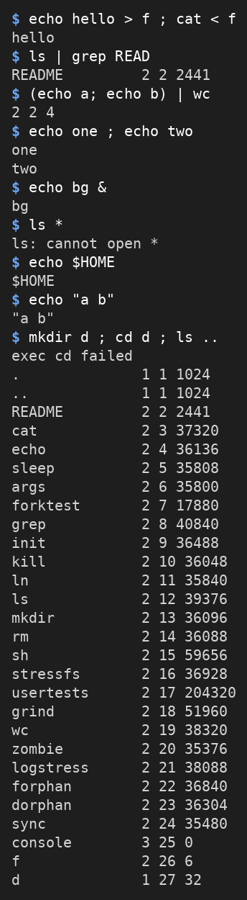
Figure 2.2 – The same commands run in xv6
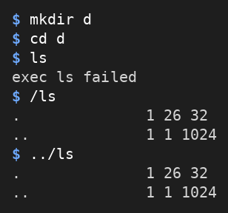
Figure 2.3 – ls failing after cd d, and the working alternative
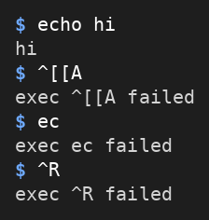
Figure 2.4 – Arrow up, Tab and Ctrl+R in xv6
Command | Tests | bash | xv6 | Why
echo hello > f ; cat < f | redirection | hello | hello | Both shells support < and > (and ;).
ls | grep READ | pipe | README | README 2 2 2441 | Pipes work in both. xv6 ls prints name, type, inode and size, so the whole line matches.
(echo a; echo b) | wc | grouping, list | 2 2 4 | 2 2 4 | Both run the group as one unit; wc counts 2 lines, 2 words, 4 bytes. Only the spacing differs.
echo one ; echo two | sequence | one  two | one  two | The ; operator is supported in both.
echo bg & | background | bg | bg | Both start the command in the background (in bash I added wait so the output was captured).
ls * | globbing | f  README | ls: cannot open * | bash expands * into the file names. The xv6 shell does not, so ls receives the literal name “*”.
echo $HOME | variables | /home/cup | $HOME | bash replaces the variable. The xv6 shell has no variables, so echo gets the text $HOME.
echo "a b" | quotes | a b | "a b" | bash removes the quotes. The xv6 shell does not handle quotes, so they stay inside the words.
mkdir d ; cd d ; ls .. | PATH | d  f  README | exec cd failed  (then the listing of the root directory /) | In xv6 cd is a built-in only when it is at the start of the line. Here it was started as a program, which does not exist; the shell stayed in /, so ls .. listed /. See Figure 2.3 for the PATH effect.
arrow up, Tab, Ctrl+R | history, completion | recalls the last command, completes names, searches history (as in Lab 3) | exec ^[[A failed  exec ec failed  exec ^R failed | The xv6 console only delivers a line of text to the shell. The keys arrive as ordinary characters and are run as program names, so there is no history, completion or search.

Observe
1. Both shells have: running programs from the file system, redirection of input and output (< and >), pipes (|), command lists (;), grouping with parentheses, background execution (&), and a built-in cd. Only bash has: globbing (*), variables ($HOME), quote handling (the quotes are removed), a search path for programs (PATH), command history with the arrow keys, Tab completion and Ctrl+R search. (&& and || are also missing in xv6: its list of special characters has no place for them.)
2. The xv6 shell has no PATH. It starts a program by giving the name to exec, which looks for it in the current directory. All the xv6 programs live in the root directory /, so after cd d the current directory is d, which has no file called ls, and the shell prints “exec ls failed” (Figure 2.3). The way around it is to give the path of the program: /ls (absolute path) or ../ls (relative path) both work, as the figure shows. Note that the listing printed by /ls is the content of d, the current directory, not of /.
3. In my daily work I would miss the history with the arrow keys and Tab completion most, because I use them for almost every command; without them every long path must be typed in full. The easiest feature to add looks like quote handling: the shell already splits the line into words in one small function (gettoken), so it would only need a few lines to treat text between quotes as one word. Globbing would need reading directory entries and variables would need an environment, so they are more work. (This answer is my own opinion based on reading sh.c.)

Part 3. Who expands *? A program that prints its argv

Work done
I wrote user/args.c for xv6 and added $U/_args\ to UPROGS (Figure 3.1). I also wrote args_linux.c, which uses <stdio.h> and return 0, and compiled it with gcc -o args args_linux.c. Then I ran the same four lines in both shells; in bash I used ./args in a folder that has the files a.c, b.c and args_linux.c.
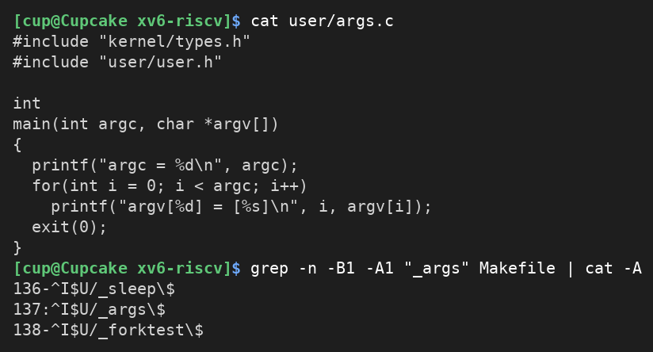
Figure 3.1 – args.c and the UPROGS line
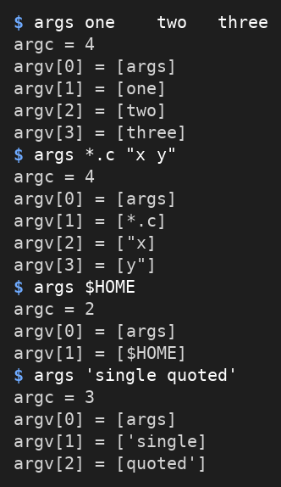
Figure 3.2 – args output in xv6
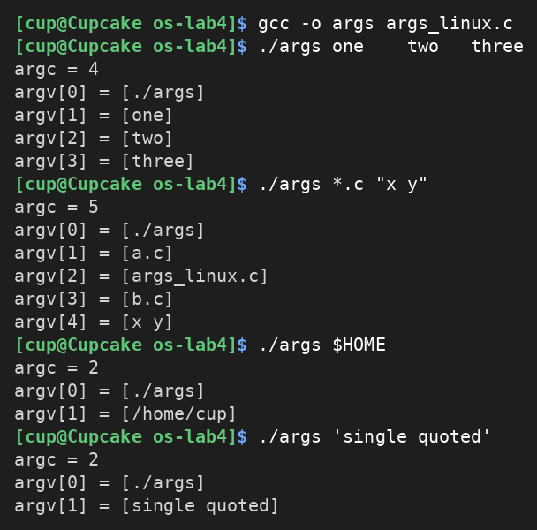
Figure 3.3 – args_linux output in bash

Observe
1. For args *.c "x y": xv6 printed argc = 4 with argv = [args], [*.c], ["x] and [y"]. bash printed argc = 5 with argv = [./args], [a.c], [args_linux.c], [b.c] and [x y]. In other words, the xv6 program received 3 arguments after its own name and the Linux program received 4 (argc also counts the program name).
2. The shell does it. Neither the program nor the kernel touches the words: the kernel only copies the argv array to the new program in exec. bash expanded *.c into the three file names and removed the quotes around x y, so that it became one argument. The xv6 shell does neither: it passed the text *.c unchanged (so the program saw a star) and cut "x y" into two words, keeping the quote characters. The same happens with $HOME and with 'single quoted'.
3. The extra spaces disappeared in both shells: for args one two three the program got argc = 4 and the words one, two and three without any spaces. The shell uses spaces only as separators between words and does not pass them on.

Part 4. Read the shell

Work done
The file user/sh.c has 499 lines. I searched it for the command kinds (#define), for the places where each kind is run (case), for the handling of cd, and for any code for * and $.
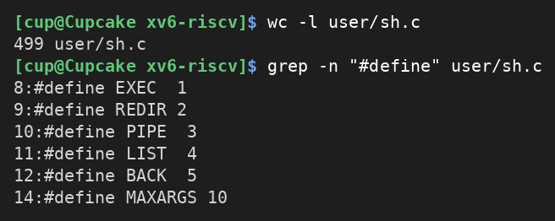
Figure 4.1 – The command kinds defined in sh.c
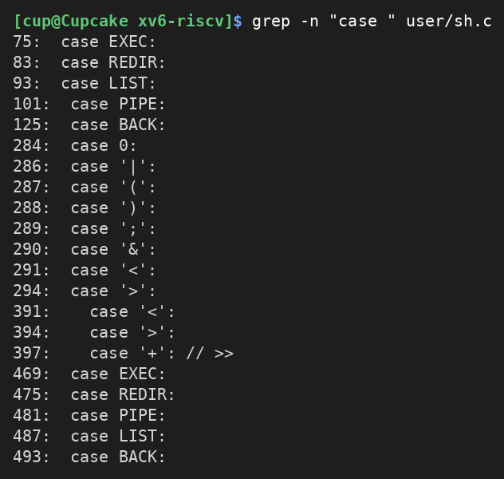
Figure 4.2 – Where each kind is run
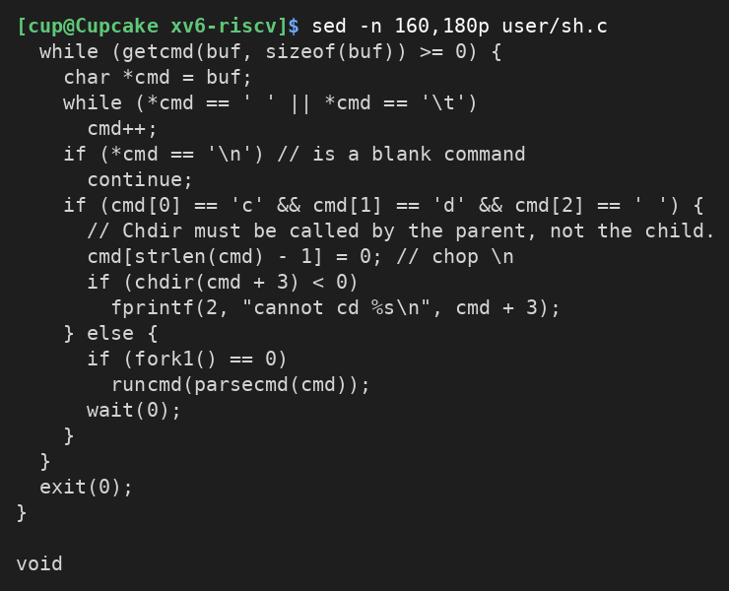
Figure 4.3 – The code that handles cd
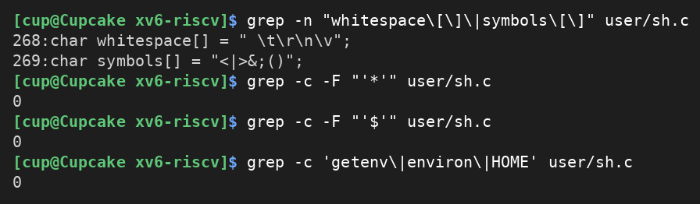
Figure 4.4 – Searching sh.c for *, $ and environment variables

Observe
1. The five kinds are: EXEC (a simple command: a program name with its arguments, made of ordinary words, no special character); REDIR (redirection, produced by < and > ; >> is handled too); PIPE (produced by |); LIST (a sequence, produced by ;); BACK (background, produced by &). The parentheses ( ) only group a command.
2. cd is handled in the main loop of the shell, in user/sh.c: the test for the text “cd ” is on line 166 and the call chdir(cmd + 3) is on line 169 (the error message “cannot cd” is on line 170). It is not a separate program because the current directory belongs to a process: a program started by the shell runs in a child process, so a chdir there would change the directory of the child, which ends immediately. The comment in the code says it too: chdir must be called by the parent, not the child. This code looks only at the start of the input line, which explains why cd failed in mkdir d ; cd d ; ls .. (the cd was run as a program).
3. There is no code for * or $ in sh.c: no star, no dollar sign, and no getenv, environ or HOME (all searches found 0 matches). The shell knows only the whitespace characters and the symbols <|>&;(). This explains Part 2: ls * received a literal star, echo $HOME printed $HOME, and the quotes were not removed. In bash all of that is done by the shell before the program starts, so a shell like the one in xv6 is the minimum a shell must do: read a line, split it into words, build the command tree and run it.

Conclusions
In this laboratory work I fixed my sleep program for the current xv6, where the system call has been renamed pause(), and compared the xv6 shell with bash. The experiments show that the xv6 shell, a program of 499 lines, does the essential job of a shell: it reads a line, splits it into words, and runs programs with redirection, pipes, lists and background execution, with cd built in because the working directory belongs to the shell process.
Everything else I am used to in bash (globbing, variables, quotes, PATH, history and Tab completion) is added by bash itself. The args program proved that neither the program nor the kernel expands * or removes quotes: it is the shell that prepares the argv array before exec. Reading sh.c confirmed this, since it has no code for * or $.

