TECHNICAL UNIVERSITY OF MOLDOVA
Faculty of Computers, Informatics and Microelectronics
Department of Software Engineering and Automation
REPORT
on laboratory work no. 3
Course: Operating Systems
Topic: The Command Line: Shell, Pipes and Text Filters
Done by: st. gr. FAF-241, Igor Boltunov
Checked by: ______________________
Chișinău, 2026

Purpose of the work
The purpose of this work is to learn to work quickly in the bash shell: to predict what the shell does to a command line before it runs (globbing, quoting and expansion), to control standard input, output and error with redirection, to chain commands and run background jobs, to answer questions about data with one-line pipelines of small text filters, and to turn the best one-liners into a first shell script.
Environment: Arch-based CachyOS on real hardware (kernel 7.2.9-2-cachyos), user cup, host Cupcake. The default shell of this system is fish, but all commands of the lab were run in bash, as required. The test data file access.log (500 lines) was generated with the command from the lab text.

Part 1. Move fast, find help

Work done
I used Tab completion, the command history, and the commands type, which, echo $PATH and $? to see how the shell finds programs. For help I used ls --help, man -k and the built-in help.
Tab completion. After ls /usr/sh the first Tab completed the name to /usr/share/, and the second Tab asked “Display all 341 possibilities?” and listed them. After cd /et, Tab completed the name to /etc/, and pressing Tab again offered the 122 entries of that directory.
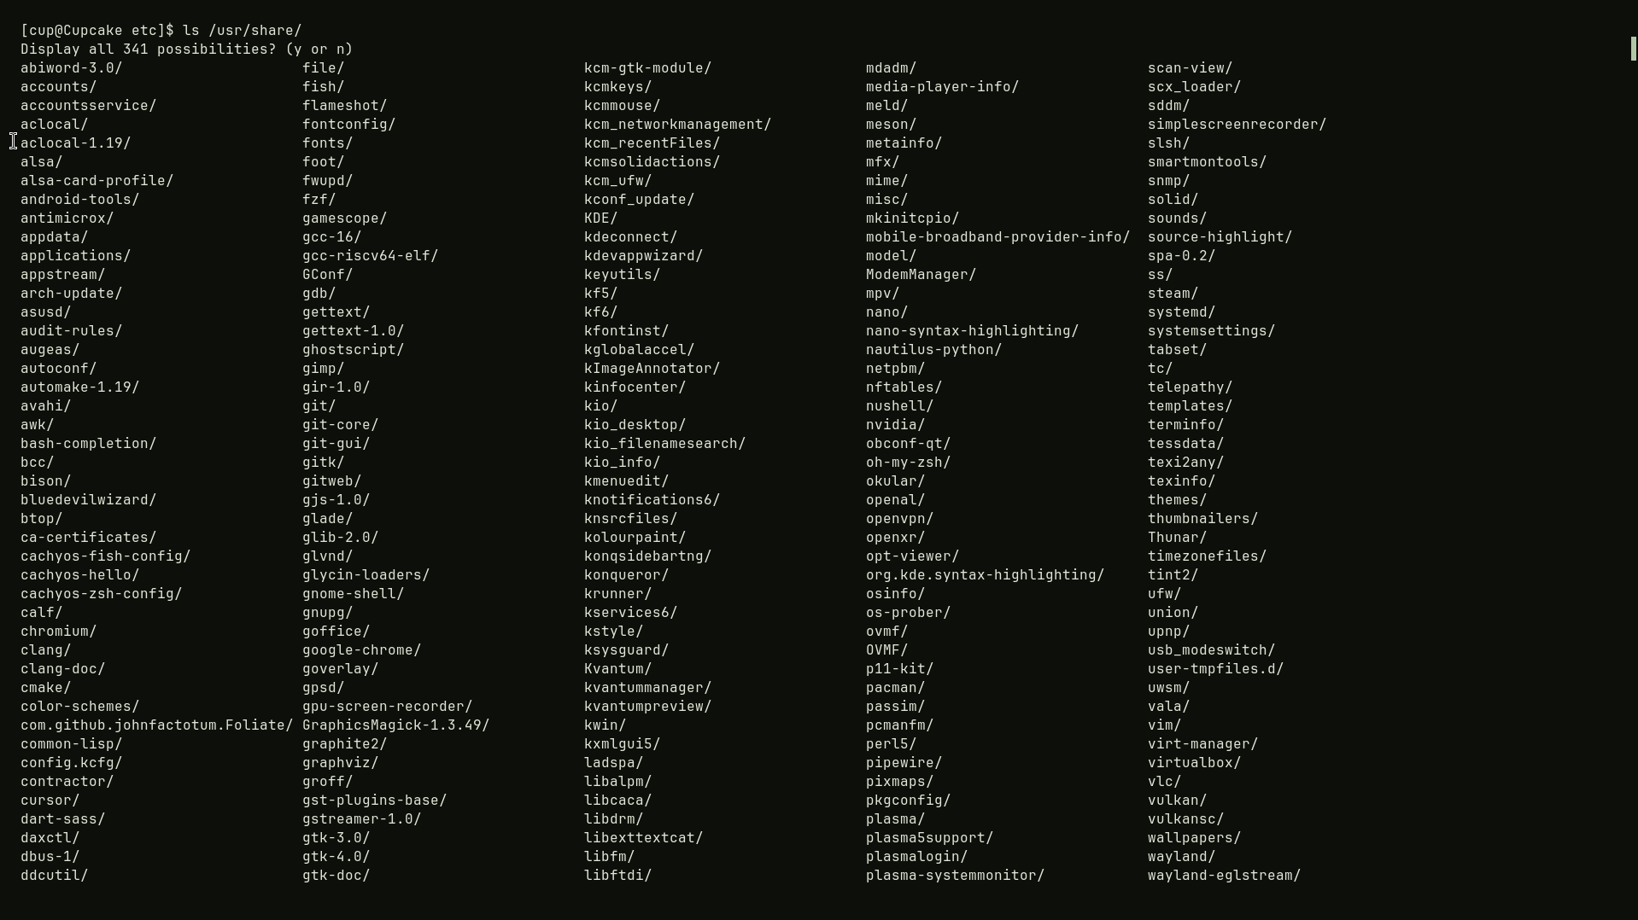
Figure 1.1 – Tab completion: ls /usr/sh and two Tabs
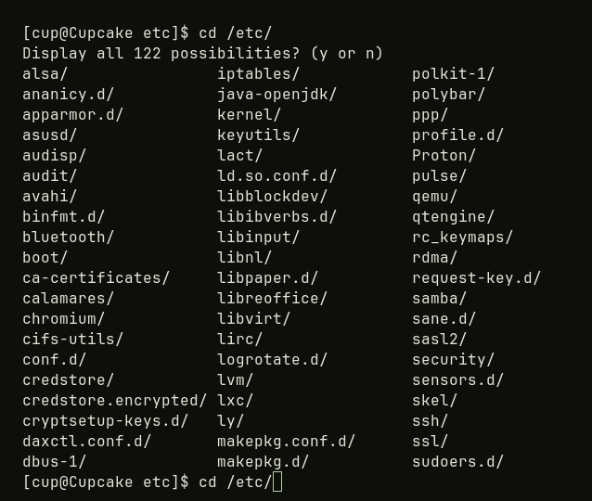
Figure 1.2 – Tab completion: cd /et and Tab
History search. I ran date, whoami, pwd and date again. Ctrl+R opens the “reverse-i-search” prompt of bash; typing a few letters (for example “dat”) shows the most recent command in the history that contains them, here date, and Enter runs it. Esc or Ctrl+G leaves the search without running anything.
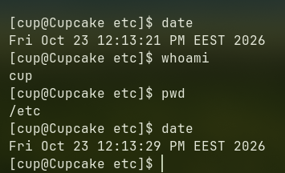
Figure 1.3 – Commands used for the history search
Note about fish. In my default shell (fish) the same keys behave differently: cd goes through zoxide (cd /et answered “zoxide: no match found”) and Ctrl+R opens a search panel instead of the bash prompt. That is why I repeated these steps in bash.
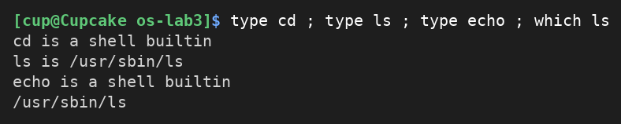
Figure 1.4 – Output of type and which
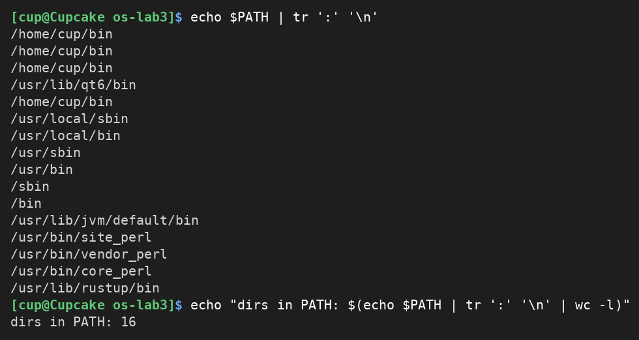
Figure 1.5 – The directories in PATH
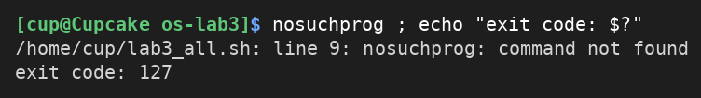
Figure 1.6 – Exit code of a missing command
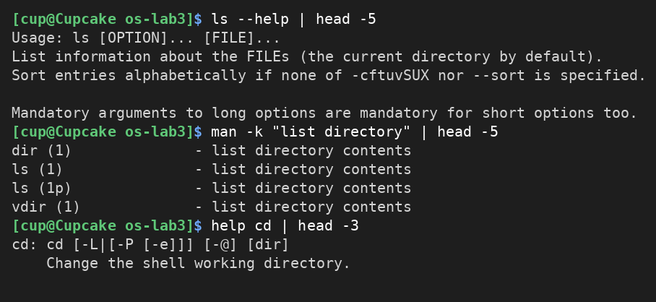
Figure 1.7 – Finding help: ls --help, man -k and help cd

Observe
1. cd and echo are shell built-ins, while ls is an external program (/usr/sbin/ls; on Arch the sbin directories are links to /usr/bin, I saw /sbin -> usr/bin in Lab 1). cd must be a built-in because the current directory is a property of the process: an external program would run in a child process and could only change its own directory, which disappears when it exits. Only the shell itself can change the directory the shell works in.
2. PATH contains 16 entries (13 distinct ones, because /home/cup/bin is repeated four times). The program ls is found in /usr/sbin, the first directory in PATH order that contains it (/usr/sbin comes before /usr/bin).
3. A command that is not found returns exit code 127.
4. The option -t sorts by modification time, newest first (-r reverses the order).

Part 2. What the shell does to your line

Work done
In ~/os-lab3/play I created the files a.c, b.c, file1.txt, file2.txt, notes.txt and “alfa beta.txt”, and then ran the ten lines from the lab. The table below gives the command, my prediction, the real output and an explanation.
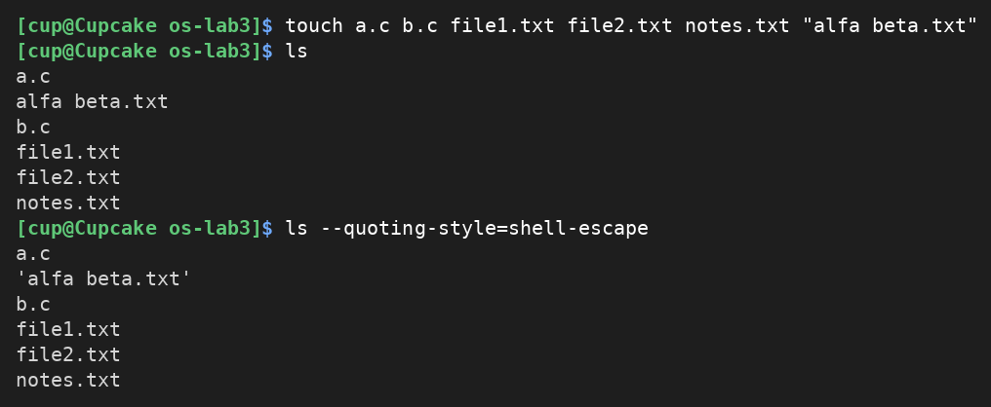
Figure 2.1 – Files created in the play directory
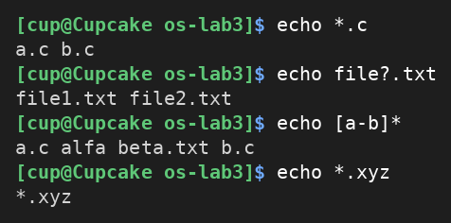
Figure 2.2 – Globbing results
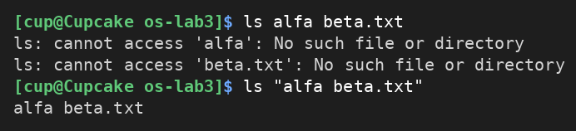
Figure 2.3 – The ls error on a name with a space, and the fix

Figure 2.4 – Single quotes, double quotes and backslash
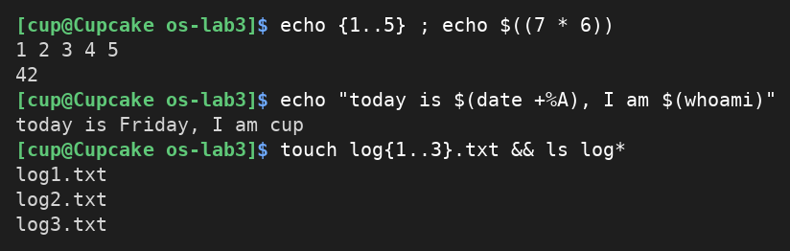
Figure 2.5 – Brace expansion, arithmetic and command substitution
Command | My prediction | Real output | Explanation
echo *.c |  | a.c b.c | The shell expands the glob *.c to the two matching files before echo runs.
echo file?.txt |  | file1.txt file2.txt | ? matches exactly one character, so file1 and file2 match.
echo [a-b]* |  | a.c alfa beta.txt b.c | Any name that starts with a or b; this includes the file with a space.
echo *.xyz |  | *.xyz | No file matches, so bash leaves the pattern unchanged and echo prints it as text.
ls alfa beta.txt |  | ls: cannot access 'alfa': No such file or directory  ls: cannot access 'beta.txt': No such file or directory | Without quotes the shell splits the line on the space, so ls receives two arguments, alfa and beta.txt.
ls "alfa beta.txt" |  | alfa beta.txt | The quotes keep the name as one argument.
echo '$HOME' "$HOME" \$HOME |  | $HOME /home/cup $HOME | Single quotes and the backslash stop expansion; double quotes still expand the variable.
echo {1..5} ; echo $((7 * 6)) |  | 1 2 3 4 5  42 | Brace expansion generates the sequence; $(( )) calculates the arithmetic.
echo "today is $(date +%A), I am $(whoami)" |  | today is Friday, I am cup | $( ) runs the commands and pastes their output into the line.
touch log{1..3}.txt && ls log* |  | log1.txt  log2.txt  log3.txt | Braces create three names for touch; && runs ls only because touch succeeded; log* is a glob.

Observe
1. See the table above (command, prediction, real output, explanation).
2. The shell produced the file names, not echo. Before running the command, bash expands the pattern *.c into the list of matching names (globbing) and gives echo the ready list a.c b.c as ordinary arguments. echo only prints what it receives.
3. Without quotes the shell splits the line at the space, so ls received two separate arguments, “alfa” and “beta.txt”, and neither file exists. Two fixes: put the name in quotes, ls "alfa beta.txt" (single quotes work too), or escape the space with a backslash, ls alfa\ beta.txt.
4. Inside single quotes everything is literal: no variable, command or backslash expansion happens, so '$HOME' prints $HOME. Double quotes protect spaces and wildcards but still allow expansion of $VARIABLE, $( ) and $(( )), so "$HOME" prints /home/cup.
Why ls shows 'alfa beta.txt' with quotes: when its output goes to a terminal, ls quotes names that contain special characters such as spaces, so that the line can be copied and pasted back into the shell safely. The quotes are only part of the display; they are not part of the file name (ls --quoting-style=shell-escape shows this explicitly in Figure 2.1).

Part 3. Redirection, chaining and jobs

Work done
I redirected the standard output (file descriptor 1) and the standard error (file descriptor 2) of ls to files, appended with >>, read from a file with <, discarded errors in /dev/null, chained commands with ; && and ||, and started and stopped a background job.
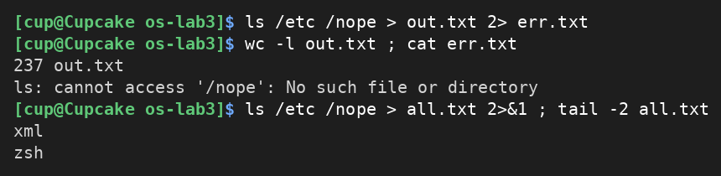
Figure 3.1 – stdout and stderr in separate files
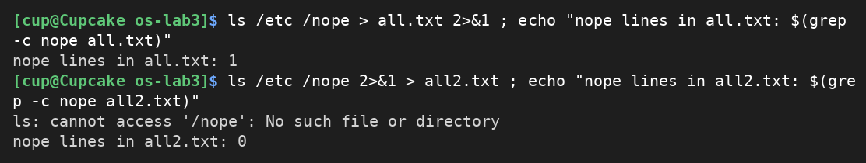
Figure 3.2 – Comparing the order of redirections
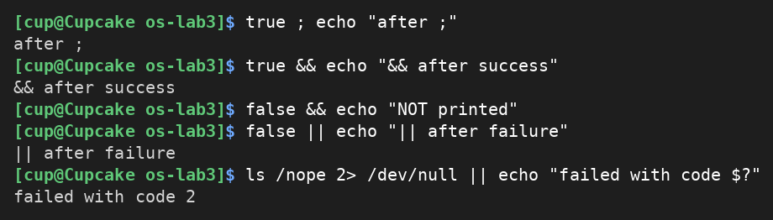
Figure 3.3 – The ; && || operators
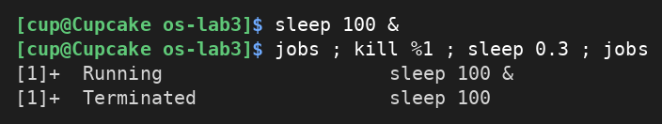
Figure 3.4 – Running a background job and stopping it
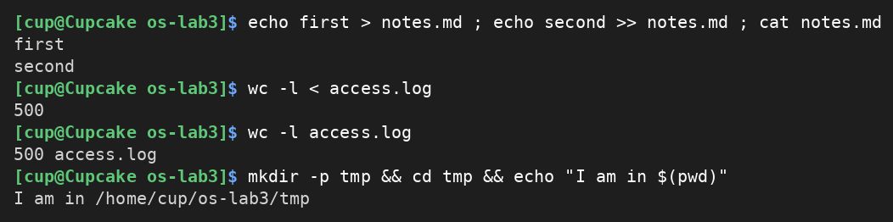
Figure 3.5 – Appending, input redirection and command substitution

Observe
1. The error message (“ls: cannot access '/nope'…”) went to err.txt, and the listing went to out.txt. out.txt has 237 lines: the 236 entries of /etc plus the heading “/etc:”, which ls prints because it received two arguments.
2. Redirections are processed from left to right, and 2>&1 means “make descriptor 2 point to the place where descriptor 1 points right now”. In > all.txt 2>&1 descriptor 1 is first sent to the file and then descriptor 2 is copied to it, so both the listing and the error end up in all.txt (1 line with “nope”). In 2>&1 > all2.txt descriptor 2 is copied while descriptor 1 still points to the terminal, and only afterwards descriptor 1 goes to the file: the error is printed on the screen and all2.txt has only the listing (0 lines with “nope”).
3. With wc -l < access.log the shell opens the file and connects it to the standard input of wc, so wc does not know any file name and prints only the number. With wc -l access.log the file name is an argument, wc opens the file itself and prints the name next to the count.
4. ; runs the next command always, one after another, whatever the result of the first. && runs the next command only if the previous one succeeded (exit code 0). || runs the next command only if the previous one failed (non-zero exit code).

Part 4. Answer questions with one-liners

Work done
Each question is answered with one command line. All lines are saved in oneliners.sh (one per question, with the question as a comment above it) and the file runs with bash oneliners.sh inside ~/os-lab3. Each line of access.log has five fields: date, time, user, result (OK or FAIL) and page.
Q1. How many requests failed?
grep -c FAIL counts the lines that contain FAIL: 100 requests failed.
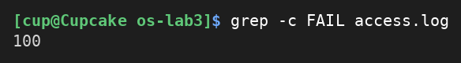
Figure 4.1 – Number of failed requests
Q2. How many different pages were requested, and which?
cut takes field 5 (the page), sort -u removes duplicates: 4 different pages, /page0, /page1, /page2 and /page3.
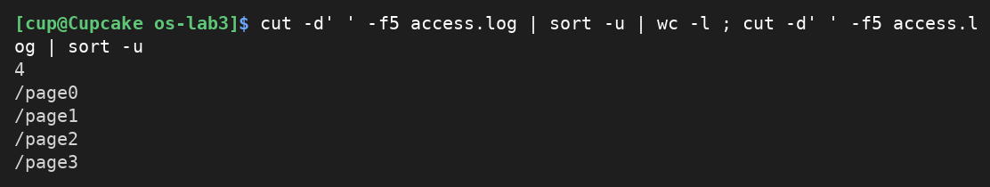
Figure 4.2 – Different pages requested
Q3. How many requests did each page get?
sort groups equal pages and uniq -c counts them: every page got 125 requests, and 4 × 125 = 500, which equals the number of lines in the log.
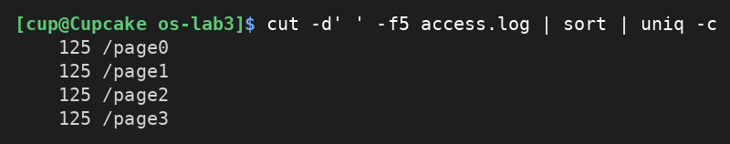
Figure 4.3 – Requests per page
Q4. Which user or users have the most failed requests, and how many?
The failed lines are counted per user (field 3) and sorted; awk keeps every line whose count equals the maximum. Two users share the maximum: user3 and user5, with 15 failures each. Check: 5 × 14 + 2 × 15 = 100, equal to the answer of Q1.
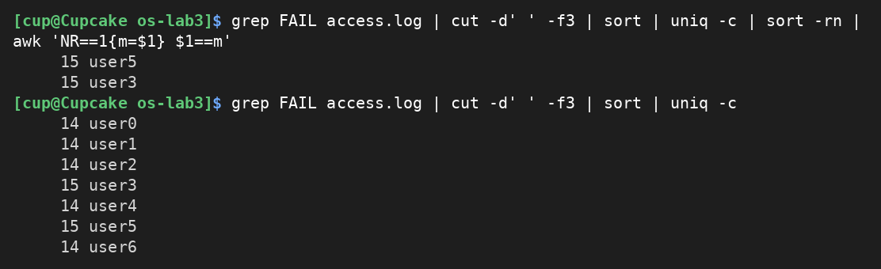
Figure 4.4 – Users with the most failed requests
Q5. How many requests did user3 make, and how many of them failed?
user3 made 72 requests and 15 of them failed. The space after user3 in the pattern avoids matching other names that start with the same text.
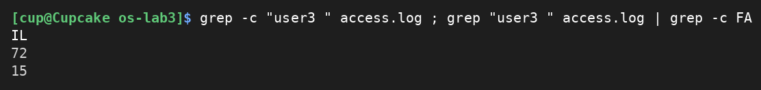
Figure 4.5 – Requests of user3
Q6. Print the last 3 failed requests, showing only time and user.
grep FAIL selects the failures, tail -3 keeps the last three, cut -d' ' -f2,3 keeps time and user: 10:10 user0, 10:15 user5 and 10:20 user3.
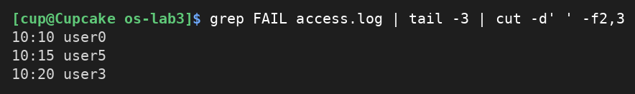
Figure 4.6 – Last 3 failed requests
Q7. Which login shells appear in /etc/passwd, and how many accounts use each?
Field 7 (separator :) is the login shell. On my system: /usr/bin/nologin is used by 37 accounts, and /usr/bin/git-shell, /usr/bin/bash, /bin/fish and /bin/false by one account each.
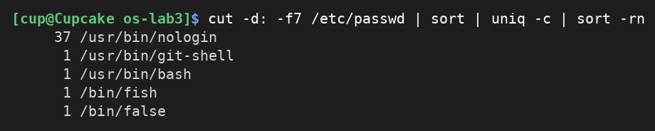
Figure 4.7 – Login shells in /etc/passwd
Q8. Why do ls /etc | wc -l and ls -l /etc | wc -l differ by exactly one?
The counts are 236 and 237. The long format prints one extra first line, “total N” (the number of disk blocks used by the listed files), before the entries, so wc counts one more line.
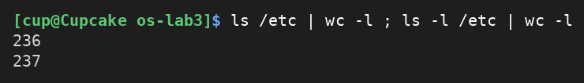
Figure 4.8 – ls | wc -l and ls -l | wc -l
Bonus. With grep -E I printed the lines where the minute ends in 0 and the request failed (the pattern is “ 10:[0-5]0 user[0-6] FAIL ”). There are 50 such lines. This is consistent with the data: a request fails when its number is a multiple of 5, and the minute ends in 0 when the number is a multiple of 10, so 500 / 10 = 50.
Figure 4.10 – Bonus: failed requests where the minute ends in 0
Self-check: the Q3 counts add up to 500 and the per-user failure counts behind Q4 add up to 100, equal to Q1. The complete run of oneliners.sh is shown below.
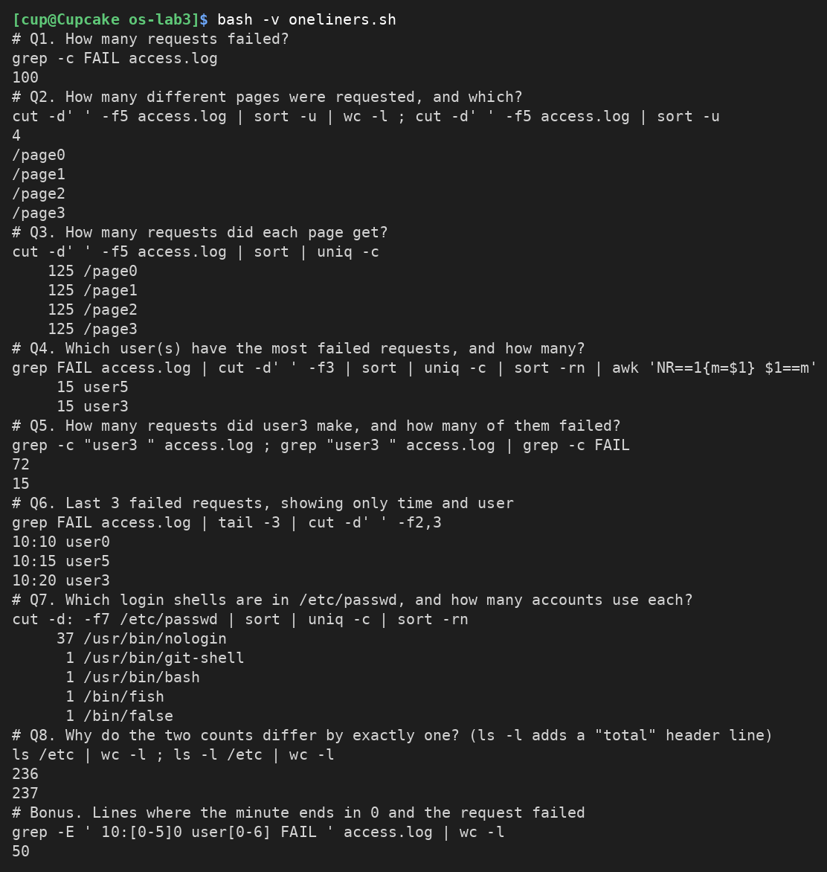
Figure 4.9 – Full run of oneliners.sh

Part 5. Your first script

Work done
I created report.sh and completed the TODO with a loop over the users user0 … user6. For every user the loop counts the lines that contain “userN FAIL” and prints “userN: X failures”. The script checks that the file exists, writes the error message to the standard error and ends with exit code 1 when it does not.
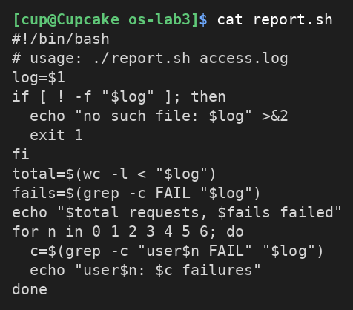
Figure 5.1 – Contents of report.sh
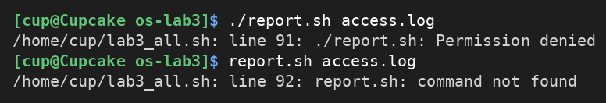
Figure 5.4 – Running the script before chmod +x, and without ./
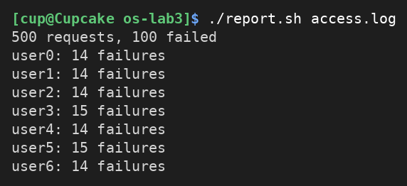
Figure 5.2 – Running the script on access.log
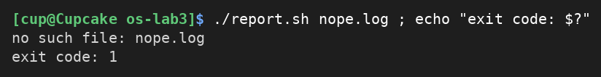
Figure 5.3 – Error handling for a missing file

Observe
1. The first line #!/bin/bash (the “shebang”) tells the system which interpreter must run the file, here /bin/bash. Before chmod +x the file has no execute permission, so ./report.sh fails with “Permission denied” (Figure 5.4).
2. The current directory is not in PATH, and the shell looks for command names only in the PATH directories. report.sh alone gives “command not found” (Figure 5.4); ./report.sh gives an explicit path, which is run directly.
3. The error message is written to the standard error (>&2), so it is not mixed with the normal output and can be redirected separately. exit 1 returns a non-zero exit code, which tells whoever called the script (the shell, &&, ||, another script, cron) that it failed; exit code 0 means success.

Conclusions
In this laboratory work I practiced the basic tools of the command line. I learned how the shell finds commands (built-ins and the directories of PATH), how it prepares the line before running a program (globbing, quoting, brace and command substitution), and how it connects programs to files with redirection, so that standard output and standard error can be sent to different places, and why the order of redirections matters.
With small filters (grep, cut, sort, uniq, wc, tail, awk) joined by pipes I answered eight questions about a 500-line log with one line each, and checked the results against each other (500 requests in total, 100 failures). Finally, I turned the one-liners into the script report.sh, which uses an exit code and the standard error correctly. The main lesson is that the shell does a lot of work before the program starts, and that predicting this work is the key to writing correct command lines.

