

PR2 Power Board
Remove/Replace Instructions

7/20/2010

PR2 Power Board Remove/Replace

Overview

Removing and/or replacing a PR2 Power Board is a difficult operation. There are many ways to cause injury to the user and/or damage to the PR2. Read entire procedure before starting.

General Safety Instructions
- Always wear an ESD wrist strap when reaching into the robot.
- Do not drop any screws into the robot. Any lost screws may cause the robot to malfunction. If you drop any screws into the robot, do not turn on the robot until you have contacted Willow Garage Support.
- When removing screws, save screws by type. You will need screws that you have removed when replacing the components.
- Use extreme caution when removing any cables. All cables are very difficult to repair or replace if broken.

If you have any questions about using this document, contact Willow Garage Support before proceeding.

Pre-Start Checklist

Before starting to remove and replace a PR2 power board, make sure you have completed these steps:
- Review instructions for “Robot Overview, Torque Tools, Loctite” and “Setting Torque Driver”.
- Remove “Top Rear”, “Bottom Rear” and “Rear Bellows” covers.
- Raise spine to approximately 25 cm from bottom. Do not raise spine to maximum height. Use instructions in “Manual Spine Movement” document if necessary. (25 cm height is about 80% of maximum height of the spine).
- Turn robot off. Disable main power breaker.
- Unplug robot from wall.

Required Tools and Materials:
- PR2 Tool Kit and PR2 Accessory Kit
- Replacement PR2 Power Board
- Grounded (ESD-safe) work surface
- Tape (masking, cellophane, electrical) to temporarily secure a bracket to the robot.
PR2 Power Board Anatomy

Refer to the following document for any component names for the main power board components.
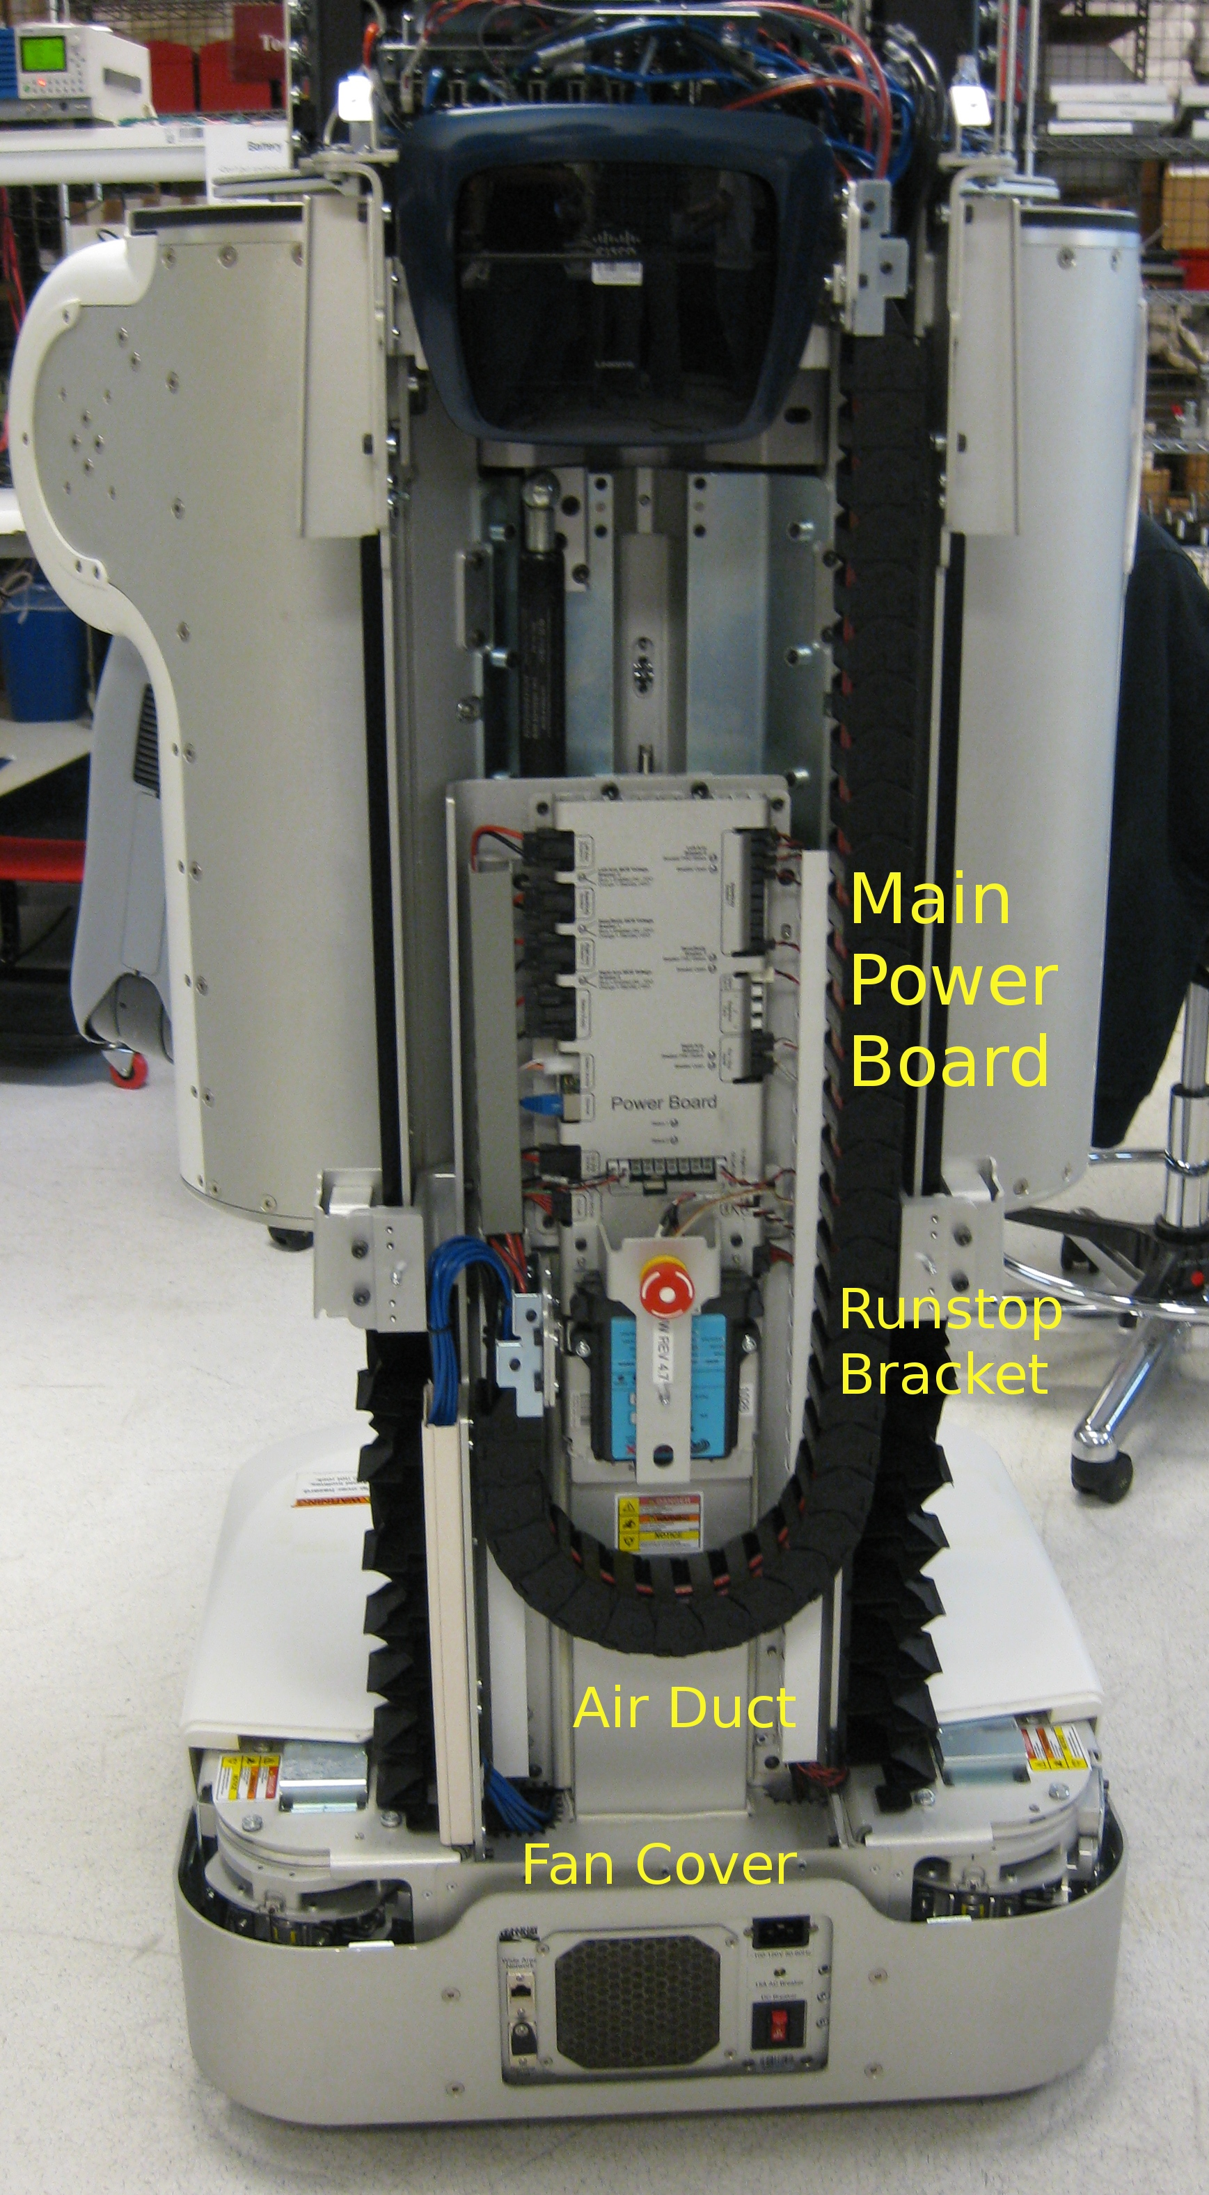

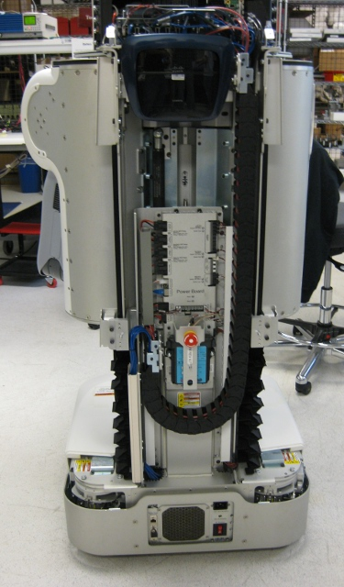Drawing 1: PR2 with rear covers removed and spine raised
- Make sure you have removed the “Top Rear”, “Bottom Rear” and “Rear Bellows” from the robot. The spine should be about 25 cm above bottom, or about 80% up (see Drawing 1).
- Remove the runstop bracket. Use a 3mm bit on the T-handle wrench. There are three screws (see Drawing 2). The bracket will remain connected to the robot with a short cable. After bracket removed, secure to the right side of the robot with a piece of tape. Do not allow bracket to hang by the cable.
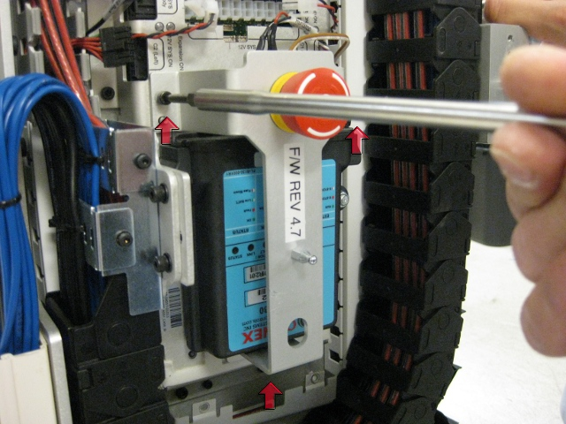Drawing 2: Remove runstop bracket. Approximate locations of screws are marked.
- Remove the screws securing the Power Board air duct. The duct is located on the underside of the power board. Use the T-handle wrench and a 3mm torque driver. See Drawing 3.
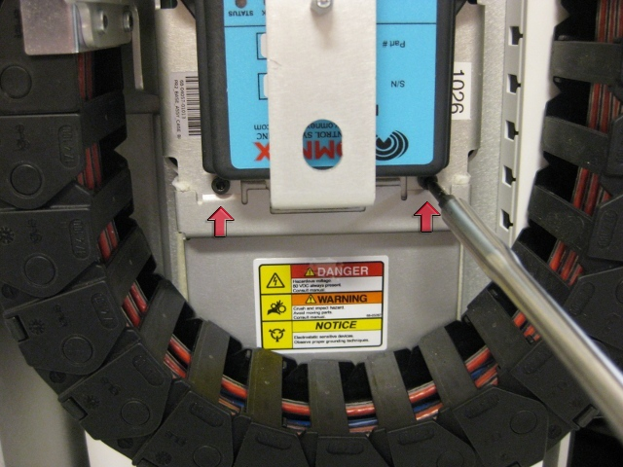Drawing 3: Power board air duct screws.
- Remove the fan cover below the air duct. Use a 3mm wrench to remove screws. You will not be able to use the T-handle wrench to remove these screws. Instead, use a right angle 2.0 Nm torque driver that is in your tool kit (see Drawing 4). There are six (6) screws holding in the fan cover (see Drawing 5). Note that the screws on the side are different than the rear, store them separately.
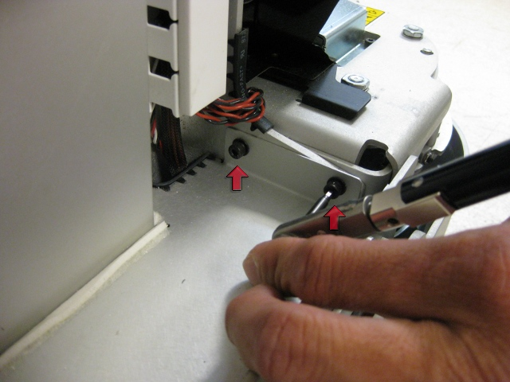Drawing 4: Remove fan cover screws using right angle torque driver.
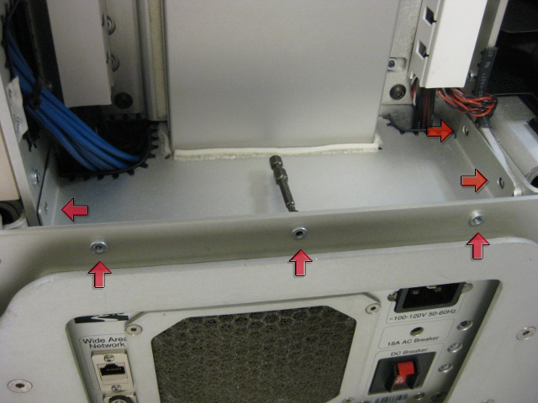Drawing 5: Six screws holding fan cover. Side screws are different than rear screws.
- Lower the air duct by about 2cm to allow clearance to the power board (see Drawing 6). You may remove the duct from the robot is desired.
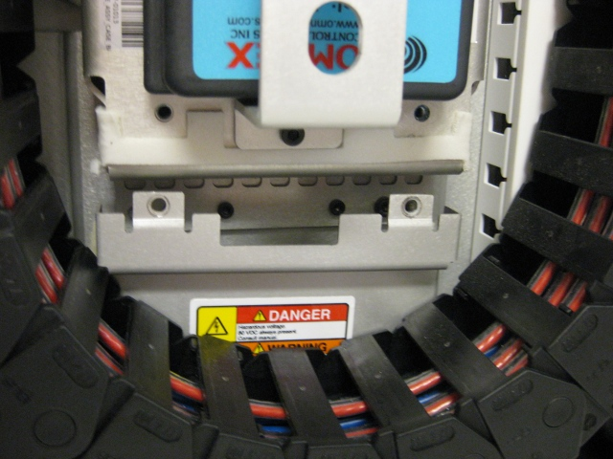Drawing 6: Lower the air duct to allow power board removal.

- Remove cable cover on left-hand side of the power board. The cover should slide up and out (Drawing 7).
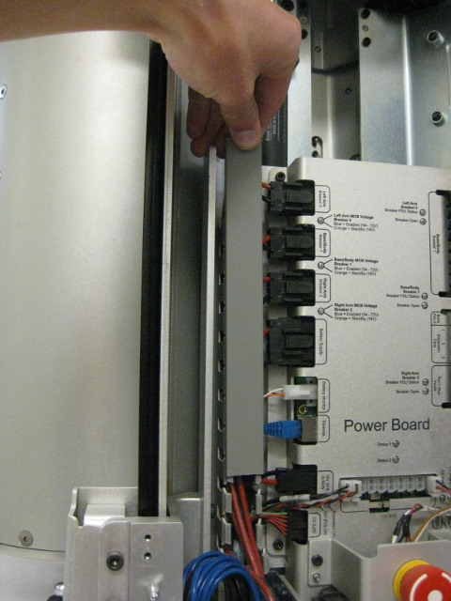Drawing 7: Cable cover on left side of power board.
- Remove all cables from the left-hand side of the power board (see Drawing 8). The cable for the “c1” computer is difficult, you may will need two hands.
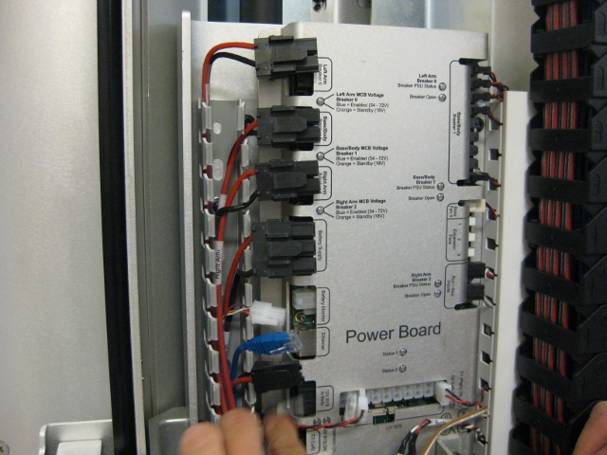Drawing 8: Left side cable removal.

- Remove cable for the runstop (see Drawing 9).
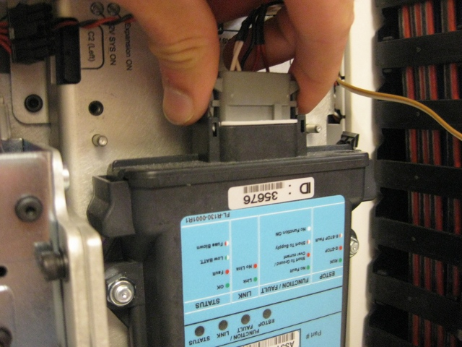Drawing 9: Runstop cable.
- Remove all cables on the right side of the power board. The order is not important for the three small 48V power cables on the top right (shown in Drawing 10). All cables should be removed from power board, except for cable that goes to runstop bracket. The cable for the “c2” computer is low on the right side, and is difficult to remove (see Drawing 11).
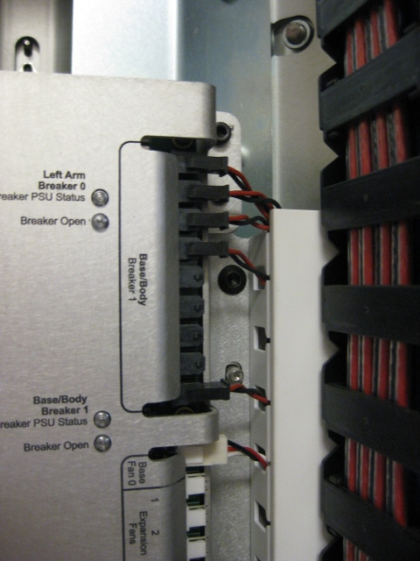Drawing 10: Right side power cables.

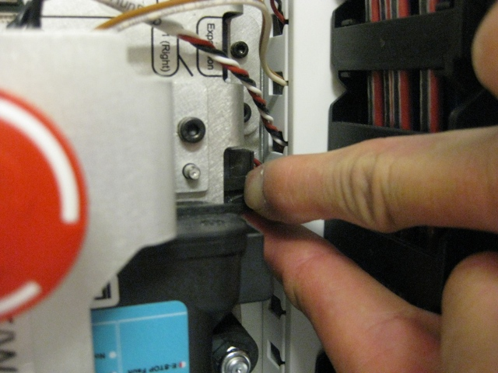Drawing 11: c2 power cable on lower right side of power board.
- Check the voltage on the “Battery Supply” cable. Use a multimeter set to DC voltage mode. MAKE SURE ALL CABLES ARE UNPLUGGED FROM THE POWER BOARD. After all cables are unplugged, turn on main breaker. Check voltage reading from “Battery Supply” cable on the left side of the robot (see Drawing 12). It should read between 56V to 68V.
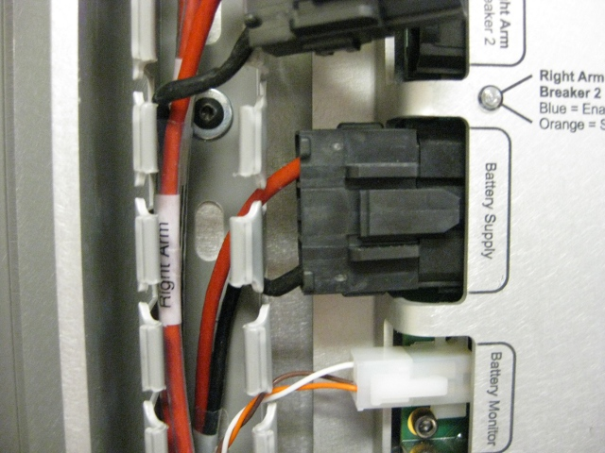Drawing 12: Check voltage on Battery Supply cable. All cables must be unplugged first.
- Remove power board. Use a 3mm bit in the T-handle wrench to remove all six screws. There are two screws on the bottom, two in the middle and two near the top. See drawings 12, 13 and 14. Be careful to remove only the correct screws. When removing the last screw, you will have to hold the power board in place to prevent it from moving.
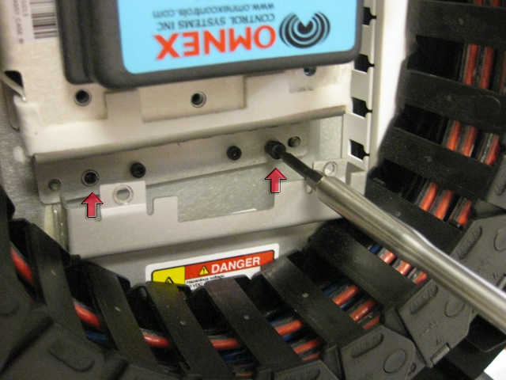Drawing 13: Bottom screws for power board.
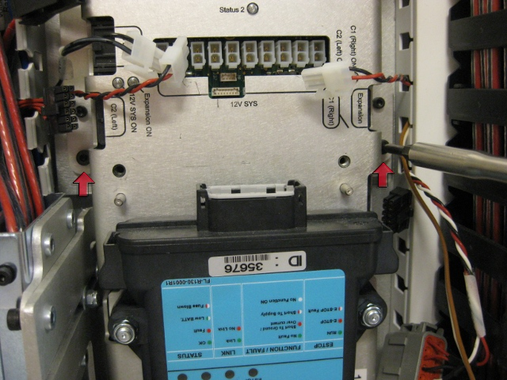Drawing 14: Power board screws -middle row.
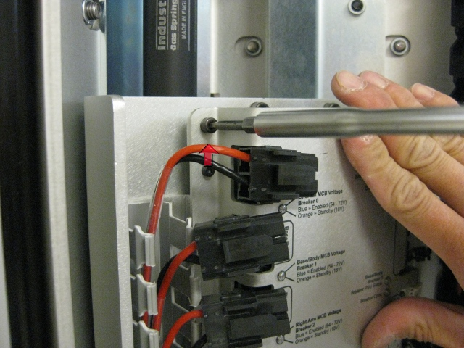Drawing 15: Top screw for power board. Right side has matching screw.
- Remove power board from robot. Slowly pull on the right side of the board, gently twist it out, and pull back. Do allow any cables to catch on the board. See Drawing 15.
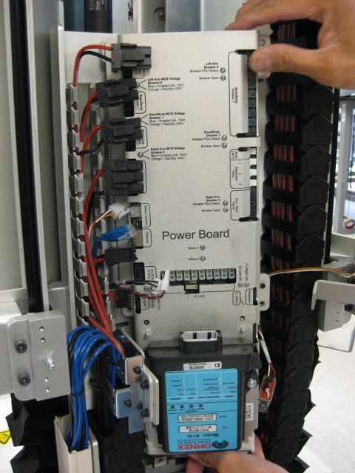Drawing 16: Remove power board. Pull right side out first, then gently pull left side. Make sure all cables are clear.
- Place the removed power board onto a grounded work surface. Remove the wireless runstop receiver. Note that international PR2's may have slightly different runstop receivers installed (see Drawing 16). Use a 10mm socket and the T-handle wrench.
- Place replacement power board onto a grounded work surface. Install the wireless runstop receiver. Use a 10mm socket with torque driver at 3.2 Nm.
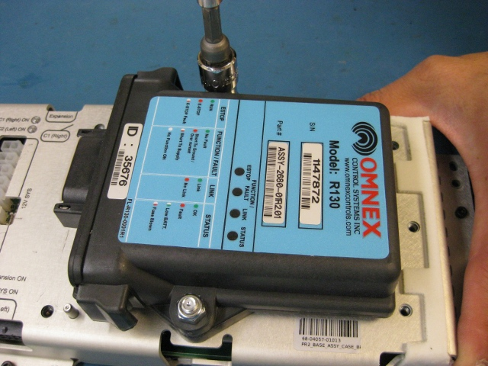Drawing 17: Remove runstop from power board. Use a grounded work surface.
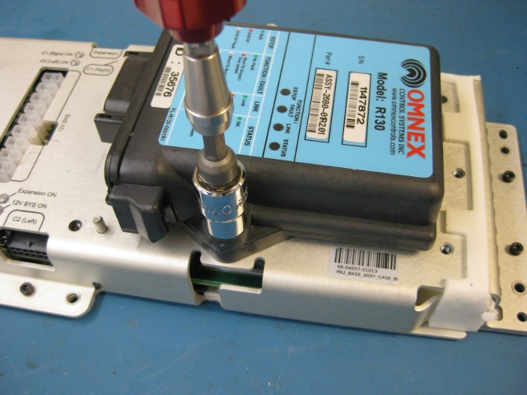Drawing 18: Replace wireless runstop receiver. Use grounded surface.
- Insert power board back into robot. Insert the left side first, and guide the right side in (see Drawing 18). Do not allow any cables to be trapped between the power board and the robot frame. The power board should be held roughly by alignment pins. Replace the six screws that were removed using a 3mm bit. Set torque wrench to 3.2 Nm. Thread all screws before tightening any of them.
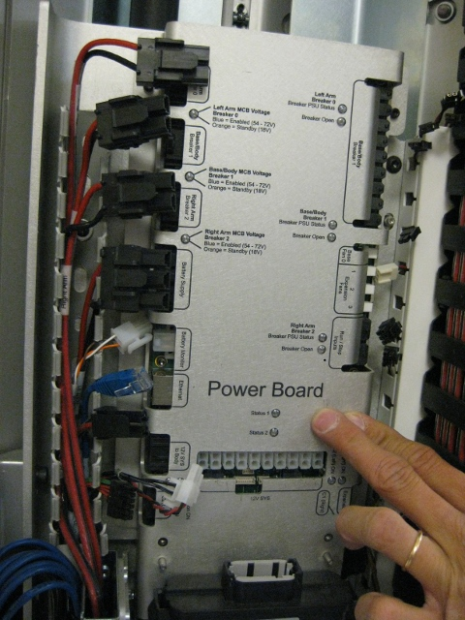Drawing 19: Replace the power board.
- Replace all cables to the power board. Start with the wireless runstop cable. When inserting MCB power cables (on top-left of power board), make sure the correct cable goes to the correct breaker, check cable labels to verify (see Drawing 19). For fan cable on right side, fan must go into “Fan 0” slot. MAKE SURE ALL CABLES SECURELY CONNECTED BEFORE PROCEEDING.
- Attach air duct to bottom of power board. Use 3mm hex bit with torque wrench set to 3.2 Nm. There are two screws to replace. See Drawing 3 for screw locations.
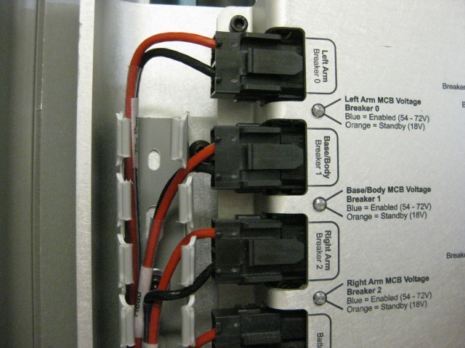Drawing 20: Replace MCB power cables. Check labels on cable and make sure they inserted into correct slot.
- Look at Drawings 4 and 5 to replace fan cover. Thread all six screws before tightening any of them. Use the right angle torque wrench from the toolkit that is set to 0.68 Nm.
- Secure the runstop bracket. Use a 3mm bit with a torque wrench set to 3.2Nm.
- Insert cable cover on left side of power board. See Drawing 7 for removal picture.
- DO NOT TURN ON ROBOT POWER. Make sure you have completed all items below before enabling power.
- All screws that were removed are secured into robot.
- All cables are connected to power board.
- Robot is unplugged.

Power up procedure:
- Make sure robot is unplugged from wall.
- Press runstop to disable motors.
- Enable main breaker on back of robot.
- The main fan should run at high power for several seconds, then slow down.
- All breaker lights on left side of power board should be orange.
- All lights on right side of power board should be green/red.
- Computer power and 12V lights should be on.
- “Status 1” and “Status 2” lights should be off.

Robot check:
- After computers boot, run “sudo pr2-systemcheck”
- With runstop disabled, run “sudo robot start” and verify diagnostic status for power system.
- Do not move robot or robot motors without covers installed.

Robot Operation:
- Power down robot and attach all covers.
- Power robot back up. Run “sudo pr2-systemcheck” to make sure robot is operating.
- Start the robot with “sudo robot start”
- Enable both runstops, make sure pr2_dashboard indicates runstops are enabled.
- Wait for the robot to calibrate. Diagnostics should be OK.

