

PR2 Service Port Diagnosis
and Remote KVM
11/1/2010
PR2 Service Port Diagnosis

This document contains instructions for using the service port of the PR2 to diagnose computer problems. It explains how to connect to the computers through the service port, and use a remote KVM utility for debugging computer problems.

Connect to PR2 Service Port

Connect your basestation or a laptop directly to the PR2 service port. The service port is the lower of the two ethernet ports on the base of your PR2. If you're using a basestation, the interface should be configured to communicate to the computer directly.

If your computer accepts DHCP on the wired ethernet port, you may get an address from c1 on the 10.68.0.X network. If DHCP isn't working, you may have to configure your computer's interface manually.

Configure Ethernet Interfaces

If you're using a laptop (or non-basestation), make sure your ethernet interface can connect to the “10.68.0.X” network. You can use “sudo ifconfig eth0 10.68.0.99 netmask 255.255.255.0” to set the interface for the current session.

You can also modify your computer's network configuration permanently. Add the following to /etc/network/interfaces:

auto eth0:1
iface eth0:1 inet static
address 10.68.0.99
netmask 255.255.255.0

Run “service networking restart” and bring up the interface eth0:1 after you edit the file.

Note: If your connection to the PR2's computers keeps dropping, try disabling “Network Manager”. The computer may try to disable the wired connection if you do not get DHCP. Run “service network-manager stop” to disable it.

Check Connection

Attempt to ping the robot at the following addresses. Note that the robot computers may not be responding on some addresses if they are hung. If none of the addresses work, check your connections to the service port.
- 10.68.0.1 – c1
- 10.68.0.2 – c2
- 10.68.0.91 – c1 BMC
- 10.68.0.92 – c2 BMC
- 10.68.0.20 – Prosilica camera. Tests if connection is present without computers

A complete list of devices on the 10.68.0.X network is found in the PR2 Manual.

Using the BMC / Remote KVM

The BMC is a micro-controller that can allow you to remotely manage the PR2's computers. It can control power to each computer, and even provides a remote KVM interface. The remote control software is a Java App that you can download to your laptop or basestation.

These instructions are tested with Ubuntu Lucid 64bit. Other Linux configurations may not work.

Computer Setup

You'll need to install 32-bit Sun (now Oracle) Java on your machine. Uncomment the following line in “/etc/apt/sources.list” to enable “partner” repositories.

deb http://archive.canonical.com/ lucid partner

Now install Sun Java.

root@laptop:~# apt-get install ia32-sun-java6-bin sun-java6-bin

Select this version of Java to be the default for “java”.

root@laptop:~# update-alternatives –config java

Select the appropriate version of Sun Java from the menu. Do the same with “javaws”.

root@laptop:~# update-alternatives –config javaws

Select “ia32-sun-java6”.

Connect to PR2's BMC

Make sure you can ping 10.68.0.91 or 10.68.0.92. Point your web browser to either address. You should see a prompt for the “Advance Console”. Select “Launch”.

This will download an application. Run the application with “javaws”.

Run the Remote KVM

Click on the panel “Remote KVM Console”. On the left tab, you should see the servers 10.68.0.91 and 10.68.0.92. Click on either one to log in. The default username and password for the PR2 is “root” and “changeme”.

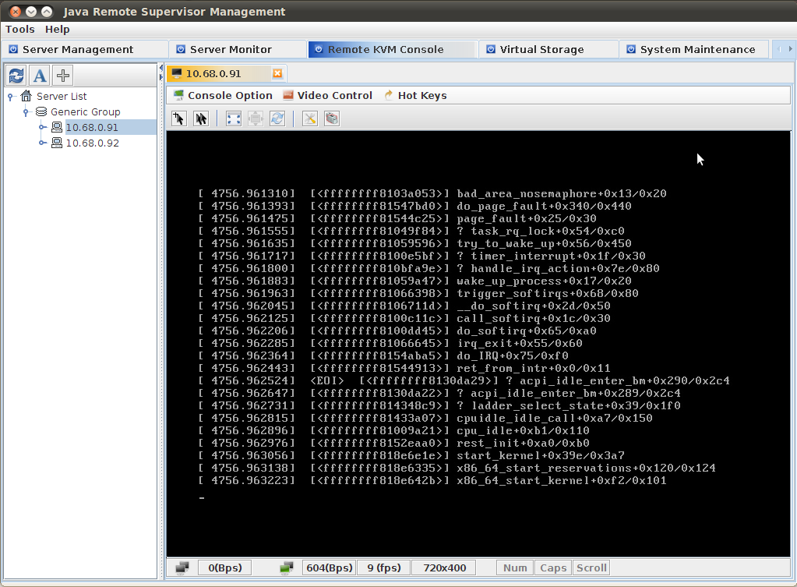
You should have access to the PR2's terminal. If you see any stack trace from a kernel panic (above), make sure you screen capture it for Willow Garage Support.

Troubleshooting

BMC Missing from Menu

If you do not see 10.68.0.91 or 10.68.0.92 in the server menu on the left hand side of the window, you can try adding them manually. Click on the “+” button and enter the server IP address, username and password manually.

After you do this, you may have to reset the BMC to get this to work.

Reset BMC

If the remote KVM doesn't start properly, or you can't log into the BMC's for each computer, you can try to restart the BMC. Under the “System Maintenance” tab (far right), select one or both BMC's and click “Reset BMC”. Ping the BMC (10.68.0.91 or 10.68.0.92) until it reboots.
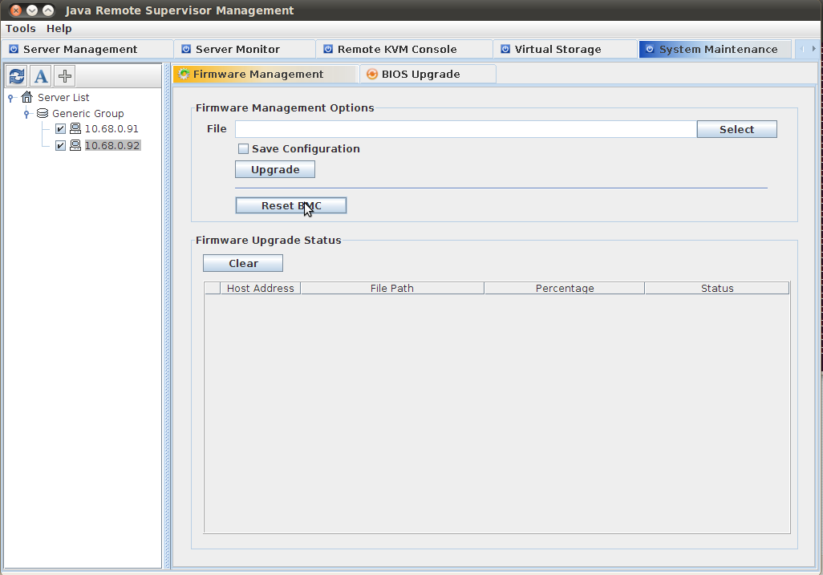

Remove Cached Files

If you have trouble opening the Java Application, you may need to clear any temporary files.

On your computer, run “ControlPanel” from a terminal. Under “Temporary Internet Files”, click “Settings”. In the dialog box, click “Delete Files”.

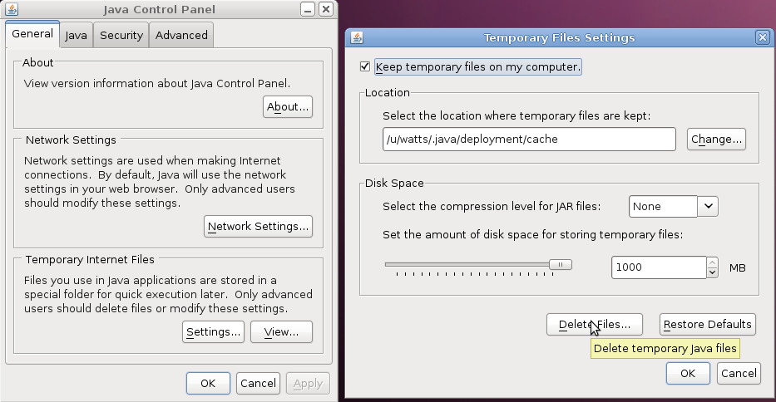

Note: You must enable temporary file storage for the BMC to work.

