

PR2 Forearm Camera
Remove/Replace Instructions

9/1/2010

PR2 Forearm Camera Remove/Replace

Overview

Removing and/or replacing a PR2 Forearm Camera may be a difficult operation. There are many ways to cause injury to the user and/or damage to the PR2. Read entire procedure before starting.

General Safety Instructions
- Always wear an ESD wrist strap when reaching into the robot.
- Do not drop any screws into the robot. Any lost screws may cause the robot to malfunction. If you drop any screws into the robot, do not turn on the robot until you have contacted Willow Garage Support.
- When removing screws, save screws by type. You will need screws that you have removed when replacing the components.
- Use extreme caution when removing any cables. All cables are very difficult to repair or replace if broken.
- Use two people. It will take one person to hold the arm in place.

If you have any questions about using this document, contact Willow Garage Support before proceeding.

Pre-Start Checklist

Before starting to remove and replace a PR2 forearm camera make sure you have completed these steps:
- Review instructions for “Robot Overview, Torque Tools, Loctite” and “Setting Torque Driver”.
- Turn robot off. Disable main power breaker.
- Unplug robot from wall.

Required Tools and Materials:
- PR2 Tool Kit and PR2 Accessory Kit
- Replacement PR2 Forearm Camera

- Remove the velcro covers from the PR2 forearm. Use a 2mm bit on your T-handle wrench to remove the forearm camera cover screw. See Drawing 1.
- Pull the forearm camera cover forward and up to free it from the forearm shell.
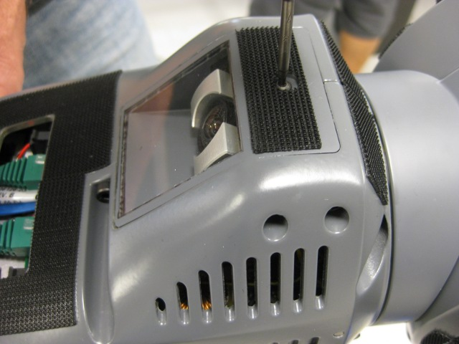Drawing 1: Forearm camera cover.d
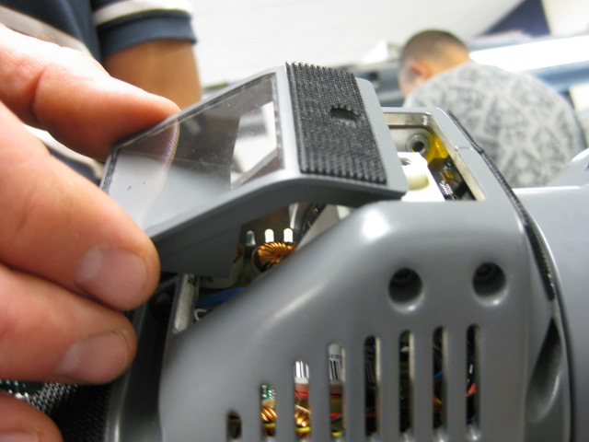Drawing 2: Pull the cover forward and up to remove it.
- Remove the four screws securing the camera to the forearm with a 2.5 mm bit and your T-handle wrench. You may need to use a tweezers to fully remove all screws. Make sure all screws are removed and in a secure container before proceeding. See Drawings 3 and 4.
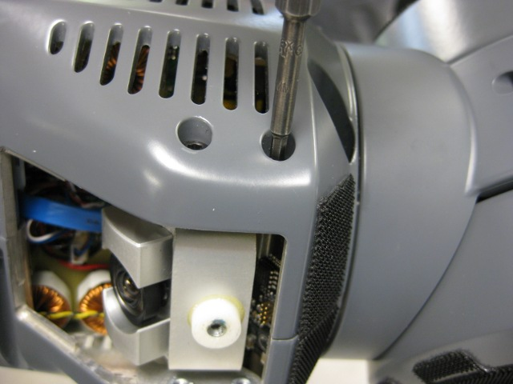Drawing 3: Remove screw using 2.5mm bit.
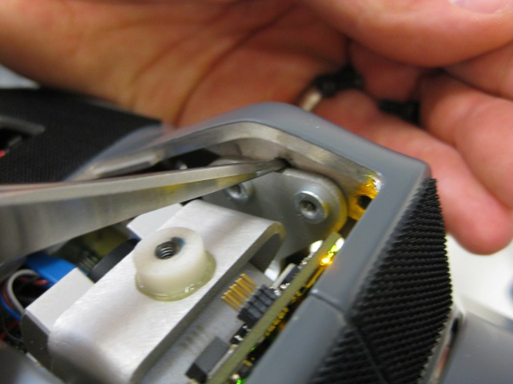Drawing 4: After screws have been loosened, you may need to use a tweezers to push them out.

- Remove the camera from the forearm. You will need to do this carefully. There are cables beneath the camera that can become snagged or caught. If you feel yourself pulling on the camera too hard, stop and contact Willow Garage Support.
  - Make sure the camera is in the position shown in Drawing 5.
  - Tilt the camera up (lens towards the back of the forearm). See Drawing 6.
  - Push the camera down then twist slightly to the robot's right. This will free the camera mount from the forearm camera case. See Drawing 7
  - Extract the camera from the forearm. The camera should be attached by two cables. See Drawing 8.
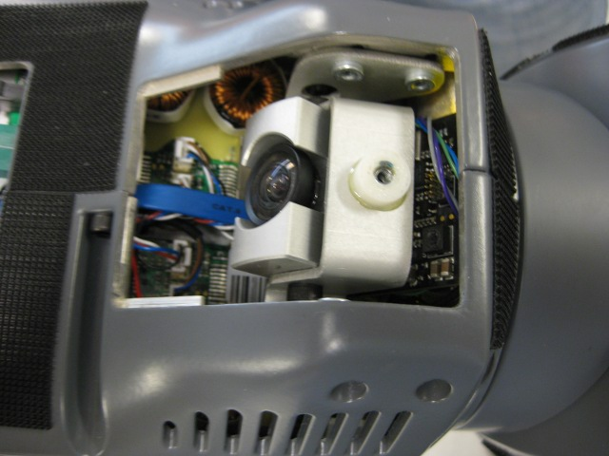Drawing 6: Camera start position
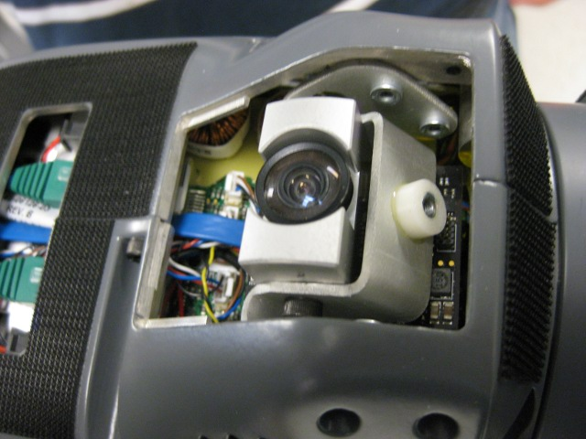Drawing 5: Tilt the camera up.
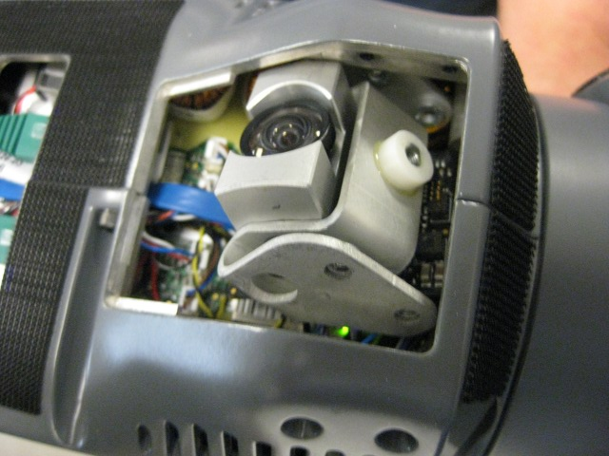Drawing 7: Push the camera down the twist to the right.
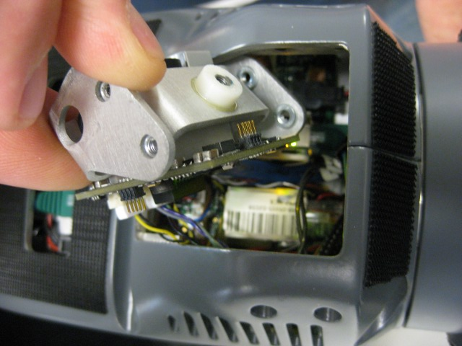Drawing 8: Keep twisting the camera and extract the camera sideways.

- Unplug the cables from the forearm camera. Use tweezers if necessary. See Drawing 9.
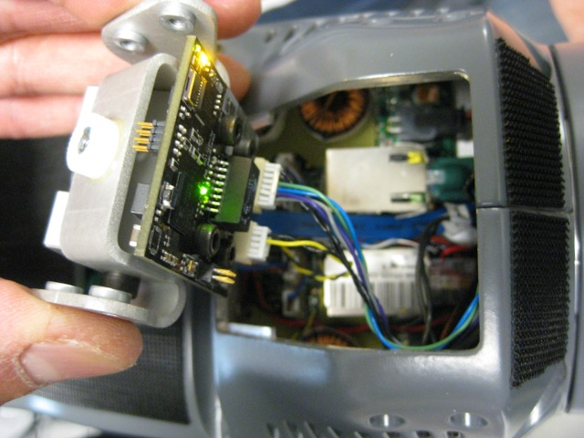Drawing 9: Camera cables.

- Plug cables into replacement forearm camera. Insert camera into the forearm sideways (see Drawing 8).
- Insert camera in reverse order of removal. Once the camera is in position, insert the four mounting screws to camera. Torque the screws using a 2.5 mm bit and set your torque driver to 1.4 Nm. Use Loctite 248 to secure the screws.
- Replace the forearm camera cover. Torque the screw holding the cover down to 0.68 Nm. Use Loctite 248 to secure the screw.

Testing the Camera

After you have installed the camera, test that it is properly working.
- Turn on the robot. After the robot has booted, run “sudo pr2-systemcheck” and verify that the cameras work.
- Start the robot software. Check the diagnostics using the pr2_dashboard and make sure they are OK.
- Check the trigger cable from the MCB to the forearm camera. Run “roslaunch pr2_bringup_tests forearm_cam_trig.launch”. After 30 seconds, the diagnostics for all cameras should be OK.

