

PR2 Left Power Breaker
Debug Instructions

2/21/2011

PR2 Arm Breaker Debug Instructions

Overview

These instructions cover the debugging and root cause of a short in the PR2 power breakers, which power each arm of the PR2. Read entire procedure before starting.

General Safety Instructions
- Always wear an ESD wrist strap when reaching into the robot.
- Do not drop any screws into the robot. Any lost screws may cause the robot to malfunction. If you drop any screws into the robot, do not turn on the robot until you have contacted Willow Garage Support.
- When removing screws, save screws by type. You will need screws that you have removed when replacing the components.
- Use extreme caution when removing any cables. All cables are very difficult to repair or replace if broken.
- Do not attempt to fix any electrical problems that are not specified in this document. Contact Willow Garage Support before attempting to service your PR2.

If you have any questions about using this document, contact Willow Garage Support before proceeding.

Pre-Start Checklist

Before starting to remove and replace a PR2 forearm camera make sure you have completed these steps:
- Review instructions for “Robot Overview, Torque Tools, Loctite” and “Setting Torque Driver”.
- Review instructions to remove bottom front, bottom rear, and top rear covers.
- Unplug robot from wall electrical power.

Required Tools and Materials:
- PR2 Tool Kit and PR2 Accessory Kit

PR2 Power Board Overview

The PR2 Power Board contains a short circuit protection system designed to prevent damage to PR2 electrical components in the event of a hard electrical short. The PR2 Power Board will remain in “disabled” status if an electrical short is detected.

The PR2 Power Board has three breakers for controlling the left arm, base-body-spine (BBS) and right arm. The three breaker operate independently.

Using this document, you will be able to localize an electrical short in your robot to a component of your PR2 arm, or the PR2 power board itself. After you have localized the electrical short, contact Willow Garage Support for instructions.

Detecting/Setting Power Board State

You can use the pr2_power_board Power GUI to detect and change the settings of the PR2 Power Board. Left-click on the “L”, “B” or “R” breakers to change the settings from “Enabled”, “Standby” or “Disabled”. The breaker status is color-coded.

The “Reset Disable” button must be pressed to change the power board state from “Disabled” to “Standby”.

To start the PR2 Power GUI, run “roslaunch pr2_power_board gui_power2.launch” on your robot.

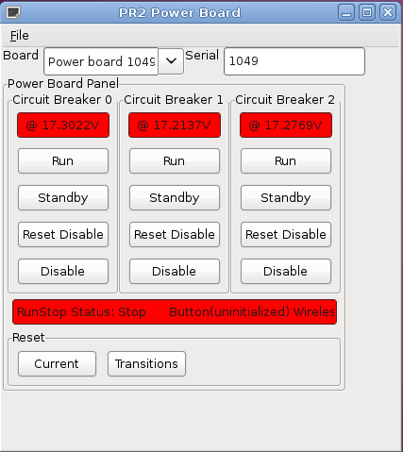Drawing 1: PR2 Power Control GUI
- Using pr2_dashboard, disable all power breakers on your robot. All breakers should be red.
- Turn off all software to the robot. Run “sudo robot stop”.
- Press main runstop to halt motors on robot.
- Remove the “Top Rear” panel. Follow remove/replace instructions on Willow Garage Support website.
- Remove the arm power cable. See Drawing 2. Leave the cable unplugged.
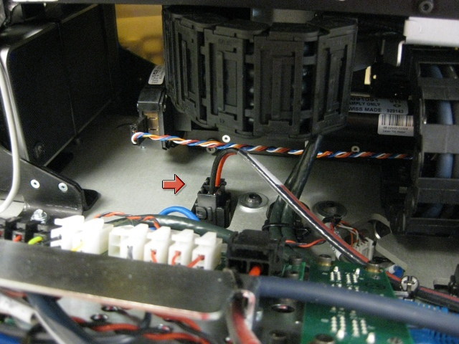Drawing 2: Arm power cable (left arm shown)
- Power board: Start the “PR2 Power Board” GUI by running “roslaunch pr2_power_board gui_power2.launch”. Click “Reset Disable” on all three breakers. Check that all breakers report approximately 14-18V. If one of the breakers still reports “Disabled”, there is a problem with your power board. Report this to Willow Garage Support.
- Click “Disable” for all breakers to turn off power. Replace the cable to the left arm that you unplugged in step 5.
- Remove the foam cover to the upper arm. After the foam cover is removed, remove the power cable the upper arm. See Drawing 3.
- Shoulder: After the power cable is removed, press “Reset Disable” on the arm breaker and see if the breaker will turn to 14-18V. If the power does not enable, there is a problem with the shoulder on your PR2. Report this to Willow Garage Support.
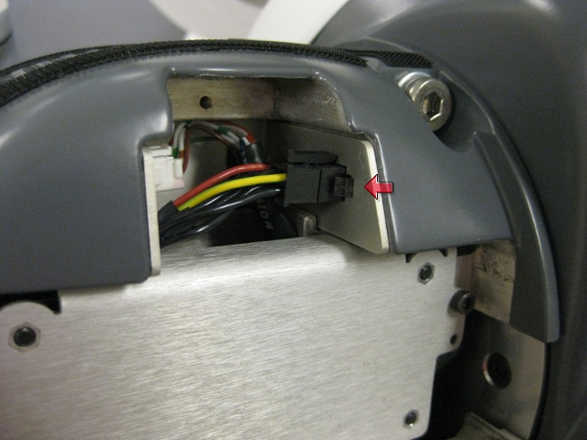Drawing 3: Power cable to PR2 upper arm.
- Plug in the power cable to the PR2 upper arm.
- Gripper: Review “Toolkit Doc3 Gripper”. Remove the “hatch cover” of the gripper. As instructed in the Toolkit document, use the needlenose pliers to remove the white power connector to the gripper. After the white cable is removed, attempt to enable the arm breaker using the Power Control GUI. If the power breaker won't enable, you have a problem with your gripper. Report this problem to Willow Garage Support.
- Forearm/Upperarm: Follow instructions in “Toolkit Doc3 Gripper” and “Toolkit Doc14 Fore Arm” to remove the PR2 gripper and forearms. After both components are removed, attempt to enable the power breaker.
  - If the power breaker will not enable, the electrical short is in the upper arm.
  - If the power breaker will enable, the electrical short is in the forearm.
  - Report this to Willow Garage Support.

