

PR2 Shoulder EtherCAT
Cable Reroute

11/23/2010

PR2 Shoulder EtherCAT Cable Reroute

Overview

This procedure will allow you to reroute cables in the PR2 head to avoid a bad or damaged connector in your head etherCAT hub.

Rerouting the PR2 shoulder etherCAT cable is a difficult operation. This procedure should only be attempted with consultation from Willow Garage support. There are many ways to cause damage to the PR2. Read entire procedure before starting.

General Safety Instructions
- Always wear an ESD wrist strap when reaching into the robot.
- Do not drop any screws into the robot. Any lost screws may cause the robot to malfunction. If you drop any screws into the robot, do not turn on the robot until you have contacted Willow Garage Support.
- When removing screws, save screws by type. You will need screws that you have removed when replacing the components.
- Use extreme caution when removing any cables. All cables are very difficult to repair or replace if broken.
- Use two people. It may take one person to hold the PR2 head at some points.

If you have any questions about using this document, contact Willow Garage Support before proceeding.

Pre-Start Checklist

Before starting to reroute cables, make sure you have completed these steps:
- Review instructions for “Robot Overview, Torque Tools, Loctite” and “Setting Torque Driver”.
- Remove “Top Rear”, and “Top Front” covers.
- Turn robot off. Disable main power breaker.
- Unplug robot from wall.

Required Tools and Materials:
- PR2 Tool Kit and PR2 Accessory Kit
- 30-45cm replacement Cat 5 ethernet cable (not included)

- Make sure you have removed the “Top Rear”, and “Top Front” covers from the robot.
- Follow instructions in Toolkit Doc 17 to remove the PR2 head from the robot. This should expose the laser tilt sled below the head.
- Unplug the ethernet cable labeled “J0” from the exposed laser sled MCB in Drawing 1.
- Plug one end of your replacement CAT 5 cable into the “J0” port of the laser sled. Pull the other end towards the front of the robot and leave it exposed.
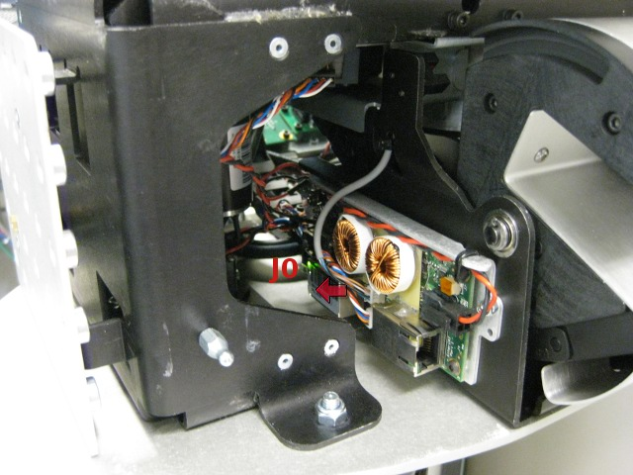Drawing 1: Unplug cable labled "J0" and replace with your replacement CAT5 cable. After the head is removed, the cable should be easily accessible.
- Follow the instructions in Toolkit Doc 17 to replace the PR2 head.
- Plug your replacement CAT 5 cable into the marked port of the head pan MCB. See Drawing 2.
- Now, reroute cables from the head etherCAT hub. Unplug the “Laser Tilt ECAT” cable from J3 of the head etherCAT hub. Remove the “Right Arm ECAT” cable from “J5” and plug in to “J3”. See Drawing 3 for cable labels. You may have to remove a cable-tie to get enough slack to move the cables. After this, port “J5” of your head etherCAT hub should be open.
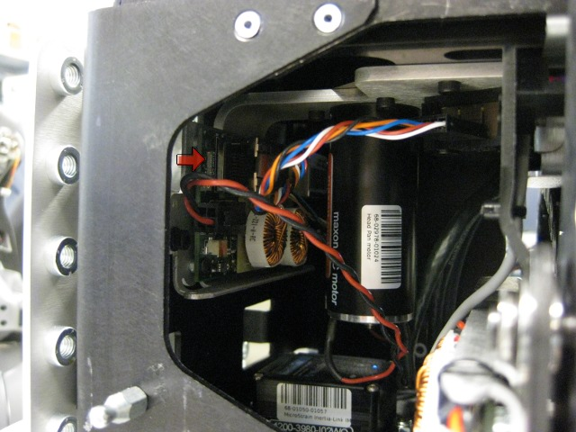Drawing 2: Plug other end of replacement ethernet cable into marked port of head pan MCB.
- Reinstall all covers to the robot.
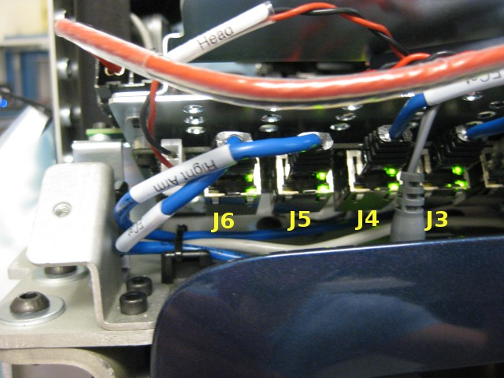Drawing 3: Head EtherCAT hub.
- Testing and integration.
  - Turn on the robot.
  - Run “sudo pr2-systemcheck” at boot. The “checkethercat.sh” script will NOT work. Make sure all other checks work.
  - Check to make sure all MCB's are present manually:
    - “roscd qualification/fwprog”
    - “pr2_grant eccount -iecat0”
    - Make sure 37 devices respond
  - Press runstop to prevent motors from moving
  - Start robot with “roslaunch /etc/ros/robot.launch”
  - Check diagnostics using pr2_dashboard to make sure all “Motors” are present.
  - Enable runstop and let robot calibrate.
  - Check diagnostics to make sure all “Motors” report OK.

