

PR2 Breaker 1 (BBS)
Debug Instructions

12/9/2010

PR2 Breaker 1 (BBS) Debug Instructions

Overview

These instructions cover the debugging and root cause of a short in the PR2 power breaker 1, which powers the base-body-spine (BBS) of the PR2. Read entire procedure before starting.

General Safety Instructions
- Always wear an ESD wrist strap when reaching into the robot.
- Do not drop any screws into the robot. Any lost screws may cause the robot to malfunction. If you drop any screws into the robot, do not turn on the robot until you have contacted Willow Garage Support.
- When removing screws, save screws by type. You will need screws that you have removed when replacing the components.
- Use extreme caution when removing any cables. All cables are very difficult to repair or replace if broken.
- Do not attempt to fix any electrical problems that are not specified in this document. Contact Willow Garage Support before attempting to service your PR2.

If you have any questions about using this document, contact Willow Garage Support before proceeding.

Pre-Start Checklist

Before starting to remove and replace a PR2 forearm camera make sure you have completed these steps:
- Review instructions for “Robot Overview, Torque Tools, Loctite” and “Setting Torque Driver”.
- Review instructions to remove bottom front, bottom rear, and top rear covers.
- Unplug robot from wall electrical power.

Required Tools and Materials:
- PR2 Tool Kit and PR2 Accessory Kit

PR2 Power Board Overview

The PR2 Power Board contains a short circuit protection system designed to prevent damage to PR2 electrical components in the event of a hard electrical short. The PR2 Power Board will remain in “disabled” status if an electrical short is detected.

The PR2 Power Board has three breakers for controlling the left arm, base-body-spine (BBS) and right arm. The three breaker operate independently.

Detecting/Setting Power Board State

You can use the pr2_power_board Power GUI to detect and change the settings of the PR2 Power Board. Left-click on the “L”, “B” or “R” breakers to change the settings from “Enabled”, “Standby” or “Disabled”. The breaker status is color-coded.

The “Reset Disable” button must be pressed to change the power board state from “Disabled” to “Standby”.

To start the PR2 Power GUI, run “roslaunch pr2_power_board gui_power2.launch” on your robot.

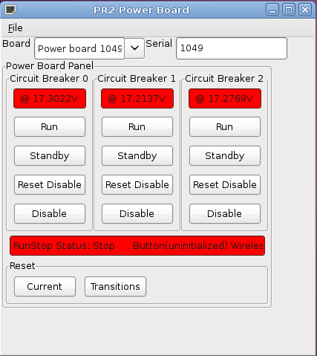

Overview of Debug Procedure

Our goal is to localize a possible electrical short. Disable your PR2 motors by hitting the physical runstop on the back of the robot. This will allow you to monitor PR2 systems without moving the robot.

We will unplug cables leading to the PR2 casters and the PR2 head electrical system to limit the scope of our search. Once we have localized the electrical problem, Willow Garage Support will take action to resolve it.

- Disable the PR2 motors by pressing the physical runstop on the back of the robot. Do not enable the runstop until you have finished the procedure.
- Shut down the robot completely. Shut down computers with “sudo pr2-shutdown”. After the computers have shut down, disable the main power breaker in the base of the robot.
- To get access to your robot, the PR2 spine must be at least 15cm (6”) above the base of the robot. If necessary, follow instructions on the PR2 Support website to manually raise the spine.
- Remove the “Bottom Front” and “Bottom Rear” covers of your PR2 according to the instructions in your PR2 Toolkit. Instructions also available online at PR2 Support.
- After removing the “Bottom Front”, “Bottom Rear” covers, unplug the power cables leading to each of the PR2 casters. Do not touch the ethernet (RJ-45) cables leading to the casters. See Drawing 1.
- Remove the “Top Rear” cover following instructions in your PR2 Toolkit.
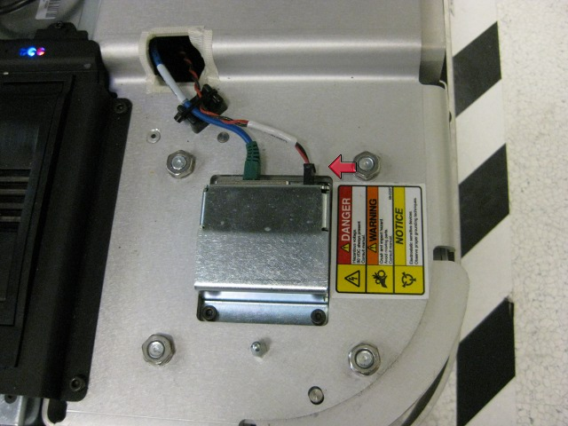Drawing 1: Caster power cables.
- After removing the “Top Rear” cover, unplug the power cable leading to the PR2 head power breakout board. See Drawing 2.
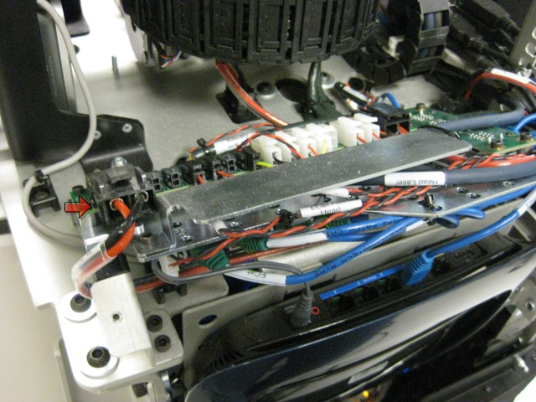Drawing 2: Head power breakout board.
- Check that the runstop is disabled. Power on the PR2 robot computers using the main power breaker.
- After the computers boot, start the PR2 power GUI on the robot.
- Check if the center breaker (“Breaker 1”) is disabled. If it is, attempt to reset it by clicking “Reset Disable” on the GUI. If the breaker will not enable, contact Willow Garage Support. The remainder of this document will not help you.
- If the power breaker state changes to “Standby”, the electrical short is in either the head electrical system, or the casters. Shut down the robot completely again to diagnose further.
- After the robot is shut down, plug in the head power cable (as shown in Drawing 2).
- Check that the runstop is disabled. Power on the PR2 computers.
- Restart the power control GUI. Check if the center breaker, “Breaker 1”, is disabled. Attempt to change the center breaker to “Standby” by pressing the “Reset Disable” button. If the center breaker will not reset, the electrical problem in the in the PR2 head. Contact Willow Garage Support.
- If the power board will reset with the head electrical system running, check the casters. For each caster, perform the following steps:
  - Shut down the robot completely. Disable main power breaker.
  - Plug in a caster power cable that you have previously disconnected.
  - Check that the runstop is disabled. Turn on the robot using the main power breaker.
  - Start up the power board GUI and attempt to reset the power board.
  - Inform Willow Garage Support of the results.

