David Skirton 8707
ocr COMPUTER SCIENCE H446
Project REPORT

Contents
0
Analysis 4
Problem Outline 4
Stakeholders 4
How can the problem be solved by computational methods 5
Thinking abstractly 5
Thinking Ahead 5
Thinking Procedurally 6
Thinking Logically 7
Thinking Concurrently 7
Conclusion 8
Research 8
Interview with Fergus Young 8
Interview Script: 22/02/23 9
Review of the interview with Fergus Young: 22/02/23 12
Research into ‘Dan The Man’ 13
How Do The Features Effect The Game Play of ‘Dan The Man’ 19
Features That Will Be Used For My Game 21
Interview: 01/03/23 21
Interview Script: 01/03/23 22
A Review Of The Interview: 01/03/23 25
Features of the Proposed Solution 27
If Original Features are Completed 28
Hardware and Software Requirements 29
Hardware Requirements 29
Software Requirements 29
Success Criteria 30
Design 34
System Diagram 34
Explanation of each module 35
Usability Features 41
Information Screens (Before Game Is Played) 41
Game Playing 44
Classes 66
List of classes 66
Classes Diagram 70
Algorithms 71
Key Variables and Data Structures 93
Test Data 97
Playing 97
Other game states 105
Acceptance Testing 109
Developing the Coded Solution (“Development Story”) 115
Sprite Creation 115
Date: 05/03/23 115
Date: 07/03/23 118
Date: 10/03/23 120
Date: 11/03/23 122
Code Deconstruction 125
Date: 17/03/23 125
Date: 02/04/23 127
Date: 10/04/23 131
Date: 13/04/23 135
Date: 20/04/23 138
Date: 05/05/23 142
Date: 14/05/23 145
Date: 026/05/23 148
Date: 01/06/23 152
Date: 03/06/23 154
Date: 05/06/23 156
Date: 013/06/23 160
Date: 16/06/23 163
Date: 01/07/23 164
Date: 03/08/23 169
Date: 04/08/23 171
Date: 06/08/23 174
Date: 11/08/23 176
Date: 16/08/23 177
Evaluation 180
Testing for evaluation 180
start up 180
menu screen 180
scoreboard 181
levels 182
playing the game 183
Usability features 194
How well does my solution match the success criteria 201
Start up 201
Menu screen 201
Scoreboard 202
lives 203
playing 203
levels 205
Maintenance 205
Current and future maintenance 205
Limitations and how they would be approached 205
Project Appendix 207
File System 207
Code Listings 209

Analysis

Problem Outline
For my game I am planning to create a game that is similar to the 2015 mobile platformer 2D beat-'em up video game, ‘Dan The Man’. I am going to name my game ‘Dav The Mav’, a shortened version of my name David and a shortened version of the word Maverick (as the character in my game will be portrayed as an unorthodox or independent-minded person which is the definition of maverick). The game uses elements of traditional beat-'em up-style video games with platformers, and I plan to follow a similar style with my game. The aim of the game is to pass various levels by collecting a certain amount of coins, all whilst avoiding moving enemies.
I plan to have multiple different game modes, including a campaign mode and a free mode. The campaign mode will have multiple levels, each level increasing in difficulty and found in a different location around the world. The difficulty of the level will be based off the number of enemies that you have to avoid, the number of coins you have to collect, and the time you have to collect them.
For the game to be playable, I will need a running score counter to keep track of how many coins are collected, a counter to show how much time you have left, and a counter to show the amount of lives you have left. I plan to give my character 3 lives, as follows the typical game tradition, as this will create a more competitive and exciting feel to the game since there are consequences if you lose concentration or make a mistake.

Stakeholders
A Stakeholder is anyone with an interest in the actions of a business or organisation, however in this case the stakeholders will be anyone interested in playing my game, or how it is made.
Therefore, the graphics of my game will be like many other modern games, a retro style meaning it will not be associated with real-life. There won’t be any speaking or voices in my game meaning it is more accessible for people from different countries, different ages and people with hearing impediments. The game is designed for PC use, using only the keyboard to move about and control the player. However, my game can very easily be adapted to be played on mobile devices or tablets, using touchscreen and joysticks to control the player. This means it would reach an even larger range of the target audience.
Because my game uses controls from a keyboard which needs you to understand how to use a keyboard, my games target audience is from the range of 5-18. Although it can still be played by people older than 18, the graphics and controls are simple enough that people above this age may find the game too boring to play.
I have selected a peer to personify my target audience, a classmate called Fergus Young. He is 16 years old who enjoys playing video games and is familiar with the original mobile game ‘Dan The Man’, so he will be able to provide me with feedback on whether my game follows a similar style to what he would expect. I will also have regular contact with Fergus during my lessons meaning he can provide me with lots of feedback on whether my game is suitable for my target audience and whether I should include any improvements or changes.

How can the problem be solved by computational methods
My problem is well suited for a computer program as it can be solved using computational methods. My game can be extracted from reality and it is able to make use of many simple algorithms which can all work together in order to make the game smooth and playable. The game can also be broken into many different conditions meaning it is suitable to be programmed. In the next sections I have given some example of how the computer is suited to solving the problem using computational methods.

Thinking abstractly
Abstract thinking is a computational method that involves taking out unnecessary details, and focusing on the most important parts. Many games use this and this is also perfect for my game because I need to decide what is necessary and what isn’t for my game to work well.
Abstraction for my game:
- Removing the 3 dimensions, restricting to 2 dimensions
- Making the game a retro style
- Removing all sounds and speaking, only having a few simplified sound effects to indicate certain things to the user and background music
- Add a simple heart counter to inform the player of their lives throughout the game
- Add a user friendly menu at the start and end of each game allowing the user to choose the game mode
- Removing all keyboard controls, only leaving the ones necessary to move the player and select things from the menu

Thinking Ahead
Thinking ahead is the process of identifying inputs and outputs to a solution before you have tackled the problem, this allows you to think of the potential problems that you will encounter and gives you time to solve them.
I plan to use python to program my game because it contains an installable library called pygame which is a good way to write simple games.
The inputs for my game will simply be keys from the keyboard, e.g. space bar for jump, arrow keys to control the movement, and other keys such as ESC or P to pause or exit the game.
The outputs of my game will consist of sound effects, and various different animations of the character, the map, and the enemies.
I plan to include a score system in my game which will show how far the user has progressed and will create something to aim for, hopefully making the game more enticing.
I will include a heart counter in the game to show the user how many lives they have left, each time they encounter an enemy, or fall off the map, they will lose a life (heart). This will create more competition and challenge for the player

Thinking Procedurally
This is similar to thinking ahead as it gives the problem more of a structure making it easier to work with as now you can work at the problem bit by bit which makes the whole process more efficient

I have broken my game into four main problems that need to be solved in order for the game to function properly, these are:
- Player, as the player is how the game is played through for the game to work the player will need movements via the controls and also the player must have lives, so that the user knows when the game ends when the player in game dies.

- Control, these need to be programmed correctly as they essentially control the player and they can either make the game, or completely break the game. There will also be instructions so the user knows how to use these controls, and there will also be a pause and/or a quit button so if the user wants to finish the game early or just needs a break there is a way for them to control this.

- Gamestate, this is important as it takes the game to different stages, the menu state will display the main menu where the player can select “play”, “instructions” or “exit”. The playing state is when the game is under way and being played, when the state is paused, the paused screen will be loaded until the playing state is resumed. Finally, the game over state is when the “YOU WON” banner is loaded up, or when the player runs out of lives in which case the “YOU RAN OUT OF LIVES” banner is loaded up, in each case there will be options to play again, return to menu, or quit.

- Points, this is important as it creates purpose for the game, and creates some challenge in which the user will have to try and get as many points as they can. For example if the player collects enough coins without running out of lives then they win the game. There will be a point meter which shows the user their current coins as the game continues. The user will either win the game, or lose the game depending on whether the coins criteria is made. And there is a time, which will alert the user how much time they have left.

Thinking Logically
Thinking logically helps me think about different ways I could solve the logical aspects of my problem.
When menu button (e.g. ‘m’) is selected the game will switch to the menu game state with the menu screen shown to the user. If an enemy hits the player, a logic branch will be activated indicating to the user they have lost a life, and the heart count of the player will decrease. As the game is running there will be a constant iteration running, checking certain conditions which will cause a branch changing the game state to the ‘game over’ game state. There will also be a constant iteration being run to check whether a time limit is met, or the player has zero lives left meaning the player is dead.

Thinking Concurrently
This is useful for thinking about how to make my solution to my problem more efficient when the solution is in use. For example my game will be updating the score, position of the player, position of enemies, time, number of coins and more whilst drawing the image to screen at the same time.

Conclusion
The previous examples have demonstrated that the features of my problem can be solved via computational methods making it suited for a computer program. These methods are useful for giving the problem some structure so it can be solved more easily solved hence making the problem suited to a computer program.
If the problem is successfully solved using a computer program the stakeholders will be able to play a game where they have to move around a scrolling map whilst dodging dangerous enemies, whilst trying to collect coins (which give you points) and not dying all within a time limit. This is aimed to be a form of entertainment for the stakeholders and will hopefully engage the attention for a prolonged period.

Research

Interview with Fergus Young

interview: 22/02/23 plan
Fergus Young is a classmate who is 16, so fits well into my games age range.
I am constructing this interview to find the basic requirements from the user for my game. This will give me an idea of how to create and what to include in my game.
The four main headings for this interview are: Why are you a suitable representation of other people your age and why do you think I should construct my game based off of your ideas?, What makes a game good?, Would you prefer to play against a friend or against the computer? And What sort of visual affects would you like in the game?
The first question is so I know what familiarity Fergus has with games, which will show me his ideas and thoughts will be suitable to construct my game off.
I have constructed an extensive range of smaller questions under each heading, the purpose of these is to make sure every aspect about my game is covered which will make the game aimed at the requirements as much as possible.
The layout for my questions:
Why are you a suitable representation of other people your age and why do you think I should construct my game based off your ideas?
- What video games do you normally play?
- Which video games do you like the most?
- How often do you play video games?
- How long do you normally play video games for in one time?
What makes a game good?
- Do sound effects affect your gaming experience?
- Do you think visuals affect your gaming experience?
- Should a score system, time limit or life system be included in the game?
- Does player movements and controls affect your gaming experience?
- How realistic should the game be, taking the target audience into consideration?
- For the ‘Dav The Mav’ game how many enemies should there be per level?
- For the ‘Dav The Mav’ game, how would you like to interact with the game and control the character?
- Do you think there should be different levels with different difficulty levels and if so how?
Would you prefer to play against a friend or against the computer?
- Was there a two player mode in the original ‘Dan The Man’ game?
- If ‘Dav The Mav’ was a two player game, what aspects of it would you like to be two player?
- If ‘Dav The Mav’ was a game played against the computer, what aspects of it would you like to be against the computer?
- Overall, would you prefer if ‘Dav The Mav’ was two player or against the computer?
What sort of visuals would you want for the game?
- If any realistic features are to be included, what would these be?
- What game style should the game be, in terms of the look of the game?
- What should the menu screen, game screen and death screen look like?
- Should the background be able to change?
- Should the characters sprite be able to change?
- Should there be sound affects for when the character moves?
- Should there be smaller particle affects such as when the character is moving or when it lands or collects a coin?
- Would the enemies be animated or just stationary?
- Should there be background music during the game or when you’re on the menu screen?
- Should there be sounds for when you take damage or when your character dies?

Interview Script: 22/02/23

Why are you a suitable representation of other people your age and why do you think I should construct my game based off of your ideas?
What video games do you normally play?
Retro style games, for example ‘Super Mario Bros’, and online games such as ‘Fortnite’ and ‘Minecraft’
Which video games do you like the most?
Any game which is challenging but entertaining, games which take me multiple times to try and get past one level, such as ‘Super Mario Bros’, but also love the aspect of free play like Minecraft
How often do you play video games?
Almost every day, definitely a few times per week at the very least
How long do you normally play video games for in one time?
Normally a few hours at a time

WHAT Makes a game good?
Do sound effects affect your gaming experience?
Yes, I think they do because if it is synchronised correctly then it can be used well to emphasize certain aspects such as when you take damage.
Do you think visuals affect your gaming experience?
Yes, although it doesn’t affect the gameplay, the visuals are very important. They must also be relevant to the age range because you can’t include gore for a game that will be played by people below the age of 16 and having a game with boring visuals or visuals more suited for younger kids similarly won’t be enjoyable to be played by an adult.
Should a score system, time limit or life system be included in the game?
Yes there should be a score system, it gives the player an objective in the game which gives the user something to aim for, this makes the game more enjoyable to play. Yes there should also be a time limit, this creates more pressure for the user which makes them more likely to keep playing if they keep dying, similarly with a life system
Does player movements and controls affect your gaming experience?
Yes and no, as long as the movement is simple and easy to understand, and the rules of the game is explained well then the actual controls don’t affect anything. If the controls are hard to master, then this game won’t be as suited for the age range given.
How realistic should the game be, taking the target audience into consideration?
Due to the genre of the game, the game does not need to be realistic, since the character and the enemies wouldn’t be real people. This doesn’t affect the gameplay either way.
For the ‘Dav The Mav’ game how many enemies should there be per level?
Per level it is hard to say without seeing the enemies and also how big the level map is, however I would say in between 2 and 20.
For the ‘Dav The Mav’ game, how would you like to interact with the game and control the character?
Using the arrow keys or the WASD keys which some people prefer, and then maybe the space bar to jump or the W or up arrow key. To pause or quit keys such as ESC or P or Q can be used.
Do you think there should be different levels with different difficulty levels or enemies?
I think so yes, different levels with different map layouts and a different number of enemies, coins or different time limit would make the game much more enjoyable to play.

would you prefer to play against a friend or against the computer?
Was there a two player mode in the original ‘Dan The Man’ game?
No, the game was only played against computer enemies.
If ‘Dav The Mav’ was a two player game, what aspects of it would you like to be two player?
Maybe have two different characters which the two players can fight against each other.
If ‘Dav The Mav’ was a game played against the computer, what aspects of it would you like to be against the
computer?
All of the enemies would be controlled by the computer.
Overall, would you prefer if ‘Dav The Mav’ was two player or against the computer?
I would prefer if ‘Dav The Mav’ was played exclusively against the computer. This is because you would always need someone else to play against if it was two player, and I enjoy playing games by myself

what sort of visual affects or sound effects would you like in the game?
If any realistic features are to be included, what would these be?
Gravity would have to be somewhat realistic, and not being able to teleport or walk through walls. The rest of the game can be as unrealistic as you want.
What game style should the game be, in terms of the look of the game?
It should have a retro style game look, very similar to the original ‘Dan the Man’ game, it should also have a similar style to the look of the 2d Mario scroller game.
What should the menu screen, game screen and death screen look like?
They should be simple but informative, show the instructions or score of the game without it being too complicated. The game screen should have a score, life counter and time left displayed somewhere on the top or the bottom, and the rest of the screen should just be the game playing.
Should the background be able to change?
I think the game background when in the playing state should stay the same during the level, however some different levels could have different backgrounds, but there should be a different background for the death screen, the pause screen and the menu screen .
Should the characters sprite be able to change?
I think this would be a very cool option, however I don’t think it is needed as it wouldn’t affect the gameplay, this should be included if the game was made two player, however one player is not necessary.
Should there be sound affects for when the character moves?
Yes, like footsteps or scuffling. And then perhaps a sound affect for when the character jumps as well
Should there be smaller particle affects such as when the character is moving or when it lands or picks up a coin?
Yes, this would make the game look much more professional and fancy, it is definitely not necessary but it would make the game better to look at.
Would the enemies be animated or just stationary?
The enemies should be animated and be able to move.
Should there be background music during the game or when you’re on the menu screen?
I think there should not be background music whilst the game is being played, as this is distracting and takes away from the playing experience, however some background music when paused, in the menu screen or on the death screen would make the game more enjoyable even when you are not playing it.
Should there be sounds for when your character dies?
Yes, definitely. This would make the game much more enjoyable, and I believe this would make the game play much more immersive and addictive.

Review of the interview with Fergus Young: 22/02/23
This interview was created to see exactly what things the stakeholders want in my game to make it as enjoyable as possible. From this interview, the stakeholder (Fergus Young) and I concluded that visuals and sound affects aren’t vital in the game and it can still be played without them, however it makes the game more unique and therefore more enjoyable. The stake holder and I created a list of exactly what the game will be like and what it will include.

Visuals
- The character and enemies will be pixel art sprites
- The background wont change during game play
- Background will only change for the menu, pause or death screens and some different levels
- The enemies, coins and character will be animated
- Small visual affects such as dust and particles will be included
Sound Effects
- Will be sound effects for losing a life
- Will be sound effects when jumping or moving
- Will be background music on the menu screen, death screen and pause screen only
- Will be sound effects for picking up coins
Controls
- The controls will be the arrow keys to move, space bar to jump, P to pause, M to go to the menu and Q to quit the game.
- The mouse will not be used
Game Play
- The game will be unrealistic so all gore will be taken out, however physics and gravity will be somewhat realistic
- Scoring system will be included to give the player a sense of achievement
- There will be different levels with different amounts of enemies
- There will be a life system and the character will ‘die’ when they run out of lives
- The game will strictly be single player

Research into ‘Dan The Man’
‘Dan The Man’ is a mobile platform beat-'em up video game. The game is a side-scrolling (so 2D) action platformer. The user plays the character ‘Dan’, who can walk, jump, attack and shoot weapons. The player must fight off enemies by attacking them, or shooting them with a weapon. The enemies drop coins when killed, however they also can deal damage to the player which can eventually kill the character and end the game if enough damage has been taken.

The game has three game modes in the main game: which are Survival Mode, Adventure Mode, and finally Story Mode. Story Mode has three Prologue stages which serve as tutorials, twelve Normal Mode stages and Hard Mode stages. Other stories include Frosty Plains, and Fright Zone, which you have to play through as the character as he completes a mission.
Survival Mode, is where they can go into an endless battle mode, surviving for however long they can. They can use tokens from Special Fighters, and use them in the Token Machine to get more tokens which can be used to purchase more characters and upgrades. They can earn coins, power-ups, and Costume Tickets.
In Adventure Mode, the player goes through different stages revolving around different themes. They can get rewards such as costumes, coins, power-ups, and even Frosty Plains for free if collecting all 34 gold trophies.
In Hard Mode, where the enemies are more powerful and the player does not start with a revival potion. The enemies have new colour palettes, and are more stronger, along with the bosses. This mode can be unlocked after beating Story Mode one time. Stats will be reset during Hard Mode however, and the player can get all stars once more to unlock a special icon.
Multiplayer Mode is where the player can play with other players around the globe. They compete with each other to see who can get the highest score. When connecting to quick matches, the game will send them to a random match with a random player. When playing private matches, they can start one or join one by using a four digit code. Multiplayer also has events every now and then.

The player can select from many different characters, Dan, Josie, Barry Steakfries, and a Custom Character. The player can collect coins to buy outfits, and upgrade characters and weapons. They also have a Revival Potion, which can save them one time if they lose their health. When the player reaches a checkpoint, it saves their progress. They can also destroy a statue with a TV, which makes them watch an ad to get a random item to use in the level, coins, food, or weapons. If they purchase premium, no ads appear in Story Mode, but ads still appear in other parts of the game.

Achievements are also available to earn in Dan The Man, being added in a recent version, which is v.1.10.05 of 2021. Achievements can be earned by doing certain tasks with characters, or in specific levels. There is a very extensive list of achievements, this makes it difficult to fully complete the game, which keeps the players interested and wanting to play.

Main Features of the game include:

Menu Screen (when you first open the game)
These buttons will lead you to characters where you can change characters or customize upgrades and power ups. Or to the shop, where you can buy in game currency, different characters and different power ups or weapons

The settings button here will take you to the setting page where you can customize the volume level, language, look at the game credits, visit the website e.t.c
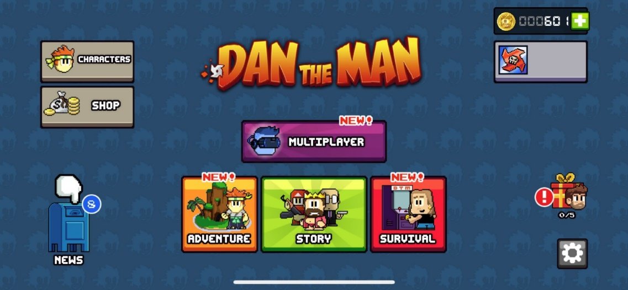

You can choose your game modes here

Character Selection and Upgrades
Back button to return back to main menu
These show which characters you have unlocked, which character is currently selected, and what level each of your unlocked characters are.

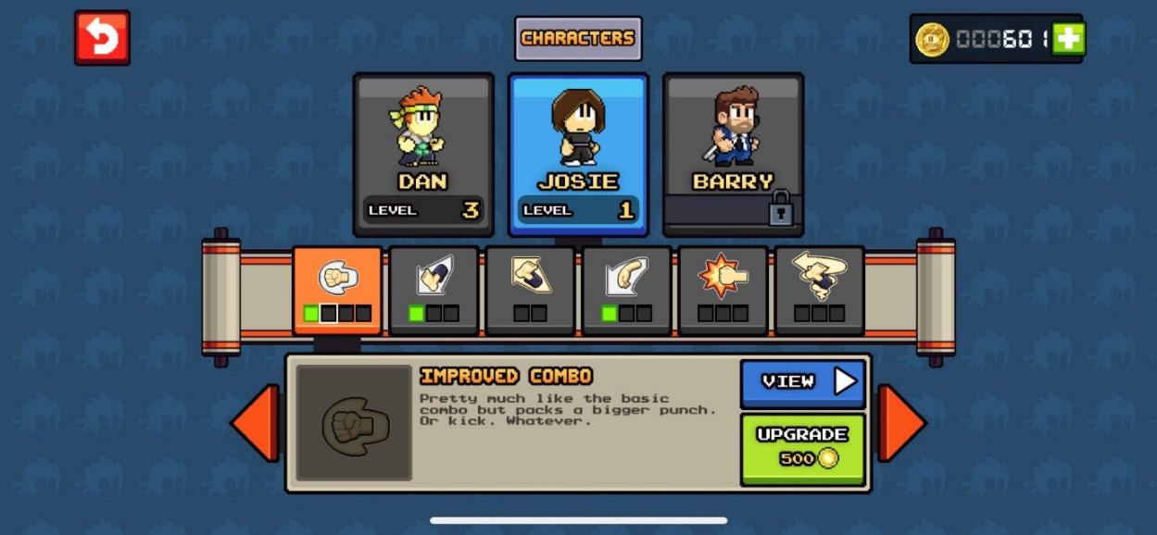
Display of the in-game currency is constantly at the top left of the screen
Each of the characters moves/attacks are displayed here, and which level they are at
Description of what the action does and how to do it, and an option to view the action performed, and to upgrade the move.

Choosing Power ups and weapons
Current ammo of your weapon displayed here
This screen will appear in game, when you visit the shop during a level
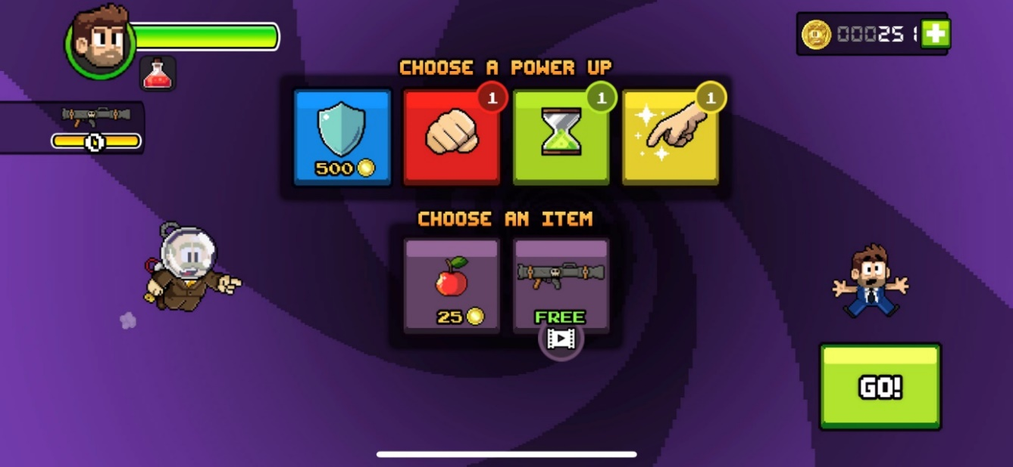
Options to buy power ups, or apples for extra health
Health of the character during the game displayed top left whilst in the shop
Button to return to the playing screen

Choosing between Story modes or endless mode
Once story mode has been chosen, within the game there are three different stories you can play out, only being able to access the next one once the previous has been completed
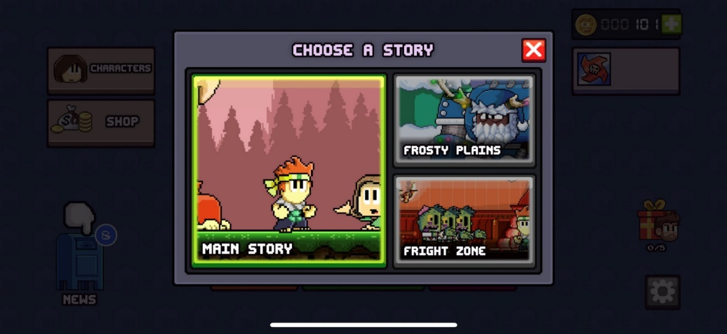

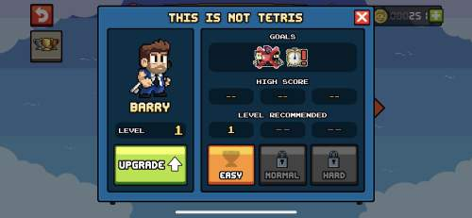
Character is shown clearly with its level, can upgrade character before playing saving the user having to go all the way back to main screen
If endless mode is chosen, the player can then choose a difficulty (depending if they have It unlocked), upgrade their player, and view previous high scores and goals they have achieved before

Level Map and choosing Level
This is the level map of the main story mode
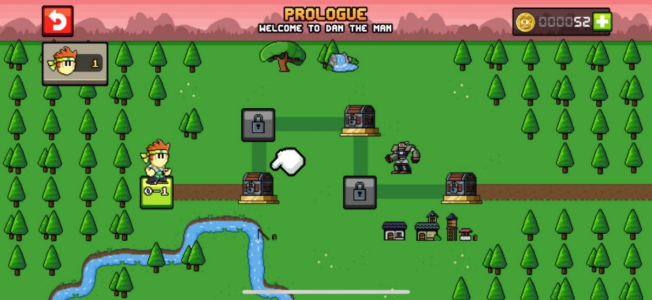
Chests on levels which give user a sense of achievement
The players number of lives are displayed here
The level the player is currently on is represented by the character standing on it
Shows the path of which levels need to be completed
Currency top left

Once a level has been chosen, this screen shows up
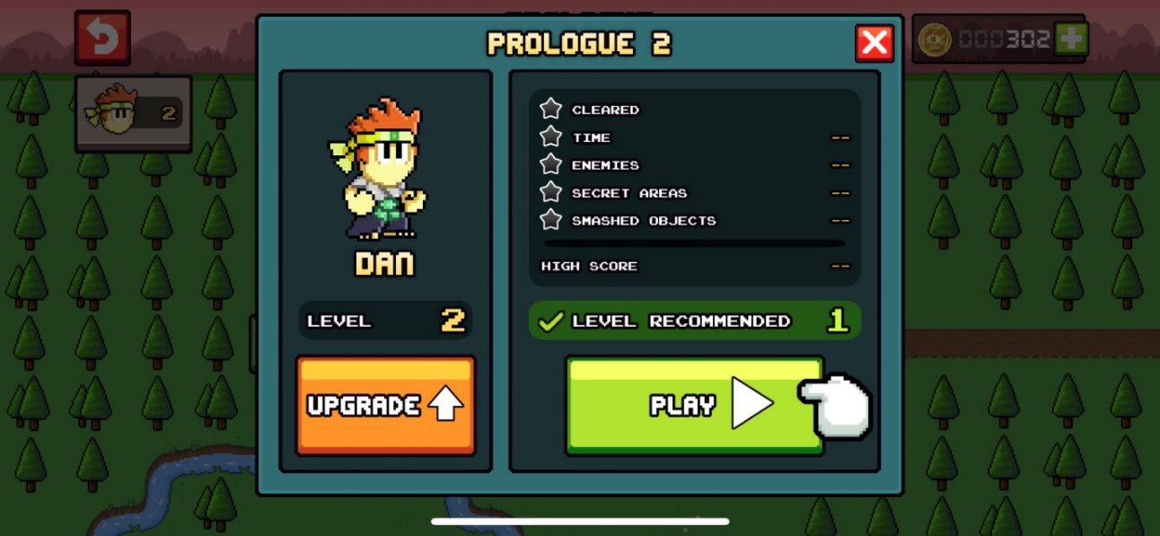
Cross button to exit level details
Details of previous level attempts displayed here, along with recommended level needed to complete this level
Character and character level displayed here, with option to upgrade character if wanted
Play button which will start the game when pressed

Main Playing Screen
Pause button to open pause menu when pressed
Character health bar displayed
Health of enemy (for boss levels)
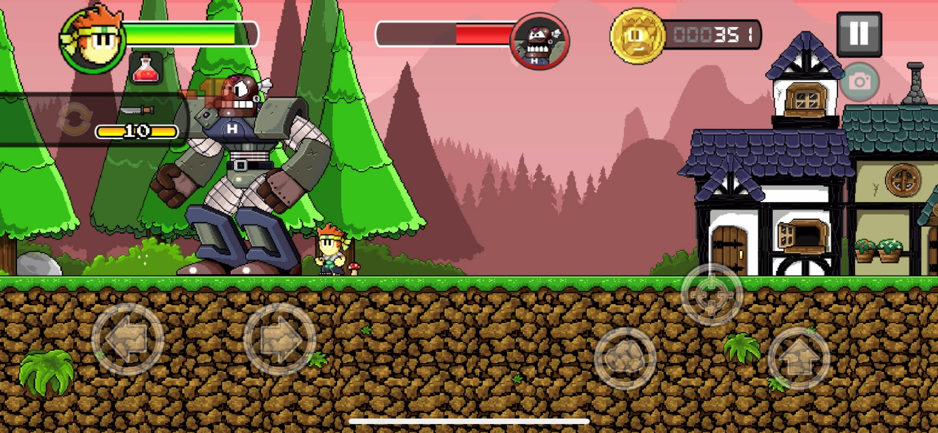
Button to use weapon and shoot it
Ammo of current weapon
Button used to jump
Moving left or right buttons, for my game these wont be shown on screen, instead left and right arrow keys will be used to move
Button used to use characters attack actions, such as punching or sliding

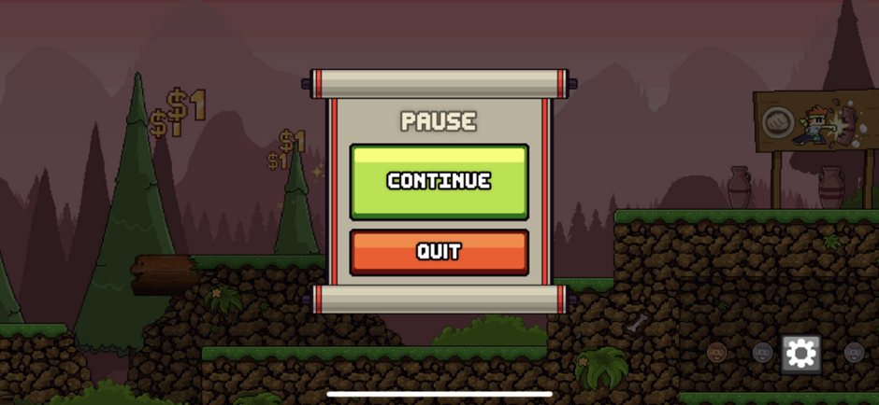
QUIT button will lead player back to the level map where they can then exit to main menu from there
If pause button is pressed, this will appear giving users the option to QUIT the game and return back to the level map, or CONTINUE with the game

Button leading to settings

Settings
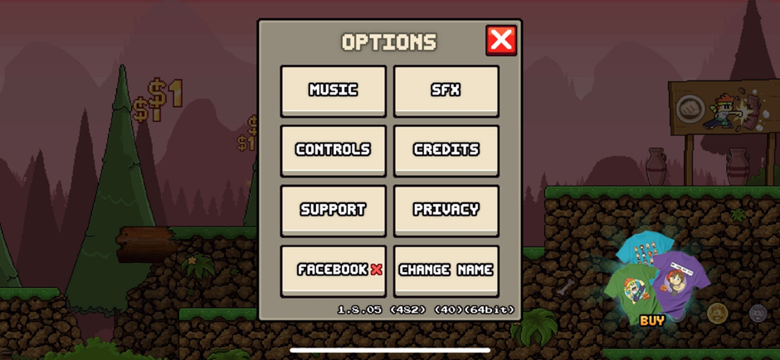
Adjust background music volume, or sound affects volume
View credits of who developed the game
Edit characters name
Visit the website for support or information on the game
View instructions on controls

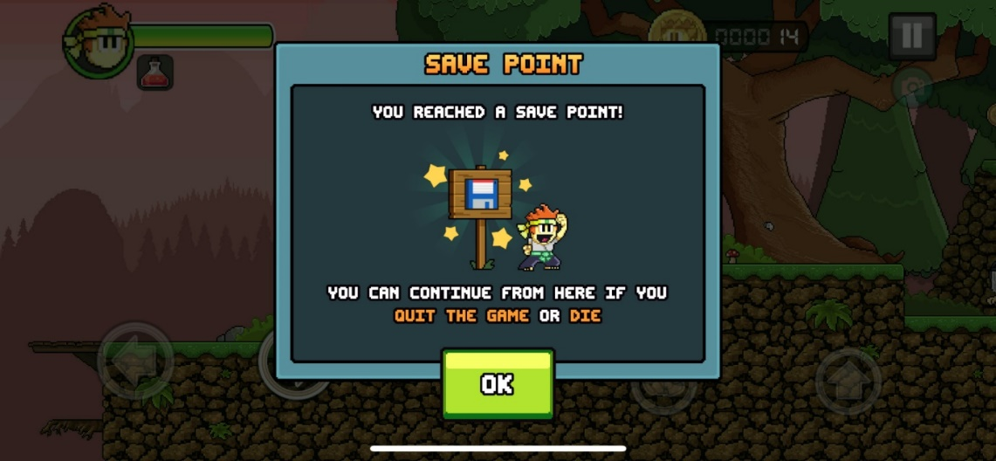
Clicking OK goes back to the game and means next time the character dies, or if the player quits they will respawn back here,
This pops up every time the player successfully makes it past a save check point

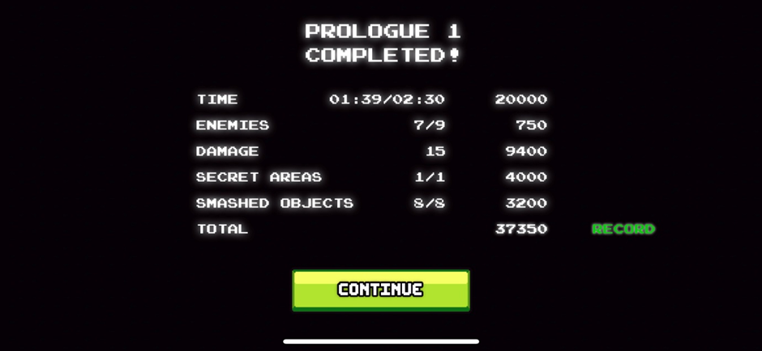
End of Game Screen
At the end of completing a successful level, the details of the game will appear
CONTINUE button will return back to the level map, ready for the player to start the next level
Gives details on how long it took, how many enemies were eliminated, damage given out, secret areas found, objects smashed, and then that all added up together to give an overall score for that level

How Do The Features Effect The Game Play of ‘Dan The Man’
Green PLAY, OK and CONTINUE buttons
Buttons which are titled PLAY, OK and CONTINUE are coloured green. The colour green represents something positive and therefore by colouring the boxes this colour, it is showing the user that clicking these buttons is ‘good’. This will encourage the user to play the game more, as they are more likely to press the next PLAY button, or the next CONTINUE button in order to go on to the next level or screen.
Red EXIT, QUIT and RETURN buttons
This is similar to with the green buttons, however the opposite. Red normally represents something bad or negative, therefore by colouring the EXIT buttons red, it shows to the user that leaving the game is ‘bad’. It also makes it easier for the user to see a red button and know it will be an EXIT button, rather than having to read the text which often takes longer to do than just looking at the colour of the button.
Grey PAUSE and SETTINGS buttons
This is similar to the red and green buttons. It helps show clearly to the user what sort of buttons they are. And in most games and scenarios, the colour grey is associated with settings. This helps the user to clearly see exactly what the button will do without having to look too closely.
Damage is represented as a red colour when giving or taking it
Red is a negative colour and can also represent blood. By having the damage taken by an enemy or the damage you’re doing to an enemy displayed in red, it adds excitement to the game as it is clear that something is being executed, and it feels like you’re achieving something and making progress as the damage you’re doing is very clear and will stand out in the colour red. Similarly, when you take damage it comes up as red too, this shows you taking damage is not a good thing, which encourages the user to be more careful around the enemies in case they do more damage.
In Game Currency
This can be earned in game by killing enemies or collecting it, or bought with real money from the in-game shop. This gives objective in the game as there are always many things you can buy with the in-game money. It is also always displayed in the top left of the screen as a little coin. This makes it clear to the user exactly what it is representing, and it makes it clear and easy to see exactly how much money the user has when they need to look.
How Sound is used
The sound affects in this game are very effectively used in this game as they compliment the visuals well. For example, when taking damage, the character lets out little moans to emphasize they have taken damage, or when walking a foot steps sound affect is played which makes it seem more realistic as the character is almost actually walking right in front of you. The sound also helps the play get more into the game and makes it overall a better experience.
Top of the screen
Health bar, enemy boss health and ammo/weapon are always at the same place displayed at the top of the screen. This makes it easy for the user to see exactly how much health their character has. These are also useful indicators to the user so they know how well they are doing in the level, so they can decide if they should be more careful, or can be more free or dangerous in how they attack enemies and move about e.t.c
Visuals/Animations
These visuals and animations aren’t essential to the game play, but they definitely enhance it making it much better. The animations are simple, this is good because it makes it very clear to the user exactly what is happening and they wont get too overcomplicated and overwhelmed by too many animations going on at the same time. The visuals are also very simple for the same reason, the game uses a simple rretro style. However they are very colourful, this is good because it is eye-catching and makes sure the user is constantly paying attention, and they also look much nicer than just duller collours.
Menu Screen
The menu screen is a very good feature of the game. It links all the different gamer modes together, provides a good interface for the user to either visit the shop, see the news, access settings, view their character or enter a game mode of their choice. Like the rest of the game it is relatively simple, only having a few buttons, this is good as it is easy for the user to look for a button and theyre not overwhelmed by too much choice or too many animations or visuals. It also boldly shows the user the title of the game ‘Dan The Man’.

All of these different features give me a good insight on what feature to include in my game, and ways in which I should create a similar game that has the potential to be just as successful as ‘Dan The Man’ .

Features That Will Be Used For My Game

Interview: 01/03/23
This interview that I will conduct will give me more specific requirements linking to the games visuals, sounds, game play, modes and levels. This interview will allow me to create my first set of requirements suitable to allow me to start s
solving the problem.

Question Layout:

Visuals/Sounds
- What animations do you want for the enemies?
- What animations do you want for the player?
- Should there be an animation for when you lose such as when you die or for when you win?
- If yes what would you like it to be?
- What would you like the overall theme of the game to be?
- Do you want a live timer on the screen the whole time?
- What sorts of sounds should there for the enemies?
- What sorts of sounds should there be for your character?
- What sort of sounds would you like for when the character picks up a coin?
- What sort of background music would you like?
- What do you want the winning or losing sound to be like?

Game Play
- How many enemies do you think there should be per round, or would you like it to be different based off of the difficulty of the level?
- How large should the map be?
- How long would you want the longest, or shortest possible game to last?
- How would you lose the game?
- How would you win the game?
- How would you like the difficulties of the levels to change?
- Should there be ways to get your lives back?
- Do you want a pause or menu button during the game?
- Should the enemies be able to shoot?
- Should there be a controls description somewhere in the game?

Score System/Points
- Should there be a scoring table with high scores?
- How would you like the points to work?
- How should the points correlate to the level or difficulty you can play at?

Modes and Levels
- How many levels should there be?
- How many difficulties should there be?
- Are the levels predetermined or are they just random?
- Should there be different themes or designs for different modes or levels?
- What game modes would you like in the game?

Interview Script: 01/03/23

Visuals/Sounds
What animations do you want for the enemies?
- I want a walking animation for when they are walking around
- I want an idle animation for when they are just standing still, such as a bit of bobbing up and down, or perhaps just turning around every few seconds
What animations do you want for the player?
- I want an animation for jumping
- I want an animation for running
- I want an animation for when they are idle
- I want an animation for when they collect a coin, or a new life
- And I want an animation for when they die, perhaps falling off the map, or dissolving into the air into little pieces
Should there be an animation for when you lose or win?
Yes
If yes what would you like it to be?
I want there to be party balloons and confetti around my character when they win, after that I want a ‘YOU WIN’ screen to pop up and then take them back to the main menu.
But for a loss, I don’t want any animation, I just want the loss screen to appear to the user, and then take them back to the main menu
What would you like the overall theme of the game to be?
I want a retro style, almost medieval theme with bright green colours and lots of nature such as trees, shrubs and bushes.
I would also like there to be different locations for the different levels or modes, such as different types of trees, a different scenery backdrop, and perhaps a different terrain that the character moves about on. Perhaps like desert soil, Forests, clouds and a snowy one e.t.c
Do you want a live timer on the screen the whole time?
Yes, I want a live timer on the screen counting down so I know exactly how long I have left.
What sorts of sounds should there for the enemies?
Grumps or moans, so the player is aware of their presence, and footsteps as they shuffle and move about on the platforms
What sorts of sounds should there be for your character?
- A sound for when they jump, perhaps a cheer, grunt or a short funny noise
- A sound for when they lose a life, such as a painful grunt or scream
- A sound for when they are walking/running such as footsteps
- A sound for when they land on the ground after a big jump, perhaps a thud
What sort of sounds would you like for when the character picks up a coin?
Perhaps a loud clang, or high-pitched bell noise, almost as if two coins have clinked together
What sort of background music would you like?
I would like Nature sounds whilst I’m playing the game, such as bird cheeping, or wind blowing. I would also like upbeat, but cartoon like music in the background for when its paused or in the menu, but not whilst playing otherwise it would be too distracting.
What do you want the winning or losing sound to be like?
A triumphant sound such as people cheering for when you win, or perhaps fireworks going off
But for when you lose perhaps booing, or a sad triumphant.

Game Play
How many enemies do you think there should be per round, or would you like it to be different based off of the difficulty of the level?
I would like it to be different depending on the difficulty of the level. I want there to be more enemies for the more difficult rounds to make it harder to complete. But less enemies for the easier levels.
How large should the map be?
The map should be as tall as the game screen (although another game mode could be a vertical scroller, rather than horizontal), however width wise it should be much wider. This would mean the character can move off the side of the map and the screen can still follow it which would make the game much more fun and interesting to play.
How long would you want the longest, or shortest possible game to last?
The longest game should not be any longer than 2 to 3 minutes, any longer and it may start to get too repetitive or too boring. And no shorter than 30 seconds, because if it was any shorter it wouldn’t give the player long enough to get involved in the game.
How would you lose the game?
Either once you lose all your lives causing your character to die or you run out of time to collect all the coins you needed to collect.
How would you win the game?
By collecting all the coins within the time frame without losing all your lives.
How would you like the difficulties of the levels to change?
- Decreasing time you have to collect the coins to make it harder
- Increasing the number of coins you have to collect to make it harder
- Increasing the number of enemies which would make it harder
- Making the platforms in the map smaller and further apart, and perhaps increasing the map size to make it harder
- Could also reduce the amount of lives you could pickup, or perhaps only start the round on one life
Should there be ways to get your lives back?
Yes, there should be lives dotted around the map which would give you an extra life if collected
Do you want a pause or menu button during the game?
Yes. There should be a pause button for when the game is playing. However, you should only be able to access the menu from the pause screen, not from within the actual game.
Should the enemies be able to shoot?
No, they should just walk around on the platform and perhaps stop moving every few seconds.
Should there be a controls description somewhere in the game?
Yes, probably in the menu screen at the start. This will tell the users the controls needed for the game and how to play it.

Score System/Points
Should there be a scoring table with high scores?
Yes there should be a scoring system. I would say a scoring table is not necessary, however some way to see your previous score, or simply if a level has been completed or not.
How would you like the points to work?
The amount of coins that you collect, how level difficulty, e.g. harder levels give you a higher points multiplier, and how fast you compete the level (e.g. how much time you have left)

How should the points correlate to the level or difficulty you can play at?
You simply just need to complete the previous levels within the time frame in order to unlock the next level, no matter how many points you have

Modes and Levels
How many levels should there be?
I would like around 3 to 5 levels minimum
How many difficulties should there be?
I think each level should just be an increasing difficulty of the previous ones.
Are the levels predetermined or are they just random?
The levels will be different to each other, but each time you play it the levels will be the same as a previous time you have played (e.g. level 1 is always the same layout, design, enemies, time etc.).
Should there be different themes or designs for different modes or levels?
Yes, each level should have a different background, different platforms and perhaps different enemies
What game modes would you like in the game?
A timed mode, and a free play mode

A Review Of The Interview: 01/03/23
Through this interview, the main features of the game have been established.

Enemies
- Move backwards and forwards but do not attack or shoot
- Number of enemies will change depending on the level
- Will be animated walking and whilst idle
- Will cause the player to lose a life if they collide with them
- Will just walk backwards and forwards on their individual platforms
- I want sounds for when they walk, and sounds every so often such as grunting

Game Indicators
- There will be a box showing the number of lives left at the top left of the screen
- There will be a box showing the time remaining for that level at the top right of the screen
- There will be a coin counter, showing you how many coins you have collected, and how many are left next to the lives counter at the top left of the screen
Score System
- Coins you collect will give you points
- The difficulty of the level will give you a points multiplier
- The faster you have completed a level (e.g. the more time you have left) will give you more points
- There will be a score board system which keeps track of your score

Levels and Maps
- The maps will all have different platforms, backgrounds and some might have different enemies
- The maps will have different sizes
- The levels will have a different number of enemies
- The levels will have a different number of coins to collect
- The levels will have a shorter/longer time limit

Game Control
- Arrow keys will be used to move the player
- Space bar used to make the player jump
- “p” to pause the game (only when playing a level)
- “P” to resume the game (only when pause screen is open)
- “m” to open the menu (only when pause screen or level maps is open)
- “q” to quit the game (only when menu or pause screen is open)
- “s” to start the game (only on menu screen)

Player
- Have a running animation
- Have an idle animation
- Have a jumping and falling animation
- Have an animation for when a life or a coin is collected
- Have an animation when colliding with an enemy and losing a life

Features of the Proposed Solution
These are the main proposed features for the game.
Coin Box | Shows how many the coins the user has collected, so they know how many are left get
Time box | Displays how long left the user has for the level, clearly counting down and displayed at the top
Starting time changes depending on the level | Creates a uniqueness about each level, making it more difficult and interesting
Life box | Shows how many lives are left, informing the user clearly
Life box has three lives inside | Adds difficulty to the game, as once all these lives run out the game is over which makes it challenging
Menu screen | Provides a link between instruction screen and level map screen
Pause screen | This will allow the user to pause the game, also creates a link between game and menu, can also quit game from here
Game over screen (win or lose) | Informs to the user clearly if they succeeded and won, or if they lost the game
Instructions screen | Clearly explains the aim of the game, how to win and the basic controls for the game. Accessed from menu before the user plays the game
Level Map screen | Creates a link between the game levels and the menu screen, can also quit from here
Game playing screen | This is where the game is played, needs to be vibrant and colourful, but also simple in order to make the game entertaining but also easy to focus on
Sound effects | This makes the game more unique and acts as an indicator for the user where visuals are unnoticed, and makes it more interesting
Keyboard controls | This was the decided controls for the game, as removing mouse controls makes it simple and easy to play
Pixel art | This is the theme I decided on as it allows the game to keep some realism but removes major gore. Suitable for the target audience
Backgrounds change for levels | This will give the game a story type feel, making it more unique to play as they progress
Points table | This will add more competition to the game
Each level has more enemies, and more coins to collect | This makes the game increasingly difficult hence making it more interesting
Enemies are constantly moving | Keeps the attention of the user, and makes it more challenging and interesting

There is also a time restraint on the game being produced as I will have around 8 months to produce this game whilst studying three other subjects along with learning my theory for the Computer Science Course. Therefore I have provided a second set of features that could be completed if the first set of features are completed.

If Original Features are Completed

Time Limitations
Requirement | Justification | Why is this a limitation?
Give the user a gun/weapon to kill the enemies | Make the game more unique to play. Adds more competition since the user can then also get points from killing enemies | There is a time restriction created due to the fact I am taking other A level course and have less than a year working by myself.
Two player modes | The user will be able to play against their friend, adds uniqueness and makes the game more interesting. | There is a time restriction created due to the fact I am taking other A level course and have less than a year working by myself.
Enemy controls in two player mode | Instead of two separate players, the second player could control the enemies. This makes the game more unique and removes the issue of having two screen being displayed at once, or two characters on the same screen at once. | There is a time restriction created due to the fact I am taking other A level course and have less than a year working by myself. Furthermore, I haven’t learnt multithreading and I don’t have the time to learn about it
Hardware Limitations
Requirements | Justification | Why is this a limitation?
Two keyboards can be linked to a computer | This will allow a two-player mode that has two people using their own keyboards to shoot at the bats | An extra piece of software and hardware will be required for this. I have neither of those things.
The game will have many objects interacting on the screen on screen | This will make the game more interesting to play as more is happing at any one time. | The computer will mostly likely struggle if a lot of things are going at the same time because I don’t have a very powerful GPU
Software Limitations
Requirement | Justification | Why is this a limitation?
Impressive visuals | This will make the game more appealing to a wider audience. | I am not able to add lighting effects or shadow casting. This is due to not having access to software such as “Pyro”
Access to game making software | This will mean I can have features like more accurate collision boxers, 3d aspects, better art visuals | I don’t have access to proper game making software on the devices I will be using to make my game

Hardware and Software Requirements

Hardware Requirements

Hardware | Justification
Monitor | To display the visuals of the game back to the user
Keyboard | To allow the users to interact with the game by allowing them to press certain keys to interact with the game
Touchscreen | If the game becomes playable for a smart phone, a touch screens capability’s will be required to play the game
Speakers/headphones | To play the sounds generated by the game e.g. intro music or sound effects
10Mb of secondary memory space | The program for the game will not be very big and the sprites will not take up very much memory
2Gb of RAM | An average computer holds at least 2Gb’s of memory meaning most people will be able to play the game with no problems.
33MHz processor | This is the minimum required processing power to run desktop version of Python specifically with pygame running

Software Requirements

software | justification
python | Python is an interpreted language, which means that the code is not compiled into machine code like some other programming languages. Instead, Python code is executed line by line by the Python interpreter. If Python not installed, your computer won't understand or execute Python code.
Pygame (python library) | Pygame installed in order to run specific Pygame elements because Pygame is a Python library specifically designed for creating 2D games and multimedia applications. Pygame provides a set of modules and functions that simplify game development, including features like graphics rendering, input handling, sound, and more.
Standard libraries | Python comes with a standard library that provides a wide range of built-in modules and functions for various tasks. These libraries are essential for many Python scripts to perform tasks like file handling, networking, and more. Without Python installed, you won't have access to these standard libraries.

Success Criteria

No | Requirements | Justification | 0 | Reference
1 | Start-up screen. | This is done to show the user what game they are about to play | 0 | A feature from the original ‘Dan the Man’ Game
2 | Player gains 50 points for collecting a coin | A player gains 50 points for collecting a coin in a game simply to make the action of collecting coins feel rewarding and to create a sense of achievement for players. | 0 | A feature from the original ‘Dan the Man’ Game
3 | Scrore box displayed at the top right of the screen | It lets players easily see and track their in-game progress and performance, making the game more engaging and competitive. | 0 | Interview with Fergus Young
4 | Scoreboard can be shown when selecting levels | It helps players track their performance and encourages them to improve and replay levels for a sense of accomplishment and fun. | 0 | A feature from the original ‘Dan the Man’ Game
5 | Three lives per level | It gives players multiple chances to overcome challenges and complete the level, reducing frustration and allowing for a more enjoyable and forgiving gameplay experience. | 0 | A feature from the original ‘Dan the Man’ Game
6 | Life box, has three lives inside, in the top left of the screen. | It visually and conveniently communicates the player's remaining lives, allowing them to gauge their survival and make strategic decisions to avoid failure, enhancing the gaming experience. | 0 | Interview with Fergus Young
7 | Time counter displayed at top right of the screen | It helps players keep track of the time remaining in the level, adding urgency and a sense of challenge to the gameplay. | 0 | Interview with Fergus Young
8 | Loading screen | A loading screen is used to hide the process of loading game assets (such as graphics, levels, or data) from players. This enhances the overall user experience by preventing players from encountering unresponsive or partially loaded game elements, ensuring a smoother and more enjoyable gameplay experience. | 0 | Interview with Fergus Young
9 | Menu with title displayed, giving options for controls, or to play the game by entering the level map | : The menu with title and options helps players easily start the game, customize settings, and understand how to play, improving the overall gaming experience. | 0 | A feature from the original ‘Dan the Man’ Game
10 | Controls screen | It provides players with a clear and accessible reference for the game's controls, helping them learn and remember how to play, reducing frustration and improving the gaming experience. | 0 | A feature from the original ‘Dan the Man’ Game
11 | Level map screen | It allows players to visually explore and choose specific levels, enhancing engagement and providing a sense of progression and choice within the game. | 0 | A feature from the original ‘Dan the Man’ Game
12 | All sprites and backgrounds will be in a pixel art style | Pixel art style adds nostalgic charm, clarity, and a unique visual identity to the game, appealing to players' sense of nostalgia and enhancing the overall aesthetic. | 0 | Interview with Fergus Young
13 | Sound effects for running | Running sound effects provide auditory feedback that immerses players in the game, making the gameplay experience more engaging and realistic. | 0 | Interview with Fergus Young
14 | Sound effects for hitting enemy | These sound effects provide satisfying feedback to players when they successfully engage with the game's combat mechanics, enhancing their sense of accomplishment and immersion. | 0 | Interview with Fergus Young
15 | Sound effects for falling off map | These sound effects provide immediate feedback to players when they make a mistake, enhancing their awareness and engagement by indicating the consequences of their actions within the game. | 0 | Interview with Fergus Young
16 | Sound effects for picking up a coin | Coin collection sound effects provide immediate and satisfying feedback to players, reinforcing their actions and making the gameplay experience more rewarding and enjoyable. | 0 | Interview with Fergus Young
17 | Animation for running | Running animations visually represent the character's movement, enhancing realism and immersion, and helping players understand the character's actions within the game world. | 0 | Interview with Fergus Young
18 | Animation for jumping | Jumping animations visually convey the character's motion, providing clarity and enhancing the player's understanding of in-game actions, making the gameplay experience more engaging and intuitive | 0 | Interview with Fergus Young
19 | Animation for falling | Falling animations visually represent the character's descent, adding realism to the game and helping players understand the character's movement within the game world, contributing to a more immersive gaming experience. | 0 | Interview with Fergus Young
20 | Animations for particle effects under player | These animations add visual flair and feedback to the player's movements, enhancing the sense of interaction with the game world and making gameplay more engaging and visually appealing. | 0 | Interview with Fergus Young
21 | Esc to escape and quit the game | The "Esc" key provides a convenient and universally recognized way for players to exit the game quickly and gracefully, enhancing the user experience and usability of the game. | 0 | Interview with Fergus Young
22 | Space bar to play the game from menu screen | The spacebar offers an intuitive and easily accessible way for players to initiate gameplay, making it user-friendly and reducing friction in starting the game. | 0 | Interview with Fergus Young
23 | C key to open controls from menu screen | Assigning the "C" key to open controls provides players with a quick and clear way to access and review the game's controls, enhancing user-friendliness and ensuring players can easily understand how to play the game. | 0 | Interview with Fergus Young
24 | P to pause the game while the game is playing | The "P" key offers a quick and accessible way for players to temporarily halt gameplay, allowing them to take a break, assess their situation, or make adjustments, enhancing their control and enjoyment of the game. | 0 | Interview with Fergus Young
25 | Press p key to close the paused state so that the game can be played again | The "P" key provides a user-friendly and consistent method for players to exit the paused state and resume playing the game, ensuring a smooth and intuitive gaming experience. | 0 | Interview with Fergus Young
26 | Background will be different for different levels | Unique backgrounds for each level visually distinguish and define the game's environments, adding variety and helping players easily recognize their progression through the game's various challenges and settings. | 0 | A feature from the original ‘Dan the Man’ Game
27 | Background noises for the levels | Background noises create a more immersive atmosphere within each level, enhancing player engagement and realism by providing auditory cues and feedback that match the game's environments and enhance the overall gaming experience. | 0 | Interview with Fergus Young
28 | Background music for the menu screen and controls screen | Background music in these screens sets the mood, adds ambiance, and creates a more enjoyable and immersive experience for players as they navigate through the menu and access game controls, enhancing the overall user experience. | 0 | A feature from the original ‘Dan the Man’ Game
29 | Sound effect for when entering different game states | These sound effects provide audio feedback to players, signalling transitions between different game states (e.g., menu to gameplay, paused to resumed), helping players understand changes in the game's context and maintaining engagement and clarity. | 0 | A feature from the original ‘Dan the Man’ Game

Design

System Diagram

Why am I using this as my approach to help design my problem?
Using this top-down model, I have used decomposition, which is a part of computational thinking in order to break down this complex problem into smaller parts allowing me to look at each part of the problem more specifically. This will allow me to use the computational thinking skill ‘thinking ahead’ to determine which inputs and outputs will be in each individual section. I am also able to use the computational thinking skill ‘thinking logically’ because I will be able to see where decisions are required and what effect they will have on other parts of my solution. This will give my working solution structure allowing me to work towards the solution more systematically and efficiently.

Explanation of each module

Start Up
Title of game
When the code is run the game will start in the start-up state, displaying the title of the game as an image with an enticing background. Text will be displayed saying “press enter to start”
Loads menu
When the user presses enter, the menu-state of the game is loaded up

Menu
Link to level map
Will have a button you can navigate to, using the keyboard, which then runs the levelmap-state when the enter key is pressed. Button says “Levels Map”.
Link to Game controls
Button you can navigate to, using keyboard, when selected and enter key is pressed will run the Gamecontrols-state. Button says “Game Controls”
Describe game
Gives a brief description of the aim of the user playing the game and how to win. Displayed on the menu screen.

Game Controls
Display Controls
Describes controls needed to play the game.
Link back to menu
Button, or key which can be pressed to run the menu-state again (go back to menu)

Scoreboard
Displays score board
Score board represents all names of users who have the highest score, e.g. top 5 names linked to the highest scores.
Highscore name
When name is inputted, will check if the name is suitable before it is stored, e.g. above and below certain character lengths, no profanity, e.t.c
New highscore alert
Checks if the users final score is greater than score boards lowest score, alert pops up saying “New highscore” after the level is completed, and adds the user to the scoreboard.

Level Map
Link to score board
Key to press, or button to navigate to which will show the current leaderboard to the user.
Link to play game
Navigate to each level and press enter when selected, will load that levels game-state
Displays level
Each level will be displayed on an abstracted retro map. Completed levels, and levels not completed
Link back to menu
Provides a button (escape) which when pressed will load the menu-state

Paused
Link to menu
Provides a link back to menu, where if you want to quit the game you can.
Unpause
Button such as ”p”, to change the paused-state to the game-state

Game Over
Game Over Display
If the player runs out of lives (life variable is set to 0), during the playing-state, the state will change to the gameover-state and load up a game over screen, displaying the score of the level.
Link Back to menu
Provides a link back to the menu screen, where the user can then play again

Game Playing
Initialize game
At the start of each new game variables such as coins collected are set to 0, lives remaining is set to 3, time remaining is set to the specific levels time, etc. Other variables are kept the same, such as levels completed, scoreboard, etc, until the game is quit.
Visuals (pixel art)
Enemies
Moving Animation
Multiple different sprites of the enemies will be played in a loop, giving the illusion the enemy is moving. There will be a set of sprites for when the enemy is walking. And a different set of sprites for when the enemy is idle (note when idle the enemy will still be moving e.g. bobbing up and down)
Player
Running animation
Set of sprites played in a loop for when the player is running, played when the user is pressing the left or right arrow key and the character is not in the air or falling
Jumping animation
Set of sprites played in a loop for when the user presses the up arrow key, only run when player is initially on the floor, if player is in the air or falling and up arrow key is pressed this jumping animation wont be run.
Falling animation
Most likely will be one sprite displayed as it falls and one as it falls. Since the character wont need to be animated as it falls
Picking up coin animation
The coins will be animated spinning by looping a set of sprites, and once the character picks up a coin it is also animated; turning bright yellow for a brief second.
Sound
Player
Jumping sound
A short grunting noise is made, only every 2 or 3 times the player jumps. And is only played if the user is not in the air.
Running sound
When the user is running, a footstep audio is played. Stops if the user jumps or falls
Landing sound
A short thud sound is played each time the user falls from the sky and lands on the floor
Picking up coin sound
A clinking sound indicates to the user when a coin is picked up
Losing life sound
When colliding with enemy or fallen off the map, a short grunt or shout is played, indicating to the user the character has lost a life
Soundstrack
Background music
Music which is played throughout the duration of the game, as long as the player has more than one life. Will change depending on the levels. Only just audible so doesn’t distract from the gameplay
Nature noises
Every few seconds will be a noise suited to the level, such as bird chirping or wood wooshing in the background. Adds to the uniqueness of each level.
Enemy
Movement noises
A shuffling noise is made. A grunting or growling noise played every few seconds to indicate to the user they are still there.
Level
Sprite arrangement
The layout of enemies and coins on the level. Will be different for each level, a coin and an enemy will never be on the same platform
Platform arrangement
This is the size and arrangement of the platforms the user can jump and run on. Also different for each level, harder levels may have smaller platforms or platforms which are more spread out
Difficulty
Number of coins
Increase difficulty by increasing the number of coins the user has to collect to pass that level
Time to complete
Increase difficulty by reducing the time the user has to complete the level to make it more competitive
Number of enemies
Increasing the difficulty by increasing the number of enemies, because the user will have more enemies to dodge and avoid
Scoring System
Coins give you points
Each coin you collect will give you 100 points.
Faster completion is more points
The faster you complete the level the more points you get. E.g. each second left after the level will be converted into 10 points
More lives left are more points
Each life left will be converted into 250 points.
Life System
Start with three lives
Each game will have you starting with 3 lives, displayed in the top left of the playing screen
Lose life if fall off map
Each time the player falls off the map, the life variable will be reduced by one, and one less life will be displayed.
Lose life for colliding with enemy
Each time the player comes into contact with an enemy, they will lose a life
Time system
Counts down
Each second the time counter will be reduced by one, until it reaches zero and if all coins have not been collected then the user loses the game.
Different for levels
Each level will have a different starting time, between 30 seconds and 2 minutes.
Movement
Player
Controls
Movement Controls
Arrow keys to move left and right, up arrow key or space bar to jump.
Pause
If the “p” key is pressed, the pause-state will be run. Can the resume the game by pressing the “p” key again which will run the game-state
Enemies
AI Movement
Coordinates movement
The enemies will use AI, as they will automatically be moving backwards and forwards on there platform, occasionally stopping for a few seconds to make them more unpredictable and more realistic movement
Changes speed
The AI will change the individual speeds of enemies, so multiple enemies on one level may have different speeds
Changes frequency of movement
AI will change how frequently the enemies move backwards and forwards on one platform

Link between each game state

Explanation of game states
- Loading game state is loaded first.
- This then loads the menu game state. This will have links to quit the game, [QUIT], play the game by entering the level map game state, [PLAY], and a controls game state which describes the controls of the game.
- On the level map, three links are provided. Link back to menu

Usability Features

Information Screens (Before Game Is Played)

Menu Screen
Keys I want the user to press are on a green button which encourages the user to click them
Title of the game displayed at the top, and in middle of screen, this is clear so the user knows exactly what the name of the game is .

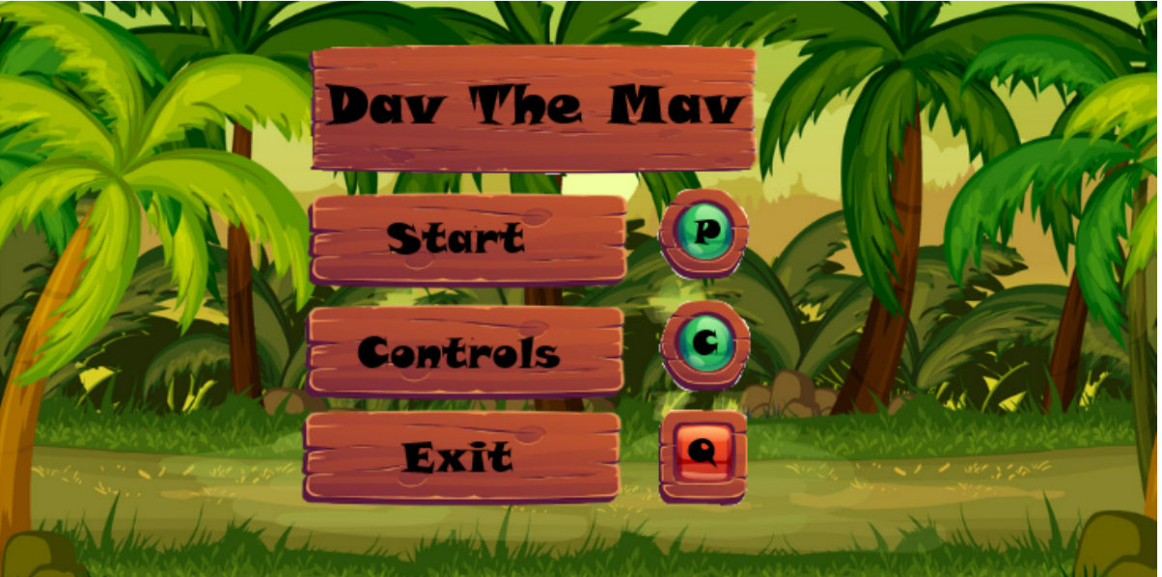

Letters on keyboard used to navigate to different states from this menu screen. Key is shown next to action so user knows what to do

Keys I don’t want the user to press are on a red button so the user known they are ‘bad’ to click
Font is large so it is clear for users of all age to read what is displayed, black colour contrasts with the brown behind making also making it clear

Controls Screen

Each new control or key is displayed in a different box, this helps the user to not forget to read or learn any controls
Title ‘Controls’ displayed at top clearly, larger font size so stands out more, shows user exactly what game state they are in
Every control for the game is displayed here, press M to go back to the menu to start the game, by using keys to pause, access menu or quit, it allows the screen to remain neat and less clustered, so the game play experience is better and easier

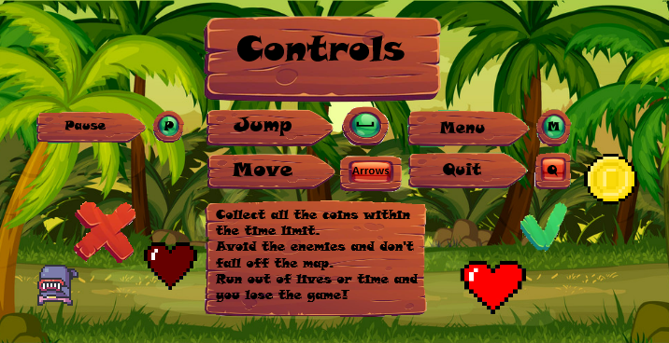
Brief description of the game, smaller font so can fit in and look neat and tidy. Aim of the game and how to win, how to lose
Green tick to show user the things that are considered ‘good’ in the game, hearts and coins
Red cross to show user the things that are considered ‘bad’ in this game, enemies and losing lives

Start up
Enemies, animations, coins, hearts, the player etc are displayed around the title of the game, this shows the user what to expect and makes them excited. It also offers a nice transition into the game since the user can expect what type of graphics will be used

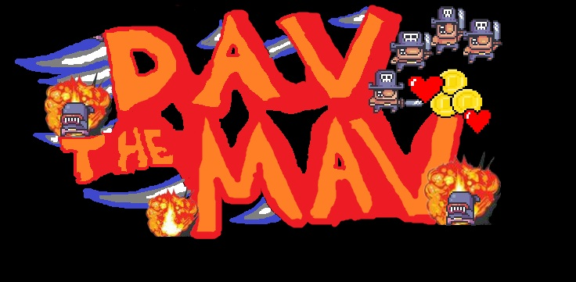

On a black screen so the logo stands out more and is therefore more memorable to the user. Also makes the colours contrast more making it more suitable for larger audiences (e.g. users with visual disabilities such as colour blindess)
Title ‘Dav the Mav’ is displayed at the start, for about 3 seconds before the game menu is open. This shows the user exactly what game they are playing and works as marketing technique since they will be able to remember the name and tell others about the game

Game Playing

Playing Screens
Running Game Screen
Remaining coins displayed in top right underneath collected coins, same as coins collected being displayed in the top right is a good place as user will always remember where to look and no game assets or sprites will block the counter
Player Spawns in a specified position, in this case in this position, controlled by space and arrow keys. Different images are shown on a loop for when idle, falling, jumping or moving in order to give the illusion the player is actually moving similar to a person. An explosion animation occurs in the same way when colliding with enemy. Sound effects played during movement such as footsteps, grunts when jumping and swooshing when falling
Hearts remaining displayed in the top left. This clearly displays to the user how many lives they have left. Each time a life is lost, from enemy or falling off the map, a new image is displayed with one heart less, indicating you have lost a life.
Tiles are static, they are displayed wherever specified in the code. These are for the player to run and jump on. If the player falls off the tiles, they lose a life and respawn at a specified point. Sound effect is played when they fall and lose a life, and sound effect played when they respawn as well.
Coins are in a static position but animated (they appear to look spinning by continuously playing 6 different images one after the other) Once the player runs into one it is deleted off the screen and the coins collected is incremented by one, and the remaining is decremented by one. Sound effect of coins making a noise is played when collected
Coins collected displayed in the top right, increments each time a coin is collected. Top right is good location to display as the user can always look there and it will never be obscured by assets on the screen
Time remaining displayed in the top middle. Decrement by one each second giving the effect of a live count down, creates excitement for the player, and displayed clearly so user knows exactly how long is left. Background music played for the duration of the game whilst countdown is above 0
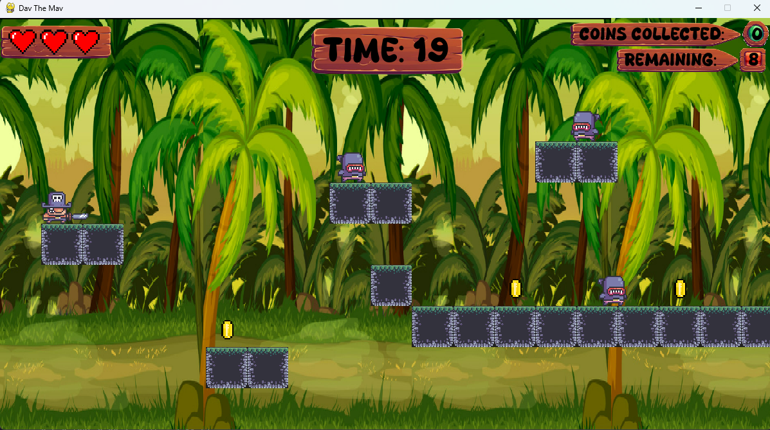
Name of game ‘Dav The Mav’ displayed in window
Enemies move backwards and forwards on top of any platforms. Also animated by looping over multiple images in a loop, change direction when they reach an edge, flip, and move the other direction. Player loses life when collide with them and one heart is removed from life counter, unless no lives are left in which the game over screen is displayed

Tiles

This is the image of the tile used to construct the level. It is only singular tile, because this adds more functionality. It allows single tiled platforms, also allows single tile thick walls to be made.
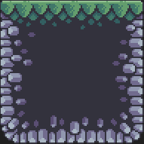

The images can be placed next to each other, this gives the illusion of one big platform, without having to have a separate image for each different sized platform. Reduces file size and makes it easier to make changes such as change the layout of levels, since there are thousands of ways to arrange the tiles on the screen for each level.
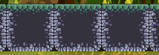

Coins


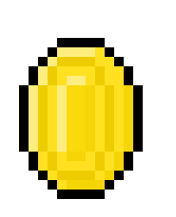
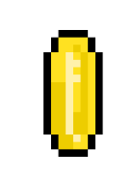

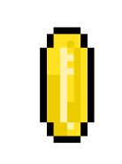
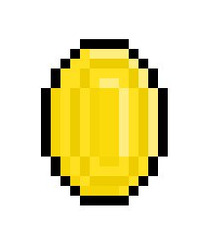

These 6 coin images are displayed very briefly before switching to the next one, this is repeated non-stop giving the effect that the coin is spinning, until the player collides with them and they are deleted from the screen. This adds to the gaming experience as it makes the game more realistic and interactive, plus it makes the coins attract attention which is good since the aim of game is to collect all the coins.

HUD (Heads-up display) Features

Coin counter.
Black on brown contrasting colours so stands out making it easy to read, thus does not take away time from the gaming experience having to concentrate to read it.


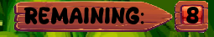

Coins collected displayed on green button background, because collecting coins is good and green has good connotations within gaming
Remaining coins displayed on red button background, shows to user this isn’t good and they need to be collected, since red in gaming has negative connotations

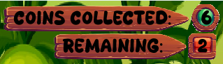
Both are pointed signs, indicating to the user where to look

Custom font downloaded from online used for the writing of the ‘coins collected: NUM’ , ‘Remaining: NUM’ and ‘Time: TIME’. Num represents the number of coins which changes, and TIME represents the time remaining. This font adds to the gaming experience as it fits the games retro pixel art arcade style more than the built in python fonts that are available
Both ‘coins collected’ and ‘remaining’ are displayed together, so user only has to look in one place to see how close they are to winning or losing. Coins collected shown over coins remaining as it is positive reinforcement, as it shows the good of how many coins they have rather than how many left they have first

Time Counter

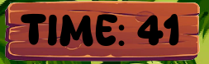

Heart Counter Display

Life lost either falling off map or colliding with enemy

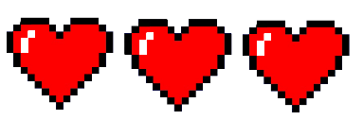

The game starts displaying all three red hearts. When the player loses a life, the next image is displayed, this is done by naming each image 0Lives, 1Lives, 2Lives, 3Lives, and displaying the corresponding image based on how many lives the player has
-1 Life

-1 Life


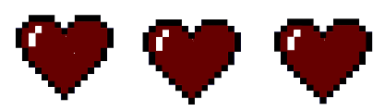
-1 Life

These are the four images which are used to display how many lives are left. It is used as a visual for the user so they always know how many lives they have. When the image with 0 red hearts is displayed, the game over screen is therefore also displayed since the player has lost

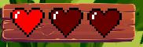
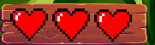
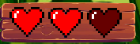

The heart images are displayed on the same themed boards as seen on the Timer and displaying of coins remaining and collected. This follows the theme of the game and shows clearly to the user they are a part of the ‘Indicators’ for the game telling you how well you are doing. Plus they offer more contrast than the coins simply being displayed plainly on the screen, this improves the overall gaming experience as it is easier for the user to see how many hearts they have left very quickly

Player
Player Run

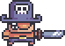
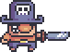
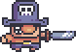
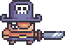
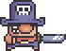
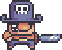

When the player runs (e.g. when the right key or left key is being pressed, in this case it is the right key), each of these images is played one after the other, until it reaches the last image and then loops back and repeats the process, this gives the illusion the character is actually running backwards and forwards, instead of just gliding on the tiles, adding to the overall smoothness of the game and therefore an improved gaming experience

When the player is moving in the other direction, the same process applies, iterating through each image until it reaches the last image and then back to the start and repeating. However in the case when the left arrow key is pressed and the player is moving in the other direction, all the corresponding images are just flipped, and then displayed in the same order as if going to the right. This is a simple way to do this however it gives the illusion that the player is changing direction and facing a different way. This adds to the gaming experience as it adds more realism to the game. It also helps to show the user in which direction they are facing/moving in

Player Jump

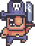
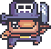
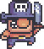

These images are only played once each time the player jumps, starting from the first, then display the second briefly, and then the third image briefly. It doesn’t loop back around to the start at the end because there is no need to, the player jumping is a one off thing in the sense it doesn’t need to be continuously animated. It is also important that each image is only displayed briefly, if it is displayed too long it will look slow and clunky, however if displayed too fast the user may not notice the animation, or it won’t be clear enough to see what is happening. All in all, this short display of three images greatly transforms the game and adds to the overall gaming experience
These three images are played when the player jumps (the user presses the space key). The y value of the player is increased and these images are played. This gives the illusion the player is propelling itself and actually jumping, adding some realism to the game.

Player Fall

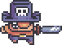
Only one image is displayed because the player only falls very briefly in general, e.g jumping and then falling the player is falling for less than a second, falling off the map the player is falling for normally less than a second or two. Therefore it is not needed for multiple images to display the falling of the player. The gaming experience isn’t affected by this, in fact it is increased because it adds to the simplicity of the game, since the user isn’t being bombarded by too many images and animations within a short space of time
This image is displayed whenever the player is falling (when the y coordinates are decreasing)

Player Idle

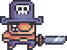
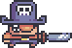
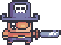
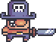
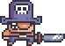

The 5 images are only briefly shown, however if they are shown too quick the player will simply look like it is glitching. Therefore it is important that I find the balance between making it look good and realistic whilst not making it look too slow and clunky or too fast and glitchy
When the player is idle (e.g. no keys are being pressed), each of these images is played one after the other, until it reaches the last image and then loops back and repeats the process, this gives the illusion the character is bobbing up and down, almost as if it is breathing or waiting to move, instead of just sitting still on the tiles. This adds to the overall realistic feel to the game and smoothness therefore providing an improved gaming experience

Player Dust Particles
Run
These 5 images are the ones used as dust particles for when the player is running on the floor. They are very small in pixel size (hence why are blurry when enlarged) so they don’t take away too much detail from the actual game play. However, these particles transform the playing experience, as they make the game much more visually appealing and realistic, thus the users are more enticed in the game play.
Displayed on Blue background so are visible on this page

The dust particles appear to look animated by using the same method as with every other aspect of the game, by continuously looping through each image and displaying it for a brief amount of time, just enough to look realistic btu without looking laggy or too slow. These are played any time the player is moving along the tiles.

Displayed above the ground, gives the effect they are floating off / disappearing into the air
This is what they look like in action whilst the player is running

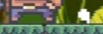
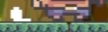
When moving to the right, the dust images are all flipped to face the other way, are displayed a few pixels behind the character (in this case an extra 5 pixels to the left for example). This gives the effect that the character is making these dust effects in the ground after they have walked, since the character is constantly moving for this animation to be played. By having the dust particles swap it makes it more visually clear which direction the character is moving in. And by having them so small, it adds a nice realistic effect to the game, whilst also not taking away from the overall simplicity and distracting the user too much. This improves the gaming experience the users will have
When moving to the left, the actual dust images are displayed a few pixels behind the character (in this case an extra 5 pixels to the right for example). This gives the effect that the character is making these dust effects in the ground after they have walked, since the character is constantly moving for this animation to be played.

Land







Each dust particle is a pair, which is displayed at the bottom of the player. Because they are spaced far enough apart in the image, dust will be shown on either side of the player, giving the effect of a thud/dust forming as it lands. They are increasingly far apart, giving the effect they are disappearing. This makes the game look more realistic, and since the particles are small, they don’t take away from the overall gaming experience, only increase it.
There are 5 different images used for the dust effect for each time the character lands. In the same way as other aspects, each image is displayed very shortly, and then the next one is displayed. Unlike the running images, which constantly iterate and loop back whilst the player is running, this selection of dust images are only played once, because the animation does not need to repeat, only plated once each time the player lands

The last two images of dust particles are displayed slightly above the tiles. This gives the effect that the dust is disappearing or floating off into the wind. Adds realism and makes the game look smoother, adding to gaming experience
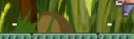

The dust particles doesn’t follow the player when it is moving, this adds the effect that at the location where the player lands is where the dust appears. If the dust was to follow the player, it would not look realistic, as dust doesn’t follow a person in reality.

When the player lands facing in the opposite direction, the images don’t need to be flipped, because they are symmetrical on either side. This is simplistic but adds a much more realistic effect to the overall game. This simple implementation of particles transforms the gaming experience

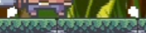

Jump







These 6 images are displayed when the player jumps. Each one is played for a very brief moment before the next one is played. The images are only displayed in one loop, they don’t loop back after the last image is displayed. This is because the dust after a jump is a on of thing, it doesn’t need to be continuously animated, only need to be displayed once per jump.
The first image is on the ground directly on the tile. Each consecutive image is then slightly above that image, and the individual part of each dust is slightly smaller, and wider apart. This gives the effect that the dust particles are dissipating and disappearing into the air. The last image is a single dust particles to show that the animation is over.

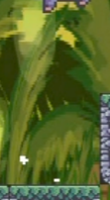
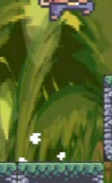
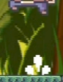
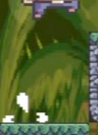
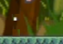
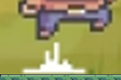
6
5
4
3
2
1

The images don’t change location even after the player moves. The initial location where the player jumps is where the centre of each dust image will play regardless of any movement after that, this adds to the realism because the player is in the air and therefore won’t be affecting the dust beneath it. If the dust followed the player this would look weird and unrealistic
First image is displayed directly on the tile. Played as soon as the space bar is pressed.
Last image displayed in the air, gives the effect the dust particles are dissipated

Enemy
Enemy



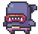
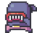
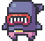
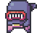

The vertical size of the images change, so it is important to make sure that the bottom of the image is always touching the tile. This gives the effect that the head of the enemy is bobbing as it walks, rather than it floating over the tiles with a gap below its feet and its head maintain a steady position. This adds to the gaming experience as it makes the enemy seem more realistic despite it not being a real thing
These are the 6 images for the enemy. These images are constantly looped through, displayed briefly before moving on to the next one. This gives the effect that the enemy is actually walking, as its arms are swinging and its legs are stepping forward.

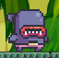
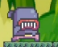
Direction

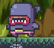
Direction

When the enemy reaches the edge of a platform, it changes direction. This effect is given by reversing the direction of the enemy, and flipping the image, until it reaches the other side and flips back again. This gives it the realistic effect that the enemy is changing directions.

This also acts as an indicator so the user is able to see which way the enemies are moving in. This gives them time to avoid or jump over them. This adds to the gaming experience as it makes the game more visually appealing to look at, whilst also making it more functional and playable.

Explosion Effect
Sound effect of an explosion is played during the animation of these images, so not only is it a visual indicator of losing a life, it also audio indicator as well. This adds to the overall gaming experience of the game.
These 10 images are used to animate the explosion effect when the player collides with an enemy and loses a life.








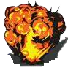


They are only displayed once, e.g. the 10 images are displayed one after the other, and then when it reaches the 10th image it no longer displays any more. This is so that the explosion is a one off animation. If it looped back it would not look realistic, and the player losing a life only needs to shown once (e.g. once each time it collides with an enemy) This adds to the game play experience, as it is a more realistic explosion, however still remains abstracted as an explosion when someone collides with something else is not very realistic.
They are just slightly bigger than the player sprite, the reason for this is that the whole player is covered when the explosion occurs. They are very briefly shown so that the whole animation is basically finished by the time the player is no longer colliding with the image, if the explosion was still occurring when the player say jumper, it would not look realistic or visually pleasing to the user.

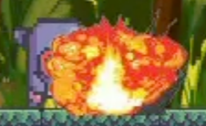
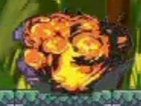
The enemy can still be seen, however the explosion is displayed in front of the enemy. This is because the explosion is the more important thing to be seen, the enemy isn’t that important to be seen in this time.
This explosion also acts as a visual indicator to clearly show the user they have collided and therefore have lost a life
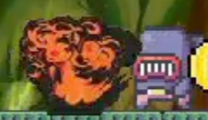
Whole player is covered by the explosion animation

Other Game Screens (Whilst Playing)

Pause Screen
The name of the current game state is displayed at the centre of the screen. ‘Paused!’ displayed in a large font to stand out, and black font on brown background creates contrast to make it stand out more. Acts as a clear visual of indicator to the user what state game is in.
This is the screen that is displayed when the game enters the Paused game state. This is achieved when the ‘P’ key is pressed whilst the game is running.

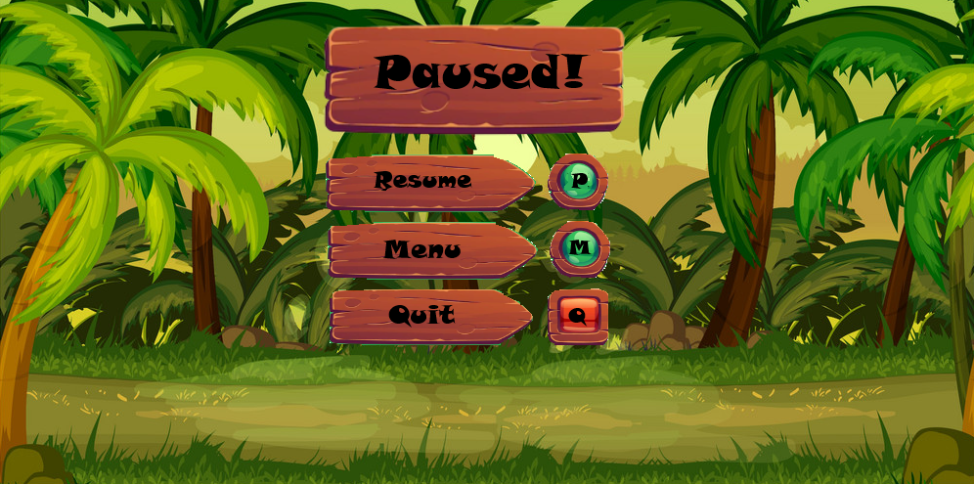
‘Quit’ displayed on brown background to follow the same theme. Sign points to indicator showing letter ‘Q’. Clearly shows to the user to quit the game they have to press the ‘Q’ key. ‘Q’ for quit. The ‘Q’ is displayed on a red background to visually show to the user it is a ‘bad’ thing and they should not press that key. There could be a confirmation after this our the ‘m’ key is pressed so the user doesn’t accidently lose all their progress in the current level
‘Menu’ displayed on brown background to follow the same theme. Sign points to indicator showing letter ‘M’. Clearly shows to the user to go back to the menu they have to press the ‘M’ key. Makes sense since menu starts with ‘M’. The ‘M’ is displayed on a green background to visually show to the user it is a ‘good’ thing and they should press that key. When this key is pressed, the game state changes back to the menu state where the user can then start the level again if they want to
‘Resume’ displayed on brown background to follow the same theme. Sign points to indicator showing letter ‘P’. Clearly shows to the user to resume the game they have to press the ‘P’ key. Makes sense since ‘P’ represents play. The ‘P’ is displayed on a green background to visually show to the user it is a ‘good’ thing and they should press that key. When ‘P’ is pressed, the game state is changed back to the playing state.
GameOver (You Win) Screen
The name of the current game state is displayed at the centre of the screen. ‘You Win!’ displayed in a large font to stand out, and black font on brown background creates contrast to make it stand out more. Acts as a clear visual of indicator to the user what state game is in. And the sound effect acts as an audio indicator to show the changing of game states, and makes the user feel more proud for completing the level. Thus increasing the overall gaming experience and making them more likely to come back and play again.
This is the screen that is displayed when the user wins the game (when all coins on that level have been collected within the time limit with at least one or more lives remaining ) Sound effect of winning trumpets is played when this screen is first shown. This screen remains until user quits the game or enters the menu
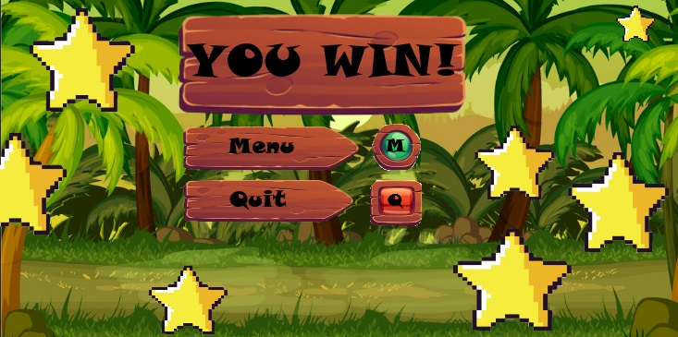
Star is used as an indicator to show the user winning is a good thing. The stars transform the usual playing background, making the winning screen more exciting and interesting. The stars also link back to the level map, in which each level is rated on a scale of 3 stars on how well they completed the level. The user is reminded of completing the levels quickly and safely and makes them excited to see how many stars they have been awarded for the current level
‘Quit’ displayed on brown background to follow the same theme. Sign points to indicator showing letter ‘Q’. Clearly shows to the user to quit the game they have to press the ‘Q’ key. ‘Q’ for quit. The ‘Q’ is displayed on a red background to visually show to the user it is a ‘bad’ thing and they should not press that key. There could be a confirmation after this our the ‘m’ key is pressed so the user doesn’t accidently lose all their progress in the current level
‘Menu’ displayed on brown background to follow the same theme. Sign points to indicator showing letter ‘M’. Clearly shows to the user to go back to the menu they have to press the ‘M’ key. Makes sense since menu starts with ‘M’. The ‘M’ is displayed on a green background to visually show to the user it is a ‘good’ thing and they should press that key. When this key is pressed, the game state changes back to the menu state where the user can then start the level again if they want to
Game Over (You Lose) Screen
The name of the current game state is displayed at the centre of the screen. ‘You Lose!’ displayed in a large font to stand out, and black font on brown background creates contrast to make it stand out more. Acts as a clear visual of indicator to the user what state game is in. And the sound effect acts as an audio indicator to show the changing of game states, and makes the user feel more annoyed for failing the level. Thus, increasing the overall gaming experience and making them more likely to come back and play again to try to pass the level.
This is the screen that is displayed when the user loses the game (when the timer hits 0 and all the coins haven’t been collected, or when the player runs out of lives and the lives counter reaches 0) Sound effect of losing trumpets is played when this screen is first shown. This screen remains until user quits the game or enters the menu to start the level again.

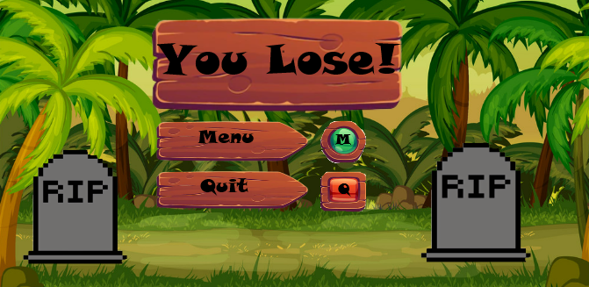
Tombstone with ‘RIP’ written in it is used as an indicator to show the user losing is a bad thing. The tombstone transform the usual playing background, making the losing screen more suitable and interesting for the context. The tombstones also link back to the level map, in which each level that you cant complete has a small tombstone on. The user is reminded of not being able to complete certain levels, which entices them and makes them want to play again. This makes the game more exciting. Only two tombstones are shown as they convey the image of death and failure without adding too much complexity and taking away from the simplicity of the graphics
‘Menu’ displayed on brown background to follow the same theme. Sign points to indicator showing letter ‘M’. Clearly shows to the user to go back to the menu they have to press the ‘M’ key. Makes sense since menu starts with ‘M’. The ‘M’ is displayed on a green background to visually show to the user it is a ‘good’ thing and they should press that key. When this key is pressed, the game state changes back to the menu state where the user can then start the level again if they want to
‘Quit’ displayed on brown background to follow the same theme. Sign points to indicator showing letter ‘Q’. Clearly shows to the user to quit the game they must press the ‘Q’ key. ‘Q’ for quit. The ‘Q’ is displayed on a red background to visually show to the user it is a ‘bad’ thing and they should not press that key. There could be a confirmation after this or the ‘m’ key is pressed so the we can be sure the user wants to perform that action and it wasn’t just a misclick or a typo. Pygame closed when this is pressed

Other Game Screens (Not Whilst Playing)

Level Map
‘Leaderboard L’ displayed in the top right. Clear indicator to the user how to access the leaderboard by pressing the ‘L’ key. In the corner so doesn’t take away detail from the level map, but still visible so the user wont overlook it
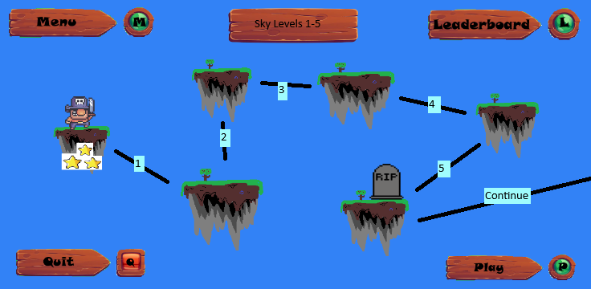
This screen shows an example of what a section of the level map would look like. Some parts are uncompleted hence the different fonts or white backgrounds. It is kept simple on purpose to fit with the overall theme of the game, and makes the levels and assets like players, stars etc to stand out more
Name of the current levels and their level numbers displayed in the middle at the top. Clearly shows to user which levels are currently being displayed and which theme/named levels are being shown
‘Quit Q’ displayed in the bottom left. Tells the user how to quit the game if they want to. ‘Q’ is on a red background because it indicates to the user that leaving the game is not a ‘good’ thing. In the bottom left so out of the way of the graphics of the levels, and being in the bottom left the user is less likely to look there and be reminded to quit the game. This means the user will likely play the game for longer before quitting meaning they will enjoy it more and have a better overall gaming experience
‘Play P’ displayed in the bottom right. An indicator that clearly shows to the user to play the level they have currently selected, they must press the ‘P’ key. Displayed in the bottom right as it is out of the way of the actual level map, however it is a clear space to put it. Plus the user will get used to looking for the ‘play’ button in the bottom right so will now exactly where to look for which key to press to start
‘Menu M’ displayed in top left. Clear indicator to user how to access the menu by pressing the ‘M’ key. In the corner so doesn’t distract the user from the level map

These lines are used to show the order in which the levels need to be completed, it provides a link between each level and a visual to the user of the order in which the levels follow each other
The number of the level is also shown on the lines linking the levels. E.g. starting at the start level, the line leads to level 1, which then leads to levels 2 and so on

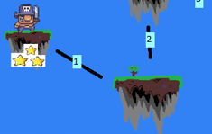
The current level the user is on is represented by the player sprite. This provides a clear visual to the user what current level will be played if the ‘P’ key is pressed. It also links nicely to when that level starts and the user sees the same player sprite they saw on the map. This adds to the gaming experience as it makes different game states seem more linked together
After each level is completed, stars are shown below the level. This is a clear visual indicator to the user which levels they have already successfully completed. If the level is completed with all three hearts and no lives, then three stars are displayed. If the player loses one life then only two stars are displayed and so forth. This adds more competition to the game which makes it more exciting for the user. It also allows the user to be able to know which levels they can go back to and play again in order to get more points for the leaderboard
Each new level is represented by a floating island. This fits the theme of the player jumping on floating platforms and avoiding falling.

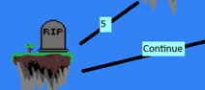

A tombstone is shown on each level that the player is unable to complete (e.g the user has played the level before, but lost all their lives) This is a clear visual indicator to which levels the user needs to complete
This line goes off the screen to the right and says ‘Continue’. This is a visual indicator to the user that there are more levels to be completed further on. The continue shows that they can ‘continue’ progressing through the level map and complete the levels on the next page. Not all the levels are displayed on the same screen, this adds excitement as the user will need to complete all the current levels in order to see what more they have to play.
Leader board

Title of game state clearly displayed at the top and middle of the screen. Acts as a indicator to the user on which game state theta re currently in.
This is what the leaderboard game state screen looks like

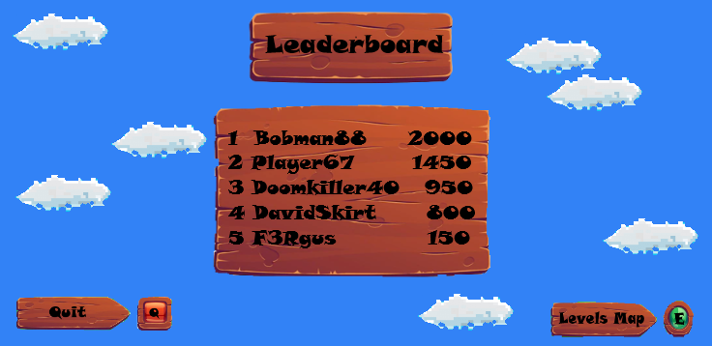
Clouds dotted around screen. Small and simple to maintain majority of focus on leaderboard, however add a nice effect making it seem like the leaderboard is displayed in the sky, rather than just on a blue background
Number shown on the left hand side of the leaderboard clearly shows to the user who is top, who is second, third e.t.c

‘Quit Q’ displayed in the bottom left. Tells the user how to quit the game if they want to. ‘Q’ is on a red background because it indicates to the user that leaving the game is not a ‘good’ thing. In the bottom left so out of the way of the graphics of the leaderboard allowing it to stay simple, and being in the bottom left the user is less likely to look there and be reminded to quit the game. This means the user will likely play the game for longer before quitting meaning they will enjoy it more and have a better overall gaming experience

‘Level Map E’ displayed at the bottom right of the screen. E represents exit which can be used to return to the level map to select which level is needed top play
High scores are all placed in the centre of the screen, this is to draw the most attention from the user. The higher the scores the higher they appear on the list. These features were used to make the high scores as clear to the user as possible

Different Levels

Enemies, Themes, Tiles
It makes sense to leave the player the same throughout, as then it makes it seem like the user and the player character are going through a journey through different levels together. This makes the user feel more involved in he game and adds to the gaming experience.
Things such as the background can be changed in order to give the level a different theme and feel. This makes it obvious to the user it is a completely new level

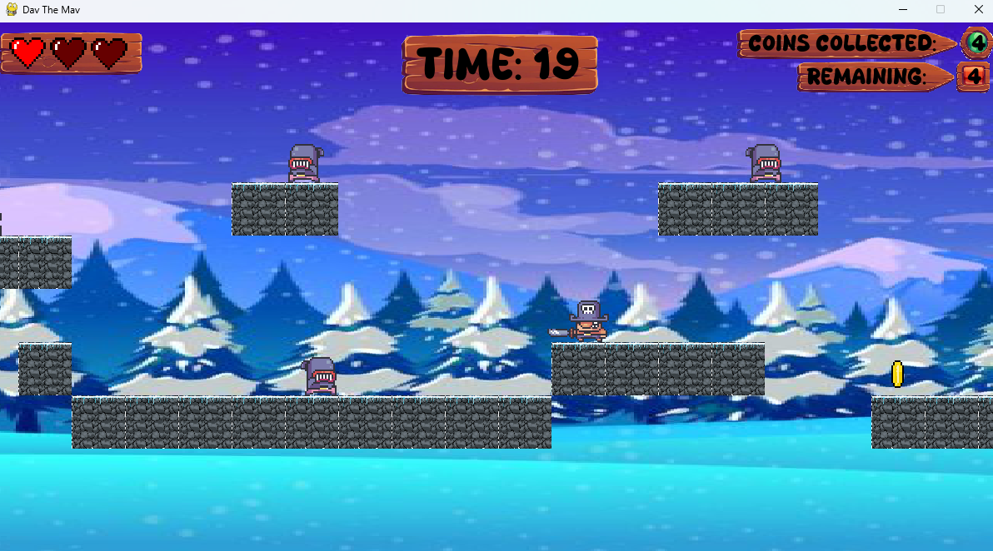

The enemies can also be replaced for a different type of enemy. For example there could be skeletons, ghosts, blobs or many more types. This adds diversity and uniqueness to each level. However before the level it would have to be made clear these are the new enemies as not to confuse the person playing the game
Tiles can be replaced with different images. For example this snowy themed level could have tiles with snow on top, rather than grass. This is a very clear visual indicator aspects of the level are different. Having new and interesting looking levels increases the overall game play experience as it offers a more unique time.

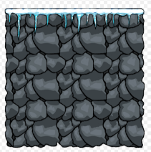

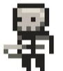
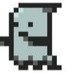

Level Layouts
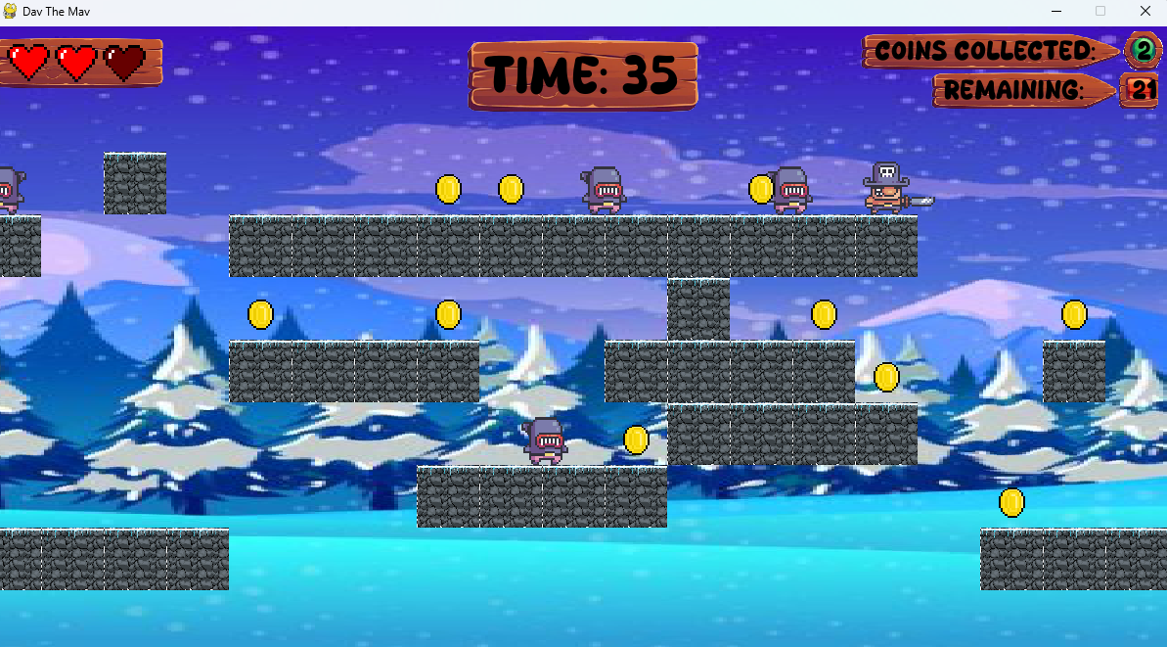
The layout of new levels can be made completely different. This includes the entire arrangement of tiles, but also where each enemy spawns, where every coin is located and where the player originally spawns in or where they respawn once they fall off.

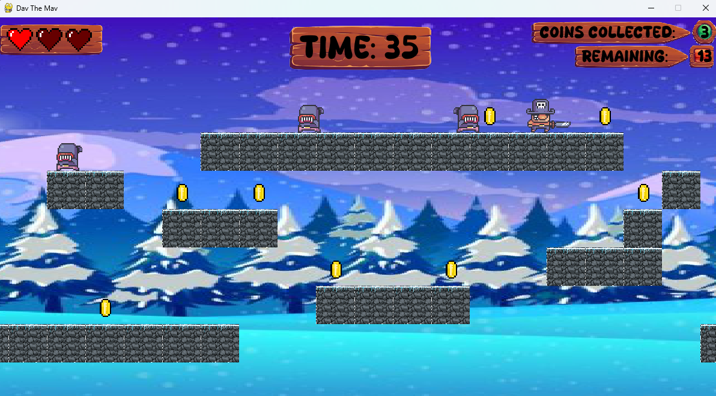
All of this functionality means there are an infinite amount of unique levels that can be made. This means that the user will always be encountering levels with changes and twists they have never seen before. This adds excitement and suspense every single time the user is playing the game. This therefore improve the gaming experience and makes them want to play more

Difficulty Changes
The time within each level that you have to collect all the coins can be increased or decreased. Decreasing the time will make the game much more difficult since you have less time to collect all the coins. Some maps may be larger in which more time is needed by default anyway
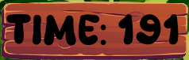

Changing the number of coins needed to be collected per level. Increasing how many coins need to be collected within the level will make that level harder, as you will have to visit more places and be more careful as to not fall trying to get to every coin


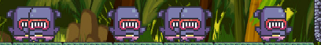
Changing the number of enemies will also change the difficulty depending on each level. For example increasing the number of enemies will increase the difficulty, as it will be harder to dodge and more chance you lose a life. Changing the number of enemies also changes the style of play, you may need to play slower and more careful for one level, but faster and less careful for a different level. This adds uniqueness within the game itself which increases the overall gaming experience

Classes

List of classes

Level Class

Description
This class manages the game's main operations, controlling how everything works together. It handles the player's actions, the behaviour of the enemies like collisions and detection with tyles, coin collection, and the timer operating during gameplay.

Use cases
This class is used whenever the game is running, overseeing all the action to make sure everything happens at the right time and in the right order.

Justification
Level class is so important because by controlling the game's core mechanics in one place, it keeps the game organized and makes it easier to change or add new features without having to change major aspects of the rest of the game

Player Class

Description
Handles everything about the player character such as how it moves, like running, jumping, how it looks and what animations to play at the right time. Also is in charge of managing how the player interacts with the game world, such as gravity and world shift

Use cases
This class is used to take in input from the keyboard, and convert these into movements for the character in the game. It is constantly being used during movement of the player

Justification
By keeping all the player-related functions and variables in a separate class and file, it makes it simpler to change how the player behaves or looks without having to drastically change other aspects of the code, or accidentally causing other parts of the game to behave in unexpected ways.

Enemy Class

Description
Manages the behaviour of the enemies in the game, such as their movement. Also managers their appearance in the game, such as their animations, the way they are facing, their size e.t.c

Use cases
This class is used all the time, since it is in affect whenever there are enemies on the screen, and in the context of this game there will always be at least one or more enemy displayed on the screen.

Justification
By having a separate class and file to handle the majority of the logic and code relating to enemies, it allows for greater functionality. It means changes can be made within the class, which will then have an instant effect on every enemy on the screen. Also makes the code simpler and more readable.

Coin Class

Description
The coin class handles how the coins appear, such as there animations, and how they disappear when the player collides with them and picks them up.

Use cases
This class is used almost all the time, similar to the enemy class it is constantly used when there are coins on the screen, as it is needed for their constant looping animation. It is also used when the player collides with a coin and it needs to be collected and removed from the screen.

Justification
Keeps most of the coin related things within one class and one file. Makes it much easier to change the behaviour of how coins look without having to change the majority of the rest of the code, also reduces the chance of introducing syntax or logic errors into other areas of the code if the coins are kept separated from it all. Also helps improve readability and file size of the code.

Tile Class

Description
Controls all the individual tiles on the game map. It is in charge of how they look and then appear on the screen (e.g. controlling the size of the displayed tiles compared to the size of the actual image of the tiles), where they are displayed onto the screen, and what happens when you touch them (either horizontally such as running into them, or vertically such as jumping or running).

Use cases
This class is used in the entire time that the game is in the playing state. It is used to physically build the map and display the tiles, therefore it has to be in affect the entirety of the game otherwise the player, enemies, coins etc. would have no where to go!

Justification
The tile class separates the tiles and construction of the game into its own class and file. Allows the tiles to be changed and rearranged without having to interfere with every other aspect of the game. Increases readability and cleanness of the overall code

Timer Class

Description
The timer class manages all the time within the game. It is in charge of controlling the countdown and displaying displaying how long is left in each level

Use cases
Similar to other classes like player, tiles, enemies etc., the timer class is also always needed within the game. Without this class then the timer displaying how long is left for each level would not work and wouldn’t be displayed on the screen. Therefore this timer class is vital in the execution and playing of the game.

Justification
Allows the game and time aspects of the game to run smoothly whilst also being separated into a separate class and file. Allows changes to be made that affects all timing aspects within the game, without affecting other code or game aspects. For example changing the time for the timer displayed on the screen, won’t cause any glitches or delayed affects for the loading of different game states, like transition from the loading screen to the menu screen, or playing screen to pausing screen and so on.

Classes Diagram

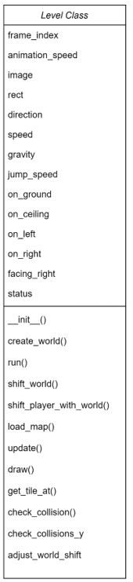
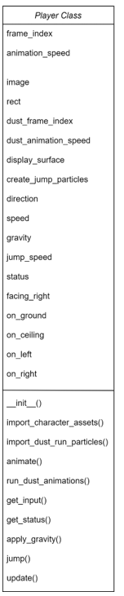
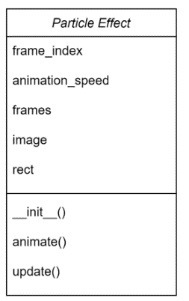

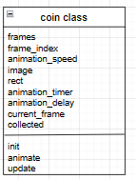
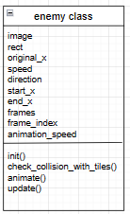
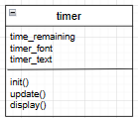
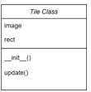

Algorithms

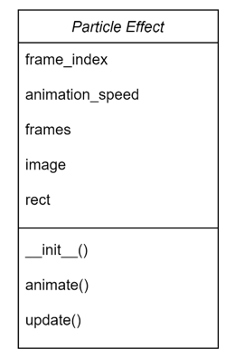
Score board
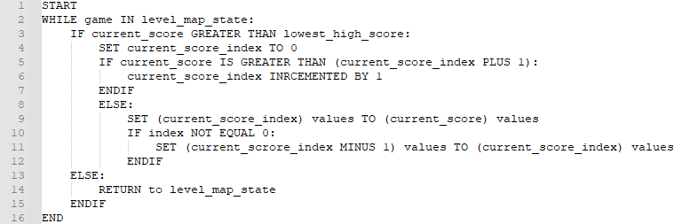
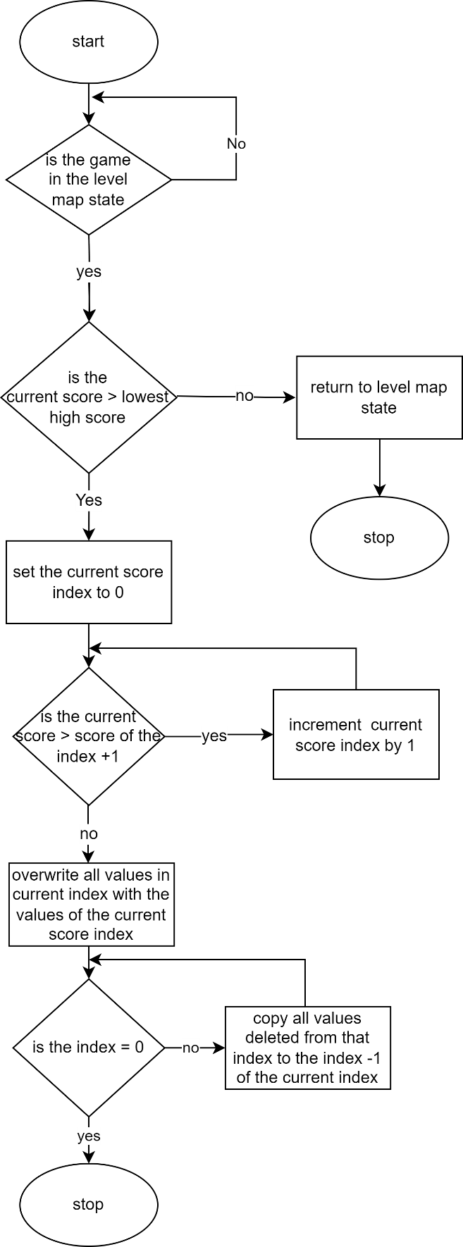
New high score

Example of leaderboard
Index | Username | Score
4 | John123 | 8520
3 | _Dave_ | 7060
2 | Firekiller64 | 4990
1 | Proplayer100 | 2400
0 | J4M3S | 860

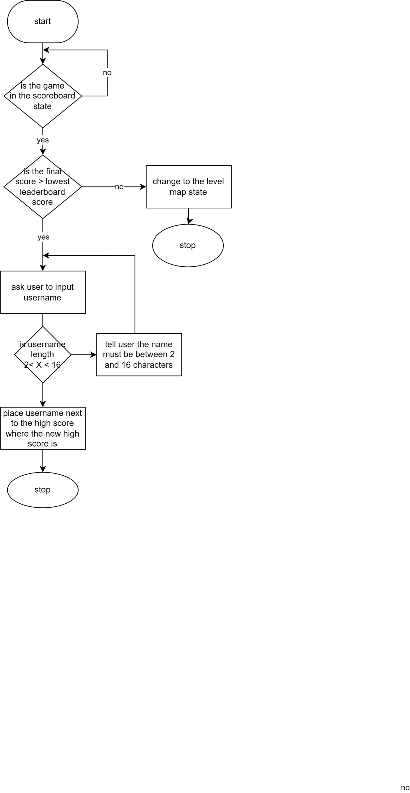
High score name and validation

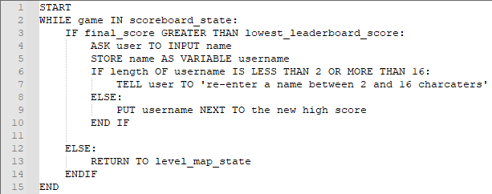

Displaying High scores
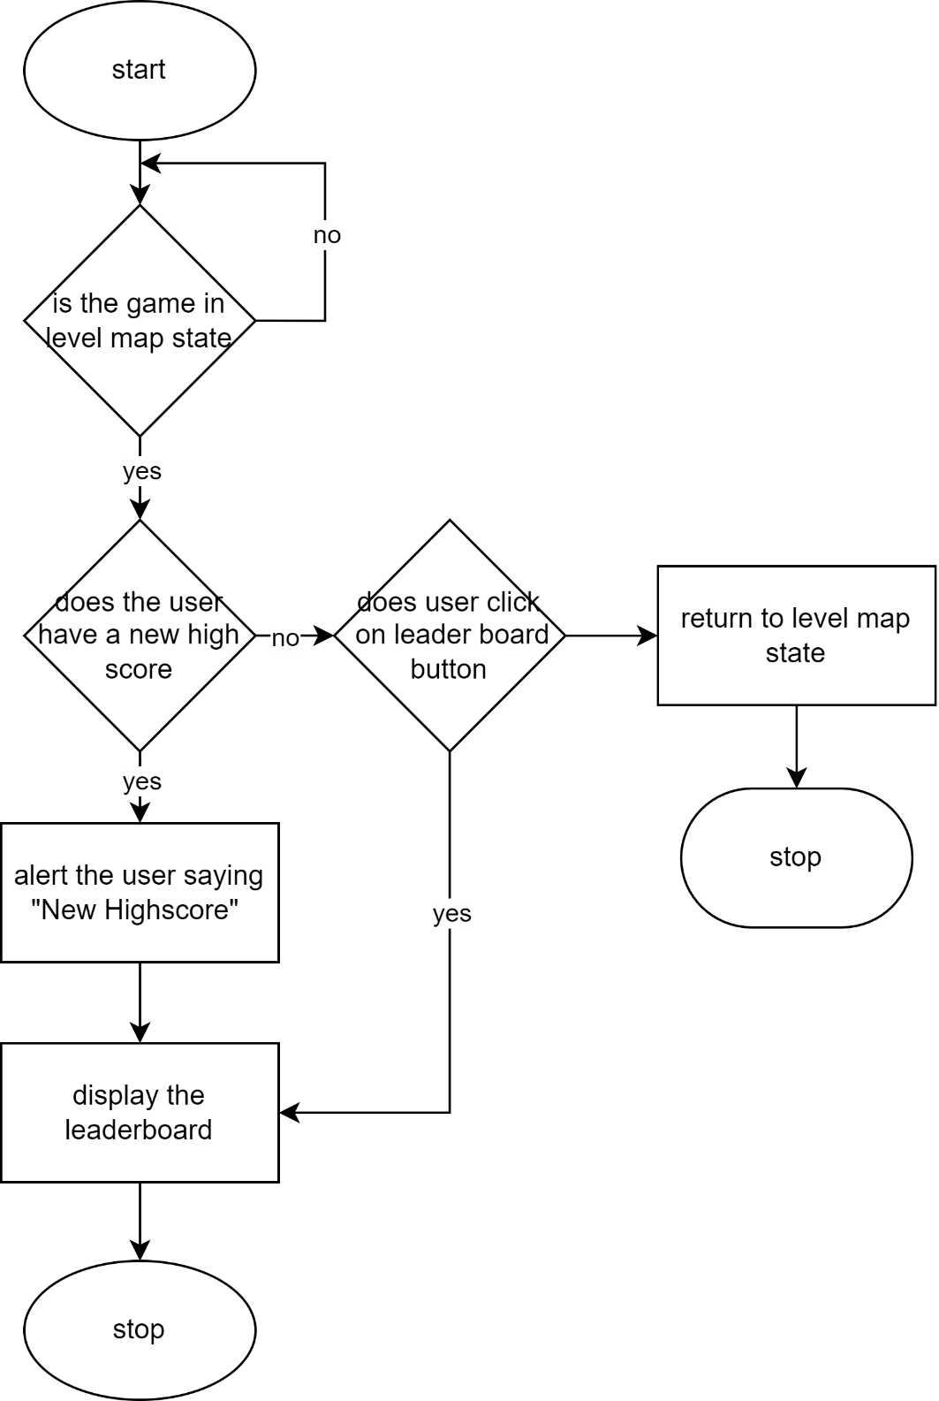

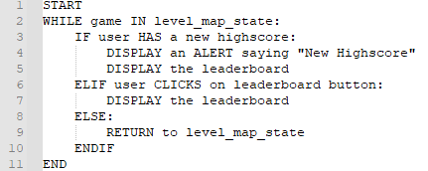

Pausing and unpausing

Pausing Unpausing
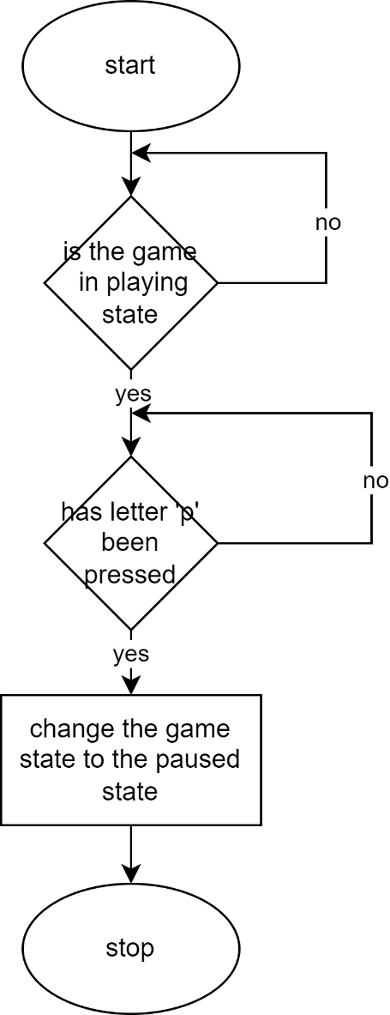
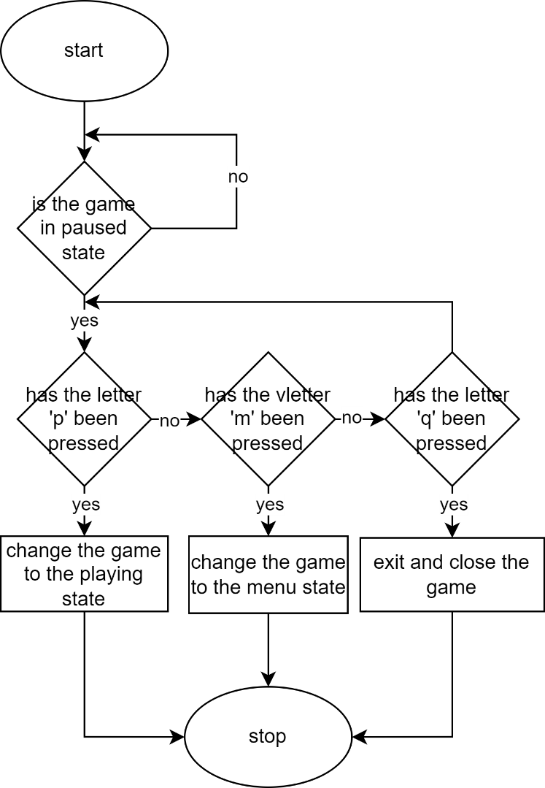

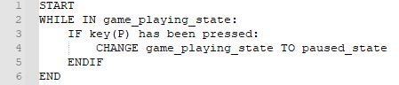

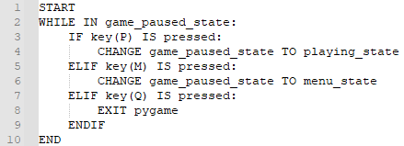

Start up

Loading screen

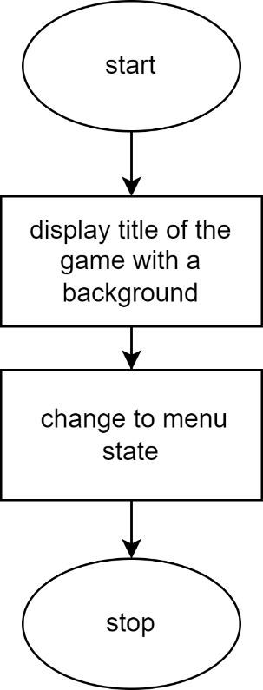

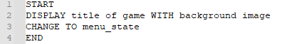

Menu

Main Menu
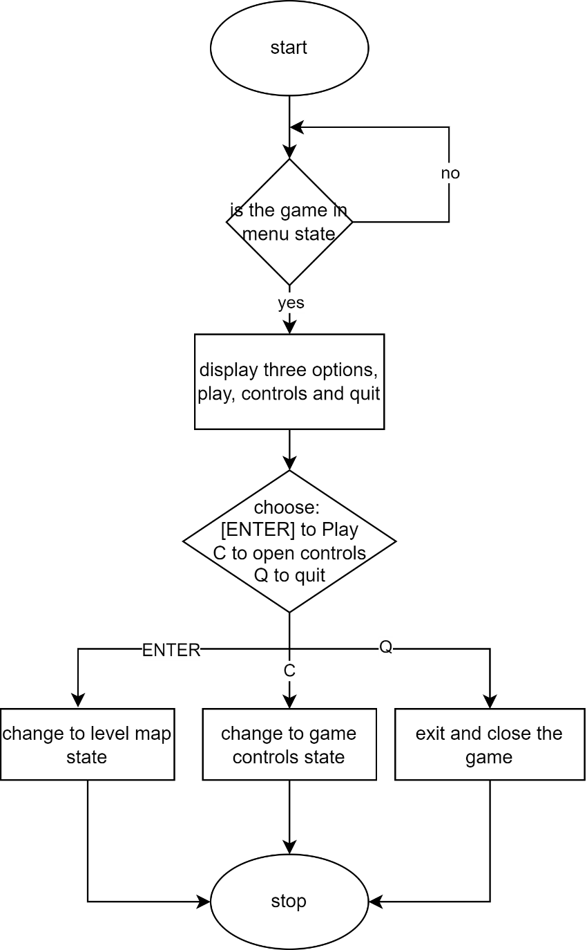

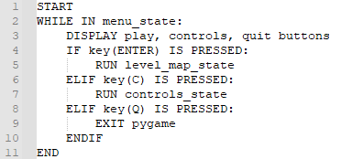

Controls Panel

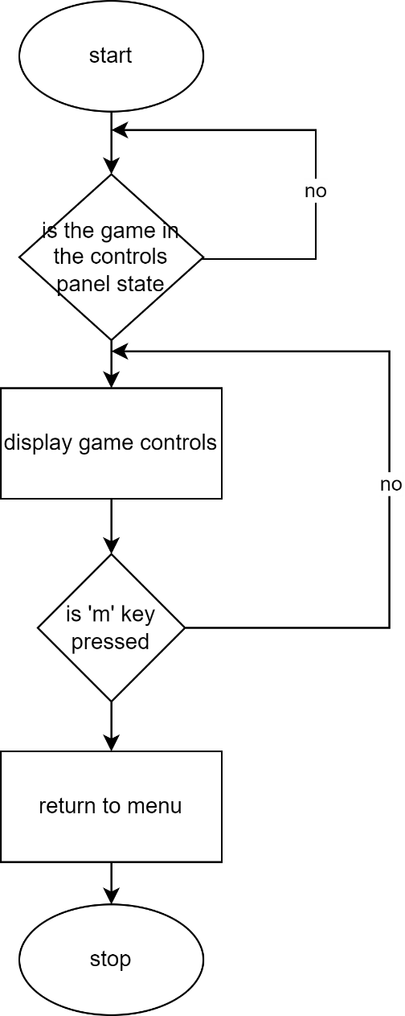

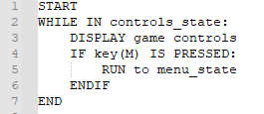

Quit
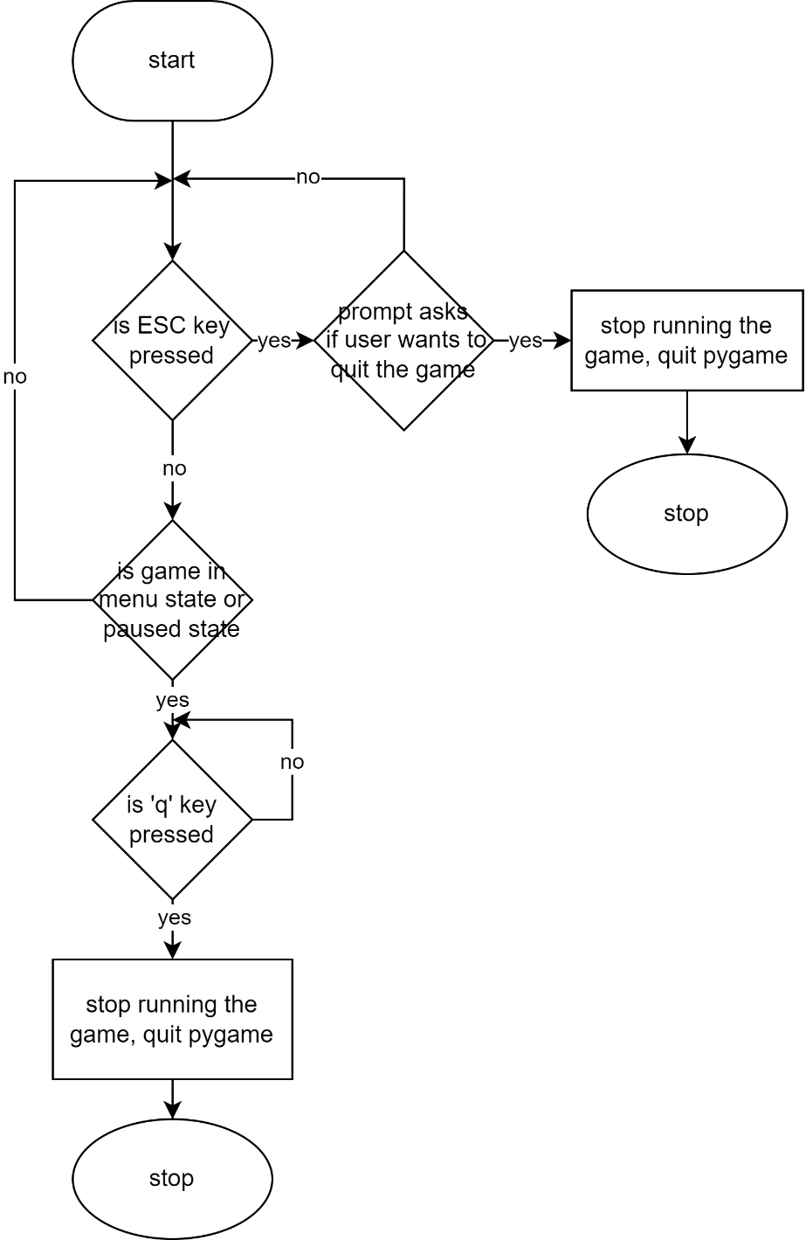

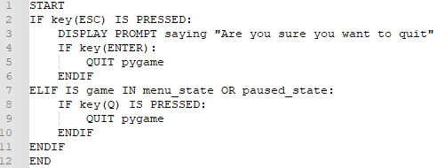

Game Over

Win the game
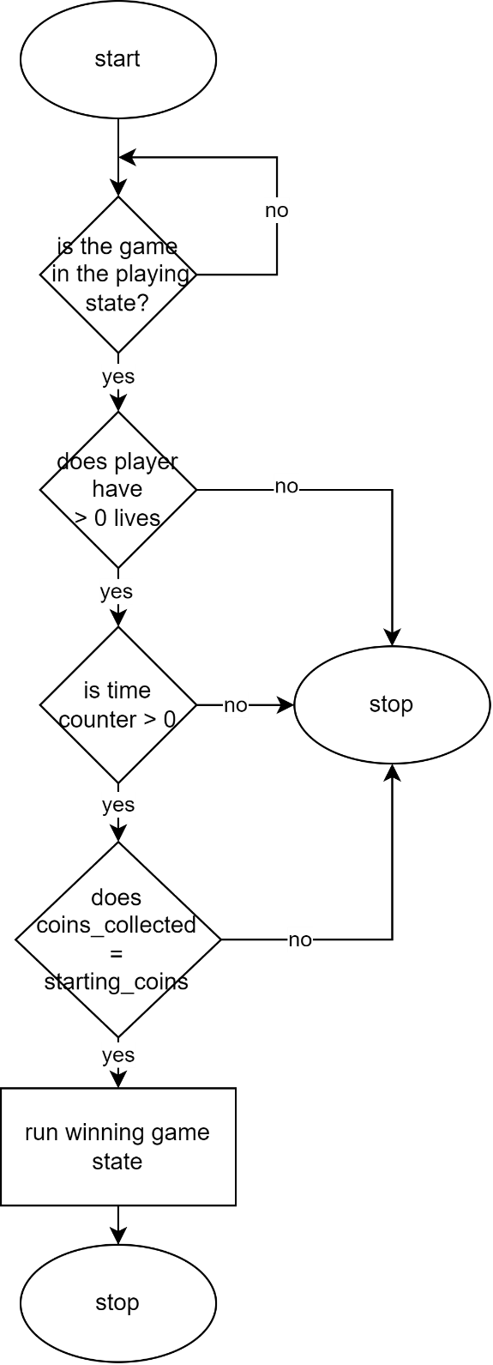
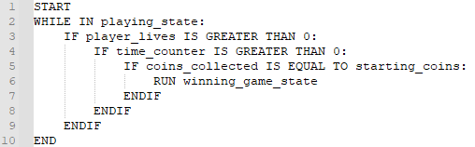

Lose the game

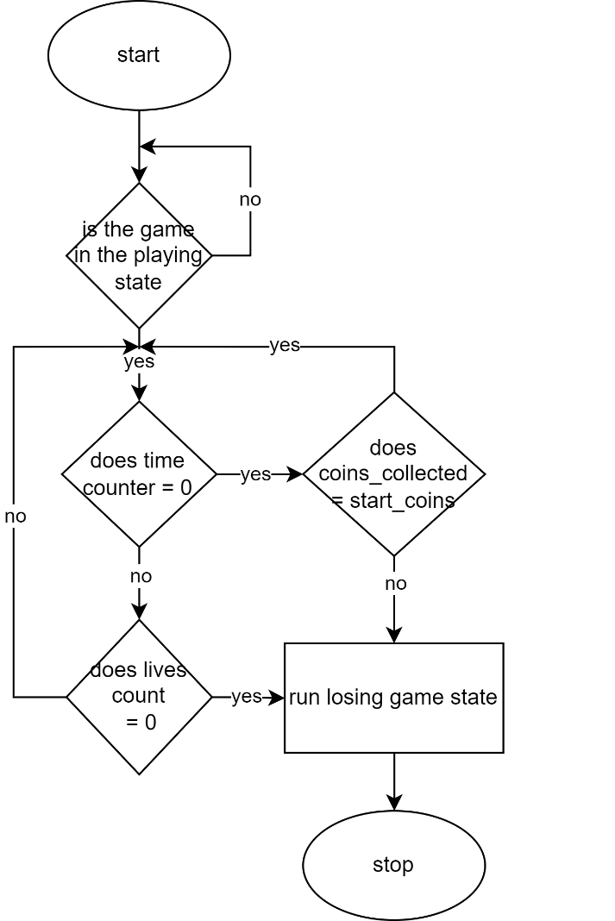

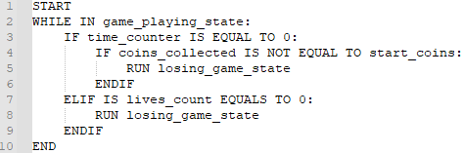

Playing the game

Picking Levels

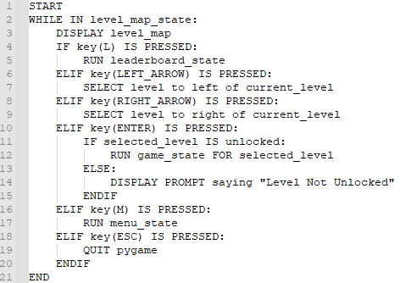
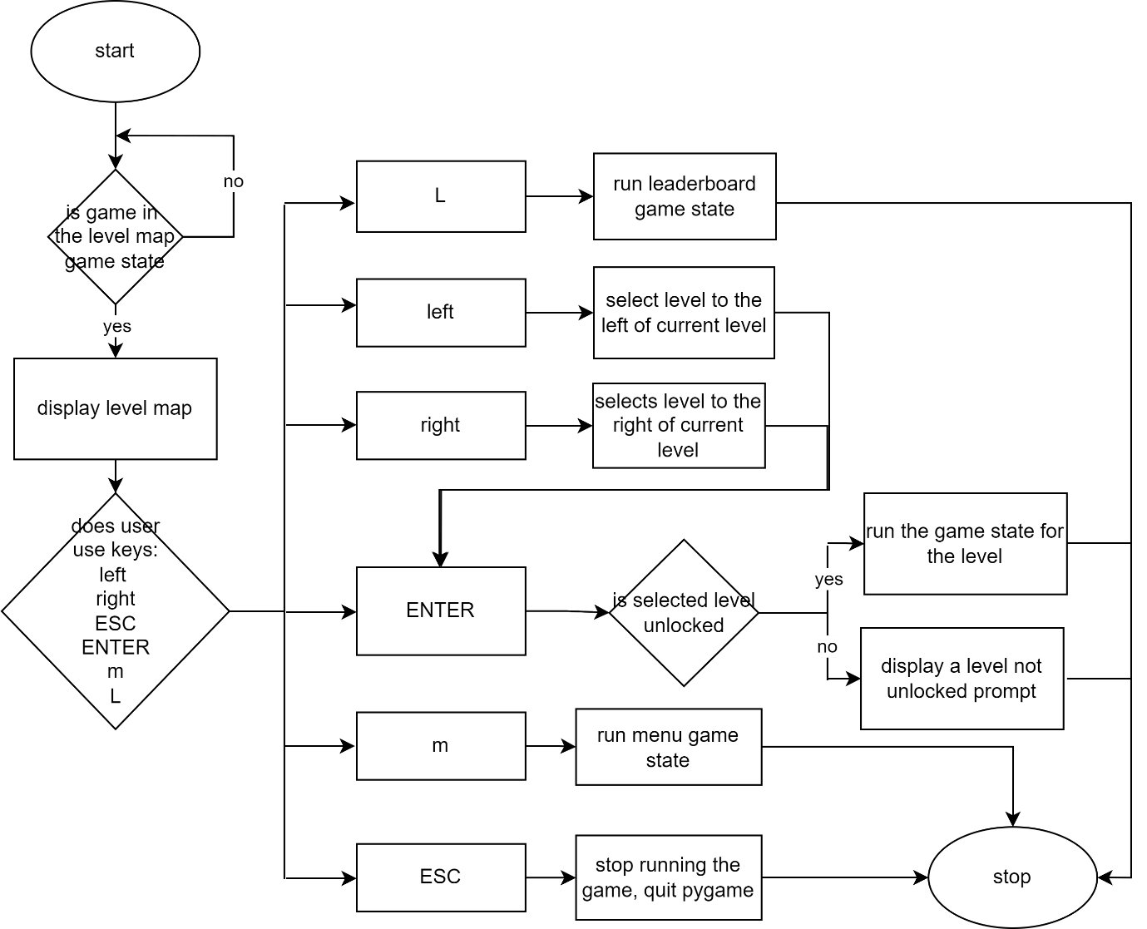

Player Movement

Horizontal Movement
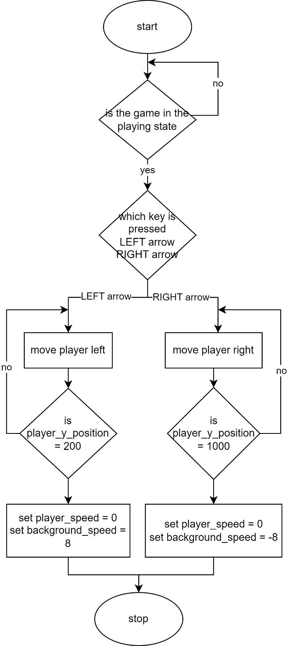
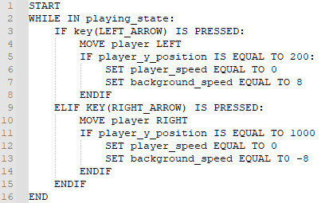

Vertical Movement
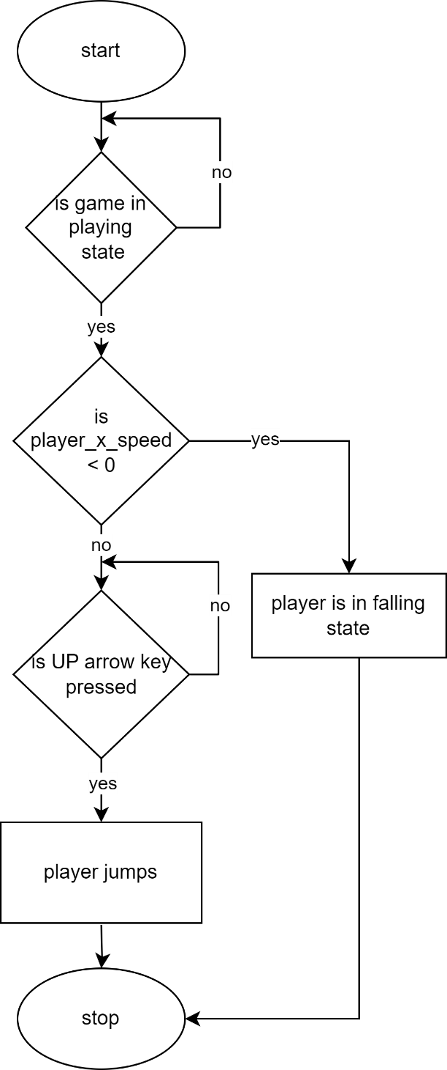

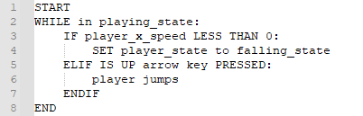

Picking up coins

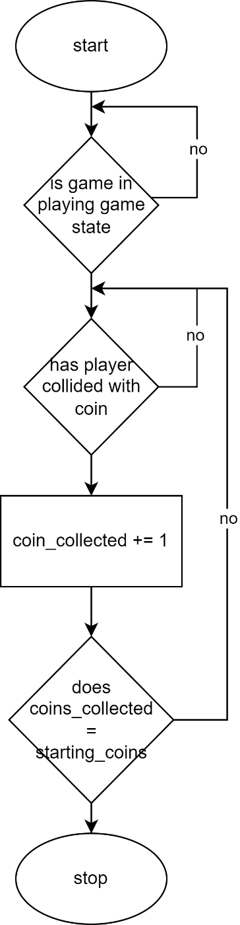

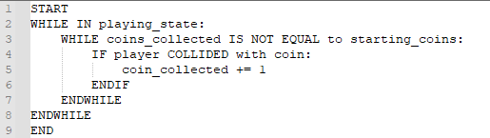

Losing lives
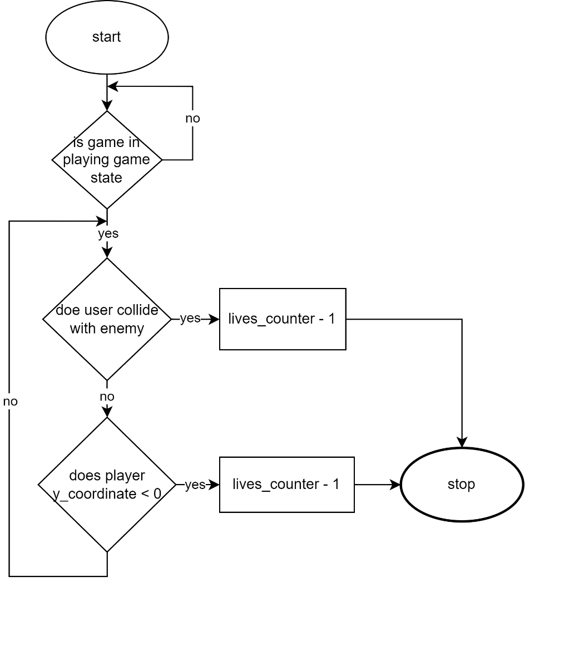

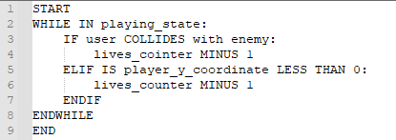

changes in game

Time Counter
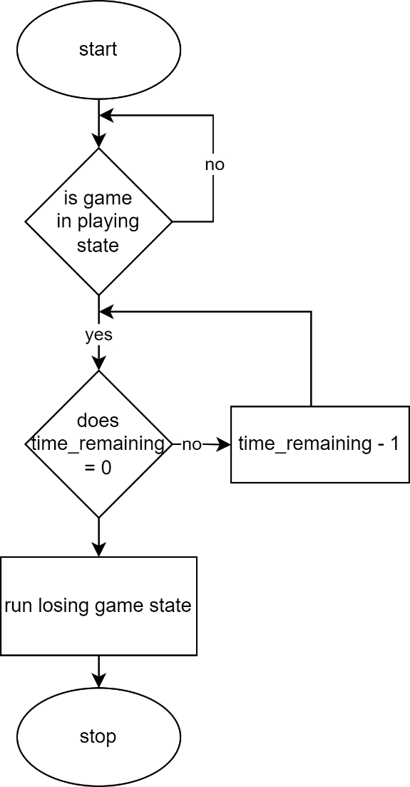

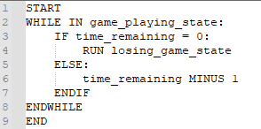

Enemy Movement
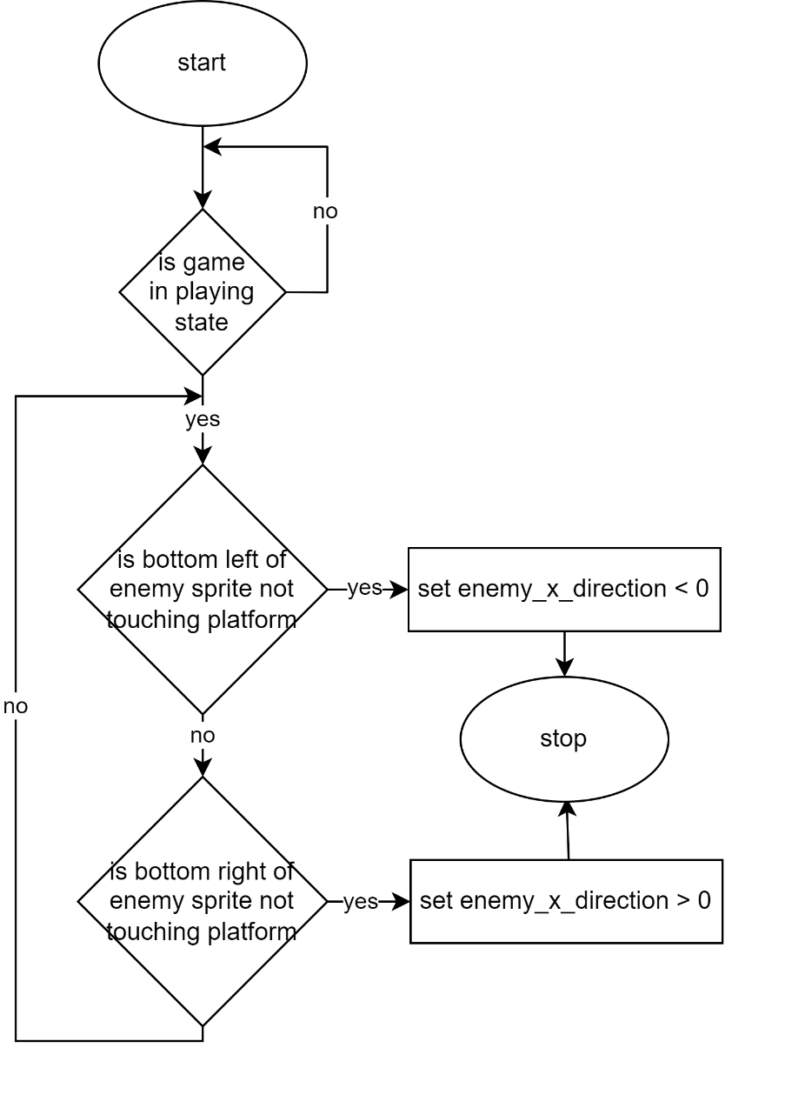

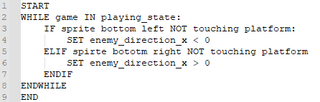

Sound Affects

Background music
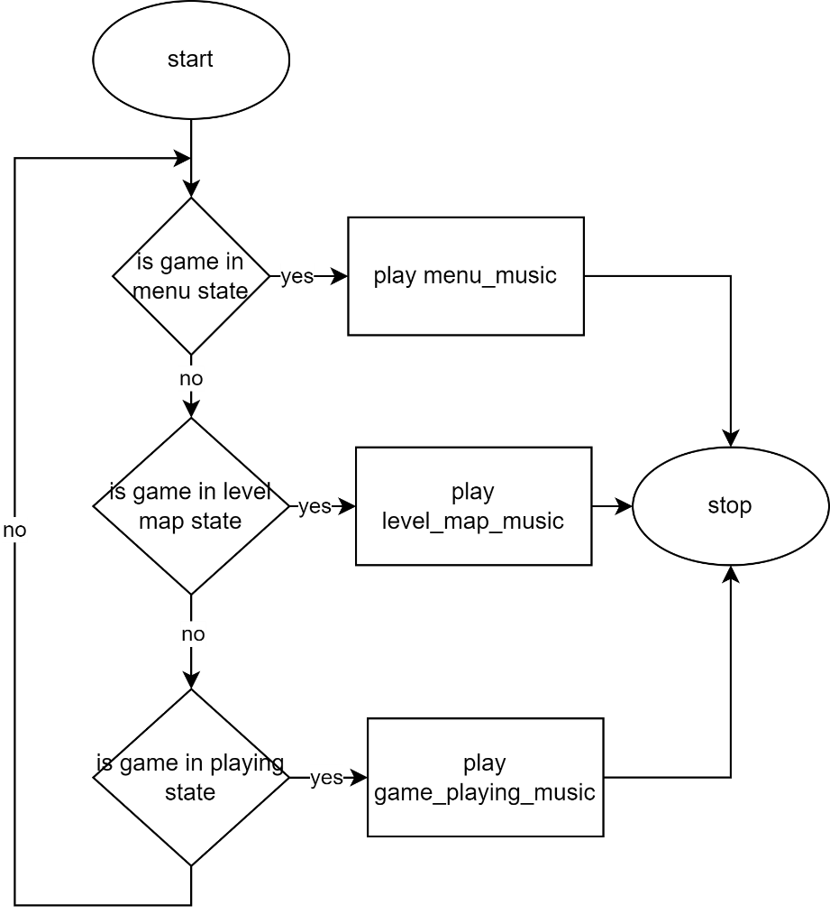

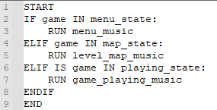

Coin Pickup
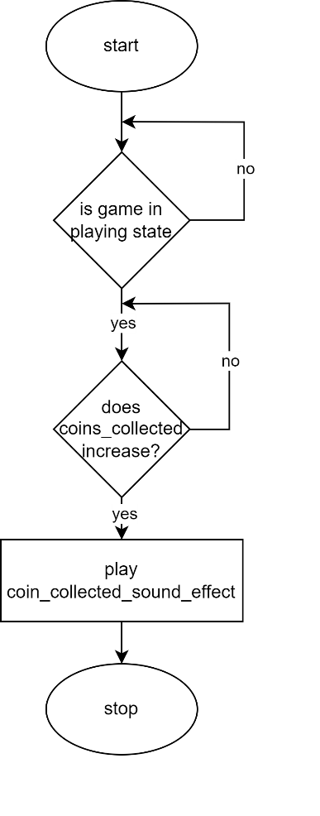

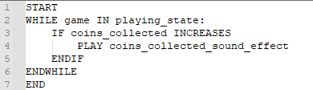

Losing Life

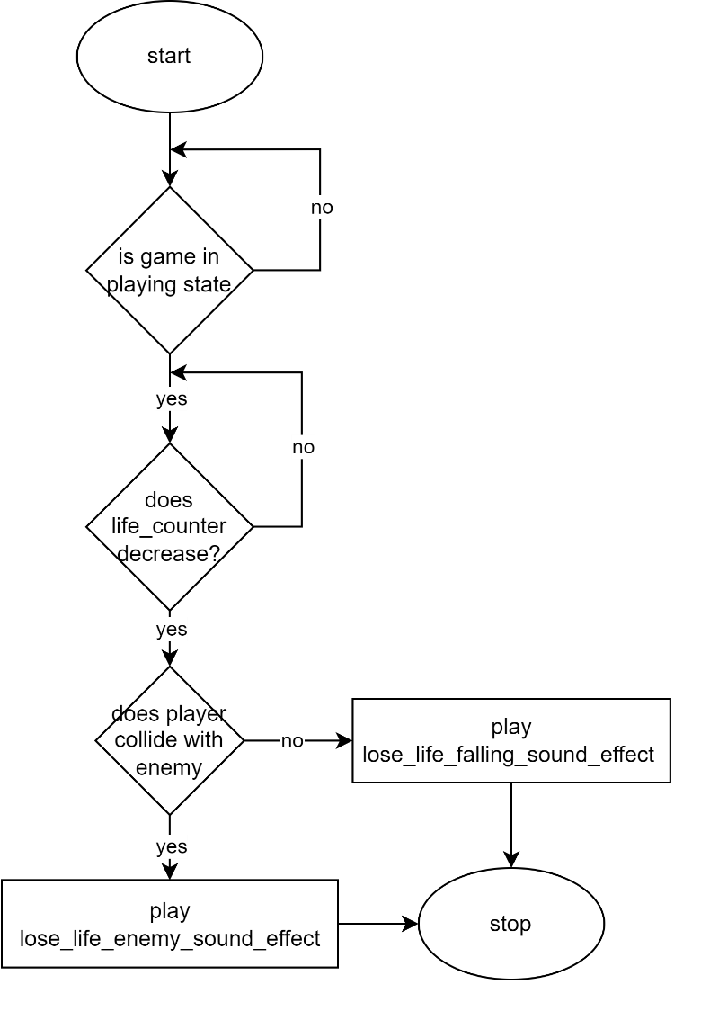

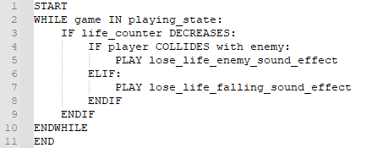

Running Landing
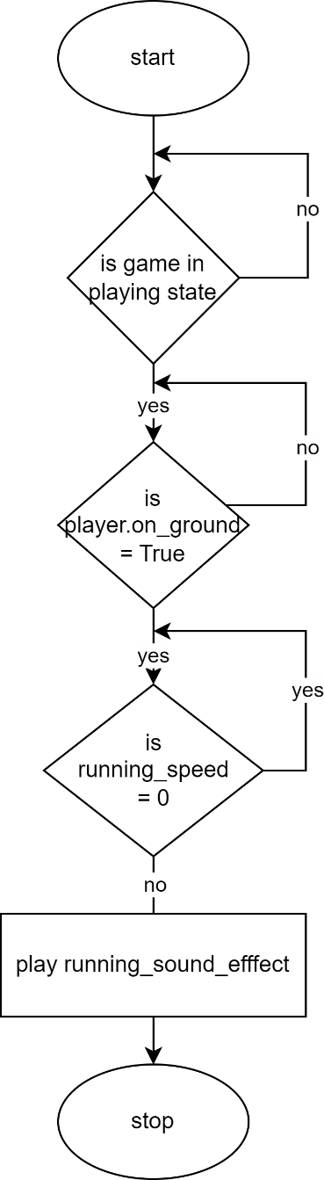
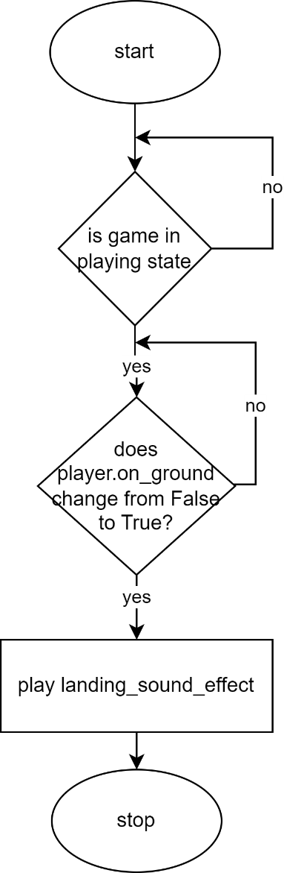

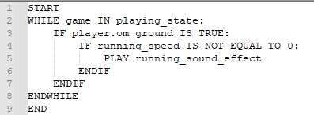

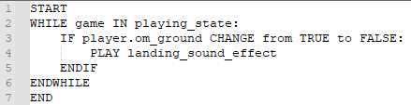
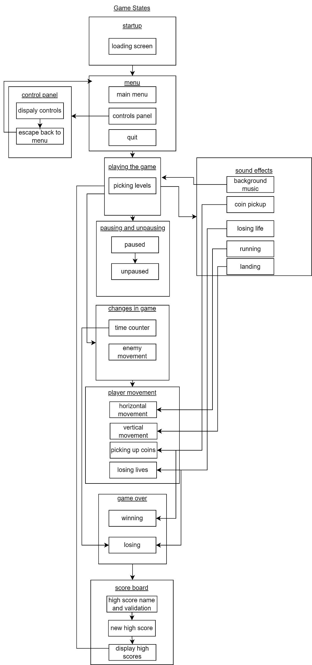
Linking All Algorithms

Key Variables and Data Structures

Method | name | Data type | explanation | justification
Variables | frame_index | Integer | is an integer variable that serves as a counter to keep track of the current frame index for animations. It helps control the sequence of frames when animating character movements, ensuring a smoothand continuous animation. | This variable is crucial for managing and synchronizing character animations, providing a seamless visual experience to the player.
Variables | animation_speed | float | floating-point variable responsible for controlling the speed at which animations change. It determines how quickly the frames of animations cycle, affecting the animation's tempo. | Adjusting the animation speed allows for fine-tuning the pacing of animations, ensuring they match the desired gameplay and visual style.
Variables | image | pygame.Surface | object that represents the player character's image. It serves as the graphical representation of the character displayed on the game screen. | This variable is used for rendering the character within the game world, providing a visual representation of the player's avatar.
Variables | rect | pygame.Rect | bject used to define the position and dimensions of in-game elements, such as the player character and tiles. It's a fundamental component for handling collision detection and accurately positioning objects. | Accurate positioning and collision detection are essential for creating a responsive and immersive gaming experience.
Variables | dust_frame_index | Integer | responsible for tracking the frame index used in dust particle animations, particularly during the player's running motion. It determines which frame of the dust particle animation to display at any given moment. | This variable plays a crucial role in creating dynamic dust effects that enhance the realism of the game world and provide visual feedback on the character's actions.
Variables | dust_animation_speed | Float | loating-point variable used to control the speed of dust particle animations. It defines how quickly the frames of dust particles change, affecting the overall appearance and movement of the particles. | Adjusting the dust animation speed allows for fine-tuning the visual impact of dust effects, ensuring they align with the desired aesthetic and gameplay experience.
Variables | display_surface | pygame.Surface | representing the canvas where all game elements, including the player character and game world, are rendered. It provides a dedicated area for drawing and updating the game's visual content. | This variable is indispensable for rendering the game environment, allowing the game to present its graphical elements to the player.
Variables | create_jump_particles | Function Reference | callback function responsible for generating jump particles. When invoked, this function creates and manages the display of particles, enhancing the visual feedback of the player's actions. | Including this function reference facilitates the customization and flexibility of particle generation, enabling unique visual effects based on game mechanics and design choices.
Variables | direction | pygame.math.Vector2 | object representing the direction of the player character's movement. It encapsulates both the horizontal and vertical components of the character's motion. | This variable is utilized to control the player character's movement, allowing for precise and dynamic motion in response to player input.
Variables | speed | Integer | determines the player character's movement speed. It specifies how fast the character can traverse the game world horizontally. | Adjusting the speed parameter is crucial for fine-tuning the character's mobility, ensuring it aligns with the intended gameplay experience and level design.
Variables | gravity | flaot | representing the gravitational force applied to thee player character. It governs the character's vertical movement, specifically affecting jumping and falling dynamics. | Implementing gravity is essential for creating realistic character physics, enhancing the game's immersion, and providing a natural feel to the character's vertical motion.
Variables | jump_speed | Float | floating-point variable responsible for defining the vertical speed at which the player character jumps. It deterfmines the initial velocity of the character when initiating a jump action. | control the height and timing of character jumpse, contributing to precise platforming and gameplay mechanics.
Variables | status | String | string variable that stores the player character's current status, such as 'idle,' 'run,' 'jump,' or 'fall.' It provides a clear indication of the character's state at any given moment. | racking the character's status is crucial for managing animations, gameplay logic, and character behavior, ensuring that the appropriate actions and animations are executed in response to player input.
Variables | facing_right | Boolean | indicates whether the player character is currently facing to the right (True) or to the left (False). It determines the character's sprite rendering direction. | This variable is essential for rendering the character correctly, ensuring that the character faces the intended direction based on the player's input and movement.
Variables | on_ground | Boolean | signifies whether the player character is in contact with the ground (True) or not (False). It assists in detecting whether the character can jump or perform other grounded actions. | Detecting the character's contact with the ground is essential for implementing precise jumping mechanics, preventing unintended actions, and controlling character behavior during gameplay.
Variables | on_ceiling | booolean | indicates whether the player character is in contact with the ceiling (True) or not (False). It helps identify if the character encounters obstacles overhead. | Detecting contact with the ceiling is vital for implementing gameplay elements that require the character to respond to overhead obstacles, such as avoiding hazards or navigating confined spaces.
Variables | on_left | Boolean | specifies whether the player character is in contact with the left side of an obstacle or object (True) or not (False). It assists in detecting lateral obstructions. | Recognizing contact with the left side of objects is essential for implementing responsive character behavior, suche as preventing the character from moving further to the left when blocked by an obstacle.
Variables | on_right |  | is in contact with the right side of an obstacle or object (True) or not (False). It assists in identifying lateral obstructions on the right. | Detecting contact with the right side of objects is crucial for responsive character interactions, ensuring that the character responds appropriately when blocked by obstacles on the right side.
File | main.py | N/A | The main script responsible for starting and controlling the game. | Essential for orchestrating game logic and execution.
File | player.py | N/A | Contains the player character's behavior and attributes. | Defines the player's actions and interactions within the game world.
File | tiles.py | N/A | Defines the properties of in-game tiles and objects. | Crucial for shaping the game world's visual and physical elements.
File | particles.py | N/A | Manages particle effects used for visual enhancements. | Enhances the game's presentation and provides dynamic visual feedback.
File | settings.py | N/A | Stores game settings, including level maps and screen dimensions. | Centralizes game configuration for easy adjustment and consistency.
File | enemy.py | N/A | Intended for defining enemy behavior and attributes (work in progress). | Reserved for implementing oppositional elements to enhance gameplay.
File | importing.py | N/A | Contains the importing function for importing image assets. | Simplifies image asset import, improving code organization.
file | support.py | N/A | Contains the import_folder function for importing image assets. | Provides a reusable utility for image asset import, enhancing code modularity and maintainability.
Variable

Test Data

Playing

Player

Player starting spawn
Test Data | Type
‘P’ within the level map | Valid
‘5’ within the level map | Invalid
‘R’ within the level map | Invalid
‘E’ within the level map | Invalid
‘C’ within the level map | Invalid
‘X’ within the level map | Invalid
‘ ‘ (empty space) within the level map | Invalid

Player respawn
Test Data | Type
‘R’ within the level map | Valid
‘R’ coordinates displayed on current viewing screen | Valid
‘R’ coordinates not displayed on current viewing screen | Invalid
‘5’ within the level map | Invalid
‘P’ within the level map | Invalid
‘E’ within the level map | Invalid
‘C’ within the level map | Invalid
‘X’ within the level map | Invalid
‘ ‘ (empty space) within the level map | Invalid

Left and right walking movement animation
Test Data | Type
LEFT ARROW key press whilst on tiles | Valid
LEFT ARROW key press whilst in air | Invalid
RIGHT ARROW key press whilst on tiles | Valid
RIGHT ARROW key press whilst in air | Invalid
Player y coordinate values changing | Invalid

Left and right walking movement sound
Test Data | Type
LEFT ARROW key press whilst on tiles for > 1 second | Valid
LEFT ARROW key press whilst on tiles for < 1 second | Invalid
LEFT ARROW key press whilst in air | Invalid
RIGHT ARROW key press whilst on tiles > 1 second | Valid
RIGHT ARROW key press whilst on tiles < 1 second | Invalid
RIGHT ARROW key press whilst in air | Invalid
Player y coordinate values changing | Invalid
RIGHT ARROW key press whilst on tiles = 1 second | Borderline
LEFT ARROW key press whilst on tiles = 1 second | Borderline

Jump movement animation.
Test Data | Type
SPACE KEY pressed when player on tile | Valid
Player y coordinates are increasing | Valid
Player y coordinates are decreasing | Invalid
Player y coordinates are static | Invalid
UP ARROW key is pressed | Invalid
Top of player colliding with tile when jumping | Invalid

Jump movement sound 1 (‘woosh’ sound)
Test Data | Type
SPACE KEY pressed when player on tile | Valid
Player y coordinates are increasing | Invalid
Player y coordinates are decreasing | Invalid
Player y coordinates are static | Invalid
UP ARROW key is pressed | Invalid
Top of player colliding with tile when jumping | Invalid

Jump movement sound 2 (‘yeah’ exclamation) .
Test Data | Type
Current number of jump counter MOD 4 = 0  (If current jump is the fourth jump) | Valid
SPACE KEY pressed when player on tile | Invalid
Player y coordinates are increasing | Invalid
Player y coordinates are decreasing | Invalid
Player y coordinates are static | Invalid
UP ARROW key is pressed | Invalid
Top of player colliding with tile when jumping | Invalid

Fall movement animation
Test Data | Type
Player y coordinates are decreasing | Valid
Top of player colliding with tile when jumping | Valid
SPACE KEY pressed when player on tile | Invalid
Player y coordinates are increasing | Invalid
Player y coordinates are static | Invalid
DOWN ARROW key is pressed | Invalid
Bottom of player touching tile | Invalid

Enemy

Enemies Starting Positions
Test Data | Type
‘E’ within the level map | Valid
‘5’ within the level map | Invalid
‘R’ within the level map | Invalid
‘P’ within the level map | Invalid
‘C’ within the level map | Invalid
‘X’ within the level map | Invalid
‘ ‘ (empty space) within the level map | Invalid

Movement Animations
Test Data | Type
Enemy is on a tile (E directly on top of X in level map) | Valid
Enemy is not on a tile (E on top of ‘ ‘, ‘C’, etc. in level map) | Invalid
(Enemy bottom left coordinates) > (top left coordinates of current adjacent platform) | Valid
(Enemy bottom left coordinates) < (top left coordinates of current adjacent platform) | Invalid
(Enemy bottom right coordinates) < (top right coordinates of current adjacent platform) | Valid
(Enemy bottom right coordinates) > (top right coordinates of current adjacent platform) | Invalid

Collision animations
Test Data | Type
Enemy collides with tile (‘X’), coin (‘C’), respawn point (‘R’) or empty space (‘ ’) | Invalid
Enemy collides with player sprite < 2 seconds from previous collision | Invalid
Enemy collides with player = 2 seconds from previous collision | Borderline
Enemy collides with player > 2 seconds from previous collision | Valid
Lives left counter < 1 | Invalid

Collision sound
Test Data | Type
Respawn sound effect is played | Invalid
Lose game sound effect is played | Invalid
Win game sound effect is played | Invalid
Enemy collides with tile (‘X’), coin (‘C’), respawn point (‘R’) or empty space (‘ ’) | Invalid
Enemy collides with player sprite < 2 seconds from previous collision | Invalid
Enemy collides with player = 2 seconds from previous collision | Borderline
Enemy collides with player > 2 seconds from previous collision | Valid
Lives left counter < 1 | Invalid

Coin

Coin location on screen
Test Data | Type
‘E’ within the level map | Valid
‘5’ within the level map | Invalid
‘R’ within the level map | Invalid
‘P’ within the level map | Invalid
‘C’ within the level map | Invalid
‘X’ within the level map | Invalid
‘ ‘ (empty space) within the level map | Invalid

Coin animation
Test Data | Type
Coin (‘C’) is on tile | Valid
Coin (‘C’) is NOT on tile | Valid
Coin currently visible on current screen | Valid
Coin not visible on current screen | Invalid
Enemy colliding with coin | Valid
Player colliding with coin | Invalid

Coin collisions
Test Data | Type
Enemy colliding with coin | Invalid
(Player sprite right coordinate) > (coin left coordinate) AND (Player sprite left coordinate) < (coin right coordinate) | Valid
(Player sprite right coordinate) < (coin left coordinate) AND (Player sprite left coordinate) > (coin right coordinate) | Invalid
(Player sprite left coordinate) > (coin left coordinate) AND (Player sprite left coordinate) < (coin left coordinate) | Invalid
(Player sprite right coordinate) > (coin right coordinate) AND (Player sprite right coordinate) < (coin right coordinate) | Invalid
(Player sprite right coordinate) = (coin left coordinate) OR (player sprite left coordinate = coin left coordinate) | Borderline

Coin collision sound
Test Data | Type
(Player sprite right coordinate) > (coin left coordinate) AND (Player sprite left coordinate) < (coin right coordinate) | Valid
(Player sprite right coordinate) < (coin left coordinate) AND (Player sprite left coordinate) > (coin right coordinate) | Invalid
(Player sprite left coordinate) > (coin left coordinate) AND (Player sprite left coordinate) < (coin left coordinate) | Invalid
(Player sprite right coordinate) > (coin right coordinate) AND (Player sprite right coordinate) < (coin right coordinate) | Invalid
(Player sprite right coordinate) = (coin left coordinate) OR (player sprite left coordinate = coin left coordinate) | Borderline
Enemy colliding with coin | Invalid
Enemy collision explosion sound currently playing | Valid
You lose audio currently playing | Invalid

Coins Remaining Check
Test Data | Type
(Coins collected) =! ((not equal to) number of coins (‘C’) displayed at start of current level) | Valid
(Coins collected) = (number of coins (‘C’) displayed at start of current level) | Invalid
Number of coins displayed at start of current level = 0 | Invalid

Coins Collected Check
Test Data | Type
(Coins collected) = (number of coins (‘C’) displayed at start of current level) | Valid
(Coins collected) =! ((not equal to) number of coins (‘C’) displayed at start of current level) | Invalid

Tiles

Displaying Tiles
Test Data | Type
‘X’ within the level map | Valid
‘5’ within the level map | Invalid
‘R’ within the level map | Invalid
‘P’ within the level map | Invalid
‘C’ within the level map | Invalid
‘E’ within the level map | Invalid
‘ ‘ (empty space) within the level map | Invalid

Shifting the world
Test Data | Type
X direction of player = 0 | Invalid
Player x coordinate = 300 | Borderline
Player x coordinate = 900 | Borderline
Player speed = 0 | Invalid
(Player x coordinate < 300) AND (x direction of player < 0) | Valid
(Player x coordinate > 900) AND (x direction of player > 0) | Valid
(Player x coordinate < 300) AND (x direction of player > 0) | Invalid
(Player x coordinate > 900) AND (x direction of player < 0) | Invalid
Player x coordinate in range between 300 -> 900. E.g. x coordinate > 300 and < 900 | Invalid

Life Removal

Removing a Life
Test Data | Type
Lives counter < 1 | Invalid
(Player y coordinate) < (screenHeight + 100 (=740)) | Valid
(Player y coordinate) > (screenHeight + 100 (=740)) | Invalid
(Player y coordinate) = (screenHeight + 100 (=740)) | Borderline
Collide with enemy and time since last enemy collision > 2 seconds | Valid
Collide with enemy when time since last enemy collision < 2 seconds | Invalid
Collide with enemy and time since last enemy collision = 2 seconds | Borderline

Pausing

Pause
Test Data | Type
“p” | Valid
“m” | Invalid
“q” | Invalid
“(” | Invalid

Un-pause
Test Data | Type
“p” | Valid
“m” | Invalid
“q” | Invalid
“(” | Invalid

Time

Time
Test Data | Type
Time = “sdfds” | Invalid
Time = 0 | Invalid
Time = 2.6 | Invalid
Time = 5 | Borderline
Time > 5 | Valid
Time < 5 | Invalid
Time = 999 | Borderline
Time < 1000 | Invalid

Time runs out
Test Data | Type
Time = 0 | Valid

Exit

Exit
Test Data | Type
“q” | Valid
“ESC” | Valid
“m” | Invalid
“p” | Invalid
“(” | Invalid

Other game states

Leaderboard

New high score
Test Data | Type
(new score) > (scores on board) | Valid
(new score) < (scores on board) | Invalid
(new score ) = (scores on board) | Borderline

High score name and validation
Test Data | Type
54 | Invalid
Bobman88 | Valid
12738219david190283winning | Invalid
[inappropriate and offensive terms or words] | Invalid
Length of name < 12 AND > 2 | Valid
Length of name > OR < 2 | Invalid
Length of name = 11 OR = 2 | Borderline

Menu

Start game
Test Data | Type
“p” | Valid
“m” | Invalid
“c” | Invalid
“(” | Invalid

Controls screen
Test Data | Type
“c” | Valid
“m” | Invalid
“p” | Invalid
“(” | Invalid

Exit game
Test Data | Type
“q” | Valid
“ESC” | Valid
“m” | Invalid
“p” | Invalid
“(” | Invalid

Controls

Return to menu
Test Data | Type
“m” | Valid
“c” | Invalid
“p” | Invalid
“(” | Invalid

Quit
Test Data | Type
“q” | Valid
“ESC” | Valid
“m” | Invalid
“p” | Invalid
“(” | Invalid

Level Map

Return to Menu
Test Data | Type
“m” | Valid
“c” | Invalid
“p” | Invalid
“(” | Invalid

Leaderboard
Test Data | Type
“l” (a lower case L) | Valid
“m” | Invalid
“p” | Invalid
“(” | Invalid

Quit
Test Data | Type
“q” | Valid
“ESC” | Valid
“m” | Invalid
“p” | Invalid
“(” | Invalid

Play level
Test Data | Type
“p” | Valid
“c” | Invalid
“(” | Invalid

Select Level
Test Data | Type
Level adjacent to any levels previously completed | Valid
Level not adjacent to any level previously completed | Invalid
RIGHT ARROW key pressed | Valid
LEFT ARROW key pressed | Valid
“p” | Invalid
“q” | Invalid

Game Over (You Lose)

Return to menu
Test Data | Type
“m” | Valid
“q” | Invalid
“(” | Invalid

quit
Test Data | Type
“q” | Valid
“ESC” | Valid
“m” | Invalid
“p” | Invalid
“(” | Invalid

Game Over (You win)

Return to menu
Test Data | Type
“m” | Valid
“q” | Invalid
“(” | Invalid

Quit
Test Data | Type
“q” | Valid
“ESC” | Valid
“m” | Invalid
“p” | Invalid
“(” | Invalid

Acceptance Testing

No. | Requirements | input | Expected outcome
1. | Title screen displayed when game is first opened . | Valid: Launching the game code  Invalid: Closing the game immediately after launching. | Valid: The title screen of the game should be the initial display upon opening the game.  Invalid: N/A (As this action doesn’t fulfill the requirement of observing the title screen), it just closes
2. | Menu screen displayed with options to navigate to, like quit, controls or play | Valid: Pressing ‘c’ or ‘q’ or ‘p’  Invalid: pressing ‘u’ or ‘6’ | Valid: Pressing "C" navigates to the controls, "P" initiates gameplay, and "Q" leads to quitting the game from the main menu.  Invalid: nothing will happen as these controls don’t cause anything to execute
3. | Users score is added to leaderboard if it is in the top 5, the users final score is added  to the score board if it is  greater than the score boards  lowest score | Valid: Achieving a score higher than the lowest score on the leaderboard.  Invalid: Achieving a score that is equal to or lower than the lowest score on the leaderboard. | Valid: The user's final score gets added to the scoreboard, replacing the lowest score if it surpasses it.  Invalid: The user's score is not added to the leaderboard or scoreboard if it doesn’t surpass the lowest score.
4. | User can enter their own custom name to be displayed in the score board, if it is greater than 2 characters and less than 21 | Valid: any usernames between 2 and 21 charcaters like “Bobman88” or “123David”  Invalid: any usernames not in this range like “a” or “davidskriton12345likesgames234” | Valid: The custom name is accepted and displayed on the scoreboard.  Invalid: The custom name entry is rejected as it exceeds the maximum character limit.
5. | User can select between different levels on a level map screen | Valid: using arrow keys to navigate between levels, ‘p’ to play the level  Invalid: pressing any other keys such as ‘u’ or space bar | Valid: level will be selected and played if “p” is pressed  Invalid: nothing should happen as these keys are not programmed in
6. | Each completed level is shown a rating out of 3 stars based off how many lives they have left at the end | Valid: 1 star, 2 star or 3 star  Invalid: anything above 3 stars  Borderline: 0 stars | Valid: these will displayed below the level  Invalid: cant be displayed below the level as not enough stars to represent then number  Borderline: a tombstone will be shown instead of stars, as the user is still unable to complete this level
7. | Remaining lives displayed top left. | Valid: player has 1, 2, or 3 lives  Invalid: player has less than 1 life | Valid: the number of lives will be displayed on the screen in the top right  Invalid: the game will be over (because you would have lost) so no lives will be displayed on the screen
8. | Time remaining displayed at the top in the middle of the screen | Valid: any time 5 seconds or above and below 1000 seconds  Invalid: a time less than 5 seconds or above 999 seconds  Borderline: a time of 5 seconds or 999 seconds | Valid: the user will have enough time to complete the game and see what is happening  Invalid: the player wont have enough time to see what is going on and play the game, or the player will have too long that the time on the screen would overlap the timer background  Borderline: the player will just about have time to play the level, and the timer will just about be within the timer box
9. | Number of coins left to collect shown top right | Valid: any number of coins greater than 0  Invalid: 0 coins left to collect | Valid: the number will be displayed  Invalid: the number of coins cant be displayed because the game winning state will be being displayed
10. | Number of Coins collected displayed top right | Valid: any positive integers  Invalid: anything other than positive integers, such as negative or floats | Valid: this number will be displayed in the top right  Invalid: this cannot be displayed as it is not possible to get, because each coin collected is equal to 1, and it increments the coins collected so always is positive
11. | Start with three lives each round | Valid: player has 3 lives at start of round  Invalid: player has anything other than 3 lives at the start of the round | Valid: player will start round with 3 lives  Invalid: player will start round with a number that is not 3 lives
12. | Different number of enemies and coins per level, and a different arrangement of tiles | Valid: different number of coins, enemies and a different arrangement of tiles  Invalid: same number of coins, enemies and same arrangement of tiles | Valid: the tiles will be displayed in the different arrangement, and there will be more/less coins to collect and more/less enemies to avoid  Invalid: tiles displayed in same place, same number of enemies and same number of coins will spawn in the level
13. | Player collects a coin when it collides with it, added to collected coins and removed from coins to collect | Valid: player collides with a coin  Invalid: player collides with anything that isn’t a coin | Valid: the coin collected counter is incremented and the coin is removed form the screen, coin remaining counter is decremented by 1  Invalid: the coin collected and coins remaining counters remain unchanged
14. | User loses a life by colliding with enemy | Valid: user has 1 or more lives and collides with player  Invalid: user doesn’t collide with player, or has less than 1 life | Valid: number of lives will be decreased  Invalid: no lives are removed if doesn’t collide, or losing state is running since player already has no lives
15. | User loses a life by falling off the map | Valid: user has 1 or more lives and y position is less than height of the screen  Invalid: user has less than 1 heart or y position doesn’t go less than screen height  Borderline: y position is equal to screen height | Valid: player loses a life and respawns at the set respawn point  Invalid: game isn’t in playing state and is already in game lost state, player doesn’t fall off the map so continues as normal  Borderline: player continues as normal
16. | Timer started as soon as game starts and counts down once per second to act as a timer | Valid: timer decrements by 1/60, since FPS is sent to 60, so it will be decrementing by 60 1/60 in a second which equals 1 second  Invalid: timer decrement by anything other than 1/60, or FPS is anything other than 60 | Valid: timer will decrease 1 per second giving it a timer decreasing effect like a clock  Invalid: tier will decrease by something other than 1, probably a float, meaning the timer will be messed up and display decimal point times
17. | All sprites are pixel art retro style | N/A | All sprites and backgrounds will be in a pixel art style
18. | Sound effect for when player is running | Valid: the player is on ground and the left or right arrow key is pressed  Invalid: ‘m’ key, or arrow keys pressed when player is in air, or any other keys pressed other than arrow keys when on grown | Valid: the sound effect will be played  Invalid: the sound effect wont be played
19. | Sound effect for when player jump | Valid: player is on ground and the space bar is pressed  Invalid: any other key is pressed such as ‘5’ or ‘5’, or the player isn’t initially on the ground | Valid: the swooshing sound effect will be played  Invalid: no jumping sound effect will be played
20. | Sound effect for when the player jumps every once in a while | Valid: player is on ground and the space bar is pressed four timesv(e.g. the player has jumped three times previously)  Invalid: any other key is pressed such as ‘5’ or ‘5’, or the player isn’t initially on the ground, or it isn’t the fourth jump | Valid: the shouting sound effect will play on every fourth jump  Invalid: no shouting sound effect is played
21. | Sound effect for falling off map | Valid: if the y direction of the player has been decreasing for more than 1 second  Invalid: y direction of player has been decreasing for less than a second, or hasn’t been decreasing at all | Valid: falling sound effect is played  Invalid: no sound effect is played
22. | Sound effect for Respawning | Valid: if the player respawns at a point given (the coordinates of the player suddenly change drastically)  Invalid: player doesn’t respawn (coordinates remain the same or consistently changing) | Valid: respawning sound effect is played  Invalid: no respawning sound effect is played
23. | Sound effect for picking up coin | Valid: if the player collides with a coin  Invalid: player collides with anything that isn’t a coin | Valid: coin sound effect is played  Invalid: no coin sound effect is played
24. | Sound effect for when you collide with enemy | Valid: player collides with an enemy  Invalid: player collides with anything other than an enemy, player collides with an enemy within 2 seconds of already colliding with an enemy | Valid: enemy colliding sound effect is played  Invalid: no enemy colliding sound effect is played
25. | Sound effect for winning the game | Valid: if all coins remaining = 0  Invalid: time left = 0 (runs out of time), player has 0 lives left, coins remaining equals anything other than 0 | Valid: winning sound effect is played  Invalid: winning sound effect is not played
26. | Sound effect for losing the game | Valid: time left = 0 (runs out of time), player has less than 1 lives left  Invalid: timer is greater than 0, player has 1 or more lives | Valid: play losing sound effect  Invalid: losing sound effect is not played
27. | Animation for the enemy walking | Valid: enemy is on a tile  Invalid: enemy is not on a tile | Valid: animation for enemy walking is played  Invalid: animation for enemy walking is played
28. | Animation for the player running | Valid: player is on ground and left or right arrow key is pressed  Invalid: player is not on ground, or any keys other than left or right arrow keys are pressed such as ‘{0 or ‘d’’ | Valid: player running animation is played  Invalid: player running animation is not played
29. | Animation for the player idle | Valid: player is not moving, no keys are being pressed  Invalid: any keys are pressed, ‘d’ or ‘3’ for example | Valid: player idle animation is played  Invalid: player idle animation is not played
30. | Animation for the player jumping | Valid: player is on ground and space bar is pressed  Invalid: player is not on ground, or any other key is pressed other than space bar, for example ‘u’ or ‘@’ | Valid: player jumping animation is played  Invalid: player jumping animation is not played
31. | Animation for the coins | Valid: coin is on a block above a tile  Invalid: coin is not on a block above a tile | Valid: coin animation is played  Invalid: coin animation is played
32. | Animation for losing a life | Valid: player collides with an enemy  Invalid: player collides with anything else other than an enemy, or collides with an enemy within 2 seconds of previously colliding with one | Valid: losing life animation is played  Invalid: losing life animation is not played
33. | Press p to pause game whilst playing | Valid: ‘p’ key is pressed  Invalid: any key other than ‘p’ is pressed | Valid: the pause screen will be displayed  Invalid: the pause screen will not be displayed, game playing state remains displayed
34. | Esc to quit the game at any time | Valid: ESC key is pressed  Invalid: any key other than the escape key is pressed | Valid: game is quit  Invalid: game is not quit, remains in current state
35. | M to get back to menu from pause state | Valid: ‘m’ key is pressed during pause state  Invalid: ‘m’ is pressed during a state which isn’t the pause state, or any key other than ‘m’ is pressed | Valid: menu state is run  Invalid: menu state is not run, paused screen is still displayed
36. | P to un pause when in paused state | Valid: ‘p’ key is pressed during paused state  Invalid: any key other than ‘p’ is pressed, ‘p’ is pressed not during paused state | Valid: game switched to game playing state and game resumes  Invalid: paused screen will remain displayed
37. | Backgrounds and tiles can be different for each level, or every 5 different levels for example | N/A | Every few levels, such as every 5 levels, the background image my change, and the tiles may be a different image tile
38. | Winning screens displayed when all coins collected within time limit | Valid: remaining coins is equal to zero  Invalid: remaining time = 0, or player has run out of lives and live counter is less than 1 | Valid: winning screen is displayed  Invalid: winning screen is not displayed
39. | Losing screens displayed when run out of time or lose all lives | Valid: remaining time = 0, or player has run out of lives and live counter is less than 1  Invalid: remaining coins is equal to zero, remaining time is greater than zero and live counter is 1 or more | Valid: losing screen is displayed  Invalid: losing screen is not displayed
40. | Check with user before quitting the game by displaying a check box | Valid: user confirms quit, by clicking ‘q’  Invalid: any key other than ‘q’ is pressed such as ‘{‘, ‘9’ or ‘m’ | Valid: game quits  Invalid: game does not quit, check box is removed from screen
41. | All backgrounds are pixel art retro style | N/A | All the backgrounds in the game will be the pixel art retro style

Developing the Coded Solution (“Development Story”)

In this section of the report, I will go through the actual development stage of my game. It will be similar to a diary with the dates followed by what I completed in that time

Sprite Creation

Date: 05/03/23

I first started by creating the background images and menu, controls etc.. I decided to do this first as it follows the sequence of the game loading, and it made logical sense to make the background first, in which every other game state screen would be based off.
I started off by using an internet browser to search for relevant pixel styled images e.g. a background, sprite sheet for the HUD (the wooden buttons and boxes), tiles etc. I then used Microsoft paint in order to edit the images together. I used Microsoft paint as it is something I am familiar working with, and it has all the features and capabilities I will need, such as resizing, drawing, copy ,paste and writing on text.
These screenshots show the process I went through.

Making the main background
Refining the search to make sure only Images with a Creative Commons licence would be displayed, meaning I wouldn’t be breaking any laws and the images will be free to use as I please
I was using the Microsoft Bing search engine, as it is the default on the computer I was working on, and offers a large selection of different types of images.

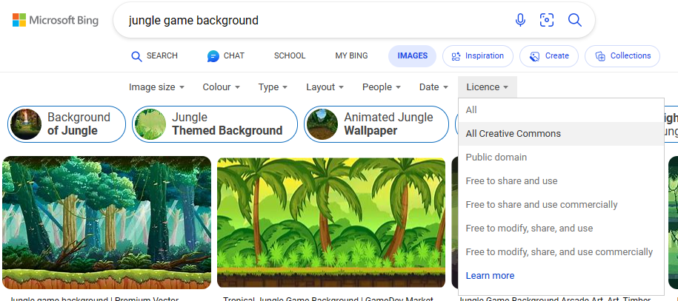

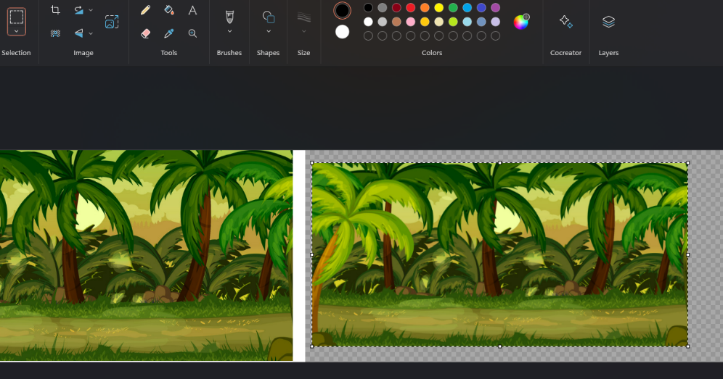

In the paint app I pasted the image I wanted as the background in, then I extended the image sideways and using the select feature I copy pasted the original image about 7 times.

This was the result, it is long enough for the level to be massive and the screen will be able to scroll and the background will look the same and be consistent throughout

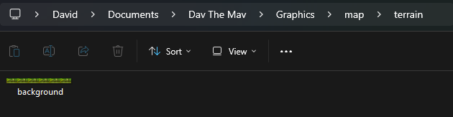

I then saved this as a .png file called background
Made a graphics folder separate from my code, so it is easier to keep track of the components of the game, and change graphics more easily if needed

Finding a user interface sprite sheet
I searced for a UI, user interface, sprite sheet which would give me the details I needed to edit the menu screen
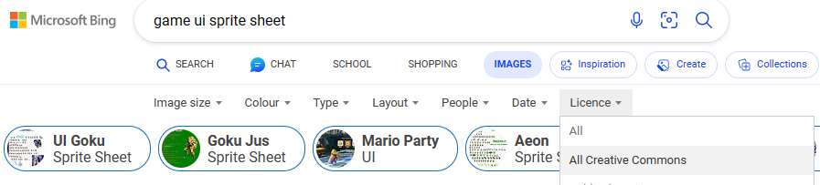

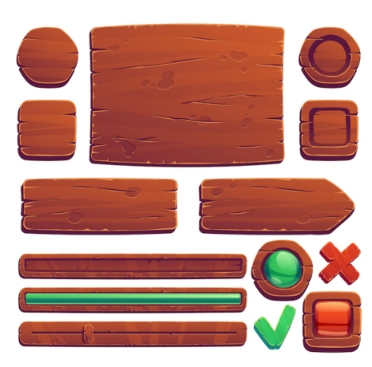
This was the sprite sheet I selected, as it was simple but included a variety of shaped boxes/signs which would allow me to customise my game. It also fit the theme of the jungle background which is suitable for this level.

Making the menu

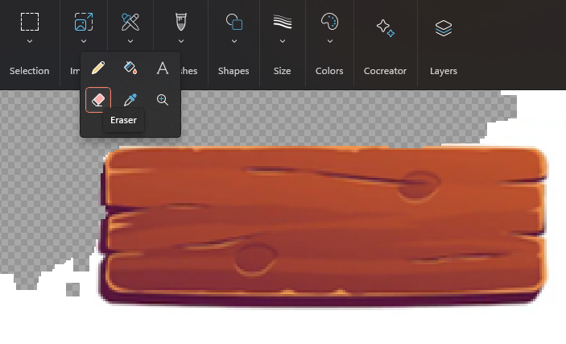
I used the select tool in Microsoft paint to single out one of the boxes, I then opened this in a new window and using the eraser tool I removed the white background around it.

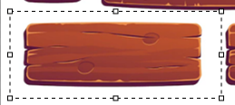

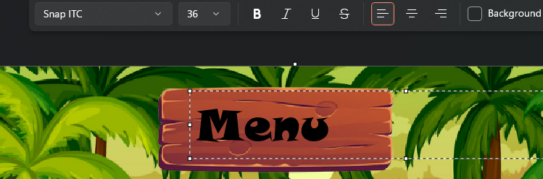
I then pasted this box with the background removed back on to the original background. I then added text and changed the font and size to fit the game theme better.
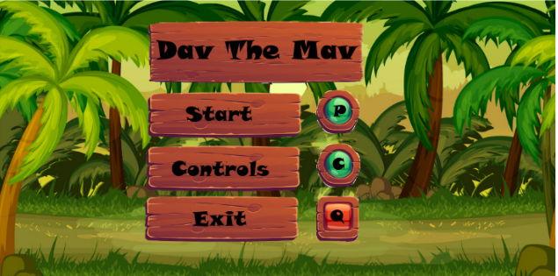
I repeated for the rest of the screen. However I decided to change from Menu to ‘Dav the Mav’, as it will remind the user what game they are playing

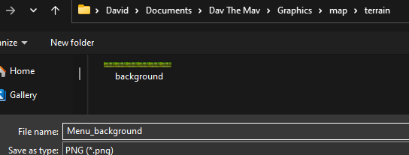
After that, I saved the menu screen as a .png file in the same folder as my background image

Date: 07/03/23

Getting the tiles sprite

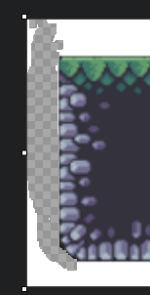
I found the tile online, as a singular image. I removed the background using the eraser feature in the Paint app and then save it in my graphics folder to be accessed by my code

Character Sprite Animations

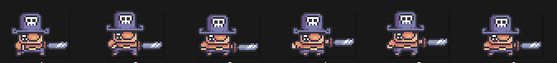
All the images for the player character I found from a free online tutorial on game development. I downloaded the player sprites from this tutorial and split them up using Microsoft Paint and the built in snipping tool for Windows, I saved each different image in its own file called 1.png, 2.png and so on.

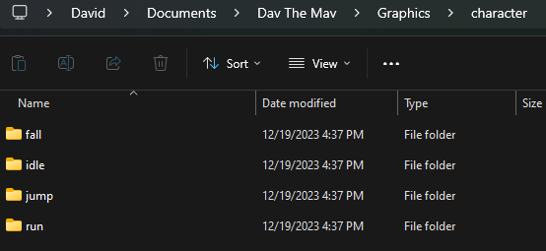

Then each different ‘category’ of player movement I saved each different set of player images into each folder, making it clear and simple when it comes to coding and organising my animations

Coin Sprite
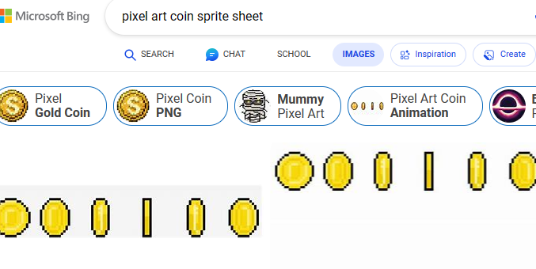
Searched pixel art to make sure it follows the same theme as the rest of my sprites so far in the game

Then I did the same for what I did with the player and split the sprite sheet up into separate image files with sensible names. I also put all of these into their own separate folder to make it easy to iterate through them when trying to animate them later
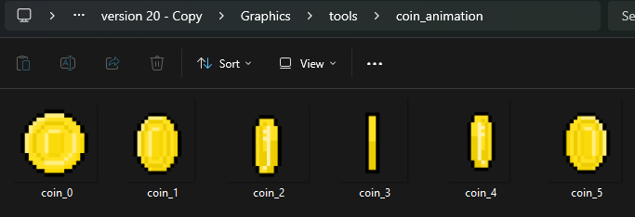

Date: 10/03/23

Setting up the Enemy sprites

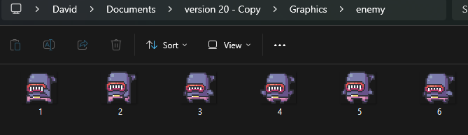
The enemy images were also gotten from the free online tutorial about game development. In the same way as before I separate the sprite sheet into individual files with suitable names, then store each image in the same folder, named ‘enemy’

Lives

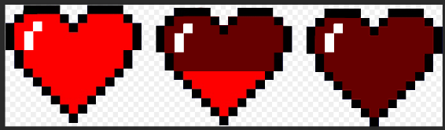
This was the original sprite sheet I used for the hearts. So I opened the image in paint, and using the select feature deleted the middle heart that I didn’t need

Then made four separate images, each one with a different combination of hearts which I obtained by deleting some hearts, and then copy pasting the others.
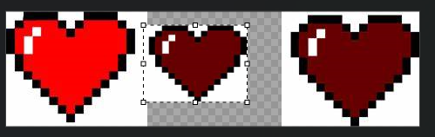

This is how I saved the hearts, each one as a .png file. The name of the image represents how many hearts are displayed in it. I then saved all four of these images in their own folder within the graphics and called it ‘lives’. Which can be easily accessed later when I am coding

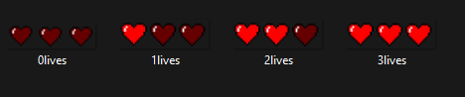

Setting up the explosion sprites

Found a sprite sheet of a pixel art explosion of about 15 images. However I only used 10 as this was all that was needed
Cropped each section of the sprite sheet, and then removed the white background to give me 10 different explosion images. Also removed parts of the bottom of the explosion using the eraser. This was to make the sprite look more realistic and suit the environment of the game more
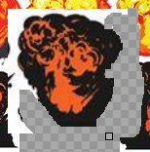

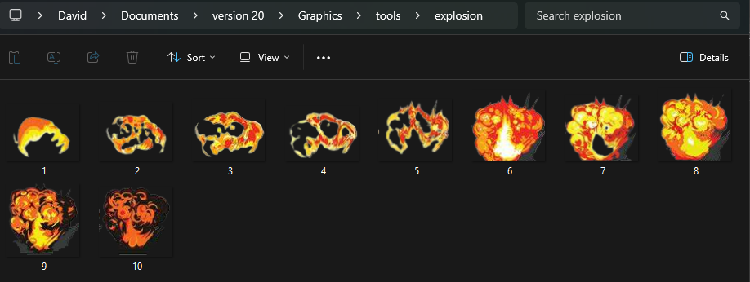
Each explosion was saved as a .png file in consecutive numbers within a folder called ‘explosion’ within my graphics. The naming of the files make it easier to iterate through and implement the animation later on

Date: 11/03/23

Creating the dust animation images
I created these dust animations myself, by using the draw feature in Microsoft paint. I drew them in black, and then used the eraser to remove the background, and then converted all the black to white. This made it easier to draw and also meant the particles were white when I saved them.
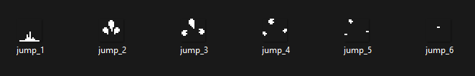

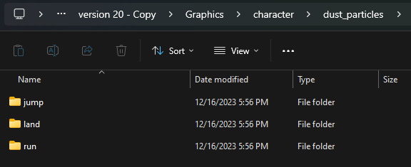
They are all stored and named appropriately, keeping everything organised. There is a folder within graphics called character which contains any images to do with the player. So I decided to include the dust particles in this folder too, in their own separate sub-folder called dust_particles.

Winning and Losing screen

Both the winning and losing screen were created the same way that the menu screen was created. By selecting, removing the background and then pasting in parts from the UI sprite sheet. And then adding the text required

These tombstones were ones I drew in Microsoft paint myself, then removed background and selected and pasted onto this screen.
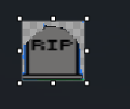

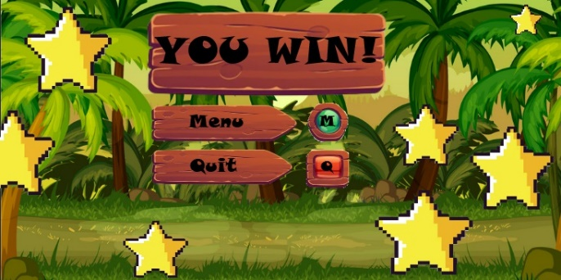
You win screen made in the same way as the you lose screen, obviously just different text for the title at the top when writing it in Microsoft paint.

The stars were ones I just found from online. I then needed to remove the background using the eraser from Microsoft paint before I pasted them on to the you win screen



Logo Design startup screen

This was done purely in Microsoft Paint, using tools such as brushes, different sizes and type, colour picker, fill tool etc.
Other sprites form the game were included in this, didn’t need to do any background removing as all these sprites had already had that

Making the controls screen

This was done in same way of losing screen and winning screen, and the same way in which other sprites were copy and pasted in like for the logo, I have done the same here. Also included the tick and cross from the sprite sheet, which I had to remove the background of
The eraser tool was used to remove the white background from these four parts of the sprite sheet. I then used the select tool to crop them out individually and then copied that image and pasted it on to the background image
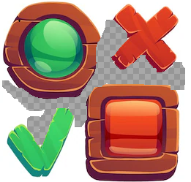

Code Deconstruction

Date: 17/03/23
This section of my solution will be closely following the development of the game code for ‘Dav The Mav’. The development will be shown through a series of screenshots, with the code heavily commented already, but then with annotations of the code along with a suitable amount of testing as I am coding to ensure the code I have written works well, and the way it is intended to. To start off my code, I decided to do some research into python and pygame, which is what I will be using to program my game. I will look into other games coded with pygame to see what their structure is like and what techniques I should be using for each individual module I try to solve.
The first article I used to start learning techniques was this one: PyGame: A Primer on Game Programming in Python – Real Python.
I have also found a YouTube video called “Creating a platformer in Pygame” by Clear Code.
And finally this website: Pygame Framework - 101 Computing

Structure

Class 4
Class 1
Main File
Class 2
See basic framework for class
Class 3

I will have the main file, where the pygame window is initialised, then I will have separate classes for things such as enemy movement, player movement, importing things etc. which are called from within the main file, some classes will also call other classes from within them. Such as the importing class will be called a lot in other classes

Here is an example of a class. I will be following this framework for every class that I make

These are just parameters that initialise the ‘name’ and ‘age’ attributes of the class
This line initiates the creation of a class named ‘Person’. Classes act as blueprints to allow us to create multiple similar objects/things and writing less code
represents the instance of the class and allows access to its attributes and methods.
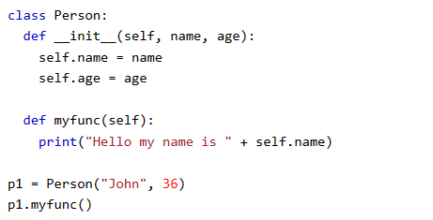
This is just a function within the class, self refers to the instance of the class
Assign the values passed when the object is created to the ‘name’ and ‘age’ attributes of the object
Constructor for the class, always called when a new instance of that class is created.
This creates a new instance of the class and passes ‘John’ as the name and ‘36’ as the age

This calls the function from within the class

Now with this basic framework for the class, and the documents/tutorials I have found on the internet. I am ready to start coding

Where will I program

I also decided to code all of my game within an IDE. I decided to use Pycharm, as it is has a large fan base if I ever have issues and need help and it is a well documented secure python IDE.
Using an IDE will be very beneficial to me, as it provides tools such as tab completion, debugging, code suggestions and much more. This will help me to save lots of time when coding and allow my code to be more clean and easier to understand.
From the official website, I downloaded the community edition (because it is free and has all the features I need)

Making sure to install the latest version of the windows Pycharm

Date: 02/04/23

Setting up the screen

I made a file called main.py and wrote this code

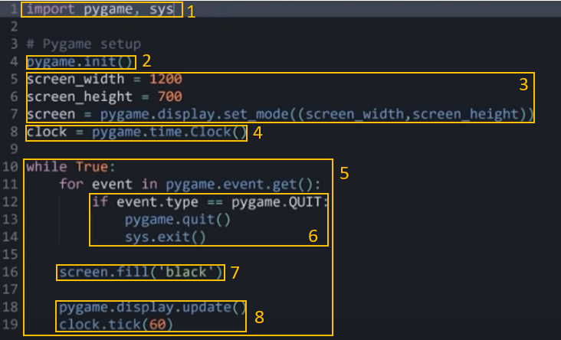

1 - Importing the libraries needed for the game. Pygame is needed to run any pygame code, and sys is needed to close the game
2 - initializes all the modules required for Pygame to function properly and ensures that all the necessary components are properly set up before any other Pygame functions are called which is why I have put this line near the start of the code
3 – these are the variables declaring the dimensions of the screen. Line 7 then creates a variable called screen which is the display surface that is used to show the screen, dimensions are passed into this function
4 - creates a Clock object. This object is used to control the framerate of the game.
5 – Creates the main game loop. This loop runs continuously until something inside the loop breaks the condition or explicitly stops the program.
6 - for event in ‘pygame.event.get():’ checks for events from the keyboard or mouse. ‘pygame.QUIT’ is when the user presses the x to close the window in the top right. If this event is detected, then pygame is quit and the system exits pygame.
7 – fills the entirety of the screen plain black
8 – ‘pygame.display.flip()’ updates the entire display everything that has been drawn to the screen, and the clock.tick just controls the frame rate. I have used a frame rate of 60 seconds as per usual of most similar games
This is the outcome of the code, and it is what was expected:
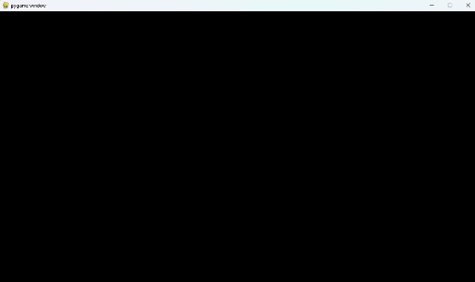

What’s being tested? | input | justification | Expected outcome | Actual outcome
Whether or not the pygame screen is initalised | Running the code file | This provides a base to display every other aspect of my game to | A plain black screen | A plain black screen

Changing window size and drawing on tiles
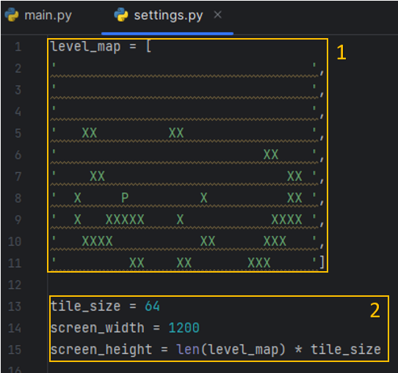
Made a new file called settings.py. This is where the details about the different levels, tile sizes, dimensions of screen etc. will be stored.
1 – creating a list called level_map, the X represents where a tile will be drawn to the screen and The P represents where the player will spawn
2- this is the dimensions of the screen, the screen width will always be 1200 pixels, however the screen height will depend on the length of the level. This means the screen will fit better with the current level and tiles being displayed
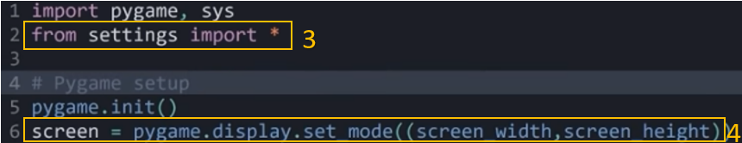

3 – * means all, so all the information from the settings file is imported into the main file, this allows me to access the variables screen_wdith and screen_height in order to declare the size of the screen on line 6
4 – this sets the screen with the new dimensions from settings.py being passed into the function
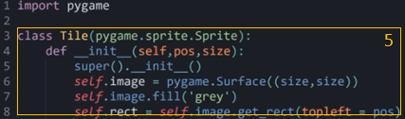

5 – in a new file called tile, I created a class named Tile, as is a suitable name in this context.
takes two parameters pos (position) and size of the tiles. Each tile is currently just coloured grey. Then create a surface of the tile of a size ‘size’, topleft sets the topleft of the new rectangle to the pos, position.
I then created a new file called level.py in which I made this level class
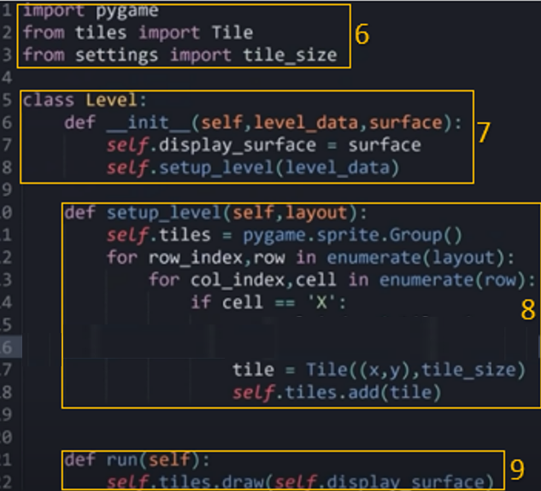

6 – Import necessary modules and variables (such as the Tile class and tile_size) required for the level setup.
7 – Defines a Level class, takes level_data (layout data for the level) and surface (the display surface to draw on) as parameters in line 5 and 6. And then line 7 Sets the display surface for the level. The in line 8 it calls the setup_level method with the provided level_data to create this specific level.
8 – function to set up level based off the level_map we already made, it iterates over the rows and columns of the provided level_map list, if it's 'X', it creates a Tile instance at that position and adds it to the self.tiles sprite Group.

9 - Method to draw the tiles onto the display surface using self.tiles.draw(self.display_surface).
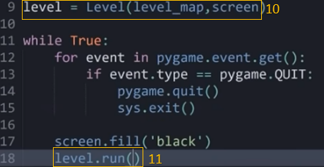

10 – then went back to my main.py file and added these changes, instantiates a Level object using level_map and the screen
11 - Calls the run() method of the Level object so that the level class can actually be run

Outcome:
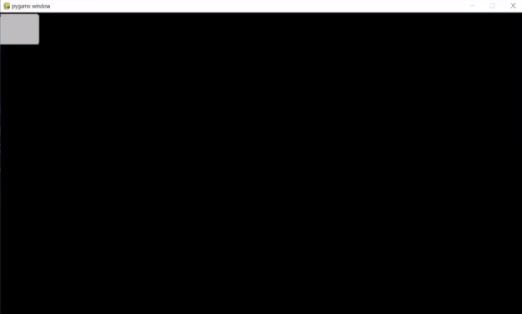

Reason for error, each tile was being displayed between 0 and 10 on the x and y axis, as this is the size of the level_map, so when I make this change by timising by the tile size, which is 64, then all the tiles fall into the correct position

What’s being tested? | input | justification | Expected outcome | Actual outcome
If grey tiles will be displayed on screen | N/A | This will give the layout of the level | The grey tiles to be in the locations specified by ‘X’ in the level_map lsit | All the grey tiles are displayed on top of each other in the top left

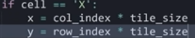

New outcome which is how we expected it to look based off the level_map:
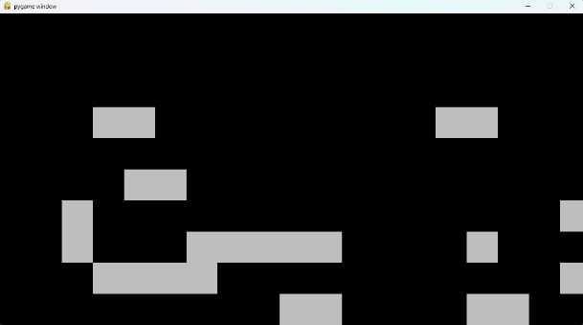

Date: 10/04/23

Setting up the world shift

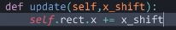
In my tile file
1

In my level file
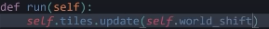
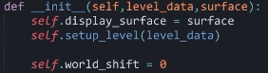
3
2

1 – what this does is adds the value of x_shift to the x coordinate of the tiles, this will change their position giving the screen a scrolling effect
2 – sets the world_shift to 0 as a default, I can influence this when the player moves to make the screen scroll in the appropriate manner
3 – this updates the tiles with the world_shift

Creating the player
I created a new file called player.py to write my player class in
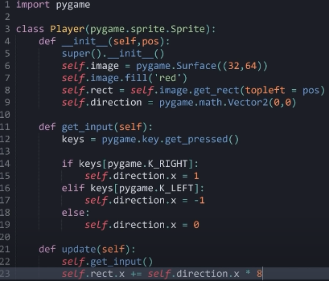
1

2

3

4

1 –Imports the Pygame library, defines a class named Player that inherits from pygame.sprite.Sprite.
2 – line 4 Initializes the Player class with a position parameter. Line 6 Creates a surface (image) for the player with a width of 32 pixels and height of 64 pixels. Line 7 fills the player's surface with a red color. Line 8 creates a rectangle (self.rect) representing the player's position and size on the screen based on the position it is given. Line 9 keeps track of the player's movement direction.
3 – line 12 gets the state of all keyboard keys so knows if any have been pressed or are being pressed.
If right arrow key pressed then direction is positive 1, if left is pressed then direction is -1, if neither then set direction to static 0
4 – def update(self):: Defines an update method for the player. Calls get_input() method in line 22, line 23 updates the player's horizontal position based on the direction it is moving in. Value is timesed by 8 because it was moving too slow at normal speed

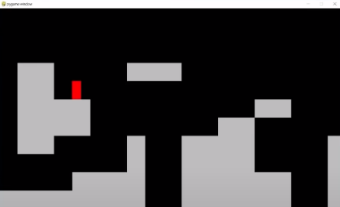
Outcome as expected:

What’s being tested? | input | justification | Expected outcome | Actual outcome
Whether the red box can move on the screen | LEFT ARROW and RIGHT ARROW | This will test if the player can move to the left and the right | The red box will move to left when LEFT ARROW key is pressed and to the right when RIGHT ARROW | The red box moved right when RIGHT ARROW was pressed and left when LEFT ARROW was pressed

Implement a way so the player causes the world shift

In my level.py file I added this method to allow the player to cause when the world shifts to the right or to the left
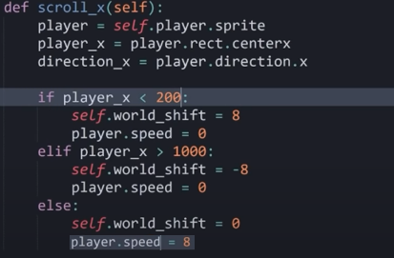

1

In my level.py file
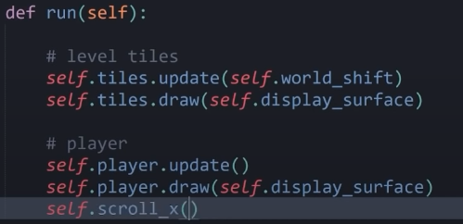

2

1 – when the player touches 200 on the y coordinate, the self.world_shift is set to 8, and the player speed is set to 0, this causes the effect of the world to shift in the opposite direction whilst looking like the player is still moving. If the player reaches 1000 on the y coordinate self.world_shift is set to -8, so moves in the opposite direction and like above the speed of player is set to. If neither of these cases are true, then the player.speed remains at 8 and the world shift is set to 0
2 - updates the tiles, taking into account the world_shift and displays them on the display_surface. Updates the player, and then runs the scroll_x to check if the map should be shifted

Outcome:
The world shifts like intended when the player character reaches the desired position, however once it reaches this boundary, it continues moving and doesn’t stop.

What’s being tested? | input | justification | Expected outcome | Actual outcome
Whether the player affects the world shift | LEFT and RIGHT ARROWS | This test is to see if the player moving to the left or right will affect the world_shift | It will move the screen in the opposite direction it moves, giving the effect it is scrolling | Once the player reaches the boundary to move the screen, it doesn’t stop even when the player stop moving

So this is the change I am making, so that it only shifts if the player is continually up against the boundary moving in that direction, because once it reached that position before it would just stay there and therefore constantly move
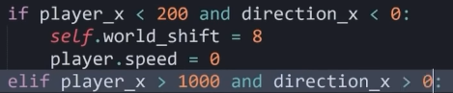

New outcome:
The player now interacts with the world shift as expected and can stop moving whenever the left and right arrow keys are removed

Date: 13/04/23

Adding gravity to my game

This is within my player class in my player.py file
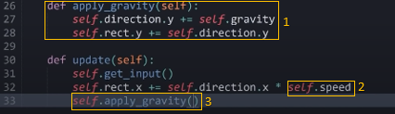

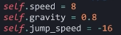
4
14
2

1 – create a method called apply_gravity, in charge of sorting out the gravity in the game. The y direction of the player will be affected by self.gravity, in this case I have given it the value of 0.8, as it feels realistic and smooth
2 – changed self.speed from just a number to writing it in __init__, as it means it will be easier to change it or have an affect on it later if needed
3 – when I am updating the player, I call this method, making sure that gravity is applied in the game
4 - this is the speed at which the player jumps vertically into the air, I set it now so I don’t forget later. It will be used shortly
Outcome:
The outcome was not as expected, the gravity has an effect and the player falls, however the tiles do nothing at stopping the player falling, and there is still no option to jump. So I will implement jumping now and then collisions with the tiles to fix these issues.
What’s being tested? | input | justification | Expected outcome | Actual outcome
Whether gravity works in the game and if the player can jump | SPACE bar to jump | This will test if gravity has effect on the player and we can jump as well as move left and right | Player will fall due to gravity, when SPACE bar is pressed, player will jump | Gravity has an effect, however pressing SPACE has no affect on player

Adding jumping

Still within player class in player.py file
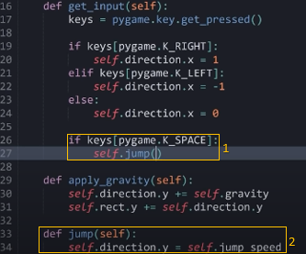
1 – in the get_input() method, check if the space bar has been pressed, if it has been pressed then jump() will be run
2 – this is the jump() method, what is happening here is that when the function is called (space bar is pressed), then the y direction of the player is set to the jump_speed. We defined jump_speed earlier as -16, this will have the reverse effect on the player (the way the coordinate system works in pygame) causing it to move upwards giving it the jump effect

Outcome:
The player can now jump now as expected, and once it has reached its peak of the jump, gravity applies again. However, the player collisions still aren’t working

What’s being tested? | input | justification | Expected outcome | Actual outcome
Can player jump | SPACE bar | This allows the player to jump and avoid enemies or jump on to tiles when we later implement these | Player will increase in y coordinates causing it to jump when space is pressed | Player jumps when space is pressed

Player Horizontal Collision with tiles
In the level class in the level.py file, I have created two functions which separate the vertical and horizontal collisions of the player. This also allows the movement of the player to be controlled from within the level class
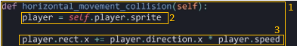

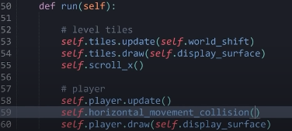

4

1 – creates a method called ‘hoirzontal_movement_collisions’ that allows me to isolate the horizontal collisions
2 – assign the variable player to self.player.sprite, this helps save me a lot of time having to write self.player.sprite each time I need it
3 – this is what causes my players horizontal movements to change (essentially is what makes the player move sideways)
4 – calls the method to make sure it is run, is below self.player.update() because the player needs to be updated first and then we can check for collisions

Outcome:
The player now moves around the same way as before. This shows that the player movement is now being run in the level class in the level file. Runs smoothly
What’s being tested? | input | justification | Expected outcome | Actual outcome
If level class can control player movement | LEFT and RIGTH arrows and SPACE bar | This will allow player to be controlled from within level class which increases functionality | Player will move as normal | Player moves as normal

I then added some nested if loops to my horizontal_movement_collision in order to check if the player is colliding, and behaviour in the appropriate way if it is colliding.
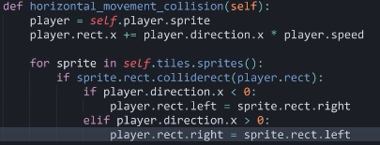
2
1
3
4

1 – ‘for sprite in self.tiles.sprites()’ Iterates through the tiles in the game level.
2 – this checks for collision between the player and a tile sprite, using the built in python colliderect() which can check collisions between two rectangles
3 – if statement checks if the player is moving to the left. If the player is moving to the left and colliding with a tile, the positions the player's left side to the right side of the tile it collided with. This means the player cant move through a tile sideways
4 - – if statement checks if the player is moving to the right. If the player is moving to the left and colliding with a tile, the positions the player's right side to the left side of the tile it collided with. This means the player cant move through a tile sideways

Outcome:
When the player collides with the tiles, they behaviour in the intended way.

This is a visual representation of this in action:
Direction player moving in
Direction player moving in

Player
tile
Player
tile

If player moving to the right, and collides with a tile, then the right hand side of the player is set to the left hand side of the tile.
If player moving to the left, and collides with a tile, then the left hand side of the player is set to the right hand side of the tile.

Date: 20/04/23

Player Vertical Collisions with tiles
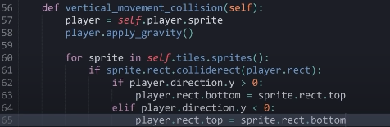
1

2
4
3

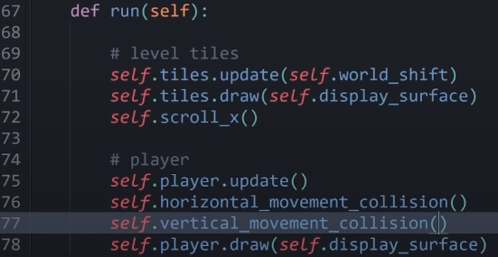

5

1 – create a method called vertical_movement_collision in the same way I did with the horizontal_movement_collision
2 – using the same approach as I did with the horizontal_movement_collision, iterating through the tiles, and using the pygames built in colliderect() to detect collision between the rectangles
3 – this is where it is different as I changed the player.direction.x to player.direction.y, and set it > 0. This means if the player is on a tile then the bottom of the player is set to the top of the file so it is sitting on top.
4 – did the same for this bit, except swappnig the correct bit, such as setting < 0 and player.rect.top = sprite.rect.bottom, so when you jump and hit the head of the player they are set to the bottom of that tile so they don’t phase through it
5 – and then remember to run this method just below running the horizontal_movement_collision()

Expected outcome:
The player would now be able to walk on the platofrms, stand still and jump etc.

Actual outcome:
The collisions work, however when staying idle for too long, you just fly downwards.
This is because gravity is only set to 0 when you jump, so when you stay idle, the gravity is constantly increasing until its so great you just glitch through the top of the files. This is how I fixed this:
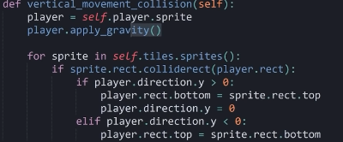
By adding this one simlpe line, wheneber the player is standing on a tile, the gravity is set to 0, this stop it non stop increasing causing the game to break

Replacing the red ‘player’ on the screen with character and animating it

There are about 15 player images that I will need in order to animate the player in all of its different states. So because of this I want to get the status of the player, and then access these images from a dictionary of all the possible animations.
So in my player class I create a new method called import_character_assets() in order to get all these images.

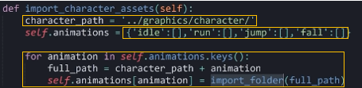
adding a new method called import_character_assets() into my player class in my player.py file
1
2

3
1
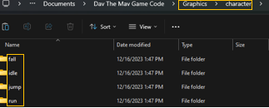

2

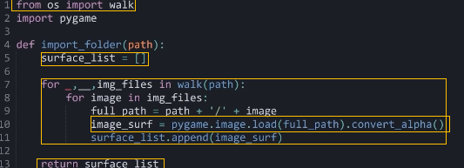
in a new file called support.py
4

5
6
7
8

1 – this creates a variable which points to the folder which contains all the subfolders for the animation. The ‘..’ means ‘go back’ two times within the file path, which makes it go back to the ‘dav the mav game code’ folder and then can go forewards to the graphics folder from there.
2 – The method initializes an empty dictionary called animations with keys for different types of character animations: 'idle', 'run', 'jump', and 'fall'. These keys represent different states of the character.
3 - It iterates through each key in the animations dictionary ('idle', 'run', 'jump', 'fall'). For each animation key, it constructs the full path by adding the animation key to the base character path (character_path). For example, if character_path is '../graphics/character/', then for the 'idle' animation, the full_path becomes '../graphics/character/idle'. This means each subfolder with actions can be located and accessed easily. It then retrieves and loads the image frames associated with each animation type (idle, run, jump, fall) from their subfolders. loaded frames then stored in the animations dictionary, associating each animation key ('idle', 'run', 'jump', 'fall') with its corresponding imported frames.
4 - imports the walk function from the os module. walk generates the file names in a directory tree by walking through directories
5 -. Initializes an empty list called
6 - traverses through the directory, then terates through each image file, and Constructs the full path to each image by concatenating the path (directory path) and the image file name obtained from the directory traversal. Finally it appends the loaded image (surface) to the surface_list.
7 - Uses Pygame's image.load() function to load the image from the full_path and converts it to a format that allows it to be transparent using convert_alpha().
8 - Once all images in the specified folder are loaded and appended to the surface_list, the function returns this list containing all the loaded images.
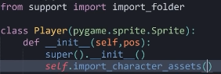
99
9 – import the function import_folder from the support file
10
10 – runs the method so that the player can be animated

Outcome:
No change in view on screen, but get no error so I know I am along the right lines

What’s being tested? | input | justification | Expected outcome | Actual outcome
Whether the red square is replaced with an animated character | N/A | Will allow the user to see the player animated | Player will be animated | Player is not animated

Date: 05/05/23

Animating the player when in runnning state

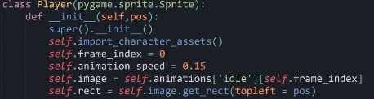
within my player class in my player.py file
0.15 -> 0.3 -> 0.45 -> 0.6 -> 0.75 -> 0.9 -> 1.05
2
1
3
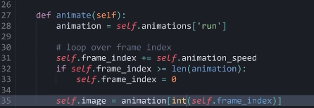
4

5
6

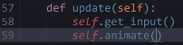
7

1 - Initializes the frame index variable to zero. This index determines which frame of the animation is currently being displayed. So by default it makes sense to start it at the first image and go on from there
2 - Sets the speed at which the animation frames change. This value controls the speed of the animation. It is such a small number, as if it was any smaller the animation would be too slow and clunky, and any larger and you may not be able to see the animation very clearly
3 - Sets the initial image of the player sprite to the first frame of the 'idle' animation. It accesses the 'idle' animation stored in the self.animations dictionary and retrieves the first frame using the frame_index and Initializes the sprite's rectangular area (‘rect’) based on the dimensions of the loaded image and positions it at the specified ‘pos’
4 - this retrieves the 'run' animation frames stored in the animations dictionary and assigns them to the ‘animation’ variable.
5 – adds the animation speed to the frame index, then checks if the frame index exceeds the length of the animation frames. If it does then set the self.frame_index = 0, this resets the frame index to start the animation from the first frame, so it is continually looping
6 - Sets the image attribute of the sprite to the current frame based on the frame_index. It retrieves the frame from the animation list using the integer part of frame_index as the index. The fact it is an integer, means it can loop a few times, before reaching an integer and then having to loop back to 0 again.
7 – not forgetting to run this method so it can actually have an effect on the game

Outcome:
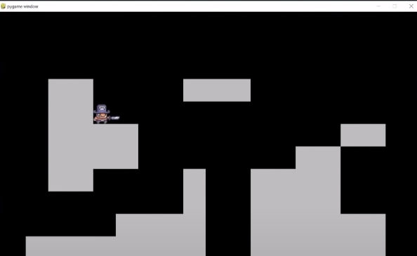

this is the outcome, the player is constantly animated in the running state which is good. However, I need different animations to play at different states, e.g when falling, idle or jumping the status needs to be looked at and then the correct animation should be played.

Implementing The Get_Status() method to allow different animations to be played

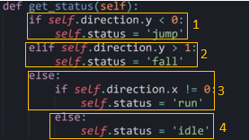

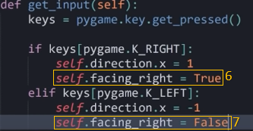

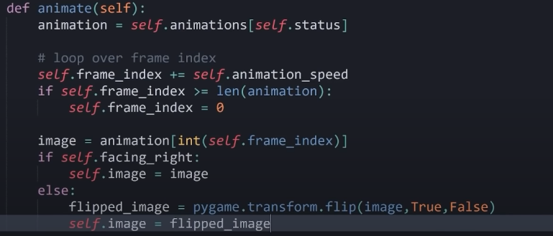

8

9

1 - checks if the player's vertical direction is negative. If it is, it means the player is moving upward (jumping), so the status is set to 'jump'
2 - checks if the player's vertical direction is greater than 1. It means there is a downward movement, indicating a fall. If true, the status is set to 'fall'.
3 - checks if the player's horizontal direction is not zero, meaning the player is moving horizontally (left or right). If true, it indicates the player is running, so the status is set to 'run'.
4 - If none of the above conditions are met, it implies the player is not actively moving. If there's no movement in either the vertical or horizontal direction, it sets the status to 'idle'.
5 - self.animations[self.status] accesses the dictionary of animations (self.animations) based on the current status of the player (self.status), so then it assigns the animation frames corresponding to the current status to the variable animation. For example, if the status is 'jump', it retrieves the jump animation frames.
6 – if the direction is 1, so moving to the right, then self.facing_right is set to true
7 –if the direction is -1, so moving to the left, then self.facing_right is set to false
8 – Retrieves the current frame of the animation based on the updated frame inde, then in the if statement if the player is facing right, it sets the player's image to the retrieved frame. Image does not need to be flipped
9 – If the player is not facing right (i.e., facing left), it flips the retrieved frame horizontally using pygame.transform.flip() to make the player face left, and then sets the player's image to the flipped frame.

Outcome:
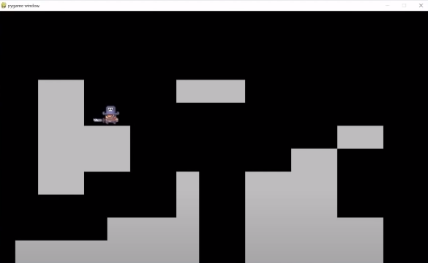
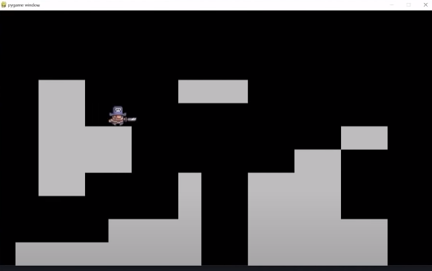

Moving left
Moving right
This works exactly how I wanted it, when moving to the right the player doesn’t need to change, but when facing left the image is flipped so the character faces the way it is moving in.

Date: 14/05/23

Implementing dust particles

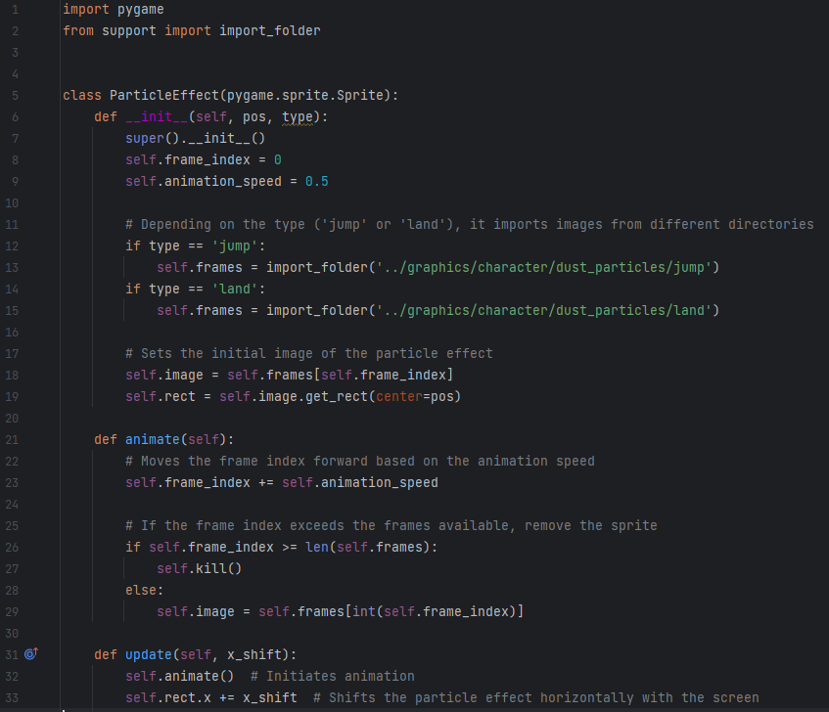
create a new file called particles.py, and create a new class called ParticleEffect()

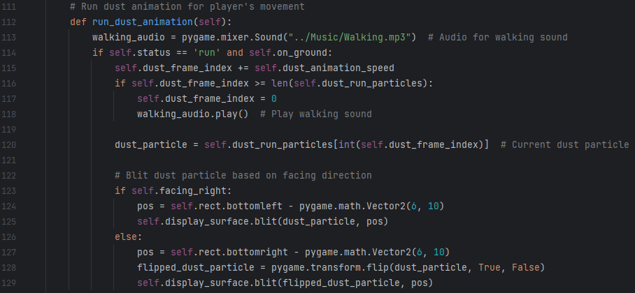
Then in my player class within the player.py file create a new method called run_dust_animation()
Both of these snippets have comments I left on them, these describe exactly what is happening so there is no need to annotate the code again

Outcome:
The outcome from this change in code, is that now the correct dust animations are run for the corresponding player status, when landing, jumping, running etc. the correct dust animations are run.

What’s being tested? | input | justification | Expected outcome | Actual outcome
Is dsut animations shown underneath player | Left and right arrow, space | If the dust particles are displayed correctly for the corresponding movement, then it makes the game look very smooth and professional | Particles to be animated beneath the player | Particles to be animated beneath the player

Converting the grey tiles on the screen into my Custom tile Images

Created a new file called tile.py with the Tile class inside it
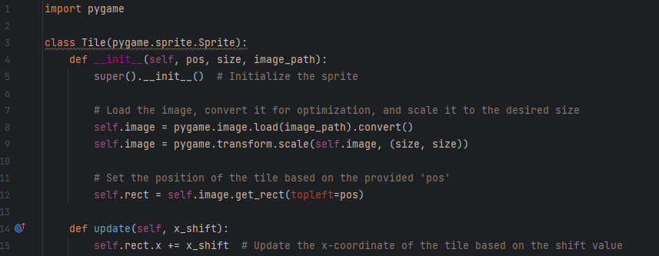

1

2
3

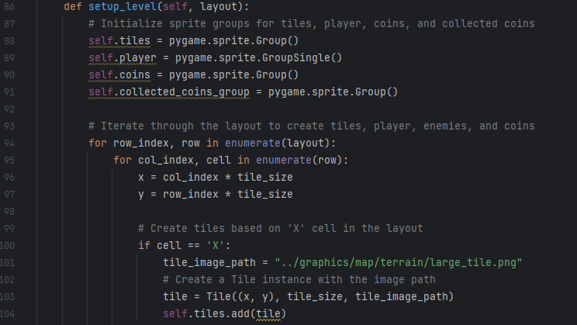
Then in my setup_level() method in my level class
5
4

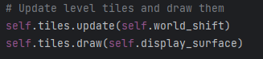
6
7

1 - Loads the image from the provided image_path, converts it so can be displayed on the screen and then Scales the loaded image to the specified size of the tiles (in this case was 64)
2 - Creates a rectangular area (self.rect) based on the loaded image's dimensions and sets its top-left corner to the provided pos (position).
3 - Modifies the x-coordinate of the tile's rectangle (self.rect.x) by adding the provided x_shift value, facilitating horizontal movement. This is basically updating the displayed tiles with the world_shift so that they shift.
4 - Initializes an empty pygame sprite group to contain tiles.
5 - Iterates through each row and column in level_map. For each cell it calculates the x and y positions based on the col_index and row_index, multiplied by the tile_size. If the cell contains an 'X' (indicating a tile in the layout) it will assign a specific image path (tile_image_path) for that tile. And then creates an instance of the Tile class (not shown here) with the calculated position and image path. Finally will aadd the created tile instance to the self.tiles group.
6 – updates the tiles with the world shift so they move when we scroll
7 – finally draws the updated tiles to the screen so we as the user can see them

Outcome:
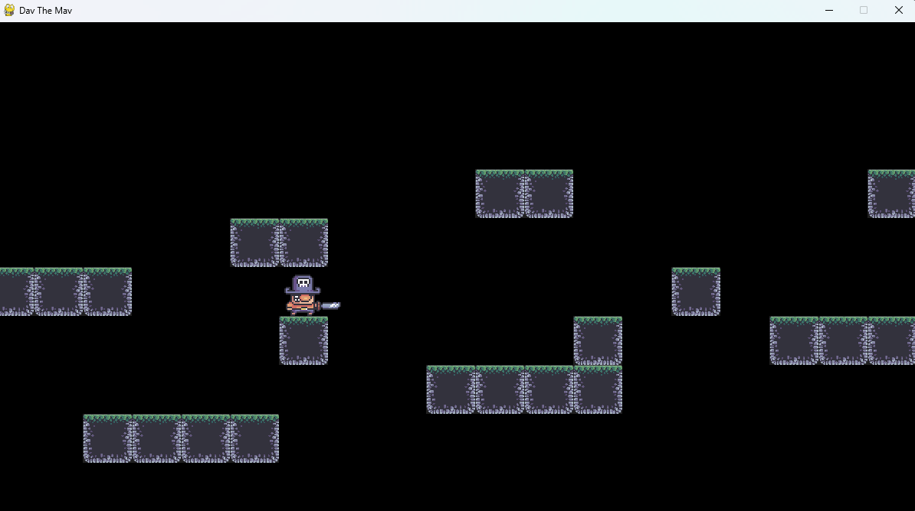

This is the outcome from the code I had added, works exactly how I wanted and is perfect.

Date: 026/05/23

Adding the background image

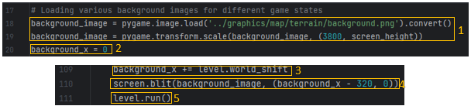
1 – loads the image of the background image and stores it as ‘background_image’ which is a very suitable name, then converts it so it can be displayed on the screen in pygame and changes the size of the image, so that it will fit the screen, but also extend it so the level can scroll for longer

2 – sets background_x to 0, this is the x position of where the start of the background image will be displayed, this allows the background to get manipulated by the world_shift
3 – this is where the world_shift affects the background so it can scroll along with the rest of the attributes on the screen
4 – this actually blits (display) the background image on to the screen (320 pixels left of wherever it is from scrolling, this means the level can then scroll to the left as well as the right and the background will look the same.
5 – this runs the level, everything like player and tiles etc. is run from calling level() here
Outcome
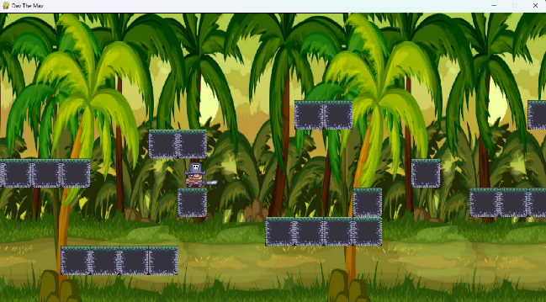

This is exactly how I wanted it to look.

Adding coins

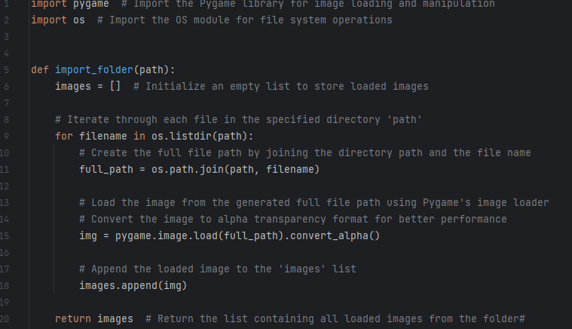
Make an import_coins folder to import the coin images in the same way I had a file to import the player images

When coding I left enough comments on this function, that I wont need to analyse it again here as my comments describe it suitably.

Mad a new file called coin.py to handle my coin class
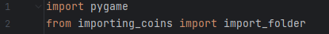
1
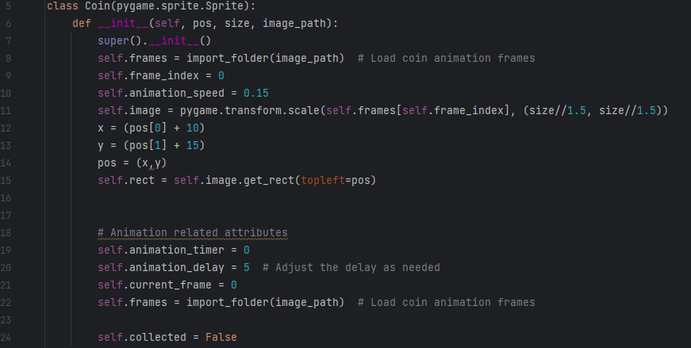
2
6
7
5
4
3
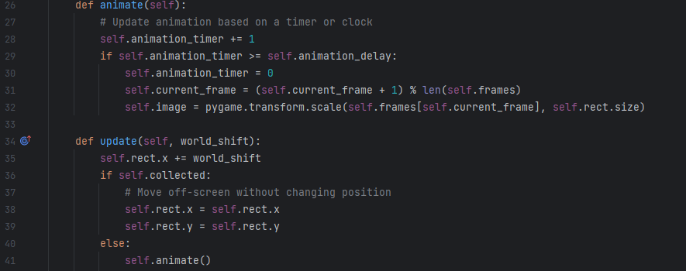
10
112
9
8
12

1 – imports the function importing_coins from import_folder in order to use the function within this class
2 - Loads a sequence of images representing the frames of the coin animation using the import_folder function then sets up attributes frame_index (which indicates the current frame of the animation), animation_speed (defines the speed at which the animation changes frames)
3 - sets the initial image of the coin, scaling it to a specific size, 1.5 times as small as the original of the coin
4 - adjusts the initial start position of the coins by a fixed value, and 10 more for x coordinates and 15 for y, this is to centre each coin within its ‘block’.
5 - rect sets the collision rectangle based on the initial image.

6 – by setting ‘self.animation_timer’ = 0 we initialize a timer for animation, setting ‘control.self.animation_delay’ = 0.15 will set a delay for the animation and by setting ‘updates.self.current_frame’ = 0 it tracks the current frame index of the animation.
7 – ‘self.collected’ = False: Initializes the collection status of the coin to "not collected". This allows us to check when it is or isn’t collected later on
8 – when run it increments the animation timer to point to the next image and checks if the timer exceeds the delay for updating frames to then calculate the index of the next frame in the animation sequence.
9 - Updates the image to the next frame in the animation sequence. And ten loops the animation back around to 0
10 – this updates the horizontal position of the coin based on the value of world_shift.
11 - Checks if the coin has been collected.
12 – calls the animate() method so the changes are actually executed

Outcome:
nothing happens, no coins appear on my screen

What’s being tested? | input | justification | Expected outcome | Actual outcome
If coins appear on screen | N/A | If coins appear on screen then this is what we want as the aim is to collect the coins | Coins to appear animated on screen | Coins don’t appear on the screen

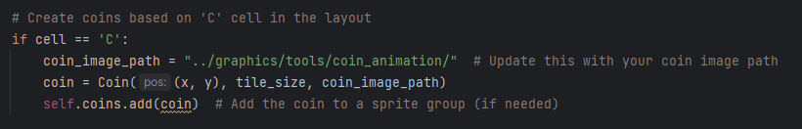
Reason for this is because there is nothing checking where the coins actually are on the level map. To fix this I added this code to the setup_level() method in my level class within with level.py file.
4
3
2
1

1 – checks if cell is ‘C’ within the level map
2 – specifies the location of the folder containing all the animations

3 – creates an instance of the coin class, with the values passed in
4 – instance of the class is then added to the self.coins sprite group, allowing it to be changed/updates like every other coin on the screen.
New outcome:
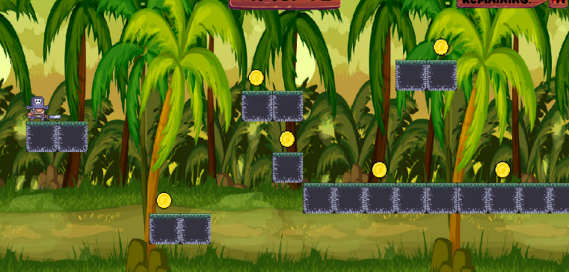

The coins now display anywhere on the screen where I place an ‘C’ in the level map, and are animated like I wanted. I had to change the animation speed a few times, in order to get them to look like they are spinning at a suitable speed.

Date: 01/06/23

Counting coins and displaying to screen

In the level class in my level.py file:
Within my __init__method
1

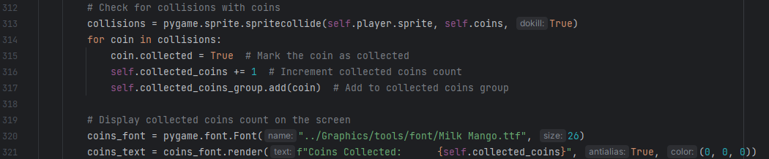
within my run() method
2
3
4

5
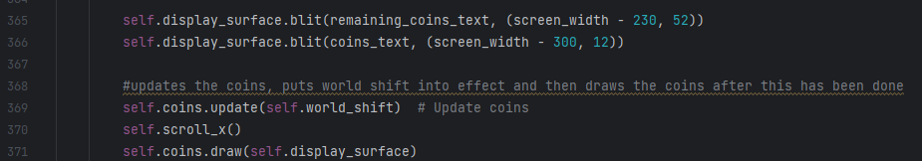
6

7

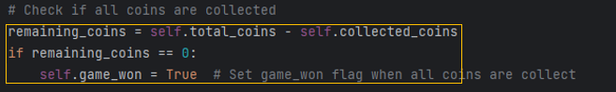
8

1 – in the __init__ method initialises a count for collected coins, finds how many coins there are in total for that level
2 – checks if the player sprite has collided with the coin sprite using the built in spritecollide() method in pygame
3 – if a collision has been detected coins collected is incremented and adds that coin to the collected coin group
4 – this is the text on the screen displaying the collected coins, displayed in white
5 – this is the text on the screen displayed how many coins are remaining, displayed in white
6 – this is blitting/drawing both texts to the screen so we can read it
7 – updating the coins, so they move with the world_shift and making sure they are drawn onto the screen
8 – this is a check to see if all the coins have been collected by looking at the remaining_coins variable, if yes then we can make a winning screen as you have won the game

Outcome:

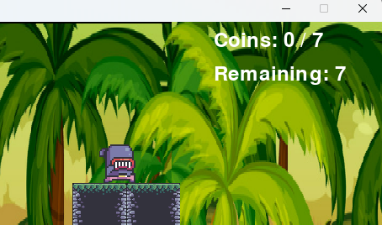

This is how I imagined it, I had to play around with the size, and positioning in order to get it in the right

Date: 03/06/23

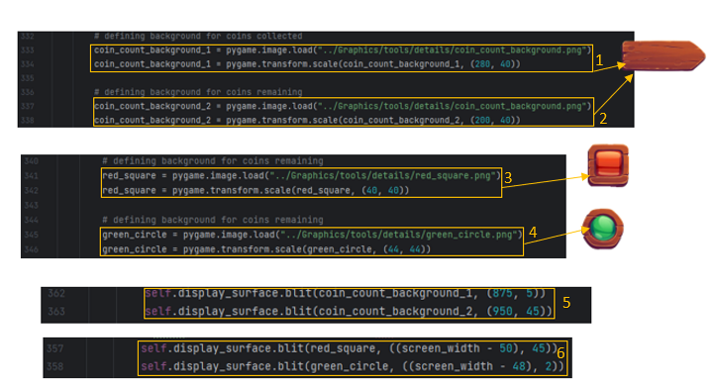
Coin Counter Background

1 – creates and transforms the brown background pointer board to the right size to fit the text saying “coins collected”
2 – creates and transforms the brown background pointer board to the right size to fit the text saying “coins remaining”
3 – loads and resizes the red square used as a background for “coins remaining”
4 -– loads and resizes the green circle used as a background for “coins collected”
5 – blits both of the signs onto the screens in the correct positions for their specific text
6 – blits both the red square and green circle on to the screen in the correct corresponding positions, next to the brown signs so they’re being pointed to

Outcome:
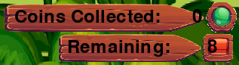

What’s being tested? | input | justification | Expected outcome | Actual outcome
if text is displayed | N/A | So user can see how many coins they have/need to collect | Text displayed on screen in right position | Text displayed on screen but not in the correct position

to fix this I simply added more spaces between f”Coins Collecteed:” and {self.collected_coins}, this saves having to separate the text so was much easier and faster to fix
New outcome:
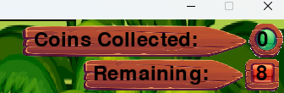

Implementing the Custom font

To implement this custom font, I found it online and downloaded it as a .ttf file, where I can then import it into my code
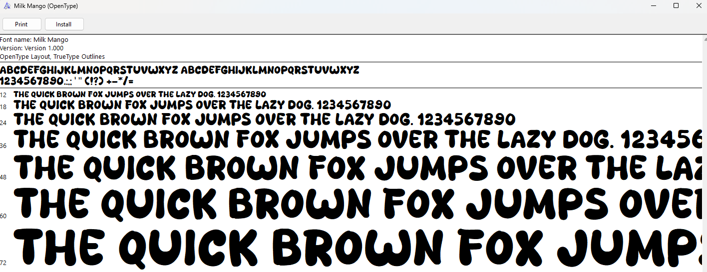

1

1 – load in the custom font for my text, with the size

Outcome:
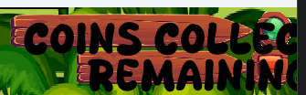

The text is the correct font, however the wrong size, so by changing the size form 56, to 26, it will fit nicely within the background boxes I implemented

New outcome:
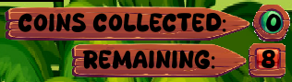

Now this fits perfectly, I have the backgrounds, and the text with the custom font.

Date: 05/06/23

Setting up the Timer

To create the timer I made a new file called timer.py and made a timer class within it.

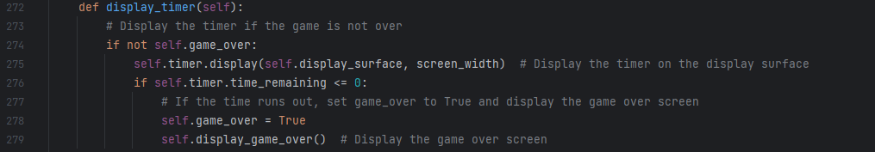
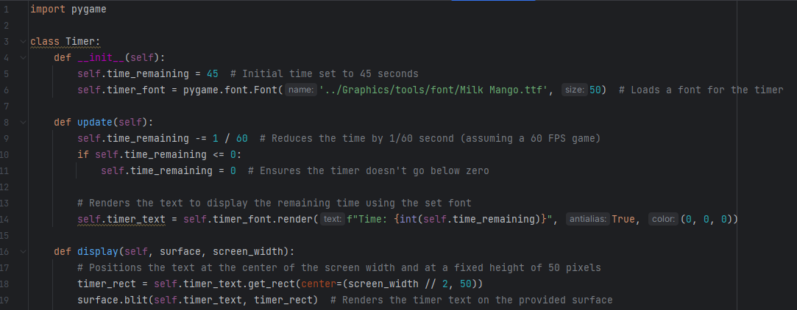

Both of these have comments I wrote as I was coding it, that explain in enough suitable detail what is happening, therefore I don’t need to annotate both of these code snippets.

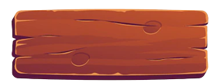
In the same way I have with the text about the coins, I added a background for the timer. However this one is slightly different, but the same principle applies for how I did this
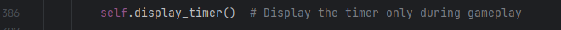

The display_timer() method is put at the very end of the run() method, this is so that it will appear on top of the screen background and the timer background, and be visible to the user.

Outcome:
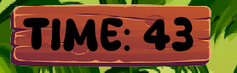

The outcome is as expected, had to change position of timer text, and size of it, and size of background and where is it positioned etc. in order to get it to fit well.

Setting up Enemies
Firstly I want it displayed on the screen and animated. So I create a new file called enemy.py and make a class within in called enemy.
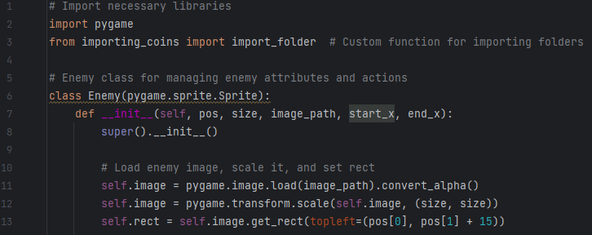
1

2

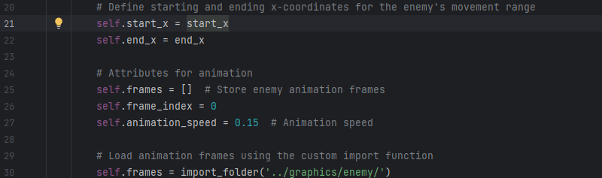
then in the __init__ method
4
3

then I created a method called animate() to sort out the enemies animations
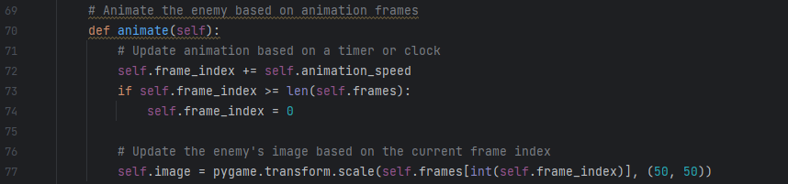
6
5

then in the update() method of enemy
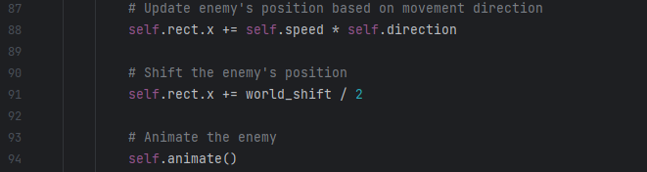
7
8

9

1 – import the import_folder method from importing_coins.py file, this allows us to grab the various images of the enemy
2 – Loads the enemy's image, scales it, and sets its rectangle based on the provided parameters (pos, size, image_path).
3 – initialises attributes for animation (frames, frame_index, animation_speed).
4 - Loads animation frames using the custom function import_folder(), this will allow us to loop through all of the image frames
5 - Increments the frame_index of the enemy by the animation_speed value. This value controls the speed at which the frames of the animation cycle. The if statement will reset the frame_index to 0 if it exceeds the total number of frames in self.frames, ensuring the animation loops back to the beginning once it reaches the end, giving a nice smooth repeating animating effect
6 - Updates the self.image attribute of the enemy with the image from self.frames at the index given by the frame_index. And also scales the image so that it is a suitable size for the game
7 – adjusts the enemies location based on the player movement, this is so that it continually moves even whilst the player is moving and the world_shift is in effect
8 – this shifts the enemy position so it doesn’t move along with the world_shift
9 – and finally we call the animate() method so all our enemy animations are run

Outcome:
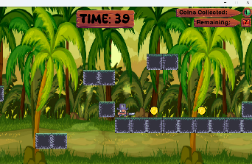

The enemy is not displayed on the screen, this is because there is nothing checking where the enemies actually need to spawn. To fix this I go to my level.py file and in the setup_level() method, add this code:

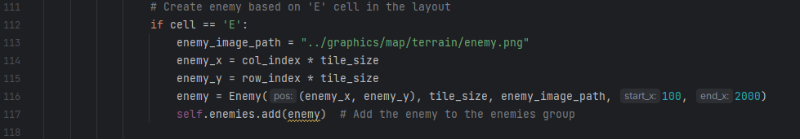
This is exactly like what I did with the tiles, and with the coins, so I know it will work and I wont have any issues.

Also need to create a sprite group for the enemies, so they can all be added to a group and the changes can have effect on all of them

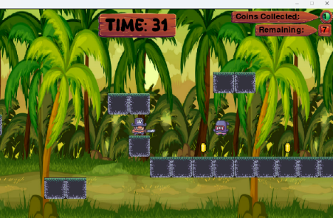
New outcome:

Now the enemy is displayed on the screen, and is constantly looping through the animation of it walking, I now need to implement ways so that it can sit on top of the tiles and walk backwards and forwards.

Date: 013/06/23

Enemy Moving backwards and forewards on tiles
To do this I created another method. By doing this I will check if the enemy reaches the end of a platform, when it does it moves back the other direction (speed is set to 1 or -1 correspondingly)

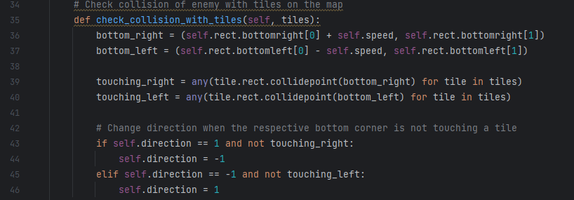
Outcome:
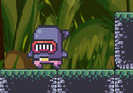
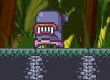

Moving to right. Still facing left
Moving to left. Facing left

What’s being tested? | input | justification | Expected outcome | Actual outcome
If enemy animation works well | N/A | If the enemy switch directions once it reaches the edge and changes direction, it improves game play as it makes it seem much more realistic | Player changes direction and faces the other way | Player changes direction but doesn’t change the way it is facing

The enemy now changes direction and moves back the other direction when it reaches the end of the platfor, this works how I intended it. However an issue I get is that the enemy faces the same way regardless of the direction. I will make a change so the enemy flips when it reaches the edge, to give more of an effect it Is hanging directions.
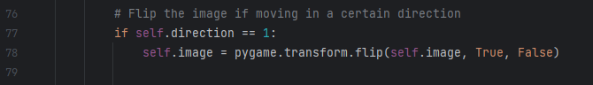

This was simple to do, if the direction was 1, so moving to the right, then the the images are just simply flipped in the x direction, and when the direction is not 1, so moving to the left, the images automatically flip back

New outcome:
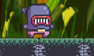

Moving to right. Now faces right
Moving to left. Facing left

This change worked, so now the player faces the correct way when moving in that direction.

sorting out the collisions with the player

To do this I first need to sort out the lives, as I will need lives in order to lose a life when a collision is detected.
Once I had coded my game so the player would start with 3 hearts, then when they collide with an enemy they lose a life, and once all three have been lost, pygame would quit, this was giving me an issue, as the game would detect all three collisisons at once, since they were happengin one after the other if the player remainde in contact with the enemy, which it always did. To fix this I added a cooldown of 2 seconds after losing a life, this means once you lose a life you are invincible to losing another life, but only for 2 seconds.
This is how I implemented all of these changes along side my initial setting up of the life system (these are well commented so analysis wont be too necessary):
In my player class in my player.py file, in the __init__() method
1

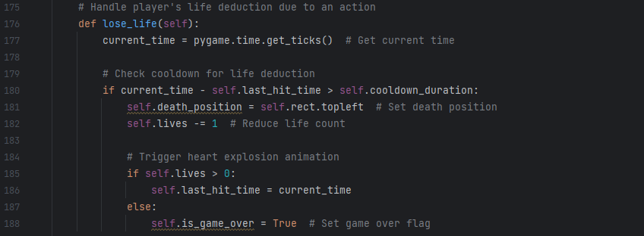
create a new method called lose_life()
2

In my level class in level.py file create a bnew method called update_playerlives()
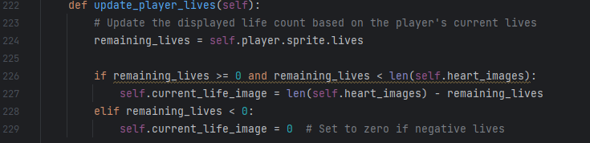
3

and then within the level classes horizontal_movement_collision()
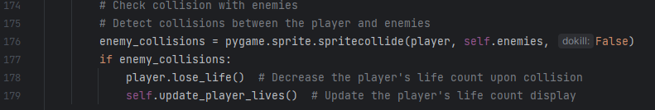
4
1 – sets the player lives initially to 3 at the start of each level
2 – created a new method to sort out the cooldown after colliding with an enemy, the comments describe what is happening within this method, and in charge or removing a life from the player when called
3 – created a new method called update_player_lives() which is in charge of updating when the player loses a life
4 – this is used to detect collisions with enemy, lose_life() method is called when colliding with an enemy

Outcome:
Every time the player now collides with an enemy, they lose a life, when reaching 0 lives pygame will close, There is also a brief 2 second invincibility period after colliding with an enemy giving the user time to move away from the enemy.

Date: 16/06/23

sorting out losing a life when Falling off map

when the player falls off the map, I also want them to lose a life, I then want them to respawn at a specified place on the map each time. Here is how I did this:
creating a new method in player class in my player.py file
3

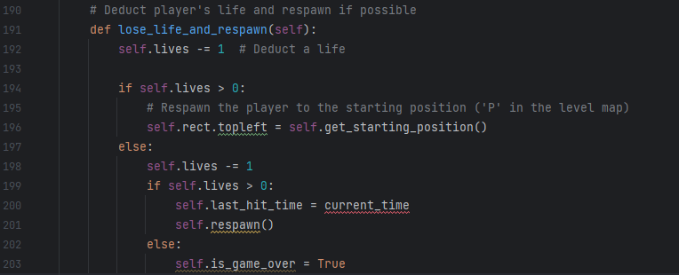
2
1

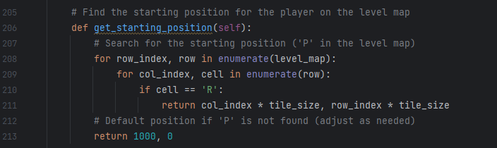
creating a new method called get_starting_positin() in the player class
4

in the update() method in the player class
5

1 - Checks if the player has more than 0 lives remaining, if true, move the sprite rectangle (self.rect) to the starting position obtained from self.get_starting_position(). This will respawn the player at point R, which coordinates can be obtained from the get_starting_position() method which I code after
2 - Decrements an extra life
3 - checks if there are still more lives available, if true it records the time of the last hit (self.last_hit_time) and respawns the player by calling the respawn() method. If false (so player has no more lives), it sets the is_game_over flag to True, indicating that the game is over due to lack of lives, and pygame will quit
4 – iterates through level_map for the starting position marker ('R') and returns the corresponding coordinates. If the marker is not found, it defaults to the position (1000, 0).
5 – if the player y coordinate is greater than the screen_height + 100 (because I want the player to fall off the screen not just instantly respawn when it touches the bottom), the lose_life_and_respawn() method is called, causing the get_starting_positon() to be called from within that, which causes the player to respawn
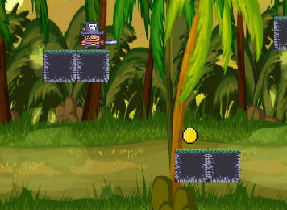
Outcome:
Respawns at ‘R’
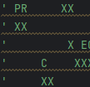
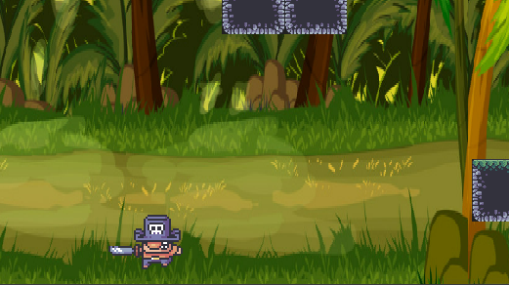

Once the player falls, they respawn at the point ‘R’ specified in level_map, this is perfect.

Date: 01/07/23

Displaying Lives on screen

I then needed the lives to be displayed on to the screen in the top right, so the user knows how many lives they have left. This was my approach to this problem:
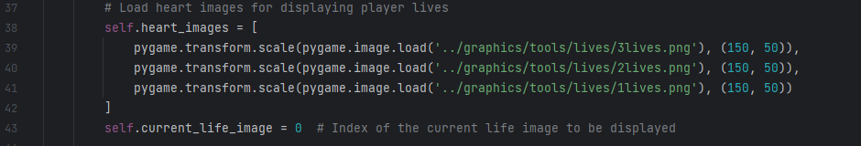
In __init__() method in level class in my level.py file
3
2
1

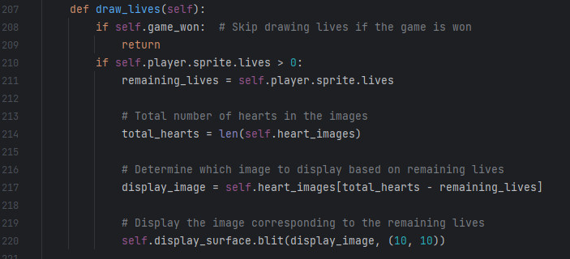
In my level class, create a new method called draw_lives
4
5

6
7

1 – creates a is a list containing heart images.
2 - loads an image from the lives folder, then transforms to the correct size, note all of them are the set to the same size
3 – current_life_image is set to 0, indicating the index of the current life image to be displayed, and is then incremented or decremented as needed
4 - Verifies if the player has remaining lives to display and stores the number of remaining lives the player has in the ‘remaining_lives’ variable
5 – finds the total number of heart images available for displaying lives.
6 – Selects the heart image corresponding to the remaining lives. It accesses the correct image by subtracting the remaining lives from the total number of heart images.
7 - Displays the chosen heart image on the game surface at the coordinates (10, 10). blit renders the image onto the game surface to represent the remaining lives so we as users can see them
Outcome:
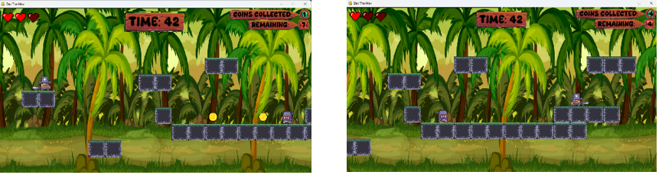
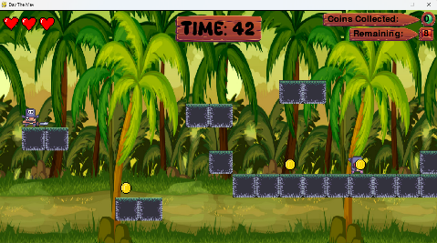
Now the hearts are displayed on the screen, corresponding to how many hearts the player actually has, and when the player loses a life, the next heart image is displayed
I do want however the hearts to have the same themed background as the time and coin counters, so I will use the same background as I did for the timer
10
2
1 – loads the same image that I used for the timer, then transforms it to scale to the correct size for the hearts
2 – blits to the surface in the correct position to fully go behind the hearts.

New outcome:
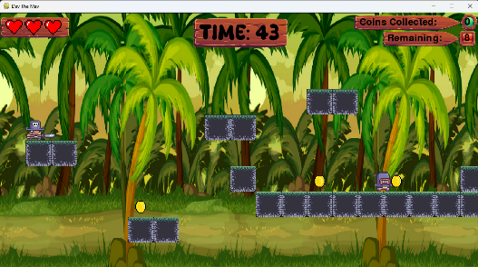

This works exactly how intended and looks good now

Enemy Collision Explosion Animation
Then I coded an explosion when player collides with enemy, this is how I did that:
In my player,py file in the player class, added these to the _init__() method
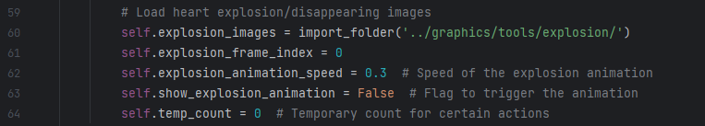
10
30
20
40

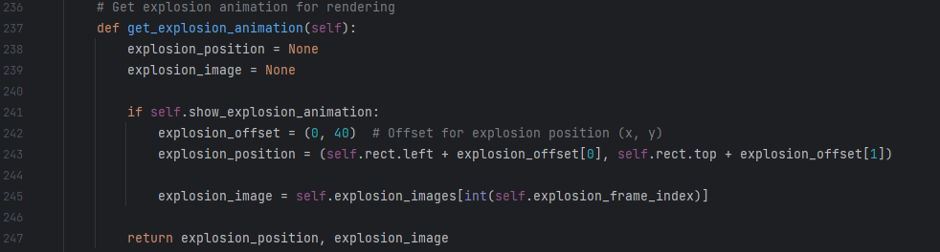
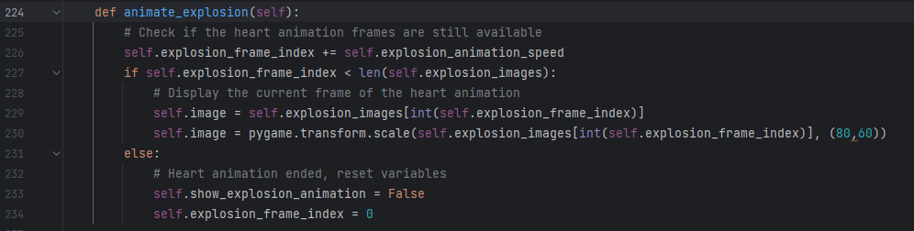
Then added two new methods called animate_explosion() and get_explosion_animation()
120
110
100
90
80
70
60
50

1 - Loads the set of images representing the explosion. These images are fetched using the import_folder function
2 - Sets the initial frame index for the explosion animation to zero. This index is used to track which frame of the animation is currently being displayed. Defines the speed at which the explosion animation cycles through its frames. A lower value results in a slower animation, while a higher value speeds it up.
3 - Creates a flag (‘show_explosion_animation’) to control whether to display the explosion animation. It's initially set to False, so the animation of the explosion isn’t always playing
4 – creates a temporary variable we will use later
5 - This function is responsible for controlling the animation of an explosion effect.
6 - Increases the ‘explosion_frame_index’ by the value defined in ‘explosion_animation_speed’. This index tracks the current frame of the explosion animation.
7 - Checks if the current frame index is within the range of available explosion images, if true then updates the image attribute with the current frame of the explosion animation. The image is obtained from explosion_images based on the current frame index. Then scaled to 80x60 pixels
8 - when the explosion animation reaches the end it sets show_explosion_animation to false to stop the animation and resets the explosion_frame_index to zero ready for when the next explosion starts
9 – purpose of this method is to provide information about the explosion animation, such as the position of it
10 - Initialises variables to store the explosion position and image. They're set as None because at the moment there is nothing to store in them
11 - controls whether the explosion animation should be displayed, if true then calculates the explosion position on the screen, uses the offset (explosion_offset) to position the explosion relative to the sprite's top-left corner (self.rect). This position is stored in explosion_position, then it assigns the current frame of the explosion animation to explosion_image.
12 - Returns the explosion position and image. If there's no explosion animation to display, both values remain None, so no explosion is shown

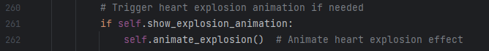
Then not forgetting to call it in the update() method
130

13 - handles the animation of the explosion effect. This helps ensure that the explosion animation is only executed when the player loses a life from colliding with enemies

Outcome:
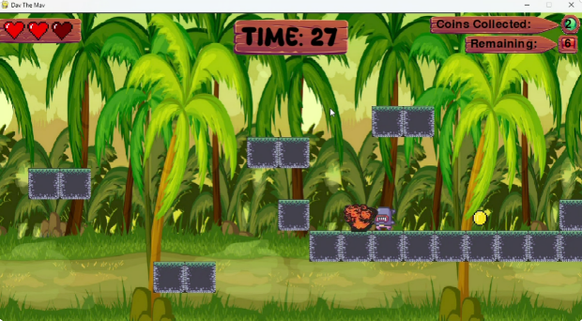

What’s being tested? | input | justification | Expected outcome | Actual outcome
If explosion animation occurs when colliding with enemy | N/A | Teis animation shows to the user they have clearly collided so it is important this works exactly as intended | Animation is smooth and runs nicely | Animation was too slow/too quick

The explosion plays as soon as you come into contact with the enemy, and only when losing a life so the cooldown still applies which is what I wanted. However it was either too quick so you couldn’t tell what was happening, or it was too slow and laggy
Had to play around to get the animation smooth.
Now the explosion works exactly how I wanted it to.

Date: 03/08/23

Loading Game State

Now I will implement all of my game states
In the main.py file
20
10
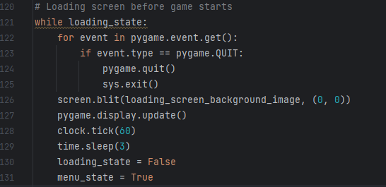
30

40

1 – loads the loading screen image into a variable named loading_screen_backgruond, and then scales it to perfectly fit the size of display screen
2 – a variable which allows us to change between states, acts as a flag/check
3 – creates a while loop, so as long as the flag variable is true then the menu is run
4 – after three seconds the loading_state is closed and the menu_state is set to true so it will run

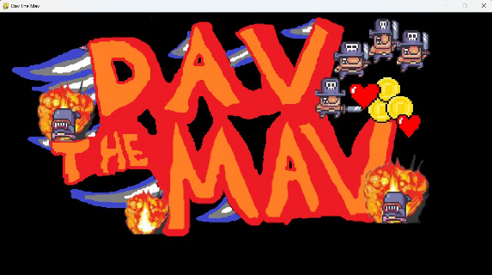
Outcome:
3 seconds
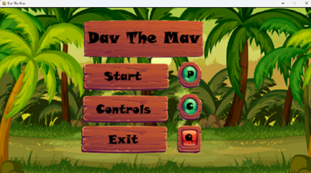

This works exactly how I wanted it to, after three seconds changes to the menu_state

Menu Game State
This is the loading screen, which is displayed for about 3 seconds before the actual game is loaded up, in which it shows the menu_state.
20
10
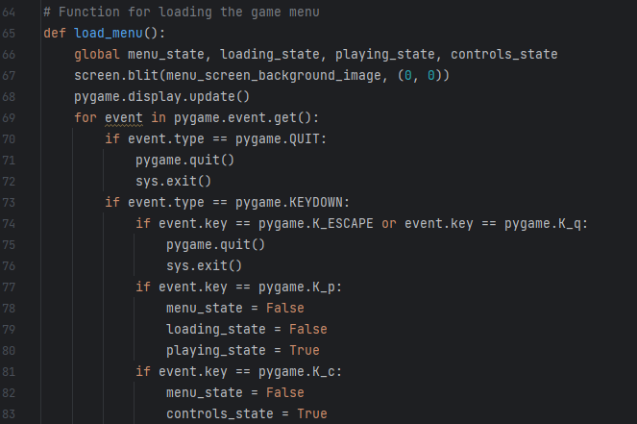
30

4
50

60

1 – loads the menu_background.png image, and scales it to fit the screen dimensions
2 – another flag to determine which state to run, initially false, and then set to true once loading screen is run
3 – makes these variables global so can be accessed out of this function
4 – checks for key presses, if Q or escape is pressed then pygame closes and quits
5 – if P key is pressed, playing_state is set to true so the actual game level starts
6 – if the ‘c’ key is pressed, then the controls_state is loaded

Outcome:
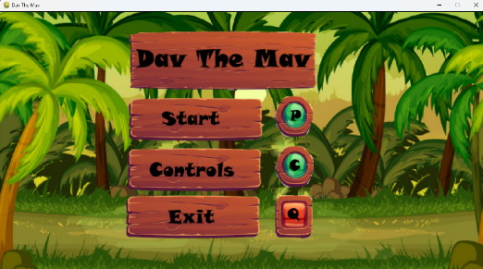

Date: 04/08/23

Controls Game State
This is how I set up the controls game state
10
20
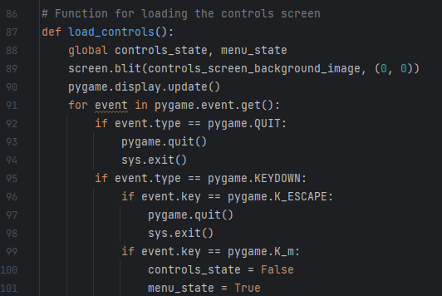
30

4

50

1 – like before loads the image for controls and scales it to screen dimensions
2 – variable flag used to set the states, this is switched to true form menu by pressing ‘c’
3 – makes these variables global so can be accessed from anywhere
4 - if escape key is pressed then pygame quits and is closed
5 – if m key is pressed, it will run the menu_state and go back to menu

Outcome
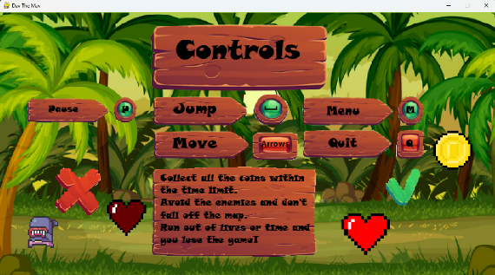

This is how the screen looks, the outcome depends on what key is pressed. I’ve tried both and it works like intended

Game Over menu state (Lose the game)

In level class in level.py file in the __init__() method
10

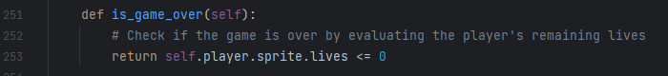
create a new method called is_game_over
20

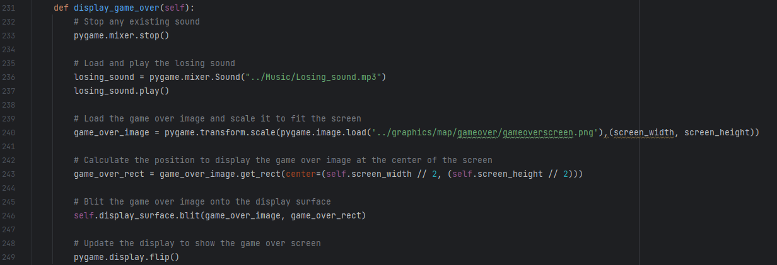
create a method called display_game_over
50
40
30

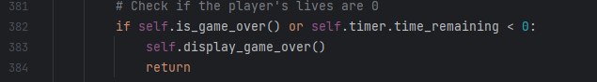
in the run() method
70
60

1 – flag used to determine if gameover state is to be run
2 – returns true or false depending on if the player lives is less than or equal to 0
3 – loads the game over image and scales it to the dimensions of the scren
4 – calculates the centre of the screen and displays the image here
5 – draws the game over screen to the surface and then updates the display
6 – if timer runs out, or players lives are 0, this is the only time the game_over_state is run
7 – if not then it skips out of the loop and returns Null

Outcome:
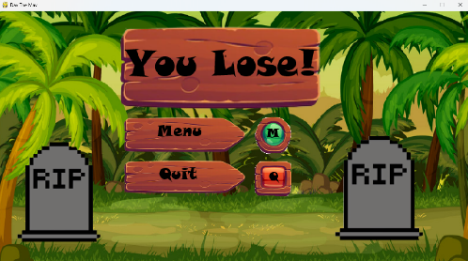

This appears when you either run out of lives or time, this works how expected
What’s being tested? | input | justification | Expected outcome | Actual outcome
If you lose screen appears when run out of lives | N/A | Once the player loses, the game needs to stop, so the you lose screen shows this clearly to the user | You lose screen is displayed | You lose screen is displayed

Displaying the you win screen

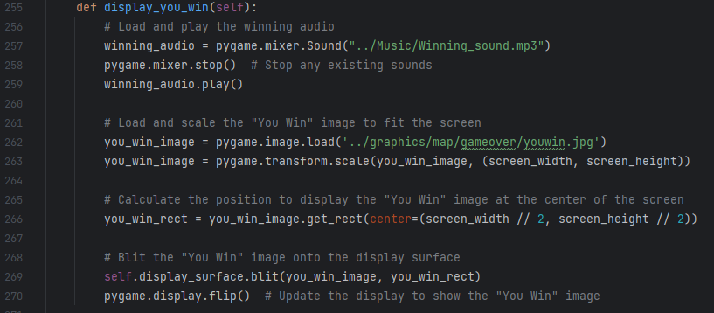

10
20

30

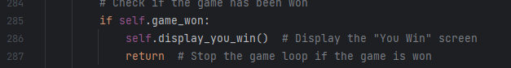
40
50

1 – loads and scales the youwin.jpg image to the screen
2 – calculates and positions the image in the centre of the screen
3 – draws the image to the surface and updates it so it is visible to the user
4 – only displays this if self.game_won is true, this is set when all the coins have been collected
5 – stops the game loop when the game is won, as it won’t need to continue updating player, enemies etc.

Outcome:
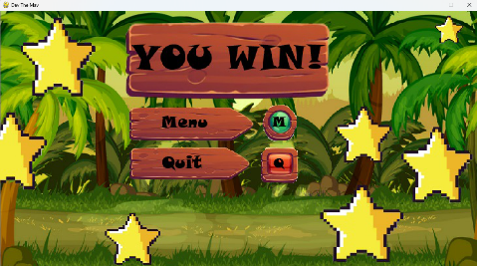

This is how I expected the you win screen to appear once you_win_game_state is set to true (player collects all the coins)

Date: 06/08/23

Now I will add all of my music
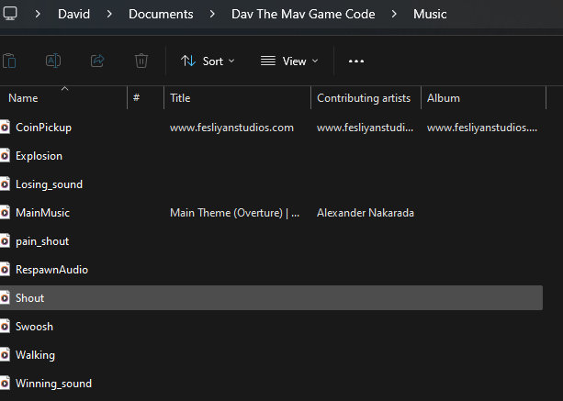
Made a folder alongside the code folder, and the graphics folder which I named Music, this contains any music or sound effects used in my game.

Main game music (constantly playing in background)

In main.py file, outside of any game loops
10
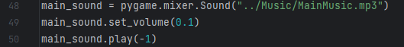
30
20

1 – loads the main music for the game into main_sound variable
2 – sets the volume to 1/10 as it was too loud before
3 – plays the main_sound music, on repeat hence the -1 passed into the method
Outcome:
The main music plays throughout the entirety of the game playing, and menu screens etc.

Coin pickup sound effect
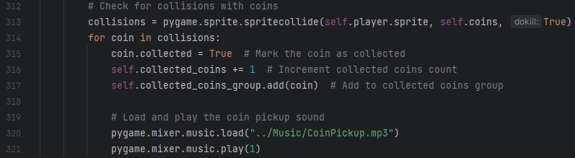
in run() method in level class in the level.py file
10

1 – loads the sound effect for picking up coins, and plays it a singular time

Outcome:
Everytime collision with coin is detected, the picking up coins sound effect is played once

What’s being tested? | input | justification | Expected outcome | Actual outcome
Does coin sound effect play | N/A | Adds excitement and acts as a visual indicator to user that coin has been collected | Sound effect is played | Sound effect is played

Date: 11/08/23

Enemy collision sound effect

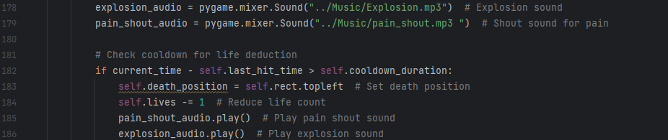
in the lose_life() method in player class in player.py file
20
10

1 – loads both the explosion sound effect and the shouting sound effect to be played each time player collides with enemy
2 – first plays the grunting/shouting of pain audio, followed by the explosion audio.

Outcome:
Each time a life is lost colliding with the enemy, both explosion and shouting sound effects are played

Respawning sound effect
In lose_life_and_respawn() method in the player class in player.py file
20
10
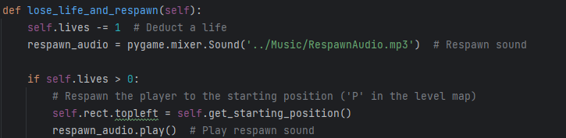

1 – loads the respawn audio, which is trumpets
2 – plays this audio once when player respawns

Outcome:
When the player respawns, the audio for respawning is played

Jumping sound effects

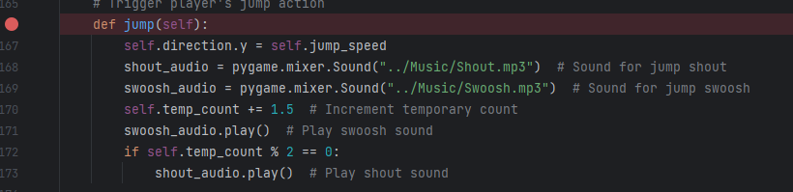
in the jump() method within the player class in player.py file
4
30
10
20

1 – loads the shouting audio for jumping and the swooshing
2 – temporary counter is incremented by 1.5
3 – for every jump swoosh audio is played
4 – if temp_counter MOD 2 equals 0, meaning it is divisible by zero, the shout audio is played, this means it is only played once every four jumps

Outcome:
Swoosh audio played every jump, shout audio (along with swoosh audio) played every four jumps

Date: 16/08/23

Running Sound effects

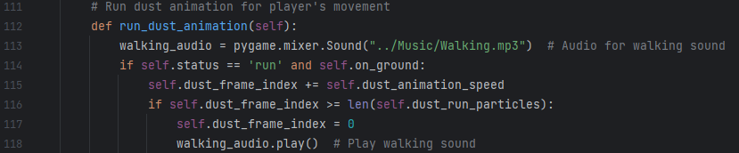
In run_dust_animation() in player class in the player.py file
20
10

1 – loads the walking_sound_effect
2 – plays the walking sound effect whenever the player is on ground and walking

Outcome:
Whenever player is on ground and moving left or right, footsteps are played from the walking sound effect

Losing game sound effect
In level class in display_game_over() method within the level.py file
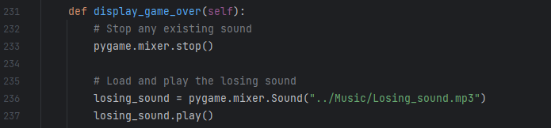
10

20

1 – stops all currently running sound effects
2 – loads and plays the losing_sound.mp3 file

Outcome
When the game is lost, sad trumpets are played from the losing_sound effect

What’s being tested? | input | justification | Expected outcome | Actual outcome
If losing sound effect is played when game is lost | N/A | Acts as a audio indicator to user that they have lost, and adds a bit more uniqness to the game | Losing sound effect is played when game lost | Losing sound effect is played when game is lost

Winning game sound effect
In the display_you_win() method within the level class in my level.py file
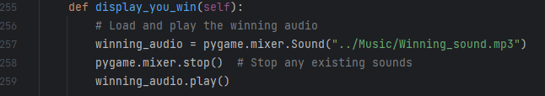
20
10

1 – winning sound effect is loaded, all current running audio is stopped
2 – winning sound effect is played
Outcome:
When the player wins and the win screen is displayed, happy triumphant trumpets are played from the winning_audio sound effect

What’s being tested? | input | justification | Expected outcome | Actual outcome
Is the winning_Audio sound effect played | N/A | Acts as a audial indicator to the user and adds uniqueness to my game | Sound effect is played | Sound effect is played

Evaluation

Testing for evaluation

start up
This section tests the start up screen.
No. | Tests | Input | Expected outcome | Actual outcome | Video reference
1. | Title screen displayed when game is first opened . | Valid: Launching the game code | Valid: The title screen of the game should be the initial display upon opening the game. | As expected | N/A
 |  | Invalid: Closing the game immediately after launching | Invalid: N/A (As this action doesn’t fulfill the requirement of observing the title screen), it just closes | As expected | N/A

menu screen
This section tests the menu screen.
No. | Tests | Input | Expected outcome | Actual outcome | Video reference
2. | Menu screen displayed with options to navigate to, like quit, controls or play | Valid: Pressing ‘c’ or ‘q’ or ‘p’ | Valid: Pressing "C" navigates to the controls, "P" initiates gameplay, and "Q" leads to quitting the game from the main menu. | As expected | N/A
 |  | Invalid: Invalid: pressing ‘u’ or ‘6’ | Invalid: nothing will happen as these controls don’t cause anything to execute | As expected | N/A

scoreboard
This section tests the scoreboard. I was unable to implement the score system features into the game
No. | Tests | Input | Expected outcome | Actual outcome | Video reference
3. | Users score is added to leaderboard if it is in the top 5, the users final score is added  to the score board if it is  greater than the score boards  lowest score | Valid: Achieving a score higher than the lowest score on the leaderboard | Valid: The user's final score gets added to the scoreboard, replacing the lowest score if it surpasses it. | This feature was  not implemented | N/A
 |  | Invalid: Achieving a score that is equal to or lower than the lowest score on the leaderboard. | Invalid: The user's score is not added to the leaderboard or scoreboard if it doesn’t surpass the lowest score. | This feature was  not implemented | N/A
4. | User can enter their own custom name to be displayed in the score board, if it is greater than 2 characters and less than 21 | Valid: any usernames between 2 and 21 charcaters like “Bobman88” or “123David” | Valid: The custom name is accepted and displayed on the scoreboard. | This feature was  not implemented | N/A
 |  | Invalid: any usernames not in this range like “a” or “davidskriton12345likesgames234” | Invalid: The custom name entry is rejected as it exceeds the maximum character limit | This feature was  not implemented | N/A

levels
This section tests the different levels and selection of levels. I was unable to implement the different levels and level map features into my game due to time restrictions
No. | Tests | Input | Expected outcome | Actual outcome | Video reference
5. | User can select between different levels on a level map screen | Valid: using arrow keys to navigate between levels, ‘p’ to play the level | Valid: level will be selected and played if “p” is pressed | This feature was  not implemented | N/A
 |  | Invalid: pressing any other keys such as ‘u’ or space bar | Invalid: nothing should happen as these keys are not programmed in | This feature was  not implemented | N/A
6. | Each completed level is shown a rating out of 3 stars based off how many lives they have left at the end | Valid: 1 star, 2 star or 3 star | Valid: these will displayed below the level | This feature was  not implemented | N/A
 |  | Invalid: anything above 3 stars | Invalid: cant be displayed below the level as not enough stars to represent then number | This feature was  not implemented | N/A
 |  | Borderline: 0 stars | Borderline: a tombstone will be shown instead of stars, as the user is still unable to complete this level | This feature was  not implemented | N/A
12. | Different number of enemies and coins per level, and a different arrangement of tiles | Valid: different number of coins, enemies and a different arrangement of tiles | Valid: the tiles will be displayed in the different arrangement, and there will be more/less coins to collect and more/less enemies to avoid | As expected | N/A
 |  | Invalid: same number of coins, enemies and same arrangement of tiles | Invalid: tiles displayed in same place, same number of enemies and same number of coins will spawn in the level | As expected | N/A
37. | Backgrounds and tiles can be different for each level, or every 5 different levels for example | N/A | Every few levels, such as every 5 levels, the background image my change, and the tiles may be a different image tile | As expected | N/A

playing the game
This section tests anything that happens during the playing of the screen, most of these features I implemented however some of them I didn’t.
No. | Tests | Input | Expected outcome | Actual outcome | Video reference
33. | Press p to pause game whilst playing | Valid: ‘p’ key is pressed | Valid: the pause screen will be displayed | This feature was  not implemented | N/A
 |  | Invalid: any key other than ‘p’ is pressed | Invalid: the pause screen will not be displayed, game playing state remains displayed | This feature was  not implemented | N/A
36. | P to un pause when in paused state | Valid: ‘p’ key is pressed during paused state | Valid: game switched to game playing state and game resumes | This feature was  not implemented | N/A
 |  | Invalid: any key other than ‘p’ is pressed, ‘p’ is pressed not during paused state | Invalid: paused screen will remain displayed | This feature was  not implemented | N/A
8. | Time remaining displayed at the top in the middle of the screen | Valid: any time 5 seconds or above and below 1000 seconds | Valid: the user will have enough time to complete the game and see what is happening | As expected | N/A
 |  | Invalid: a time less than 5 seconds or above 999 seconds  Borderline: a time of 5 seconds or 999 seconds | Invalid: the player wont have enough time to see what is going on and play the game, or the player will have too long that the time on the screen would overlap the timer background | As expected | N/A
 |  |  | Borderline: the player will just about have time to play the level, and the timer will just about be within the timer box | As expected | N/A
9. | Number of coins left to collect shown top right | Valid: any number of coins greater than 0 | Valid: the number will be displayed | As expected | N/A
 |  | Invalid: 0 coins left to collect | Invalid: the number of coins cant be displayed because the game winning state will be being displayed | As expected | N/A
10. | Number of Coins collected displayed top right | Valid: any positive integers | Valid: this number will be displayed in the top right | As expected | N/A
 |  | Invalid: anything other than positive integers, such as negative or floats | Invalid: this cannot be displayed as it is not possible to get, because each coin collected is equal to 1, and it increments the coins collected so always is positive | As expected | N/A
 |  | Invalid: player has less than 1 life | Invalid: the game will be over (because you would have lost) so no lives will be displayed on the screen | As expected | N/A
13. | Player collects a coin when it collides with it, added to collected coins and removed from coins to collect | Valid: player collides with a coin | Valid: the coin collected counter is incremented and the coin is removed form the screen, coin remaining counter is decremented by 1 | As expected | N/A
 |  | Invalid: player collides with anything that isn’t a coin | Invalid: the coin collected and coins remaining counters remain unchanged | As expected | N/A
16. | Timer started as soon as game starts and counts down once per second to act as a timer | Valid: timer decrements by 1/60, since FPS is sent to 60, so it will be decrementing by 60 1/60 in a second which equals 1 second | Valid: timer will decrease 1 per second giving it a timer decreasing effect like a clock | As expected | N/A
 |  | Invalid: timer decrement by anything other than 1/60, or FPS is anything other than 60 | Invalid: tier will decrease by something other than 1, probably a float, meaning the timer will be messed up and display decimal point times |  | N/A
34. | Esc to quit the game at any time | Valid: ESC key is pressed | Valid: game is quit | As expected | N/A
 |  | Invalid: any key other than the escape key is pressed | Invalid: game is not quit, remains in current state | As expected | N/A
35. | M to get back to menu from pause state | Valid: ‘m’ key is pressed during pause state | Valid: menu state is run | As expected | N/A
 |  | Invalid: ‘m’ is pressed during a state which isn’t the pause state, or any key other than ‘m’ is pressed | Invalid: menu state is not run, paused screen is still displayed | As expected | N/A
40. | Check with user before quitting the game by displaying a check box | Valid: user confirms quit, by clicking ‘q’ | Valid: game quits | This feature was  not implemented | N/A
 |  | Invalid: any key other than ‘q’ is pressed such as ‘{‘, ‘9’ or ‘m’ | Invalid: game does not quit, check box is removed from screen | This feature was  not implemented | N/A

Sound effects
This section tests all the sound effects in the game
No. | Tests | Input | Expected outcome | Actual outcome | Video reference
18. | Sound effect for when player is running | Valid: the player is on ground and the left or right arrow key is pressed | Valid: the sound effect will be played | As expected | N/A
 |  | Invalid: ‘m’ key, or arrow keys pressed when player is in air, or any other keys pressed other than arrow keys when on grown | Invalid: the sound effect wont be played | As expected | N/A
19. | Sound effect for when player jump | Valid: player is on ground and the space bar is pressed | Valid: the swooshing sound effect will be played | As expected | N/A
 |  | Invalid: any other key is pressed such as ‘5’ or ‘5’, or the player isn’t initially on the ground | Invalid: no jumping sound effect will be played | As expected | N/A
20. | Sound effect for when the player jumps every once in a while | Valid: player is on ground and the space bar is pressed four timesv(e.g. the player has jumped three times previously) | Valid: the shouting sound effect will play on every fourth jump | As expected | N/A
 |  | Invalid: any other key is pressed such as ‘5’ or ‘5’, or the player isn’t initially on the ground, or it isn’t the fourth jump | Invalid: no shouting sound effect is played | As expected | N/A
21. | Sound effect for falling off map | Valid: if the y direction of the player has been decreasing for more than 1 second | Valid: falling sound effect is played | As expected | N/A
 |  | Invalid: y direction of player has been decreasing for less than a second, or hasn’t been decreasing at all | Invalid: no sound effect is played | As expected | N/A
22. | Sound effect for Respawning | Valid: if the player respawns at a point given (the coordinates of the player suddenly change drastically) | Valid: respawning sound effect is played | As expected | N/A
 |  | Invalid: player doesn’t respawn (coordinates remain the same or consistently changing) | Invalid: no respawning sound effect is played | As expected | N/A
26. | Sound effect for losing the game | Valid: time left = 0 (runs out of time), player has less than 1 lives left | Valid: play losing sound effect | As expected | N/A
 |  | Invalid: timer is greater than 0, player has 1 or more lives | Invalid: losing sound effect is not played | As expected | N/A
25. | Sound effect for winning the game | Valid: if all coins remaining = 0 | Valid: winning sound effect is played | As expected | N/A
 |  | Invalid: time left = 0 (runs out of time), player has 0 lives left, coins remaining equals anything other than 0 | Invalid: winning sound effect is not played | As expected | N/A
24. | Sound effect for when you collide with enemy | Valid: player collides with an enemy | Valid: enemy colliding sound effect is played | As expected | N/A
 |  | Invalid: player collides with anything other than an enemy, player collides with an enemy within 2 seconds of already colliding with an enemy | Invalid: no enemy colliding sound effect is played | As expected | N/A
23. | Sound effect for picking up coin | Valid: if the player collides with a coin | Valid: coin sound effect is played | As expected | N/A
 |  | Invalid: player collides with anything that isn’t a coin | Invalid: no coin sound effect is played | As expected | N/A

Animations
This section tests all of my animations
No. | Tests | Input | Expected outcome | Actual outcome | Video reference
17. | All sprites are pixel art retro style | N/A | All sprites and backgrounds will be in a pixel art style | As expected | N/A
27. | Animation for the enemy walking | Valid: enemy is on a tile | Valid: animation for enemy walking is played | As expected
 |  | Invalid: enemy is not on a tile | Invalid: animation for enemy walking is played | As expected | N/A
28. | Animation for the player running | Valid: player is on ground and left or right arrow key is pressed | Valid: player running animation is played | As expected | N/A
 |  | Invalid: player is not on ground, or any keys other than left or right arrow keys are pressed such as ‘{0 or ‘d’’ | Invalid: player running animation is not played | As expected | N/A
29. | Animation for the player idle | Valid: player is not moving, no keys are being pressed | Valid: player idle animation is played | As expected | N/A
 |  | Invalid: any keys are pressed, ‘d’ or ‘3’ for example | Invalid: player idle animation is not played | As expected | N/A
30. | Animation for the player jumping | Valid: player is on ground and space bar is pressed | Valid: player jumping animation is played | As expected | N/A
 |  | Invalid: player is not on ground, or any other key is pressed other than space bar, for example ‘u’ or ‘@’ | Invalid: player jumping animation is not played | As expected | N/A
31. | Animation for the coins | Valid: coin is on a block above a tile | Valid: coin animation is played | As expected | N/A
 |  | Invalid: coin is not on a block above a tile | Invalid: coin animation is played | As expected | N/A
41. | All backgrounds are pixel art retro style | N/A | All the backgrounds in the game will be the pixel art retro style | As expected | N/A

lives
This section tests anything about the lives system in the gmae
No. | Tests | Input | Expected outcome | Actual outcome | Video reference
14. | User loses a life by colliding with enemy | Valid: user has 1 or more lives and collides with player | Valid: number of lives will be decreased | As expected | N/A
 |  | Invalid: user doesn’t collide with player, or has less than 1 life | Invalid: no lives are removed if doesn’t collide, or losing state is running since player already has no lives | As expected | N/A
11. | Start with three lives each round | Valid: player has 3 lives at start of round | Valid: player will start round with 3 lives | As expected | N/A
 |  | Invalid: player has anything other than 3 lives at the start of the round | Invalid: player will start round with a number that is not 3 lives | As expected | N/A
7. | Remaining lives displayed top left. | Valid: player has 1, 2, or 3 lives | Valid: the number of lives will be displayed on the screen in the top right | As expected | N/A
 |  | Invalid: player has less than 1 life | Invalid: the game will be over (because you would have lost) so no lives will be displayed on the screen | As expected | N/A
14. | User loses a life by colliding with enemy | Valid: user has 1 or more lives and collides with player | Valid: number of lives will be decreased | As expected | N/A
 |  | Invalid: user doesn’t collide with player, or has less than 1 life | Invalid: no lives are removed if doesn’t collide, or losing state is running since player already has no lives | As expected | N/A
15. | User loses a life by falling off the map | Valid: user has 1 or more lives and y position is less than height of the screen | Valid: player loses a life and respawns at the set respawn point | As expected | N/A
 |  | Invalid: user has less than 1 heart or y position doesn’t go less than screen height | Invalid: game isn’t in playing state and is already in game lost state, player doesn’t fall off the map so continues as normal | As expected | N/A
 |  | Borderline: y position is equal to screen height | Borderline: player continues as normal | As expected | N/A

winning game
This tests the winning game screen
No. | Tests | Input | Expected outcome | Actual outcome | Video reference
38. | Winning screens displayed when all coins collected within time limit | Valid: remaining coins is equal to zero  Invalid: remaining time = 0, or player has run out of lives and live counter is less than 1 | Valid: winning screen is displayed  Invalid: winning screen is not displayed | As expected | N/A

losing the game
This tests the losing of the game screen.
No. | Tests | Input | Expected outcome | Actual outcome | Video reference
39. | Losing screens displayed when run out of time or lose all lives | Valid: remaining time = 0, or player has run out of lives and live counter is less than 1 | Valid: losing screen is displayed | As expected | N/A
 |  | Invalid: remaining coins is equal to zero, remaining time is greater than zero and live counter is 1 or more | Invalid: losing screen is not displayed | As expected | N/A

Usability features

Here I will annotate an image of a game highlighting all its useable features. This will be followed by a brief
explanation from me and then a statement from the stakeholder, Fergus Young

menu screen

When ‘p’ is pressed level is loaded to play

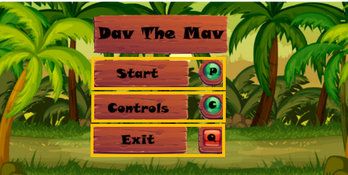

When c is pressed controls screen is opened
When ‘q’ is pressed game is quit

Me:
As we discussed previously in a former interview, the user should have been able to navigate the menu using a buttons. However, due to my unfamiliarity with implementing this and time constraints, I opted to use keys instead. However I made it very clear on what keys to press to in order to access different states. Given more time, this issue could easily be addressed by adjusting the sprites or implementing mouse-based navigation.
Fergus Young:
I remember us discussing this, and I agree with everything you mentioned. However, this wouldn't suffice as a final game, as the navigation buttons are unclear. Nevertheless, using keys for navigation is a simpler alternative that could replace mouse navigation.

Controls screen

When ‘m’ key is pressed then return back to menu

When ‘q’ is pressed then game is closed

Me:
We previously discussed incorporating a controls screen for the game, providing players with a clear understanding of how to navigate and interact within the game world. This screen will detail the keyboard controls for movement, actions, and any special abilities. Implementing this will ensure a smoother gaming experience, particularly for players new to this genre or style of game.

Fergus Young:
Absolutely, having a dedicated controls screen is pivotal in ensuring players understand how to engage with the game mechanics effectively. It's essential to present this information in a clear and accessible manner, allowing players to easily reference it during gameplay. Additionally, it aligns with the user-friendly aspect we aim to maintain in the game's interface and user experience.

Game Playing Screen
All the HUD displayed here, tell the user what is going on and is updated during the game
Player is animated and moves
Enemy is animated and moves

Me:
During our previous discussion, we talked about the layout and design of the game playing screen. The goal is to create an engaging and immersive environment that showcases the gameplay prominently. This involves organizing elements such as the player character, enemies, collectibles, and the game world in a way that ensures visibility and a seamless gaming experience.

Fergus Young:
Absolutely, ensuring that the game playing screen is well-structured and visually appealing is crucial for player engagement. It should provide clear visual cues, smooth transitions, and an intuitive layout to help players navigate and interact within the game environment. The focus should be on balancing aesthetics with functionality to create an enjoyable gaming experience.

You win Screen

When ‘m’ is pressed then return to menu state

When ‘q’ is pressed then game is closed

Me:
In our previous discussion, we explored ideas for the "You Win" screen. The intention is to create a celebratory and gratifying experience for the player upon completing the game. This screen will display a congratulatory message or animation, providing a sense of accomplishment and closure.

Fergus Young:
Right, the "You Win" screen is pivotal for player satisfaction. It should deliver a rewarding moment, perhaps with vibrant visuals, uplifting music, or animations that signify the player's success. This screen serves as a culmination of the player's efforts, emphasizing the achievement and acknowledging their progress throughout the game.

You lose screen

When ‘m’ is pressed then return to menu state

When ‘q’ is pressed then game is closed

me:
For the "You Win" screen, the focus is on delivering a satisfying conclusion to the player's journey. This involves incorporating celebratory elements, such as congratulatory messages, triumphant music, and engaging visuals, to highlight their achievement and evoke a sense of accomplishment.

Fergus Young:
Indeed, the "You Win" screen acts as a rewarding endpoint, providing closure and a positive experience for the player. It should be visually appealing, ensuring that players feel a sense of fulfilment and success upon completing the game's objectives.

Selecting levels screen
When ‘m’ is pressed then menu is opened
When ‘l’ is pressed then leaderboard opens

When ‘p’ is pressed then game is played
When ‘q’ is pressed then game is closed

The "Selecting Levels" screen will serve as a pivotal navigation point, allowing players to choose from different levels available in the game. It should provide a clear layout with intuitive controls, enabling players to seamlessly navigate through the various levels. Visual cues and concise information about each level will aid players in making informed choices.

Fergus Young:
The "Selecting Levels" screen plays a crucial role in enhancing gameplay by granting players the autonomy to choose their desired level. A user-friendly interface with engaging visuals and succinct details about each level will empower players to explore and select levels according to their preferences. This screen should be accessible and visually appealing to maintain player engagement.

Leaderboard screen

When ‘e’ is pressed then level map is opened
When ‘q’ is pressed then game is closed

Me:
The "Leaderboard" screen is a platform showcasing top player scores, fostering competition and motivation among players. It should display names or aliases of leading players alongside their respective high scores. The interface must be intuitive, allowing players to navigate through scores easily and comprehend their position in the ranking.

Fergus Young:
The "Leaderboard" screen serves as a benchmark for players to measure their progress against others. It's essential to design a clear and organized layout, highlighting the top scores prominently while allowing players to scroll through the list for a comprehensive view. This screen should instil a sense of achievement and drive players to improve their scores.

How well does my solution match the success criteria

The following will be looking all the requirements created in the research stage. I will be looking at how well the solution matches the requirements, talking about any changes that were made to the design of the game during the development process and how I would have I would have approached the completion of any unmet requirements.

Start up
No | Requirements | Justification
1 | Start-up screen. | This is done to show the user what game they are about to play
This requirement was met because the the start-up screen was implemented effectively to provide users with a clear introduction to the game they are about to engage with

Menu screen
No | Requirements | Justification
8 | Loading screen | A loading screen is used to hide the process of loading game assets (such as graphics, levels, or data) from players. This enhances the overall user experience by preventing players from encountering unresponsive or partially loaded game elements, ensuring a smoother and more enjoyable gameplay experience.
9 | Menu with title displayed, giving options for controls, or to play the game by entering the level map | : The menu with title and options helps players easily start the game, customize settings, and understand how to play, improving the overall gaming experience.
10 | Controls screen | It provides players with a clear and accessible reference for the game's controls, helping them learn and remember how to play, reducing frustration and improving the gaming experience.
23 | C key to open controls from menu screen | Assigning the "C" key to open controls provides players with a quick and clear way to access and review the game's controls, enhancing user-friendliness and ensuring players can easily understand how to play the game.
28 | Background music for the menu screen and controls screen | Background music in these screens sets the mood, adds ambiance, and creates a more enjoyable and immersive experience for players as they navigate through the menu and access game controls, enhancing the overall user experience.
28 | Background music for the menu screen and controls screen | Background music in these screens sets the mood, adds ambiance, and creates a more enjoyable and immersive experience for players as they navigate through the menu and access game controls, enhancing the overall user experience.

All these requirements were met. The implementation of a loading screen serves the purpose of concealing the loading process of game assets, such as graphics or levels, from players. This ensures a smoother and more enjoyable gameplay experience by preventing players from encountering partially loaded or unresponsive game elements. A menu displaying the game title and offering options for controls or entering the level map facilitates an easy start for players, allowing customization of settings and providing clarity on how to play. This significantly enhances the overall gaming experience. The inclusion of a dedicated controls screen provides players with a clear and easily accessible reference for the game's controls. This feature aids players in learning and remembering how to play, reducing frustration and improving the gaming experience. Assigning the "C" key to open controls from the menu screen offers players a quick and direct method to access and review the game's controls. This enhances user-friendliness and ensures players can easily understand how to play the game. Incorporating background music for the menu and controls screens creates a specific mood, adds ambiance, and contributes to a more immersive and enjoyable experience for players navigating through these screens. This contributes significantly to enhancing the overall user experience.

Scoreboard
No | Requirements | Justification
2 | Player gains 50 points for collecting a coin | A player gains 50 points for collecting a coin in a game simply to make the action of collecting coins feel rewarding and to create a sense of achievement for players.
3 | Scrore box displayed at the top right of the screen | It lets players easily see and track their in-game progress and performance, making the game more engaging and competitive.
4 | Scoreboard can be shown when selecting levels | It helps players track their performance and encourages them to improve and replay levels for a sense of accomplishment and fun.
Only some of these requirements were met. Player gaining 50 points wasn’t implemented, but this could be done easily by simply creating a new variable which is incremented by 50 each time a coin is coleced. Score box requirement was met, scoreboard being shown can just be sandwiched between game states, and dispalye until condition is met to remove it

lives
No | Requirements | Justification
5 | Three lives per level | It gives players multiple chances to overcome challenges and complete the level, reducing frustration and allowing for a more enjoyable and forgiving gameplay experience.
6 | Life box, has three lives inside, in the top left of the screen. | It visually and conveniently communicates the player's remaining lives, allowing them to gauge their survival and make strategic decisions to avoid failure, enhancing the gaming experience.
All of these requirements were met. Implementing three lives per level provides players with multiple attempts to conquer challenges and finish levels. This setup reduces frustration and contributes to a more enjoyable and forgiving gameplay experience. The inclusion of a Life Box in the top-left corner of the screen, displaying three lives, serves as a visual indicator of the player's remaining lives. This feature offers a clear understanding of the player's survival status, allowing them to make strategic decisions and avoid failure, which enhances overall gameplay.

playing
No | Requirements | Justification
12 | All sprites and backgrounds will be in a pixel art style | Pixel art style adds nostalgic charm, clarity, and a unique visual identity to the game, appealing to players' sense of nostalgia and enhancing the overall aesthetic.
13 | Sound effects for running | Running sound effects provide auditory feedback that immerses players in the game, making the gameplay experience more engaging and realistic.
14 | Sound effects for hitting enemy | These sound effects provide satisfying feedback to players when they successfully engage with the game's combat mechanics, enhancing their sense of accomplishment and immersion.
15 | Sound effects for falling off map | These sound effects provide immediate feedback to players when they make a mistake, enhancing their awareness and engagement by indicating the consequences of their actions within the game.
16 | Sound effects for picking up a coin | Coin collection sound effects provide immediate and satisfying feedback to players, reinforcing their actions and making the gameplay experience more rewarding and enjoyable.
17 | Animation for running | Running animations visually represent the character's movement, enhancing realism and immersion, and helping players understand the character's actions within the game world.
18 | Animation for jumping | Jumping animations visually convey the character's motion, providing clarity and enhancing the player's understanding of in-game actions, making the gameplay experience more engaging and intuitive
19 | Animation for falling | Falling animations visually represent the character's descent, adding realism to the game and helping players understand the character's movement within the game world, contributing to a more immersive gaming experience.
20 | Animations for particle effects under player | These animations add visual flair and feedback to the player's movements, enhancing the sense of interaction with the game world and making gameplay more engaging and visually appealing.
21 | Esc to escape and quit the game | The "Esc" key provides a convenient and universally recognized way for players to exit the game quickly and gracefully, enhancing the user experience and usability of the game.
24 | P to pause the game while the game is playing | The "P" key offers a quick and accessible way for players to temporarily halt gameplay, allowing them to take a break, assess their situation, or make adjustments, enhancing their control and enjoyment of the game.
25 | Press p key to close the paused state so that the game can be played again | The "P" key provides a user-friendly and consistent method for players to exit the paused state and resume playing the game, ensuring a smooth and intuitive gaming experience.

Only some of these requirements were met. A pixel art style is employed throughout, offering a nostalgic and unique visual identity. Sound effects were added for running, hitting enemies, falling off the map, and collecting coins, providing immediate and engaging auditory feedback. Running, jumping, falling animations, as well as particle effects under the player, were integrated, contributing to visual realism, gameplay comprehension, and immersive interaction. Additionally, the ESC key serves as a convenient and universally recognized method to exit the game, enhancing usability and user experience.
The ones not met were the pausing requirements, but this would be very easy to implement as it is only having to check for one more key press, and then play a different state

levels
No | Requirements | Justification
11 | Level map screen | It allows players to visually explore and choose specific levels, enhancing engagement and providing a sense of progression and choice within the game.
26 | Background will be different for different levels | Unique backgrounds for each level visually distinguish and define the game's environments, adding variety and helping players easily recognize their progression through the game's various challenges and settings.

Only number of 11 of this requirement was met, 26 was not met. The Level Map screen was implemented, offering players a visual interface to navigate and select specific levels. This feature enriches engagement, empowering players to choose their paths and fostering a sense of progression and choice within the game.

Maintenance

Current and future maintenance
I have not implemented any maintenance features in to the game however I understand that if this game where to be professional distributed these features would be required to fix bugs that are found or update the game by adding more features.
My solution is not complete, but upon completion I would add a feature into the game that would allow the user to check for any updates, this feature could be placed into the menu. I would also need to set up some sort of form that would allow people to report problems they have found in the game which I, or a team of people, would fix and then release as a patch to remove the found issues. Furthermore, depending on the success of the game I could code more features into it, this would make the game playable for longer as the target audience would be entertained for longer by the game

Limitations and how they would be approached
This section consists of a series of limitations followed by how they would be approached.
Requirement | Justification
Implement Score Tracking | Adding a scoring system would enhance player engagement and competitiveness, encouraging players to go for higher scores. It adds an additional layer of challenge and motivation to the gameplay.

Approach: Increase the score whenever the player collects a coin or completes a level. Show the current score on the game screen, updating it dynamically during gameplay, or when the leaderboard is opened

Requirement | Justification
Introduce the Levels | adds depth to the game, providing a sense of achievement as players advance through increasingly challenging levels, means the user will be able to play the game in a unique way for a longer period of time
Approach: Define multiple levels with different layouts or tile arrangements When completing a level, transition the player to the next level with increased difficulty or new challenges.
Requirement | Justification
Implement color-blind mode | ensure players with color vision deficiencies can distinguish game elements effectively. This enhancement will cater to a wider audience, making the game more inclusive and enjoyable for all players.
Instead of relying solely on colours to convey information, , if colours indicate different items or obstacles, add symbols or text descriptions to differentiate them, or add a high contrast mode with very obviously distinct colours.

Requirement | Justification
Power-Ups | offer temporary advantages, making gameplay more dynamic and rewarding skilled play, which creates uniqueness to the game as a whole and within levels too
Develop classes or modules for each power-up type. Each class should manage the activation, effects, and duration of the power-up. Implement collision detection between the player and power-ups. When the player collides with a power-up, trigger the corresponding power-up effect.

Requirement | Justification
Achievements | Determine game milestones, challenges, and accomplishments that can be tracked as achievements.
to add achievements, define specific milestones or goals players can reach, track their progress internally, and display notifications or icons when they accomplish these milestones. Keep track of these achievements in the player's profile or a dedicated menu section.

Requirement | Justification
Dynamic Weather Effects | Design weather effects that enhance gameplay without hindering visibility or gameplay mechanics.

Can be done by creating animations that run throughout the duration of the level, and are spawned at random location on the screen

Requirement | Justification
Impressive visuals | This will make the game more appealing to a wider audience
to implement this requirement, I would need additional software such as Pyro. This would allow me to add lighting effects and shadow into the game making it look more astatically pleasing.

Requirement | Justification
Two player modes | This would create a local two player competitive mode which will give the user more content

For a two-player mode, I'll design unique controls for each player, ensuring simultaneous interaction. By creating either a split-screen or a shared display, I'll carve out separate spaces for both players to engage. Mechanics will encourage either cooperation or competition, aiming for balanced and enjoyable experiences. Rigorous testing ensures smooth interaction and maintains fairness in gameplay for both participants.

Project Appendix

File System
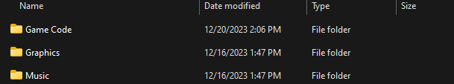

Game code
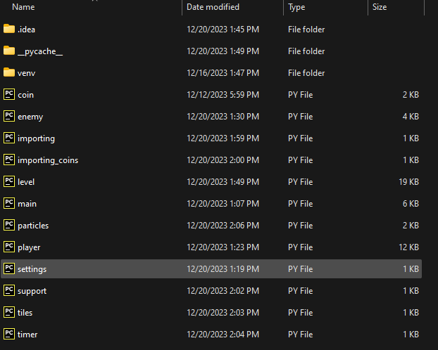

Graphics
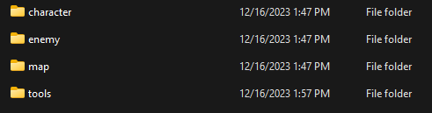

Character
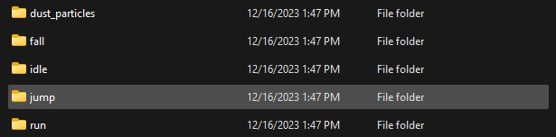

Map
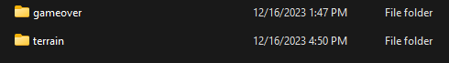

Tools
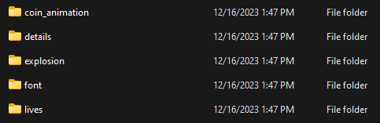

Music

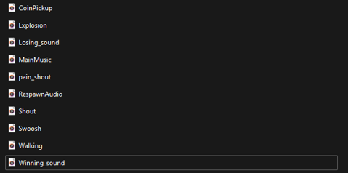

Code Listings

Main.py file
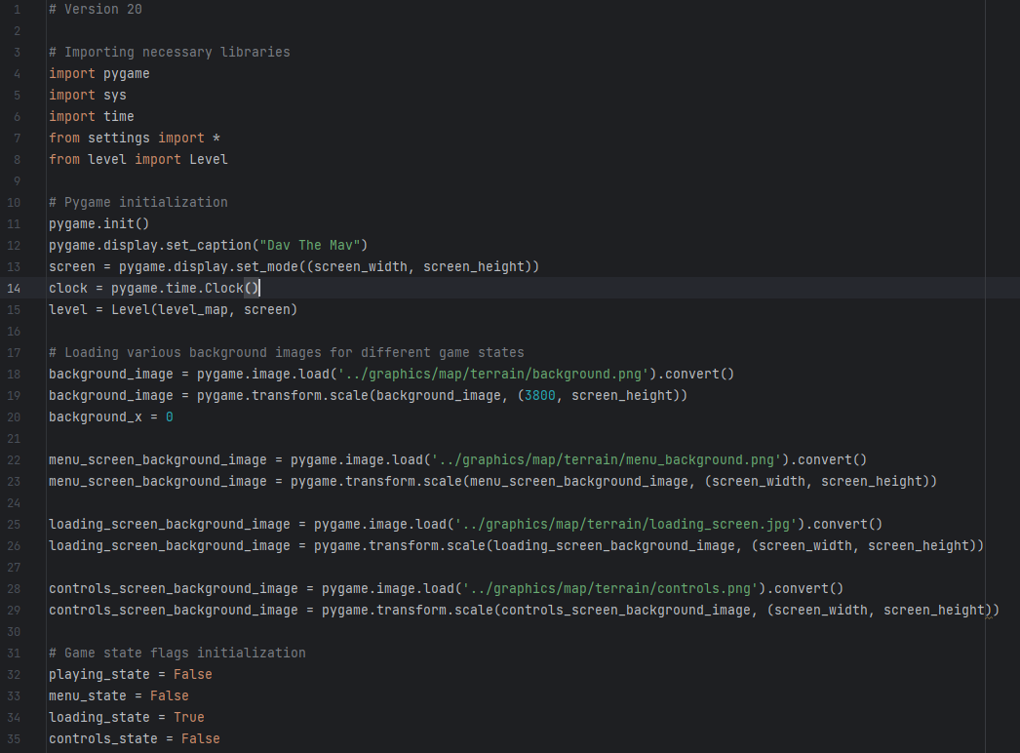

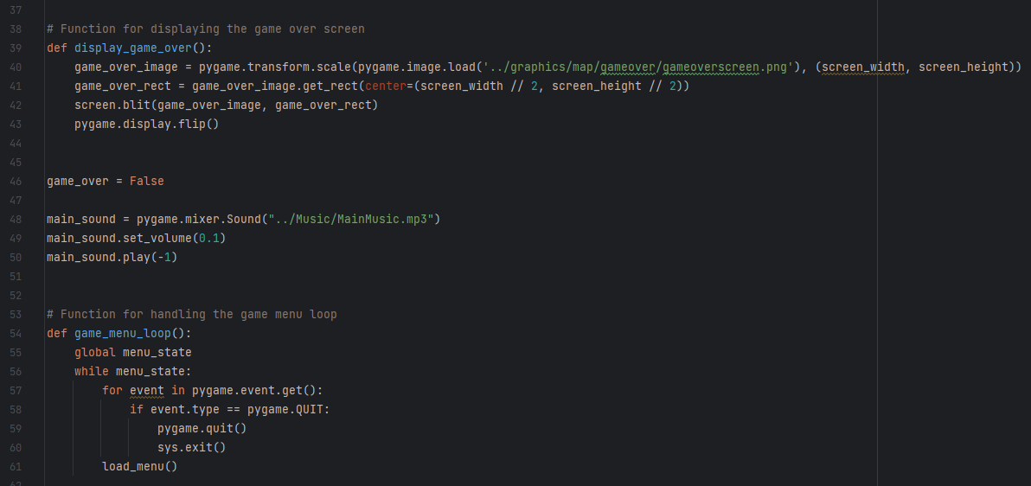

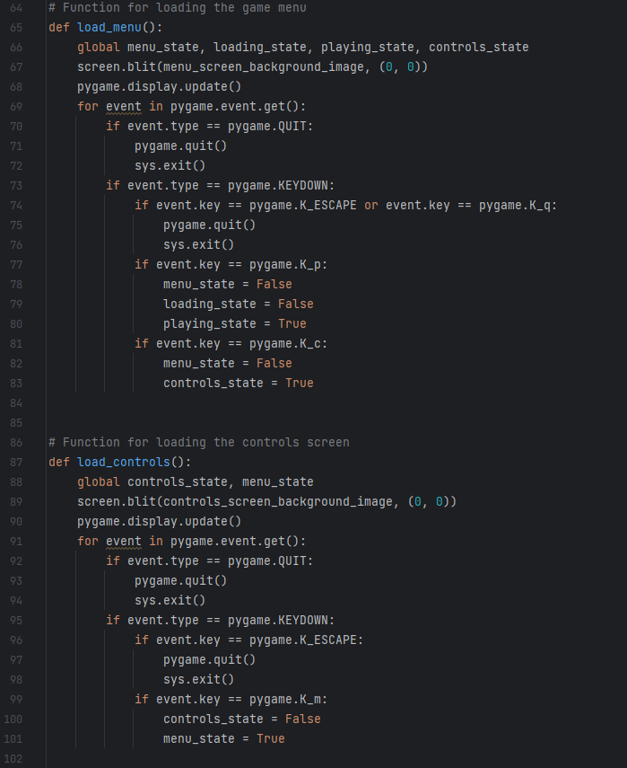

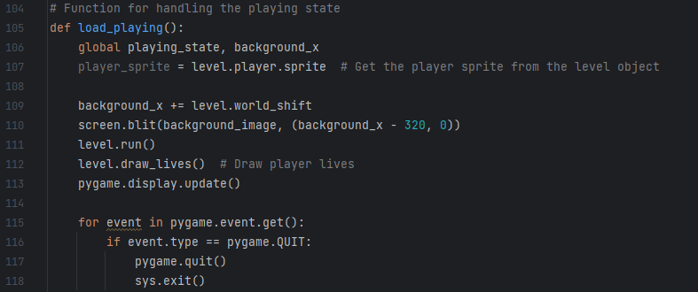
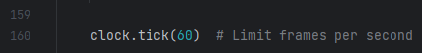
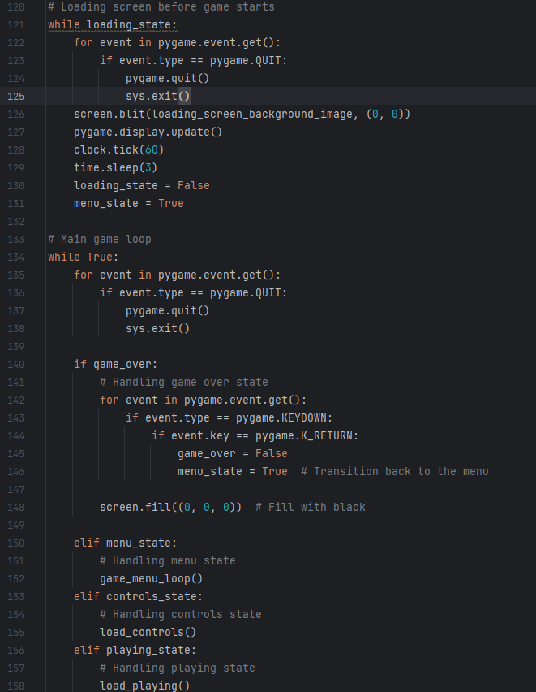

Player.py file
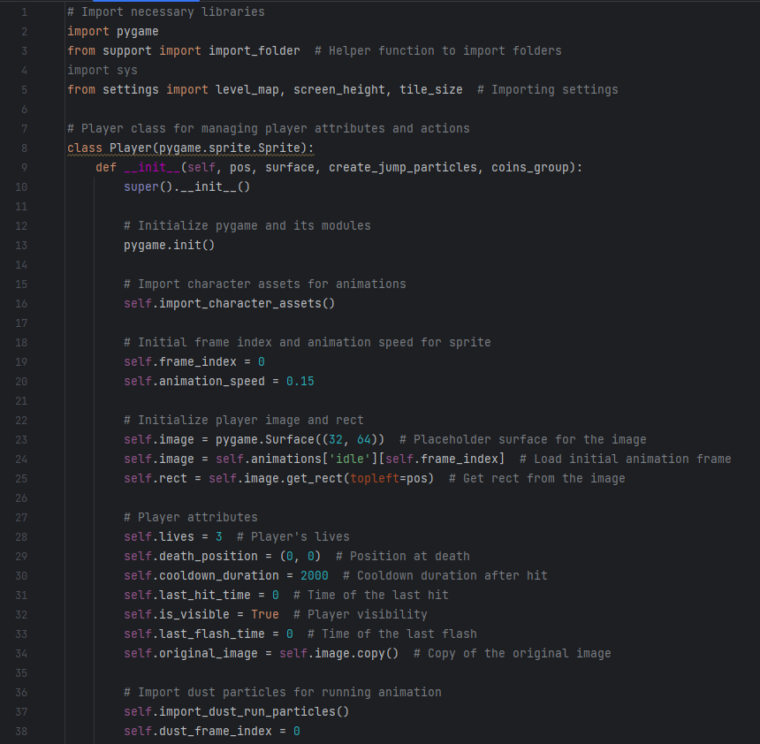

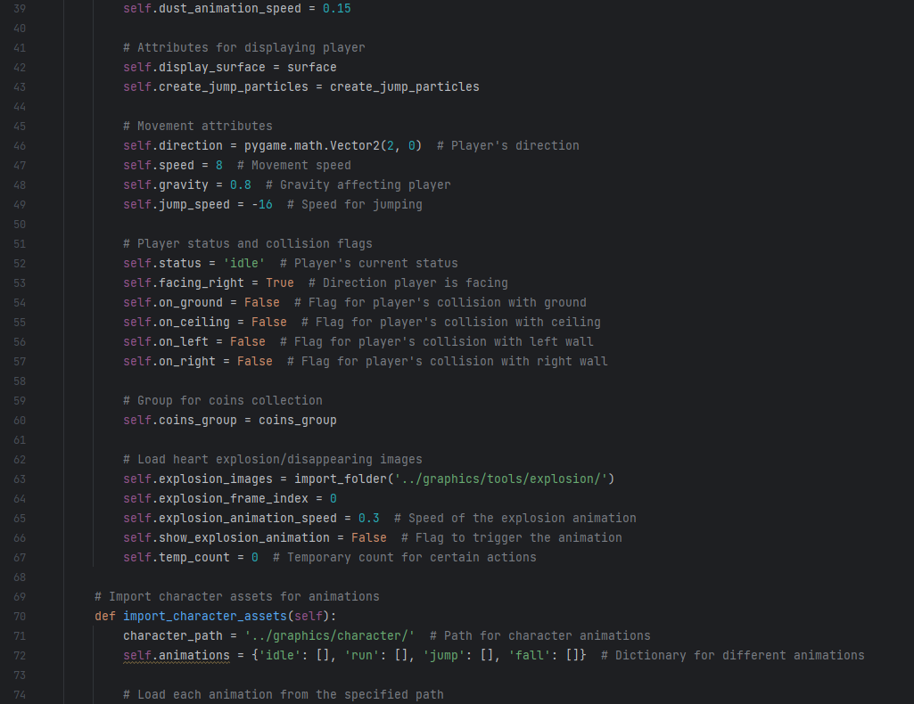
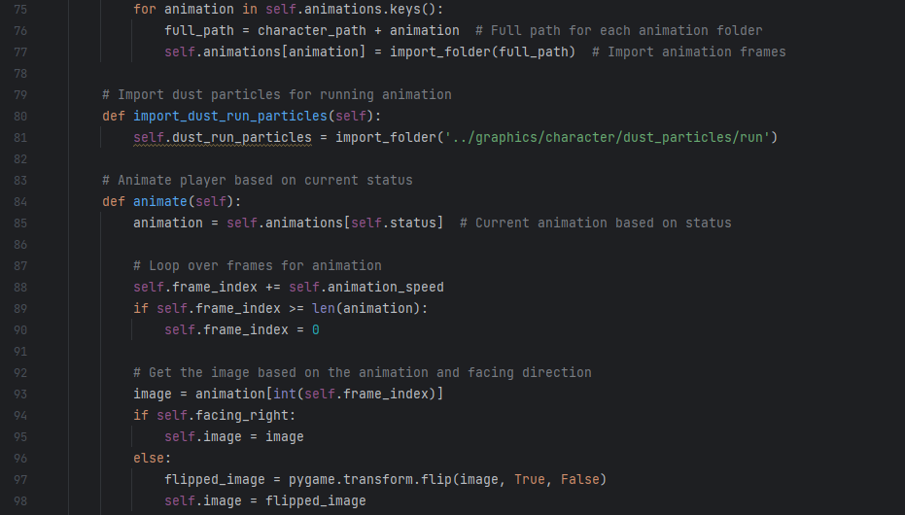

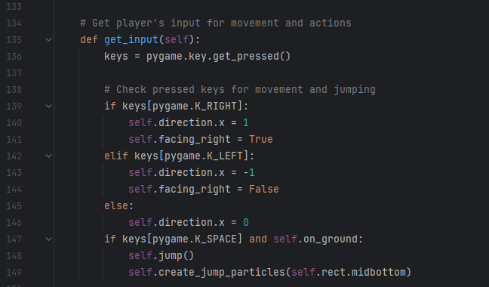
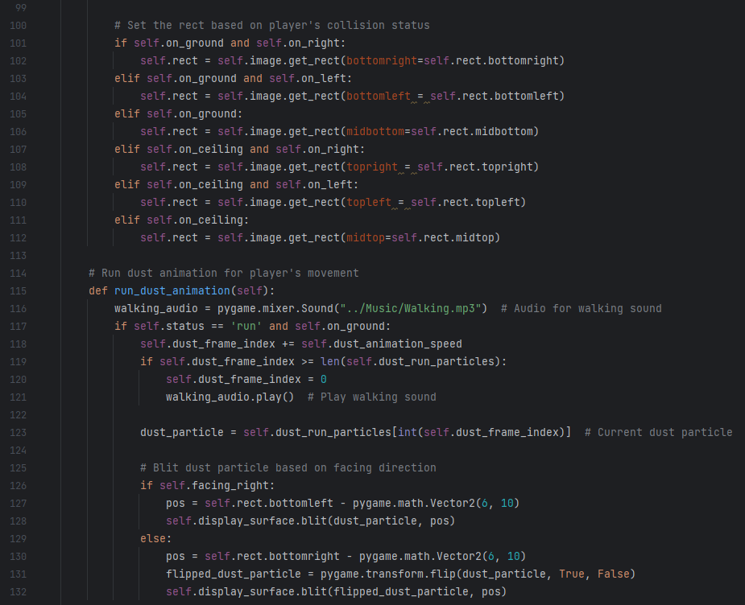

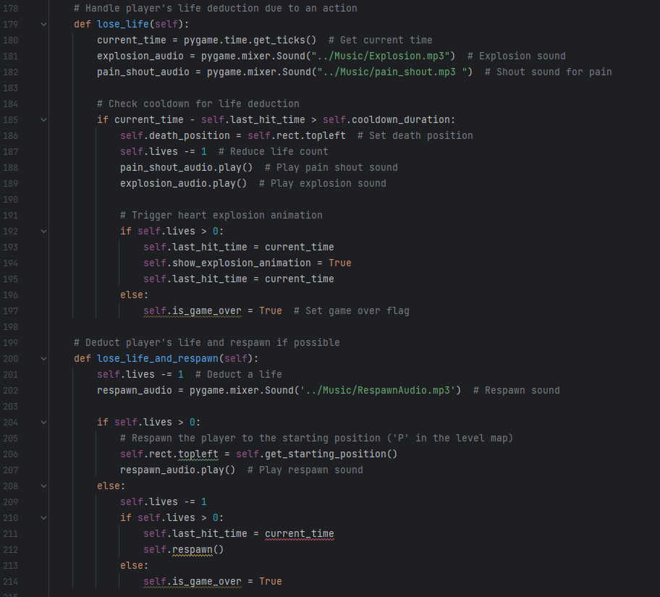
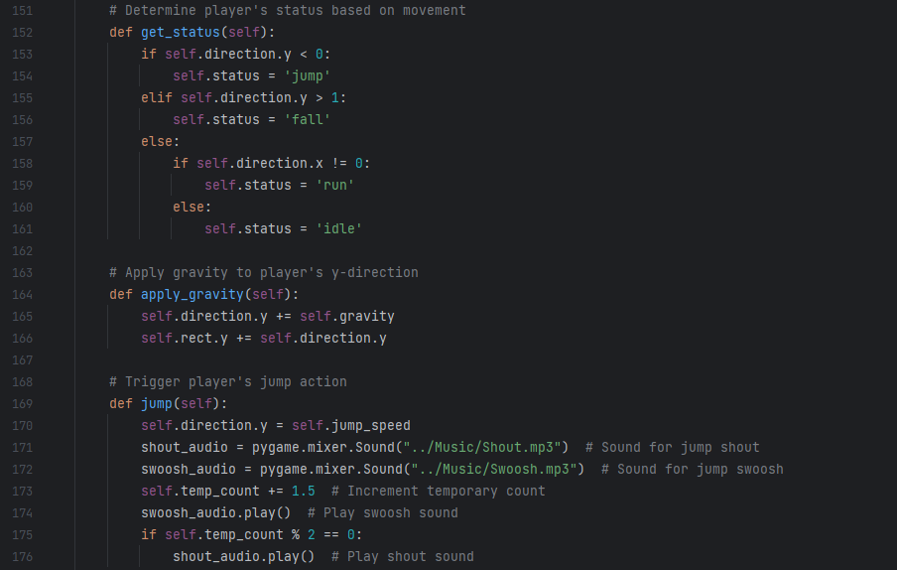
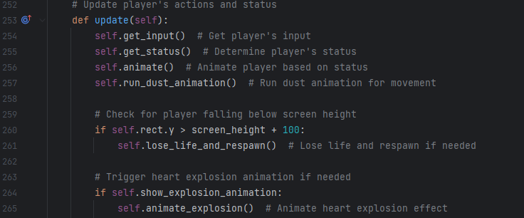
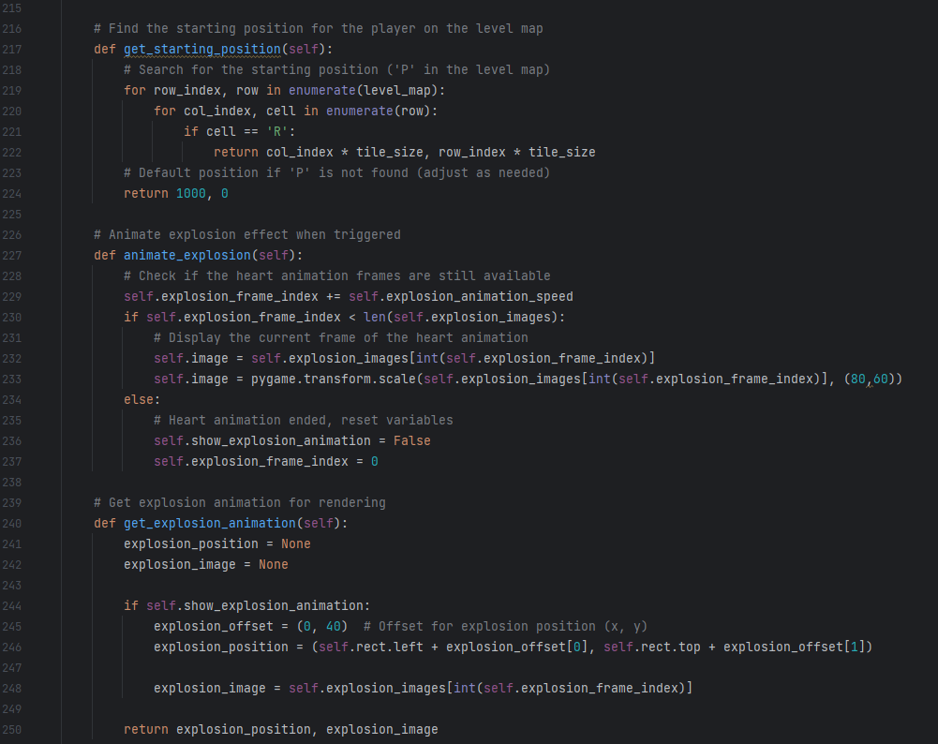

Enemy.py file
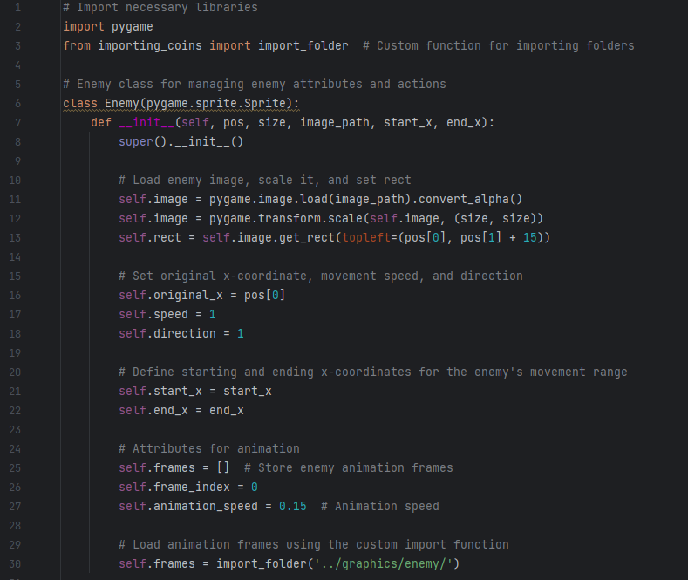

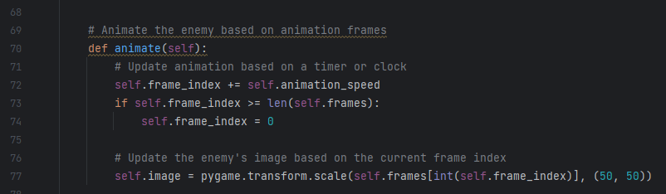
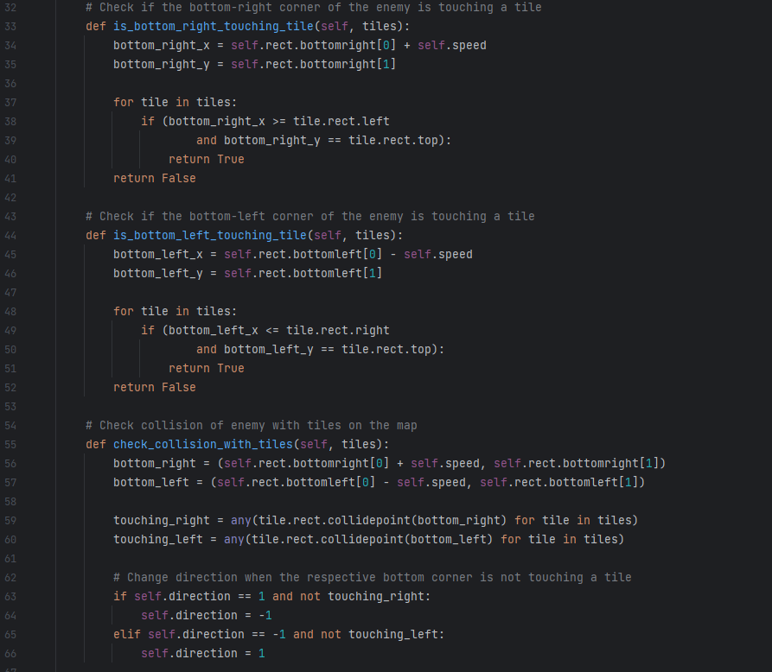

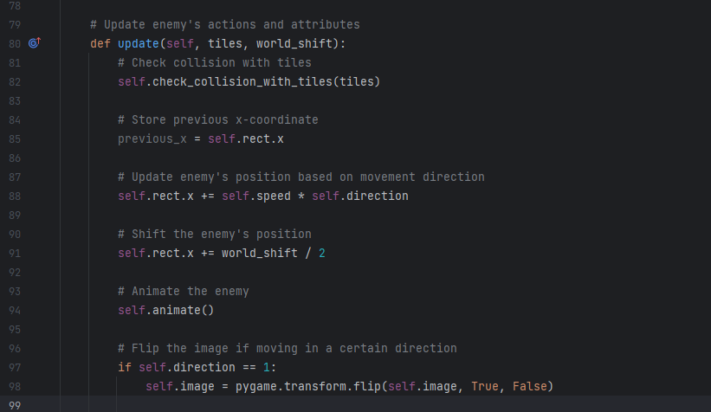

Level.py file

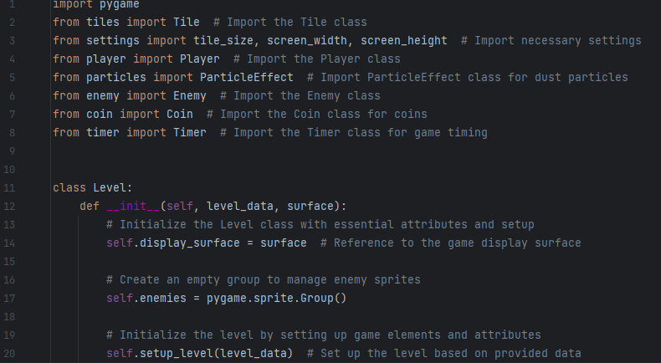

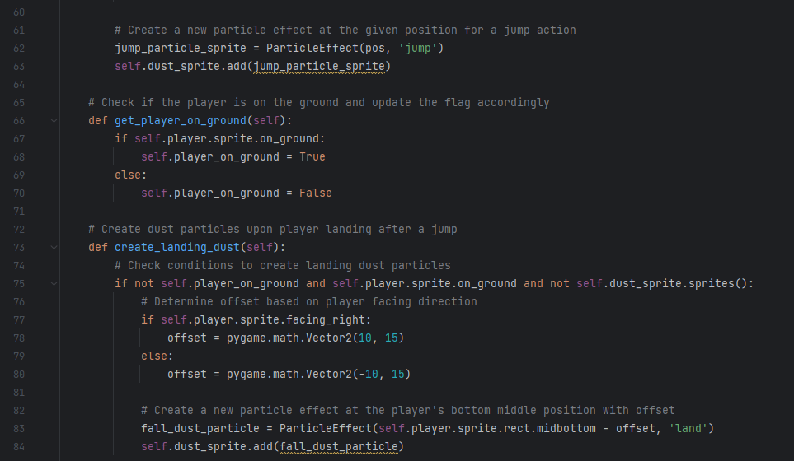
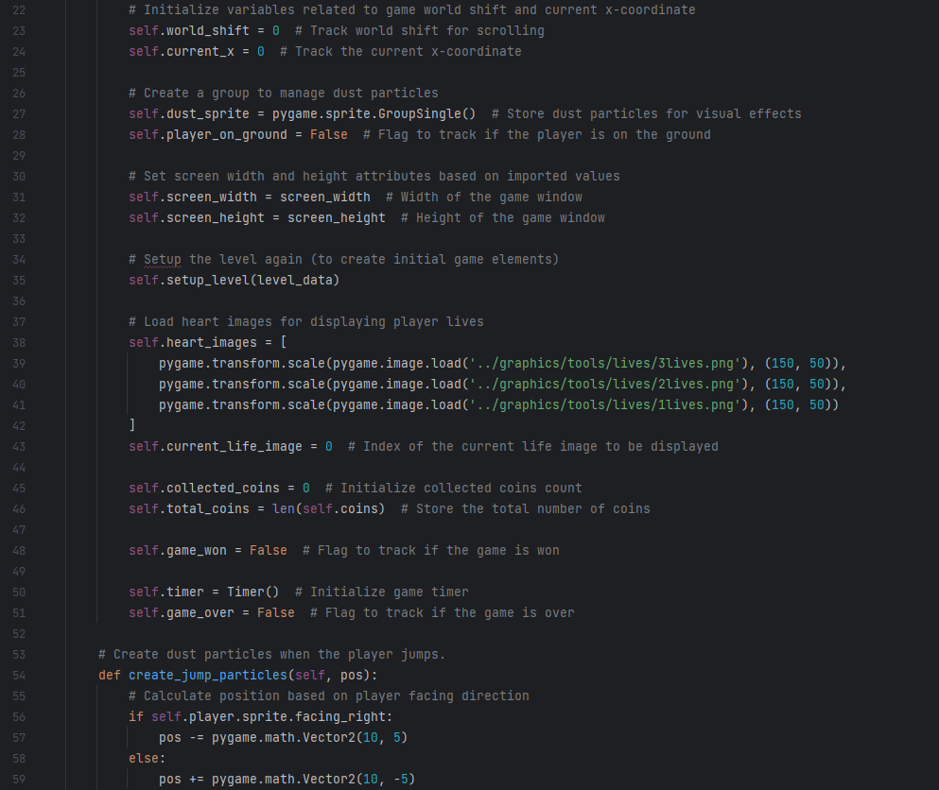

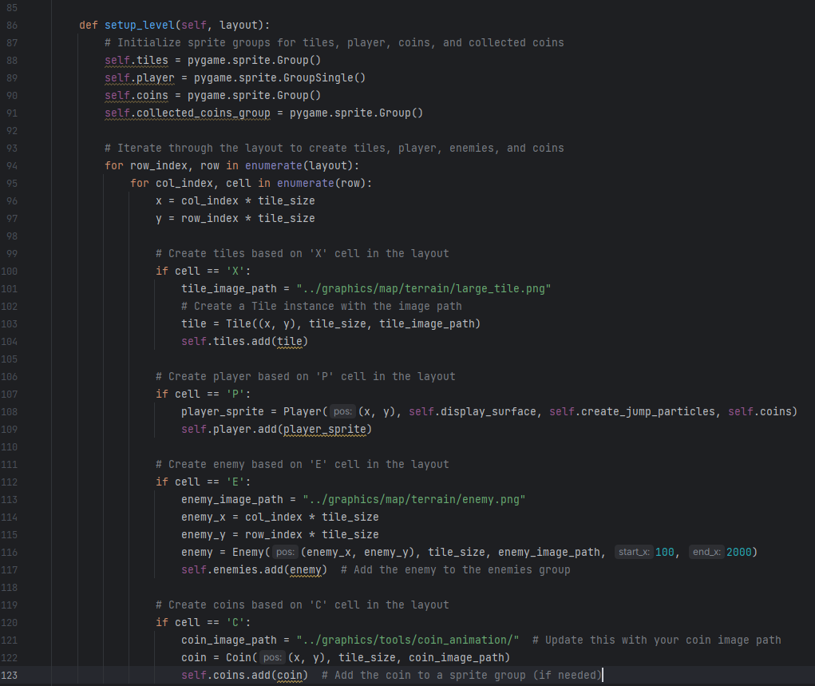
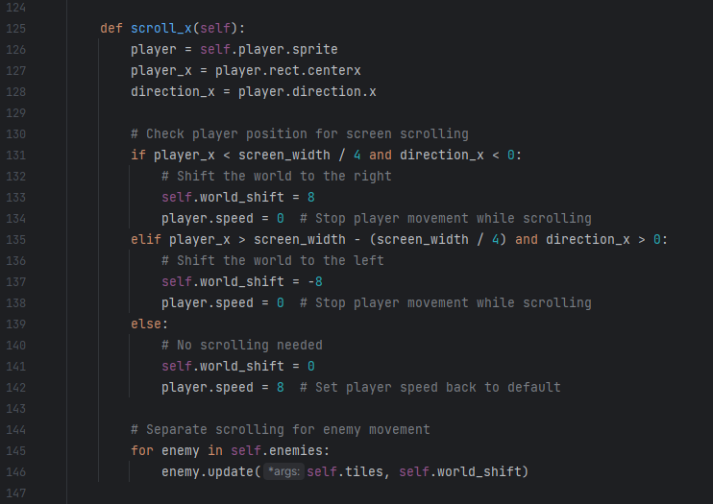

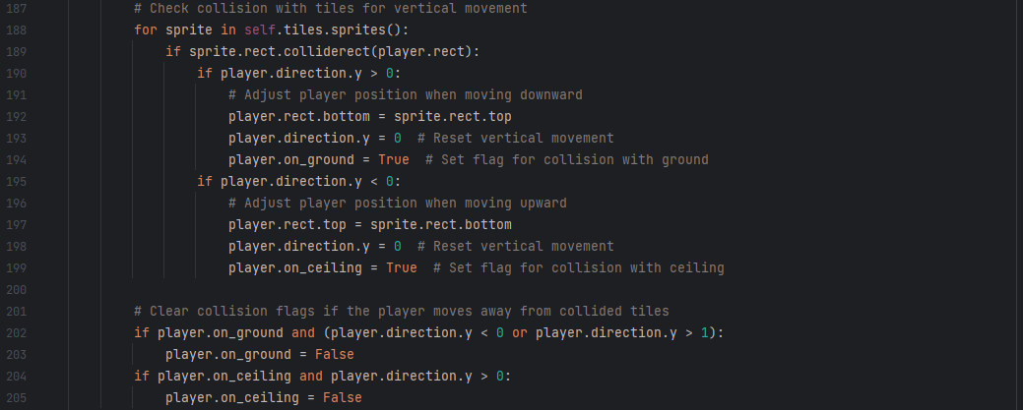
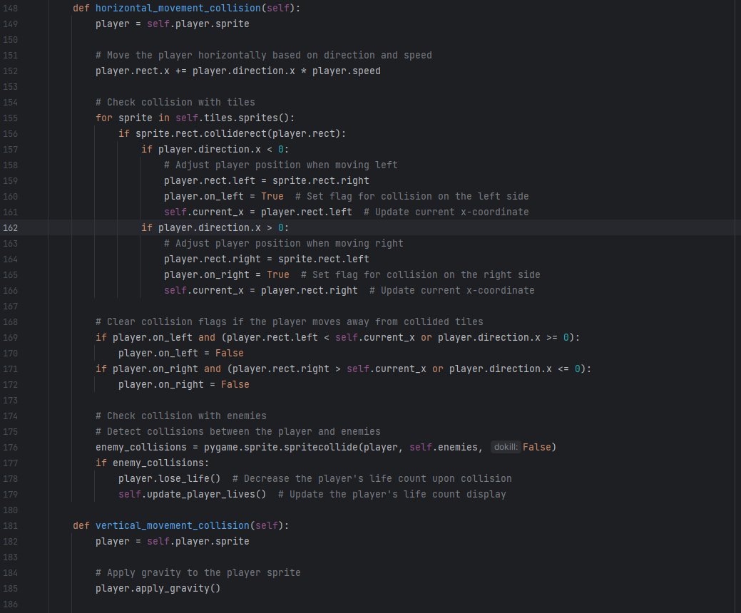

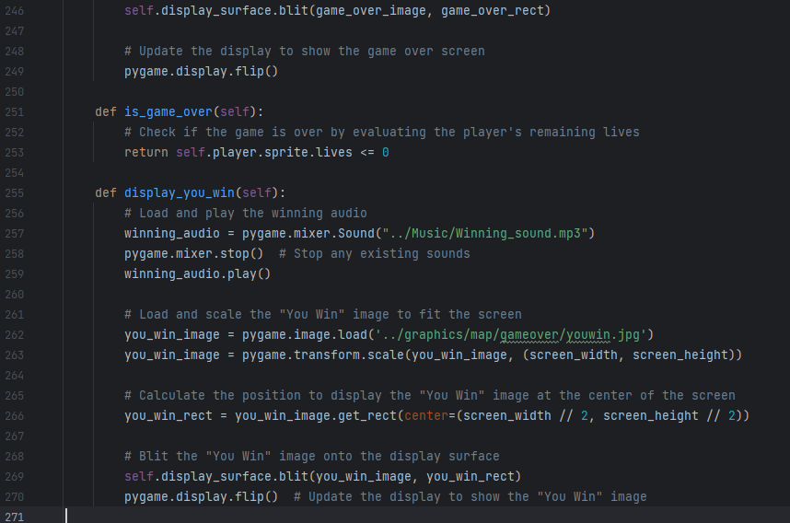
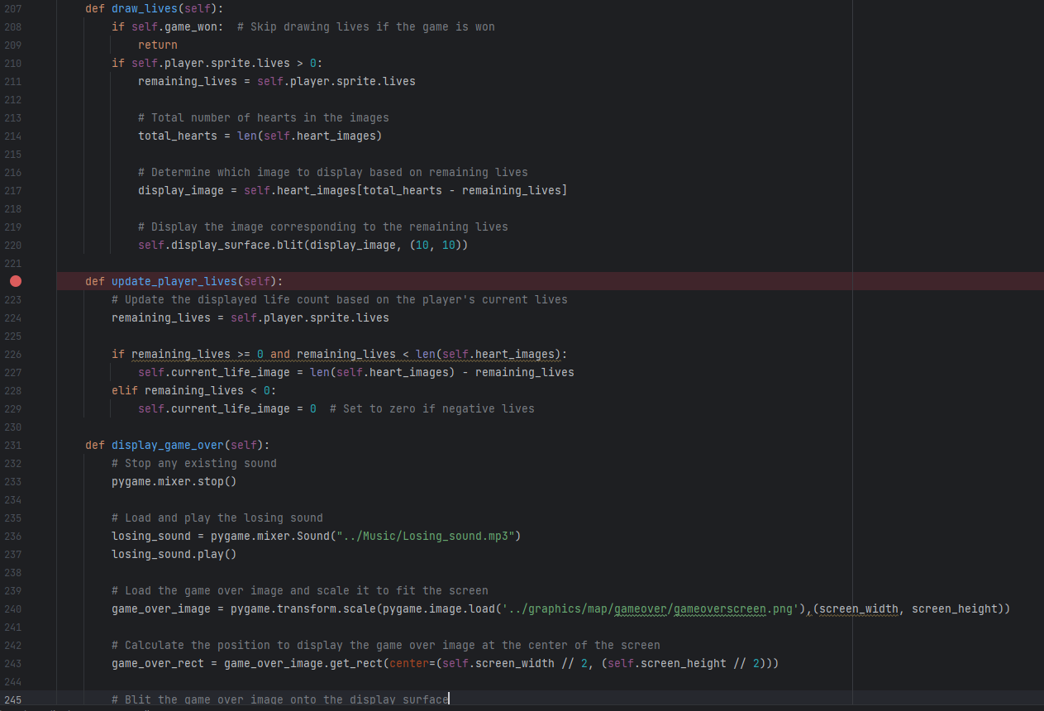

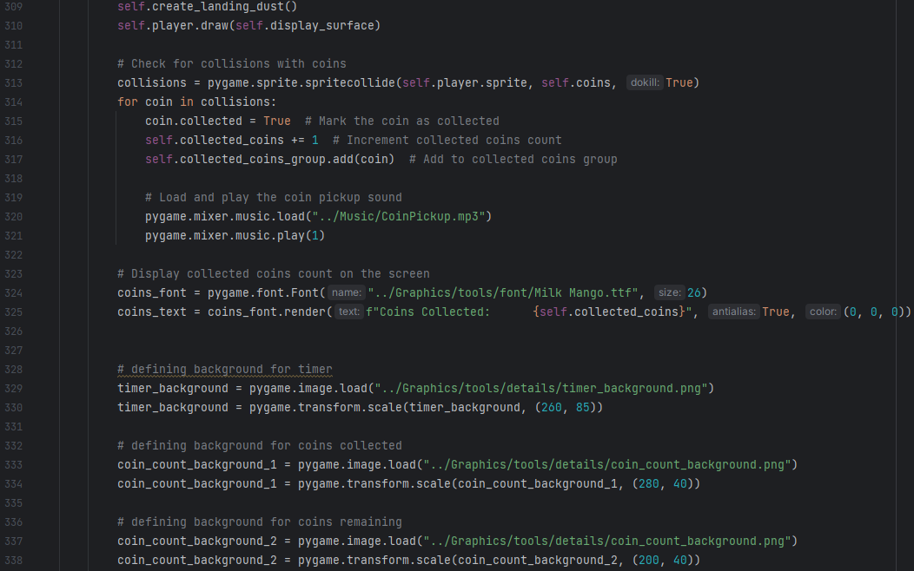
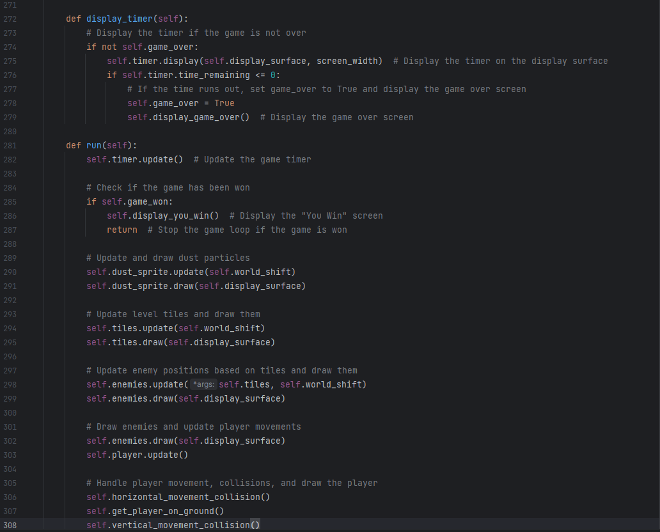

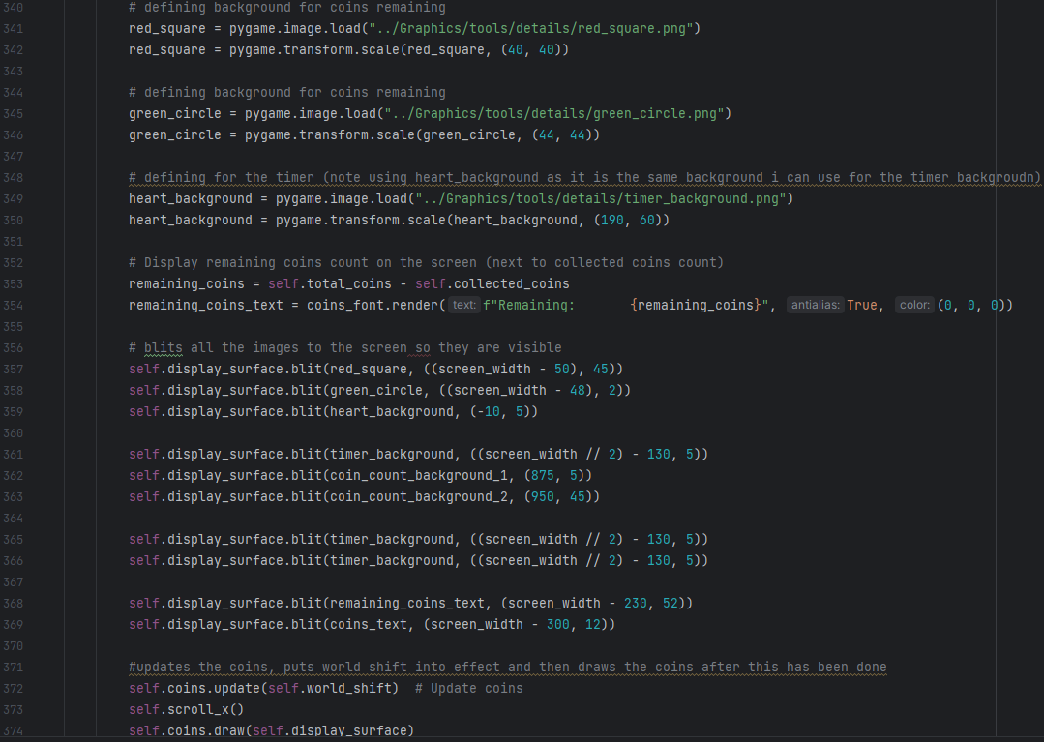

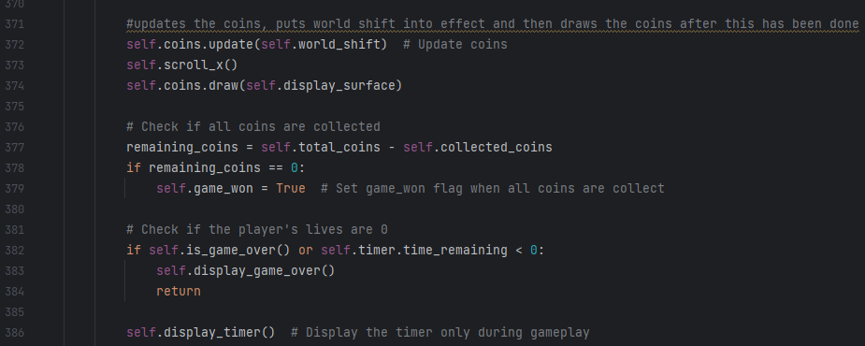

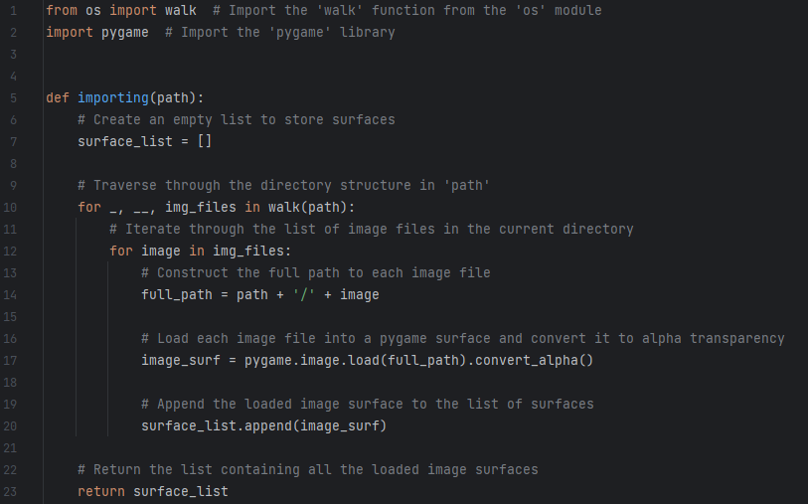
Importing.py file

Importing_coins.py file
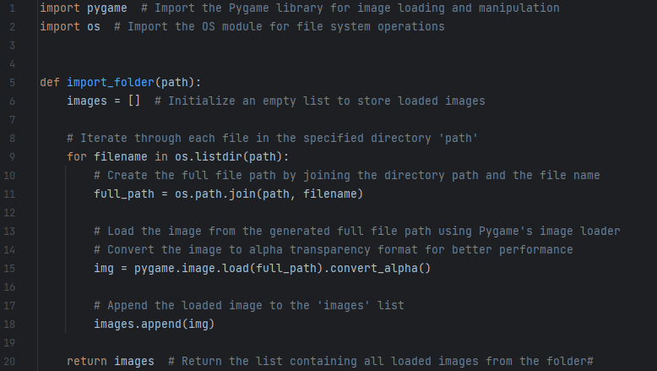

Support.py file
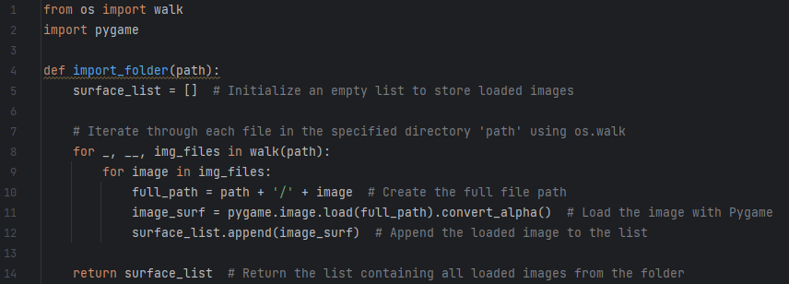

Tiles.py file
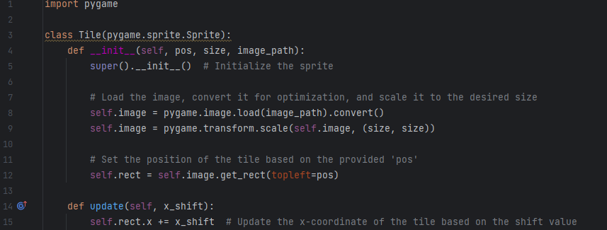

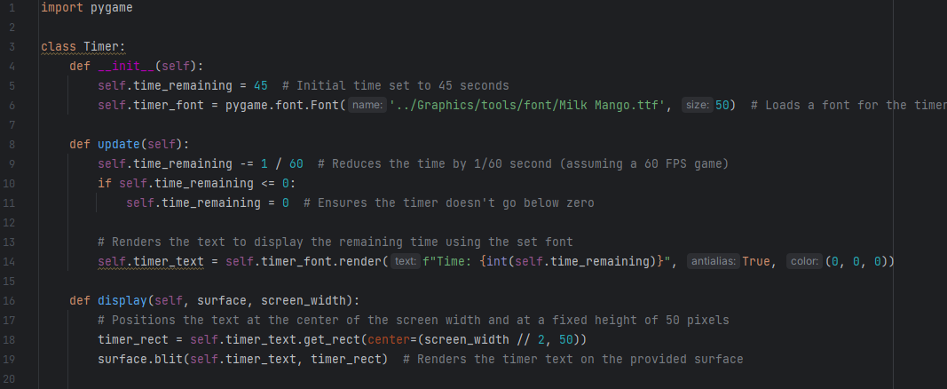
Timer.py file

settings.py file
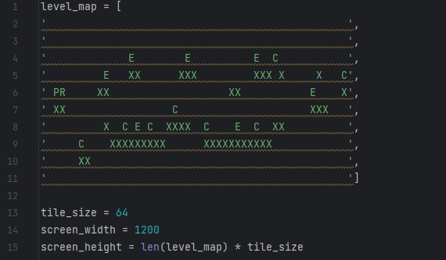

Coin.py file
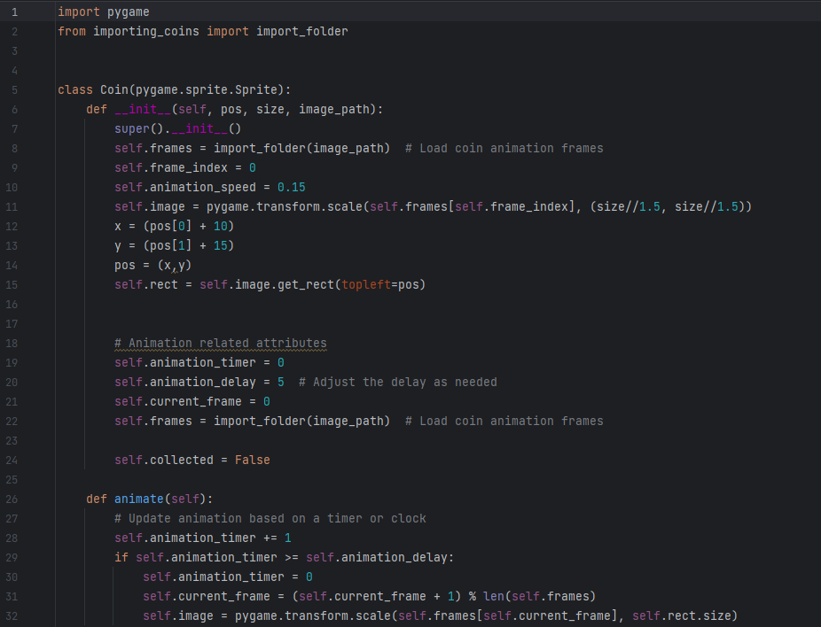

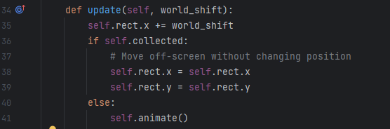

Particles.py file


