**First Test**

Post url for upload one file add time

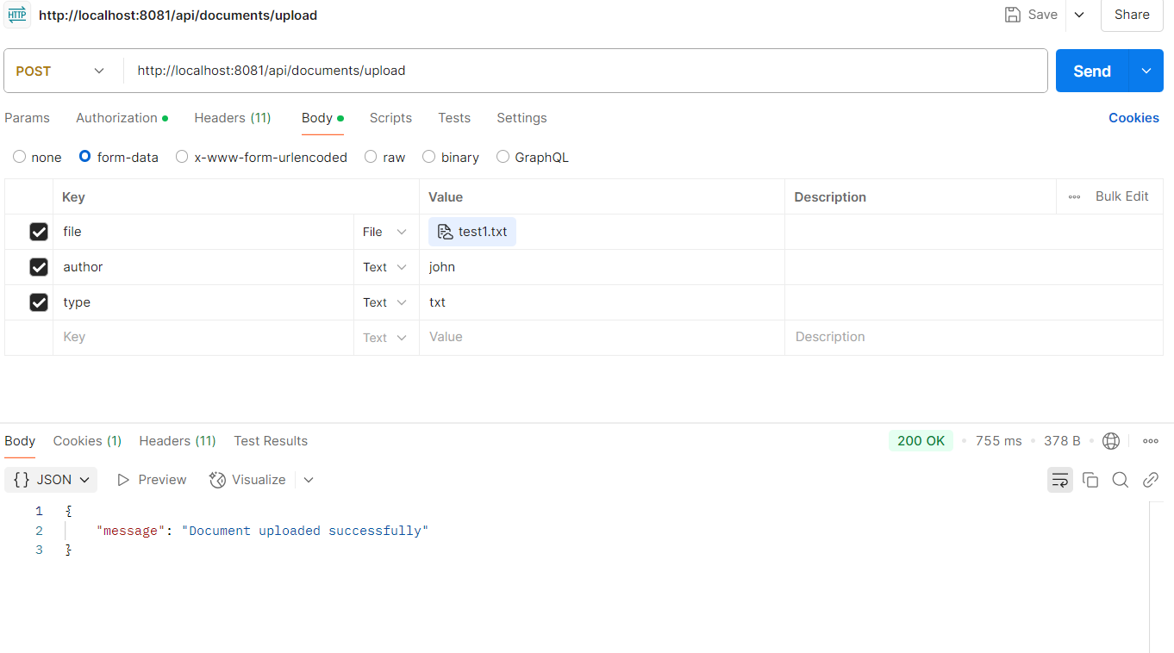

**Second test**   
For upload multiple same time like async proceed

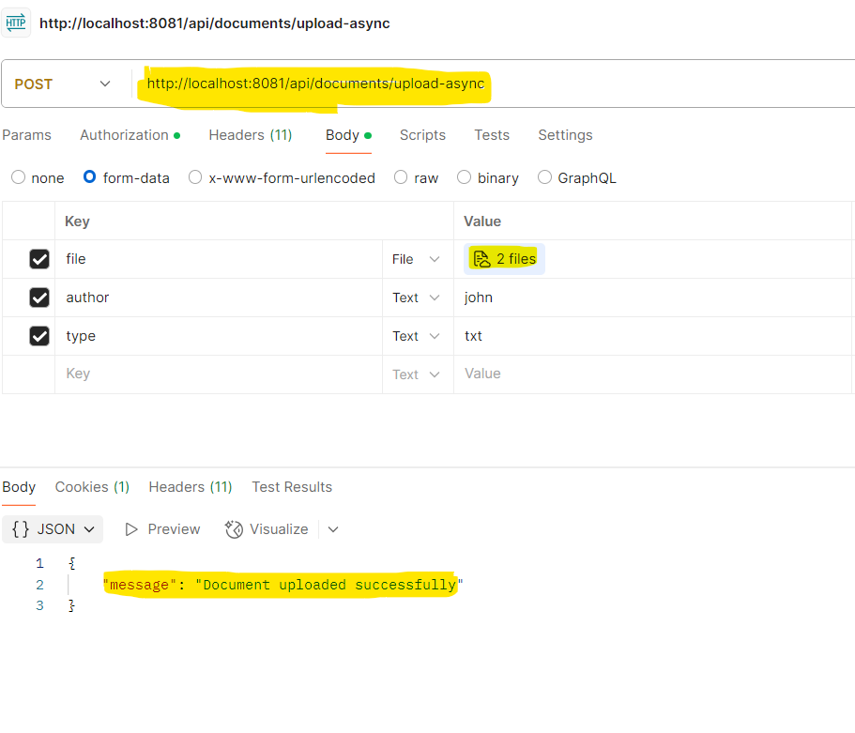

Third Test Case case

Search base any message like sample

