CareBridge AI: Intelligent Hospital Operations and CSCM-Based FDI Detection in IoMT
SWE3004 – Software Design and Development Project

Submitted in partial fulfillment of the requirements for the degree of

Master of Technology in Software Engineering
in
Department of Software and Systems Engineering

by
Prabakar P
22MIS0527

Under the guidance of

Dr. Prabhu J, Professor Grade 2, SCORE

Professor Grade 2, SCORE

School of Computer Science Engineering and Information Systems
VIT, Vellore



CareBridge AI: Intelligent Hospital Operations and CSCM-Based FDI Detection in IoMT
GraphGuard: An Explainable Graph Neural Network for Intelligent Intrusion Detection
SWE3004 – Software Design and Development Project

Submitted in partial fulfillment of the requirements for the degree of

Master of Technology in Software Engineering
in
Department of Software and Systems Engineering

Prabakar P
22MIS0527
22MIS0541

Dr. Prabhu J, Professor Grade 2, SCORE

Dr. Prabhu J

Professor Grade 2, SCORE

School of Computer Science Engineering and Information Systems
VIT, Vellore

November, 2026
I hereby declare that the SWE3004 - Software Design and Development Project entitled “CareBridge AI: Intelligent Hospital Operations and CSCM-Based FDI Detection in IoMT” submitted by me, for the award of the degree of Master of Technology in Software Engineering in the Department of Software and Systems Engineering, School of Computer Science Engineering and Information Systems, Vellore Institute of Technology, is a record of bonafide work carried out by me under the supervision of Dr. Prabhu J, Professor Grade 2, SCORE.

DECLARATION

I hereby declare that the SWE3004 - Software Design and Development Project entitled “Project / Internship title" submitted by me, for the award of the degree of Master of Technology in Software Engineering in Department of Software and Systems Engineering, School of Computer Science Engineering and Information Systems to VIT is a record of bonafide work carried out by me under the supervision of <Off – Campus Internship Guide Name>, < Designation>, <Company Name> and <VIT – Faculty Guide Name, Designation, SCORE, VIT, Vellore>.
I further declare that the work reported in this project / internship has not been submitted and will not be submitted, either in part or in full, for the award of any other degree or diploma in this institute or any other institute or university.

Place: Vellore
Date: 03.11.2026

This is to certify that the SWE3004 - Software Design and Development Project entitled “CareBridge AI: Intelligent Hospital Operations and CSCM-Based FDI Detection in IoMT” submitted by Prabakar P, 22MIS0527, SCORE, VIT, for the award of the degree of Master of Technology in Software Engineering in the Department of Software and Systems Engineering, is a record of bonafide work carried out by him / her under my supervision during the period 06.07.2026 to 03.11.2026, as per the VIT code of academic and research ethics.
Signature of the Candidate

CERTIFICATE
This is to certify that the SWE3004 – Software Design and Development Project entitled “GraphGuard: An Explainable Graph Neural Network for Intelligent Intrusion Detection”, submitted by PARAMESHWAR P (22MIS0541), SCORE, VIT, for the award of the degree of Master of Technology in Software Engineering in the Department of Software and Systems Engineering, is a record of bona fide work carried out by him under my supervision during the period from 06.07.2026 to 03.11.2026, as per the VIT Code of Academic and Research Ethics.
The contents of this report have not been submitted and will not be submitted, either in part or in full, for the award of any other degree or diploma at this institute or any other institute or university. The project fulfills the requirements and regulations of the University and, in my opinion, meets the necessary standards for submission

Place: Vellore
Date: 03.11.2026

Signature of the VIT-SCORE - Guide

Internal Examiner External Examiner

Head of the Department
Department of Software and Systems Engineering

ACKNOWLEDGEMENT

It is my pleasure to express my deep sense of gratitude to my project guide, Dr. Prabhu J, Professor Grade 2, SCORE, School of Computer Science Engineering and Information Systems, Vellore Institute of Technology, Vellore, for his constant guidance, valuable suggestions, and continuous encouragement throughout my project, “GraphGuard: An Explainable Graph Neural Network for Intelligent Intrusion Detection.” His knowledge and support have been invaluable in helping me complete this project successfully and enhance my understanding of graph neural networks and intelligent intrusion detection.

"I would like to express my heartfelt gratitude to Honorable Chancellor Dr. G Viswanathan; respected Vice Presidents Dr. Sankar Viswanathan, Dr. Sekar Viswanathan, Vice Chancellor Dr. V. S. Kanchana Bhaaskaran; Pro-Vice Chancellor Dr. Partha Sharathi Mallick; and Registrar Dr. Jayabarathi T.

My whole-hearted thanks to Dean Dr. Daphne Lopez, School of Computer Science Engineering and Information Systems, Head, Department of Software and Systems Engineering Dr. Thanapal P, MTech - Software Engineering Project Coordinators Dr. Thilagavathi M and Dr. Brijendra Singh, SCORE School Project Coordinator Dr. Karthikeyan P, all faculty, staff and members working as limbs of our university for their continuous guidance throughout my course of study in unlimited ways.
Date: 03.11.2026
Prabakar P

Place: Vellore
Date: <Student Name>

CareBridge AI is a multi-tenant hospital operations and clinical coordination platform serving five canonical roles: hospital administrator, doctor, nurse, laboratory technician and patient. It unifies patient records, appointment scheduling, verified document intake, cross-document conflict detection, prescription safety and public integrity verification, prioritised care tasks, deterministic insurance estimation and tenant-scoped operational analytics. A separate research component evaluates a physiology-aware cross-sensor consistency model for detecting coordinated multi-channel false data injection attacks in the Internet of Medical Things. Across two public datasets and three seeds, graph message passing improved clinical detection while explicit consistency features did not, a negative result reported with confidence intervals. The platform passed 128 automated backend tests, cross-tenant and role-boundary security checks, and end-to-end browser verification on synthetic data in an in-house deployment. No clinical validation was performed.

CONTENTS
CHAPTER 1 INTRODUCTION, PROBLEM STATEMENT, OBJECTIVES AND SCOPE 1
1.1 Introduction 1
1.2 Problem Statement 2
1.3 Motivation 2
1.4 Objectives 3
1.5 Scope of the Project 4
1.6 Significance of the Work 4
1.7 Organisation of the Report 4
CHAPTER 2 BACKGROUND, EXISTING SYSTEMS AND RELATED WORK 6
2.1 Overview 6
2.2 Hospital Information Systems and Coordination Failure 6
2.3 Multi-Tenant Architecture in Healthcare 7
2.4 Clinical Decision Support and Medication Safety 7
2.5 The IoMT Threat Model and False Data Injection 7
2.6 Graph-Based and Consistency-Aware Detection 8
2.7 Large Language Models in Clinical Workflows 9
2.8 Existing System Categories and Their Limitations 9
2.9 Gap Analysis 10
2.10 Summary 10
CHAPTER 3 REQUIREMENTS AND TECHNICAL SPECIFICATIONS 11
3.1 Overview 11
3.2 Requirement Elicitation 11
3.3 Functional Requirements 11
3.4 Role-Based Access Requirements 12
3.5 Non-Functional Requirements 13
3.6 Research Requirements 14
3.7 Constraints and Assumptions 14
3.8 Requirement Prioritisation 15
3.9 Summary 15
CHAPTER 4 SYSTEM ARCHITECTURE AND DESIGN 16
4.1 Overview 16
4.2 Architectural Drivers 16
4.3 Logical Architecture 16
4.4 Deployment Architecture 17
4.5 Multi-Tenancy and Isolation Design 18
4.6 Database Design 18
4.7 API Design 20
4.8 Security Architecture 20
4.9 Document Ingestion and Conflict Detection Design 21
4.10 Prescription Integrity Design 22
4.11 Insurance Estimation Design 22
4.12 Conversational Assistant Design 22
4.13 CSCM Integration Design 23
4.14 Design Trade-offs 24
4.15 Summary 24
CHAPTER 5 IMPLEMENTATION 25
5.1 Overview 25
5.2 Technology Stack 25
5.3 Repository and Module Organisation 25
5.4 Authentication and Session Management 26
5.5 Role Workspaces 26
5.6 Appointment and Clinical Coordination 30
5.7 Document Processing and Conflict Detection 31
5.8 Prescription Safety and Verification 31
5.9 Insurance Assistance 32
5.10 Operational Analytics 32
5.11 Conversational Assistant 33
5.12 CSCM Service Integration 33
5.13 Implementation Challenges 33
5.14 Summary 34
CHAPTER 6 CSCM-BASED FALSE DATA INJECTION DETECTION IN IOMT 35
6.1 Overview 35
6.2 Research Problem and Question 35
6.3 Threat Model 35
6.4 Datasets 36
6.5 Preprocessing and Windowing 36
6.6 Synthetic Attack Generation 37
6.7 Model Architectures 37
6.8 Training Protocol 40
6.9 Evaluation Methodology 40
6.10 Results 40
6.11 Statistical Analysis 42
6.12 Error Analysis 42
6.13 Discussion 43
6.14 Threats to Validity 44
6.15 Integration with the Platform 44
6.16 Summary 44
CHAPTER 7 TESTING, RESULTS AND DISCUSSION 46
7.1 Overview 46
7.2 Test Strategy 46
7.3 Test Environment 46
7.4 Automated Backend Testing 47
7.5 Security and Isolation Testing 47
7.6 End-to-End Workflow Verification 48
7.7 Defects Found and Resolved 49
7.8 Research Verification 49
7.9 Discussion 50
7.10 Limitations of the Evaluation 50
7.11 Summary 50
CHAPTER 8 CONCLUSION, LIMITATIONS AND FUTURE ENHANCEMENTS 51
8.1 Summary of Work 51
8.2 Contributions 51
8.3 Limitations 52
8.4 Future Enhancements 52
8.5 Conclusion 53
REFERENCES 54
APPENDICES 57
APPENDIX A: Database Table Catalogue 57
APPENDIX B: Verification and Test Catalogue 57
APPENDIX C: Reproduction Commands 58
APPENDIX D: Screenshot Inventory and Exclusions 58
- DISSERTATION / INTERNSHIP DEMONSTRATION .

8 | SUMMARY | .
 | REFERENCES | .
 | APPENDIX A | .
Fig. 4.1 Logical component architecture of the platform 17
Fig. 4.2 Deployment view of the in-house prototype 18
Fig. 4.3 Entity-relationship diagram of the database schema 19
Fig. 4.4 Document ingestion and conflict detection flow 21
Fig. 4.5 CSCM inference service integration 23
Fig. 5.1 Clinical portal authentication page 26
Fig. 5.2 Hospital administrator governance view 27
Fig. 5.3 Physician clinical workstation 28
Fig. 5.4 Nursing care coordination task board 28
Fig. 5.5 Diagnostic laboratory workstation 29
Fig. 5.6 Patient health portal 30
Fig. 5.7 Appointment booking wizard 30
Fig. 5.8 Public prescription verification page 32
Fig. 6.1 Coordinated multi-channel injection example 37
Fig. 6.2 Model progression from encoder to CSCM 39
Fig. 6.3 Absolute performance across models and datasets 41

Table 2.1 Comparison of existing system categories against project requirements 9
Table 3.1 Functional requirements 11
Table 3.2 Role capability matrix 12
Table 3.3 Non-functional requirements 13
Table 3.4 Prioritisation summary 15
Table 4.1 Database tables grouped by domain 19
Table 4.2 API modules and route handler counts 20
Table 5.1 Implementation technology stack 25
Table 6.1 Evaluation datasets and partitions 36
Table 6.2 Absolute performance, mean and standard deviation over three seeds 41
Table 6.3 Paired bootstrap confidence intervals for the F1 difference and McNemar test on thresholded predictions 42
Table 6.4 Error analysis of the graph-only model on PhysioNet, pooled over seeds 42
Table 6.5 Channel breakdown on single-channel attacks, graph-only model, pooled over seeds 43
Table 7.1 Verification environment 46
Table 7.2 Backend test modules and scope 47
Table 7.3 Security and isolation verification results 47
Table 7.4 Defects identified during verification and their resolutions 49
Table A.1 Base tables in the CareBridge AI schema 57
Table B.1 Verification suites and outcomes 57
Table D.1 Screenshot inventory and selection rationale 58

List of Tables

AI Artificial Intelligence
API Application Programming Interface
APA American Psychological Association
CSCM Cross-Sensor Consistency Model
CDSS Clinical Decision Support System
DDI Drug-Drug Interaction
DPDP Digital Personal Data Protection Act, 2023
ER Entity Relationship
FDI False Data Injection
FDIA False Data Injection Attack
FHIR Fast Healthcare Interoperability Resources
GNN Graph Neural Network
GRU Gated Recurrent Unit
HIPAA Health Insurance Portability and Accountability Act
HMAC Hash-based Message Authentication Code
ICU Intensive Care Unit
IoMT Internet of Medical Things
JWT JSON Web Token
LLM Large Language Model
MoSCoW Must, Should, Could, Won't prioritisation
MRN Medical Record Number
NFR Non-Functional Requirement
OCR Optical Character Recognition
OWASP Open Worldwide Application Security Project
PHI Protected Health Information
PII Personally Identifiable Information
RBAC Role-Based Access Control
REST Representational State Transfer
RFC Request for Comments (Internet standard)
RLS Row-Level Security
RNN Recurrent Neural Network
SHA Secure Hash Algorithm
SQL Structured Query Language
VIT Vellore Institute of Technology
WESAD Wearable Stress and Affect Detection dataset
2G Second Generation
3G Third Generation
X Multivariate physiological window of C channels over T steps
C Number of physiological channels (sensors)
T Window length in samples
z Latent temporal embedding of a channel
r Relation representation for a channel pair
E Edge set of the physiological channel graph
m Message passed along an edge
y Ground-truth window label, attack present or absent
s Anomaly score produced by the detection head
δ Injected perturbation vector applied to the signal
S Set of channels targeted by an injection
τ Decision threshold calibrated on validation data
L Binary cross-entropy training objective
μ Mean of a signal or feature
σ Standard deviation of a signal or feature

Symbols and Notations

CHAPTER 1

INTRODUCTION, PROBLEM STATEMENT, OBJECTIVES AND SCOPE

1.1 Introduction
Hospitals operate as information-intensive organisations in which a single patient encounter generates appointments, clinical notes, laboratory results, prescriptions, insurance claims and administrative records. In most Indian hospitals these artefacts are still distributed across departmental systems, spreadsheets and paper files, and the coordination between them depends on manual communication. The consequence is not only administrative inefficiency but also a class of safety failure in which clinically important information exists somewhere in the hospital yet never reaches the clinician who needs it at the moment of decision.
CareBridge AI was conceived as an integrated answer to this coordination problem. It is a multi-tenant hospital operations and clinical coordination platform that unifies patient administration, scheduling, document intelligence, medication safety, care-task coordination, prescription integrity and insurance assistance on a single tenant-isolated data model. The platform defines five canonical roles, namely Hospital Administrator, Doctor, Nurse, Laboratory Technician and Patient, and gives each role a workspace that exposes only the information and actions that role is authorised to use.
The project has a second, research-oriented component. Bedside monitoring in intensive care and ambulatory settings increasingly depends on networked physiological sensors that constitute the Internet of Medical Things (IoMT). A false data injection (FDI) attack corrupts the measurements that clinicians and downstream algorithms trust, and a coordinated multi-channel attack can keep every individual channel within its physiological bounds while violating the relationship between channels. CareBridge AI therefore integrates a physiology-aware cross-sensor consistency model (CSCM) that evaluates multi-channel physiological windows and reports whether the joint signal is internally consistent.
The two components are deliberately coupled. The platform supplies the operational context in which a monitoring alert would be consumed, while the research component supplies a detection capability that a purely administrative system cannot offer. This report documents the implemented platform, the research method and evaluated results of the CSCM component, and the evidence collected during verification. It also states plainly what has not been demonstrated.

1.2 Problem Statement
Hospital coordination fails at the boundaries between departments. A referral is written but not scheduled, a laboratory result is produced but not reviewed, a discharge summary and an external laboratory report disagree and nobody reconciles them, and a prescription is dispensed without a structured check against the patient's recorded allergies. Each of these failures is individually mundane; together they constitute the operational and clinical risk that the project addresses.
Three specific problems motivated the design. First, patient data is fragmented across systems that do not share identity, so the same patient exists in several incompatible records. Second, clinical safety checks are performed manually and inconsistently, particularly drug-allergy and duplicate-therapy checks, and the rationale for overriding an alert is rarely recorded. Third, the operational view that hospital administrators need, such as departmental load and physician availability, is produced through ad hoc spreadsheets rather than from the transactional system itself.
A fourth problem belongs to the research domain. Physiological monitoring assumes that sensor readings are authentic. Single-channel threshold alarms detect values that are individually implausible, but they do not detect a coordinated manipulation in which several channels are shifted together so that each remains plausible. Detecting such attacks requires reasoning about the consistency of channels with respect to one another, and it requires an evaluation protocol that does not leak patient identity across training and test partitions.

1.3 Motivation
The motivation for the platform is safety rather than novelty. During the requirements study it became clear that the most damaging failures were not caused by missing functionality but by information that existed and was not delivered. A conflict-detection mechanism that surfaces a diagnostic discrepancy at the moment a physician opens a consultation is worth more than a sophisticated analytics dashboard that nobody consults. The design therefore prioritises the delivery of the right information to the right role at the right moment.
The motivation for the research component is the asymmetry between attack and defence in IoMT deployments. An adversary who can influence several sensors simultaneously can craft perturbations that remain individually unremarkable, whereas a defender who examines channels in isolation has no signal to act on. If physiological relationships are stable in healthy and pathological states, then a model that learns those relationships should be able to flag windows in which the relationships break down. The project tests that proposition rather than assuming it.
A third motivation is reproducibility. Healthcare software claims are frequently asserted rather than measured. The project therefore treats evidence as a first-class artefact: every functional claim is tied to a test or a captured screen, and every research claim is tied to a stored metric file with its seed, split and statistical test recorded.

1.4 Objectives
The project pursued the following objectives.
1. Design and implement a multi-tenant hospital platform that isolates the data of participating hospitals at the database and application layers.
2. Provide five role-specific workspaces with least-privilege authorisation, so that each user sees only the patients, documents and actions relevant to that role.
3. Implement appointment scheduling and clinical coordination with explicit state transitions, doctor availability and conflict detection.
4. Implement medical document ingestion with entity extraction, human verification, and automated detection of diagnostic discrepancies across documents belonging to the same patient.
5. Implement prescription safety checks at the point of issuance and a public, zero-PHI mechanism for verifying the integrity of a dispensed prescription.
6. Implement care-task coordination, patient self-service, insurance assistance and operational analytics without exposing patient-identifying information to roles that do not require it.
7. Design, train and evaluate a physiology-aware cross-sensor consistency model for detecting coordinated multi-channel false data injection attacks in IoMT physiological time series.
8. Evaluate the resulting system with automated tests, security boundary tests and statistical analysis of the research results, and report both positive and negative findings honestly.

1.5 Scope of the Project
The implemented scope covers the operational and clinical coordination functions listed above for a single deployment serving multiple hospitals. It includes authentication, role-based authorisation, row-level security, audit logging, document processing, conflict detection, care tasks, prescriptions, insurance estimation, analytics, a grounded conversational assistant, and a CSCM inference integration.
The following items are explicitly outside the implemented scope. CareBridge AI does not provide diagnosis, does not replace a certified medical device, and does not claim regulatory clearance. It does not integrate with live hospital information systems through HL7 or FHIR interfaces, because no such interface was available in the project environment. Payment processing, pharmacy inventory and radiology image interpretation are not implemented. The deployment is an in-house prototype: the backend and frontend run as local services against a hosted PostgreSQL instance, and no public production rollout or clinical pilot has taken place.
For the research component, the scope is limited to two public datasets, PhysioNet/CinC Challenge 2012 and WESAD, with synthetically generated attack profiles. No real attack corpus was available, and no live bedside device was instrumented.

1.6 Significance of the Work
The significance of the platform lies in demonstrating that a small number of well-chosen coordination mechanisms can be implemented coherently on a shared tenant-isolated schema. The decisions that matter, such as verifying extracted entities before they influence clinical records, recording an override rationale rather than merely dismissing an alert, and masking demographics for laboratory staff, are transferable to other hospital systems. The significance of the research component lies in its negative result: explicit cross-sensor consistency features did not outperform a graph-only baseline and were significantly worse at one seed. Reporting that outcome with effect sizes and confidence intervals is more useful than a marginal claim of improvement, because it redirects attention towards the mechanism that did help, namely graph structure.

1.7 Organisation of the Report
Chapter 2 reviews the background and related work and derives the gap that the project addresses. Chapter 3 specifies the functional, role-based, non-functional and research requirements. Chapter 4 presents the architecture and design decisions, and Chapter 5 describes the implementation. Chapter 6 presents the CSCM research methodology, experiments and statistical analysis. Chapter 7 reports verification results and defects, Chapter 8 concludes, and the references and appendices follow.

CHAPTER 2

BACKGROUND, EXISTING SYSTEMS AND RELATED WORK

2.1 Overview
This chapter establishes the technical and clinical context of the project. It reviews hospital information systems and their coordination limitations, examines multi-tenant software architecture as it applies to healthcare, surveys clinical decision support and medication safety research, introduces the IoMT threat model and the false data injection literature, and reviews graph-based and consistency-aware learning. It then compares existing categories of systems against the requirements derived in Chapter 3 and states the gap that CareBridge AI addresses.

2.2 Hospital Information Systems and Coordination Failure
A hospital information system is the transactional backbone of a hospital. It records patient identity, encounters, orders, results and billing, and in mature deployments it is complemented by a picture archiving system, a laboratory information system and a pharmacy system. The architectural weakness of this landscape is that each subsystem tends to own its own patient identity and its own notion of an encounter, and integration between them is achieved through interface engines that translate messages between proprietary formats.
The consequences are well documented in the health informatics literature. Bates and colleagues argued that information technology reduces medication errors only when it is designed around the actual workflow of prescribing and administration rather than around the data model of the software (Bates et al., 2001). Kuperman and colleagues reviewed medication-related clinical decision support in computerised provider order entry and found that alert fatigue and poor integration with clinical workflow were the dominant reasons for limited effectiveness (Kuperman et al., 2007). Both findings point to the same design principle: a safety feature must appear at the moment of decision, with enough context to act on, and must not require the clinician to leave the task at hand.
Indian hospitals add a further constraint. Many mid-sized hospitals operate a mixture of commercial billing software, departmental spreadsheets and paper records, and the staff who coordinate between them are often the least senior members of the clinical team. A coordination platform for this environment cannot assume a fully digital upstream; it must accept documents, tolerate incomplete data and make the human verification step explicit.

2.3 Multi-Tenant Architecture in Healthcare
Multi-tenancy is the property of a software system in which a single instance serves multiple customer organisations, called tenants, while keeping their data logically separate (Mell & Grance, 2011). Fowler describes three broad strategies for implementing it: a separate database per tenant, a shared database with a separate schema per tenant, and a shared database and schema with a tenant discriminator column (Fowler, 2002). The third strategy offers the lowest operational cost and the highest density, at the price of requiring every query to be constrained by tenant identity.
In healthcare the price is not merely technical. A tenant leak is a confidentiality breach with legal consequences under the Health Insurance Portability and Accountability Act in the United States and the Digital Personal Data Protection Act, 2023 in India. The project therefore adopts defence in depth: tenant identity is carried in the authenticated token, enforced in the application layer for every query, and enforced again by PostgreSQL row-level security policies so that a missing application filter fails closed rather than leaking rows. Access control follows the role-based model formalised by Sandhu and colleagues, in which permissions are assigned to roles and roles to users (Sandhu et al., 1996).

2.4 Clinical Decision Support and Medication Safety
Clinical decision support systems (CDSS) are software functions that present clinical knowledge or patient-specific information to assist a decision. The evidence base supports two conclusions that shaped this project. First, simple and specific alerts are accepted, whereas broad and repetitive alerts are ignored. Second, the value of an alert depends on the availability of a recorded response, because an override without a reason cannot be audited and cannot inform later review.
CareBridge AI therefore implements a narrow class of checks: drug-allergy conflicts, duplicate therapy within the same therapeutic class, and diagnostic discrepancies between documents belonging to the same patient. Each alert requires an explicit disposition. A clinician who overrides an alert must supply a rationale, which is stored with the identity of the clinician and the timestamp, and the conflict record retains the source documents that produced it.

2.5 The IoMT Threat Model and False Data Injection
The Internet of Medical Things denotes the network of sensors, wearables and bedside monitors that collect physiological data and transmit it to aggregators and clinical systems. Alsubaei and colleagues surveyed the security and privacy risks of the IoMT and observed that device heterogeneity, constrained hardware and long deployment lifetimes make conventional endpoint security difficult to apply (Alsubaei et al., 2017). The result is a large population of devices whose measurements are trusted more than their provenance justifies.
False data injection attacks were first formalised in the context of power-grid state estimation. Liu, Ning and Reiter showed that an adversary who knows the system topology can inject a bias vector that is consistent with the measurement model, so that residual-based bad-data detection cannot distinguish the corrupted state from a legitimate one (Liu et al., 2011). Mo and colleagues generalised the analysis to cyber-physical infrastructures and identified the integrity of measurements, rather than their confidentiality, as the critical security property (Mo et al., 2012).
The IoMT inherits this structure with a different physical substrate. Each channel, such as heart rate, blood pressure or temperature, has a plausible range, and a naive detector tests each channel against that range. A coordinated attack perturbs several channels simultaneously and chooses magnitudes such that every marginal value remains plausible. The marginal distributions survive while the joint distribution is violated, which is precisely the regime in which per-channel thresholding fails.

2.6 Graph-Based and Consistency-Aware Detection
Graph neural networks provide a mechanism for reasoning about entities and their relations. Kipf and Welling introduced a spectral formulation of graph convolution that aggregates neighbouring node features (Kipf & Welling, 2017), and Gilmer and colleagues generalised the idea into neural message passing, in which a learned function computes a message for each edge and a permutation-invariant operator aggregates messages at each node (Gilmer et al., 2017). Battaglia and colleagues argued that such relational inductive biases are the appropriate prior whenever the underlying problem is composed of entities with structured interactions (Battaglia et al., 2018).
Physiology is such a problem. Heart rate, blood pressure and respiration are coupled by known mechanisms, and the coupling is stable across a wide range of states. A graph whose edges encode known physiological relationships gives a model the structure it needs to evaluate pairs of channels rather than treating them as an unordered feature vector. Recurrent encoders remain the standard mechanism for summarising temporal morphology; the gated recurrent unit (Cho et al., 2014) and the long short-term memory network (Hochreiter & Schmidhuber, 1997) are both well established for this purpose.
A natural hypothesis follows: if the model is given explicit consistency features, such as the absolute difference between two channel embeddings, it should detect a violation of consistency more easily than a model that must infer the relationship from raw concatenation. Chapter 6 tests this hypothesis directly, and the result is negative. The graph structure itself carries most of the benefit, and the explicit arithmetic is redundant or harmful.

2.7 Large Language Models in Clinical Workflows
Large language models (LLMs) have demonstrated substantial clinical knowledge in benchmark evaluations (Singhal et al., 2023), and reviews of their application in medicine emphasise both the breadth of possible tasks and the risk of confident fabrication (Thirunavukarasu et al., 2023). The safe deployment pattern that has emerged is retrieval-grounded generation: the model is constrained to answer from a supplied evidence set, its output is presented as advisory, and a human remains accountable for the decision.
CareBridge AI follows this pattern. The conversational assistant is grounded in the platform's own API responses, it is instructed to decline questions that fall outside the hospital's data, and it is presented throughout the interface as an advisory aid rather than a diagnostic authority.

2.8 Existing System Categories and Their Limitations
Rather than compare against individual commercial products, whose internal behaviour cannot be verified from public documentation, the review compares categories of systems against the requirements of this project. Table 2.1 summarises the comparison.
Table 2.1 Comparison of existing system categories against project requirements
System category | Typical capability | Limitation relevant to this project
Hospital information and billing systems | Registration, billing, orders, results | Coordination between roles is manual; alerts are not contextual; no document-level discrepancy detection
Electronic health record platforms | Longitudinal clinical record, order entry | Heavy configuration and cost; assumes full digital upstream; limited support for external document reconciliation
Telemedicine and appointment platforms | Scheduling, video consultation, payments | Do not model inter-role clinical coordination, care tasks or prescription integrity
Laboratory information systems | Accessioning, analysers, result release | Isolated from clinical reconciliation; demographic exposure is not always minimised
IoMT security research prototypes | Attack detection on physiological signals | Rarely integrated with an operational clinical platform; evaluations often leak subject identity across splits
General-purpose hospital analytics | Dashboards and reporting | Aggregate after the fact; not tied to a tenant-isolated transactional model

2.9 Gap Analysis
The comparison exposes four gaps. The first is the coordination gap: systems record transactions but do not deliver the resulting obligation to the role that must act on it. The second is the reconciliation gap: documents arriving from external laboratories, other hospitals and patients are stored but not compared against the existing record, so contradictions persist silently. The third is the auditability gap: safety alerts are dismissed without a recorded rationale, which prevents both audit and learning. The fourth is the integration gap between operational healthcare software and IoMT integrity research, which leaves detection models as standalone experiments rather than components of a clinical system.
CareBridge AI addresses all four in one architecture: a tenant-isolated transactional core, role-specific workspaces that surface obligations, a document pipeline with entity verification and cross-document conflict detection, an override protocol with mandatory rationale, and a CSCM inference service integrated into the physician workstation.

2.10 Summary
The literature establishes that coordination and reconciliation, rather than raw data capture, are the persistent weaknesses of hospital systems; that multi-tenancy requires layered enforcement because a single missing filter is a confidentiality breach; and that IoMT integrity is a genuine and under-addressed security problem. Graph-based relational modelling is a principled response to physiological coupling, but whether explicit consistency features add value over graph structure is an open empirical question. The remainder of the report describes the system that was built to answer both the engineering and the research question, and the evidence obtained.

CHAPTER 3

REQUIREMENTS AND TECHNICAL SPECIFICATIONS

3.1 Overview
This chapter specifies what the system must do, for whom, and under which constraints. Requirements were derived from three sources: an analysis of the coordination failures described in Chapter 2, an inspection of the workflows that the five canonical roles actually perform, and the technical needs of the CSCM research component. Each requirement is stated so that it can be verified, and each is traced to the chapter in which it is designed, implemented or tested.

3.2 Requirement Elicitation
Elicitation proceeded in three passes. The first produced a domain model by enumerating the artefacts that a hospital already produces, namely registration forms, discharge summaries, laboratory reports, prescriptions and insurance policies. The second mapped each artefact to the role that creates it and the role that must act on it. The third examined what happens when those artefacts disagree, because disagreement is where coordination fails.
Two constraints emerged from elicitation and shaped the specification. First, the system must tolerate an incomplete digital upstream, because documents arrive as PDFs and images rather than as structured messages. Second, the system must never present an unverified extracted value as clinical fact, because an extraction error propagated into a prescription would be a safety defect rather than a data-quality issue.

3.3 Functional Requirements
Table 3.1 lists the functional requirements. The identifier, description and priority are given; priority follows the MoSCoW convention discussed in Section 3.8.
Table 3.1 Functional requirements
ID | Requirement | Priority
FR-01 | Authenticate a user against the platform and issue a signed token carrying identity, role and tenant | Must
FR-02 | Enforce role-based authorisation on every route and return a standards-compliant error when it fails | Must
FR-03 | Isolate all data by hospital tenant at the application and database layers | Must
FR-04 | Register and maintain patient demographic and clinical summary records | Must
FR-05 | Create, confirm, cancel and complete appointments with doctor availability validation | Must
FR-06 | Ingest clinical documents, extract entities and require human verification of extracted values | Must
FR-07 | Detect diagnostic discrepancies across documents belonging to the same patient | Must
FR-08 | Detect drug-allergy and duplicate-therapy conflicts at prescription issuance | Must
FR-09 | Record a mandatory rationale when a clinician overrides a safety alert | Must
FR-10 | Issue a digitally signed prescription and expose a public verification endpoint | Must
FR-11 | Create, claim and complete care tasks with priority ordering and resolution notes | Should
FR-12 | Provide a patient portal with appointments, records and a guided booking workflow | Should
FR-13 | Estimate insurance coverage deterministically from hospital policy rules | Should
FR-14 | Provide tenant-scoped operational analytics with bounded caching | Should
FR-15 | Provide a conversational assistant grounded in the platform's own data | Could
FR-16 | Evaluate multi-channel physiological windows for cross-sensor inconsistency | Must
FR-17 | Mask patient demographics for roles that do not require them | Must
FR-18 | Write a structured, zero-PHI audit record for security-relevant events | Must

3.4 Role-Based Access Requirements
The platform defines five canonical roles. Table 3.2 states the intended capability of each role. The matrix is the authoritative specification against which the authorisation tests in Chapter 7 are written.
Table 3.2 Role capability matrix
Capability | Hospital Admin | Doctor | Nurse | Lab Technician | Patient
View hospital operations dashboard | Yes | No | No | No | No
Manage departments and doctor roster | Yes | No | No | No | No
View own consultation queue | No | Yes | No | No | No
Read full patient record | No | Yes | Yes | No | Own only
View demographics (name, contact) | Yes | Yes | Yes | Masked | Own only
Verify extracted document entities | No | Yes | No | No | No
Resolve clinical conflicts | No | Yes | No | No | No
Create and issue prescriptions | No | Yes | No | No | No
Record vitals and perform intake | No | No | Yes | No | No
Claim and complete care tasks | No | Yes | Yes | No | No
Accession specimens and record results | No | No | No | Yes | No
Book own appointment | No | No | No | No | Yes
View insurance policy and estimates | No | No | No | No | Yes
Verify a prescription by hash | Public | Public | Public | Public | Public

3.5 Non-Functional Requirements
Table 3.3 lists the non-functional requirements. Targets that were measured during verification are marked accordingly; targets that were not measured are identified as design goals so that the distinction is explicit.
Table 3.3 Non-functional requirements
ID | Attribute | Requirement | Verification status
NFR-01 | Security | Every request authenticated and authorised; tenant enforced in database as well as application | Verified by automated tests
NFR-02 | Privacy | No protected health information in audit logs or public verification responses | Verified by inspection and tests
NFR-03 | Integrity | Prescription payloads carry a cryptographic signature that detects tampering | Verified by tests
NFR-04 | Auditability | Security and clinical override events recorded with actor, action and timestamp | Verified by tests
NFR-05 | Usability | Each role reaches its primary task within one navigation step from its landing page | Observed in captured screens
NFR-06 | Responsiveness | Interactive pages render on desktop and mobile viewports | Observed in captured screens
NFR-07 | Maintainability | Domain logic separated into modules with typed schemas and migrations | Verified by code structure
NFR-08 | Reliability | Database migrations are reversible through paired down migrations | Verified by file inspection
NFR-09 | Scalability | Analytics served from bounded server-side caches rather than per-request scans | Design goal
NFR-10 | Portability | Services run locally from documented commands against a hosted database | Verified in the environment
NFR-11 | Reproducibility | Research results reproducible from stored seeds and metric files | Verified by file inspection

3.6 Research Requirements
The research component imposes requirements that are independent of the platform. They are stated separately because their verification is statistical rather than functional.
1. The evaluation must use at least two public datasets representing different physiological contexts.
2. Data partitioning must be performed at subject or record level, never at window level, so that no patient contributes to both training and test data.
3. Normalisation statistics and decision thresholds must be derived from training and validation partitions only.
4. Every architecture must be trained with multiple seeds so that initialisation variance can be separated from architectural effect.
5. Differences between architectures must be reported with confidence intervals and a paired statistical test, not as point estimates alone.
6. The attack generator must produce additive, multiplicative and drift families at controlled severities, and must clip injections so that single-channel plausibility is preserved.
7. Results must be reported for attack composition, attack family, missingness and channel, so that aggregate metrics cannot conceal a systematic failure.

3.7 Constraints and Assumptions
The implementation is subject to the following constraints. The project uses open-source components and free-tier hosted infrastructure, so the database is a shared Supabase instance rather than a dedicated cluster. The deployment target is a Windows workstation running the backend, frontend and inference service as local processes, which means that availability, horizontal scaling and production hardening were not exercised. No hospital information system interface was available, so document ingestion is the integration mechanism.
The following assumptions are recorded. It is assumed that a hospital can supply its own department and physician roster, that clinical documents are legible enough for extraction, and that staff will complete the verification step rather than bypass it. It is assumed that physiological relationships among channels are stable within the populations represented by the two public datasets. Where an assumption does not hold, the corresponding limitation is stated in Chapter 8.

3.8 Requirement Prioritisation
Requirements were prioritised using the MoSCoW method. Must-have requirements constitute the minimum viable clinical platform: authentication, authorisation, tenancy, patient records, appointments, document ingestion and verification, conflict detection and prescription safety. Should-have requirements improve operational completeness and include care tasks, the patient portal, insurance estimation and analytics. Could-have requirements add convenience and include the conversational assistant. This division guided implementation order and determines what can be removed without invalidating the core claim of the project.
Table 3.4 Prioritisation summary
Priority | Requirements | Rationale
Must | FR-01 to FR-10, FR-16 to FR-18 | Without these the platform cannot be used safely or the research question cannot be answered
Should | FR-11 to FR-14 | Operational completeness; improves the realism of the evaluation
Could | FR-15 | Convenience layer; not required for any safety claim
Won't (this release) | Payment processing, pharmacy inventory, imaging interpretation, HL7 and FHIR interfaces | Out of scope as stated in Section 1.5

3.9 Summary
The requirements specify a tenant-isolated clinical platform with five role workspaces, a document reconciliation pipeline, a prescription integrity mechanism and an integrated consistency detector, together with a research protocol that controls for leakage and initialisation variance. The next chapter describes the architecture and design decisions that satisfy these requirements.

CHAPTER 4

SYSTEM ARCHITECTURE AND DESIGN

4.1 Overview
This chapter describes how CareBridge AI is structured. It begins with the architectural drivers that constrained the design, presents the logical and deployment views, and then examines the decisions that carry the most risk: tenant isolation, database schema, authorisation, document reconciliation, prescription integrity, insurance estimation, assistant safety and CSCM integration. Each decision is presented with its rationale and with the alternative that was rejected.

4.2 Architectural Drivers
Five drivers shaped the architecture. First, confidentiality: a tenant leak is a legal and ethical failure, so isolation must be enforced at more than one layer. Second, safety: clinical alerts must be delivered at the point of decision and their disposition must be recorded. Third, traceability: every state transition that affects a patient must be attributable to an actor and a time. Fourth, heterogeneity: documents arrive in formats that cannot be controlled, so ingestion must be separated from verification. Fifth, research separability: the detection research must run as an independent service so that the platform does not depend on a model checkpoint and the model can be evaluated without the platform.
The resulting style is a layered service architecture with a transactional core, a synchronous REST interface and one out-of-process inference service. It is not a microservice architecture in the strict sense, because the platform is deployed as a single backend process; extracting the inference service was a deliberate exception made for the reasons above.

4.3 Logical Architecture
The logical architecture is shown in Figure 4.1. The presentation tier is a Next.js application that renders server and client components and calls the API through a typed client. The application tier is a FastAPI backend organised into API modules, domain services, schemas and persistence. The data tier is PostgreSQL with row-level security, and the inference tier is a separate FastAPI service that loads the CSCM checkpoint.
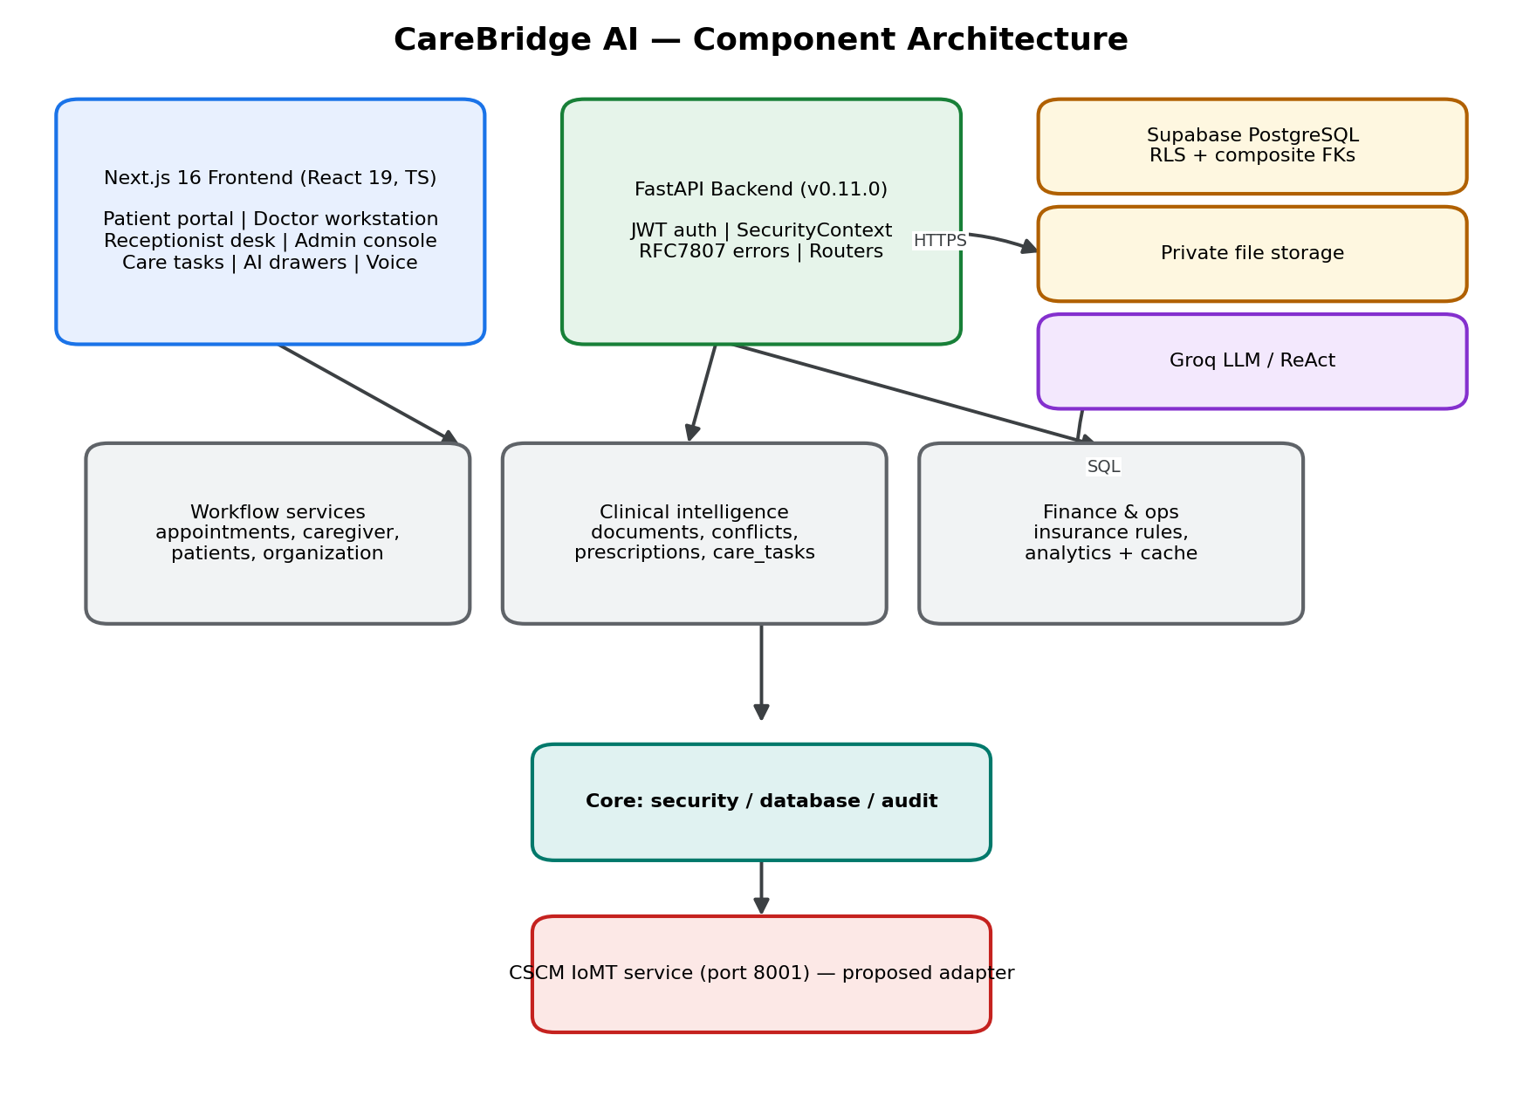
Fig. 4.1 Logical component architecture of CareBridge AI, showing the presentation, application, data and inference tiers
Four cross-cutting components deserve emphasis. The security module decodes and validates tokens, extracts the role and tenant claims, and exposes a request context to every route. The audit module writes structured JSON lines that deliberately exclude patient identifiers. The database module owns the connection pool and sets the tenant context on each connection so that row-level security policies can evaluate it. The assistant module orchestrates retrieval from platform endpoints and constrains generation to the retrieved evidence.

4.4 Deployment Architecture
The deployment view is shown in Figure 4.2. The backend listens on port 8000, the frontend on port 3000 and the inference service on port 8001. The database is a hosted PostgreSQL instance reached over TLS. This is an in-house prototype deployment: the services run as local processes on a workstation, there is no container orchestration, no reverse proxy and no public ingress. The arrangement is sufficient for development and for the verification reported in Chapter 7, but it is not a production topology.
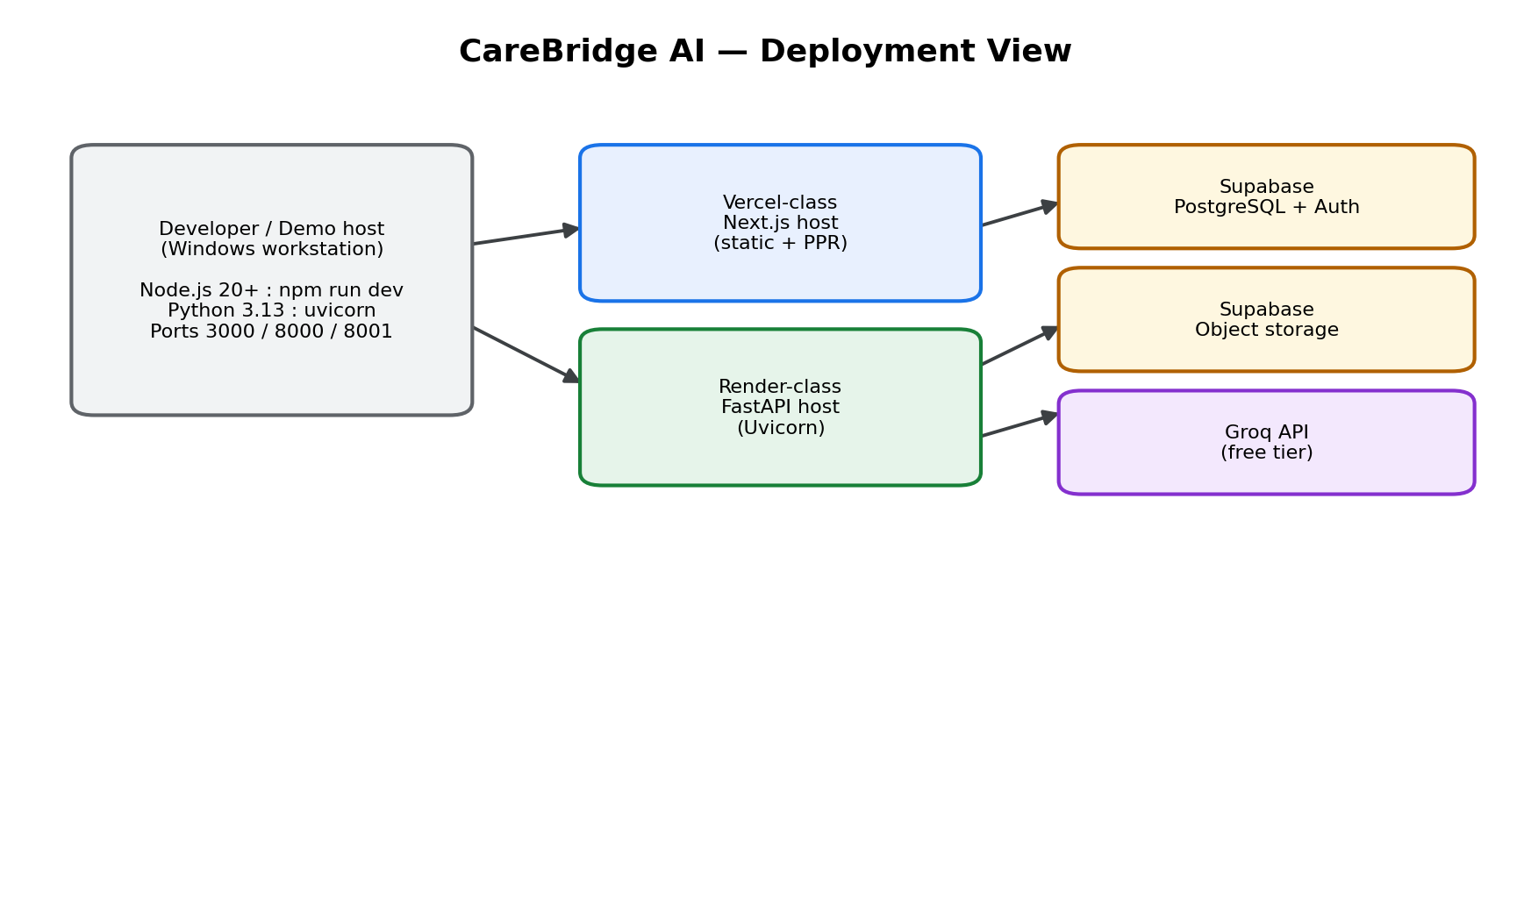
Fig. 4.2 Deployment view of the in-house prototype, showing local service processes and the hosted database

4.5 Multi-Tenancy and Isolation Design
Tenant isolation is implemented in three layers. At the identity layer, the hospital identifier is a claim in the signed token and cannot be supplied by the client in a request body. At the application layer, every repository function receives the tenant from the request context and constrains its query accordingly. At the database layer, row-level security policies compare the row's hospital identifier against a session variable set from the validated token, so that a query which omits the predicate returns no rows rather than foreign rows.
The third layer is what makes the design defensible. Application-layer filtering is easy to state and easy to forget; a single missing where-clause would be invisible in normal testing. Row-level security converts that omission into a fail-closed condition. The policies are defined across the schema, with separate policies for select, insert, update and delete, and the migration set includes a reversible down migration for each.
Cross-tenant access attempts are deliberately reported as not-found rather than as forbidden, so that the response does not confirm the existence of a record in another hospital. This decision is visible in the verification evidence discussed in Section 7.5.

4.6 Database Design
The schema comprises eighteen base tables. Rather than list every column, Table 4.1 groups the tables by domain and states the purpose of each group. The entity-relationship view is given in Figure 4.3.
Table 4.1 Database tables grouped by domain
Domain | Tables | Purpose
Tenancy and identity | hospitals, profiles, patient_accounts | Hospital registry, staff and patient identities, and verified links between a patient profile and a clinical record
Clinical core | patients, departments, doctors, appointments | Demographic record, organisational structure, physician roster and scheduling
Documents | clinical_documents, extracted_entities | Uploaded artefacts, extracted text and candidate clinical entities awaiting verification
Conflicts | clinical_conflicts, clinical_conflict_sources | Detected discrepancies, their severity, disposition and the documents that produced them
Care coordination | care_tasks | Interdisciplinary obligations with priority, assignee and resolution
Prescriptions | prescriptions, prescription_items, medication_adherence_logs | Signed prescriptions, their line items and adherence observations
Insurance | patient_insurance_policies, insurance_claims | Policy parameters and deterministic claim estimates
Audit | audit_logs | Zero-PHI structured security and state-transition events

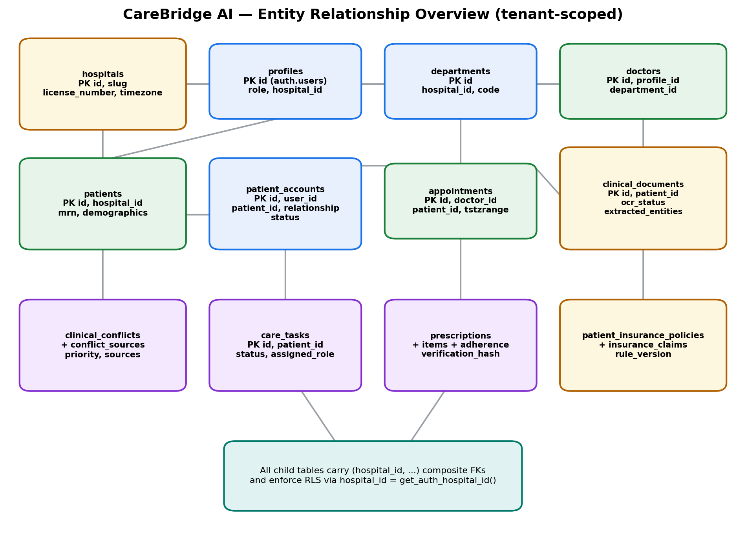
Fig. 4.3 Entity-relationship diagram of the CareBridge AI schema, showing tenant-scoped relationships
Three schema decisions carry safety consequences. First, every clinical table carries a hospital identifier and a foreign key that includes it, so that a cross-tenant reference is rejected by the database rather than merely discouraged by convention. Second, clinical documents and extracted entities are separate tables, so that an extracted value can exist in an unverified state without contaminating the clinical record. Third, conflicts reference their source documents through a join table, which allows a reviewer to see the evidence behind an alert rather than trusting the alert itself.
The migration set contains eight forward migrations, each with a paired down migration. The final migration retires the legacy receptionist and caregiver roles and rewrites the dependent policies, which is why the current role enumeration has five members rather than the six present in the earliest schema.

4.7 API Design
The API is versioned under a single prefix and organised by clinical domain. Table 4.2 lists the modules and the number of route handlers in each.
Table 4.2 API modules and route handler counts
Module | Handlers | Responsibility
auth | 2 | Login and identity resolution
patients | 3 | Patient registration and roster queries
appointments | 4 | Scheduling and state transitions
documents | 7 | Upload, extraction, entity verification and review
conflicts | 5 | Conflict listing, detail and disposition
care_tasks | 7 | Task board, claiming and completion
prescriptions | 8 | Issuance, dispensing, listing and public verification
insurance | 6 | Policy retrieval and coverage estimation
analytics | 2 | Operational aggregates
doctors | 2 | Physician roster
organization | 2 | Departments and hospital profile
agent | 2 | Assistant session and query
chat | 3 | Conversational endpoints
cscm | 4 | Physiological stream, attack simulation and prediction proxy
caregiver | 3 | Legacy compatibility router, not reachable by retired roles

The API follows REST conventions as described by Fielding (2000). Resources are nouns, state transitions are expressed as sub-resource actions, and errors conform to RFC 7807 with a type, title, status, detail and instance. The error contract is important for the security posture: it allows the frontend to distinguish authorisation failures from validation failures without parsing prose, and it prevents internal exception text from reaching the client.

4.8 Security Architecture
The security design has four layers. Authentication establishes identity and issues a signed token with a bounded lifetime. Authorisation evaluates the role claim against a route-level dependency, so that a route cannot be reached without the required role even if the frontend never renders the link. Tenancy constrains every query as described in Section 4.5. Auditing records the security-relevant event without recording the clinical content.
Passwords are stored as bcrypt hashes and verified through the database's crypt extension. Tokens are signed with HMAC-SHA256. The application rejects tokens whose algorithm does not match the expected value, which prevents the classic algorithm-confusion attack, and it validates expiry on every request. Retired roles are rejected explicitly with a dedicated error code rather than being treated as unknown, so that the failure is diagnosable.
The privacy design follows the principle of minimum necessary disclosure. Laboratory technicians receive a medical record number, an accession identifier and a specimen barcode, but not a name, date of birth or contact number. The public prescription verification endpoint returns the medication, the issuing clinician and a validity verdict, but never the patient's identity. Audit records contain the actor identifier, the action and the timestamp, but not the clinical payload.

4.9 Document Ingestion and Conflict Detection Design
Document handling is designed as a pipeline with a mandatory human gate. A document is uploaded, stored and processed for text. Candidate entities are extracted and classified as diagnoses, medications, laboratory values, vitals or allergies. Each candidate is written as an unverified entity with a confidence value and a source span. The clinician reviews candidates side by side with the source text and accepts, edits or rejects each one. Only accepted entities participate in downstream logic.
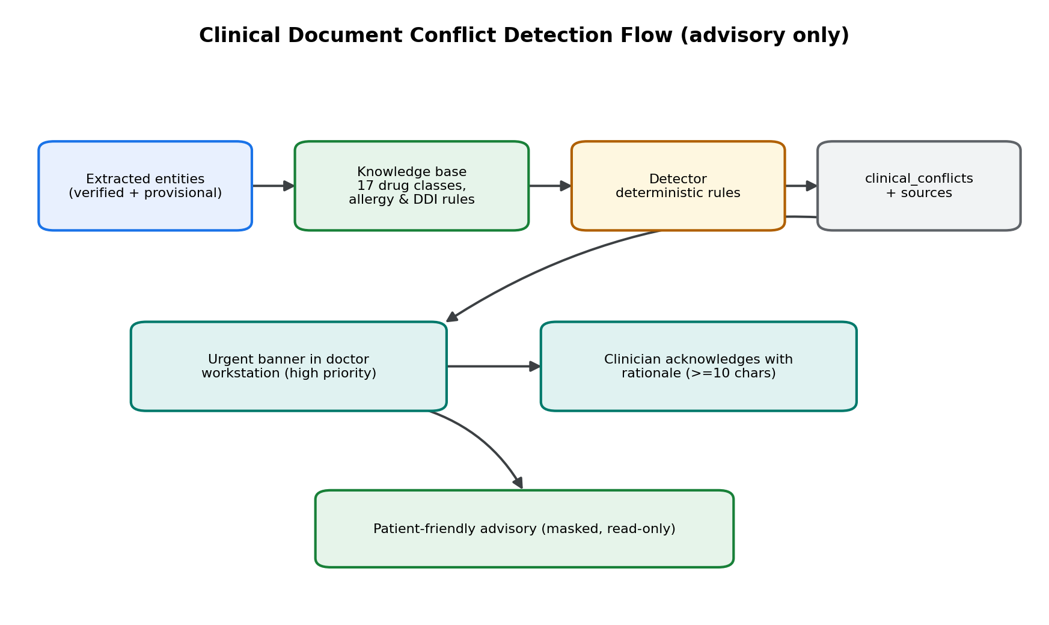
Fig. 4.4 Document ingestion and clinical conflict detection flow, including the mandatory verification gate
Conflict detection compares accepted entities against the patient's existing record. Three comparison rules are implemented. A diagnostic discrepancy arises when the same analyte appears with materially different values in documents that are both current, as in a discharge summary recording glycated haemoglobin at 6.2 percent and an external laboratory report recording 8.5 percent. A drug-allergy conflict arises when a prescribed ingredient matches a recorded allergy. A duplicate-therapy conflict arises when two active medications share a therapeutic class.
Each conflict carries a type, a severity, a review priority and a resolution status. Resolution requires a disposition and, for an override, a free-text rationale. The rationale is not merely stored; it is associated with the conflict so that a subsequent reviewer can understand why the alert was closed.

4.10 Prescription Integrity Design
A prescription is a clinical order and a legal document. The design therefore treats its integrity as a first-class property. At issuance the backend assembles a canonical payload from the prescription header and its line items, computes a signature over that payload, and stores both the payload digest and the signature. The signature is exposed to the patient as a machine-readable code, and the public verification route recomputes the digest from the stored payload and compares it with the presented value.
The design separates verification from disclosure. Anyone holding the code can confirm that a prescription is authentic and unmodified, but the verification response contains no patient name, no address and no clinical notes. A forged or unknown identifier produces an explicit unverified verdict rather than a generic error, because a generic error is indistinguishable from a network failure and could be misread as a transient problem.

4.11 Insurance Estimation Design
Insurance estimation is deliberately deterministic. A policy record stores the sum insured, the remaining balance, the co-payment percentage, the deductible and the list of exclusions. Given a procedure category and an estimated cost, the estimator applies the exclusion list, subtracts the remaining deductible, applies the co-payment percentage and caps the payable amount at the remaining sum insured. No model is involved, so the same inputs always produce the same output and the result can be explained line by line.

4.12 Conversational Assistant Design
The assistant is designed as a retrieval-grounded interface rather than an open-domain chatbot. A user question is classified into an intent that maps to one or more platform endpoints. The backend calls those endpoints with the user's own credentials, so the assistant can never retrieve data that the user could not retrieve directly. The retrieved records are summarised and supplied to the language model with an instruction to answer only from that evidence.
Three safety controls follow from this design. The assistant cannot answer questions about a patient the user is not authorised to see, because the underlying call would fail. It cannot invent a clinical value, because the generation is constrained to the retrieved set and the response is presented with its source. It cannot take an action, because the assistant has read-only access and every mutation remains an explicit user operation.

4.13 CSCM Integration Design
The CSCM component is integrated as an out-of-process inference service with a narrow contract. The backend exposes a stream endpoint that produces a multi-channel physiological window for a bedside device, an attack simulation endpoint that perturbs the window for demonstration, and a prediction proxy that forwards the window to the inference service and returns the anomaly score, the binary verdict and per-channel attribution.
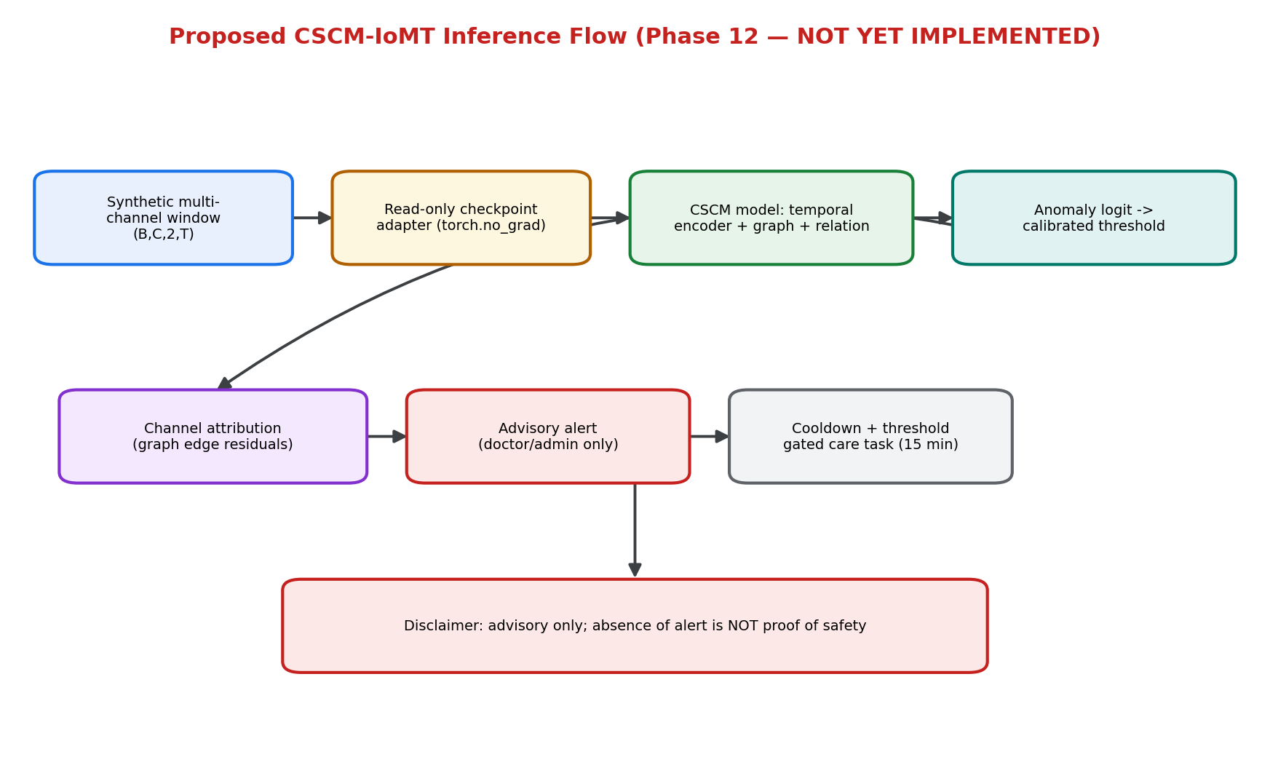
Fig. 4.5 Integration of the CSCM inference service with the physician workstation and the physiological stream
The separation has two benefits. The platform can run without a model checkpoint, which is necessary because the checkpoint is large and environment-specific. The research code can be evaluated independently of the platform, which is necessary for the statistical protocol in Chapter 6. The cost is an additional network hop and the need to keep the feature contract synchronised between the two services.
The workstation presents the monitor as advisory. A visible disclaimer states that the signal is an integrity warning and does not replace clinical assessment or certified equipment. This wording is a design control, not decoration: it prevents the detector's output from being read as a diagnosis.

4.14 Design Trade-offs
Several trade-offs were deliberate. A shared schema with tenant discriminators was chosen over schema-per-tenant because it keeps migrations tractable for a small team, accepting the need for rigorous policy enforcement. A single backend process was chosen over microservices because the operational overhead of many services would exceed the benefit at this scale. Deterministic insurance estimation was chosen over a learned model because explainability mattered more than marginal accuracy, and human verification of extracted entities was chosen over full automation because an extraction error that reaches a prescription is a safety defect. The most consequential trade-off concerns the research component: the ablation between the graph-only and full CSCM models holds the temporal encoder constant, which isolates the feature effect but leaves the two models unequal in parameter count. Chapter 6 states the resulting confound explicitly rather than hiding it.

4.15 Summary
The architecture is a layered system with a tenant-isolated transactional core, a mandatory human verification gate for documents, deterministic financial estimation, a grounded assistant and a separately deployed inference service. The design decisions are conservative where safety is at stake and explicit where a trade-off was accepted. Chapter 5 describes how these decisions were implemented.

CHAPTER 5

IMPLEMENTATION

5.1 Overview
This chapter describes how CareBridge AI was implemented. It begins with the technology stack and repository organisation, then walks through authentication and the five role workspaces, and finally examines the cross-cutting implementation of appointments, document processing, prescriptions, insurance, analytics, the assistant and the CSCM service. Screenshots are included where they provide evidence of a specific implemented behaviour; each caption states what the image shows and the surrounding text states what it does not prove.

5.2 Technology Stack
The stack was chosen for maturity and for the availability of documentation rather than for novelty. Table 5.1 lists the principal components.
Table 5.1 Implementation technology stack
Layer | Technology | Role in the system
Frontend | Next.js 16 with React and TypeScript | Role workspaces, routing, forms and client-side data access
Frontend | Tailwind CSS | Consistent styling and responsive layout
Backend | FastAPI on Python 3.13 | REST API, validation, dependency injection and authorisation
Backend | Pydantic v2 | Request and response schemas, validation and error typing
Database | PostgreSQL 15 on Supabase | Transactional storage, row-level security and cryptographic functions
Inference | FastAPI and PyTorch | CSCM model serving and prediction API
Assistant | Groq-hosted language model | Grounded natural-language responses
Testing | pytest and Playwright | Backend integration tests and browser capture

5.3 Repository and Module Organisation
The repository separates the platform from the research assets. The platform lives under a single top-level directory containing the backend, the frontend and the inference service. The research code, datasets, model checkpoints and generated results live outside that directory and are treated as read-only during platform work. This separation is enforced socially and by a verification script that hashes the research tree; the final verification confirmed that all research files were unmodified.
The backend is organised by domain rather than by technical layer. Each domain has a route module, a schema module and, where the logic is non-trivial, a service module. Cross-cutting concerns live in a core package containing configuration, security, auditing and database access. The frontend mirrors the backend domains, with route groups for authentication, the dashboard and the public verification page.

5.4 Authentication and Session Management
Authentication begins at a single portal that accepts an institutional email address and a password. The backend verifies the password against a bcrypt hash stored in the profile record, checks that the profile is active and that its role is canonical, and issues a signed token containing the user identifier, role and hospital tenant. The frontend stores the token in memory and attaches it to every request.
The portal also exposes five demonstration personas, one per canonical role, so that a reviewer can enter each workspace without provisioning an account. The distinction between demonstration access and institutional access is visible in the interface: the demonstration panel is labelled as synthetic and the password field is marked optional only for those personas.
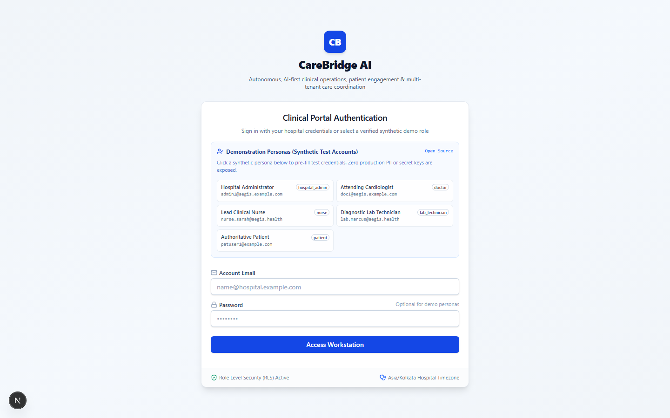
Fig. 5.1 Clinical portal authentication page showing the five demonstration personas, one for each canonical role
The token design has two consequences worth stating. Role and tenant are taken from the signed token rather than from the request, so a client cannot escalate by editing a payload. The token lifetime is bounded, and expiry is validated on every request rather than only at login.

5.5 Role Workspaces
Each canonical role has a dedicated landing route. The routes are not merely different views of one dashboard; they are separately authorised, and a user who navigates to a route outside their role receives a denial rather than an empty page. The navigation shown to a user is derived from the same role claim that the backend enforces, so the interface and the API agree by construction.

5.5.1 Hospital Administrator
The administrator workspace is an operational view of the hospital as an organisation. It presents facility metadata, active departments with their heads, the physician roster with specialisation, licence number and consultation fee, and aggregate consultation load by department. The aggregates are computed server-side from transactional data and cached for a bounded period, so the dashboard does not expose individual patient records.
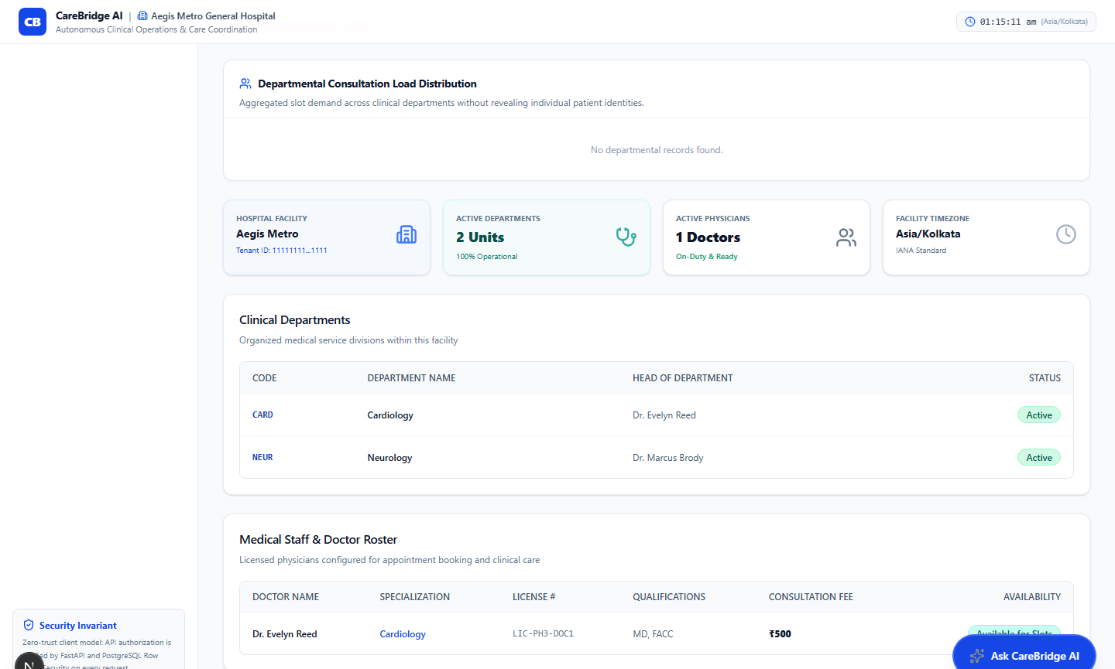
Fig. 5.2 Hospital administrator governance view showing facility metrics, clinical departments and the physician roster

5.5.2 Doctor
The physician workstation combines a consultation queue, a patient encounter view, a conflict review surface and a bedside monitor panel. The queue is filtered by status and ordered by appointment time, and each row exposes the chief complaint and a truncated clinical record so that the physician can prioritise without opening every encounter.
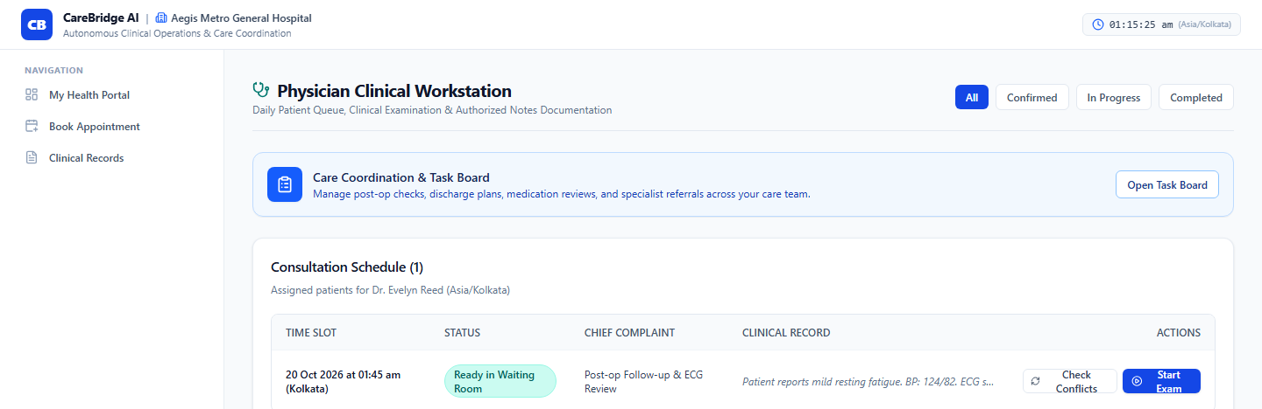
Fig. 5.3 Physician clinical workstation showing the consultation queue with status, chief complaint and per-encounter actions
The conflict review surface is reached from the queue and from a notification banner. It presents the conflicting values side by side, identifies the source documents, and requires the physician to select the authoritative value or record a rationale for overriding the alert. The decision is stored against the conflict with the physician's identity and the timestamp.

5.5.3 Nurse
The nursing workspace supports intake, rapid check-in and care-task coordination. The intake desk lists today's scheduled consultations with a pending-arrival count, and the task board organises obligations into urgent, high-priority and open team pools. A nurse can claim an unassigned task and later complete it with mandatory resolution notes.
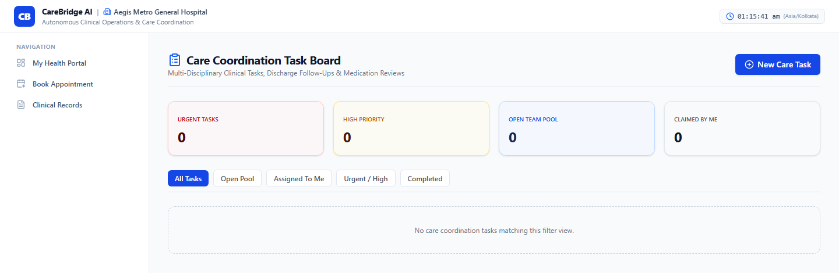
Fig. 5.4 Nursing care coordination task board showing priority queues and filter controls
The captured view shows the board in an empty filter state for a freshly seeded account. It demonstrates the implemented structure of the board, namely the priority counters and the filter set, but it does not demonstrate a populated workload. Populated task behaviour is instead evidenced by the automated tests described in Section 7.4, which create, claim and complete tasks and assert the resulting state transitions.

5.5.4 Laboratory Technician
The laboratory workspace is the clearest implementation of the minimum-disclosure principle. It provides specimen accessioning, a diagnostics queue and a demographic verification search. The interface displays a persistent badge indicating that demographic masking is active, and the patient lookup returns the medical record number, accession identifier, specimen barcode and blood group while withholding the name, date of birth and contact details.
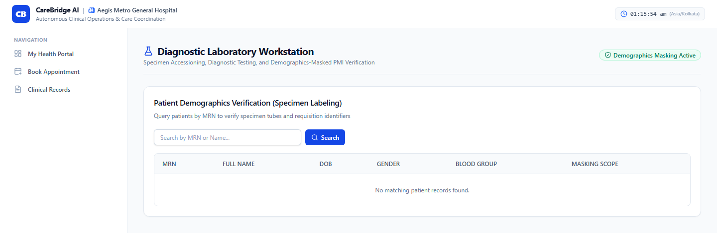
Fig. 5.5 Diagnostic laboratory workstation showing the active demographic masking control and the MRN-based specimen search
The masking is enforced in the backend response schema rather than by hiding columns in the browser. A laboratory technician who calls the patient endpoint directly receives the masked projection, and an attempt to read a full record returns a denial. This distinction matters because client-side masking is a presentation choice, whereas response-schema masking is an access control decision.

5.5.5 Patient
The patient portal provides a health record overview, an insurance panel with a deterministic co-payment calculator, a document repository and a guided appointment booking workflow. The portal is scoped to the authenticated patient's own record; there is no route through which a patient can query another patient's data.
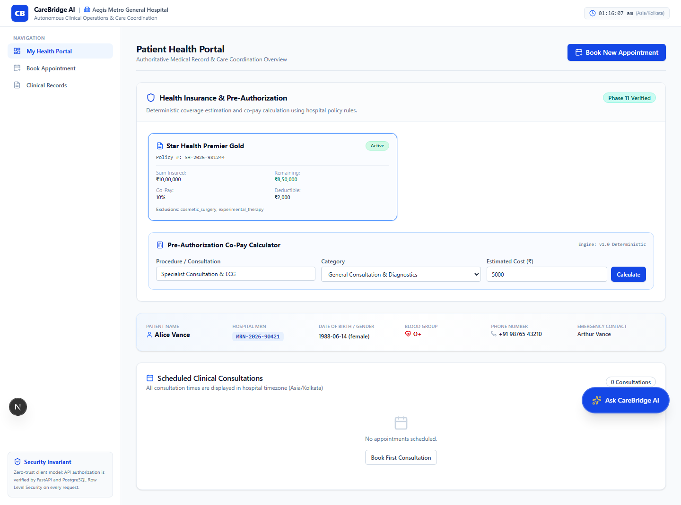
Fig. 5.6 Patient health portal showing the insurance policy summary, pre-authorisation calculator and demographic panel
The booking workflow is a three-step wizard. The patient selects a department, then a physician with displayed availability and fee, then a slot, and finally reviews the booking before confirmation. The wizard validates availability at each step and prevents a slot from being requested twice.
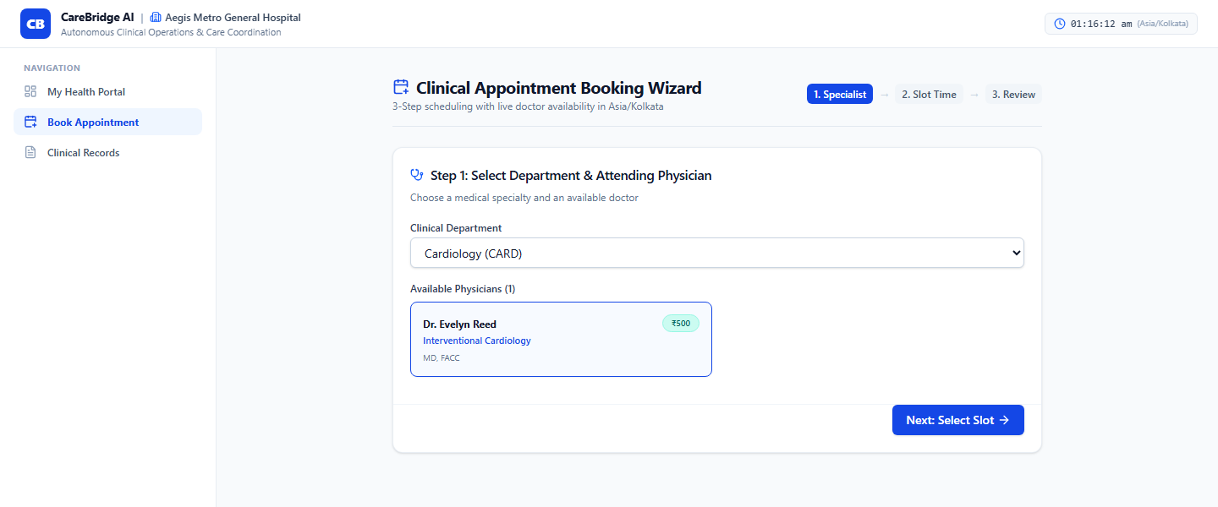
Fig. 5.7 Three-step appointment booking wizard showing department selection and available physicians

5.6 Appointment and Clinical Coordination
Appointments are implemented as a state machine with the states scheduled, confirmed, in progress, completed, cancelled and no-show. Transitions are validated in the service layer, so an illegal transition such as completing an appointment that was never started is rejected with a validation error rather than silently accepted. Creation validates that the requested physician belongs to the same hospital, that the slot is within the physician's availability and that the slot is not already taken.
Coordination beyond scheduling is carried by care tasks. A task has a type, a priority, an optional assignee, a due date and a resolution note. Tasks can be created by a physician or a nurse, claimed from an open pool, and completed with a note that is stored as part of the record. The board exposes filters for open pool, assigned to me, urgent and high priority, and completed, which correspond directly to the queries the roles perform.

5.7 Document Processing and Conflict Detection
Document upload accepts PDF and image files, stores the original, and extracts text. Extraction is followed by entity recognition, which produces candidates classified as diagnoses, medications, laboratory values, vitals or allergies, each with a confidence value and a source span. The review surface presents the extracted text on the left and the candidate entities on the right, grouped by category, with per-entity accept, edit and reject actions.
Only verified entities are written to the clinical record. This is the central safety decision of the pipeline: the extraction model is allowed to be wrong because its output is a proposal, not a fact. When a verified laboratory value contradicts an existing value for the same analyte, the conflict service creates a diagnostic discrepancy with a computed severity and a review priority.
The conflict record retains the identifiers of the source documents. A clinician reviewing the alert can therefore open the evidence rather than trusting a summary. Resolution requires a disposition and, for an override, a rationale. The rationale requirement is enforced by the API schema, not only by the form, so a direct API call cannot bypass it.

5.8 Prescription Safety and Verification
Prescription issuance performs three checks before the record is written. It validates that every prescribed item is a known medication, that no item matches a recorded allergy, and that no item duplicates the therapeutic class of an active medication. A blocking conflict prevents issuance; a non-blocking conflict requires an explicit acknowledgement with a rationale.
Once the checks pass, the backend assembles a canonical payload, computes a digest and signs it. The signature is stored with the prescription and encoded into a verification reference that the patient can present at a pharmacy. The public verification route recomputes the digest and returns a verdict. Figure 5.8 shows the verification surface rejecting an unknown reference, which is the behaviour required for a forged or mistyped code.
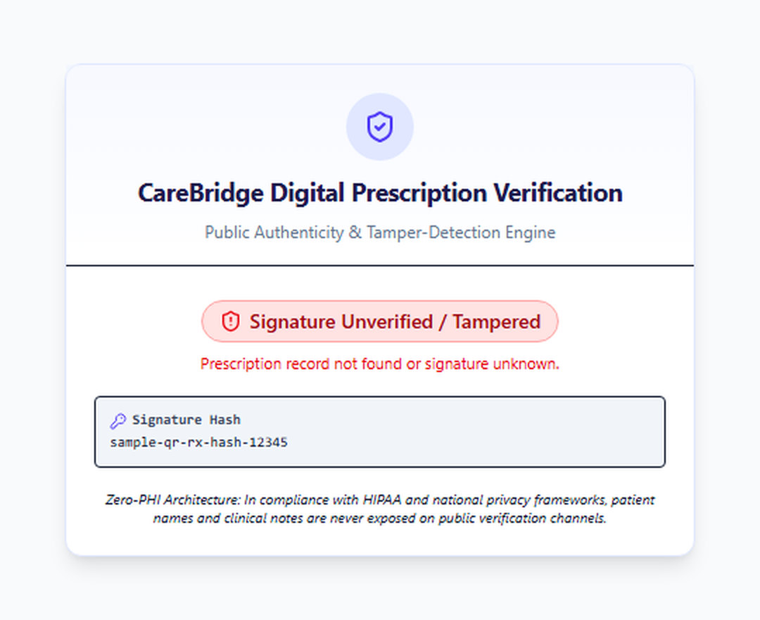
Fig. 5.8 Public prescription verification page returning an unverified verdict for an unknown signature reference
The page is deliberately sparse. It displays the verification verdict, the reference and a statement that patient names and clinical notes are never exposed on public channels. It does not display a patient identifier, which is what allows the endpoint to be public without becoming a disclosure channel.

5.9 Insurance Assistance
The insurance module stores a policy per patient with the sum insured, remaining balance, co-payment percentage, deductible and exclusion list. The estimator applies exclusions, subtracts the deductible, applies the co-payment and caps the payable amount. The patient portal presents the result with the arithmetic exposed, so a patient can see how the figure was produced.
The implementation deliberately separates the policy record from the claim record. A policy describes what the patient is entitled to; a claim records an estimate for a specific procedure. This allows the portal to show entitlement without creating a claim, and it allows a claim to be regenerated when the estimated cost changes.

5.10 Operational Analytics
Analytics are computed server-side from the transactional tables and cached for a bounded window. The dashboard exposes consultation load by department, active physician count, facility metadata and time-window filters for today, seven days and thirty days. Individual patient rows are never returned to the administrator; only aggregates are exposed.

5.11 Conversational Assistant
The assistant is implemented as an orchestration layer rather than as a free-form model endpoint. A query is mapped to one or more platform endpoints, the endpoints are called with the requesting user's token, and the responses are summarised into an evidence block that is supplied to the language model together with a system instruction restricting the answer to that block. If the retrieval returns nothing, the assistant states that the information is unavailable rather than speculating.
The assistant is read-only by design. It can describe a queue, summarise a policy or explain a conflict, but it cannot create an appointment, issue a prescription or resolve a conflict. This boundary keeps every state change attributable to a human action.

5.12 CSCM Service Integration
The inference service loads the trained checkpoint at startup and exposes a health endpoint and a prediction endpoint. The backend stream endpoint produces a window of five physiological channels, the simulation endpoint applies one of several named perturbation profiles, and the proxy endpoint forwards the window to the inference service and returns the score, the verdict and per-channel attribution.
The integration is deliberately narrow. The platform does not embed the model, does not retrain it and does not interpret its output as a diagnosis. The workstation presents the result as an integrity warning with an explicit advisory disclaimer, and the clinical record is not modified by a detection result.

5.13 Implementation Challenges
Four challenges shaped the implementation. Authentication reliability came first: the hosted identity provider intermittently returned server errors, so a local credential verification path was implemented that validates the same bcrypt hashes and mints compatible tokens, with the frontend falling back to it when the provider is unavailable. Validation of synthetic email domains came second, requiring a relaxed but explicitly validated string type so that reserved test domains could be used. Schema constraint alignment between the synthetic data generator and the database came third. Cross-tenant foreign key enforcement came fourth, requiring composite keys so that a reference could not cross a hospital boundary. Each is recorded as a defect with its root cause and resolution in Section 7.7. They are reported because the workarounds have consequences: the local authentication path is a fallback that must be reviewed before any production deployment, and the relaxed email validation is acceptable only because the platform is not exposed publicly.

5.14 Summary
The implementation delivers five role workspaces on a shared tenant-isolated backend, with a document pipeline that separates extraction from verification, a prescription mechanism that separates integrity from disclosure, deterministic financial estimation and a narrowly integrated inference service. The next chapter describes the research component in detail.

CHAPTER 6

CSCM-BASED FALSE DATA INJECTION DETECTION IN IOMT

6.1 Overview
This chapter presents the research component of the project: a physiology-aware cross-sensor consistency model (CSCM) for detecting coordinated multi-channel false data injection attacks in IoMT physiological time series. The chapter states the research question, defines the threat model, describes the datasets and attack generator, presents three architectures that differ only in how channel representations are combined, specifies the evaluation protocol, and reports the results with their statistical uncertainty. The headline finding is negative and is reported as such.

6.2 Research Problem and Question
The research addresses the following question: can physiology-aware cross-sensor consistency modelling improve the detection of coordinated multi-channel FDI attacks in IoMT physiological time-series data compared with a single-channel detection baseline and with naive multi-channel fusion?
The question decomposes into two comparisons. The first asks whether structuring channels as a graph and learning pairwise messages improves detection over a flat concatenation of channel embeddings. The second asks whether adding explicit consistency features, namely the absolute pairwise difference and the element-wise product of channel embeddings, improves detection further. The first comparison tests graph structure; the second tests the specific hypothesis that motivates the CSCM name.

6.3 Threat Model
The adversary is assumed to have compromised one or more physiological sensors or the link between the sensor and the aggregator, and can therefore modify the digital readout before it reaches any downstream consumer. The adversary knows the physiological ranges that the monitoring system treats as normal and can craft perturbations that remain inside those ranges.
Attacks are classified by composition. A single-channel attack perturbs one sensor. A coordinated two-channel attack perturbs two sensors, and a coordinated three-channel attack perturbs three, with the perturbation directions chosen so that the resulting values remain jointly plausible. The adversary's objective is to shift the clinical interpretation of the patient state, for example by making a deteriorating patient appear stable, without triggering a range-based alarm.
The defender observes only the resulting multi-channel window. The defender does not observe the injection mask and does not know which channel, if any, was manipulated. The task is therefore to decide whether a window contains an injection anywhere, which is a weakly supervised problem in which a single label covers a multi-channel event.

6.4 Datasets
Two public datasets were used, chosen to represent opposite ends of IoMT monitoring. The PhysioNet/CinC Challenge 2012 corpus provides irregular, sparse, asynchronous clinical observations from intensive care patients (Silva et al., 2012). WESAD provides high-frequency, tightly synchronised wearable recordings from a chest and wrist device (Schmidt et al., 2018). Table 6.1 summarises the evaluation substrate.
Table 6.1 Evaluation datasets and partitions
Property | PhysioNet/CinC 2012 | WESAD
Monitoring context | Intensive care | Wearable laboratory
Channel count used | 5 core parameters | 14 channels
Sampling | Irregular, asynchronous | High frequency, synchronised
Split unit | Record identifier | Subject identifier
Partitioning | 70 percent train, 15 percent validation, 15 percent test | 70 percent train, 15 percent validation, 15 percent test
Seeds | 42, 123, 2024 | 42, 123, 2024
Test windows pooled over seeds | 6501 | 1719

Splitting at the record or subject level is the most important control in the protocol. A window-level split would allow the same patient to appear in training and test data, and a model could then memorise patient-specific morphology instead of learning attack characteristics. Because the split unit is the patient, the reported metrics estimate performance on unseen patients rather than on unseen windows from seen patients.

6.5 Preprocessing and Windowing
Channels within a record are aligned to a common time axis. High-frequency wearable signals are down-sampled to a common rate, and asynchronous clinical observations are binned into uniform steps. Short gaps in clinical data are forward-filled, and a binary observation mask records where the original signal was absent so that missingness remains representable rather than silently imputed away.
Normalisation uses per-channel z-scores whose mean and standard deviation are computed on the training partition only and then frozen. Normalisation is applied before attack injection, so the standardisation reflects the sensor distribution rather than the attack. Aligned series are segmented into windows of 120 steps, giving an input tensor with a batch, time and channel dimension.
The window length is a compromise between two requirements. It must be long enough to contain both fast dynamics, such as beat-to-beat variability, and slower cycles such as respiration, and short enough that an alert refers to a clinically meaningful interval. One hundred and twenty steps satisfies both for the datasets used.

6.6 Synthetic Attack Generation
Attacks are generated deterministically from a stored seed. Three families are implemented. Additive attacks add a constant or piecewise-constant offset, modelling calibration tampering. Multiplicative attacks scale the signal by a gain factor, modelling attenuation or amplification. Drift attacks apply a progressive ramp, modelling a sensor that degrades over time. Each family is instantiated at three severity levels.
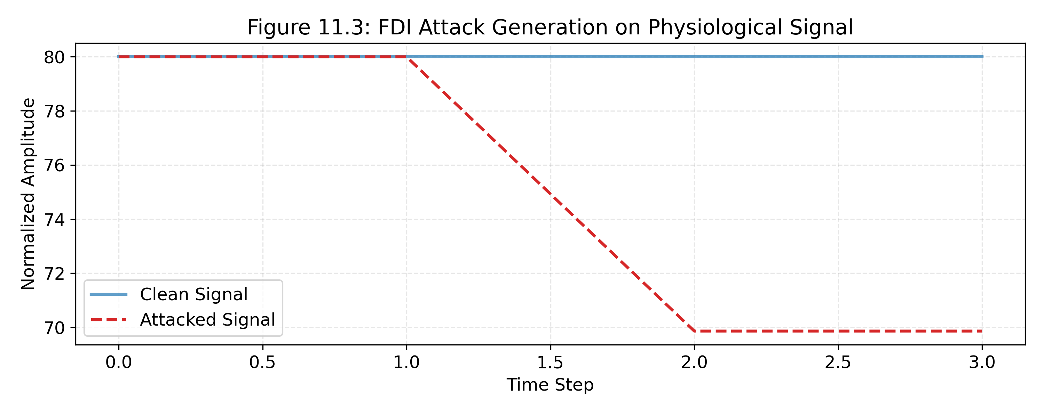
Fig. 6.1 Illustrative coordinated multi-channel injection showing the clean signal, the attacked signal and the resulting attack mask
Two constraints make the generator adversarial in the intended sense. The injected values are clipped so that no channel leaves its physiological bounds, which removes the trivial cue that range-based alarms rely on. And in coordinated attacks the perturbation direction is coupled across channels, so that a naive model that evaluates each channel separately has no anomalous marginal to detect.

6.7 Model Architectures
Three architectures were implemented. All three share an identical temporal encoder so that differences in performance can be attributed to the fusion mechanism rather than to representation capacity at the encoder level.
The encoder applies a one-dimensional convolutional front end followed by a bidirectional gated recurrent unit to each channel independently, producing a 256-dimensional embedding per channel. Batch normalisation is applied between layers. Model A concatenates the channel embeddings into a single vector and classifies it with a multi-layer perceptron. It therefore sees all channels but receives no structural prior about which pairs are physiologically related.
Model B replaces concatenation with message passing over a fixed, physiology-informed channel graph. For each edge the relation input is the concatenation of the two node embeddings, and a relation network maps it to a message. Messages at each node are aggregated with a permutation-invariant sum, and the pooled graph representation is classified by a linear layer with a sigmoid output.
Model C, the full CSCM, augments the relation input with the absolute pairwise difference and the element-wise product of the two embeddings. The motivation is that the difference supplies an explicit distance between sensors and the product supplies an explicit co-activation, so that a decoupled pair during a coordinated attack becomes easier to separate. Figure 6.2 shows the progression from the shared encoder to the three fusion heads.
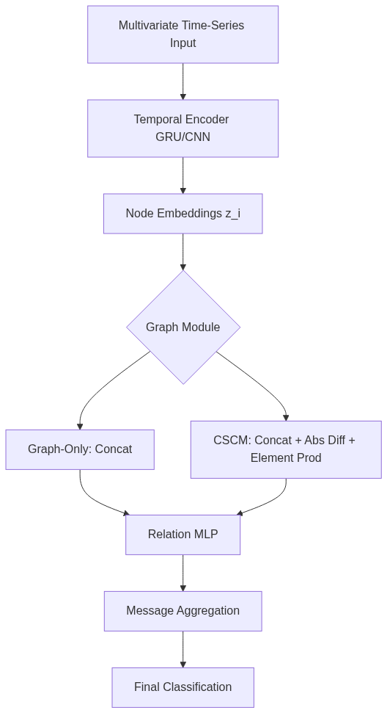
Fig. 6.2 Model progression from the shared temporal encoder to flat fusion, graph-only message passing and CSCM with explicit consistency features
The ablation is clean with respect to features but not with respect to parameters. Because the relation input of Model C is twice as wide as that of Model B, its relation network has approximately 448 thousand parameters against approximately 381 thousand for Model B, a difference of about seventeen percent. The consequence is stated in Section 6.14 rather than concealed: a difference between B and C cannot be attributed to the features alone.

6.8 Training Protocol
All models are trained with binary cross-entropy weighted by the ratio of clean to attacked windows in the training partition. Optimisation uses Adam with early stopping on validation area under the receiver operating characteristic curve (Kingma & Ba, 2015). The architectures are implemented in PyTorch (Paszke et al., 2019) with graph operations from PyTorch Geometric (Fey & Lenssen, 2019), and the evaluation metrics are computed with scikit-learn (Pedregosa et al., 2011). The decision threshold is selected on the validation partition by maximising F1 and is then frozen and applied to the test partition, so the reported test F1 is not inflated by test-time threshold tuning.
Each model is trained with three seeds. Three seeds are sufficient to expose gross instability but not sufficient for a precise variance estimate, and this is a limitation rather than a design choice. The seeds are reported individually as well as in aggregate so that a reader can see where a mean is concealing disagreement.

6.9 Evaluation Methodology
Three metrics are reported: window-level F1, area under the precision-recall curve and area under the receiver operating characteristic curve. Accuracy is omitted because the class balance makes it uninformative. AUPRC is the most sensitive to the minority class, while AUROC is included for comparability with prior work.
Differences between architectures are assessed with a hierarchical paired bootstrap of one thousand resamples drawn at the subject level and with McNemar's test with continuity correction on the thresholded predictions (Efron & Tibshirani, 1993; Dietterich, 1998). Subject-level resampling preserves the intra-patient correlation that window-level resampling would destroy. A difference is treated as reliable only when its 95 percent confidence interval excludes zero and the paired test agrees.

6.10 Results
Table 6.2 reports performance averaged over the three seeds. On PhysioNet the graph-only model is the strongest on all three metrics, and the full CSCM does not recover the gap. On WESAD the models are separated by less than one standard deviation on every metric, and the full CSCM has the highest mean F1 while the graph-only model has the highest AUPRC and AUROC.
Table 6.2 Absolute performance, mean and standard deviation over three seeds
Dataset | Model | F1 | AUPRC | AUROC
PhysioNet | A Naive | 0.8788 plus or minus 0.0019 | 0.9550 plus or minus 0.0008 | 0.8946 plus or minus 0.0017
PhysioNet | B Graph-only | 0.8863 plus or minus 0.0031 | 0.9583 plus or minus 0.0012 | 0.9029 plus or minus 0.0021
PhysioNet | C CSCM | 0.8827 plus or minus 0.0030 | 0.9556 plus or minus 0.0019 | 0.8962 plus or minus 0.0036
WESAD | A Naive | 0.8509 plus or minus 0.0033 | 0.8820 plus or minus 0.0087 | 0.6812 plus or minus 0.0183
WESAD | B Graph-only | 0.8489 plus or minus 0.0068 | 0.8877 plus or minus 0.0035 | 0.6909 plus or minus 0.0110
WESAD | C CSCM | 0.8520 plus or minus 0.0008 | 0.8822 plus or minus 0.0015 | 0.6806 plus or minus 0.0051

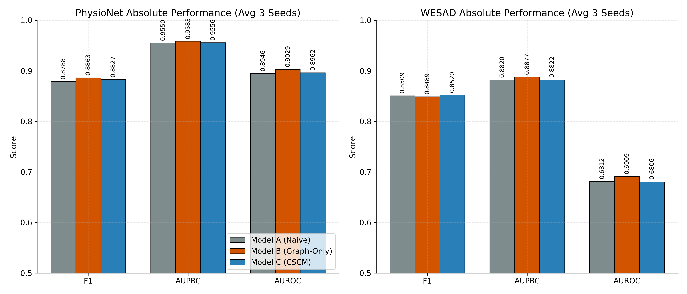
Fig. 6.3 Absolute F1, AUPRC and AUROC for models A, B and C on both datasets, averaged over three seeds
The WESAD result requires careful reading. An F1 of approximately 0.85 with an AUROC of approximately 0.68 means that the thresholded classifier achieves a useful F1 largely through a permissive threshold that favours recall, while its ranking of attacked above clean windows is only modestly better than chance. The F1 alone would overstate the capability, which is why AUROC is reported alongside it.
The ablation deltas make the direction of the effect explicit. On PhysioNet, moving from naive fusion to graph message passing improves F1 by 0.0075, AUPRC by 0.0033 and AUROC by 0.0082. Moving from graph-only to full CSCM reduces F1 by 0.0035, AUPRC by 0.0027 and AUROC by 0.0067. On WESAD the first step is negative on F1 and positive on AUROC, and the second step is positive on F1 and negative on AUROC, with all changes within noise.

6.11 Statistical Analysis
Table 6.3 reports the paired bootstrap intervals and McNemar results. Only two comparisons are reliable. At PhysioNet seed 2024 the graph-only model beats naive fusion with a 95 percent interval for the F1 difference of 0.0018 to 0.0187 and a McNemar p of 0.0003. At PhysioNet seed 42 the full CSCM is reliably worse than graph-only, with an interval of minus 0.0180 to minus 0.0005 and a p of 0.0198.
Table 6.3 Paired bootstrap confidence intervals for the F1 difference and McNemar test on thresholded predictions
Dataset and seed | Comparison | F1 difference, 95 percent interval | McNemar p | Reading
PhysioNet 42 | B minus A | minus 0.0016 to 0.0177 | 0.399 | Not significant
PhysioNet 42 | C minus B | minus 0.0180 to minus 0.0005 | 0.020 | CSCM reliably worse
PhysioNet 123 | B minus A | minus 0.0038 to 0.0118 | 0.360 | Not significant
PhysioNet 123 | C minus B | minus 0.0078 to 0.0116 | 0.508 | Not significant
PhysioNet 2024 | B minus A | 0.0018 to 0.0187 | 0.0003 | Graph reliably better
PhysioNet 2024 | C minus B | minus 0.0130 to 0.0060 | 0.443 | Not significant
WESAD, all seeds | Both comparisons | All intervals span zero | 0.499 to 1.000 | Not significant

The honest summary is that graph message passing produces a small, seed-dependent gain on clinical data, and that explicit consistency features produce no reliable gain on either dataset. The significant negative result at seed 42 is not a single outlier to be discarded; it is evidence that the added features can perturb optimisation enough to lose accuracy.

6.12 Error Analysis
Because the graph-only model is the strongest on PhysioNet, the failure analysis focuses on it and pools predictions across seeds. Table 6.4 breaks performance down by attack composition, attack family and missingness.
Table 6.4 Error analysis of the graph-only model on PhysioNet, pooled over seeds
Subgroup | Recall | Precision | F1
Single-channel attack | 0.9068 | 0.9293 | 0.9179
Coordinated two-channel | 0.8974 | 0.8656 | 0.8812
Coordinated three-channel | 0.9046 | 0.8259 | 0.8635
Additive family | 0.9103 | 0.9340 | 0.9220
Multiplicative family | 0.8792 | 0.9316 | 0.9046
Drift family | 0.9358 | 0.9221 | 0.9289
Fully observed windows | 0.9120 | 0.8743 | 0.8927
Windows containing missing values | 0.8956 | 0.8299 | 0.8615

Three patterns are visible. Coordinated attacks are harder than single-channel attacks, and the difficulty grows with the number of coordinated channels: F1 falls from 0.9179 for single-channel to 0.8635 for three-channel. The multiplicative family is the hardest to detect, which is consistent with a gain error preserving signal shape and therefore preserving many of the temporal cues a model relies on. Missingness costs approximately three F1 points, because forward filling preserves the shape of a signal but not the information that was absent.
Table 6.5 isolates channel discriminability using single-channel attacks. PhysioNet performance is fairly even across the five parameters, with heart rate the easiest and diastolic pressure the hardest. WESAD exposes a stark edge case: attacks localised to the chest respiration channel were never detected, with recall of zero on a subgroup of eighteen windows.
Table 6.5 Channel breakdown on single-channel attacks, graph-only model, pooled over seeds
Channel | Recall | Precision | F1
HR, PhysioNet | 0.9061 | 0.9655 | 0.9349
NIMAP, PhysioNet | 0.9326 | 0.9121 | 0.9222
NISysABP, PhysioNet | 0.8977 | 0.9368 | 0.9168
NIDiasABP, PhysioNet | 0.8902 | 0.9289 | 0.9091
Temp, PhysioNet | 0.9074 | 0.8950 | 0.9011
chest_Resp, WESAD | 0.0000 | 0.0000 | 0.0000

The respiration failure is a sparse-positive problem. The chest respiration channel is slow, low-dimensional and unlike the dense cardiovascular signals in the same window, so its embedding contributes little to the pooled graph representation and an attack confined to it does not change the aggregate enough to cross the threshold. The practical implication is that a deployment must evaluate channel-level attribution rather than relying on a single window-level verdict, which is why the inference service returns per-channel inconsistency scores.

6.13 Discussion
The results support a simple interpretation. Graph structure is a useful inductive bias for physiological data because it encodes the relationships that physiology actually contains. Hand-engineered consistency arithmetic, by contrast, appears redundant: a relation network operating on the raw concatenation of two embeddings is expressive enough to approximate whatever non-linear distance boundary matters, and supplying the arithmetic explicitly adds correlated inputs without adding information.
The dataset contrast reinforces the point. On WESAD the signals are clean, synchronised and already highly informative, so there is little relational structure for a graph to add and all three models converge. On PhysioNet the signals are sparse and noisy, and modelling relations pays off. The parameter confound must be kept in view: Model C is approximately seventeen percent larger than Model B, so its deficit may reflect optimisation dynamics as much as the features themselves, and a parameter-matched comparison was not performed.

6.14 Threats to Validity
Construct validity. The attacks are synthetic. They are drawn from three mathematical families and clipped to remain physiologically plausible, which is the correct control for testing evasion of range-based monitors, but they are not real attacks and they do not model an adversary who optimises against the detector.
Internal validity. The B and C models are not parameter-matched, and only three seeds were used. A single significant result in either direction should therefore be read as evidence about a particular initialisation rather than as a stable property of the architecture.
External validity. Two datasets, one frozen split and one injection configuration bound the generalisation of the findings. Cross-dataset transfer was not tested, and no live bedside device was instrumented.
Conclusion validity. The subject-level bootstrap controls for intra-patient correlation, but the number of independent subjects limits the precision of the intervals. The negative findings are more robustly supported than the positive one, because they are consistent across seeds and datasets, whereas the positive finding appears at one seed only.

6.15 Integration with the Platform
The trained model is served by the inference microservice described in Section 4.13. The physician workstation requests a window, optionally applies a named perturbation for demonstration, and receives a score, a verdict and per-channel attribution. The result is displayed as an integrity warning with an explicit advisory disclaimer, is never written into the clinical record, and never alters a prescription or an appointment.
The integration demonstrates that a research detector can be exposed inside a clinical workflow without being mistaken for a diagnostic authority. Whether such a warning improves clinician decisions is an empirical question that this project did not test, and it is listed as future work.

6.16 Summary
Three architectures were compared under a leakage-controlled protocol on two public datasets. Graph message passing over a physiology-informed channel graph improved detection on the clinical dataset and was statistically reliable at one seed. Explicit cross-sensor consistency features did not improve detection on either dataset and were reliably worse at one seed. The result reframes the contribution: the value lies in the relational structure, not in the arithmetic, and the community benefit lies in reporting the negative result with its uncertainty rather than in claiming a marginal win.

CHAPTER 7

TESTING, RESULTS AND DISCUSSION

7.1 Overview
This chapter reports how CareBridge AI was verified and what the verification established. It describes the test strategy, the environment, the automated backend suite, the security and isolation tests, the end-to-end workflow checks, the defects found during verification, and the separate verification of the research component. It then discusses what the results do and do not demonstrate.

7.2 Test Strategy
The strategy combines four levels. Unit and integration tests exercise backend behaviour directly, including authorisation, state transitions and validation. Security tests attempt the actions that a hostile or mistaken client would attempt, such as presenting a token from another tenant, presenting a retired role, or calling a route without a token. End-to-end browser tests drive the running frontend against the running backend and capture screens as evidence. Invariant checks verify that the research assets and historical audit records were not modified by any of the above.
The levels are complementary rather than redundant. An integration test can assert that a cross-tenant read returns not-found, but only a browser test can show that the interface does not offer the action in the first place. Conversely, a browser test can be satisfied by a hidden button, whereas an integration test cannot. The project therefore treats a capability as verified only when both the API behaviour and the reachable interface agree.

7.3 Test Environment
All verification was executed against the live services rather than against mocks. Table 7.1 records the environment.
Table 7.1 Verification environment
Component | Version or configuration
Operating system | Windows 11
Python | 3.13.2
Backend framework | FastAPI with Uvicorn on port 8000
Frontend | Next.js 16.4.0 with Turbopack on port 3000
Database | Supabase hosted PostgreSQL 15
Inference service | FastAPI on port 8001
Backend test runner | pytest
Browser automation | Playwright with Chromium
Tenants exercised | Two synthetic hospitals
Accounts exercised | Twenty synthetic accounts across five roles

7.4 Automated Backend Testing
The backend suite comprises 128 tests organised by domain. Table 7.2 lists the modules and the behaviour each is responsible for. The suite completed with 128 passing tests and no failures in 1013 seconds, approximately seventeen minutes, which is consistent with integration tests that exercise a hosted database rather than an in-memory substitute.
Table 7.2 Backend test modules and scope
Module | Scope
Security and identity | Token validation, signature tampering, role claims, tenant claims and retired-role rejection
Workflow state | Appointment creation, availability validation and illegal state transitions
Documents | Upload, extraction, entity verification and review authorisation
Conflicts | Detection rules, severity assignment, disposition and mandatory override rationale
Care tasks | Creation, claiming, completion and resolution-note enforcement
Prescriptions | Issuance checks, signature generation, dispensing and public verification
Insurance and analytics | Deterministic estimation, exclusion handling and aggregate scoping
Assistant | Intent routing, grounding and refusal behaviour
CSCM integration | Stream, simulation, prediction proxy and error handling
Security end-to-end | Cross-tenant access, privilege boundaries and retired-route behaviour

The tests are integration tests in the sense that they exercise the real HTTP surface and the real database. They are not end-to-end tests in the browser sense, which is why the browser captures in Section 7.6 are reported separately.

7.5 Security and Isolation Testing
Security verification produced the results in Table 7.3. The distinction between functional success and negative security success is important: it is easy to demonstrate that an authorised user can read a record and much harder to demonstrate that an unauthorised user cannot.
Table 7.3 Security and isolation verification results
Verification suite | Cases | Result | Observation
Account authentication | 20 | 20 passed | All five roles authenticated across both tenants and received valid role and tenant claims
Negative authentication | 3 | 3 passed | Wrong password and unknown user returned 401; malformed credentials returned 422
Role boundary enforcement | 6 | 6 passed | Patient and cross-role attempts to reach privileged routes were denied
Multi-tenant isolation | 4 | 4 passed | Attempts to read another hospital's patient or document returned not-found
Retired route handling | 2 | 2 passed | Receptionist and caregiver routes rendered not-found boundaries
Audit log preservation | 48 | 48 passed | Historical audit entries were byte-for-byte unchanged

The tenant tests are the most consequential. Each attempt used a valid token from one hospital to request a resource belonging to the other, so the failure cannot be explained by an invalid session. The returns were not-found rather than forbidden, which is the deliberate choice described in Section 4.5: a forbidden response would confirm that the record exists.
Two limitations must be stated. First, these are functional security tests, not a penetration test; no adversarial assessment of the deployed services was performed. Second, the environment is an in-house prototype without a reverse proxy or public ingress, so network-level controls were not exercised.

7.6 End-to-End Workflow Verification
Browser verification exercised the five role workspaces and the cross-role clinical scenario. Thirty-one captures were produced across nine categories. The selections included in this report are those that demonstrate a specific implemented behaviour; the remainder are retained in the project artefact directory.
The cross-role scenario is the strongest end-to-end evidence. A discharge summary recording glycated haemoglobin at 6.2 percent and an external laboratory report recording 8.5 percent were ingested for the same patient. The conflict service created a diagnostic discrepancy with high review priority, the physician workstation surfaced it, and the reconciliation workflow allowed the physician to select the authoritative value or record a rationale. In parallel, care tasks for medication reconciliation and laboratory review were created, assigned and tracked through the board.
The prescription flow was verified end to end. A prescription was issued after passing allergy and duplicate-therapy checks, a signature was generated over the canonical payload, and the public verification route validated the reference. A forged reference produced an explicit unverified verdict, which is shown in Figure 5.8.
The verification establishes that the workflows operate on synthetic data in a controlled environment. It does not establish clinical effectiveness, usability under load, or correctness of the clinical rules against an external formulary. Those claims are not made.

7.7 Defects Found and Resolved
Four defects were identified during verification. They are reported because a defect list is evidence of a testing process, whereas a claim of zero defects is usually evidence of insufficient testing.
Table 7.4 Defects identified during verification and their resolutions
ID | Severity | Description | Resolution
DEF-01 | High | The hosted identity provider intermittently returned server errors on password grant requests | Implemented a local credential verification path that validates the same hashes and mints compatible tokens, with automatic fallback in the client
DEF-02 | Medium | Strict email validation rejected reserved test domains used by synthetic accounts | Relaxed the login schema to an explicitly validated string, retaining format and length checks
DEF-03 | Low | Conflict insertion failed against a check constraint because the type value did not match the allowed enumeration | Aligned the synthetic data generator with the database constraint
DEF-04 | Low | Patient account self-link failed because the verifier was not an active staff member of the same tenant | Seeded a tenant-matching administrative verifier

DEF-01 deserves emphasis. The fallback restores availability, but it adds a second authentication path that must be reviewed before any production deployment. It is documented as a known risk rather than presented as a feature.

7.8 Research Verification
The research component was verified separately from the platform. The evaluation produced stored metric files for every dataset, model and seed, a statistical test file containing the bootstrap intervals and McNemar results, and an error-analysis report covering attack composition, attack family, missingness and channel. The numbers reported in Chapter 6 are taken from those files rather than recomputed for this report.
An invariant check confirmed that all research files remained unmodified throughout platform development. This matters because the research results are only meaningful if the code and data that produced them were not silently changed while the platform was being built.
The research verification has two gaps. The results were produced by the project's own pipeline and were not reproduced by an independent party, and the statistical power is limited by three seeds and a small number of independent subjects.

7.9 Discussion
The platform results support a modest but defensible claim: a tenant-isolated clinical coordination platform with five role workspaces, a verification gate for extracted documents, deterministic prescription integrity and deterministic insurance estimation can be implemented and verified on a conventional open-source stack. The evidence is strongest for negative security properties, because cross-tenant and cross-role attempts were actively made and failed closed.
The research results support a different claim: graph structure is a useful inductive bias for physiological anomaly detection, and explicit consistency arithmetic is not. The two results interact in a way worth noting. The platform demonstrates that a detector can be integrated into a clinical workflow with the right advisory framing, while the research demonstrates that an aggregate metric is not a sufficient basis for clinical trust: a window-level F1 of 0.88 can coexist with complete failure on a specific channel, which is why per-channel attribution is exposed in the interface.

7.10 Limitations of the Evaluation
Four limitations bound the conclusions. No real user participated, so usability is unmeasured. The evidence is functional rather than adversarial, because no penetration test was performed. Testing used synthetic rather than production data. Finally, load and availability behaviour was not exercised, because the deployment is an in-house prototype rather than a production service.

7.11 Summary
The platform passed 128 automated backend tests, twenty account authentication checks, negative authentication checks, six role-boundary checks, four cross-tenant isolation checks and two retired-route checks, with four defects found and resolved. The research component produced a statistically analysed negative result. Chapter 8 concludes the report and states what remains to be done.

CHAPTER 8

CONCLUSION, LIMITATIONS AND FUTURE ENHANCEMENTS

8.1 Summary of Work
This project delivered two connected artefacts. The first is CareBridge AI, a multi-tenant hospital operations and clinical coordination platform with five role workspaces, a document reconciliation pipeline, prescription integrity, care-task coordination, insurance assistance, operational analytics and a grounded conversational assistant. The second is a physiology-aware cross-sensor consistency model for detecting coordinated multi-channel false data injection attacks in IoMT physiological data, evaluated on two public datasets under a leakage-controlled protocol.
The platform was built on a conventional open-source stack and verified with 128 automated backend tests, twenty account authentication checks, negative authentication checks, role-boundary tests, cross-tenant isolation tests and end-to-end browser exercises. Four defects were found and resolved during verification. The research component produced a statistically analysed comparison of three architectures across two datasets and three seeds, with subject-level bootstrap intervals and McNemar tests.

8.2 Contributions
The first contribution is an integrated design for clinical coordination. The platform does not merely store records; it delivers obligations to the role that must act on them. Conflicts appear at the point of consultation, care tasks appear on the board of the team that owns them, and a patient sees the insurance arithmetic that determines their out-of-pocket cost. The second contribution is a layered isolation design in which tenant identity is enforced in the token, in the application and in the database, so that cross-tenant attempts fail closed at the API even when the token is valid.
The second contribution is a layered isolation design in which tenant identity is enforced in the token, in the application and in the database. The verification evidence shows that cross-tenant attempts fail closed at the API even when the token is valid, which is the property that matters in a shared-schema deployment.
The third contribution is a safety pattern for document intelligence: extraction is treated as a proposal rather than a fact, only verified entities enter the clinical record, conflicts retain their source documents, and overrides require a recorded rationale. The fourth is the research result: graph message passing improves detection on clinical data, and explicit hand-engineered consistency features do not. Reporting the negative result with effect sizes and intervals is more useful than a marginal positive claim, because it redirects effort towards the mechanism that works.

8.3 Limitations
The limitations are stated plainly because they bound every claim in this report. The deployment is an in-house prototype: the services run as local processes against a hosted database, with no container orchestration, no reverse proxy, no public ingress and no clinical pilot. Availability, scalability and production hardening were therefore not exercised.
No real user evaluated the platform. The role workspaces were captured in automated browser sessions, not in a usability study, so workflow fit for clinicians, nurses, laboratory staff and administrators is unmeasured. Several captured screens show empty filter states because the seeded account had no active workload at the moment of capture; those screens evidence interface structure, not operational throughput.
Security verification is functional rather than adversarial. Cross-tenant and cross-role attempts were made and failed closed, but no penetration test was conducted and the local authentication fallback introduced to mitigate an identity-provider outage has not been independently reviewed.
The research component used synthetic attacks, two datasets, one frozen split and three seeds. The B and C models are not parameter-matched, so the comparison of explicit consistency features is confounded by capacity. No cross-dataset transfer experiment was performed, and no live bedside device was instrumented.

8.4 Future Enhancements
Five enhancements follow from the limitations. First, integrate with hospital information systems through HL7 or FHIR interfaces so that ingestion does not depend on documents. Second, conduct a usability study with representative users for each role and measure task completion time and error rate. Third, perform load and soak testing at hospital-scale concurrency and add a reverse proxy, container orchestration and health-based restarts. Fourth, commission an independent security review covering the authentication fallback, the row-level security policies and the public verification endpoint. Fifth, strengthen the research design by adding published baselines, increasing the number of seeds, matching parameters across the ablation and testing cross-dataset transfer.
Fourth, commission an independent security review covering the authentication fallback, the row-level security policies and the public verification endpoint. Fifth, strengthen the research design by adding published detection baselines, increasing the number of seeds, matching parameters across the ablation, replacing forward filling with a missingness-aware encoder and testing cross-dataset transfer. Sixth, extend the monitoring integration from demonstration windows to live device streams with calibrated alarms and a documented escalation policy.
A further enhancement concerns the assistant. The current implementation is read-only and grounded in platform endpoints. A natural next step is to evaluate whether grounded answers reduce the time staff spend navigating the system, and to add explicit citation of the retrieved records so that a user can verify each statement.

8.5 Conclusion
CareBridge AI shows that the coordination problem in hospital software is tractable with conventional engineering, provided that the design takes safety seriously at three points: the delivery of information to the role that must act, the separation of extraction from verification, and the recording of why an alert was overridden. The research component shows that physiology-aware modelling is worth pursuing but that its value comes from relational structure rather than from hand-engineered consistency arithmetic.
The project therefore closes with one positive engineering result, one negative research result, and a clear statement of what has not been demonstrated. The platform passed its functional and security verification on synthetic data in an in-house deployment; the detector improved on clinical data through graph structure alone and failed to improve on a clean wearable dataset. Both outcomes are reported with the evidence that supports them, and the remaining work is identified rather than implied.

REFERENCES
Alsubaei, F., Abuhussein, A., & Shiva, S. (2017). Security and privacy in the Internet of Medical Things: Taxonomy and risk assessment. In Proceedings of the IEEE 42nd Conference on Local Computer Networks Workshops (pp. 112-120). IEEE. https://doi.org/10.1109/LCN.Workshops.2017.72
Bass, L., Clements, P., & Kazman, R. (2021). Software architecture in practice (4th ed.). Addison-Wesley.
Bates, D. W., Cohen, M., Leape, L. L., Overhage, J. M., Shabot, M. M., & Sheridan, T. (2001). Reducing the frequency of errors in medicine using information technology. Journal of the American Medical Informatics Association, 8(4), 299-308. https://doi.org/10.1136/jamia.2001.0080299
Battaglia, P. W., Hamrick, J. B., Bapst, V., Sanchez-Gonzalez, A., Zambaldi, V., Malinowski, M., Tacchetti, A., Raposo, D., Santoro, A., Faulkner, R., Gulcehre, C., Song, F., Ballard, A., Gilmer, J., Dahl, G., Vaswani, A., Allen, K., Nash, C., Langston, V., ... Pascanu, R. (2018). Relational inductive biases, deep learning, and graph networks. arXiv. https://arxiv.org/abs/1806.01261
Cho, K., van Merrienboer, B., Gulcehre, C., Bahdanau, D., Bougares, F., Schwenk, H., & Bengio, Y. (2014). Learning phrase representations using RNN encoder-decoder for statistical machine translation. In Proceedings of the Conference on Empirical Methods in Natural Language Processing (pp. 1724-1734). Association for Computational Linguistics. https://doi.org/10.3115/v1/D14-1179
Dietterich, T. G. (1998). Approximate statistical tests for comparing supervised classification learning algorithms. Neural Computation, 10(7), 1895-1923. https://doi.org/10.1162/089976698300017197
Efron, B., & Tibshirani, R. J. (1993). An introduction to the bootstrap. Chapman & Hall.
Fey, M., & Lenssen, J. E. (2019). Fast graph representation learning with PyTorch Geometric. In Proceedings of the ICLR Workshop on Representation Learning on Graphs and Manifolds.
Fielding, R. T. (2000). Architectural styles and the design of network-based software architectures [Doctoral dissertation, University of California, Irvine].
Fowler, M. (2002). Patterns of enterprise application architecture. Addison-Wesley.
Gilmer, J., Schoenholz, S. S., Riley, P. F., Vinyals, O., & Dahl, G. E. (2017). Neural message passing for quantum chemistry. In Proceedings of the 34th International Conference on Machine Learning (pp. 1263-1272). PMLR.
Government of India. (2023). The Digital Personal Data Protection Act, 2023. Ministry of Law and Justice.
Hochreiter, S., & Schmidhuber, J. (1997). Long short-term memory. Neural Computation, 9(8), 1735-1780. https://doi.org/10.1162/neco.1997.9.8.1735
Ioffe, S., & Szegedy, C. (2015). Batch normalization: Accelerating deep network training by reducing internal covariate shift. In Proceedings of the 32nd International Conference on Machine Learning (pp. 448-456). PMLR.
Kingma, D. P., & Ba, J. (2015). Adam: A method for stochastic optimization. In Proceedings of the 3rd International Conference on Learning Representations.
Kipf, T. N., & Welling, M. (2017). Semi-supervised classification with graph convolutional networks. In Proceedings of the 5th International Conference on Learning Representations.
Kuperman, G. J., Bobb, A., Payne, T. H., Avery, A. J., Gandhi, T. K., Burns, G., Classen, D. C., & Bates, D. W. (2007). Medication-related clinical decision support in computerized provider order entry systems: A review. Journal of the American Medical Informatics Association, 14(1), 29-40. https://doi.org/10.1197/jamia.M2170
Liu, Y., Ning, P., & Reiter, M. K. (2011). False data injection attacks against state estimation in electric power grids. ACM Transactions on Information and System Security, 14(1), 1-33. https://doi.org/10.1145/1952982.1952995
Mell, P., & Grance, T. (2011). The NIST definition of cloud computing (NIST Special Publication 800-145). National Institute of Standards and Technology.
Mo, Y., Kim, T. H.-J., Brancik, K., Dickinson, D., Lee, H., Perrig, A., & Sinopoli, B. (2012). Cyber-physical security of a smart grid infrastructure. Proceedings of the IEEE, 100(1), 195-209. https://doi.org/10.1109/JPROC.2011.2161428
OWASP Foundation. (2021). OWASP Top 10:2021 - The ten most critical web application security risks. https://owasp.org/Top10/
Paszke, A., Gross, S., Massa, F., Lerer, A., Bradbury, J., Chanan, G., Killeen, T., Lin, Z., Gimelshein, N., Antiga, L., Desmaison, A., Kopf, A., Yang, E., DeVito, Z., Raison, M., Tejani, A., Chilamkurthy, S., Steiner, B., Fang, L., ... Chintala, S. (2019). PyTorch: An imperative style, high-performance deep learning library. In Advances in Neural Information Processing Systems 32 (pp. 8024-8035).
Pedregosa, F., Varoquaux, G., Gramfort, A., Michel, V., Thirion, B., Grisel, O., Blondel, M., Prettenhofer, P., Weiss, R., Dubourg, V., Vanderplas, J., Passos, A., Cournapeau, D., Brucher, M., Perrot, M., & Duchesnay, E. (2011). Scikit-learn: Machine learning in Python. Journal of Machine Learning Research, 12, 2825-2830.
Sandhu, R. S., Coyne, E. J., Feinstein, H. L., & Youman, C. E. (1996). Role-based access control models. Computer, 29(2), 38-47. https://doi.org/10.1109/2.485845
Schmidt, P., Reiss, A., Duerichen, R., Marberger, C., & Van Laerhoven, K. (2018). Introducing WESAD, a multimodal dataset for wearable stress and affect detection. In Proceedings of the 20th ACM International Conference on Multimodal Interaction (pp. 400-408). ACM. https://doi.org/10.1145/3242969.3242985
Silva, I., Moody, G., Scott, D. J., Celi, L. A., & Mark, R. G. (2012). Predicting in-hospital mortality of ICU patients: The PhysioNet/Computing in Cardiology Challenge 2012. In Proceedings of Computing in Cardiology (pp. 245-248). IEEE.
Singhal, K., Azizi, S., Tu, T., Mahdavi, S. S., Wei, J., Chung, H. W., Scales, N., Tanwani, A., Cole-Lewis, H., Pfohl, S., Payne, P., Seneviratne, M., Gamble, P., Kelly, C., Babiker, A., Scharli, N., Chowdhery, A., Mansfield, P., Demner-Fushman, D., ... Natarajan, V. (2023). Large language models encode clinical knowledge. Nature, 620(7972), 172-180. https://doi.org/10.1038/s41586-023-06291-2
Thirunavukarasu, A. J., Ting, D. S. J., Elangovan, K., Gutierrez, L., Tan, T. F., & Ting, D. S. W. (2023). Large language models in medicine. Nature Medicine, 29(8), 1930-1940. https://doi.org/10.1038/s41591-023-02448-8
U.S. Department of Health and Human Services. (1996). Health Insurance Portability and Accountability Act of 1996 (HIPAA). Public Law 104-191.
APPENDICES

APPENDIX A: Database Table Catalogue
The schema contains eighteen base tables. Table A.1 lists each table with its purpose. All tables carry a hospital identifier and are protected by row-level security policies.
Table A.1 Base tables in the CareBridge AI schema
Table | Purpose
hospitals | Tenant registry with facility metadata, timezone and licence reference
profiles | Staff and patient identities with role, contact data and active status
patient_accounts | Verified link between a patient profile and a clinical record, with verification status
patients | Clinical demographic record including medical record number and blood group
departments | Clinical departments with code, name and head of department
doctors | Physician roster with specialisation, licence number and consultation fee
appointments | Scheduled encounters with status, slot, reason and clinical record reference
clinical_documents | Uploaded artefacts with storage reference, type and processing state
extracted_entities | Candidate clinical entities with category, confidence, source span and verification state
clinical_conflicts | Detected discrepancies with type, severity, review priority and resolution status
clinical_conflict_sources | Join table linking a conflict to the documents that produced it
care_tasks | Interdisciplinary obligations with type, priority, assignee and resolution note
prescriptions | Signed prescription headers with integrity reference and dispensing state
prescription_items | Individual medication lines with dose, frequency and duration
medication_adherence_logs | Observed adherence events associated with a prescription
patient_insurance_policies | Policy parameters including sum insured, co-payment, deductible and exclusions
insurance_claims | Deterministic coverage estimates for a procedure and cost
audit_logs | Zero-PHI structured audit events with actor, action and timestamp

APPENDIX B: Verification and Test Catalogue
Table B.1 lists the verification suites executed for this report and their outcomes. Counts refer to the number of assertions or artefacts in each suite.
Table B.1 Verification suites and outcomes
Suite | Scope | Cases | Outcome
Backend regression | Authentication, authorisation, workflows, documents, conflicts, tasks, prescriptions, insurance, analytics, assistant and CSCM proxy | 128 | All passed
Account authentication | Five roles across two tenants receiving valid claims | 20 | All passed
Negative authentication | Wrong password, unknown user, malformed payload | 3 | All passed
Role boundary | Cross-role access to privileged routes | 6 | All passed
Tenant isolation | Cross-tenant access with a valid token | 4 | All passed
Retired routes | Receptionist and caregiver route boundaries | 2 | All passed
Browser workflows | Desktop and mobile captures across nine categories | 31 | All captured
Research invariant | Bit-for-bit comparison of research files against baseline hashes | 17727 | All unchanged
Audit preservation | Historical audit records compared byte for byte | 48 | All unchanged

APPENDIX C: Reproduction Commands
The following commands reproduce the verification environment. They assume that the repository root is the working directory and that environment variables for the database are configured as described in the project README.
cd carebridge/backend
uvicorn main:app --host 127.0.0.1 --port 8000 --reload
cd ../frontend
npm run dev
cd ../cscm-service
uvicorn main:app --host 127.0.0.1 --port 8001 --reload
The backend regression suite is executed with the backend directory on the Python path.
$env:PYTHONPATH="carebridge\backend"
pytest carebridge/backend/tests/ -v --tb=short
The research evaluation is reproduced by re-running the training and evaluation scripts with the recorded seeds. The metric files in the results directory are the authoritative source for the values reported in Chapter 6.

APPENDIX D: Screenshot Inventory and Exclusions
Thirty-five browser captures were available in the verification artefact directory. Eight were selected for this report. The selection rule was that a capture must demonstrate a specific implemented behaviour clearly and without a conflicting error state. Table D.1 records the selection and the reason each excluded capture was not used.
Table D.1 Screenshot inventory and selection rationale
Capture | Used as | Rationale
00-login-default | Figure 5.1 | Shows the five canonical demonstration personas and the authentication form
01-admin-roster | Figure 5.2 | Shows facility metrics, departments and the physician roster with populated data
02-doctor-queue | Figure 5.3 | Shows a populated consultation queue with per-encounter actions, cropped above an unrelated telemetry error panel
03-nurse-care-tasks | Figure 5.4 | Shows the care-task board structure and filters in an empty filter state
04-lab-diagnostics-desk | Figure 5.5 | Shows the active demographic masking control and the MRN-based specimen search
05-patient-portal-home | Figure 5.6 | Shows the insurance panel, co-payment calculator and demographic summary
05-patient-booking-wizard | Figure 5.7 | Shows the three-step booking wizard with physician selection
06-prescription-verification | Figure 5.8 | Shows an explicit unverified verdict for an unknown signature reference
00-landing-hero, 00-landing-mobile, 00-demo-preview | Not used | Public marketing surfaces; no implemented clinical behaviour
00-login-with-demo-accounts | Not used | Near duplicate of the login capture
01-admin-dashboard, 01-admin-operations | Not used | Contain an authorisation error banner from the capture session
01-admin-mobile, 02-doctor-mobile, 03-nurse-mobile, 04-lab-mobile, 05-patient-mobile | Not used | Mobile variants duplicate the desktop content at greater height
02-doctor-patient-detail, 02-doctor-conflicts-review | Not used | Scrolled variants containing an unrelated telemetry error panel
03-nurse-intake-desk, 03-nurse-rapid-checkin | Not used | Empty queue with no consultable record
04-lab-specimen-accessioning, 04-lab-demographics-masked | Not used | Near duplicates of the laboratory workstation capture
05-patient-records | Not used | Duplicates the record content already shown in the portal capture
06-conflict-detection-banner, 06-conflict-resolution-flow | Not used | Duplicate the physician workstation view without showing the reconciliation modal
06-care-task-coordination | Not used | Duplicates the nursing task board
07-cross-tenant-isolation-404, 07-unauthorized-role-boundary-403 | Not used | The rendered frames show a missing-header banner rather than the intended denial page, so the images are weaker evidence than the API test results reported in Section 7.5
07-decommissioned-receptionist-404, 07-decommissioned-caregiver-404 | Not used | Render the generic not-found boundary; behaviour is better evidenced by the route tests
08-invalid-login-rejection | Not used | Captured during submission, before the rejection message rendered
08-rfc7807-error-response | Not used | Bare JSON payload with no interface context

No capture contained exposed credentials, secrets or real patient data. All clinical content in the captures is synthetic. Captures were cropped only to remove an unrelated error panel or surrounding whitespace, and no content was altered.
- Screen shots of the Dissertation / Internship ; use sample images only, whichever is important

Cover Page - Format


