

School of Computer Science Engineering and Information Systems

Fall Semester 2026-2027

Department of Software and Systems Engineering

SWE3004 - Software Design and Development Project

Review -1

Date: 13.8.2026
Coordinated Multi-Channel FDI Detection Using Physiology-Aware CSCM in IoMT
22MIS0527 – PRABAKAR P
Under the Guidance of
PRABHU J
Professor Grade 1
SCORE

Guide Signature with date
PRABHU J

Internal Examiner -1 Internal Examiner-2
Signature Signature

ABSTRACT:
Internet of Medical Things (IoMT) devices continuously transmit patient vital signs, making them attractive targets for False Data Injection (FDI) attacks that falsify sensor readings and threaten patient safety. Existing physiology-aware detection methods validate each physiological channel independently against plausible medical ranges, leaving a blind spot: a coordinated adversary can manipulate multiple correlated vital-sign channels simultaneously, keeping each individual reading physiologically plausible while the combination violates known relationships between vital signs. This coordinated multi-channel FDI threat has received limited attention and remains insufficiently addressed in existing IoMT security literature. To address this gap, the project proposes a Cross-Sensor Consistency Modeling (CSCM) framework that jointly analyzes relationships among vital-sign channels using a physiology-aware graph attention approach informed by known clinical correlations. The framework will be implemented and evaluated on public ICU and wearable physiological datasets, including PhysioNet/CinC-2012, MIMIC-III Waveform, and WESAD, using physiological variables available in each dataset, and benchmarked against single-channel baselines to assess effectiveness against coordinated attacks while preserving performance on conventional scenarios. This research aims to contribute: (i) a coordinated multi-channel FDI attack model, (ii) a physiology-aware CSCM framework for coordinated attack detection, and (iii) an experimental evaluation across multiple public healthcare datasets, addressing an underexplored security vulnerability in medical IoT networks.
KEYWORDS: Internet of Medical Things (IoMT),False Data Injection Attack (FDIA), Coordinated Multi-Channel Attack, Physiology-Aware Detection, Cross-Sensor Consistency Modeling, Graph Attention Network (GAT), Cyber-Physical Systems (CPS) Security, Intrusion Detection System (IDS)

[1] INTRODUCTION:
The Internet of Medical Things (IoMT) refers to the growing network of connected medical devices — bedside patient monitors, infusion pumps, and wearable health sensors — that continuously collect and transmit physiological data such as heart rate, oxygen saturation, blood pressure, respiratory rate, and temperature. These devices enable real-time patient monitoring and early clinical intervention, making them integral to modern healthcare infrastructure. Their network connectivity, however, exposes them to False Data Injection (FDI) attacks, where an adversary alters sensor readings in transit. Since clinical decisions increasingly depend on this data, a successful FDI attack can mask a genuine emergency or trigger an incorrect intervention. Recent physiology-aware detection methods improve on purely network-based intrusion detection by validating whether each sensor reading is medically plausible on its own. This channel-independent validation, however, does not account for an adversary who manipulates several correlated channels together, keeping each reading individually plausible while their combination is physiologically inconsistent. This project investigates that coordinated multi-channel threat and develops a detection framework designed specifically to address it, evaluated on real physiological data from ICU and wearable monitoring sources.
[2] PROBLEM STATEMENT:
Existing physiology-aware FDI detection systems for IoMT validate each physiological channel independently against medically plausible value ranges. This approach is effective against single-channel attacks but does not account for a coordinated adversary capable of simultaneously manipulating multiple correlated vital-sign channels in a way that keeps each individual reading within plausible bounds while violating the relationships expected between them. This gap has received limited attention in current IoMT security literature, leaving existing detection systems potentially vulnerable to coordinated, cross-channel manipulation that individual-channel validation cannot reliably detect.
[3] OBJECTIVES:
- To review existing physiology-aware and AI-based FDI detection approaches for IoMT and identify their limitations in handling coordinated multi-channel attacks.
- To formally define and construct a coordinated multi-channel FDI attack model that manipulates correlated physiological channels while preserving individual plausibility.
- To empirically demonstrate that existing single-channel detection baselines fail to reliably detect coordinated multi-channel attacks.
- To design and implement a physiology-aware Cross-Sensor Consistency Modeling (CSCM) framework using a graph attention-based approach that analyzes relationships among vital-sign channels.
- To evaluate the proposed framework against single-channel baselines on public physiological datasets using standard performance and statistical significance metrics.
- To analyze the framework's ability to detect coordinated attacks while preserving performance on conventional single-channel attack scenarios.

[4] SCOPE OF THE PROJECT:
This project focuses on detecting coordinated multi-channel False Data Injection attacks in IoMT environments using physiological vital-sign data. The scope includes:
- Development of a simulated coordinated multi-channel attack generator, evaluated using PhysioNet/CinC-2012 and WESAD as primary datasets (confirmed, freely accessible), with MIMIC-III Waveform included as a secondary cross-dataset generalization test, subject to completion of PhysioNet credentialing.
- Design and implementation of a physiology-aware Cross-Sensor Consistency Modeling framework using graph attention-based deep learning, with physiological variables selected or derived as appropriate to each dataset's available channels.
- Evaluation limited to offline analysis of recorded physiological datasets; the project does not involve deployment on live hospital networks or real IoMT hardware.
- Comparison against existing single-channel physiology-aware detection baselines using standard classification and statistical significance metrics.
- The project does not cover network-layer intrusion detection, encryption/authentication mechanisms, or attack mitigation/response actions beyond detection.
- A provisional patent filing and research paper submission are included as intended outcomes, subject to institutional IP and publication processes.

[5] PROPOSED SYSTEM:
The proposed system consists of three main components. First, a coordinated multi-channel attack generator simulates an adversary capable of manipulating multiple correlated physiological channels simultaneously, ensuring each injected value remains within medically plausible bounds while violating the joint physiological relationships expected between channels. Second, a Cross-Sensor Consistency Modeling (CSCM) framework serves as the core detection mechanism, using a graph attention network built on a physiologically-informed graph representing known clinical relationships between vital-sign channels, allowing the model to learn and score the consistency of the joint pattern across channels rather than validating each channel in isolation. Third, an evaluation and benchmarking module compares the proposed framework against existing single-channel detection baselines using standard metrics (sensitivity, specificity, F1-score, AUROC) and statistical significance testing (e.g., McNemar's test), across PhysioNet/CinC-2012, WESAD, and — pending credentialing — MIMIC-III Waveform, to assess both detection effectiveness against coordinated attacks and generalization across data sources. An explainability component is incorporated to indicate which sensor-channel relationships contributed to a given detection decision, supporting interpretability for clinical and technical stakeholders.

[6] LITERATURE SURVEY:
S.No. | Title / Journal or Conference / Publisher / Author(s) & Year | Methodology | Key Contribution | Limitations / Gap | Relevance to Project
1 | “ConAML: Constrained Adversarial Machine Learning for Cyber-Physical Systems” — Proceedings of the 2021 ACM Asia Conference on Computer and Communications Security — ACM — Li et al. (2021) | Constrained adversarial machine learning for generating physically plausible attacks. | Demonstrates adversarial attacks that manipulate CPS measurements while satisfying system constraints. | Focuses on general CPS rather than physiological multi-channel data or IoMT. | Provides the FDI/adversarial attack foundation for the proposed coordinated attack scenario.
2 | “A Technique to Detect and Mitigate False Data Injection Attacks in Cyber-Physical Systems” — Computers & Security — Elsevier — Padhan & Turuk (2025) | Machine-learning-based FDI detection and mitigation in CPS. | Provides methods for detecting and mitigating FDI attacks in cyber-physical systems. | Does not explicitly consider physiological relationships or coordinated multi-channel attacks in IoMT. | Provides a relevant FDI detection approach in CPS and supports baseline comparison and FDI threat modelling.
3 | “Graph Neural Network-Based Anomaly Detection in Multivariate Time Series” — Proceedings of the AAAI Conference on Artificial Intelligence — AAAI — Deng & Hooi (2021) | Graph neural networks for learning dependencies between variables in multivariate time series. | Shows that inter-variable relationships can improve anomaly detection. | Does not incorporate domain-specific physiological constraints. | Provides the GNN foundation for cross-sensor consistency modelling.
4 | “GTAD: Graph and Temporal Neural Network for Multivariate Time Series Anomaly Detection” — Entropy — MDPI — Guan et al. (2022) | Combines graph neural networks with temporal neural networks. | Captures both variable relationships and temporal dependencies. | Designed for general multivariate time series rather than IoMT or FDI attacks. | Supports the proposed combination of graph-based and temporal modelling.
5 | “A Deep Neural Network for Unsupervised Anomaly Detection and Diagnosis in Multivariate Time Series Data” — Proceedings of the AAAI Conference on Artificial Intelligence — AAAI — Zhang et al. (2019) | Uses multi-scale signature matrices with convolutional encoding and ConvLSTM to model inter-sensor correlations and temporal patterns. | Detects and diagnoses anomalies by learning correlations and temporal dependencies among multiple variables. | Correlations are data-driven and are not explicitly based on physiological knowledge. | Supports multi-channel correlation and temporal anomaly detection for the proposed framework.
6 | “Correlation-Aware Spatial-Temporal Graph Learning for Multivariate Time-Series Anomaly Detection” — IEEE Transactions on Neural Networks and Learning Systems — IEEE — Zheng et al. (2023) | Correlation-aware spatial-temporal graph learning. | Models relationships between variables together with temporal dependencies. | Does not explicitly incorporate clinical/physiological constraints or coordinated FDI attacks. | One of the closest methodological works to the proposed cross-sensor graph module.
7 | “Masked Graph Neural Networks for Unsupervised Anomaly Detection in Multivariate Time Series” — Sensors — MDPI — Xu et al. (2023) | Masked graph neural network for unsupervised anomaly detection. | Learns normal relationships between variables without requiring extensive anomaly labels. | Does not explicitly model physiological knowledge or FDI attacks. | Useful as a GNN-based anomaly detection reference and baseline.
8 | “Multivariate Time-Series Anomaly Detection Based on Enhancing Graph Attention Networks with Topological Analysis” — Proceedings of the 33rd ACM International Conference on Information and Knowledge Management — ACM — Liu et al. (2024) | Graph attention networks enhanced using topological analysis. | Captures complex structural relationships in multivariate time series. | Does not incorporate physiological knowledge or coordinated FDI scenarios. | Supports the use of graph attention and structural relationships in the proposed CSCM framework.
9 | “Robust Anomaly Detection for Multivariate Time Series Through Stochastic Recurrent Neural Network” — Proceedings of the 25th ACM SIGKDD International Conference on Knowledge Discovery & Data Mining — ACM — Su et al. (2019) | Stochastic recurrent neural network with latent-variable modelling. | Captures temporal dependencies and uncertainty in multivariate time-series data. | Primarily focuses on temporal behaviour and lacks explicit cross-sensor physiological consistency. | Provides a temporal anomaly-detection reference for comparison.
10 | “USAD: Unsupervised Anomaly Detection on Multivariate Time Series” — Proceedings of the 26th ACM SIGKDD International Conference on Knowledge Discovery & Data Mining — ACM — Audibert et al. (2020) | Unsupervised adversarial autoencoder-based anomaly detection. | Detects anomalies without requiring large amounts of labelled attack data. | Does not explicitly model physiological relationships or coordinated FDI attacks. | Provides a general unsupervised anomaly-detection baseline for comparison.
11 | “MAD-GAN: Multivariate Anomaly Detection for Time Series Data with Generative Adversarial Networks” — Artificial Neural Networks and Machine Learning – ICANN 2019: Text and Time Series — Springer — Li et al. (2019) | GAN-based joint modelling of multivariate time-series data. | Learns normal joint behaviour across multiple variables and detects deviations. | Generic time-series setting; lacks physiology-aware constraints and FDI-specific modelling. | Supports the importance of joint multi-channel analysis.
12 | “TranAD: Deep Transformer Networks for Anomaly Detection in Multivariate Time Series Data” — Proceedings of the VLDB Endowment — VLDB — Tuli et al. (2022) | Transformer-based reconstruction with adversarial training. | Captures complex temporal and variable dependencies for anomaly detection. | Does not specifically address physiological consistency or coordinated FDI attacks. | Provides a strong transformer-based reference for multivariate anomaly detection.
13 | “Anomaly Transformer: Time Series Anomaly Detection with Association Discrepancy” — International Conference on Learning Representations (ICLR) — OpenReview/ICLR — Xu et al. (2022) | Transformer architecture using association discrepancy to identify abnormal relationships. | Detects anomalies through discrepancies between normal and abnormal associations. | General-purpose approach without clinical or IoMT-specific constraints. | Supports attention-based temporal and association modelling relevant to cross-sensor analysis.
14 | “Explainable Transformer-Based Intrusion Detection in Internet of Medical Things (IoMT) Networks” — 2024 International Conference on Machine Learning and Applications (ICMLA) — IEEE — Kalakoti et al. (2024) | Transformer-based intrusion detection with explainability. | Applies transformer-based security detection specifically to IoMT networks. | Focuses mainly on network intrusion rather than manipulation of physiological measurements. | Establishes the IoMT cybersecurity context and supports the explainability component.
15 | “GEMLIDS-MIOT: A Green Effective Machine Learning Intrusion Detection System Based on Federated Learning for Medical IoT Network Security Hardening” — Computer Communications — Elsevier — Ioannou et al. (2024) | Federated-learning-based machine-learning intrusion detection. | Addresses privacy-preserving and distributed security for medical IoT networks. | Network-level IDS rather than physiological FDI detection. | Supports the broader IoMT security motivation and distributed-learning perspective.
16 | “XAI-XGBoost: An Innovative Explainable Intrusion Detection Approach for Securing Internet of Medical Things Systems” — Scientific Reports — Nature — Hosain & Çakmak (2025) | XGBoost-based intrusion detection combined with explainable AI. | Provides interpretable machine-learning-based IoMT cybersecurity detection. | Does not specifically address coordinated manipulation of physiological channels. | Relevant to explainability and IoMT security.
17 | “A Novel Internet of Medical Things Hybrid Model for Cybersecurity Anomaly Detection” — Sensors — MDPI — Khan et al. (2025) | Hybrid machine-learning approach combining graph and temporal modelling for IoMT cybersecurity anomaly detection. | Demonstrates hybrid ML for detecting security anomalies in IoMT environments. | Does not specifically target coordinated physiological FDI attacks. | Provides a recent IoMT cybersecurity reference involving graph and temporal modelling.
18 | “A Systematic Review of Intrusion Detection Systems for Internet of Medical Things: Performance, Efficiency, Explainability, and Generalization” — Digital Threats: Research and Practice — ACM — Adohinzin & Harrath (2026) | Systematic review of IoMT intrusion-detection approaches. | Identifies challenges involving performance, efficiency, explainability, and generalization. | Review does not propose a specific coordinated physiological FDI detection method. | Helps establish the broader research gap and motivates explainable and generalizable IoMT detection.
19 | “MIMIC-III Waveform Database (Version 1.0)” — PhysioNet — PhysioNet — Moody et al. (2020) | Large-scale ICU physiological waveform dataset. | Provides real-world physiological measurements from critical-care environments. | Dataset was not designed for FDI attacks and does not contain coordinated attack labels. | Provides an important real physiological dataset for evaluating the proposed method.
20 | “Introducing WESAD, a Multimodal Dataset for Wearable Stress and Affect Detection” — Proceedings of the 20th ACM International Conference on Multimodal Interaction — ACM — Schmidt et al. (2018) | Multimodal wearable physiological sensing and synchronized measurements. | Provides multiple physiological and motion signals collected from wearable sensors. | Designed for stress/affect detection rather than cybersecurity or FDI attacks. | Useful for evaluating cross-sensor physiological consistency in wearable/IoMT data.

[6.1] FINDINGS IN LITERATURE SURVEY
The literature survey indicates that FDI attacks and anomaly detection in CPS and IoMT have been extensively studied using machine learning, deep learning, GNNs, and transformer-based approaches. However, the following key gaps were identified:
- Limited physiology-specific FDI detection: Existing FDI studies mainly focus on general CPS environments, while IoMT security research largely addresses network-level attacks. These approaches do not specifically consider manipulation of physiological sensor measurements and their clinical relationships.
- Insufficient cross-sensor physiological modeling: GNN and spatial-temporal approaches have demonstrated the importance of modeling dependencies between multiple variables. However, most learn these relationships directly from data rather than incorporating clinically informed relationships among vital signs such as HR, SpO₂, blood pressure, and respiratory rate.
- Vulnerability to coordinated multi-channel attacks: Existing sensor-wise and single-channel anomaly detectors may identify abnormal individual readings, but an attacker can manipulate multiple correlated channels simultaneously while keeping each reading within its normal physiological range. Such an attack may remain undetected even though the combined measurements are physiologically inconsistent.
- Lack of integrated temporal and physiological consistency analysis: Transformer, recurrent, and multivariate anomaly-detection methods effectively capture temporal and statistical dependencies. However, they generally do not explicitly determine whether multiple physiological signals remain jointly consistent over time during a coordinated FDI attack.
- Limitations of available physiological datasets: Datasets such as MIMIC-III Waveform and WESAD provide realistic multi-channel physiological measurements but were not created specifically for cybersecurity research and therefore lack coordinated FDI attack labels. This creates a need for a controlled and reproducible attack-injection methodology for evaluation.
- Need for explainable and generalizable detection: Recent IoMT security research emphasizes the importance of explainability, efficiency, and generalization. However, these aspects have not been sufficiently combined with physiology-aware coordinated FDI detection. Therefore, there is a clear opportunity for a Cross-Sensor Consistency Modeling (CSCM) framework that combines physiological relationships, graph-based learning, temporal information, coordinated attack modeling, and explainability.
[7] METHODOLOGY:
- Literature Review and Baseline Selection:
Existing physiology-aware and AI-based FDI detection approaches for IoMT are reviewed to identify the specific detection gap this project addresses. A suitable FDI detection approach identified from the literature is selected as the baseline for comparison.

- Data Acquisition and Preprocessing:
Public physiological datasets (PhysioNet/CinC-2012, WESAD, and MIMIC-III Waveform where accessible) are acquired and preprocessed — handling missing values, normalizing channels, and segmenting data into fixed-length time windows suitable for model input, using physiological variables appropriate to each dataset's available channels.
- Baseline Reproduction:
The selected baseline single-channel detection method is reimplemented and validated against its reported methodology and results where possible, given available implementation details, confirming the correctness of the experimental pipeline before introducing any novel components.
- Coordinated Attack Modelling:
A coordinated multi-channel False Data Injection attack generator is designed and implemented. It manipulates two or more correlated physiological channels simultaneously, constructed such that each individual injected value preserves per-channel physiological plausibility while the joint combination violates known cross-channel physiological consistency. This preservation of individual plausibility while violating joint consistency forms the central mechanism of the proposed threat model.
- Vulnerability Evaluation:
The coordinated attack is run against the reproduced baseline detector to evaluate whether single-channel validation is vulnerable to coordinated, cross-channel manipulation. This evaluation constitutes an experimental result establishing the motivating evidence for the proposed defense, rather than an assumed outcome.
- Proposed Defense Design and Implementation:
The Cross-Sensor Consistency Modeling (CSCM) framework is designed and implemented, using a graph attention network built over a physiologically informed channel relationship graph to jointly evaluate consistency across multiple vital-sign channels.
- Model Training:
The CSCM framework is trained on labeled data comprising normal readings, single-channel attacks, and coordinated multi-channel attacks, using appropriate train/validation/test splits. The test set is constructed to include attack instances and channel combinations not seen during training, ensuring that the evaluation reflects the model's ability to generalize to unseen coordinated attack patterns rather than memorized combinations.
- Evaluation and Benchmarking:
The trained framework is evaluated against the baseline using sensitivity, specificity, precision, false-positive rate, F1-score, and AUROC, with appropriate statistical significance testing (e.g., McNemar's test for paired predictions) to determine whether observed improvements are statistically significant. False-positive rate is reported explicitly given its importance in medical monitoring contexts, where excessive false alarms can impose significant operational costs.
- Ablation Studies:
Component-wise ablation is performed to isolate and quantify the specific contribution of the cross-sensor consistency module relative to the baseline architecture.

- Explainability Analysis:
Attention weights from the graph-based model are analysed as interpretability evidence indicating which channel-pair relationships the model weighted most heavily during detection. These attention patterns are treated as partial and indicative signals of model behaviour rather than as complete causal explanations of individual model decisions.
[8] SOFTWARE REQUIREMENTS:
Functional Requirements:
ID | Requirement
FR1 | The system shall load, preprocess, and segment physiological time-series data from selected public datasets into fixed-length time windows suitable for model input.
FR2 | The system shall implement a reproducible single-channel FDI detection baseline and a coordinated multi-channel attack generator that manipulates correlated physiological channels while preserving individual channel plausibility.
FR3 | The system shall inject and label generated attacks, including single-channel and coordinated multi-channel attacks, for training and evaluation.
FR4 | The system shall implement and train the proposed Cross-Sensor Consistency Modeling (CSCM) framework using a physiology-informed graph attention mechanism with appropriate train, validation, and test partitions.
FR5 | The system shall evaluate and compare the proposed framework with the baseline using standard detection metrics and appropriate statistical significance tests.
FR6 | The system shall generate reproducible experiment results and interpretability outputs, including metrics, plots, model checkpoints, logs, and relevant channel-attention information.

Non-Functional Requirements:
ID | Requirement
NFR1 | Performance — The system shall operate within available computing resources such as Google Colab or a standard local machine with reasonable execution time.
NFR2 | Reproducibility — Experiments shall be reproducible using fixed random seeds, version-controlled code, documented dependencies, and configuration files.
NFR3 | Scalability — The pipeline shall support datasets of different sizes and channel configurations without requiring fundamental architectural changes.
NFR4 | Maintainability — The implementation shall use modular components for data processing, attack generation, model development, training, and evaluation.
NFR5 | Reliability — The system shall handle missing, invalid, or malformed physiological data without unexpected failure of the complete pipeline.
NFR6 | Security and Privacy — The system shall use only publicly available, de-identified research datasets and shall not process patient-identifiable information.

[9] SYSTEM ARCHITECTURE:
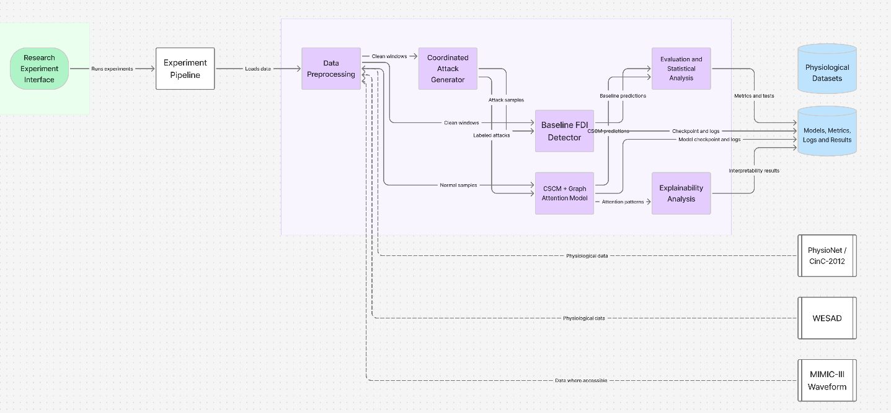
[10] UML DIAGRAM:
Use Case Diagram:
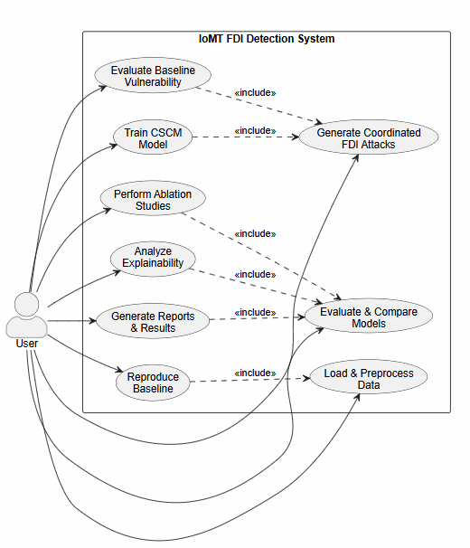

Class Diagram:
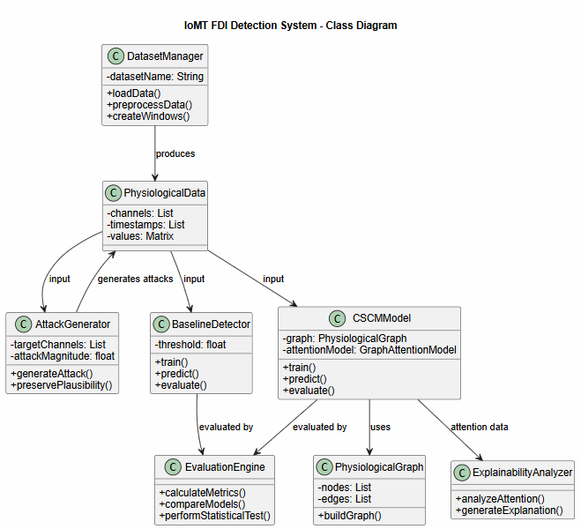
[11] SUMMARY:
The proposed project, “Coordinated Multi-Channel False Data Injection Attack Detection Using Physiology-Aware Cross-Sensor Consistency Modeling in IoMT,” focuses on improving the security and reliability of physiological data transmitted by Internet of Medical Things (IoMT) devices. Medical monitoring systems continuously collect vital signs such as heart rate, oxygen saturation, blood pressure, respiratory rate, and temperature, making these systems potential targets for False Data Injection (FDI) attacks. Existing detection approaches often evaluate individual sensor channels independently or focus mainly on network-level intrusions. This creates a potential vulnerability where an attacker can simultaneously manipulate multiple correlated physiological signals while keeping each individual value within a medically plausible range. Although the manipulated values may appear normal separately, their combined pattern may violate expected physiological relationships. The project therefore aims to formally model this coordinated multi-channel FDI threat and experimentally evaluate the vulnerability of existing detection approaches using real physiological datasets.
To address this limitation, the project proposes a Cross-Sensor Consistency Modeling (CSCM) framework that jointly analyzes relationships among multiple physiological channels. The system will preprocess public physiological datasets such as PhysioNet/CinC-2012, WESAD, and MIMIC-III Waveform where accessible, generate controlled coordinated FDI attacks, and compare the proposed approach with appropriate baseline detection methods. A physiology-informed graph attention network will represent relationships between vital-sign channels and learn patterns of cross-sensor consistency for attack detection. The proposed system will be evaluated using metrics such as sensitivity, specificity, precision, F1-score, false-positive rate, and AUROC, together with statistical significance testing, ablation studies, and attention-based interpretability analysis. The expected outcome is a reproducible detection framework capable of identifying coordinated attacks that may evade independent sensor-level validation while maintaining performance against conventional attacks. The project aims to contribute a coordinated multi-channel attack model, a physiology-aware cross-sensor detection framework, and a comprehensive experimental evaluation for improving the security and reliability of IoMT physiological monitoring systems.
REFERENCES:
- Li, J., Yang, Y., Sun, J. S., Tomsovic, K., & Qi, H. (2021). CONAML: Constrained adversarial machine learning for cyber-physical systems. In Proceedings of the 2021 ACM Asia Conference on Computer and Communications Security (pp. 52–66). ACM.
- Padhan, S., & Turuk, A. K. (2025). A technique to detect and mitigate false data injection attacks in cyber-physical systems. Computers & Security, 150, Article 104253.
- Deng, A., & Hooi, B. (2021). Graph neural network-based anomaly detection in multivariate time series. Proceedings of the AAAI Conference on Artificial Intelligence, 35(5), 4027–4035.
- Guan, S., Zhao, B., Dong, Z., Gao, M., & He, Z. (2022). GTAD: Graph and temporal neural network for multivariate time series anomaly detection. Entropy, 24(6), Article 759.
- Zhang, C., Song, D., Chen, Y., Feng, X., Lumezanu, C., Cheng, W., Ni, J., Zong, B., Chen, H., & Chawla, N. V. (2019). A deep neural network for unsupervised anomaly detection and diagnosis in multivariate time series data. Proceedings of the AAAI Conference on Artificial Intelligence, 33(1), 1409–1416.
- Zheng, Y., Koh, H. Y., Jin, M., Chi, L., Phan, K. T., Pan, S., Chen, Y.-P. P., & Xiang, W. (2023). Correlation-aware spatial-temporal graph learning for multivariate time-series anomaly detection. IEEE Transactions on Neural Networks and Learning Systems, 35(9), 11802–11816.
- Xu, K., Li, Y., Li, Y., Xu, L., Li, R., & Dong, Z. (2023). Masked graph neural networks for unsupervised anomaly detection in multivariate time series. Sensors, 23(17), Article 7552.
- Liu, Z., Huang, X., Zhang, J., Hao, Z., Sun, L., & Peng, H. (2024). Multivariate time-series anomaly detection based on enhancing graph attention networks with topological analysis. In Proceedings of the 33rd ACM International Conference on Information and Knowledge Management (pp. 1555–1564). ACM.
- Su, Y., Zhao, Y., Niu, C., Liu, R., Sun, W., & Pei, D. (2019). Robust anomaly detection for multivariate time series through stochastic recurrent neural network. In Proceedings of the 25th ACM SIGKDD International Conference on Knowledge Discovery & Data Mining (pp. 2828–2837). ACM.
- Audibert, J., Michiardi, P., Guyard, F., Marti, S., & Zuluaga, M. A. (2020). USAD: Unsupervised anomaly detection on multivariate time series. In Proceedings of the 26th ACM SIGKDD International Conference on Knowledge Discovery & Data Mining (pp. 3395–3404). ACM.
- Li, D., Chen, D., Jin, B., Shi, L., Goh, J., & Ng, S. K. (2019). MAD-GAN: Multivariate anomaly detection for time series data with generative adversarial networks. In Artificial Neural Networks and Machine Learning – ICANN 2019: Text and Time Series (pp. 703–716). Springer.
- Tuli, S., Casale, G., & Jennings, N. R. (2022). TranAD: Deep transformer networks for anomaly detection in multivariate time series data. Proceedings of the VLDB Endowment, 15(6), 1201–1214.
- Xu, J., Wu, H., Wang, J., & Long, M. (2022). Anomaly transformer: Time series anomaly detection with association discrepancy. In International Conference on Learning Representations (ICLR).
- Kalakoti, R., Nõmm, S., & Bahsi, H. (2024). Explainable transformer-based intrusion detection in Internet of Medical Things (IoMT) networks. In 2024 International Conference on Machine Learning and Applications (ICMLA) (pp. 1164–1169). IEEE.
- Ioannou, I., Nagaradjane, P., Angin, P., Balasubramanian, P., Kavitha, K. J., Murugan, P., & Vassiliou, V. (2024). GEMLIDS-MIOT: A green effective machine learning intrusion detection system based on federated learning for medical IoT network security hardening. Computer Communications, 218, 209–239.
- Hosain, Y., & Çakmak, M. (2025). XAI-XGBoost: An innovative explainable intrusion detection approach for securing Internet of Medical Things systems. Scientific Reports, 15(1), Article 22278.
- Khan, M. Z., Sabur, A., & Ghandorh, H. (2025). A novel Internet of Medical Things hybrid model for cybersecurity anomaly detection. Sensors, 25(20), Article 6501.
- Adohinzin, O., & Harrath, Y. (2026). A systematic review of intrusion detection systems for Internet of Medical Things: Performance, efficiency, explainability, and generalization. Digital Threats: Research and Practice, 7(2), 1–38.
- Moody, B., Moody, G., Villarroel, M., Clifford, G., & Silva, I., III. (2020). MIMIC-III Waveform Database (version 1.0) [Data set]. PhysioNet.
- Schmidt, P., Reiss, A., Dürichen, R., Marberger, C., & Van Laerhoven, K. (2018). Introducing WESAD, a multimodal dataset for wearable stress and affect detection. In Proceedings of the 20th ACM International Conference on Multimodal Interaction (pp. 400–408). ACM.

