ANALYSING HOUSING PRICES IN METROPOLITAN AREAS OF INDIA

1, INTRODUCTION :

Log relative price of the residential house prices, average real house prices.

Since the inception of the theory and idea of development, the common feature that emerged in different point of time is the developmental gap that emerged in different parts of the world and also among various parts of a country in a particular time period. This disparity in development, like many other indicators, has also been reflected in India. Traditional development theories believed that agriculture, industrialisation, urbanisation, are significant ingredients of growth, and, ultimately important prerequisites for achieving development. Within the economy itself, the status of growth of a state can be judged through its performance in agricultural and industrial production, performance of service sector and urbanisation, and their impact through their contribution in income and employment generation at the national level. Thus, house price behaviour may also reflect some short of developmental status of the households of a country. Keeping in view the above fact of rapid urbanisation and regional disparities, it is not unexpected that it may lead to some sort of differences in regional house prices, where housing and real estate are considered as major sources of physical and financial asset. This also leads to the differences in the dynamics of house price determination. It simply means that there might be shift of house prices in cities from average, in the country, depending upon its economic status. For instance, average house prices in the poorer provinces might be lower than the national average. Similarly, for richer states, the urban house prices, on average might be higher than the national average.
Log relative price of the residential house prices, average real house prices


2, PROBLEM DEFINITION & DESIGN THINKING :

  - Empathy map

2.2 Brainstorming map

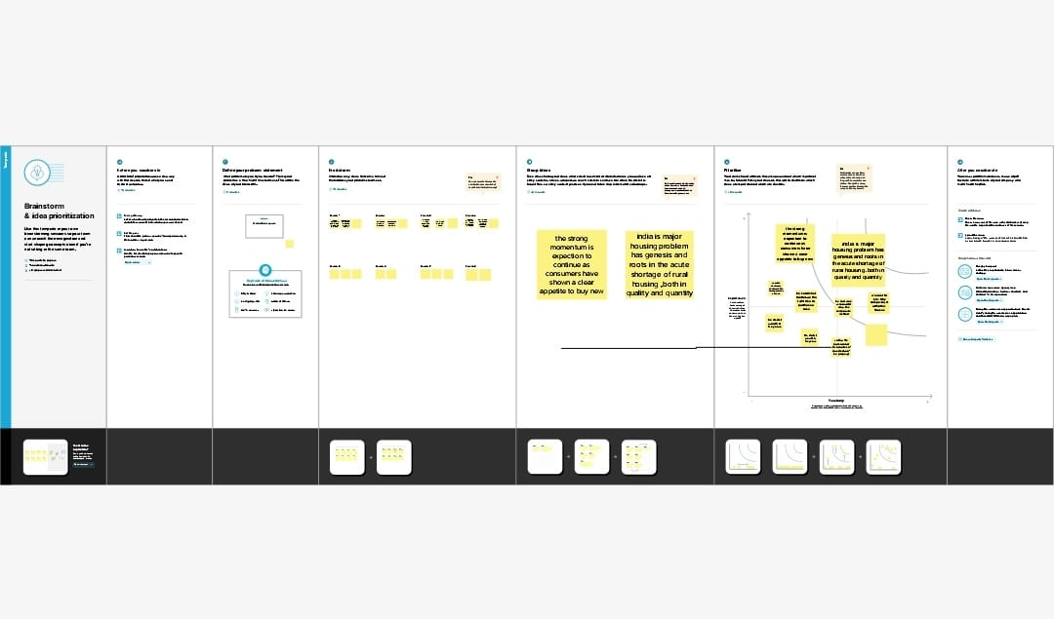

3 RESULT

Here we provide the result of the tableau peovide result of analysing housing prices in metropolitan areas of india to has be shown in the example of the result.

4 ADVANTAGES & DIS ADVANTAGES

> ADVANTAGES

1, It can be faster to get from place to place in a city or town.

2, Most amenities and entertainments are easy to reach.

3, More job opportunities.

> DISADVANTAGES

1, Higher wages in cities on averages.

2, Traffic congestion ,air pollution ,higher crime rates , Etc........

3, Noise . Many major cities share onr thing : Noise levels.........

5 APPLICATION

1, Help the develop determine the selling price of a house and can help the customer to arrange the right time to purchase a house.

2, Home prices and home sales

3, Demand for houses depends on consumer confidence.

6 CONCLUSION

1, House prices in the 15 metropolitan cities do not converage to the LOOP

2, Property prices in india are expected to increase 7.5% on a pan-india basic this year

3, Based on the criterion of price convergence

7 FUTURE SCOPE

1, Help the developer determine the selling price of a house and can help the customer to arrange the right time to purchase a house.

2, Property prices will still rise.

3, Machine learning : Regression

4, The real estate sector is considered to be the second-highest employment generating sector in india.

5, Average home prices in major markets now expected to fall less than anticipation at the start of the year and rise into 2024.

