**PROFILE PORTFOLIO** —

By using HTML, CSS & JAVASCRIPT

**ADHI COLLEGE OF ENGINEERING & TECHNOLOGY,** SANKARAPURAM, KANCHEEPURAM — ***B.TECH AI&DS***

### **2021 - 2025**

Secured with **8.2 C.G.P.A**  upto 6 th semester.

**TO-DO-LIST** —

By using HTML, CSS & JAVASCRIPT

**E-COMMERCE WEBSITE** —

By using HTML, CSS & JAVASCRIPT

**TECHNICAL SKILLS:**

**JAVA - HTML5 - CSS - C - MY-SQL .**

**SOFT SKILLS:**

**COMMUNICATION SKILL - PROBLEM SOLVING –MANAGEMENT SKILL - CRITICAL THINKING -**

**ORGANIZING SKILL - TIME MANAGEMENT.**

PRADEEPKUMAR R

FRONT- END DEVELOPER | JAVA DEVELOPER

[Git-Hub](https://github.com/PRADEEP1911)



[Linkedin](https://www.linkedin.com/in/pradeepkumar-r-ab661628a?utm_source=share&utm_campaign=share_via&utm_content=profile&utm_medium=android_app)



**r.pradeep40534@gmail.com**

**5\25,Subramaniyar Kovil Street, Kallathur, Jayankondam,**

**Ariyalur - 621803**

**+91 9360015216**





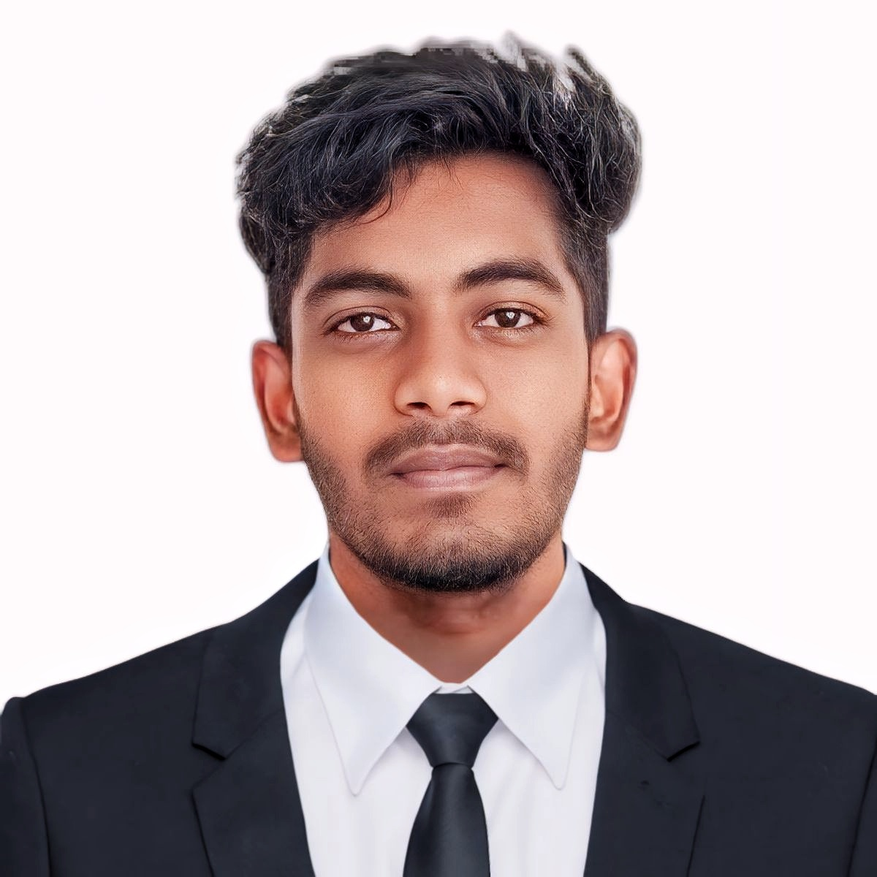

**GHSSCHOOL,** KALLATHUR-THANDALAI — ***12 TH***

### **2020 - 2021**

Secured with **85.46%**

**GHSSCHOOL,** KALLATHUR-THANDALAI — ***10 TH***

### **2018 – 2019**

### Secured with **79.6%**

**EDUCATION:**

**PROJECTS:**

**SUMMARY:**

"As a final-year B.TECH AI and Data Science student at Adhi College of Engineering and Technology, I have a solid foundation front-end development. Proficient in HTML5, CSS, Bootstrap, Java, and MySQL, I am eager to join a dynamic team to create user-friendly web applications. Seeking an entry-level position to leverage and enhance my skills in AI, Data Science, and front-end development."

**SKILLS:**

**INTERNET OF THINGS :**

Internship at MARCELLO TECH focused on Internet of Things (IoT), gaining hands-on experience in IoT device deployment, data analytics, and implementing solutions for connected systems.

**ACHIVEMENTS:**

**JAVA :**

"Completed Java certification from SILICON SOFTWARE SERVICES, mastering core programming concepts and practical application, proficient in developing robust and scalable applications."

**MY-SQL :**

"Completed SQL certification from SILICON SOFTWARE SERVICES ,gaining proficiency in SQL syntax, data manipulation, and database design to streamline data workflows."

**INTERNSHIP:**

**LANGUAGES:**

* TAMIL
* ENGLISH