**Visvesvaraya Technological University**

**Belagavi, Karnataka 590018**

**A Project Report on**

**“PHARMACY MANAGEMENT SYSTEM”**

**Project Report submitted upon the completion of Mini Project**

**For the 5th Semester’s**

**Database Management System Laboratory (18CSL58)**

|  |  |
| --- | --- |
|  | **Submitted by** |
| **Pradnya Vadrali** | **2JR20CS054** |
| **Pragati Ghasti** | **2JR20CS055** |
|  | **Under the Guidance of** |
| **Vijayalaxmi Naganur** | **Basavaraj Madagouda** |
| **Asst. Professor** | **Asst. Professor** |

**JAIN COLLEGE OF ENGINEERING AND RESEARCH**

**(Approved by AICTE, Affiliated to VTU and Recognized by Govt. of Karnataka)**

**UDYAMBAG, BELAGAVI**

**DEPARTMENT OF COMPUTER SCIENCE AND ENGINEERING 2021-22**

**Jain Group of Institutions’**

**Jain College of Engineering and Research, Belagavi**

**Department of Computer Science and Engineering**

**CERTIFICATE**

**This is to certify that the project work entitled “PHARMACY MANAGEMENT SYSTEM” carried out by Ms. Pradnya Vadrali, USN 2JR20CS054, and Ms. Pragati Ghasti, USN 2JR20CS055, bonafide students of Jain College of Engineering and Research, Belagavi, in partial fulfillment for the Mini project in the subject Database Management System Laboratory in Computer Science and Engineering department of the Visvesvaraya Technological University, Belagavi during the year 2023-2024. It is certified that all correction/suggestions indicated for Internal Assessment have been incorporated in the report deposited in the departmental library. The project report has been approved as it satisfies the academic requirements in respect of project work prescribed for the said subject.**

**Prof. Vijayalaxmi Naganur**

**Guide**

**Dr. Pritam Dhumale**

**Head of Dept.**

**Examiner** **Signature with Date:**

**1.**

**2.**

** PHARMACY MANAGEMENT SYSTEM**

**ABSTRACT:**

Pharmacists can use the Pharmacy Management System program to help them methodically manage their pharmacies. When a medicine's name is input, the Pharmacy Management System can help by providing details about the medicine. A computer displays information about the medicine, such as its dosage and expiration date. In large medical stores, manually handling the specifics of all the drugs becomes very tough. We can keep track of all the medicines by using this pharmacy management system. It is updated with new information as new medicines are introduced, and it includes an expiration date as well as a search option. When we complete the name of a medicine, it displays the medicine's details. To make this was used. The SQL database was created with MySQL.

|  |  |
| --- | --- |
| **DEPT OF CSE, JAIN COLLEGE OF ENGINEERING AND RESEARCH, BELAGAVI** | **3** |

**PHARMACY MANAGEMENT SYSTEM**

**Contents**

**Abstract ………………………………………………………………………………………... 3**

* **Chapter One………………………………………………………………………………... 6 Introduction ……………………………………………………………………………………… 6**
  1. **Aim of the Project …………………………………………………………………………... 6**

**1.2 Hardware Requirement ………………………………………………………………6**

**1.3 Software Requirement ……………………………………………………………………… 6**

* **Chapter Two …………………………………………………………………………….. 7 Literature Survey ………………………………………………………………………………... 7**

**2.1 Theoretical review ………………………………………………………………………….. 7**

**2.2 Empirical Review ……………………………………………………………………………7**

**2.3 Data Flow Diagram …………………………………………………………………………. 8**

**2.3.1** **Entity Relationship Diagram …………………………………………………………….10**

* **Chapter Three …………………………………………………………………………. 11 Methodology …………………………………………………………………………………… 11**

**3.1 Planning …………………………………………………………………………………… 11**

**3.2 Design ……………………………………………………………………………………... 11**

**Preliminary of General Design ………………………………………………………… 11**

**Structured of Detailed Design ………………………………………………………….. 12**

**3.3 Prototype and Implementation …………………………………………………………….. 12**

**Coding …………………………………………………………………………………. 12**

**3.4 Testing ……………………………………………………………………………………… 12**

**Program test ……………………………………………………………………………. 13**

**System Test …………………………………………………………………………….. 13**

**3.5 Cutover ……………………………………………………………………………………... 13**

* **Chapter Four ………………………………………………………………………….. 14**

**4.1 Result ……………………………………………………………………………………… 14**

|  |  |
| --- | --- |
| **DEPT OF CSE, JAIN COLLEGE OF ENGINEERING AND RESEARCH, BELAGAVI** | **4** |

**GROCERY STORE MANAGEMENT SYSTEM**

**Login Page ……………………………………………………………………………... 14**

**New Register Page ……………………………………………………………………... 14**

**Add new medicine Page ………………………………………………………………... 15**

**Add medicine information …………………………………………………………… 15**

**Update medicine Page ………………………………………………………………... 16**

**Add New Orders page ………………………………………………………………….. 16**

**Add Product to Order Page …………………………………………………………….. 17**

* **Chapter Five …………………………………………………………………………... 18 5.1 Conclusion ………………………………………………………………………………… 18**

**5.2 References ……………………………………………………………………………….... 19**

|  |  |
| --- | --- |
| **DEPT OF CSE, JAIN COLLEGE OF ENGINEERING AND RESEARCH, BELAGAVI** | **5** |

**PHARMACY MANAGEMENT SYSTEM**

**CHAPTER 1**

**INTRODUCTION:**

A Pharmacy management system is a management system that is meant to improve your accuracy and to raise the secureness and time-saving in the store. This based system which helps Pharmacists to improve manage cost and safety. This system gives the user to enter the manufactured and expiry date for a particular medicine. This system will show a report list of product expiry after the specified date before the product expires. The pharmacist may want to generate a report for the Shipment or movement of medicines in and out of the pharmacy, taking information about the medicines example. expiry date, date bought, the number of medicines/drug type remained location of medicine in the pharmacy. At the moment, a manual system is being used in the pharmacy. It needs the pharmacist to manually monitor each medicine that is there in the pharmacy The Pharmacy Management System application has more benefits, Easy to find medicine because we use strong search option and easy to add medicine, medicine type, medicine deadline and also delete and modify option it help to both of customer and pharmacist.

**1.1 Aim of the Project:**

The aim of this project is to develop a software for the effective management of the grocery store that will be able to achieve the following objectives:

-A software product which provides solution for Pharmacy Management System (managing Pharmacist, managing medicine stock, ..)

-Admin can view the new Pharmacist List, add a new Pharmacist, add the medicine stock, Edit/Update/Delete Medicine.

-Improving pharmacists efficiency

-Improving patient health outcomes

-Preventing medicine fraud

-Web-based ordering systems

**1.2 Hardware Requirements**

Processor Intel(R) Pentium(R) CPU N3700 @ 1.60 GHz

RAM 4 GB

System type 64-bit Operating System, x64 based processor

Output device Monitor (1366*768 Resolution)

Input device Keyboard,Mouse

**PHARMACY MANAGEMENT SYSTEM**

**1.3Software Requirements**

Operating System Windows 7 or Higher

Language used Python

Database My SQL

User interface design Python Tkinter

Software MySQL server, Visual studio code

|  |  |
| --- | --- |
| **DEPT OF CSE, JAIN COLLEGE OF ENGINEERING AND RESEARCH, BELAGAVI** | **6** |



**PHARMACY MANAGEMENT SYSTEM**

**CHAPTER 2**

**2. LITERATURE SURVEY:**

The pharmacy management system kept paper and pen away mostly cause of the way it's Managing a very huge pharmacy with records stored online and on papers which surely seems difficult to keep track of inventories with dignity but this system makes it look easier. The medicines in the pharmacy store, expiry date, quantity of medicines available are fixed on the categories and their functions A major amount of time is taken for writing the order as the pharmacist needs to check through the stock balance and make an estimate of the amount to order based on Figures.

**2.1 Theoretical Review:**

Pharmacy Management system is a web base system that works as a website to manage and functioning all pharmacy activities through a web server (Apache). A web page is what you see on the screen when you type in a web address, click on a link, or put a query in a search engine. A web page can contain any type of information, and can include text, color, graphics. When someone gives you their web address, it generally takes you to their website's home page, which should introduce you to what that site offers in terms of information or other services. From the home page, you can click on links to reach other sections of the site. A website can consist of one page, or of tens of thousands of pages, depending on what the site owner is trying to accomplish.

**2.2 Empirical Review:**

Over the past 40 years, information technology has had a major impact on the working lives of millions of people. Many industries have embraced computer technology because of the benefits of automated information processing. These include enabling routine, repetitive and monotonous tasks to be conducted with consistent accuracy; standardisation and consistent use of terminology and nomenclature; and mass customisation (the capacity of information technology to provide services to a large population, yet in a way that can be customised to the individual) For prescribers and pharmacists, IT can enabe the storage of structured sales records, facilitate the electronic prescribing. customers and management of medicines, automate the handling of medicines in the supply chain and provide tools for monitoring the efficacy and safety of medicines in the inventory. IT can therefore improve pharmacy management, enable professionals to provide high quality services and help to provide accuracy data through the system that will be able to handle all necessary activities in the pharmacy.

|  |  |
| --- | --- |
| **DEPT OF CSE, JAIN COLLEGE OF ENGINEERING AND RESEARCH, BELAGAVI** | **7** |

**PHARMACY MANAGEMENT SYSTEM**

**2.3 Data flow diagram:**

Data-flow diagrams (DFDs) are system models that show a functional perspective where each transformation represents a single function or process. DFDs are used to show how data flows through a sequence of processing steps. These processing steps or transformations represent software processes or functions where data-flow diagrams are used to document a software design.

The DFD also provides information about the outputs and inputs of each entity and the process itself. A data-flow diagram has no control flow — there are no decision rules and no loops. Specific operations based on the data can be represented by a flowchart**.**

The data-flow diagram is a tool that is part of structured analysis and data modelling When using UML, the activity diagram typically takes over the role of the data-flow diagram. A special form of data-flow plan is a site-oriented data-flow plan.

DFDs can also be used for the visualization of data processing (structured design) and show what kind of information will be input to and output from the system, where the data will come from and go to, and where the data will be stored. It does not show information about the timing of processes or information about whether processes will operate in sequence or in parallel.

|  |  |
| --- | --- |
| **DEPT OF CSE, JAIN COLLEGE OF ENGINEERING AND RESEARCH, BELAGAVI** | **8** |

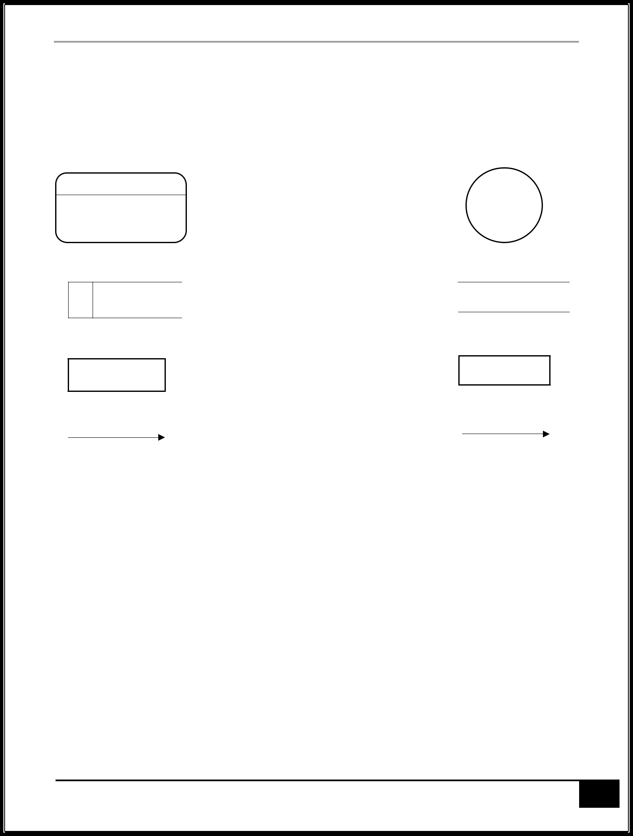

**PHARMACY MANAGEMENT SYSTEM**

There are rules for designing the Data Flow Diagrams:

A process must have at least one input data flow and one output data flow Data cannot flow between two entities

Data cannot flow between two data stores

Data cannot flow directly from an entity to data store

A data store must have at least one input data flow and one output data flow Two data flows cannot cross each other

All the process in the system must be linked to minimum one data store or any other process

|  |  |
| --- | --- |
| **DEPT OF CSE, JAIN COLLEGE OF ENGINEERING AND RESEARCH, BELAGAVI** | **9** |

**PHARMACY MANAGEMENT SYSTEM**

**2.4 ENTITY RELATIONSHIP DIAGRAM**

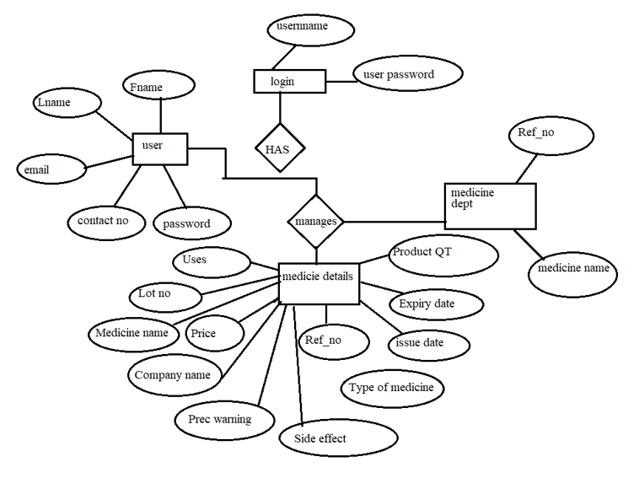Entity–Relationship (ER) model is a popular high-level conceptual data model. This model and its variations are frequently used for the conceptual design of database applications, and many database design tools employ its concepts.

The diagrammatic notation associated with the ER model, known as ER diagrams.

The above ER Diagrams is for Grocery Pharmacy Management System. The ‘user’ manages other entities such as medicine dept and medicine details.



|  |  |
| --- | --- |
| **DEPT OF CSE, JAIN COLLEGE OF ENGINEERING AND RESEARCH, BELAGAVI** | **10** |

**PHARMACY MANAGEMENT SYSTEM**

**CHAPTER 3**

**3. METHODOLOGY:**

A methodology is the combination of logically related methods and step by step techniques for successful planning control and delivery of the project. It is a scientifically-proven, systematic and disciplined approach to project development and implementation. Approach that will be used in System Development

In this project I have used System Development Life Cycle (SDLC) Methodology. System Development life cycle (SDLC) is a traditional methodology for developing maintaining and reaching information system This methodology consists of different phases that describe the procedures for successful system development.

Planning

Analysis

Design

Implementation and

Maintenance

**3.1 Planning**

It is the process of identifying problems, opportunities, and objectives. This phase required the analysts to look honestly at what is occurring in a business. Then, together with other organizational members, the analyst pinpoints problems. Identifying objectives is also an important component of the first phase. The analyst first discovered what the business is trying to do. Then the analyst was able able to see whether some aspect of information systems applications can help the business reach its objectives by addressing specific problems or opportunities.

**3.2 Design**

It is the most crucial phase in the developments of a system The logical system design arrived at as a result of systems analysis is converted into physical system design. Normally, the design proceeds in two stages:

**Preliminary or General Design:**

In the preliminary or general design, the features of the new system are specified. The costs of implementing these features and the benefits to be derived are estimated. If the project is still considered to be feasible, we move to the detailed design stage.

|  |  |
| --- | --- |
| **DEPT OF CSE, JAIN COLLEGE OF ENGINEERING AND RESEARCH, BELAGAVI** | **11** |

** PHARMACY MANAGEMENT SYSTEM**

**Structured or Detailed Design:**

In the detailed design stage, computer oriented work begins in earliest. At this stage, the design of the system becomes more structured. Structure design is a blue print of a computer system solution to a given problem having the same components and inter-relationships among the same components as the original problem There are several tools and techniques used for describing the system design of the system

**3.3 Prototyping and Implementation**

After having the user acceptance of the new system which has developed, the implementation phase began. Implementation is the stage of a project during which theory is turned into practice. The major steps involved m this phase are:

**Coding**

The system design needed to be implemented to make it a workable system This demands the coding of design into computer understandable language example programming language. This is also called the programming phase in which the programmer converts the program specifications into computer instructions, which we refer to as programs. It is an important stage where the defined procedures are transformed into control specifications by the help of a computer language.

**3.4 Testing**

Before actually implementing the new system into operation, a test run of the system has done for removing the bugs, if any. It is an important phase of a successful system. After codifying the whole programs of the system, a test plan should be developed and run on a given set of test data. The output of test run should match the expected results. Sometimes, system testing is using the test data following test run are carried out:

|  |  |
| --- | --- |
| **DEPT OF CSE, JAIN COLLEGE OF ENGINEERING AND RESEARCH, BELAGAVI** | **9** |



**PHARMACY MANAGEMENT SYSTEM**

**Program Test**

When the programs coded, compiled and brought to working conditions, it was individually tested with the prepared test data. Any undesirable happening has been noted and debugged

(error connections)

**System Test**

After carrying out the program test for each of the programs of the system and errors

removed, then system test has done. At this stage the test has been done on actual data. The completed system has been executed on the actual data. At each stage of the execution, the results or output of the system was analysed. During the result analysis, was found that the outputs are not matching the expected output of the system In such case, the errors in the particular programs has identified and fived and further tested for the expected output

**3.5 Cutover**

It resembles the final tasks in the after the implementation and testing phase, including data conversion, testing, changeover to the new system, and user training. Compared with traditional methods, the entire process is compressed. As a result, the new system is built, delivered, and placed in operation much sooner.

|  |  |
| --- | --- |
| **DEPT OF CSE, JAIN COLLEGE OF ENGINEERING AND RESEARCH, BELAGAVI** | **12** |



**PHARMACY MANAGEMENT SYSTEM**

|  |  |
| --- | --- |
| **DEPT OF CSE, JAIN COLLEGE OF ENGINEERING AND RESEARCH, BELAGAVI** | **13** |

** PHARMACY MANAGEMENT SYSTEM**

**CHAPTER 4**

**4.1 RESULT:**

**LOGIN PAGE:**

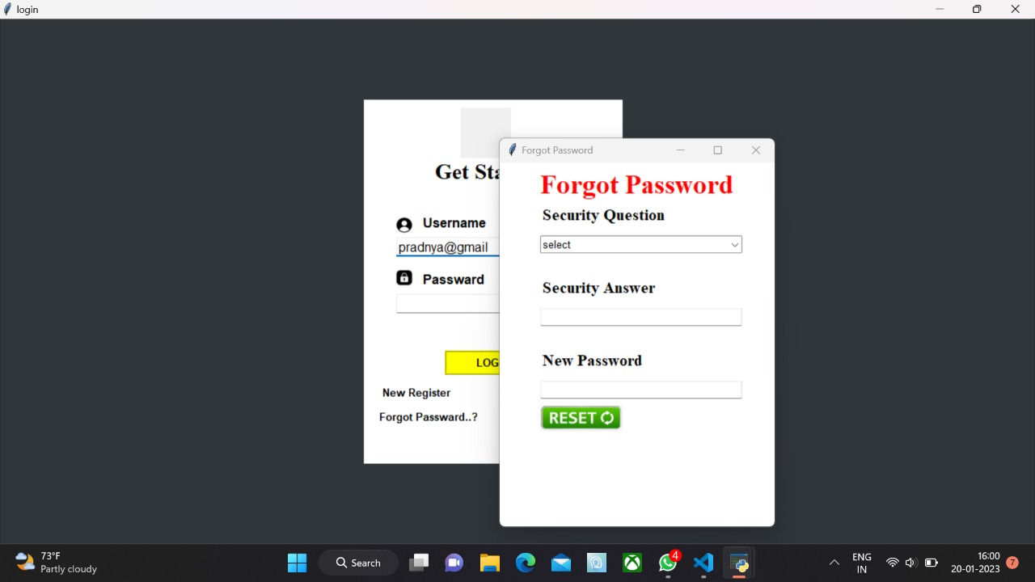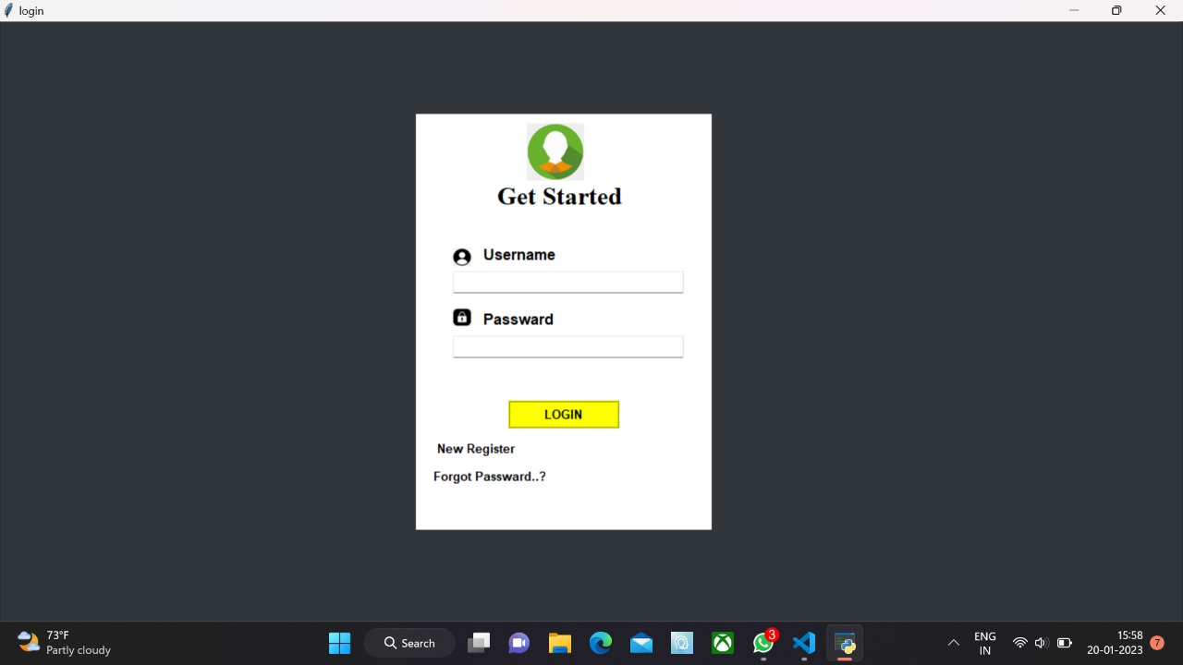

The Login Page is used by the store manager to enter into the website

**NEW REGISTER PAGE:**

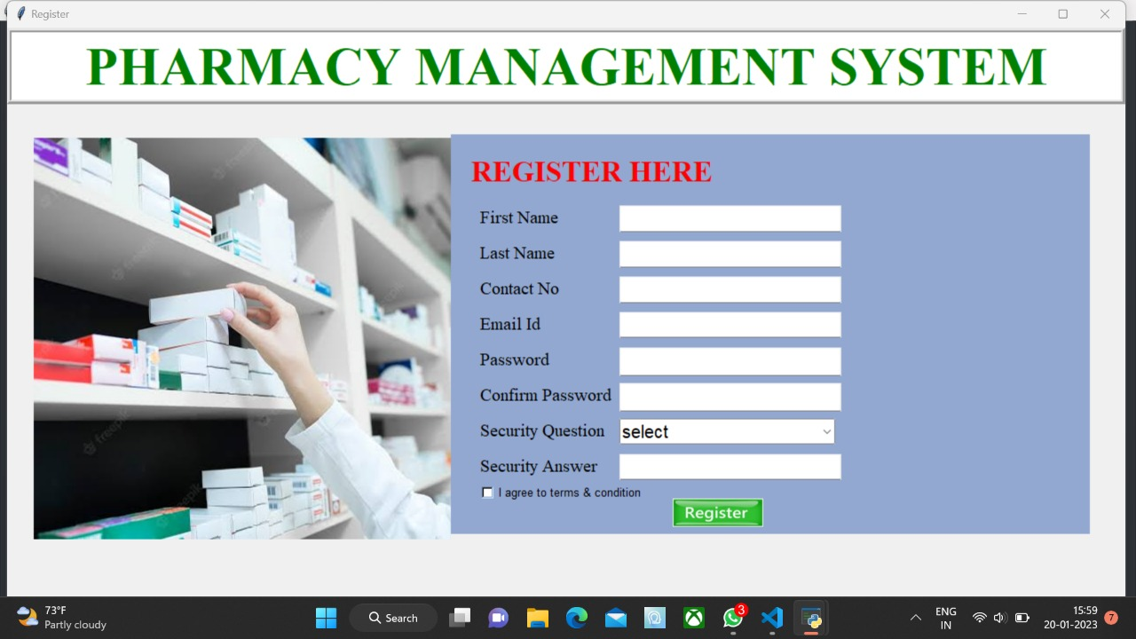

New register page

|  |  |
| --- | --- |
| **DEPT OF CSE, JAIN COLLEGE OF ENGINEERING AND RESEARCH, BELAGAVI** | **14** |

** PHARMACY MANAGEMENT SYSTEM**

**ADD NEW MEDICINE PAGE:**

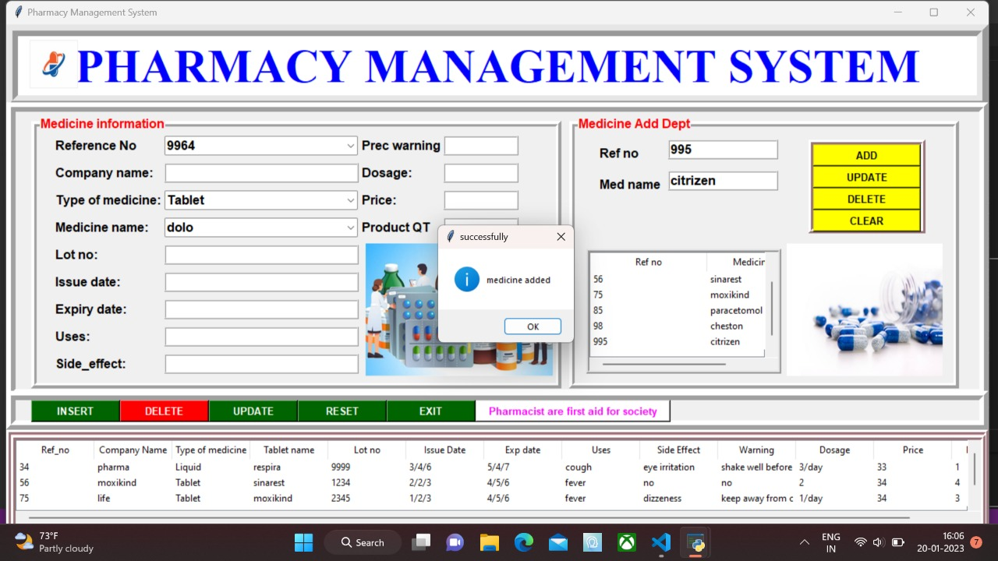

New medicine page.

**ADD MEDICINE INFORMATION PAGE**

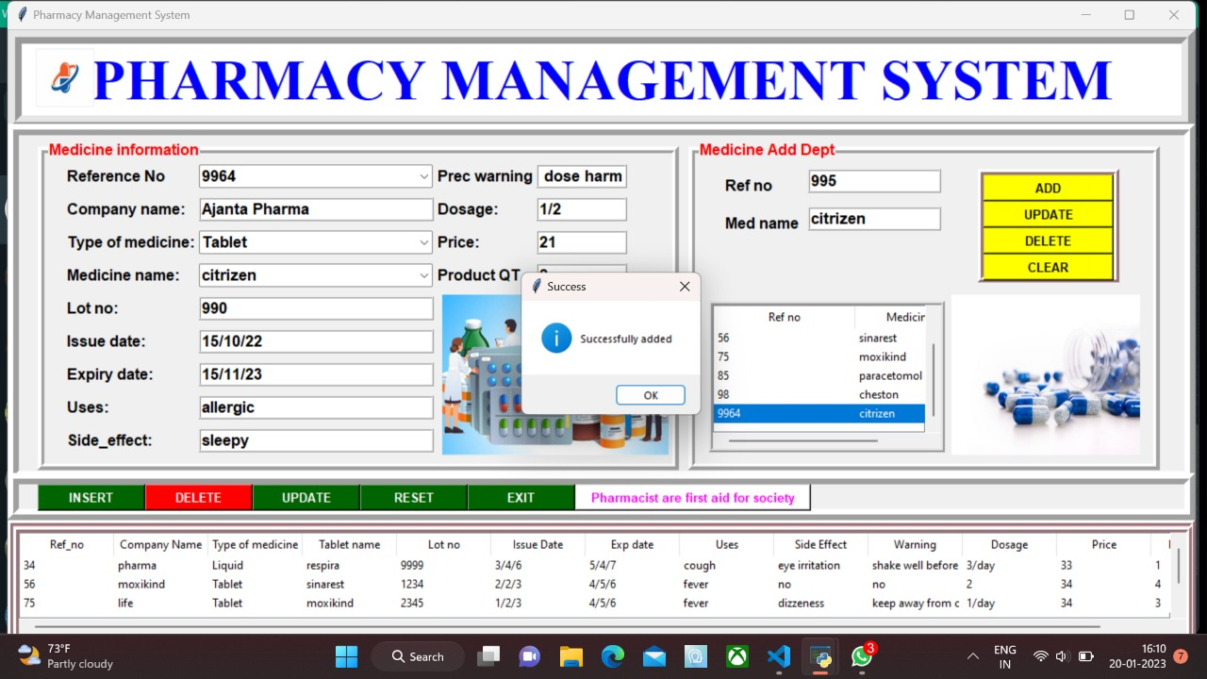

New medicine information page

|  |  |
| --- | --- |
| **DEPT OF CSE, JAIN COLLEGE OF ENGINEERING AND RESEARCH, BELAGAVI** | **15** |

**PHARMACY MANAGEMENT SYSTEM**

**ORDER DETAILS PAGE**

**The Order Details Page will show the details of the specific order.**

**NEW ORDER PAGE**

**The New Order page will prompt the user to enter the details for a new order.**

|  |  |
| --- | --- |
| **DEPT OF CSE, JAIN COLLEGE OF ENGINEERING AND RESEARCH, BELAGAVI** | **16** |

**PHARMACY MANAGEMENT SYSTEM**

**ADD PRODUCT TO ORDER PAGE**

**This page will prompt the user to add new products to their orders.**

**BILL GENERATE PAGE**

**This page is to generate a bill which is in the PDF for the user and also for record keeping.**

|  |  |
| --- | --- |
| **DEPT OF CSE, JAIN COLLEGE OF ENGINEERING AND RESEARCH, BELAGAVI** | **17** |



**PHARMACY MANAGEMENT SYSTEM**

**CONCLUSION**

Pharmacy management system is actually a software which handle the essential data and save the data and actually about the database of a pharmacy and its management. This software helps in effectively management of the pharmaceutical store or shop. It provides the statistics about medicine which data can also be updated and edited. It

works as per the requirement of the user and have options accordingly. It allow user to enter manufacturing as well as the expiry date of medicine and This software also has ability to print reports and receipts etc. There is other function available too. The main purpose is effectively and easily hand ling of pharmacy data and its management

|  |  |
| --- | --- |
| **DEPT OF CSE, JAIN COLLEGE OF ENGINEERING AND RESEARCH, BELAGAVI** | **18** |

** PHARMACY MANAGEMENT SYSTEM**

**REFERENCES:**

|  |  |
| --- | --- |
| **DEPT OF CSE, JAIN COLLEGE OF ENGINEERING AND RESEARCH, BELAGAVI** | **19** |