PROJECT REPORT

Project Title: EMI & Monthly Budget Planner

Course: BTech CSE (AI & ML)

Submitted By: Pragya Sharma

Reg. Number: 25BAI11495

Introduction
- What is EMI?
EMI stands for Equated Monthly Instalment which is a fixed sum of money a borrower pays to a lender each month to repay a loan. This payment includes both a portion of the principal amount borrowed and the interest charged by the lender and it is paid over a set period until the loan is fully repaid.

- Why budgeting is important?
Budgeting is important because it provides control over finances, helps achieve goals like saving and debt reduction, and builds financial stability through informed decision-making and emergency preparedness . By tracking income and expenses, a budget acts as a financial roadmap, allowing you to reduce wasteful spending and allocate funds toward both your needs and future aspirations.

- Why this project is useful?
An Equated Monthly Instalment (EMI) and a comprehensive monthly finance planner are critical for sound financial health, providing predictability, structure, and control over your money.

Problem Statement
Students and users commonly struggle with manual expense tracking,managing debt (EMIs),resisting impulse spending, and a general lack of financial literacy and discipline.An effective app addresses these issues by automating the process, providing clear insights, and offering tools for goal-oriented financial management.

Objectives of the Project
- To calculate EMI easily and also tell how maximum EMI we can afford.
- To help users plan their monthly budget

Implementation
- Python
- Tkinter (GUI)
- Basic Finance formulas

System Requirements
- Python (should be 3.8+)
- Any IDE (IDLE, VS Code)
- Windows/Linux/Mac

Analysis
- Functional Requirements
Input monthly income
Input monthly expenses
Input loan amount, interest, tenure
EMI calculation
Affordable EMI calculation

- Non-Functional Requirements
Easy to understand GUI
Instant calculation
Runs on any system with Python
Mathematical accuracy

System Design
- Input (Income per month , Expenses per month, Loan Amount, Interest, Tenure)
- Processing (EMI Formula, Affordability check)
- Output (Calculated EMI + Approve/Reject + maximum affordable EMI)

Methodology
Step-by-step procedure
- Example:
1. User enters monthly income and expenses
2. User enters loan details
3. App calculates EMI
4. App checks if EMI ≤ affordable limit
5. Shows result in GUI

FOLDER
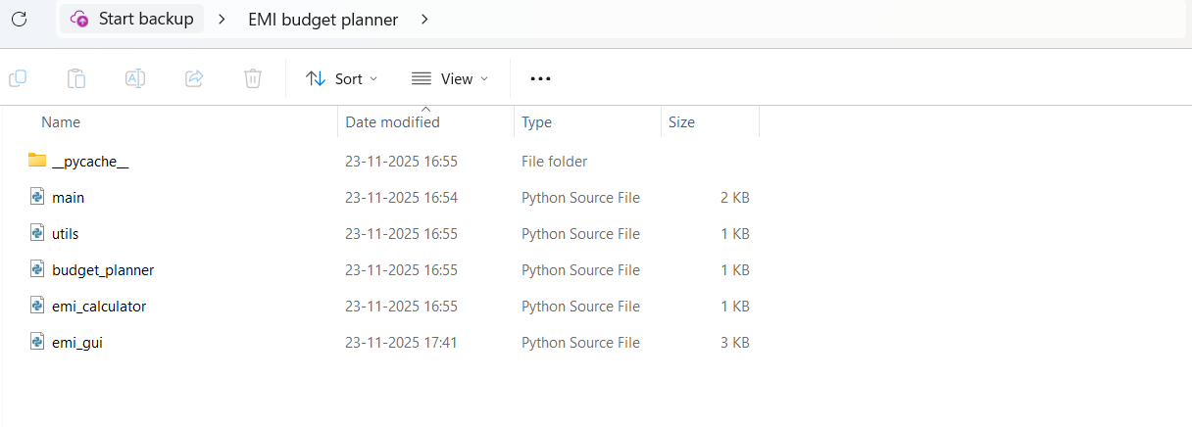

GUI Input Code
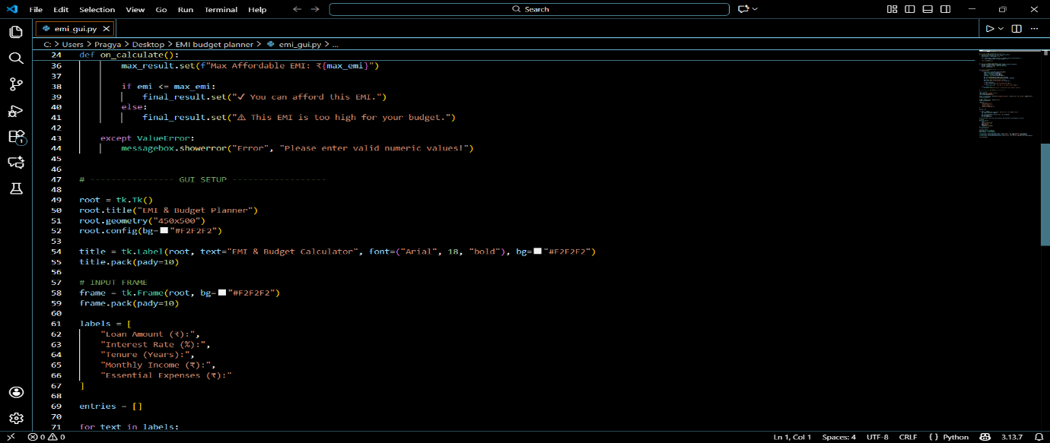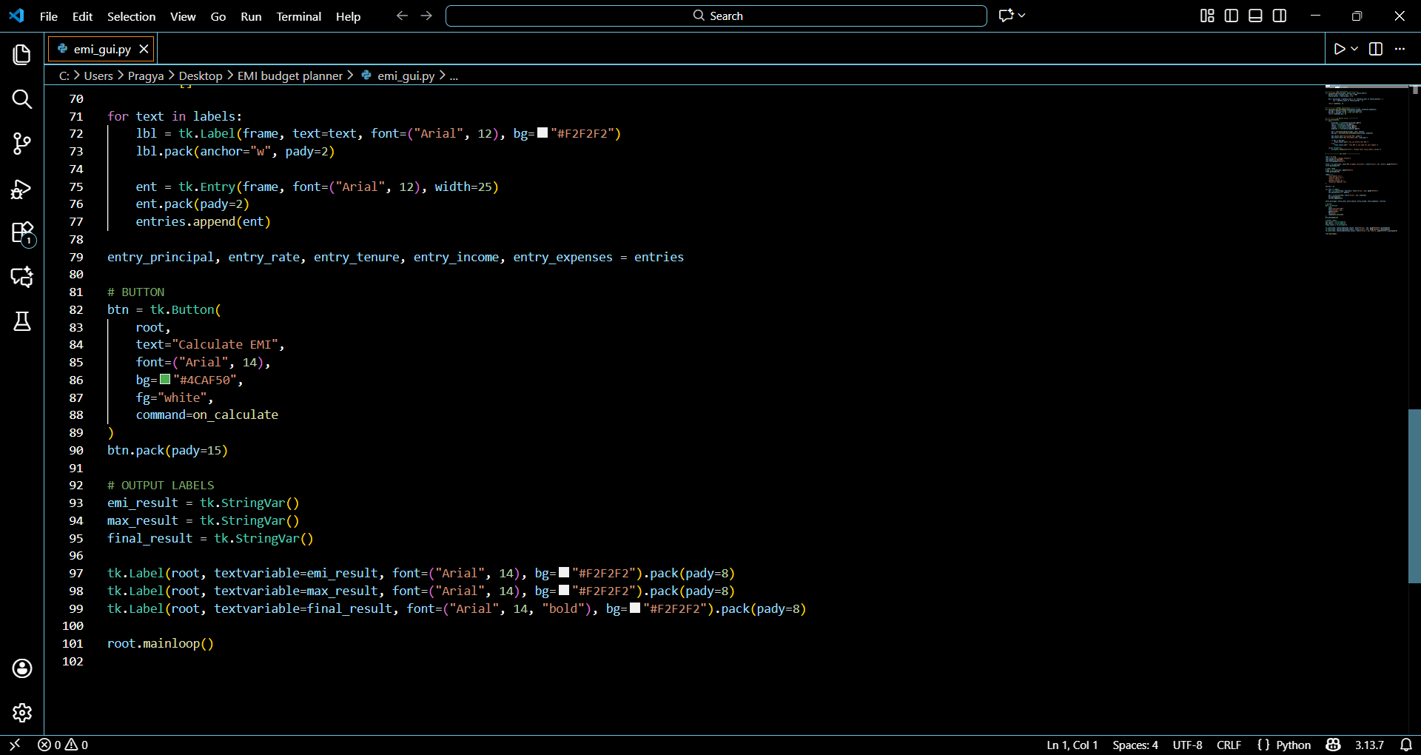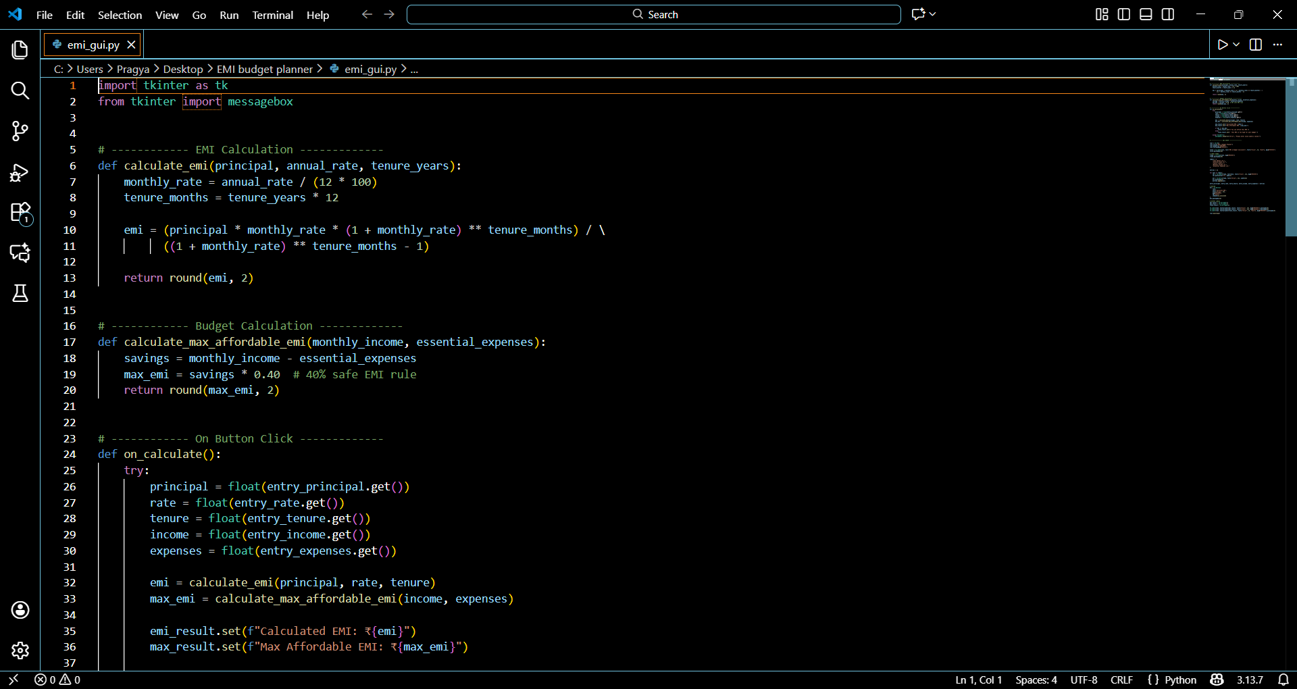
GUI Output Code
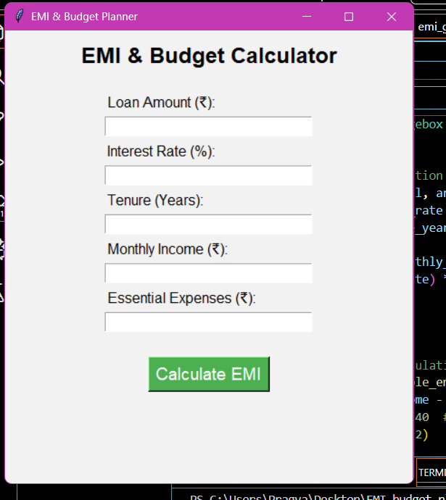
Example
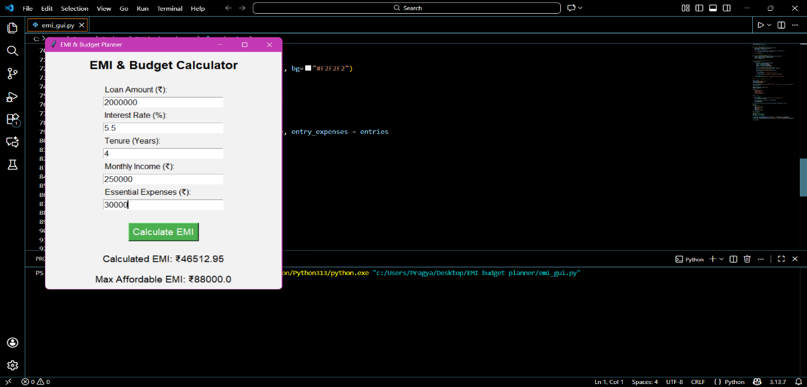

Conclusion
This EMI and monthly budget planner successfully helps us to know about how much EMI and loan a person can afford keeping in regard their expenses & income. It is good for financial life balance.

