Selenium & Playwright Programming Structure
1-Created Properties file- src/main/java/UtilityFiles/CommonURL.properties
2-Created Login.feature file
3-Created HomePageLocator.java, 4-Created GenericMethod.java
5-Created stepDefinations.java , 6- created Login.java

1- CommonURL.properties
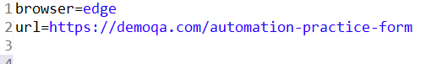
Login.feature file
