  - When we can use Headless mode- no issue in our script(TCS Suite is stable)then we can use headless, but we are doing debugging then we can use header mode
  - npm install playwright@latest
FW Structure
git hub actions-.github
2.node_module- dependencies will add
  - Test folder- we created where we want to store our e2e script
  - Gitignore- which are not part of commit that will igore by gitignore file
package. Json- js config file or java
6.Pck-lock.json- playwright version -to avoid to update of my working version ,so to lock this version we are using this
playwright.config- on which browser want to run my script,
Browser Context-without any cookies, history ,cache
Browser- modify my own browser settings manually like adding some cookies, report changing., multiple page working.
Test()- To run only specific file - /foldernm/filenm.js
PK_PLaywightFW2_2026July
npx playwright test
PK_PLaywightFW2_2026July
/fixtures.test.js
Page fixture-auto load browser,load page
------------Day2------------------------------------------------------------------------
Locators are used for finding the elements form page .like where its located. Bytagname,cssclassname,
predefined locators which is not
placeholder, bytest,byrole-dyanmically locate element- also use getByLocator
Which is notion Selenium
Each element applies auto wait mechanism
Fixtures
-page-creates the a new window
Browser-Lunches the b/w instances
BrowserCcontext-created the isolated b/w
Without create any fixture-Launch B/W
------------------------------------------------------------------------------------------
Absolutely! Since you liked the Selenium hierarchy-style notes, I'll give Playwright Java Notes in the same interview-friendly structure.
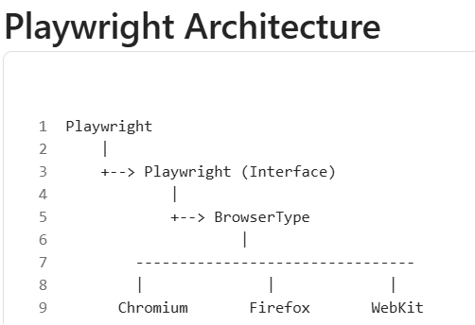

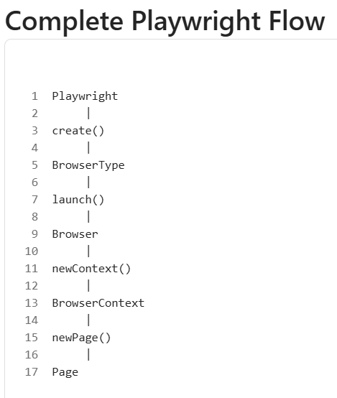

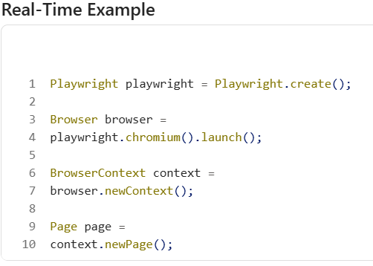

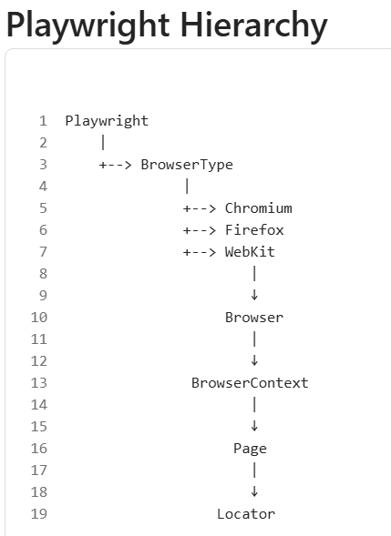
Interview Point
- chromium() = Chromium engine.
- setChannel("chrome") = Google Chrome.
- setChannel("msedge") = Microsoft Edge.
- firefox() = Firefox.
- webkit() = Safari engine.

1. Playwright Interface -- Main Entry Point
Playwright playwright = Playwright.create();
Important Methods
-chromium()
-firefox()
-webkit()
-close()

Browser is the actual Chrome/Edge/Firefox process, whereas Browser Context is an isolated Incognito-like session inside the browser. A single Browser can have multiple Browser Contexts, and they are commonly used together for parallel user session testing.

2. BrowserType Interface
Provides browser launch methods.
-playwright.chromium() ,-playwright.firefox(), -playwright.webkit()

Methods- launch() , 2- launchPersistentContext()

3. Browser Interface
Represents browser instance.
Browser browser = playwright.chromium().launch();
Methods
-newContext()
-version()
-close()
4. BrowserContext Interface
Most Asked Interview Topic
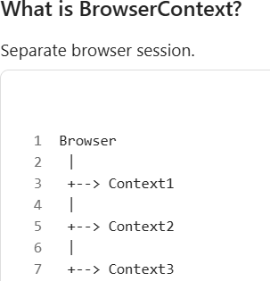
Like opening multiple Incognito windows.
Methods
  - newPage()
  - cookies()
  - clearCookies()
  - storageState()
  - close()
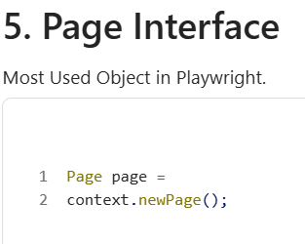
Important Page Methods
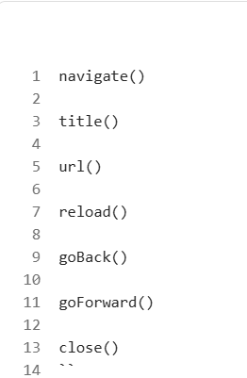

  - Open URL - page.navigate("https://google.com");
  - Get Title -String title = page.title();
  - Get URL -String url = page.url();

  - Locator Concept
In Selenium- driver.findElement(...)
In Playwright -page.locator(...)
Playwright prefers Locators.

6. Locator Interface
Most Important for Interviews
Locator user =page.locator("#username");
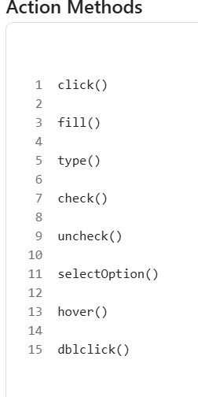

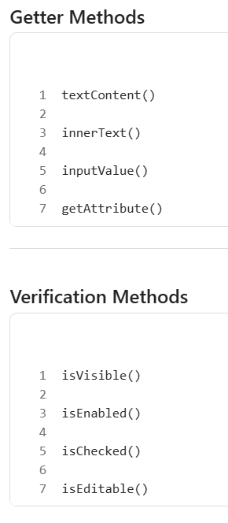

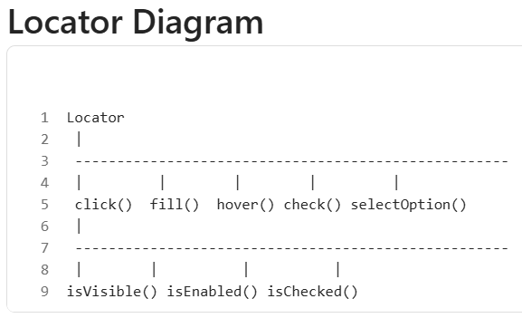

Playwright Locators
By ID - page.locator("#username");
By CSS- page.locator("input[name='username']");
By Text - page.getByText("Login");
By Placeholder - page.getByPlaceholder("Enter Username");
By Role- page.getByRole(AriaRole.BUTTON);
By Label - page.getByLabel("Username");

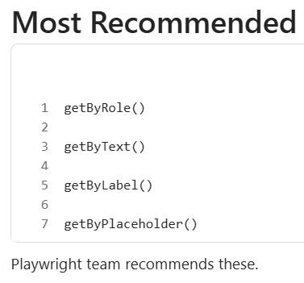

1-Fill Text
Selenium - sendKeys("Admin");
Playwright - fill("Admin");
Example: page.locator("#user").fill("Admin");
2-Click - page.locator("#login").click();
3-Checkbox- page.locator("#agree").check();
4-Radio Button- page.locator("#male").check();
5-Dropdown - page.locator("#country").selectOption("India");
6-Mouse Operations - hover() , click() , dblclick()
Example: page.locator("#menu").hover();
7-Keyboard Actions- page.keyboard().press("Enter");
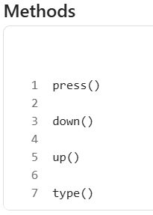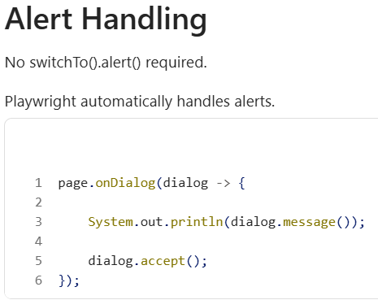

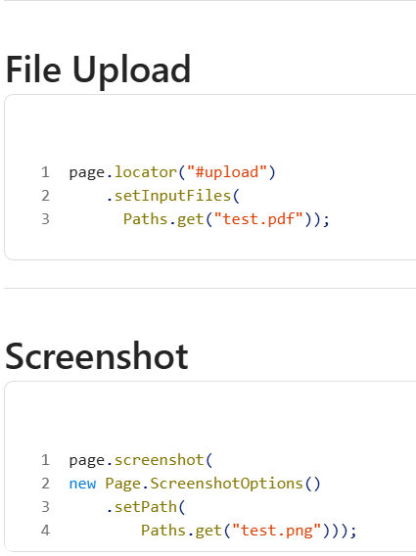

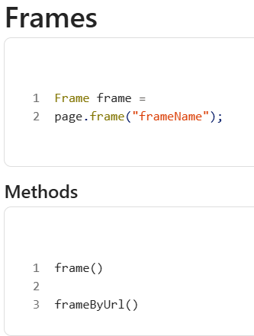

Multiple Tabs
Page newTab =context.newPage();
Playwright handles tabs much easier than Selenium.

Waits (Most Important Difference)
Selenium Implicit Wait , Explicit Wait , Fluent Wait
Playwright- Auto Wait
✅ Biggest advantage
Example - page.locator("#login").click();
Before clicking Playwright automatically waits for:
  - Visible 2. Stable 3. Enabled 4. Clickable
No explicit wait needed most of the time.

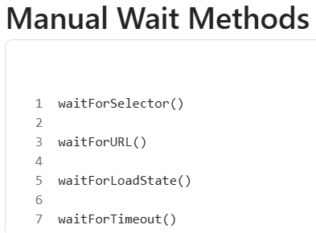

  - Wait For Element - page.waitForSelector("#login");
  - Wait For URL - page.waitForURL("**/dashboard");
Assertions- assertThat(locator) .isVisible();
Examples - assertThat(locator) .containsText("Success");
  - assertThat(locator).isEnabled();
  - assertThat(locator).isHidden();

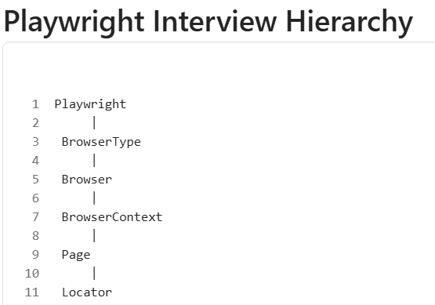

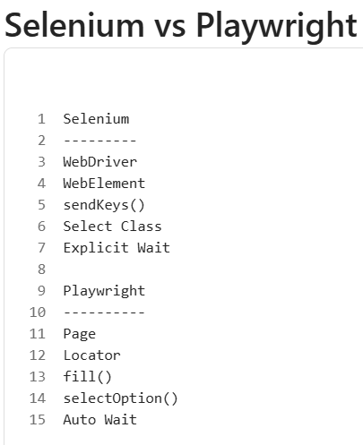

Top 20 Playwright Interview Questions
1. What is Playwright?
Modern browser automation tool developed by Microsoft.
2. Which browsers are supported?
Chromium , Firefox , WebKit
3. What is BrowserContext?
Independent browser session.
4. Difference between Browser and BrowserContext?
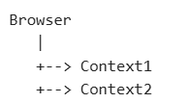
BrowserContext behaves like an Incognito session.

5. What is Locator?
Object used to locate and interact with elements.
6. Difference between Locator and ElementHandle?
Locator is recommended because it auto-retries and auto-waits.
7. Does Playwright support Auto Wait? - ✅ Yes.
8. Is Explicit Wait required? - Usually No.
9. How to handle alerts?- page.onDialog()
10. How to upload a file? - setInputFiles()
11. How to take screenshots? - page.screenshot()
12. How to handle frames? - page.frame()
13. How to handle multiple tabs? - context.newPage()
14. Can Playwright run in Headless mode? - ✅ Yes.
launch(new BrowserType.LaunchOptions().setHeadless(true));
15. What is Auto Wait?
Playwright automatically waits for element readiness.
16. What is Page Object Model?
Design pattern to separate locators from tests.
17. Does Playwright support parallel execution? - ✅ Yes.
18. Does Playwright support API Testing? - ✅ Yes.
19. Why Playwright over Selenium? – Faster , 2.Auto Wait ,3.Built-in Assertions , 4.Multiple Browser Support 5.Better Stability

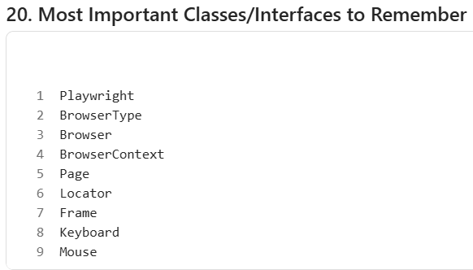

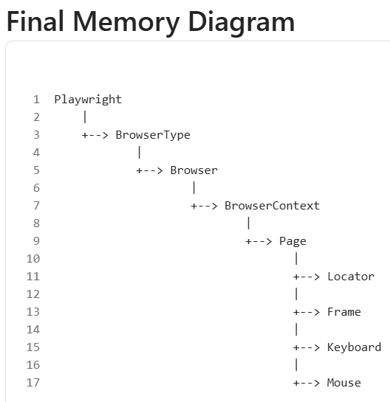

Every Playwright framework also has some generic reusable methods that you use daily.
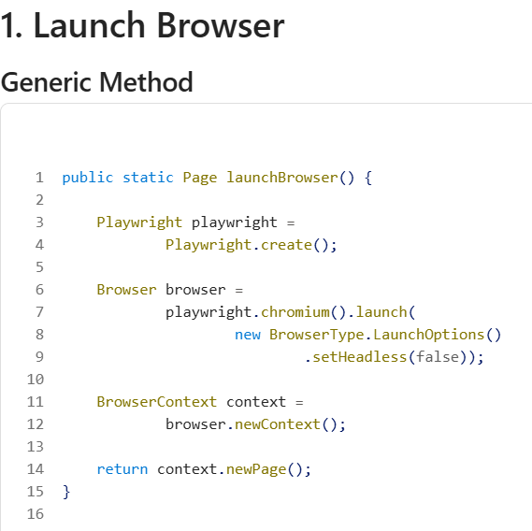
Usage - Page page = launchBrowser();
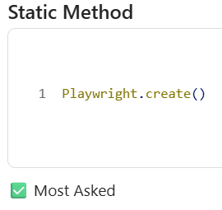
2. Open URL
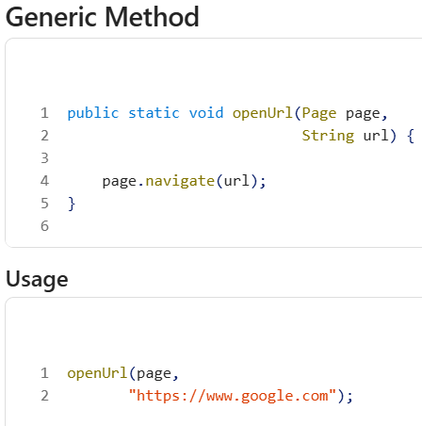
3. Fill Text
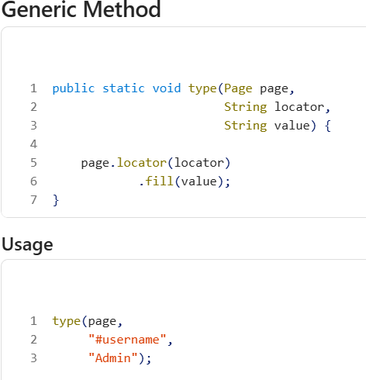

4. Click
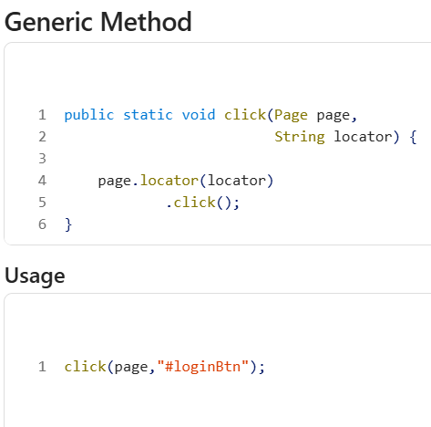

5. Get Text
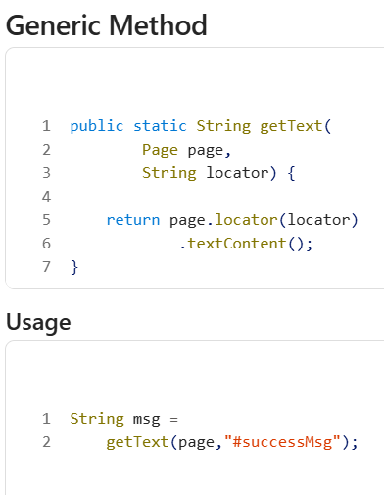

6. Dropdown Selection
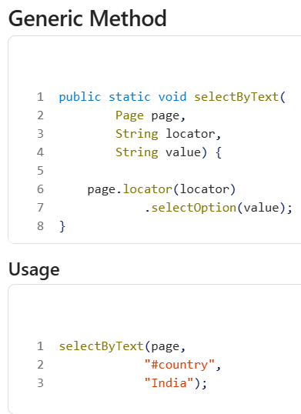

7. Checkbox
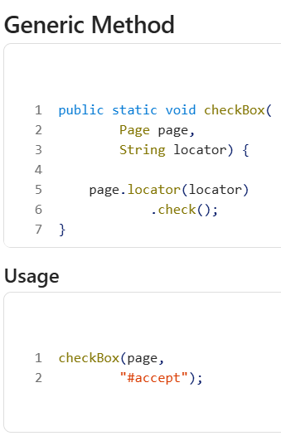

8. Uncheck Checkbox
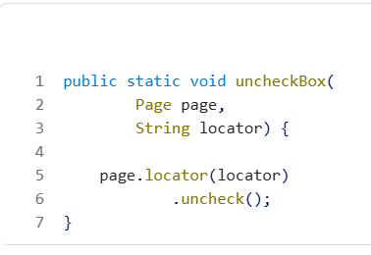

9. Verify Visible
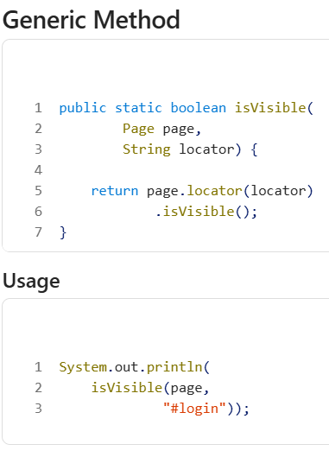

10. Wait For Element
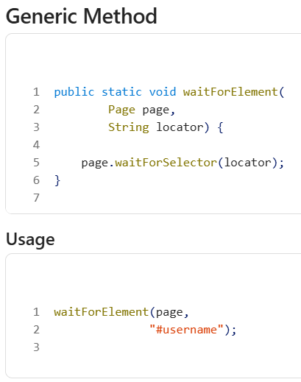

11. Wait For URL
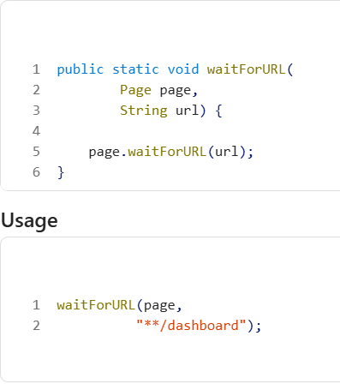

12. Screenshot
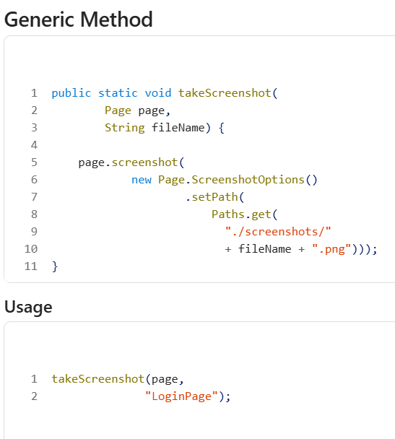

13. File Upload
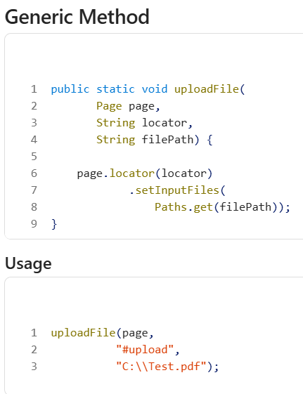

14. Mouse Hover
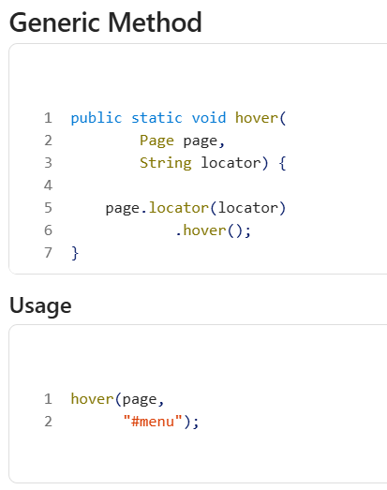

15. Double Click
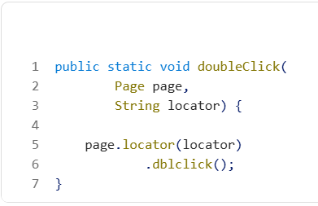

16. Keyboard Press
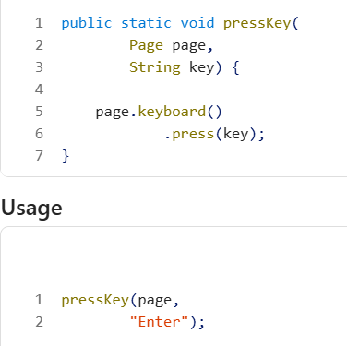

17. Read Property File
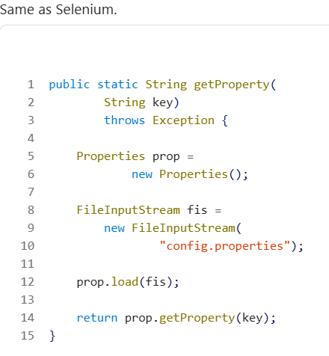
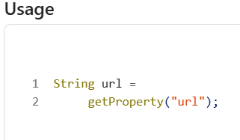
18. Read JSON Data
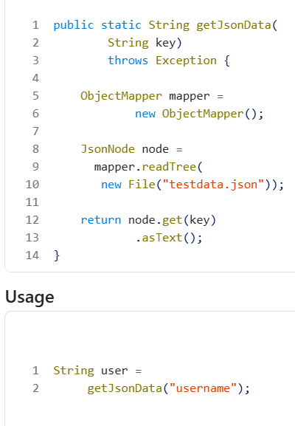
19. Generic Login
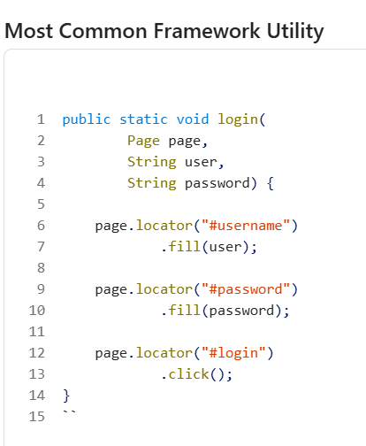

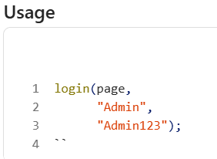
20. Assertions Utility
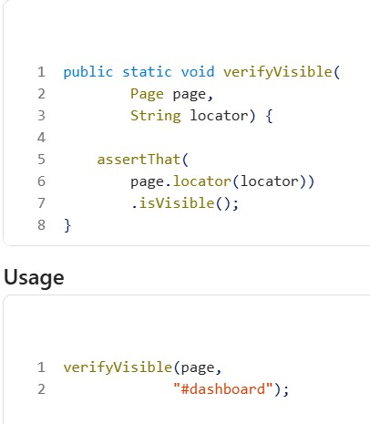

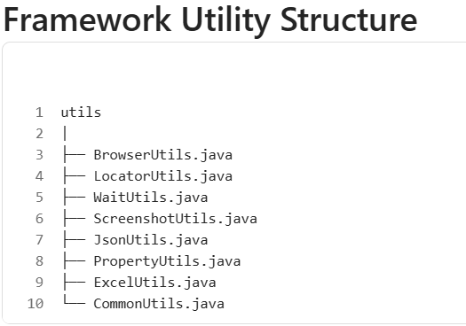

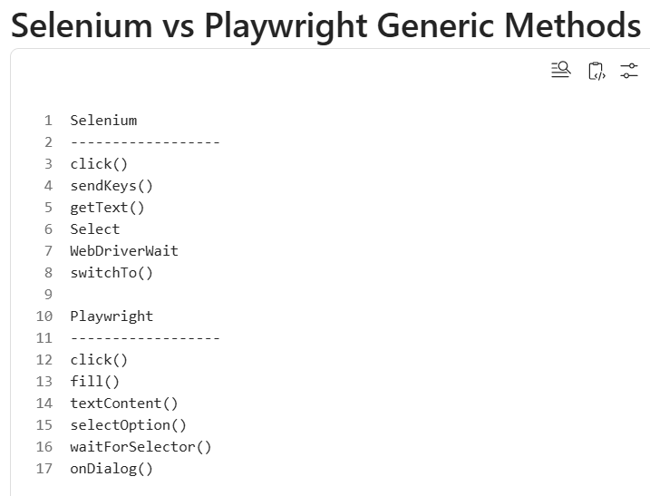

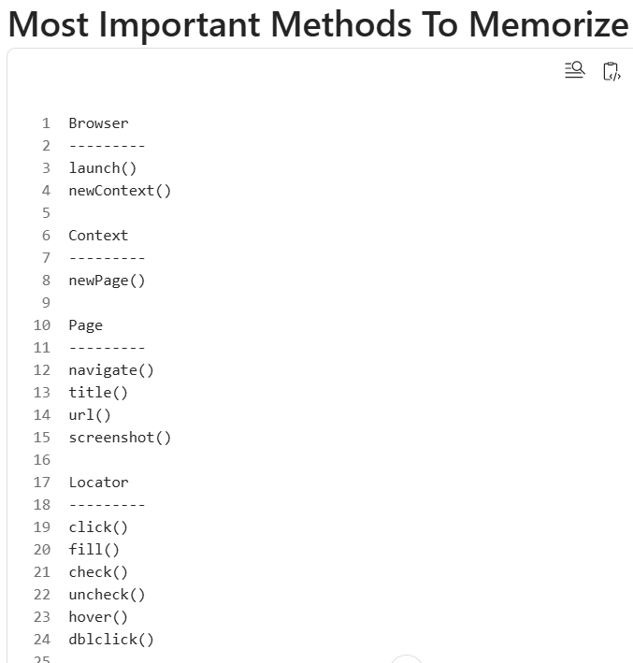

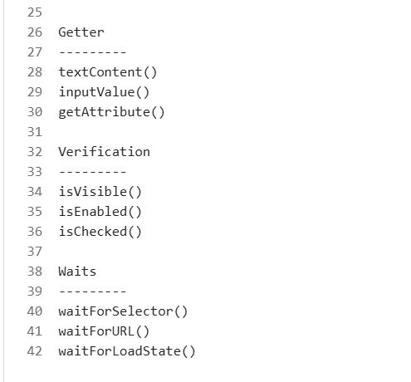

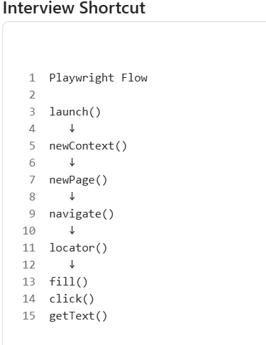

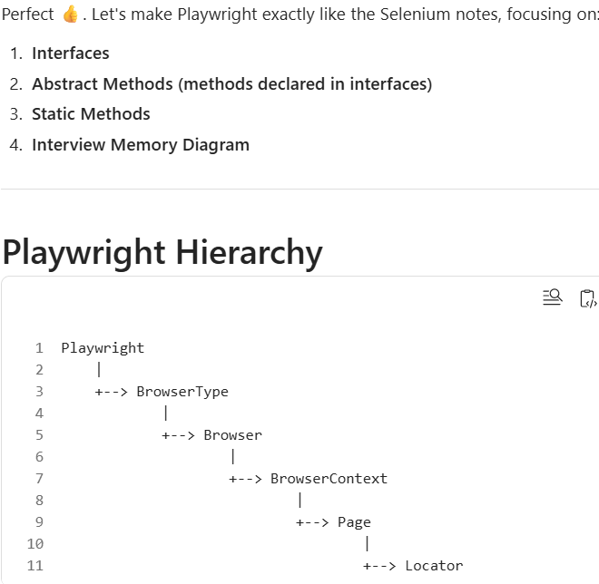

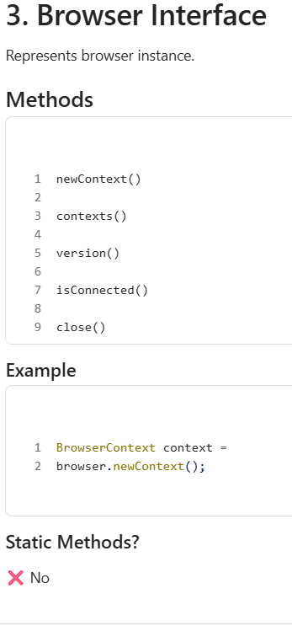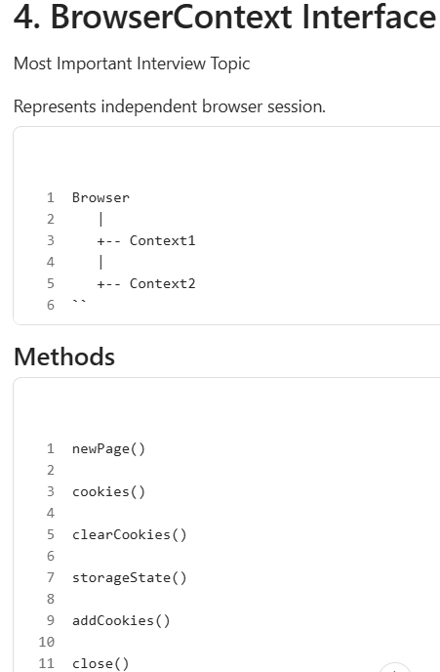

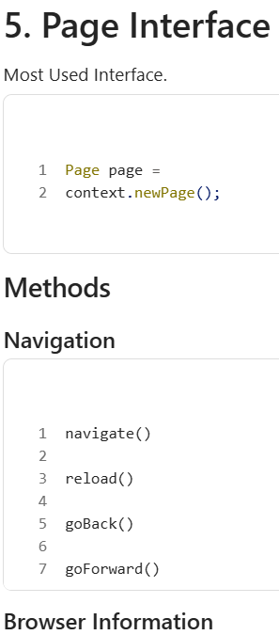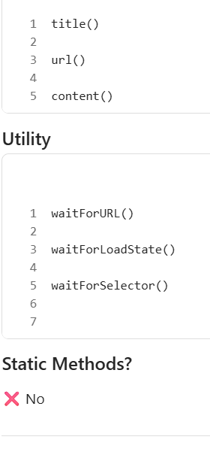

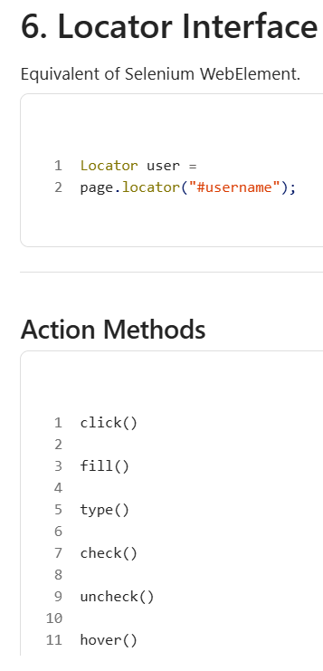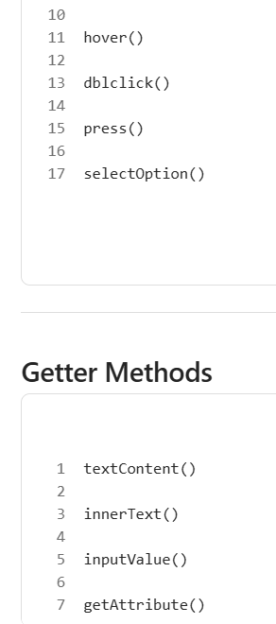

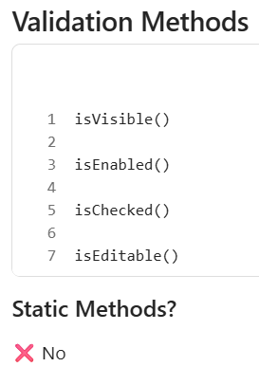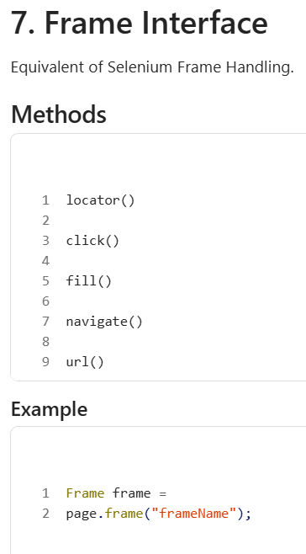

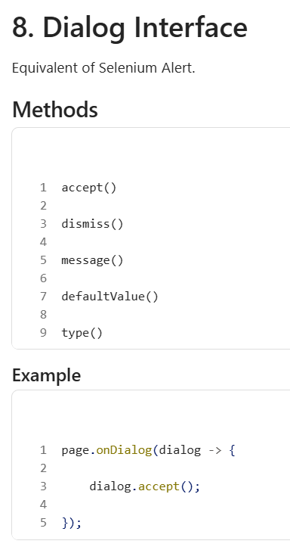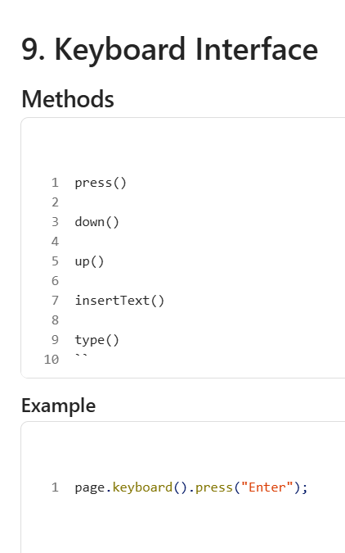

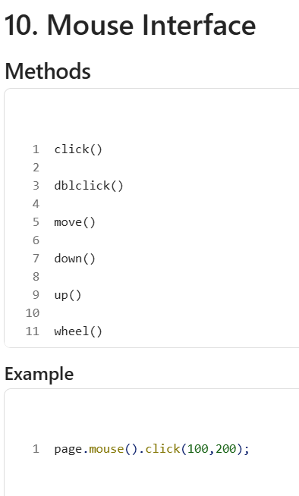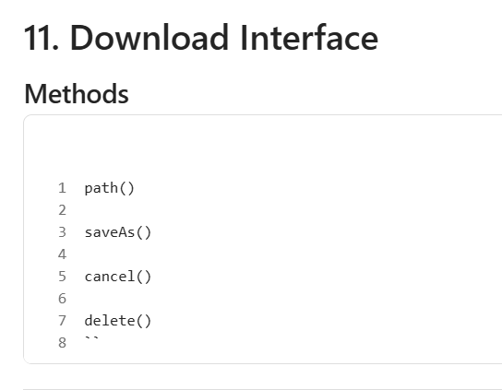

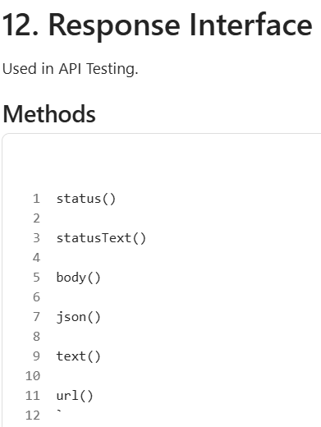

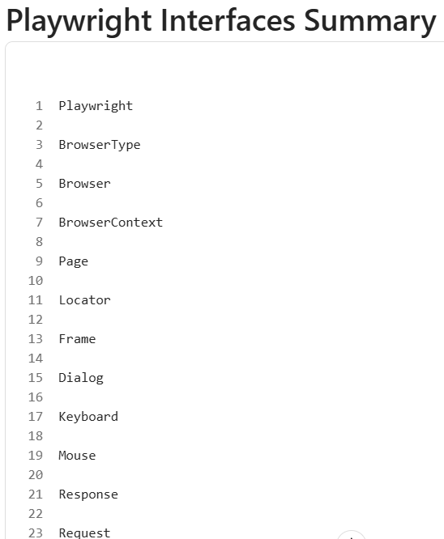

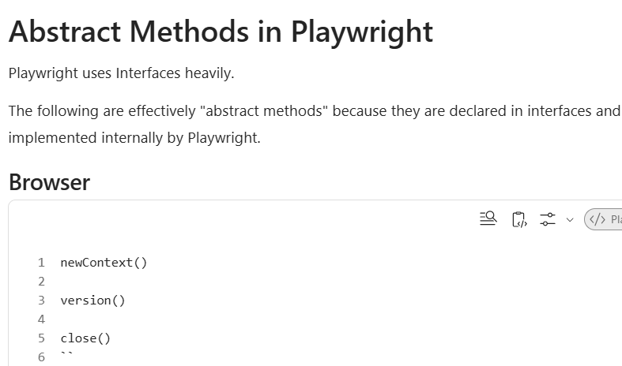

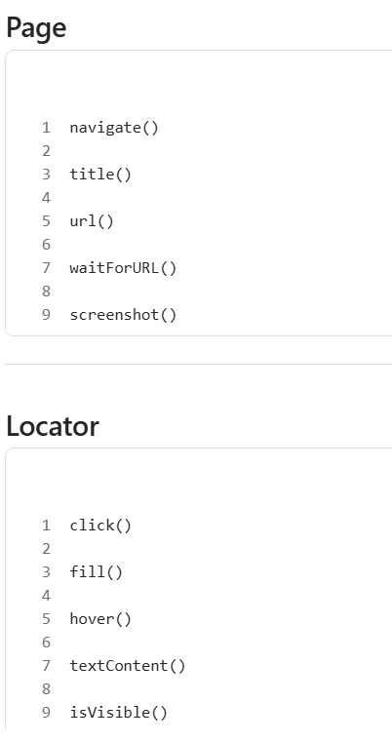

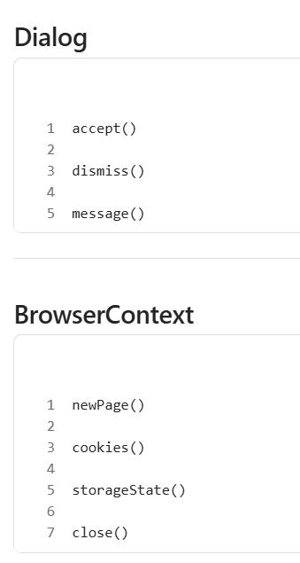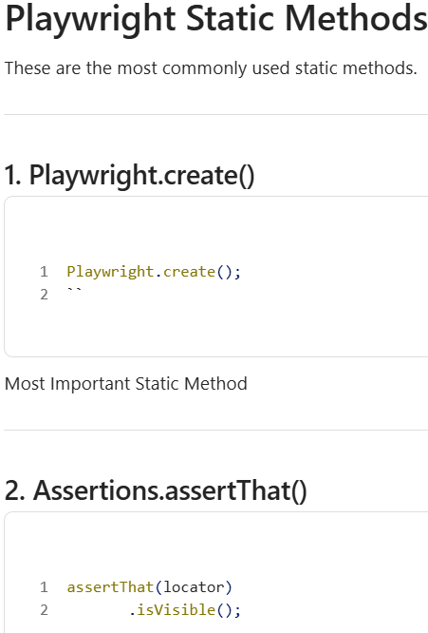

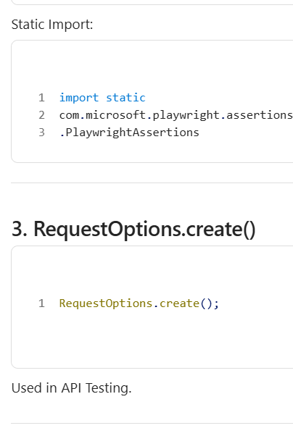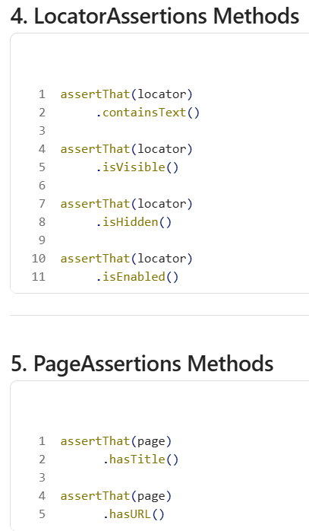

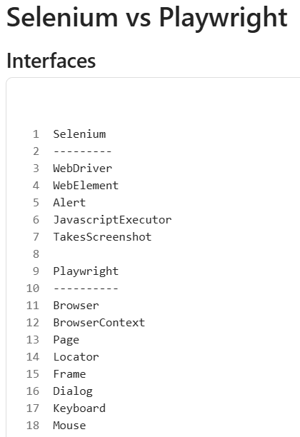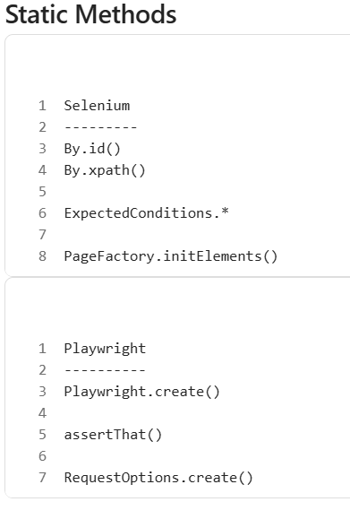

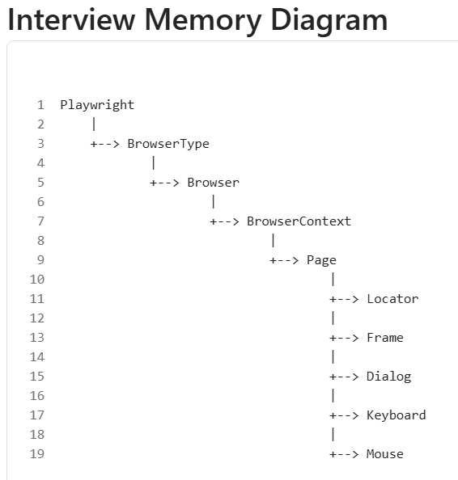

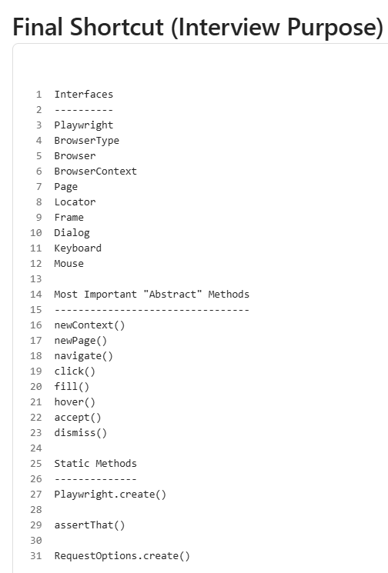

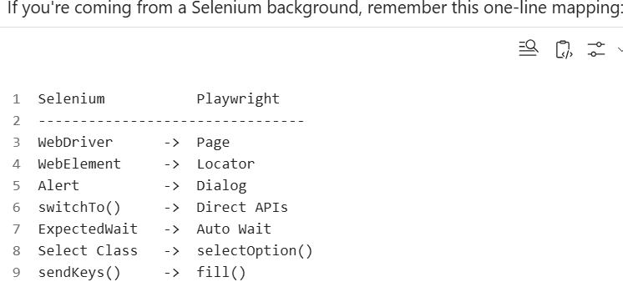

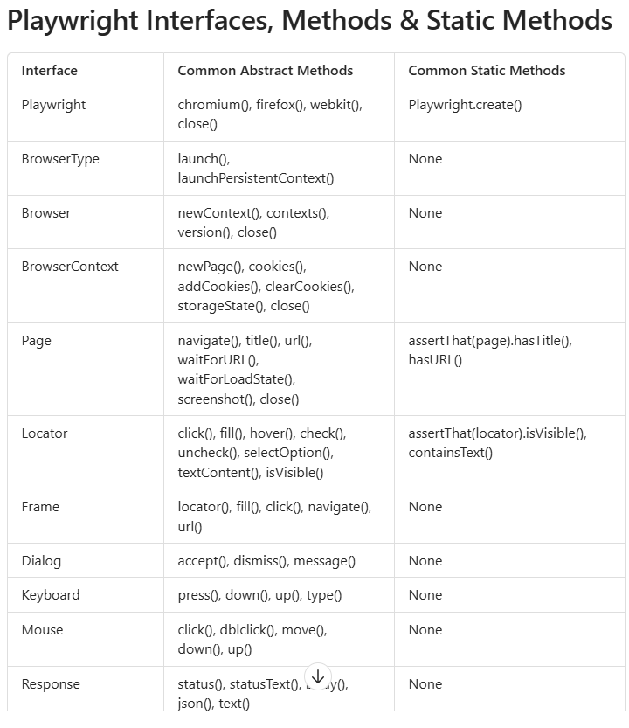

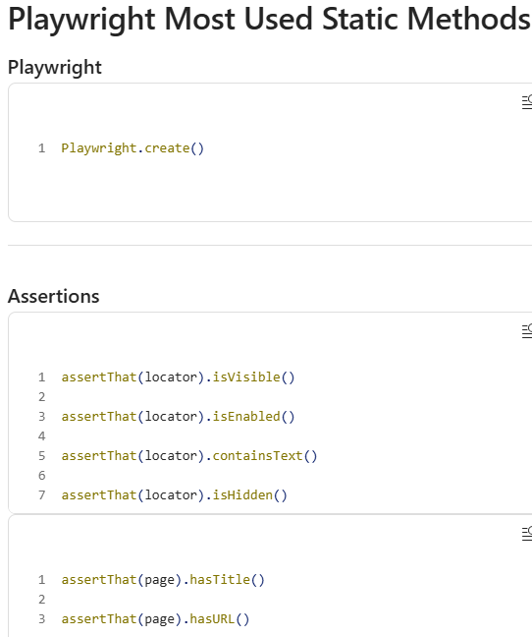

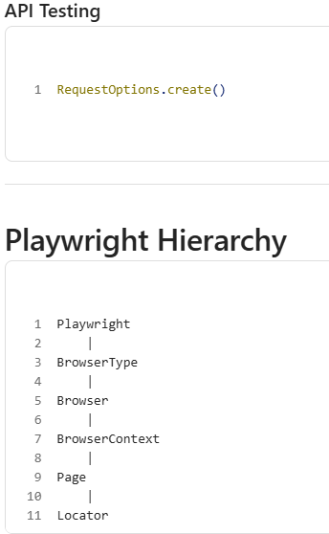

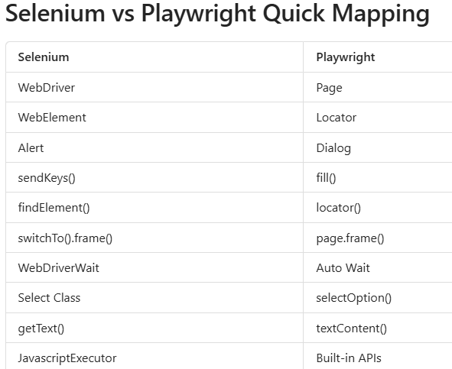

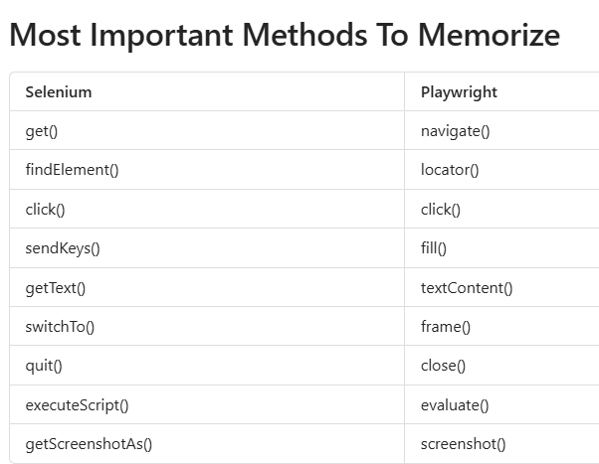

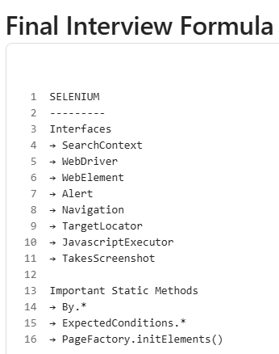

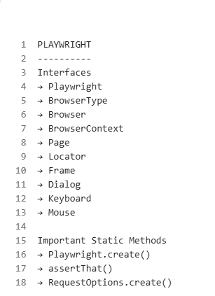

1.Full Page Screenshot
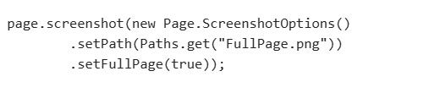
2. Element Screenshot
