Selenium Complete Notes (Simple Explanation + Programs + Interview Questions)
1. What is Selenium?
Selenium is an open-source automation testing tool used to automate web applications.
Why Selenium?
  - Automates browser actions
  - Supports multiple browsers
  - Chrome
  - Firefox
  - Edge
  - Safari
  - Supports multiple programming languages
  - Java
  - Python
  - C#
  - JavaScript
  - Supports various testing frameworks
Real-Life Example
Instead of manually:
  - Open browser
  - Enter username
  - Enter password
  - Click Login
Selenium does all these steps automatically.

2. Selenium Components
Selenium IDE
  - Record and Playback tool
  - No coding required
Selenium WebDriver
  - Automates browsers using code
  - Most widely used component
Selenium Grid
  - Executes tests on multiple machines and browsers simultaneously
3. Selenium Architecture
Test Script (Java) → Selenium WebDriver → Browser Driver(ChromeDriver) → Chrome Browser
Example
WebDriver driver = new ChromeDriver();
driver.get("https://google.com");
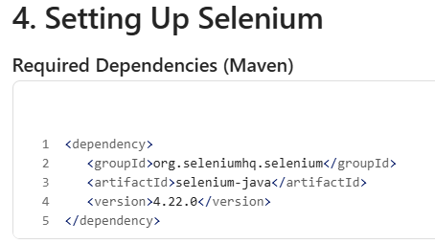
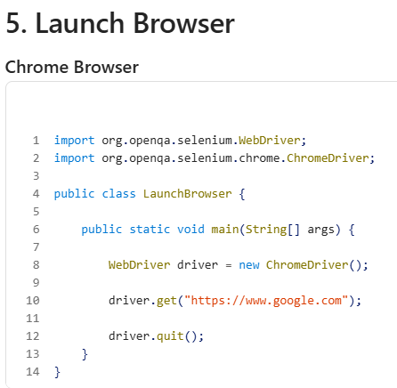
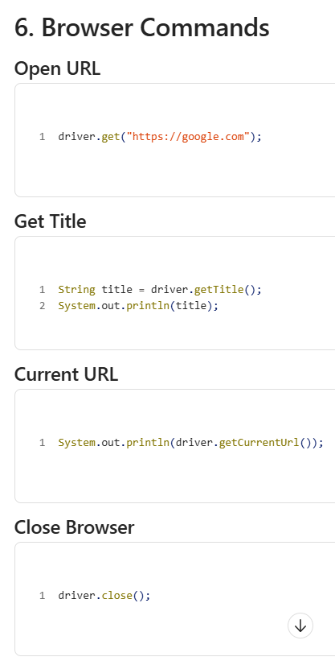
Close All Browser Windows - driver.quit();

7. Locators
Locators identify web elements.
  - ID - driver.findElement(By.id("username"));
  - Name -driver.findElement(By.name("email"));
  - Class Name -driver.findElement(By.className("login"));
  - Tag Name - driver.findElement(By.tagName("input"));
  - Link Text- driver.findElement(By.linkText("Login"));
  - Partial Link Text- driver.findElement(By.partialLinkText("Log"));
  - CSS Selector - driver.findElement(By.cssSelector("#username"));
  - XPath - driver.findElement(By.xpath("//input[@id='username']"));

8. WebElement Commands
  - Enter Text-driver.findElement(By.id("username")).sendKeys("Admin");
  - Click - driver.findElement(By.id("loginBtn")).click();
  - Clear Text- driver.findElement(By.id("username")).clear();
  - Get Text- String text = driver.findElement(By.id("msg")).getText();

9. XPath
  - Absolute Xpath- /html/body/div/input - Not recommended.
  - Relative Xpath - //input[@id='username’] --Recommended.
  - Contains- //input[contains(@id,'user')]
  - Text - //button[text() ='Login']
  - Starts-With - //input[starts-with(@id,'user')]
10. CSS Selector
  - By ID - #username
  - By Class - .login
  - Tag and ID - input#username
  - Attribute - input[name='username']

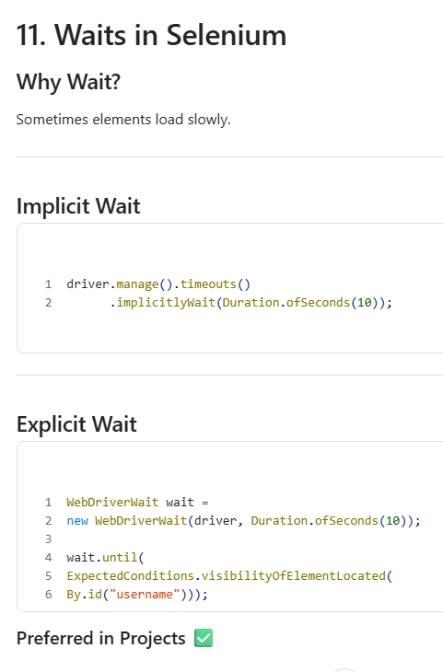
12. Handling Dropdown
  - Select Class -
Select dropdown = new Select(driver.findElement(By.id("country")));
Select by Text- dropdown.selectByVisibleText("India");
  - Select by Value- dropdown.selectByValue("IN");
  - Select by Index- dropdown.selectByIndex(1);

13. CheckBox Handling

WebElement checkbox = driver.findElement(By.id("agree"));
checkbox.click();
  - Verify Selected - System.out.println(checkbox.isSelected());

14. Radio Button
driver.findElement(By.id("male")).click();

15. Alerts
15.1- Accept Alert- Alert alert = driver.switchTo().alert();
alert.accept();
15.2-Dismiss Alert- alert.dismiss();
15.3-Get Text - String msg = alert.getText();
15.4-Enter Text - alert.sendKeys("Hello");

16. Frames
  - Switch to Frame- driver.switchTo().frame("frame1");
  - Back to Main Page - driver.switchTo().defaultContent();

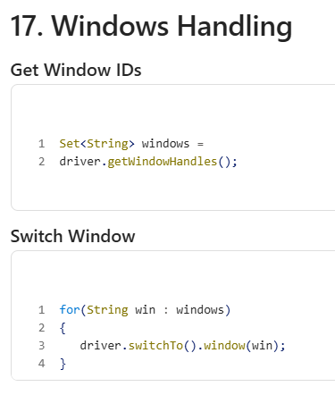
18. Mouse Actions- Using Actions class
Actions act = new Actions(driver);
  - Mouse Hover - act.moveToElement(element).perform();
  - Right Click -act.contextClick(element).perform();
  - Double Click - act.doubleClick(element).perform();
  - Drag And Drop - act.dragAndDrop(source, target).perform();

19. Keyboard Actions
Actions act = new Actions(driver);
act.keyDown(Keys.CONTROL).sendKeys("a").keyUp(Keys.CONTROL).perform();

20. Scrolling
JavascriptExecutor js = (JavascriptExecutor)driver;
js.executeScript("window.scrollBy(0,500)");

21. Screenshot
TakesScreenshot ts = (TakesScreenshot)driver;
File src = ts.getScreenshotAs(OutputType.FILE);

22. Upload File
driver.findElement(By.id("upload")).sendKeys("C:\\file.txt");

23. Download File
Usually handled using browser settings.

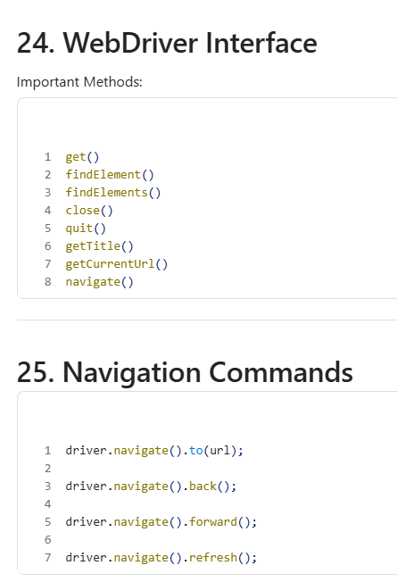
26. Selenium Framework Types
Data Driven Framework - Data from Excel/CSV.
Keyword Driven Framework - Keywords control execution.
Hybrid Framework - Combination of all.
BDD Framework - Using Cucumber.
Example: Cucumber
Given User is on Login Page
When User enters Username
Then User should login

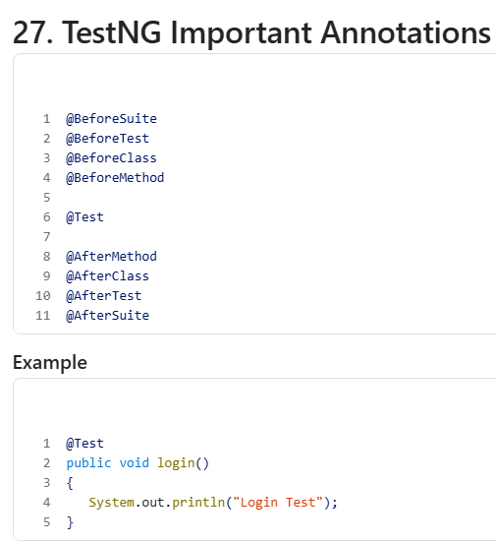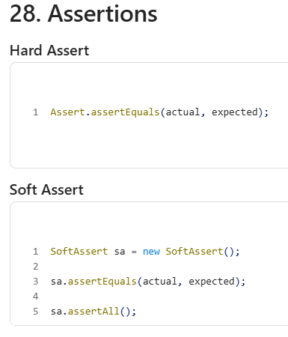
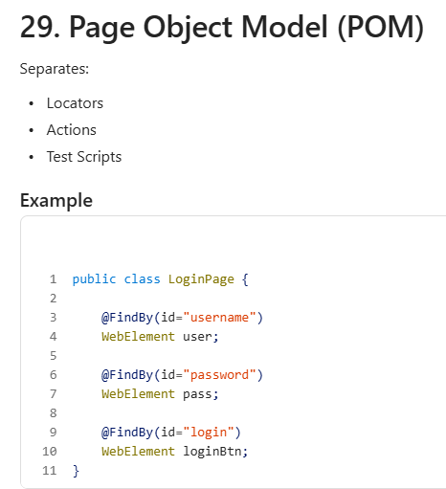

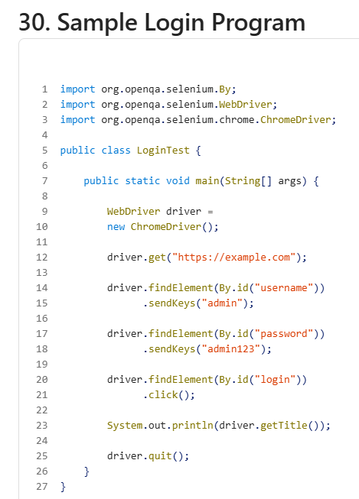

Top 30 Selenium Interview Questions
Basic Level
1. What is Selenium? - Web automation testing tool.
2. Which browsers are supported? - Chrome, Firefox, Edge, Safari.
3. What is WebDriver? - Interface used to automate browsers.
4. Difference between close() and quit()?
close() - Closes current browser
quit() - Closes all browser windows
5. Difference between findElement and findElements?
findElement - Returns single element
findElements - Returns list of elements
6. What are Locators? -Methods to identify web elements.
7. Which locator is fastest? -ID locator.
8. Difference between XPath and CSS?
XPath: Traverses both directions
CSS: Faster, Simpler
9. What is Absolute XPath? - Starts from root node.
10. What is Relative XPath? -Starts from any node.
Intermediate Level
11. What are Selenium Waits?
  - Implicit Wait
  - Explicit Wait
  - Fluent Wait
12. Difference between Implicit and Explicit Wait?
Implicit: Applies globally
Explicit: Specific element
13. What is StaleElementException? - Element refreshed and Selenium lost reference.
14. How to handle alerts? - driver.switchTo().alert();
15. How to handle dropdown? - Select select = new Select(element);
16. How to handle multiple windows? -driver.getWindowHandles();
17. What is Page Object Model? - Design pattern that separates page objects from tests.
18. What is PageFactory? - Used to initialize web elements.
19. What is Actions Class? - Handles mouse and keyboard operations.
20. What is JavaScriptExecutor? - Executes JavaScript code from Selenium.

Advanced Level
21. What is Selenium Grid? - Parallel execution on multiple machines.
22. What is Framework? - Structured way of maintaining automation code.
23. What is Data Driven Testing? - Data comes from external files.
24. Why TestNG? - Reporting, annotations, grouping.
25. Difference between Assert and Verify? -
Assert: Stops execution
Verify (Soft Assert): Continues execution
26. What are Desired Capabilities? - Used to configure browsers and environments.
27. How to capture Screenshot? - TakesScreenshot ts = (TakesScreenshot)driver;
28. Can Selenium Automate Captcha? - No. Captcha is designed to prevent automation.
29. Limitations of Selenium? - No desktop application testing
  - No built-in reporting
  - No built-in test management
30. Why is Selenium preferred? - Free, Open source, Multiple browser support, large
-------------------------------------------------------------------------------------------
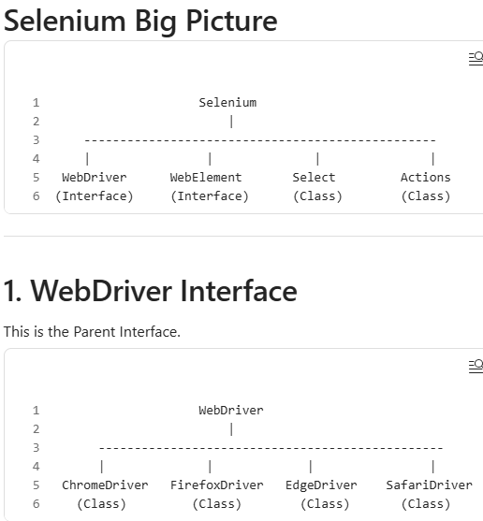
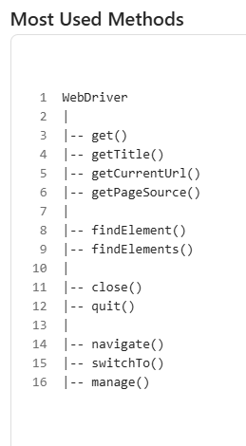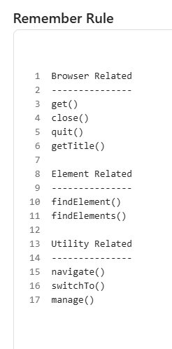
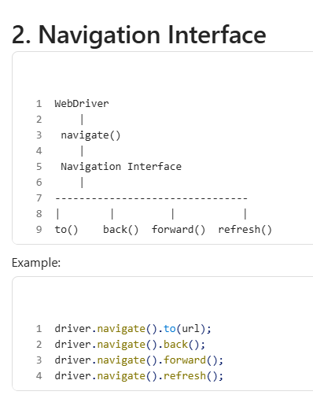
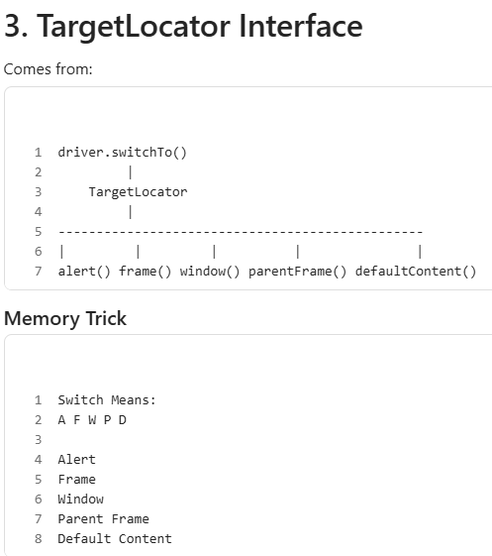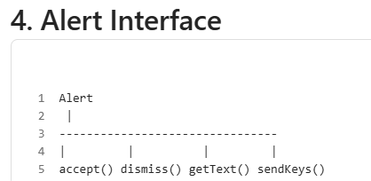

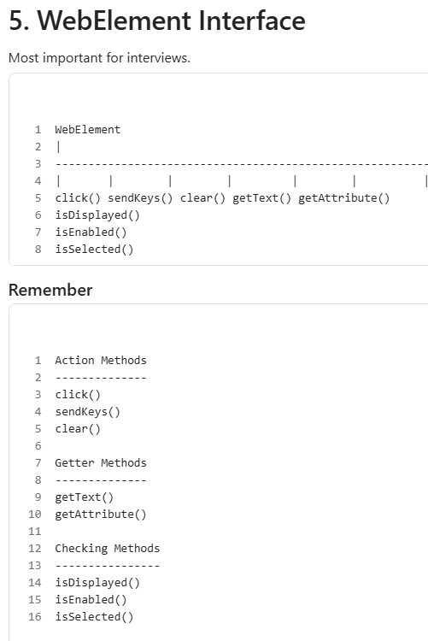
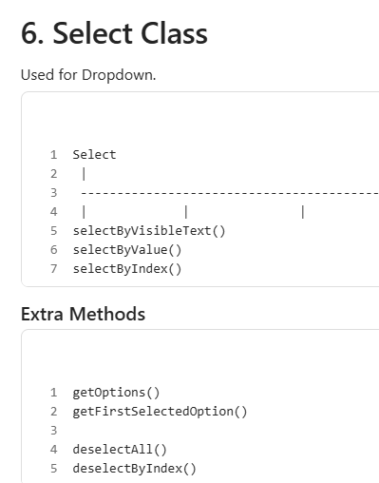
Memory Trick - VVI - Visible Text , Value, Index
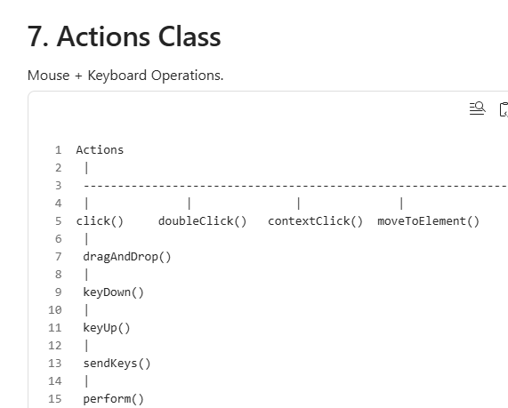|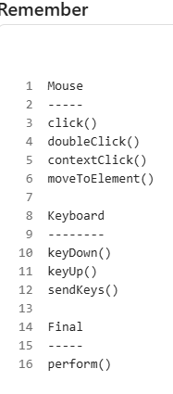
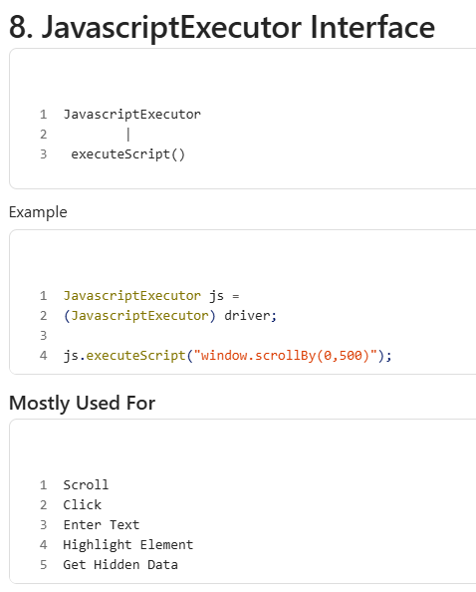
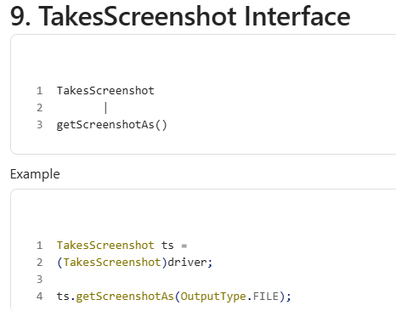
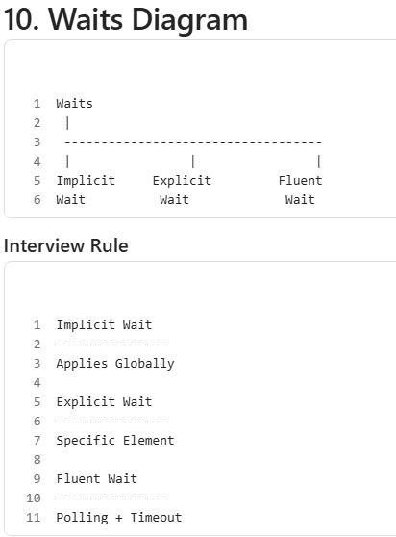
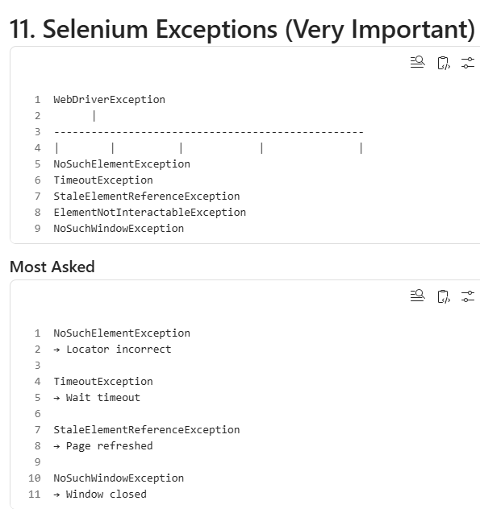
12. Complete Selenium Interview Mind Map
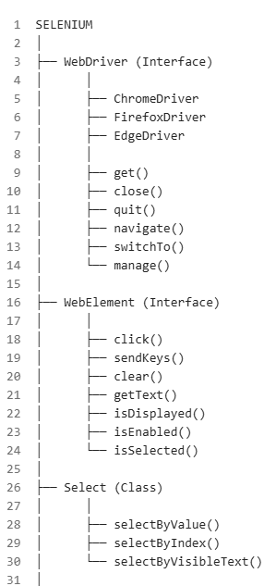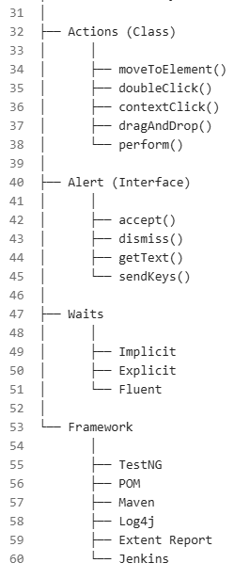
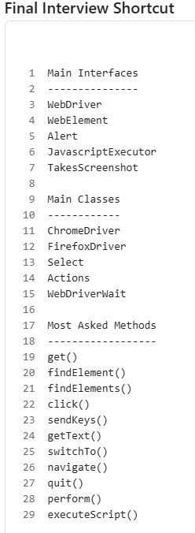

Great approach 👍. In interviews and frameworks, you don't need to memorize huge code. Just remember
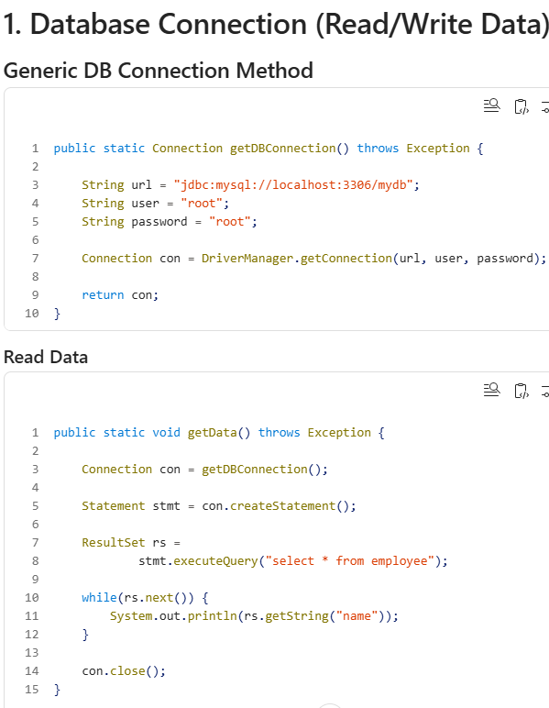1.3- 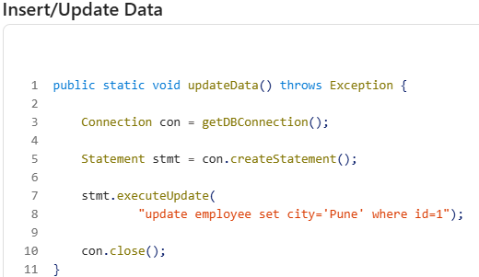
Remember -
Connection → Statement→ ResultSet

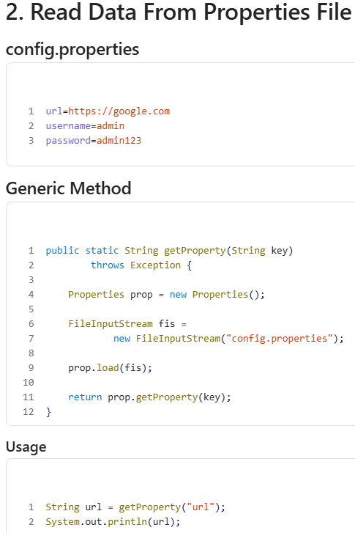
Framework Usage - driver.get(getProperty("url"));

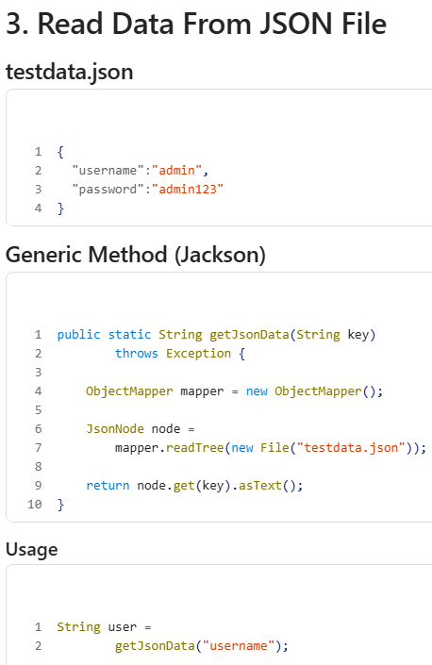
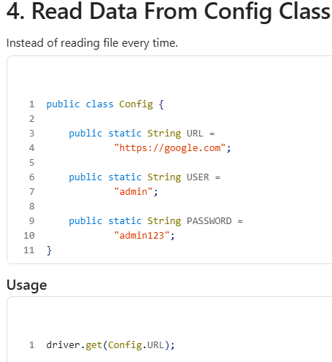

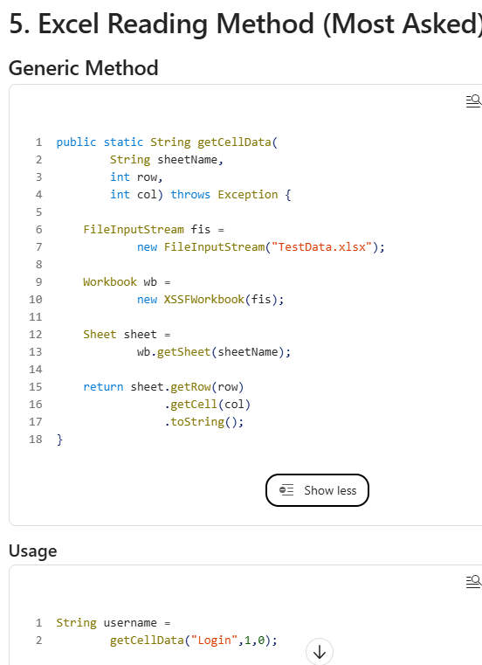
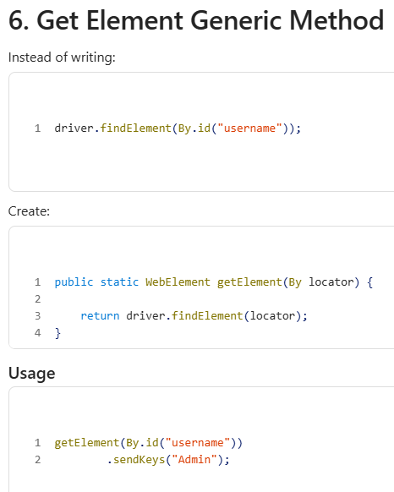
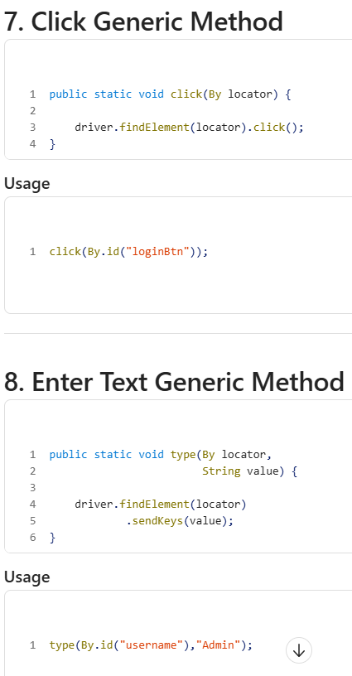

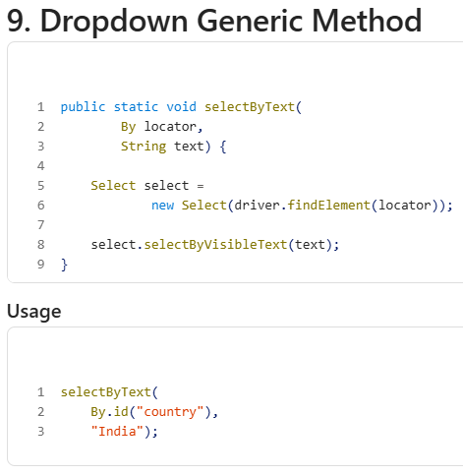
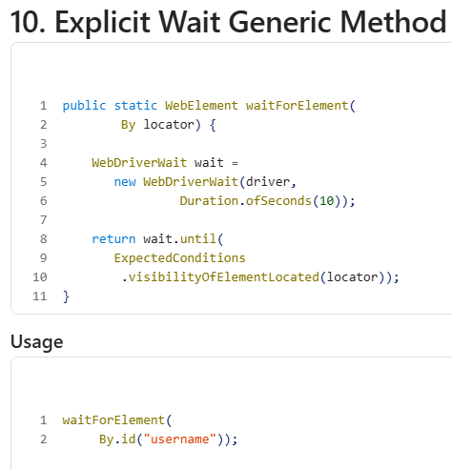

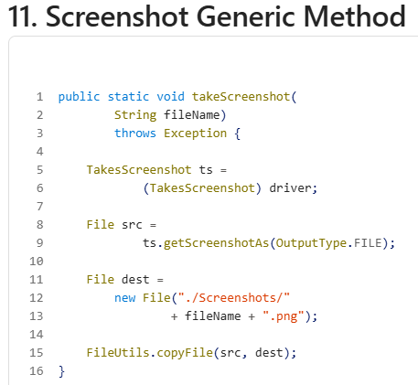
Usage- takeScreenshot("LoginPage");

12- Open a New Tab
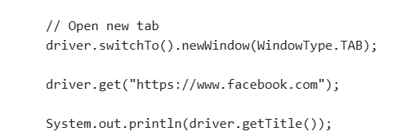
13- Open a New Window
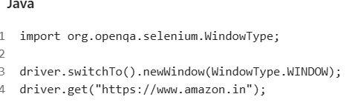
14-Open Multiple Tabs
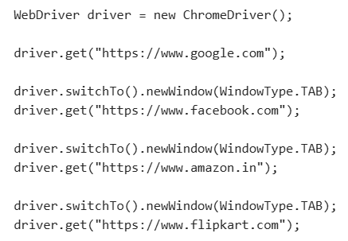
15-Switch Between Tabs/Windows
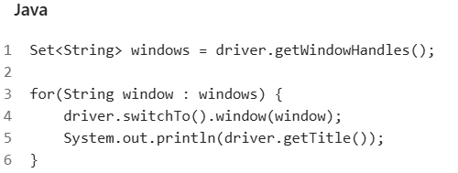
16-Store Parent and Child Window
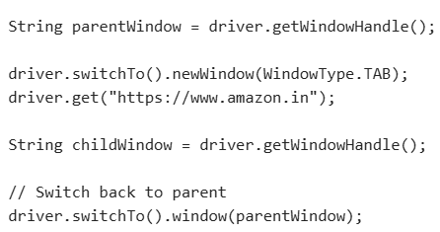
17-Switch to specific Tab by Index
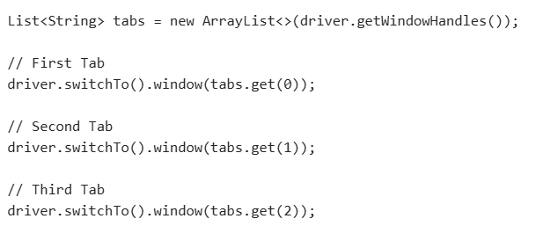
18-Close Current Tab and Return to Parent
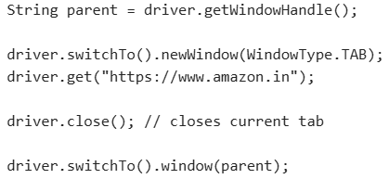
19-Selenium 4 Shortcut (JavaScript)
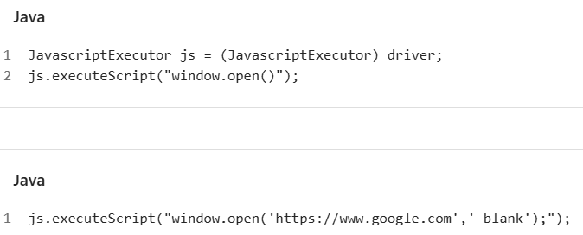

20-For Selenium Framework Utility Class for Screenshot for Page/Web Element
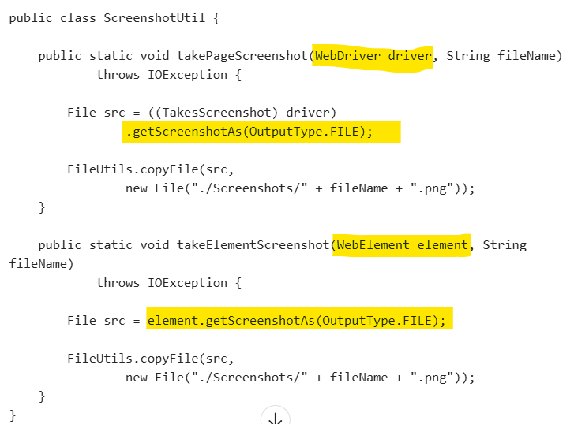

Framework Use-
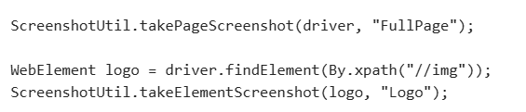

12. Read Environment Variable
public static String getEnv(String key) {
return System.getenv(key); }
Usage - String token = getEnv("API_TOKEN");
--------------------------------------------------------------------------------------------
Real Framework Structure (Most Companies)
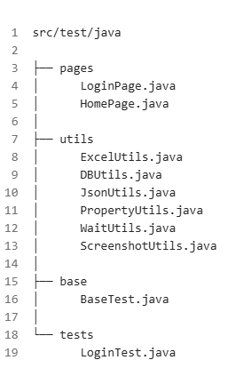

Interview Shortcut to Remember
Data Sources-- Property File, JSON File , Excel File , Database
Utilities-- Click , Type , Wait , Dropdown , Screenshot ,
DB Flow-- Connection , Statement , ResultSet
Property Flow-- Properties , FileInputStream , getProperty()
JSON Flow-- ObjectMapper , JsonNode , get()
Excel Flow-- Workbook , Sheet , Row , Cell
--------------------------------------------------------------------------------------------
Interview Question
Q1. Is WebDriver an abstract class? - ✅ No - WebDriver = Interface
Q2. Is WebElement an abstract class? - ✅ No - WebElement = Interface
Q3. Is ChromeDriver an abstract class? - ✅ No - ChromeDriver = Concrete Class
This I-A-C (Interface → Abstract → Class) pattern is the easiest way to remember Selenium architecture for interviews.

-----------Selenium Interfaces And their Abstract Methods---------- 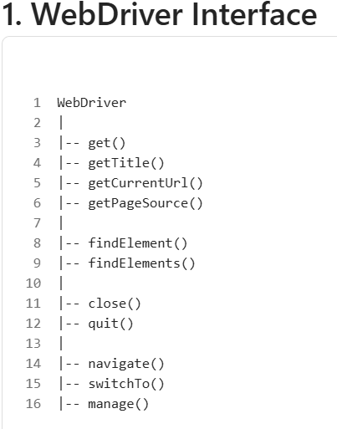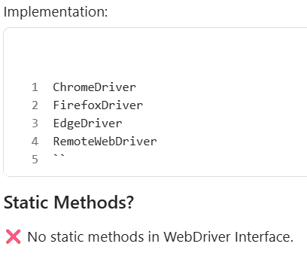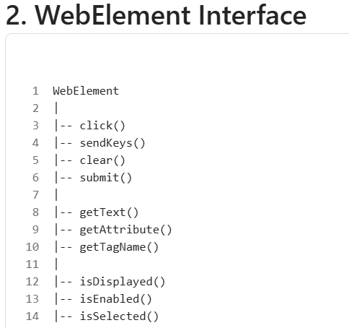 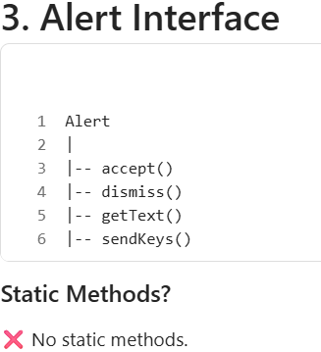

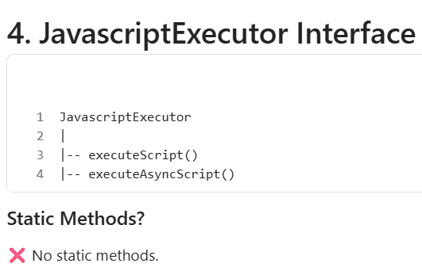

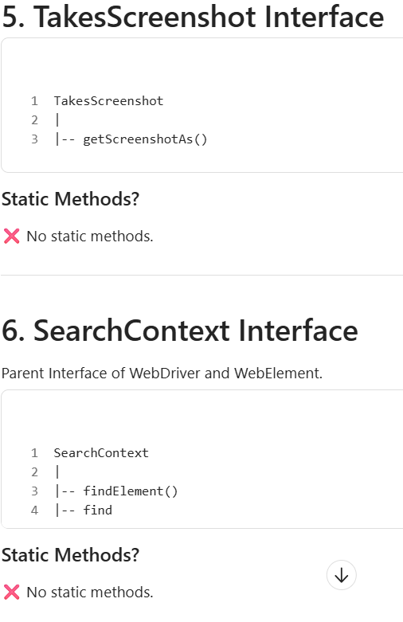

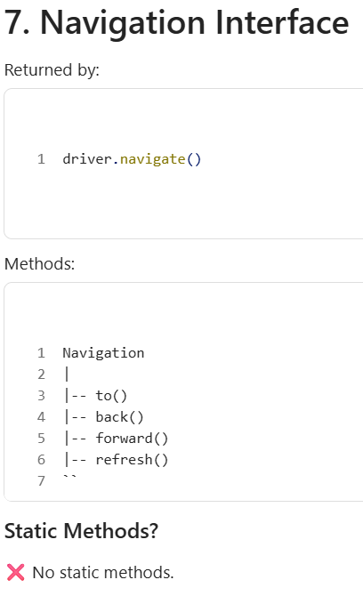

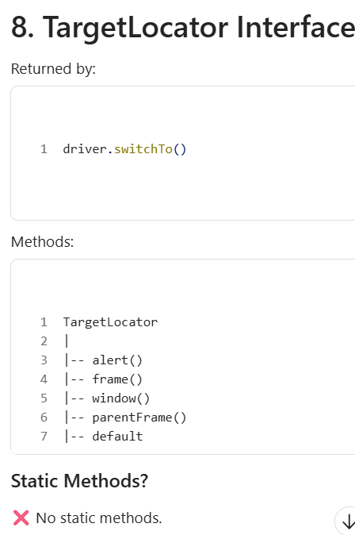

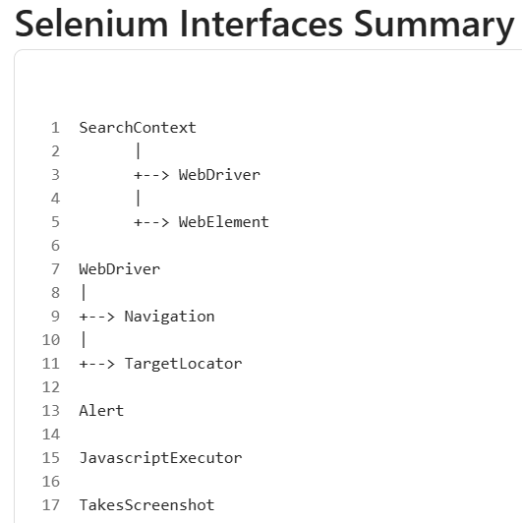
--------------------------------------------------------------------------------------------
These are Java static methods, not Selenium interface methods.
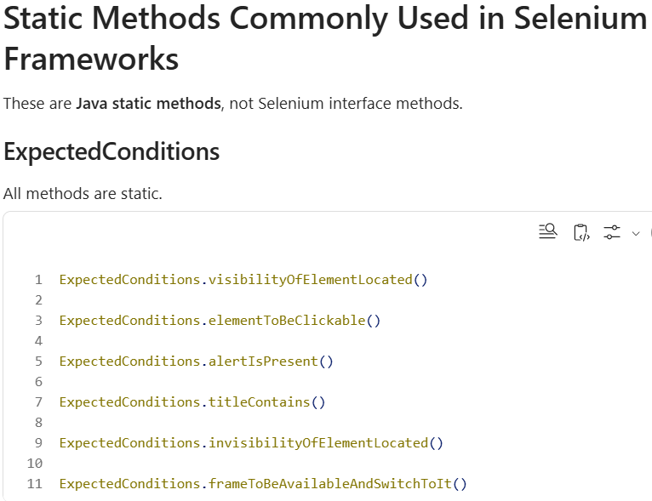

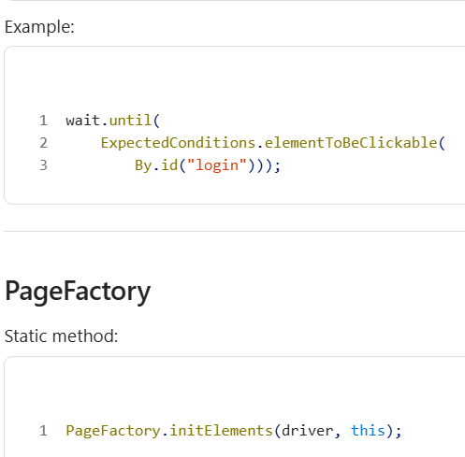

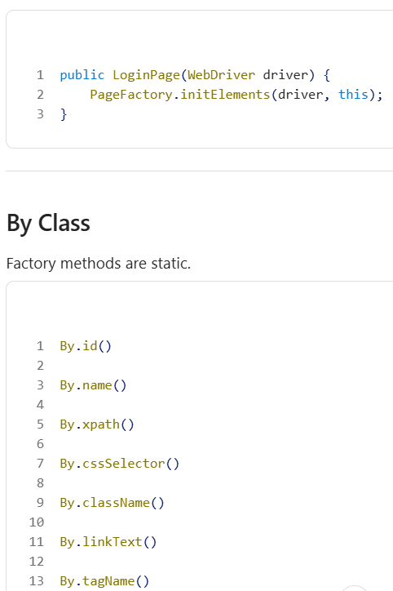

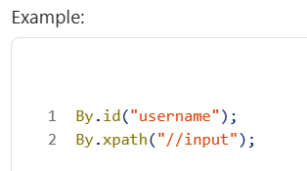

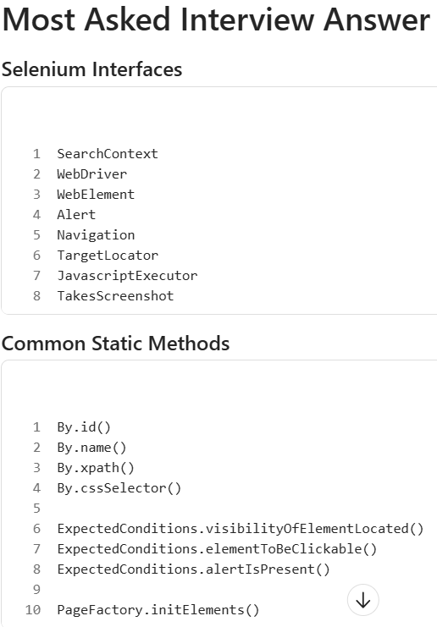

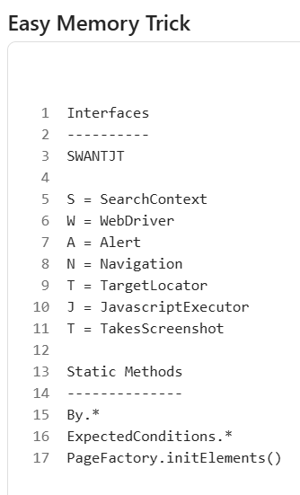
IMP-
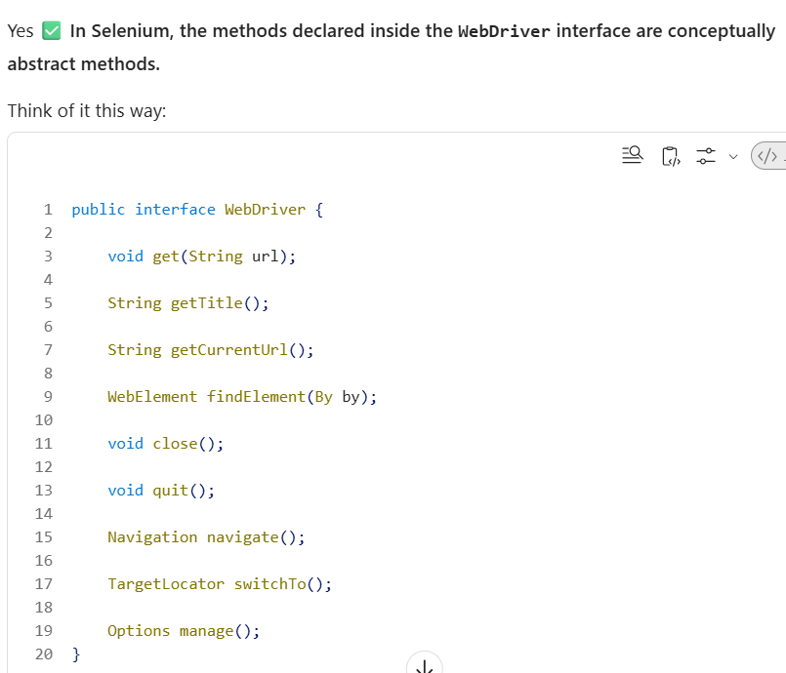

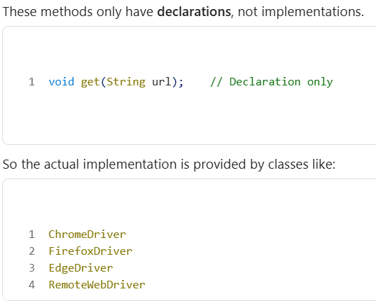
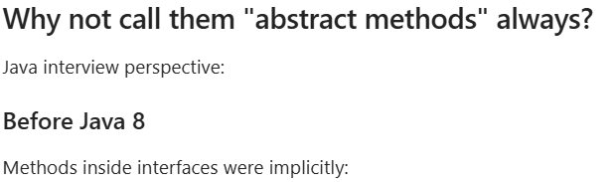
public abstract
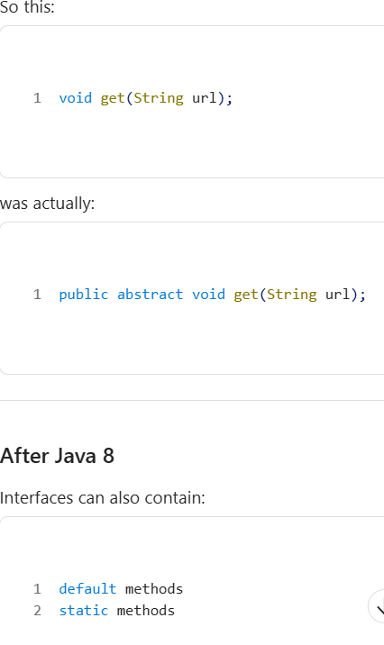

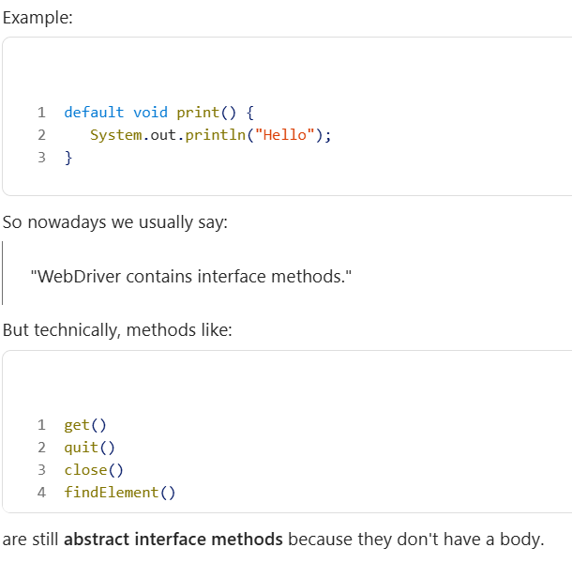

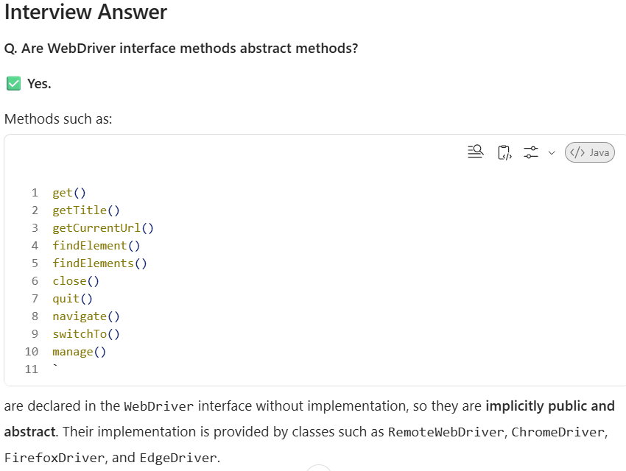

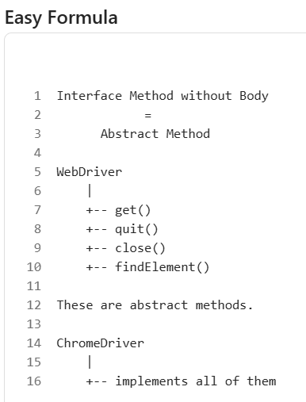

Absolutely. This is probably the best interview revision sheet because it combines:
✅ Interface Name
✅ Common Abstract Methods (declared in interface)
✅ Common Static Methods related to that interface/module
✅ Real-time usage

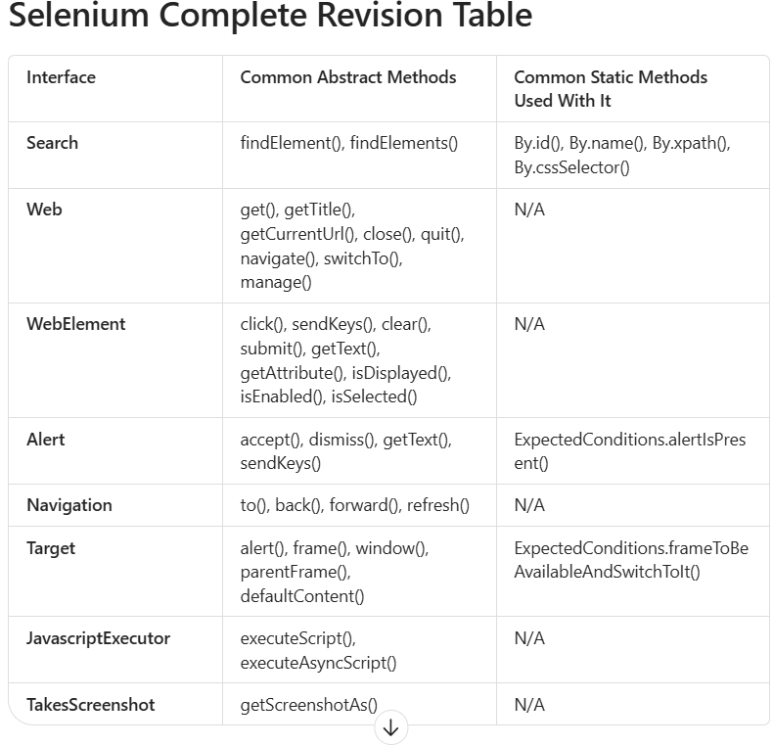

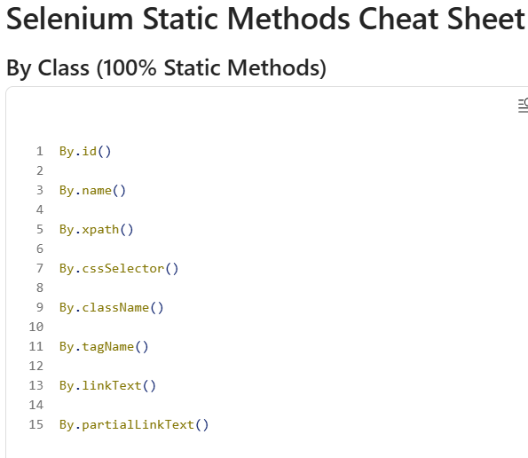
Example: driver.findElement(By.id("username"));

